Supplementary material

Supplementary methods

MRI acquisition and processing
MRI data were acquired on a Siemens Magnetom Prisma 3T scanner using a 32-channel head coil (Siemens AG, Erlangen, Germany). Structural T1- and T2-weighted images were acquired: T1 protocol: Isotropic 0.8 mm resolution, repetition time = 1810 ms, echo time = 2.41 ms, inversion time = 920 ms, and flip angle = 9°. T2 protocol: Isotropic 0.9 mm resolution, repetition time = 3200 ms, echo time = 408 ms). MRI preprocessing and grey matter multispectral segmentation were performed using SPM12 (Functional Imaging Laboratory, the Wellcome Trust Centre for NeuroImaging, London, UK), as previously described ¹.

PET data acquisition and preprocessing
A full description of the protocols for [¹¹C]UCB-J radiosynthesis, PET acquisition and preprocessing has been published previously ¹. Briefly, participants were scanned with a high-resolution research tomograph (HRRT) PET scanner (CTI/Siemens, Knoxville, TN, USA) for 120 min, starting at the time of the intravenous [¹¹C]UCB-J bolus injection. PET data were acquired in 3D list-mode and reconstructed into 40 frames using 3D OP-OSEM algorithm with all standard corrections ^{2,3}. Images consisted of 207 planes of 256 x 256 voxels of 1.22x1.22x1.22 mm³.
Arterial blood samples were collected during the PET scan to measure total whole blood and plasma radioactivity, unmetabolized radioligand (parent fraction) and radiolabeled metabolites in plasma, in order to establish an arterial input function (AIF), as well as estimate the plasma free fraction of [¹¹C]UCB-J (Johansen et al., 2023).
Following motion-correction with the AIR software (Automated Image Registration, v. 5.2.5, LONI, UCLA), individuals’ T1-weighted MR image was co-registered to participants’ PET image using SPM12. Regions of interest (ROIs) were automatically defined using a the PVElab software (https://nru.dk/index.php/allcategories/category/30-software), as previously described ⁴. Mean radioactivity was extracted from 4D PET images for all grey-matter masked ROIs to extract regional time-activity curves.

Supplementary Results
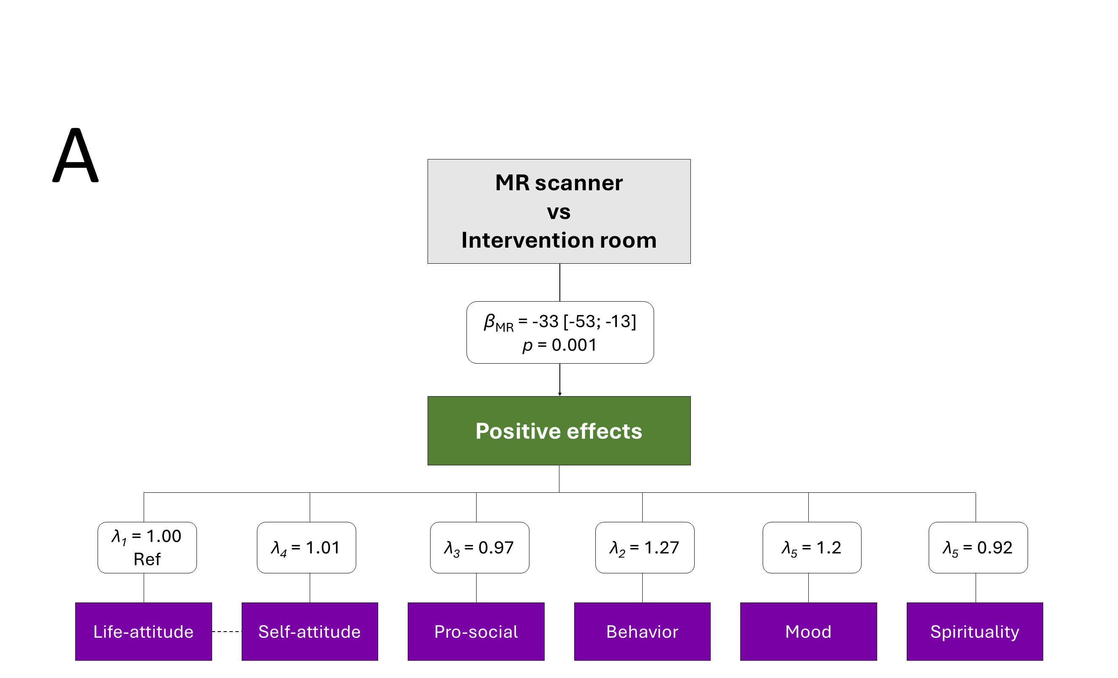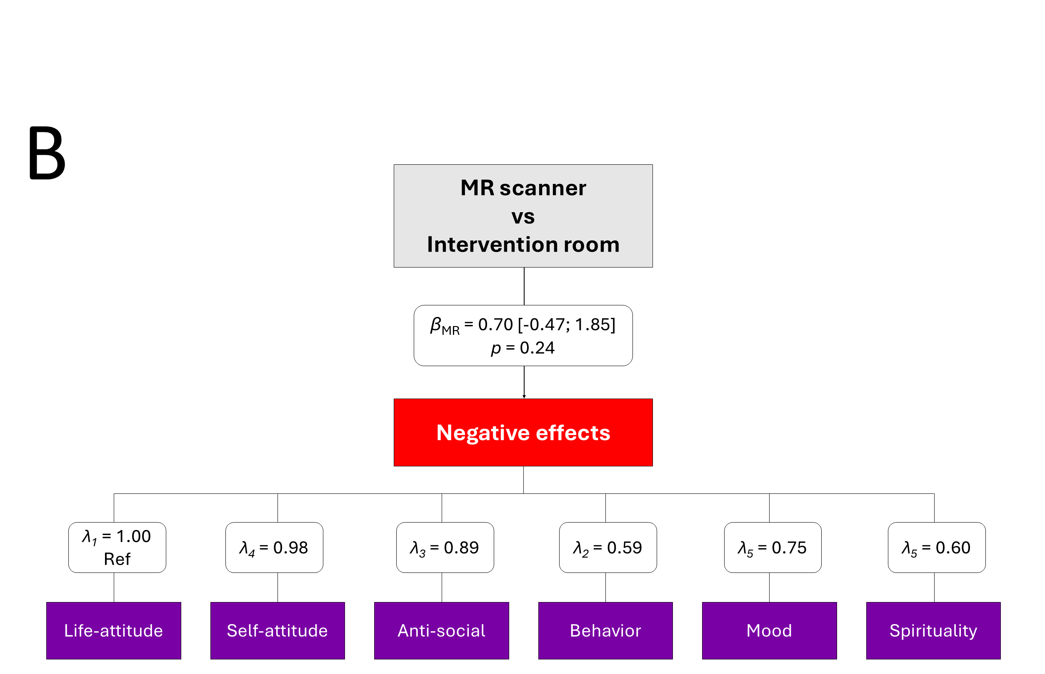
Figure S1. Latent variable models for the effect of session environment on positive persisting effects (A) and negative persisting effects (B).

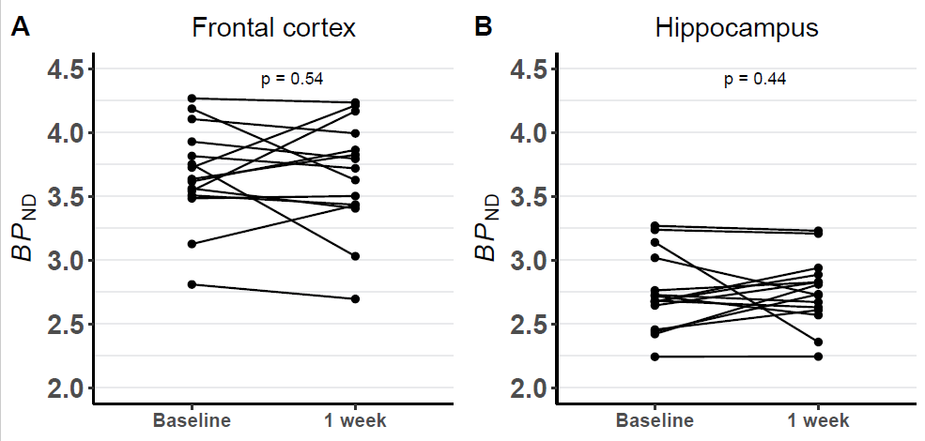
Figure S2. Changes in [¹¹C]UCB-J BP_{ND} in the frontal cortex (A) and hippocampus (B).

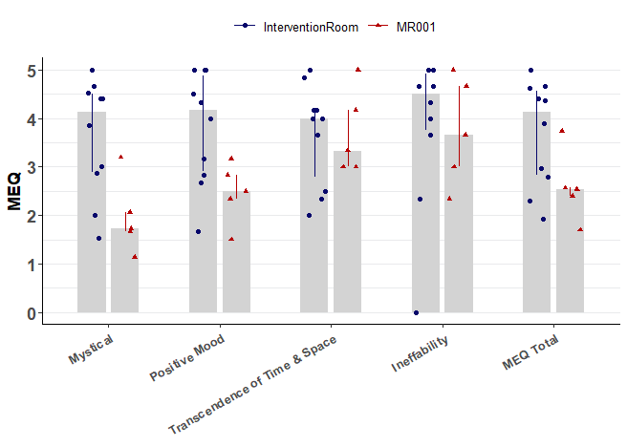
Figure S3. Distribution of MEQ subscale scores for all 15 participants. Columns: median, error bars: IQR.

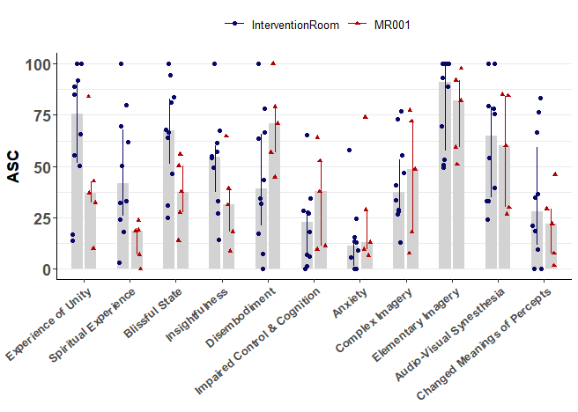
Figure S4. Distribution of ASC subscale scores for all 15 participants. Columns: median, error bars: IQR.

1. Johansen A, Armand S, Plavén-Sigray P, et al. Effects of escitalopram on synaptic density in the healthy human brain: a randomized controlled trial. Mol Psychiatry. 2023;28(10):4272-4279. doi:10.1038/s41380-023-02285-8
2. Sureau FC, Reader AJ, Comtat C, et al. Impact of Image-Space Resolution Modeling for Studies with the High-Resolution Research Tomograph. J Nucl Med. 2008;49(6):1000-1008. doi:10.2967/jnumed.107.045351
3. Keller SH, Svarer C, Sibomana M. Attenuation Correction for the HRRT PET-Scanner Using Transmission Scatter Correction and Total Variation Regularization. IEEE T Med Imaging. 2013;32(9):1611-1621. doi:10.1109/tmi.2013.2261313
4. Svarer C, Madsen K, Hasselbalch SG, et al. MR-based automatic delineation of volumes of interest in human brain PET images using probability maps. Neuroimage. 2005;24(4):969-979. doi:10.1016/j.neuroimage.2004.10.017

