Supplementary Information

Climate-induced decline of habitat and connectivity imperils the Endangered Black-bellied Tern (Sterna acuticauda) in the Ganges-Brahmaputra-Mahanadi River Basin

Imon Abedin¹, Hyun-Woo Kim^{2,3,4}, Hilloljyoti Singha^{1,5}*, Shantanu Kundu^{6,7,8}*

¹ Department of Zoology, Bodoland University, Kokrajhar 783370, Assam, India.
² Department of Marine Biology, College of Fisheries Science, Pukyong National University, Busan 48513, Republic of Korea.
³ Research Center for Marine Integrated Bionics Technology, Pukyong National University, Busan 48513, Republic of Korea.
⁴ Marine Integrated Biomedical Technology Center, National Key Research Institutes in Universities, Pukyong National University, Busan 48513, Republic of Korea.
⁵ Centre for Wildlife Research and Biodiversity Conservation, Bodoland University, Kokrajhar 783370, Assam, India.
⁶ Interdisciplinary Program of Marine and Fisheries Sciences and Convergent Technology, Pukyong National University, Busan 48513, Republic of Korea.
⁷ Ocean and Fisheries Development International Cooperation Institute, College of Fisheries Science, Pukyong National University, Busan 48513, Republic of Korea.
⁸ International Graduate Program of Fisheries Science, Pukyong National University, Busan 48513, Republic of Korea.

Authors Email address:
Imon Abedin: imon.jabedin@gmail.com
Hyun-Woo Kim: kimhw@pknu.ac.kr
Hilloljyoti Singha: singha.hilloljyoti@gmail.com
Shantanu Kundu: shantanu1984@pknu.ac.kr; shantanu1984@gmail.com
*Correspondence: Hilloljyoti Singha (singha.hilloljyoti@gmail.com); Shantanu Kundu (shantanu1984@pknu.ac.kr and shantanu1984@gmail.com)

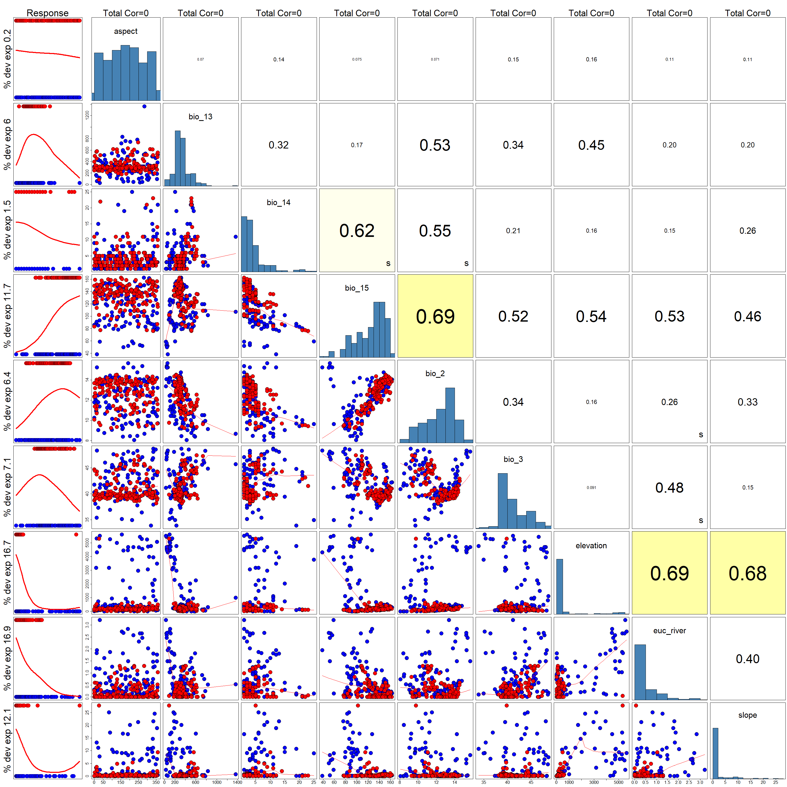
Fig. S1. Figure showing the correlation (<0.7) between the covariates chosen for final model for S acuticauda. The Pearson correlation coefficient is the primarily used here. However, if the Spearman or Kendall correlation coefficient exceeds the Pearson correlation coefficient, an “s” or “k” will be displayed in the bottom-right corner of the variable box.
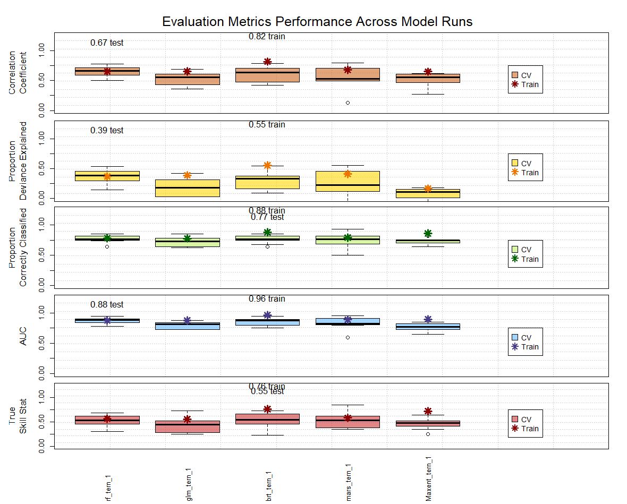

Fig. S2. Evaluation Matrix performance across model runs for S acuticauda. Brown—represents the correlation coefficient among the five different models. Yellow—represents the proportion of deviance explained; Green—represents the Proportion of correctly classified; Blue—represents Area under curve (AUC) and Pink—represents true skill statistics.

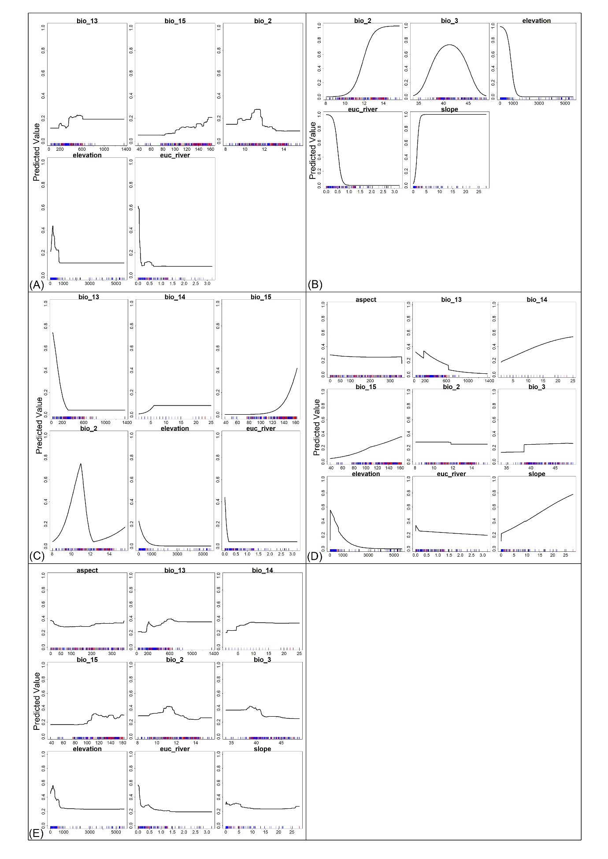
Fig. S3. Response curves of individual models used in the ensemble modeling approach for predicting S. acuticauda habitat suitability. Panels represent (A) Boosted Regression Trees (BRT), (B) Generalized Linear Models (GLM), (C) Multivariate Adaptive Regression Splines (MARS), (D) Maximum Entropy (MaxEnt), and (E) Random Forests (RF). Response curves illustrate the relationship between habitat suitability and key predictors: Temperature Mean Diurnal Range (bio_2), Isothermality (bio_3), Precipitation of Wettest Month (bio_13), Precipitation of Driest Month (bio_14), Precipitation Seasonality (bio_15), Euclidean Distance to Water (euc_river), Elevation (elevation), Aspect (aspect), and Slope (slope).

Table S1. Predicted suitable habitat area (in km²) for S. acuticauda within the GBM River basin under present and future climatic scenarios. Future projections are based on Shared Socioeconomic Pathways (SSP245 and SSP585) for the time periods 2041–2060 and 2061–2080.
Scenario | GBM River Basin
Present | 143273
SSP245 (2041-2060) | 16110
SSP245 (2061-2080) | 12885
SSP585 (2041-2060) | 11944
SSP585 (2061-2080) | 9932

