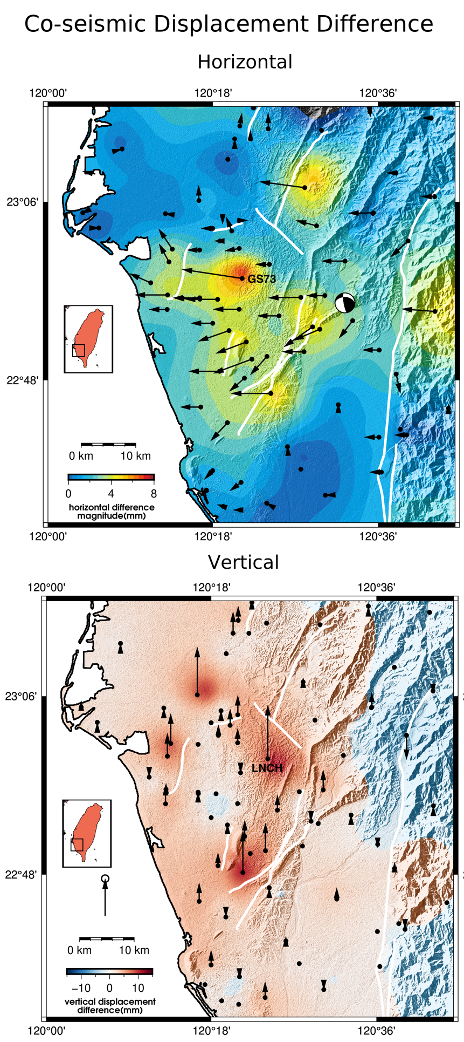
Figure S1. Differences between the estimates of horizontal (top) and vertical (bottom) co-seismic displacements using the white-noise and AR(1) acceleration models.
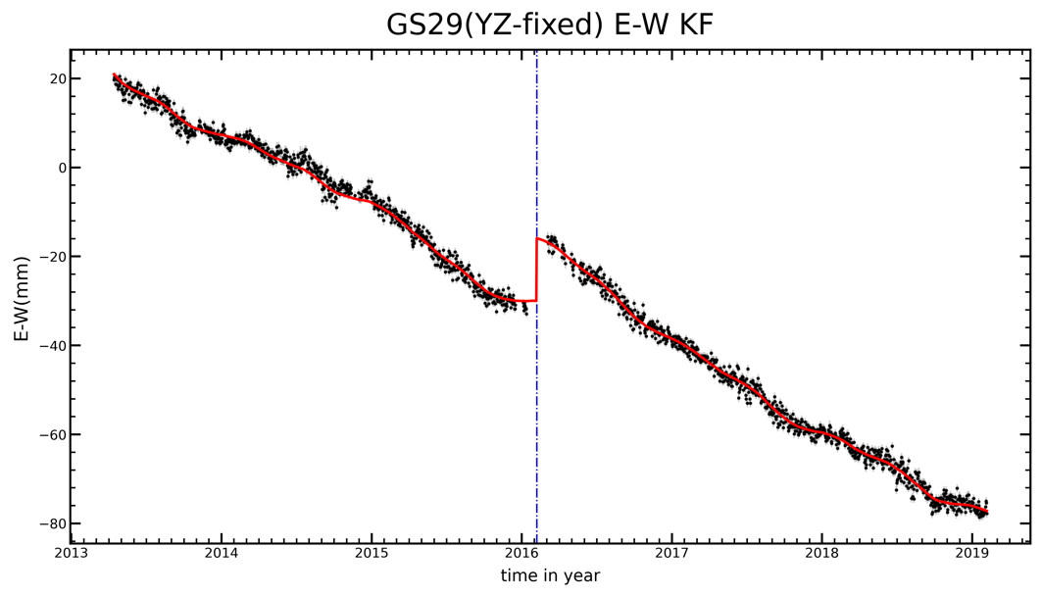
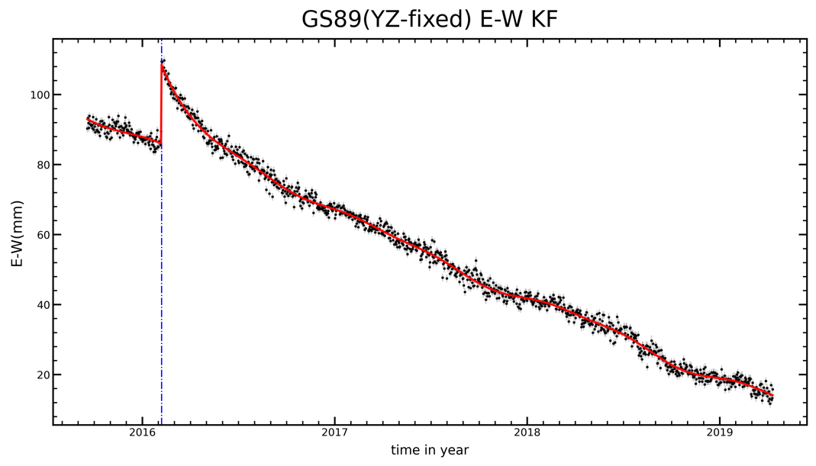
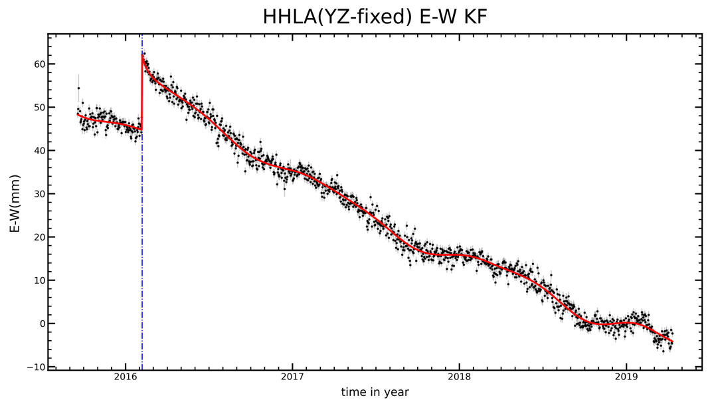
Figure S2. E-W time series (black dots) and their Kalman-filtered fits (red lines) showing eastward co-seismic displacements at three GNSS stations near the Hsinhua fault. Blue dashed lines indicate the Meinong earthquake.

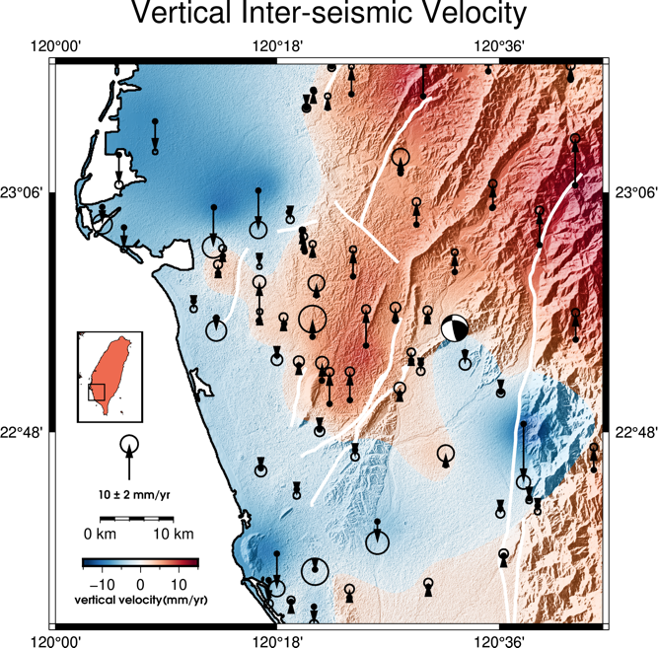
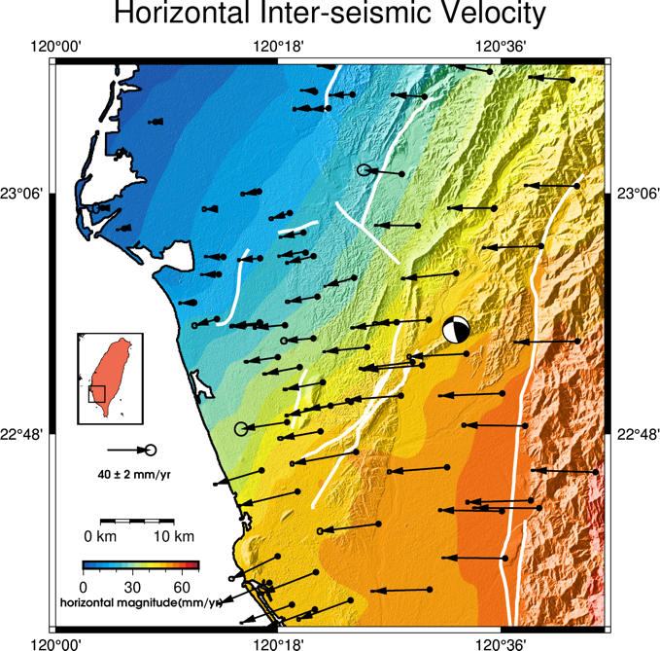

Figure S3. Horizontal (left) and vertical (right) secular motions derived from Kalman filtered GNSS time series three years prior to the Meining earthquake.

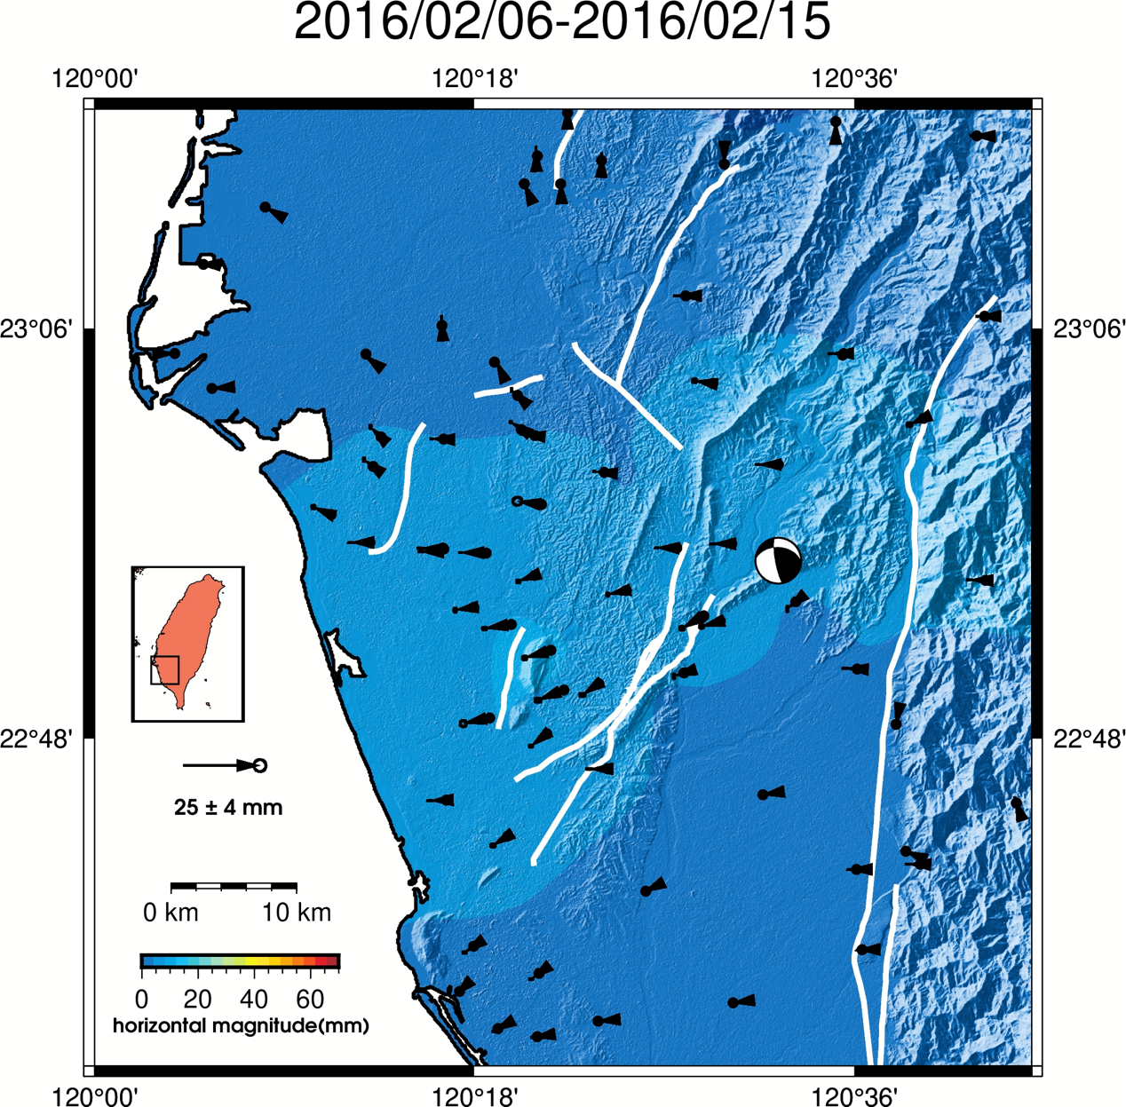
Figure S4. Animation showing the temporal evolution of the horizontal post-seismic displacement field over three years following the Meinong mainshock, with an interval of 10 days.

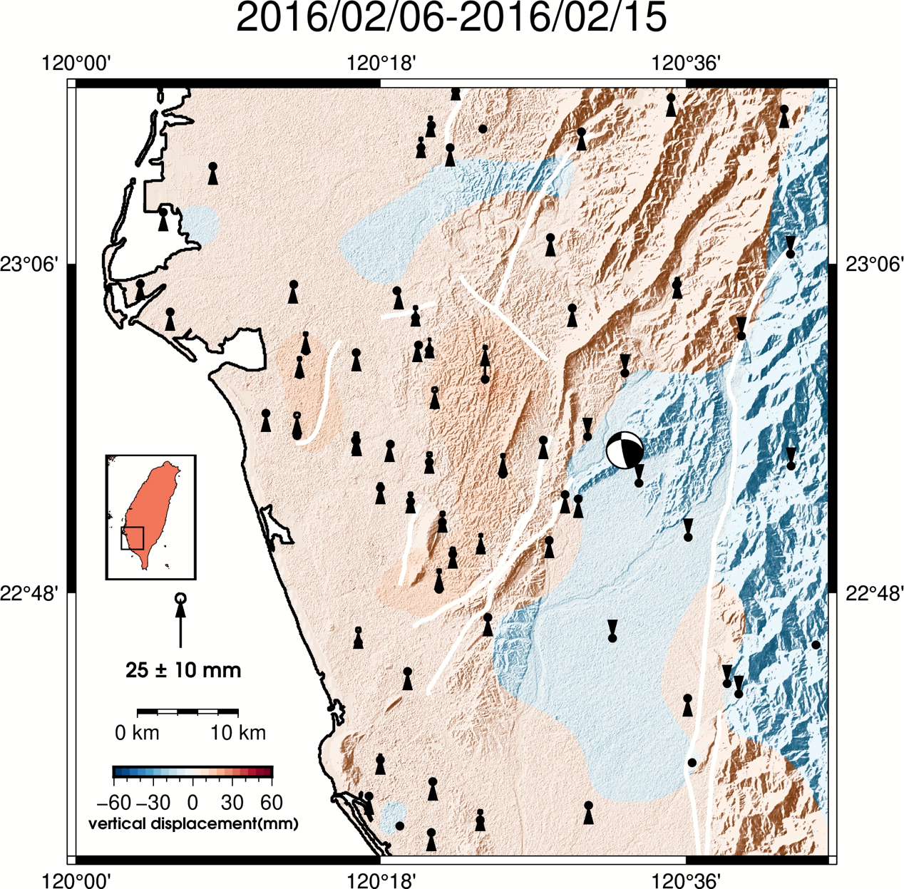

Figure S5. Animation showing the temporal evolution of the vertical post-seismic displacement field over three years following the Meinong mainshock, with an interval of 10 days.

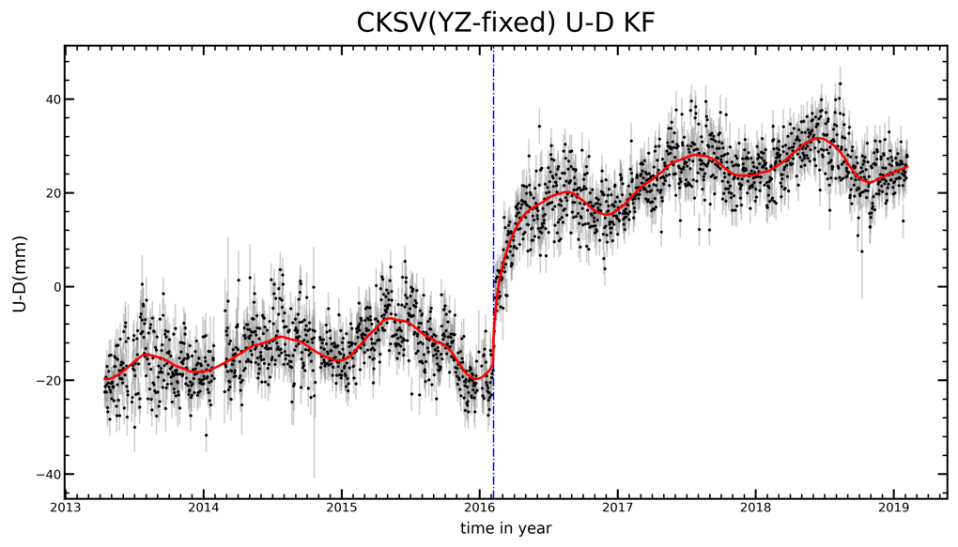
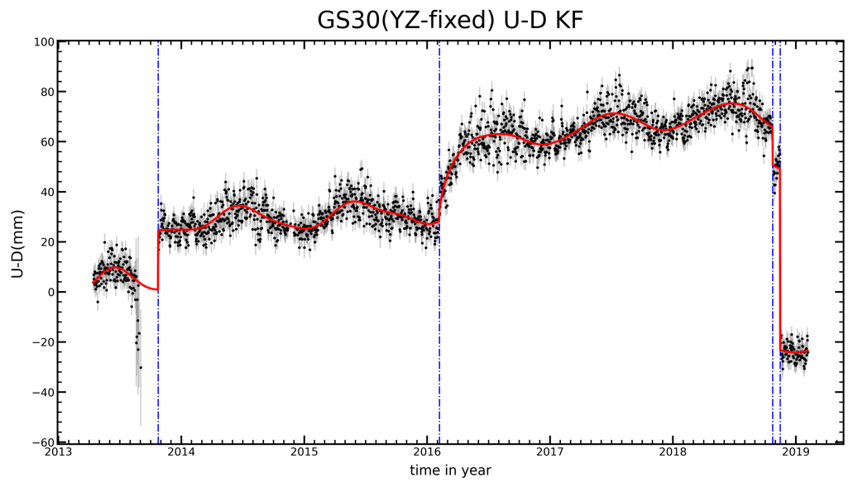
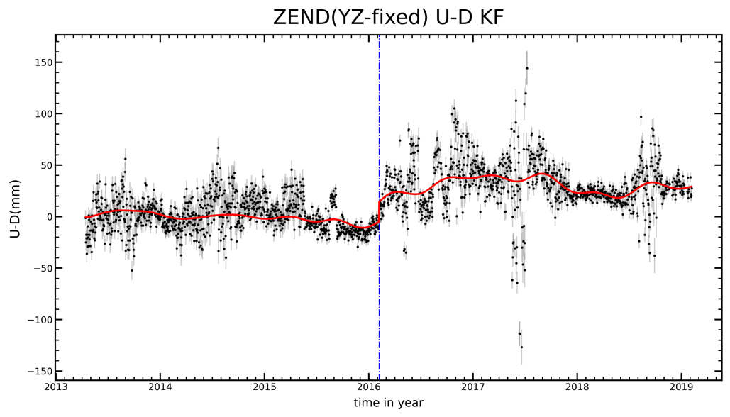
Figure S6. Vertical time series (black dots) and their Kalman-filtered fits (red lines) for three GNSS stations on the Tainan tableland. The blue dashed lines near 2016 indicate the Meinong earthquake, while the other lines in GS30 mark changes in station equipment (antenna and/or receiver).

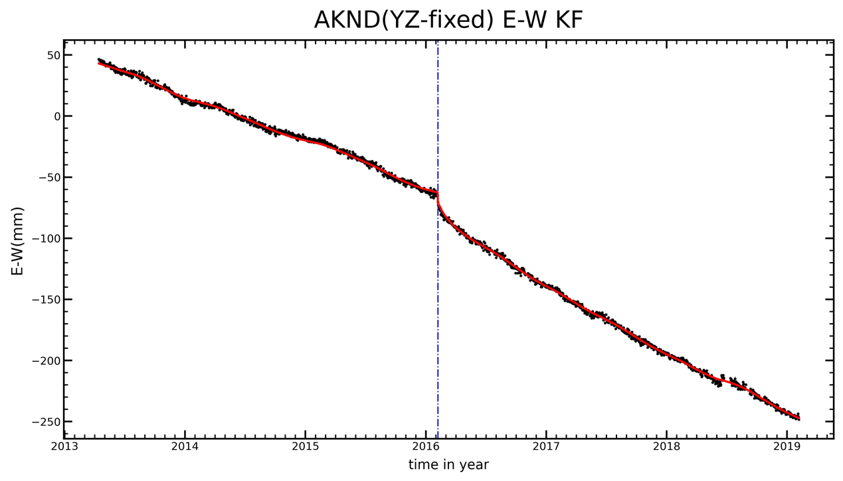
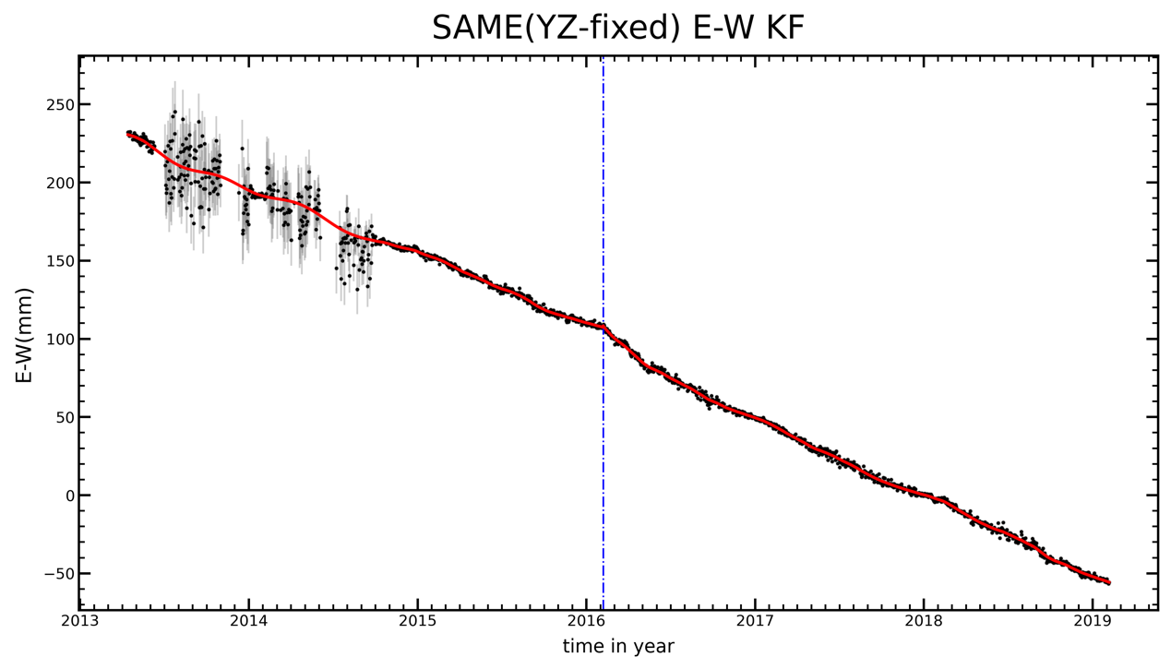
Figure S7. E-W time series (black dots) and their Kalman-filtered fits (red lines) for two GNSS stations. (top) AKND near the Hsiaogangshan fault–Dagangshan anticline. (bottom) SAME near the Youchang fault–Banpingshan anticline. Blue dashed lines indicate the Meinong earthquake

