Supplement table 1. Confusion matrix comparing GPT-estimated OAB classification with patient-reported OABSS-based diagnosis (OABSS ≥ 3 and urgency score ≥ 2).
GPT correctly classified 45 of 51 OAB cases and 21 of 26 non-OAB cases, yielding a sensitivity of 88.2% and specificity of 80.8%.
 | GPT estimated
Patients  reported |  | No OAB | OAB
Patients  reported | No OAB (n=26) | 21 | 5
Patients  reported | OAB (n=51) | 6 | 45

Supplement table 2. Spearman correlation coefficients (ρ) between GPT-estimated and patient-reported total scores for IPSS and OABSS, stratified by visit type.
Correlation was lower among patients at their first visit (ρ = 0.5 for both IPSS and OABSS) compared to the entire cohort (ρ = 0.6 and 0.7, respectively).
Asterisks (*) indicate statistical significance at p < 0.05.
“New pts.” = new patients (first-time visits), “All pts.” = entire cohort
 | New pts. | r |  | All pts. | r
IPSS, n | 5 | 0.5 |  | 52 | 0.6*
OABSS, n | 12 | 0.5 |  | 77 | 0.7*
Total, n | 17 |  |  | 91

Figure 1. (A) Spearman correlation heatmap between GPT-estimated IPSS sub-item scores and patient-reported scores.
Strongest correlations were observed in the QoL and total score domains (ρ = 0.83 and 0.60, respectively). Asterisks indicate p < 0.05.*
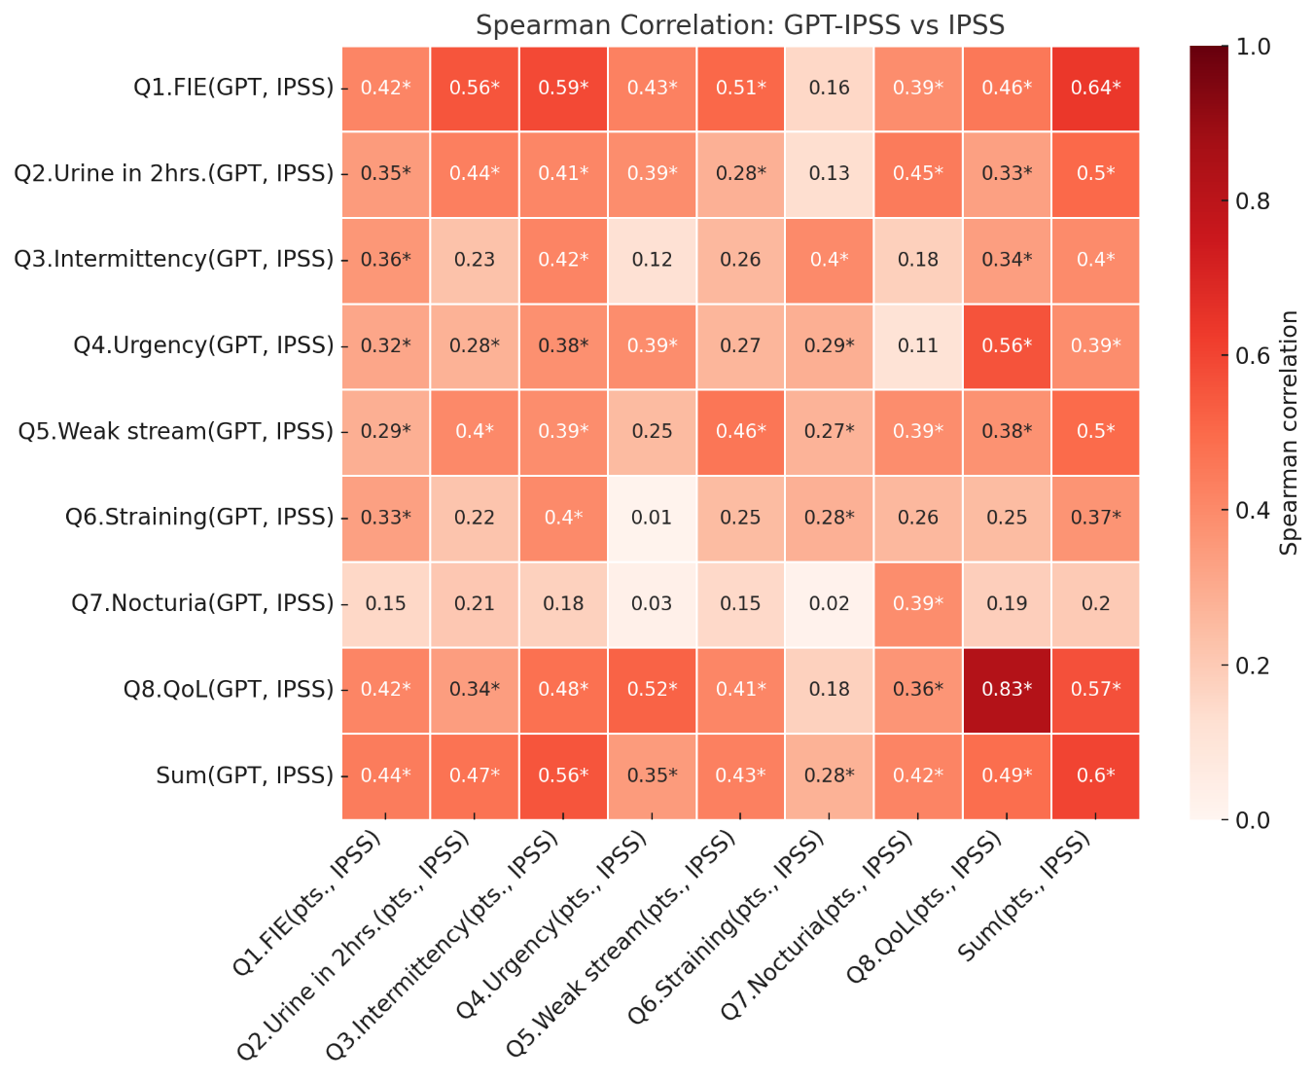

Figure 1. (B) Spearman correlation heatmap between GPT-estimated OABSS sub-item scores and patient-reported scores.
Strongest correlations were observed in the urgency and total score domains (ρ = 0.71 and 0.70, respectively). Asterisks indicate p < 0.05.*
Correlation interpretation: ρ = 0.40–0.59 = moderate, 0.60–0.79 = strong, ≥ 0.80 = very strong (Evans, 1996).
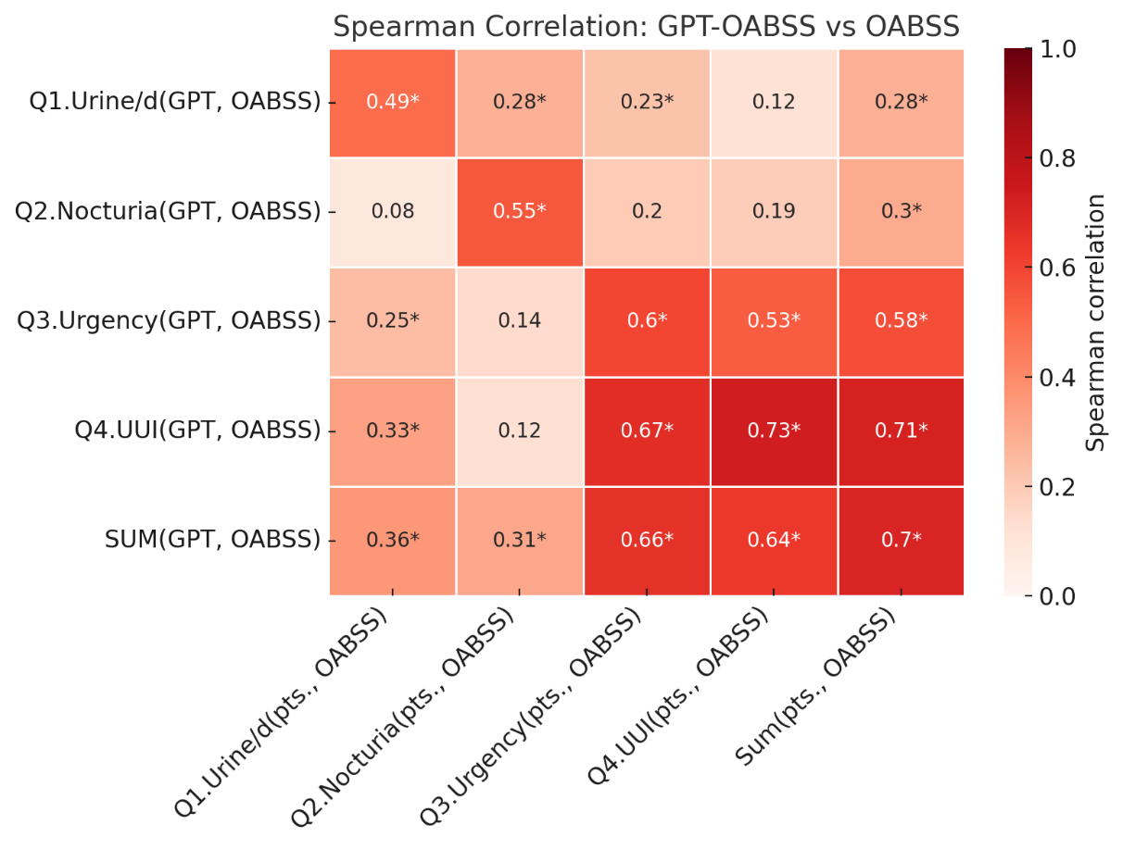

Figure 2. (A) Receiver operating characteristic (ROC) curve for LUTS prediction based on GPT-estimated IPSS total scores.
The ROC curve evaluates the performance of GPT-4o in predicting moderate-to-severe LUTS (defined as IPSS ≥ 8) using total predicted IPSS scores.
The area under the curve (AUC) was 0.81, indicating fair-to-good discriminative ability.
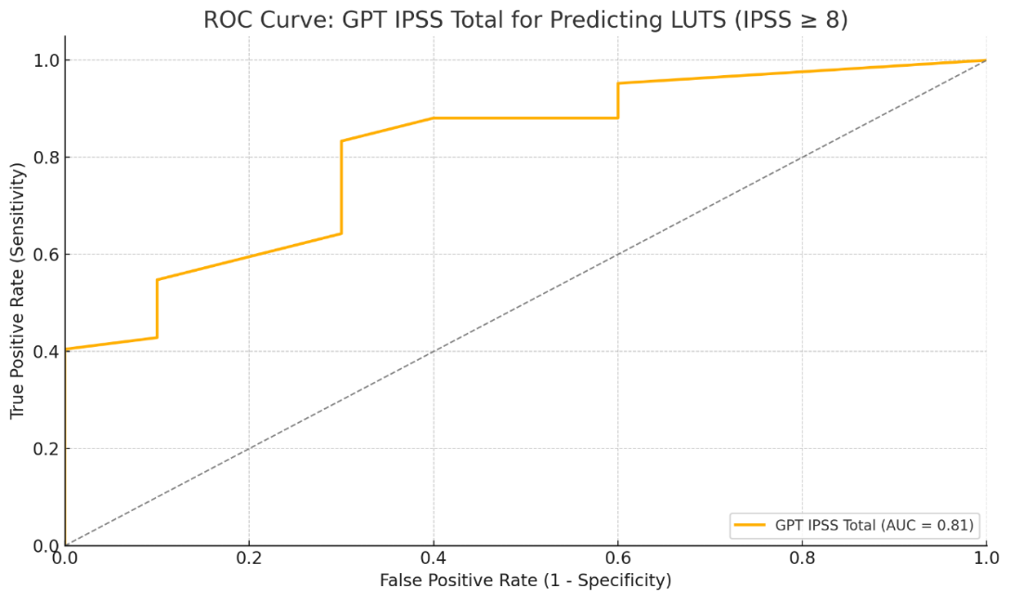

Figure 2. (B) Receiver operating characteristic (ROC) curve for OAB prediction based on GPT-estimated OABSS total scores.
The ROC curve assesses the discriminative ability of GPT-4o in predicting clinically defined OAB (OABSS ≥ 3 and urgency score ≥ 2).
The area under the curve (AUC) was 0.91, indicating excellent predictive performance.
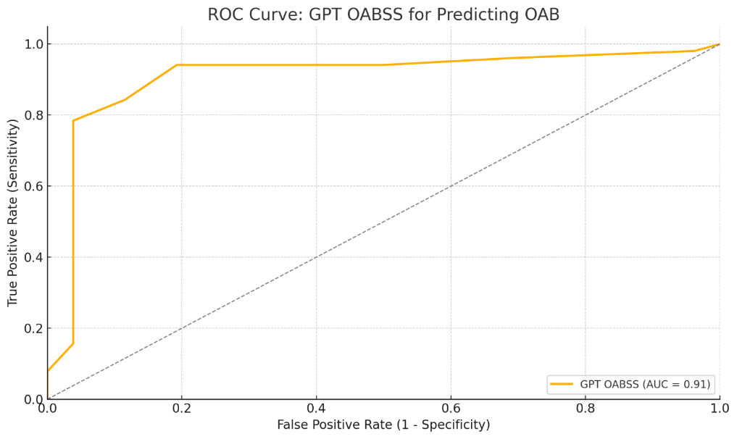

Figure 3. (A) Bland–Altman plot comparing GPT-estimated and patient-reported total IPSS scores.
Each point represents the difference between GPT-estimated and actual IPSS total scores plotted against their mean.
The red dashed line indicates the mean difference (bias = –2.37), while the upper and lower dashed lines indicate the 95% limits of agreement (LoA).
Most values fall within the agreement range, suggesting moderate consistency, though GPT tended to underestimate IPSS total scores on average. 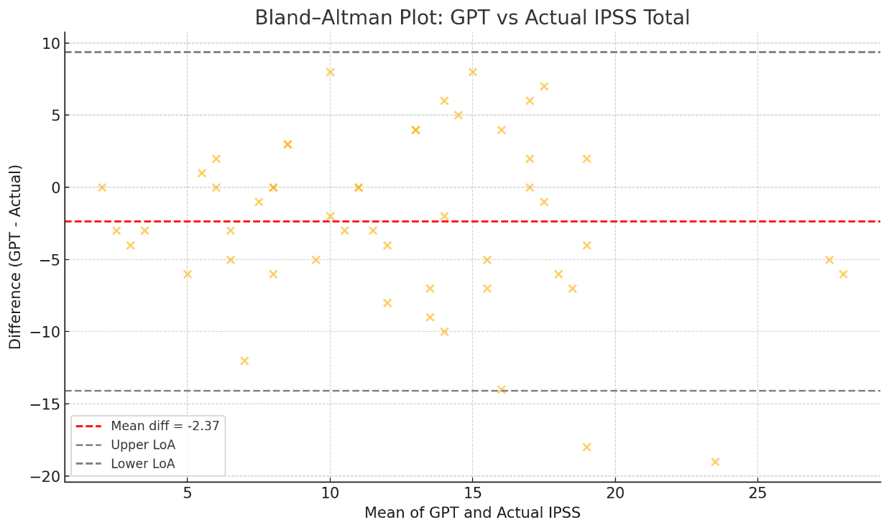

Figure 3. (B) Bland–Altman plot comparing GPT-estimated and patient-reported total OABSS scores.
Each point represents the difference between GPT-estimated and actual OABSS total scores plotted against their mean.
The mean difference (bias) was –0.13, suggesting minimal systematic bias.
The majority of data points fell within the 95% limits of agreement (LoA), indicating overall good agreement between GPT and patient-reported OABSS.
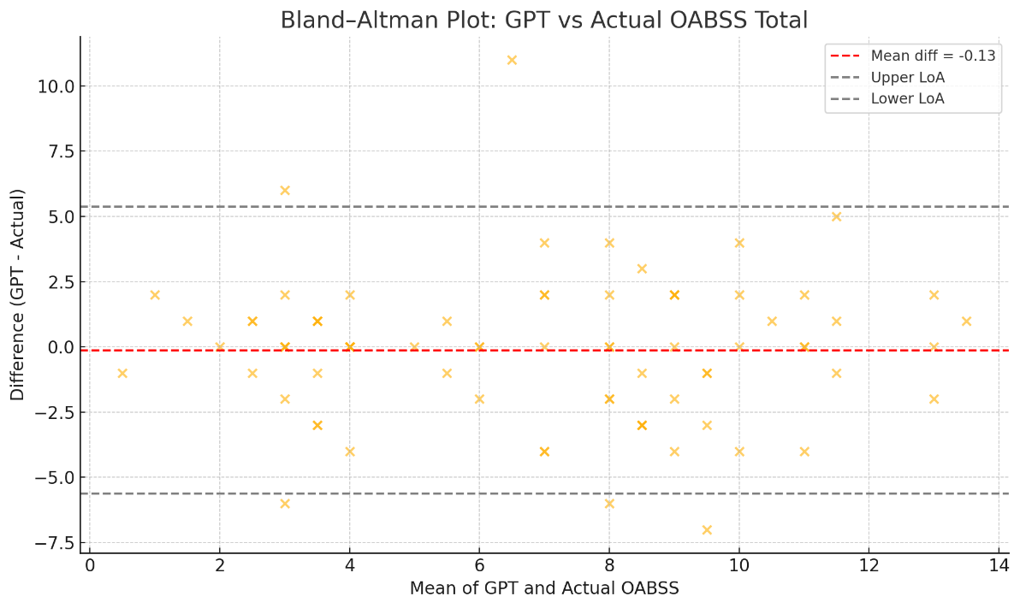
LoA: Limits of Agreement (95% agreement interval)

