Short-Term Exposure to Ambient Air Pollution and Onset of Severe Mental Disorders: A case-crossover study in northwestern China

Yajin Han^{1,†}, Guangrui Yang^{2,†}, Jinshi Wang¹, Weimin Pan^{3,*}, Xiaofeng Luo^{1,*}

Figure S1. Spatial distributions of 49,707 cases’ home addresses (dots) in Gansu province, China, from 2013 to 2020.
Table S1. Spearman correlation coefficients between air pollutants and meteorological conditions during case and control days in Gansu Province, China, 2013-2020*
Figure S2. Percentage changes in odds ratios and 95% CI for onset of severe mental disorders associated with each interquartile range increase of exposures to PM_{2.5} (interquartile range, 23.1 μg/m³), PM₁₀ (57.5 μg/m³), SO₂ (19.1 μg/m³), NO₂ (11.9 μg/m³), CO (0.51 mg/m³), and O₃ (38.3 μg/m³) with different lag periods, restricted to Han race onset cases.
Figure S3. Percentage changes in odds ratios and 95% confidence intervals for onset of severe mental disorders associated with each interquartile range increase of exposures to PM_{2.5} (interquartile range，23.1 μg/m³), PM₁₀ (57.5 μg/m³), SO₂ (19.1 μg/m³), NO₂ (11.9 μg/m³), CO (0.51 mg/m³), and O₃ (38.3 μg/m³) with different lag periods, restricted to cases who diagnosed with “schizophrenia, schizotypal, and delusional disorders”.
Figure S4. Percentage changes in odds ratios and 95% confidence intervals for onset of severe mental disorders associated with each interquartile range increase of exposures to PM_{2.5} (interquartile range, 23.1 μg/m³), PM₁₀ (57.5 μg/m³), SO₂ (19.1 μg/m³), NO₂ (11.9 μg/m³), CO (0.51 mg/m³), and O₃ (38.3 μg/m³) with different lag periods, adjusting for temperature with a df of 3.

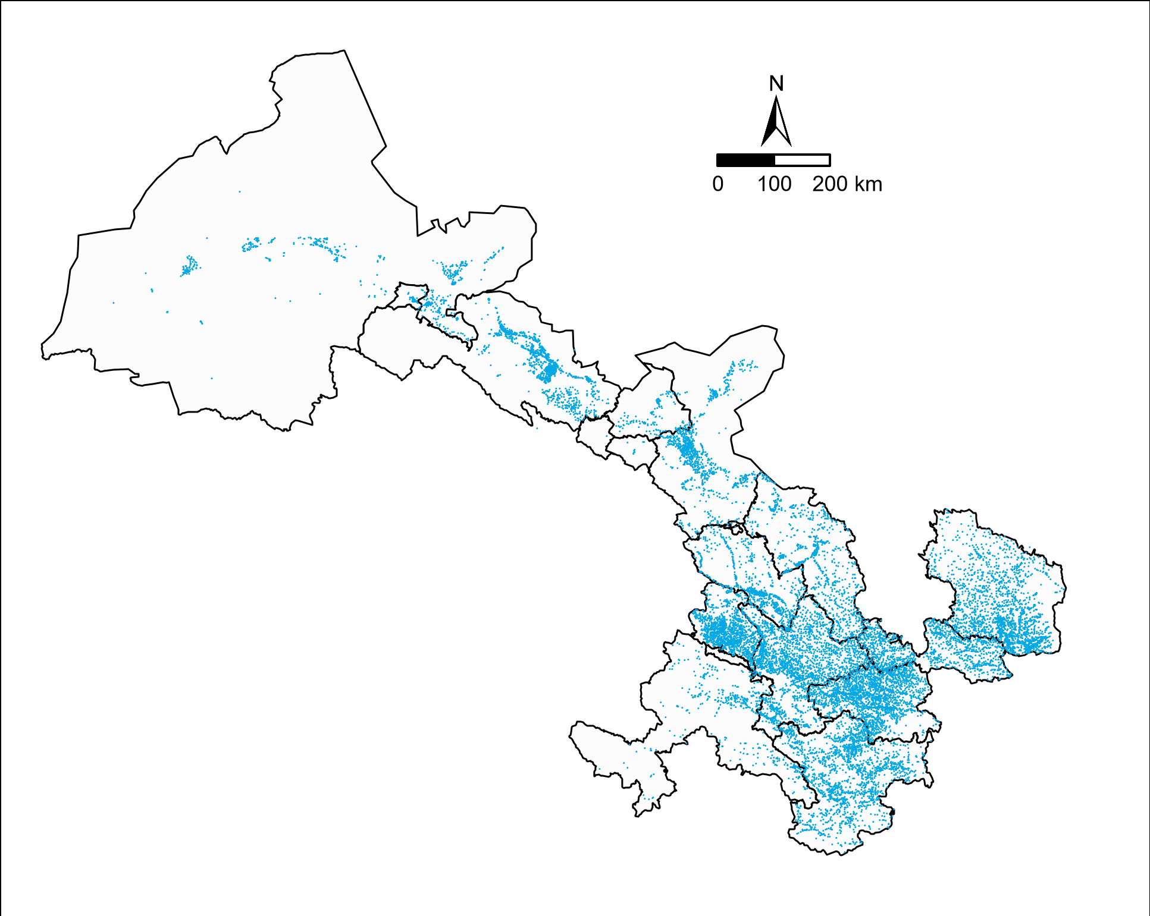
Figure S1. Spatial distributions of 49,707 cases’ home addresses (dots) in Gansu province, China, from 2013 to 2020. Each point indicates a case.

Table S1. Spearman correlation coefficients between air pollutants and meteorological conditions during case and control days in Gansu Province, China, 2013-2020*
 | PM_{2.5} | CO | NO₂ | O₃ | PM₁₀ | SO₂ | Relative humidity
CO | 0.67 | — | — | — | — | — | —
NO₂ | 0.51 | 0.61 | — | — | — | — | —
O₃ | -0.45 | -0.54 | -0.37 | — | — | — | —
PM₁₀ | 0.87 | 0.52 | 0.41 | -0.22 | — | — | —
SO₂ | 0.68 | 0.74 | 0.57 | -0.48 | 0.61 | — | —
Relative humidity | -0.14 | -0.09 | -0.13 | -0.25 | -0.33 | -0.17 | —
Temperature | -0.57 | -0.50 | -0.45 | 0.67 | -0.43 | -0.56 | -0.14
Abbreviations: PM_{2.5}, particulate matter with an aerodynamic diameter ≤2.5 mm; CO, carbon monoxide; NO₂, nitrogen dioxide; O₃, ozone; PM₁₀, particulate matter with an aerodynamic diameter ≤10 mm; SO₂, sulfur dioxide.
Notes*: All pairwise correlation coefficients were statistically significant(P<0.05)

Figure S2. Percentage changes in odds ratios and 95% CI for onset of severe mental disorders associated with each interquartile range increase of exposures to PM_{2.5} (interquartile range, 23.1 μg/m³), PM₁₀ (57.5 μg/m³), SO₂ (19.1 μg/m³), NO₂ (11.9 μg/m³), CO (0.51 mg/m³), and O₃ (38.3 μg/m³) with different lag periods, restricted to Han race onset cases.
Abbreviations: PM_{2.5}, particulate matter with an aerodynamic diameter ≤2.5 mm; CO, carbon monoxide; NO₂, nitrogen dioxide; O₃, ozone; PM₁₀, particulate matter with an aerodynamic diameter ≤10 mm; SO₂, sulfur dioxide.
Figure S3. Percentage changes in odds ratios and 95% confidence intervals for onset of severe mental disorders associated with each interquartile range increase of exposures to PM_{2.5} (interquartile range，23.1 μg/m³), PM₁₀ (57.5 μg/m³), SO₂ (19.1 μg/m³), NO₂ (11.9 μg/m³), CO (0.51 mg/m³), and O₃ (38.3 μg/m³) with different lag periods, restricted to cases who diagnosed with “schizophrenia, schizotypal, and delusional disorders”.
Abbreviations: PM_{2.5}, particulate matter with an aerodynamic diameter ≤2.5 mm; CO, carbon monoxide; NO₂, nitrogen dioxide; O₃, ozone; PM₁₀, particulate matter with an aerodynamic diameter ≤10 mm; SO₂, sulfur dioxide.
Figure S4. Percentage changes in odds ratios and 95% confidence intervals for onset of severe mental disorders associated with each interquartile range increase of exposures to PM_{2.5} (interquartile range，23.1 μg/m³), PM₁₀ (57.5 μg/m³), SO₂ (19.1 μg/m³), NO₂ (11.9 μg/m³), CO (0.51 mg/m³), and O₃ (38.3 μg/m³) with different lag periods, adjusting for temperature with a df of 3.
Abbreviations: PM_{2.5}, particulate matter with an aerodynamic diameter ≤2.5 mm; CO, carbon monoxide; NO₂, nitrogen dioxide; O₃, ozone; PM₁₀, particulate matter with an aerodynamic diameter ≤10 mm; SO₂, sulfur dioxide.

