Pathways to productivity: how functional ecosystem service flow determine crop yield in prairie landscape

- Detailed Methodology for Ecosystem Service Mapping
Note: The following detailed methodological description for the mapping of the six ecosystem services is taken directly from a companion manuscript (Pashanejad et al., submitted for publication, Journal of Cleaner Production), which focuses on the spatial patterns and trade-offs of these services across the Canadian prairies. It is reproduced here to provide the reviewers of this paper with all necessary information to understand how the input data for our statistical models were generated.
Table 1 provides an overview of all ecosystem service models used in this study, including the data sources utilized for each model. Additionally, it lists the studies and references employed to parameterize the models to the specific context of the Canadian prairies. This comprehensive summary highlights the integration of multiple datasets and research inputs to develop robust and context-specific ecosystem service assessments.
Table 1. Overview of all ecosystem service models with data sources
ES | ES model and platform | Data requirements | Data sources
Carbon Storage | InVEST carbon model  (Sharp et al. 2014) | LULC | Annual crop inventory
Carbon Storage | InVEST carbon model  (Sharp et al. 2014) | Global aboveground & belowground biomass | ORNL DAAC  (Spawn et al. 2020)
Carbon Storage | InVEST carbon model  (Sharp et al. 2014) | Carbon storage and distribution in terrestrial ecosystems of Canada | WWF Canada  (Sothe et al. 2022)
Soil Erosion Control | Sediment Delivery Ratio (SDR), InVEST  (Sharp et al. 2014) | LULC, precipitation, evapotranspiration | Climate NA
Soil Erosion Control | Sediment Delivery Ratio (SDR), InVEST  (Sharp et al. 2014) | Digital Elevation Model (DEM) | FABDEM V1-2
Soil Erosion Control | Sediment Delivery Ratio (SDR), InVEST  (Sharp et al. 2014) | Digital Elevation Model (DEM) | FABDEM V1-2
Crop Pollination | InVest, a guild-based pollination model | LULC | Annual crop inventory
Habitat provisioning & Habitat Quality | InVEST Habitat Quality | LULC | Annual crop inventory,
Habitat provisioning & Habitat Quality | InVEST Habitat Quality | Road (major & secondary) and Railways | Statistic Canada  National Railway Network - NRWN - GeoBase Series
Habitat provisioning & Habitat Quality | InVEST Habitat Quality | Urban areas | Statistic Canada
Habitat provisioning & Habitat Quality | InVEST Habitat Quality | Energy infrastructure | Alberta Energy Regulator (AER)  Government of Manitoba Petroleum: Interactive GIS Map Gallery  Government of Saskatchewn. (2019). Mining and petroleum GeoAtlas.

  - Pollination
Pollinator habitat sufficiency was assessed using the InVEST Crop Pollination model. The predicted mean total pollinator abundance during spring and summer was used as a proxy for the pollination supply capacity of the landscape. Three key pollinator guilds in the prairies were considered: bumblebees, sweat bees, and mining bees, each with distinct seasonal activity patterns and foraging distances. These guilds play a critical role in ecosystem function by supplying pollination to flowering plant species, including crops. Initial parameters were taken from Pashanejad et al. (2023), which used a similar approach in ARIES. Model coefficients refined based on local literature reviews and expert opinions.
  - Carbon storage
We used the InVEST Carbon Storage and Sequestration model to identify the spatial distribution of areas with the highest carbon storage within the study area. This model is based on the carbon cycle and accounts for four distinct carbon pools—aboveground biomass, belowground biomass, dead organic matter, and soil carbon. It estimates total carbon storage at the pixel level using land cover data. For this study, we adopted the model parameters and coefficients from Pashanejad et al. (2024), conducted on a smaller scale in central Alberta. Leveraging these published parameters, including land cover-specific coefficients derived from both global and national datasets, we applied the model to the entire Canadian prairies. Specifically, carbon pool values for aboveground and belowground biomass were sourced from a global dataset (Spawn and Gibbs 2020), while soil carbon and dead organic matter values were informed by a national dataset produced by WWF-Canada (Sothe et al. 2022).
  - Soil erosion control (Sediment Retention)
Similar to pollination and carbon storage, we used the InVEST Sediment Delivery Ratio (SDR) model, incorporating previous parameterization specifically tailored for the prairies (Pashanejad et al. 2024). The SDR model applies the Revised Universal Soil Loss Equation (RUSLE), which factors in climate, soil texture, topography, and land cover, alongside a connectivity index that accounts for the surrounding upslope and downslope characteristics of each pixel (Chaplin-Kramer et al. 2022). The model provides two primary indicators of sediment retention services: Avoided Erosion and Avoided Export. We focused on Avoided Erosion, which evaluates the effectiveness of vegetation in minimizing soil erosion at any given location, offering valuable insights for soil conservation efforts, particularly in agricultural regions where preserving topsoil is critical for soil fertility and food production (Guerra et al. 2022; Natural Capital Project 2023). This serves as a proxy for the capacity of the landscape to provide soil erosion regulation services.
  - Habitat Quality
We used the Habitat Quality model from InVEST (Sharp et al. 2014), to indirectly indicate landscape potential to support biodiversity and, in turn, maintain ecosystem function. The model evaluates habitat quality based on land cover and land use data, incorporating factors such as the suitability of different land covers for biodiversity, the impact of various anthropogenic threats, and the sensitivity of each land cover or land use type to these threats (Terrado et al. 2016). In the prairies, grasslands, wetlands, and prairie potholes provide essential habitats for a wide variety of species, including pollinators, swift fox, burrowing owls, and various waterfowl species that support multiple ecosystem functions. We developed a generalized habitat quality model rather than focusing on specific species, providing a broad overview of landscape suitability while accounting for significant threats to these habitats. The model parameters including threat weights, habitat suitability, maximum distances of threat impacts and habitat sensitivity scores were informed by similar studies in the prairies, such as Akbari et al. ( 2021); and Shaffer et al. (2019), as well as government reports. For example we used the Wildlife Habitat Capacity Index for agricultural lands that is developed and calculated at the SCL scale as part of the Canadian Environmental Sustainability Indicators (Environment and Climate Change Canada 2024). Key threats included in the model were agricultural expansion, road and railway construction, urban development, energy infrastructure, and major industries with significant CO2 emissions, as identified in the Canadian Environmental Sustainability Indicators. Table 2 below provides a full list of threats we considered in the model.
The InVEST HQ model applies a distance decay function (e.g., linear, exponential) to represent how the intensity of each habitat ‘threat’ diminishes with distance. Pixels closer to a threat such as roads, croplands, or industrial areas receive higher degradation scores, while those beyond the defined maximum distance remain unaffected. The model integrates this spatial threat information with land cover suitability and threat-specific habitat sensitivities to estimate habitat degradation and quality. It assumes that areas with higher habitat quality are more likely to support species persistence and overall biodiversity, offering a flexible, habitat-based approach that can be scaled across different landscapes. The model allows for the assignment of different suitability and sensitivity scores to each land cover type, as well as calibration of each threat’s relative importance, spatial extent, and impact on habitat quality. This allows the model to be adjusted depending on the biodiversity targets or ecosystem types in a given study. In our case, natural habitats like wetlands and native grasslands were assigned higher sensitivity scores because of their ecological value and vulnerability to disturbance. In contrast, croplands and developed areas, which have already undergone substantial modification, were assigned lower scores.
Table 2. Anthropogenic threats considered in the InVEST Habitat Quality model for the Canadian prairies. These threats represent spatial drivers of habitat degradation and were parameterized based on expert-informed sensitivity scores, maximum effective distances, and relative weights, consistent with regional studies and policy sources. Within the model, closer proximity to any threat (e.g., farmland, roads, energy infrastructure) increases habitat degradation. For expansion threats such as cropland or pastureland, natural habitat cells situated near existing agriculture face higher degradation scores, reflecting their risk of future conversion or intensification.
Threat | Description
Crop Expansion | Agricultural intensification replacing natural habitat
Pastureland Expansion | Conversion of native prairie to managed grazing lands
Urban Development | Expansion of cities, towns, and rural settlements
Major Roads | High-traffic roads increasing fragmentation
Secondary Roads | Low-traffic roads affecting local habitat connectivity
Railways | Rail infrastructure impacting species movement
Oil Extraction (Active) | Ongoing oil and gas extraction operations
Oil Extraction (Inactive) | Abandoned extraction sites
Power Plants | Energy production sites contributing to pollution & habitat disturbance
Emissions from Major Industrial Sources | Industrial CO₂ emissions contributing to air pollution

- Model Diagnostics and Variable Refinement
To improve interpretability and model stability, we applied a systematic diagnostic protocol before fitting the final models. Variance Inflation Factors (VIF) revealed high multicollinearity among Phosphorus Retention and Nitrogen Retention, and conservation tillage. These variables were excluded to prevent overfitting and variance inflation. We retained conventional tillage (TILCONV), which exhibited moderate VIF values and consistent significance across models, reflecting its relevance in prairie management practices. Although no-till (TILLNO) was assessed during diagnostics, it did not meet our retention criteria and was therefore omitted. Control variables for soil organic matter, topography, and climate were kept to capture environmental heterogeneity, even when not statistically significant. All final models demonstrated strong fit (adjusted R² ≈ 0.54–0.67) and passed diagnostic checks.
- Crop-Specific GAM Models
Table 3 presents a comparative summary of crop-specific GAMs for Canola, Barley, Spring Wheat, and Winter Wheat, using two sets of predictors: Ecosystem Services (ES) and Landscape Structure Metrics (LSM). The models consistently show moderate to high explanatory power, with adjusted R² values ranging from 0.535 to 0.642 and deviance explained between 55.2% and 65.5%. For ES models, pollination, habitat quality, and soil erosion control were frequently significant non-linear predictors, alongside spatial smooths, while tillage conservation was the most consistent and significant linear effect. In contrast, LSM models highlighted the importance of crop diversity and connectivity in some cases, though spatial smooths again remained highly significant across all crops. Linear predictors such as aggregation and habitat diversity appeared selectively, and several environmental control variables (e.g., soil organic matter, elevation, and precipitation) were often non-significant. These results underscore the distinct yet complementary contributions of ecosystem function and landscape configuration to crop productivity patterns.
Table 3. Summary of Generalized Additive Model (GAM) Performance Across Crops
Crop | Model Type | Adjusted R² | Deviance Explained (%) | Significant Smooth Terms | Non-Significant Smooth Terms | Significant Linear Terms | Non-Significant Linear Terms
Canola | Ecosystem Services | 0.577 | 59.3 | Pollination, Habitat Quality, Erosion Control, Spatial Coordinates | None | Carbon Storage (–), Elevation (+), Temperature (+), Tillage (+) | Soil Organic Matter, Precipitation
Canola | Landscape Structure | 0.587 | 60.4 | % Natural Habitat, Crop Diversity, Connectivity, Spatial Coordinates | None | Habitat Diversity (+), Temperature (+), Tillage (+) | Soil Organic Matter, Precipitation, Aggregation, Edge Density, Elevation
Barley | Ecosystem Services | 0.542 | 55.9 | Pollination, Habitat Quality, Erosion Control, Spatial Coordinates | None | Tillage (+) | Carbon Storage, Soil Organic Matter, Elevation, Temperature, Precipitation
Barley | Landscape Structure | 0.535 | 55.2 | Spatial Coordinates | % Natural Habitat, Crop Diversity, Connectivity | Aggregation (+), Tillage (+) | Soil Organic Matter, Habitat Diversity, Edge Density, Elevation, Temperature, Precipitation
Spring Wheat | Ecosystem Services | 0.637 | 65.1 | Pollination, Habitat Quality, Erosion Control, Spatial Coordinates | None | Elevation (+), Precipitation (–), Tillage (+) | Carbon Storage, Soil Organic Matter, Temperature
Spring Wheat | Landscape Structure | 0.642 | 65.5 | Connectivity, Spatial Coordinates | % Natural Habitat, Crop Diversity | Habitat Diversity (+) Precipitation (–), Tillage (+) | Soil Organic Matter, , Edge Density, Elevation, Temperature
Winter Wheat | Ecosystem Services | 0.590 | 60.5 | Habitat Quality, Erosion Control, Spatial Coordinates | Pollination | Temperature (–), Tillage (+) | Carbon Storage, Soil Organic Matter, Elevation, Precipitation
Winter Wheat | Landscape Structure | 0.585 | 59.9 | Crop Diversity, Spatial Coordinates | % Natural Habitat, Connectivity | Temperature (–), Tillage (+) | Soil Organic Matter, Habitat Diversity, Aggregation, Edge Density, Elevation, Precipitation
- Scatter plot between major crop yield and ecosystem service models
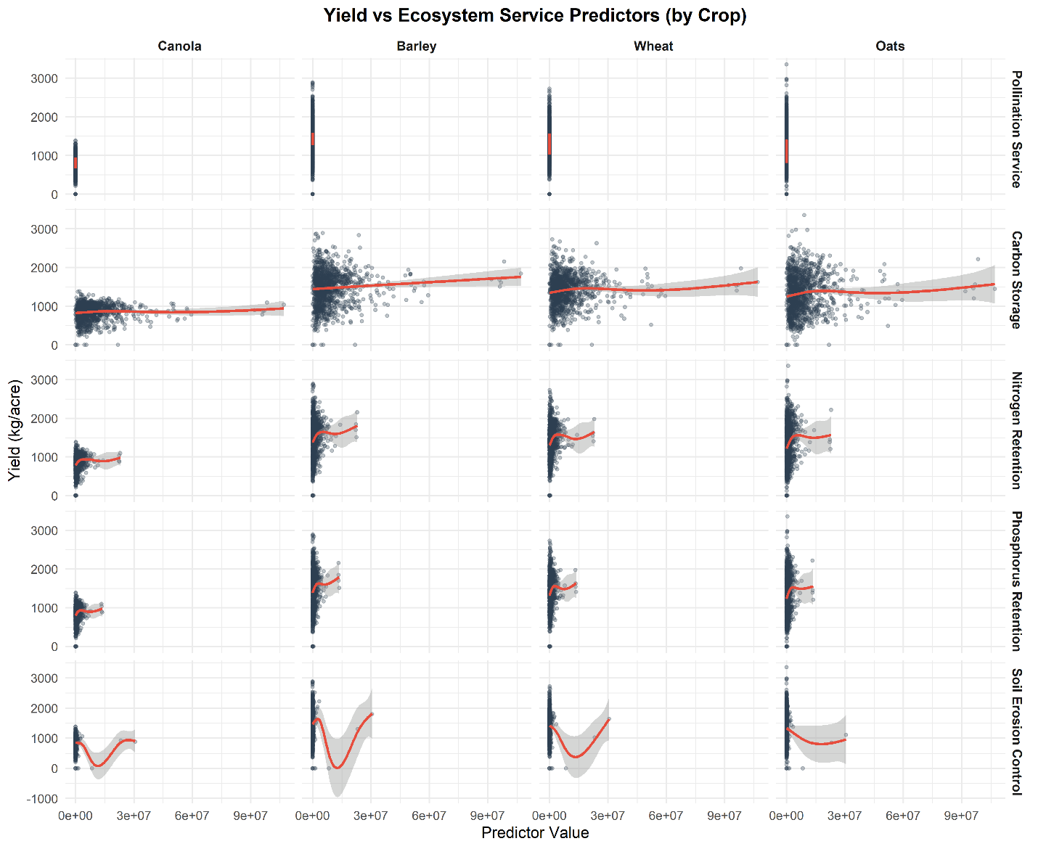
Figure 1. Scatter plots showing the relationship between crop yield and selected ecosystem service predictors across four major crop types: canola, barley, wheat, and Oats. Each column corresponds to one crop, while each row represents a different ecosystem service indicator. Red lines indicate smoothed trends, and shaded ribbons denote 95% confidence intervals. The plots reveal both linear and nonlinear relationships, highlighting how different ecosystem services influence crop yield dynamics across crop types.
- Scatter plot between major crop yield and landscape structure metrics
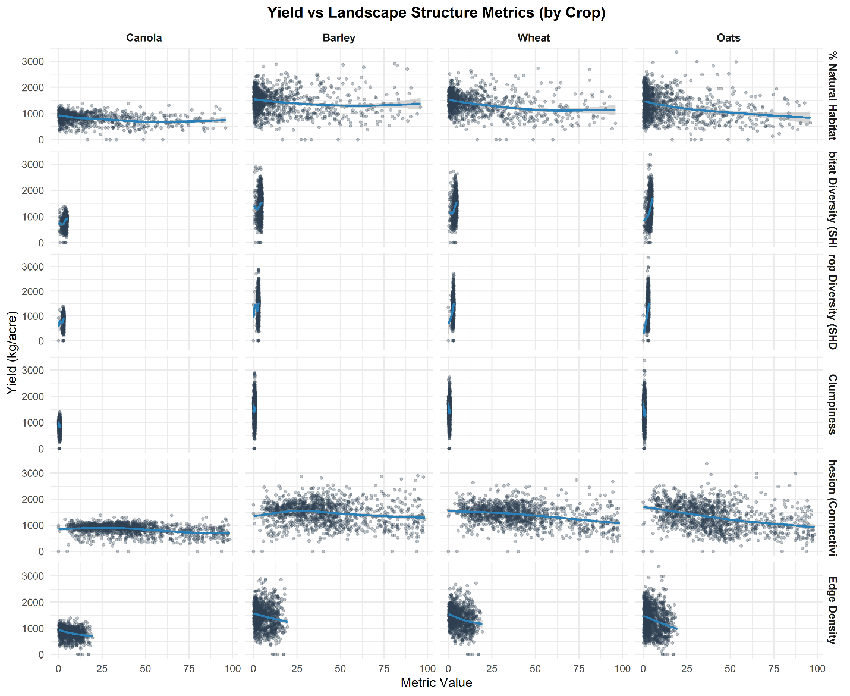
Figure 2. Scatter plots illustrating the relationship between crop yield and landscape structure metrics across four major crop types: canola, barley, wheat, and Oats. Each column represents a crop, while each row displays a different landscape structure metric, such as edge density, patch richness, and aggregation index. The plots provide a visual overview of how structural features of the surrounding landscape correlate with crop yield at the spatial unit level. These exploratory plots support the assessment of landscape configuration effects on agricultural productivity across crop types in prairie agroecosystems.

. https://www.agr.gc.ca/atlas/apps/metrics/index-en.html?appid=aci-iac
. https://daac.ornl.gov/VEGETATION/guides/Global_Maps_C_Density_2010.html
. https://wwf.ca/carbonmap/
. https://climatena.ca/
https://doi.org/10.5523/bris.s5hqmjcdj8yo2ibzi9b4ew3sn

