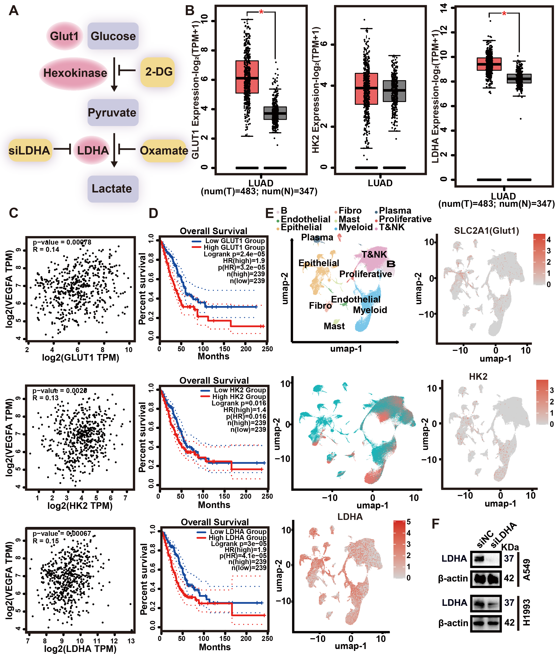
Figure S1. Glycolysis-related gene expression and clinical correlations in LUAD. A. Schematic diagram. B. Expression levels of GLUT1, hexokinase, and LDHA analyzed in the TCGA database. C. Correlation analysis of lactate production genes with VEGFA expression in TCGA LUAD database. D. Prognostic analysis of glycolysis-related genes in LUAD patients from TCGA, indicating association with poor survival (LUAD cases from TCGA). E. Single-cell RNA-seq analysis (GSE131907) demonstrating elevated LDHA expression in LUAD tumor cells compared to normal lung cells. F. Western blotting validation of LDHA knockdown efficiency in LUAD cells. Two-tailed t-tests. *p < 0.05; **p < 0.01; ***p < 0.001; ****p < 0.0001.
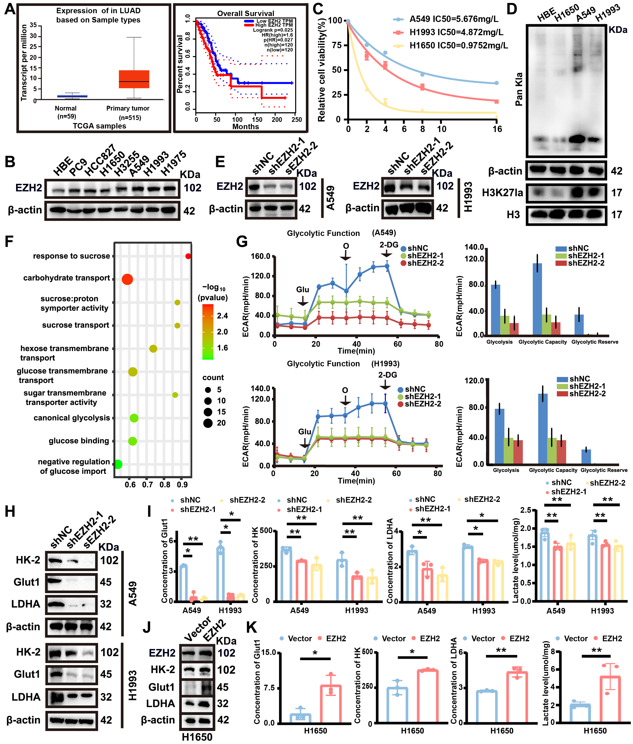
Figure S2. EZH2-mediated promotion of glycolysis and lactylation in LUAD. A. EZH2 expression in LUAD from UALCAN dataset and prognosis analysis in GEPIA dataset. B. EZH2 protein levels screened in LUAD cell lines by Western blotting. C. The IC50 of bevacizumab in A549, H1993, and H1650 cell lines was determined by CCK-8 assay. D. Pan Kla and H3K27la detected by Western blotting in LUAD cell lines and HBE. E. EZH2 knockdown efficiency (shEZH2-1 and shEZH2-2) validated by Western blotting. F. Enrichment of glycolysis-related terms in GO analysis of RNA-seq between shEZH2 and shNC groups. G. The Seahorse metabolic analysis measured the extracellular acidification rate in shEZH2 and shNC groups of A549 and H1993 cells. H. Protein expression of Glut1, HK-2, and LDHA in EZH2-knockdown groups detected by Western blotting. I. ELISA analysis of GLUT-1, HK, lactate dehydrogenase, and lactate levels in EZH2-knockdown cells (n = 3). J. Protein expression of Glut1, HK-2, and LDHA in EZH2-overexpression groups detected by Western blotting. K. ELISA analysis of GLUT1, HK, lactate dehydrogenase, and lactate levels in EZH2- overexpression cells (n = 3). Data were shown as mean ± SEM. Two-tailed t-tests. *p < 0.05; **p < 0.01; ***p < 0.001; ****p < 0.0001; ns not significant.
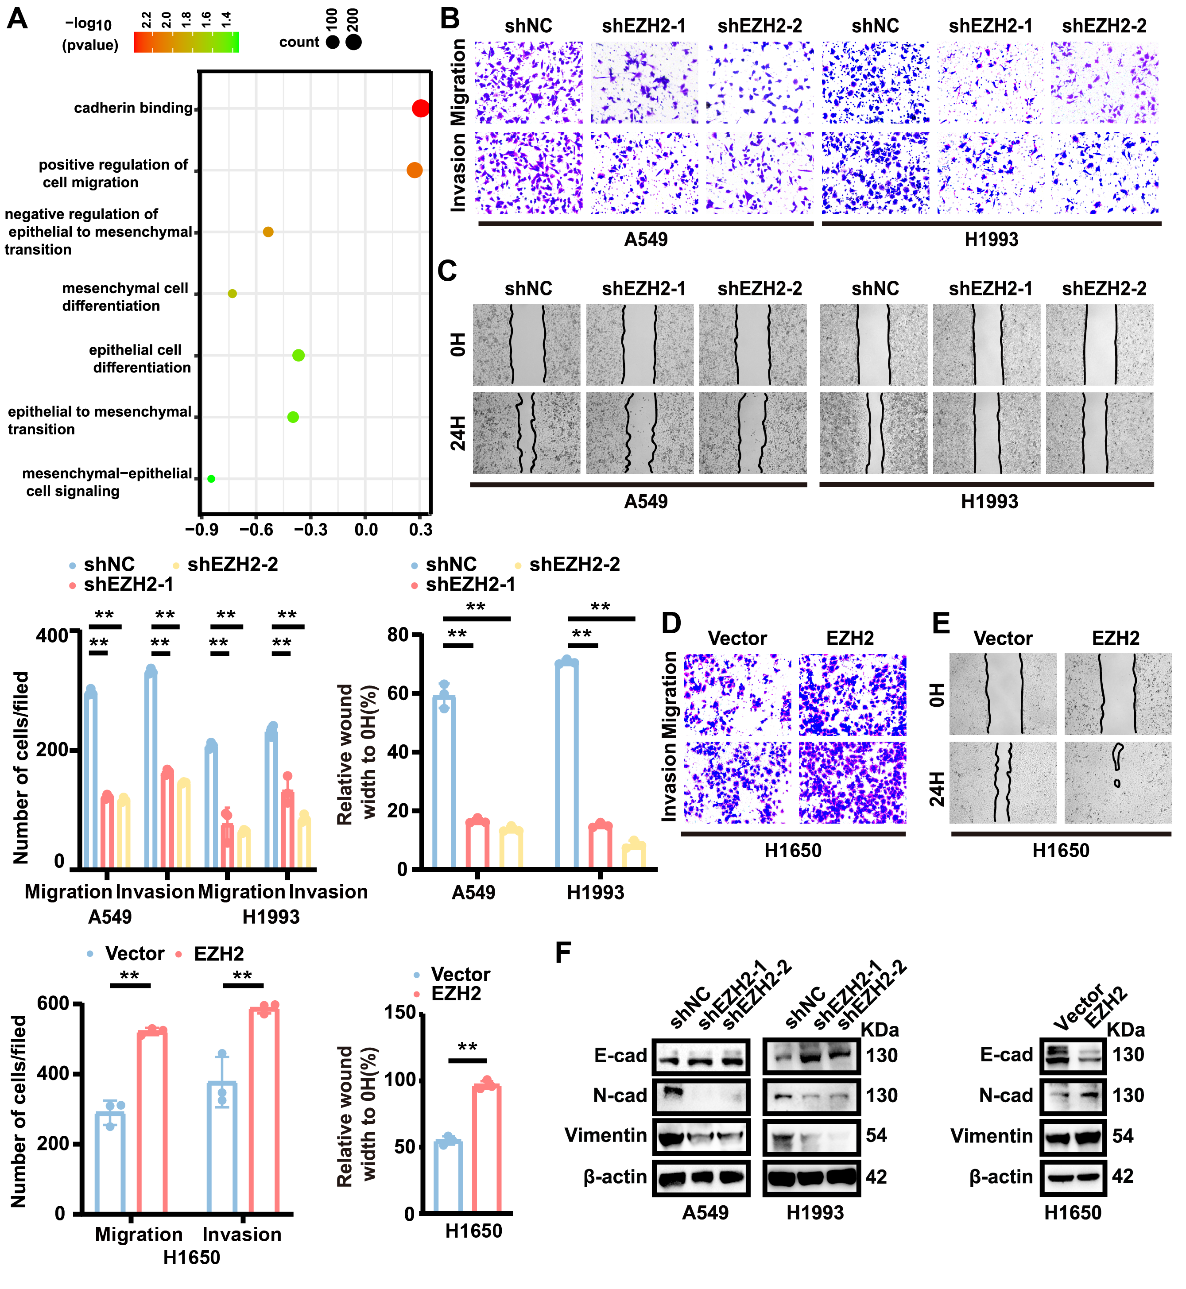
Figure S3. EZH2 promotes tumor metastasis through EMT induction. A. GO analysis of RNA-seq data from control (shNC) and EZH2-knockdown (shEZH2) cells (n = 3). B-E. Invasion ability and migration capacity following EZH2 overexpression and knockdown were determined by Transwell and wound healing assays (n = 3). F. Expression of EMT markers (E-cadherin, N-cadherin, Vimentin) in EZH2-overexpression and knockdown groups analyzed by Western blotting. Data were shown as mean ± SEM. Two-tailed t-tests. *p < 0.05; **p < 0.01; ***p < 0.001; ****p < 0.0001.
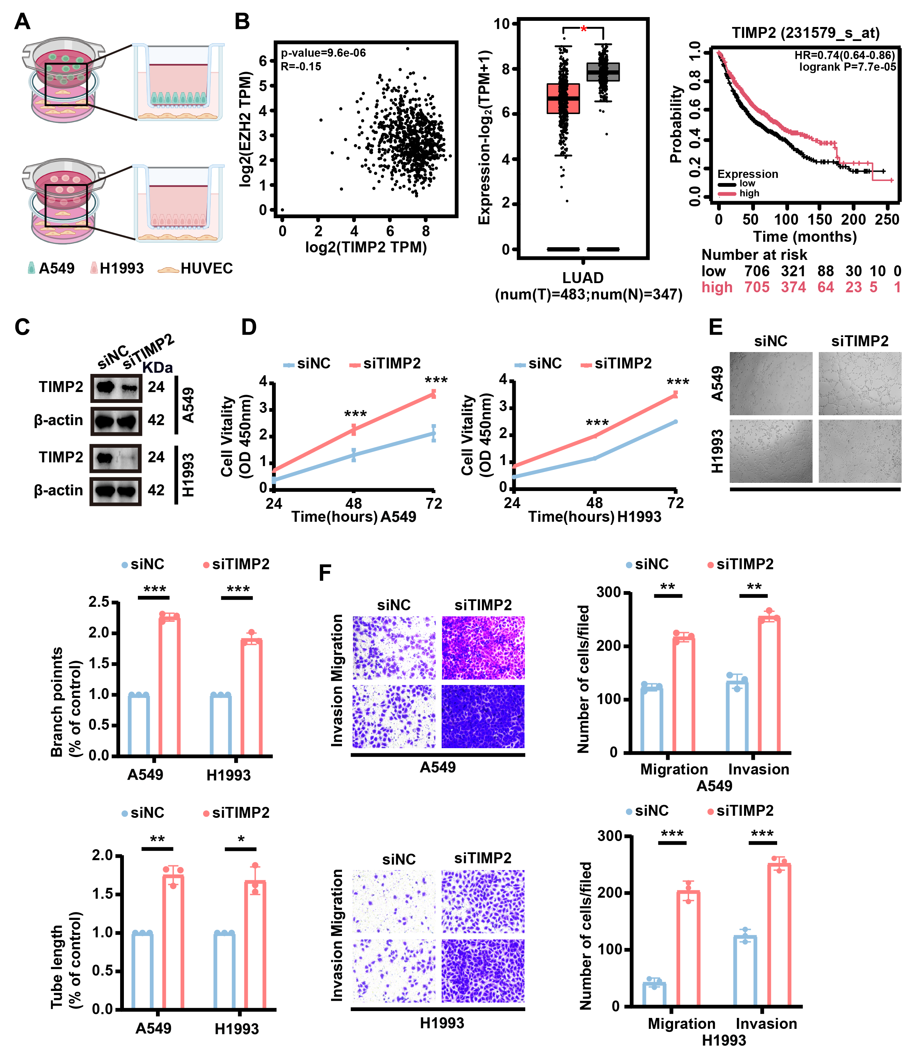
Figure S4. TIMP2 functionally regulates angiogenesis in LUAD. A. Schematic diagram. B. The correlation between TIMP2 and EZH2 was analyzed in the GEPIA database, TIMP2 expression was assessed in the TCGA LUAD dataset, and its relationship with LUAD patient prognosis was evaluated. C. The successful knock-down of TIMP2 in A549 and H1993 cells was verified by WB. D. Proliferation of HUVECs co-cultured with siTIMP2-transfected or siNC-transfected LUAD cells was measured by CCK-8 assay. E. Tube formation ability of HUVECs co-cultured with siTIMP2-transfected or siNC-treated LUAD cells was determined by Matrigel assay (n = 3). F. Migration capacity of HUVECs co-cultured with siTIMP2-transfected or siNC-treated LUAD cells was assessed by Transwell assay (n = 3). Data were shown as mean ± SEM. Two-tailed t-tests. *p < 0.05; **p < 0.01; ***p < 0.001; ****p < 0.0001; ns not significant.
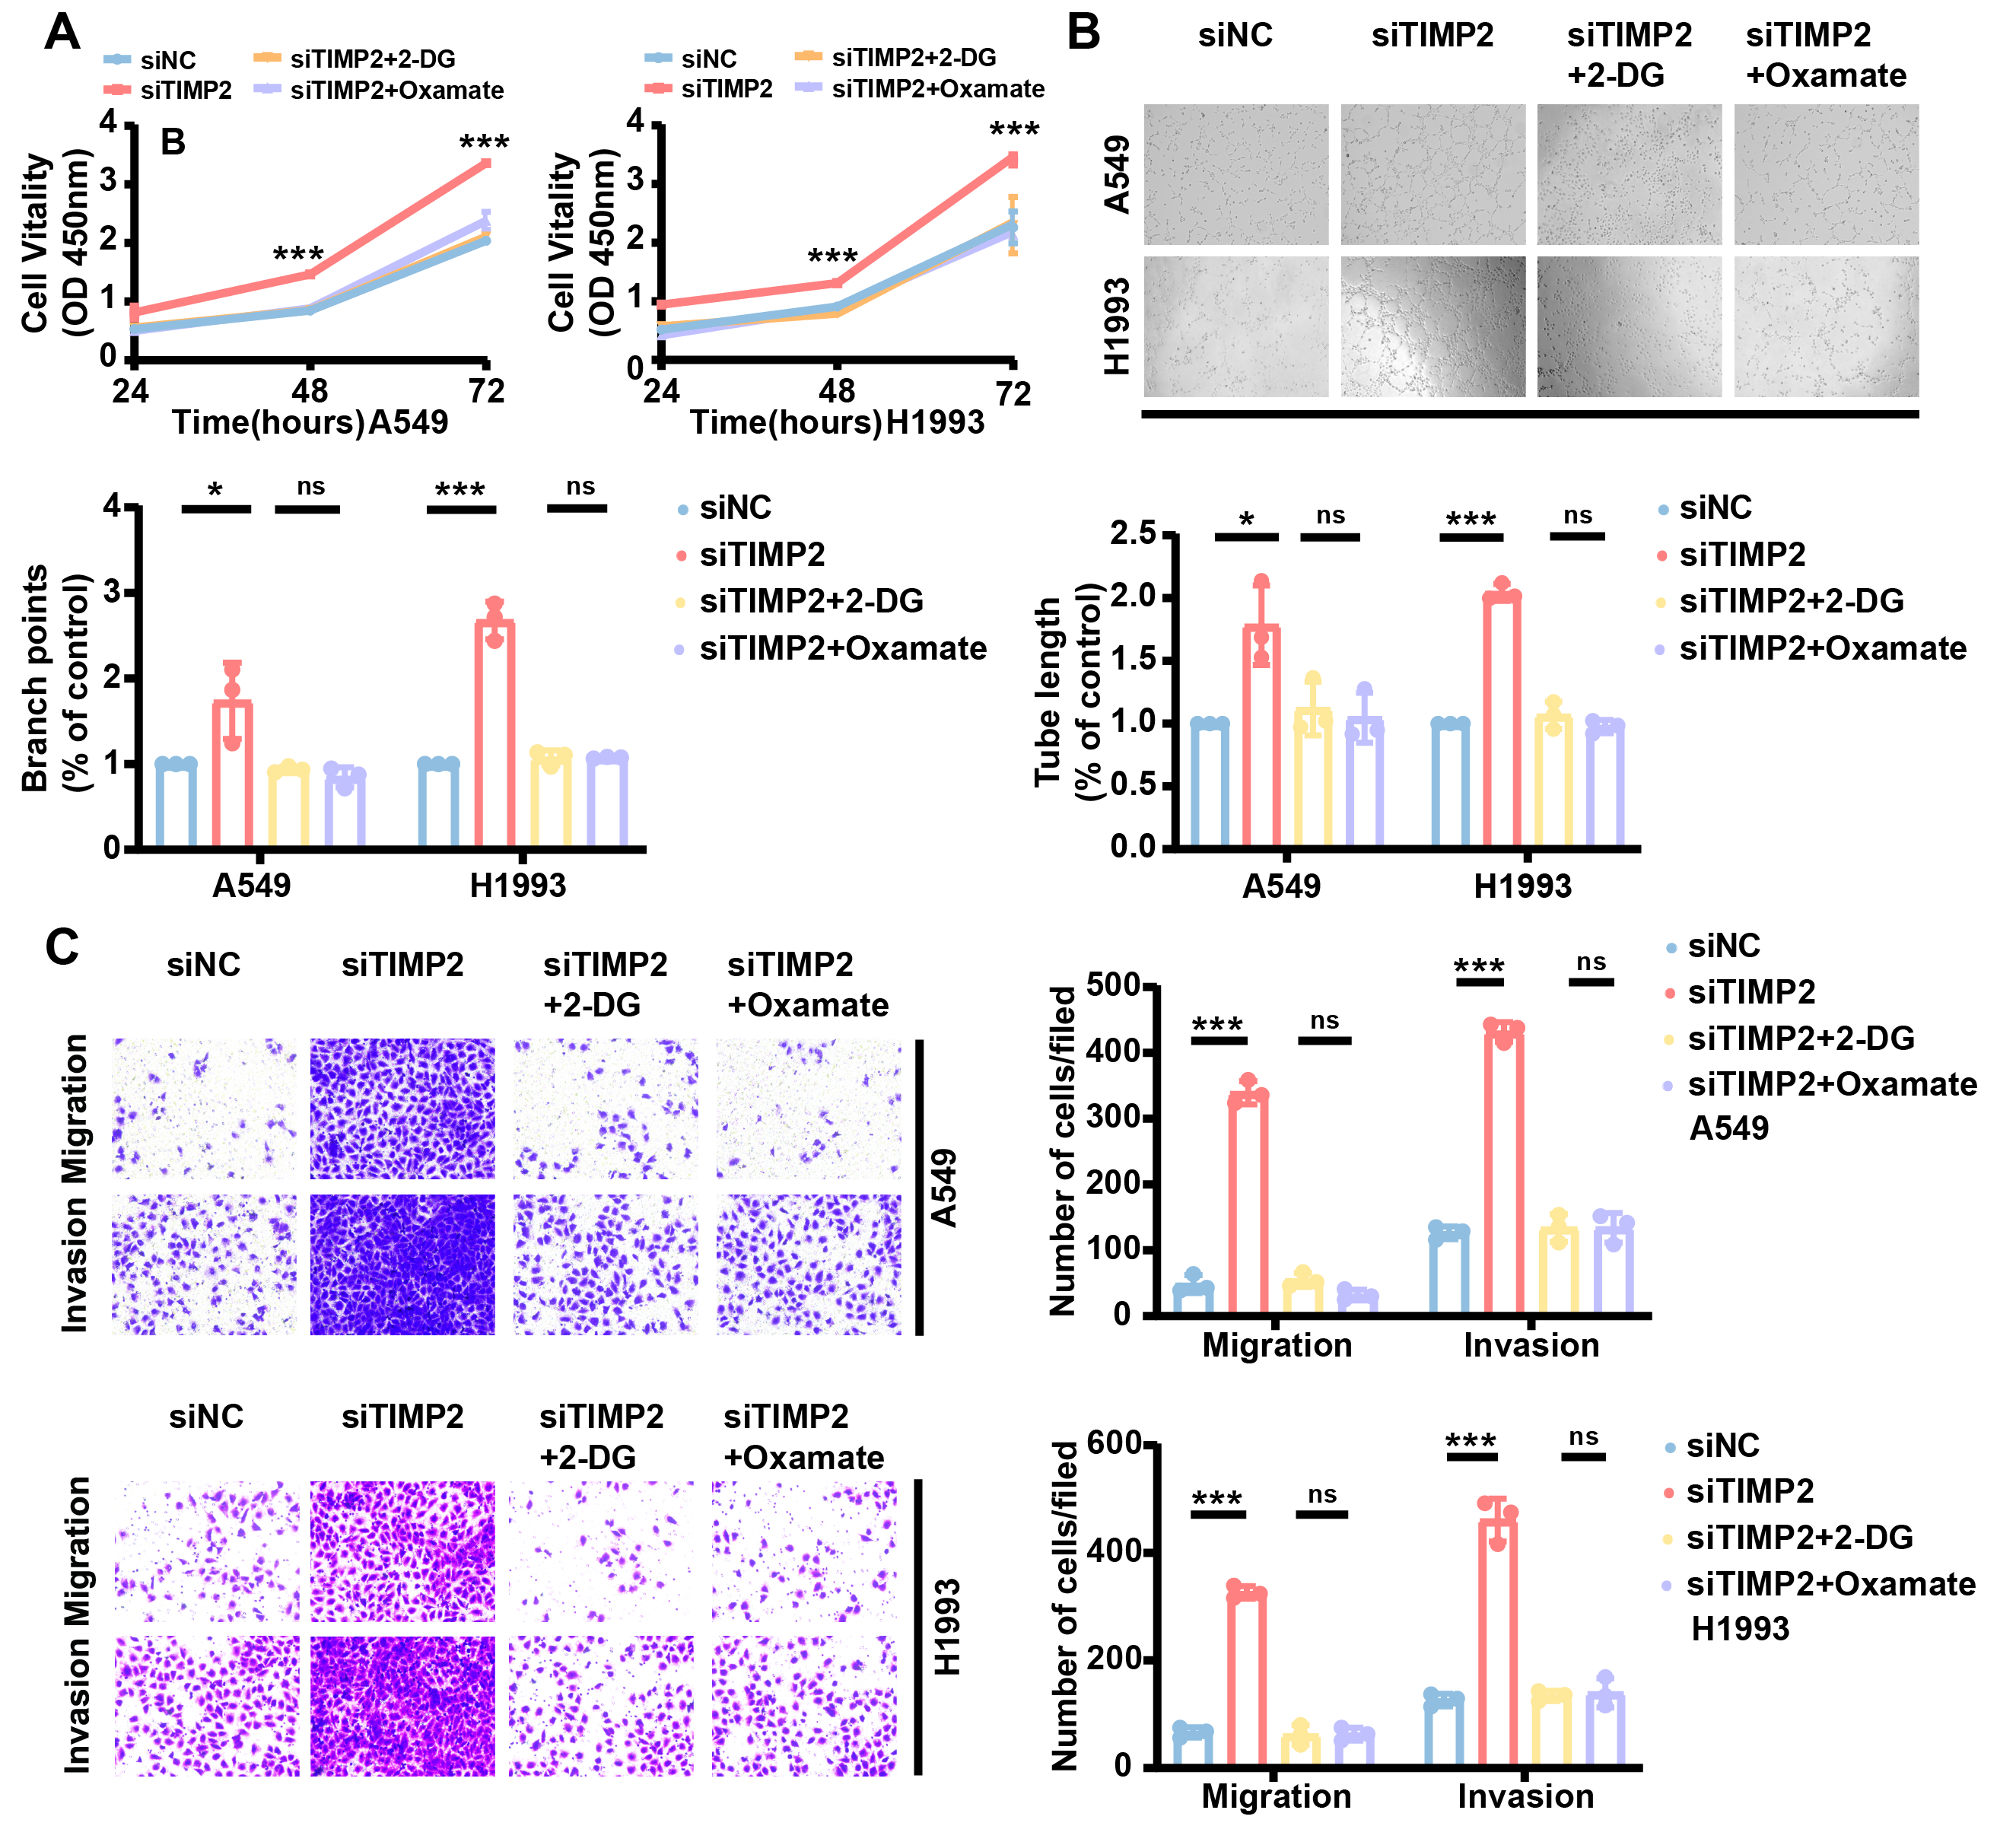
Figure S5. TIMP2 regulates H3K27la-mediated angiogenesis upon glycolysis inhibition. A. Proliferation of HUVECs co-cultured with siTIMP2-treated A549/H1993 cells and glycolysis inhibitors (Oxamate, 10 mM; 2-DG, 10 mM) was measured by CCK-8 assay. B. Tube formation ability of HUVECs co-cultured with siTIMP2-treated A549/H1993 cells and glycolysis inhibitors (Oxamate, 10 mM; 2-DG, 10 mM) was determined by Matrigel assay (n = 3). C. Metastatic capacity of HUVECs co-cultured with siTIMP2-treated A549/H1993 cells and glycolysis inhibitors (Oxamate, 10 mM; 2-DG, 10 mM) was assessed by Transwell assay (n = 3). Data were shown as mean ± SEM. Two-tailed t-tests. *p < 0.05; **p < 0.01; ***p < 0.001; ****p < 0.0001; ns not significant.
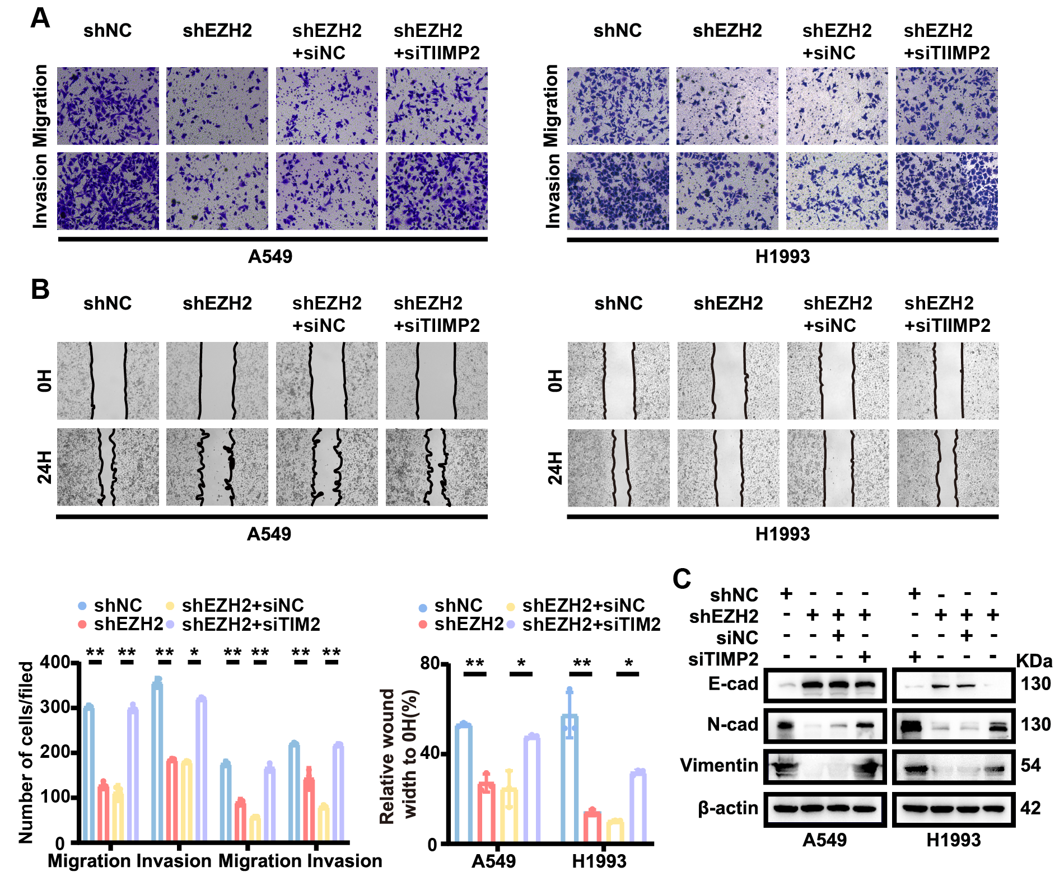
Figure S6. TIMP2 regulates EZH2-mediated metastasis. A. Invasion ability of A549 and H1993 cells treated with siTIMP2 and shEZH2 was analyzed by Transwell invasion assay (n = 3). B. Migration capacity of A549 and H1993 cells treated with siTIMP2 and shEZH2 was assessed by wound healing assay (n = 3). C. Expression of EMT markers (E-cadherin, N-cadherin, Vimentin) in A549 and H1993 cells treated with siTIMP2 and shEZH2 was analyzed by Western blotting. Data were shown as mean ± SEM. Two-tailed t-tests. *p < 0.05; **p < 0.01; ***p < 0.001; ****p < 0.0001.
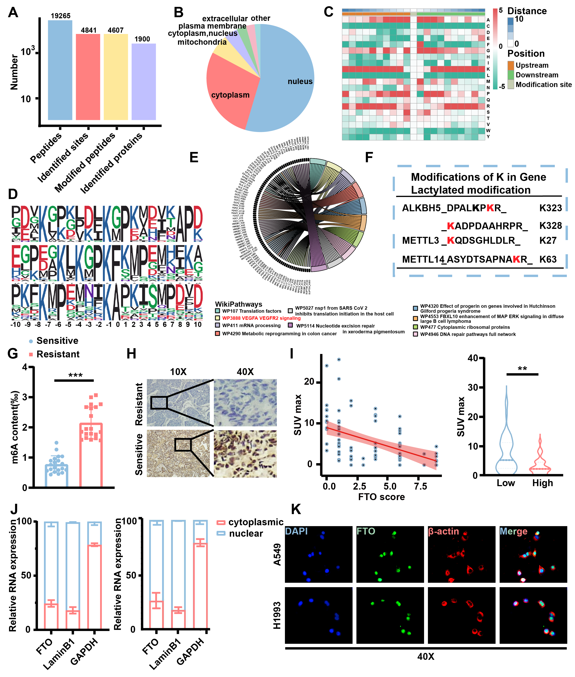
Figure S7. Lactylation mediates epigenetic crosstalk in Bev-resistant LUAD. A. Global lactylation profiling in A549 cells showing 4,841 lactylation sites across 1,900 proteins. B. Quality control of peptide length distribution in lactylation proteomics data. C. Amino acid sequence preference analysis of Kla sites compared to human proteome background. D. Frequency of cysteine (C) and leucine (L) residues flanking Kla sites. E. Enrichment of VEGFA-VEGFR2 signaling pathway in lactylated proteins analyzed by WikiPathways. F. Lactylation modification of m⁶A-related proteins (METTL3, METTL14, ALKBH5) detected by immunoprecipitation-mass spectrometry. G. Global m⁶A levels in Bev-resistant versus Bev-sensitive LUAD tissues were quantified by m⁶A ELISA (n = 20). H. FTO protein expression in Bev-resistant LUAD tissues was assessed by IHC (n = 84). I. The correlation between FTO expression and SUVmax was analyzed. J. Subcellular localization of FTO in LUAD cells was determined by nuclear-cytoplasmic fractionation combined with qPCR. K. FTO localization in LUAD cells was visualized by IF. Data were shown as mean ± SEM. Two-tailed t-tests. *p < 0.05; **p < 0.01; ***p < 0.001; ****p < 0.0001.
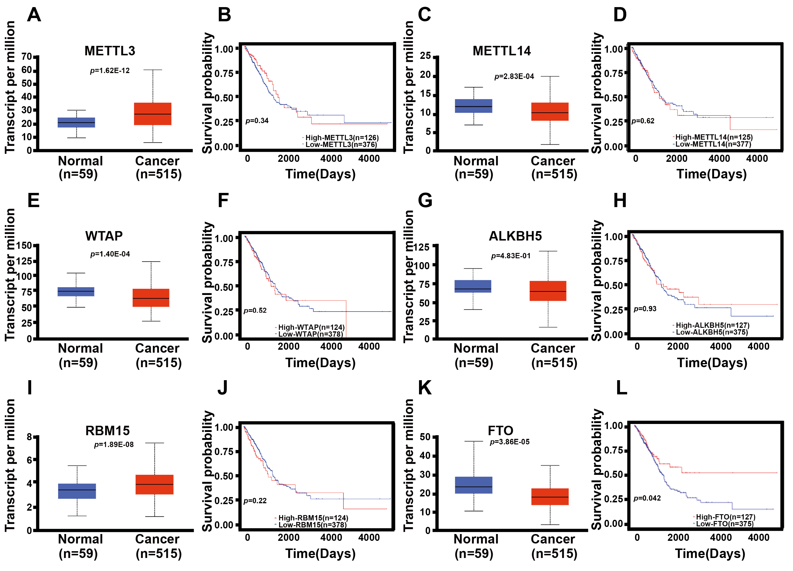
Figure S8. m⁶A-related enzymes predict clinical outcomes in LUAD. A-L. The mRNA expression levels of m⁶A-related enzymes in LUAD tissues from the TCGA dataset were analyzed (n = 574). Compared with other m⁶A writing proteins and erasing proteins, FTO expression is related to the overall survival of patients with LUAD.
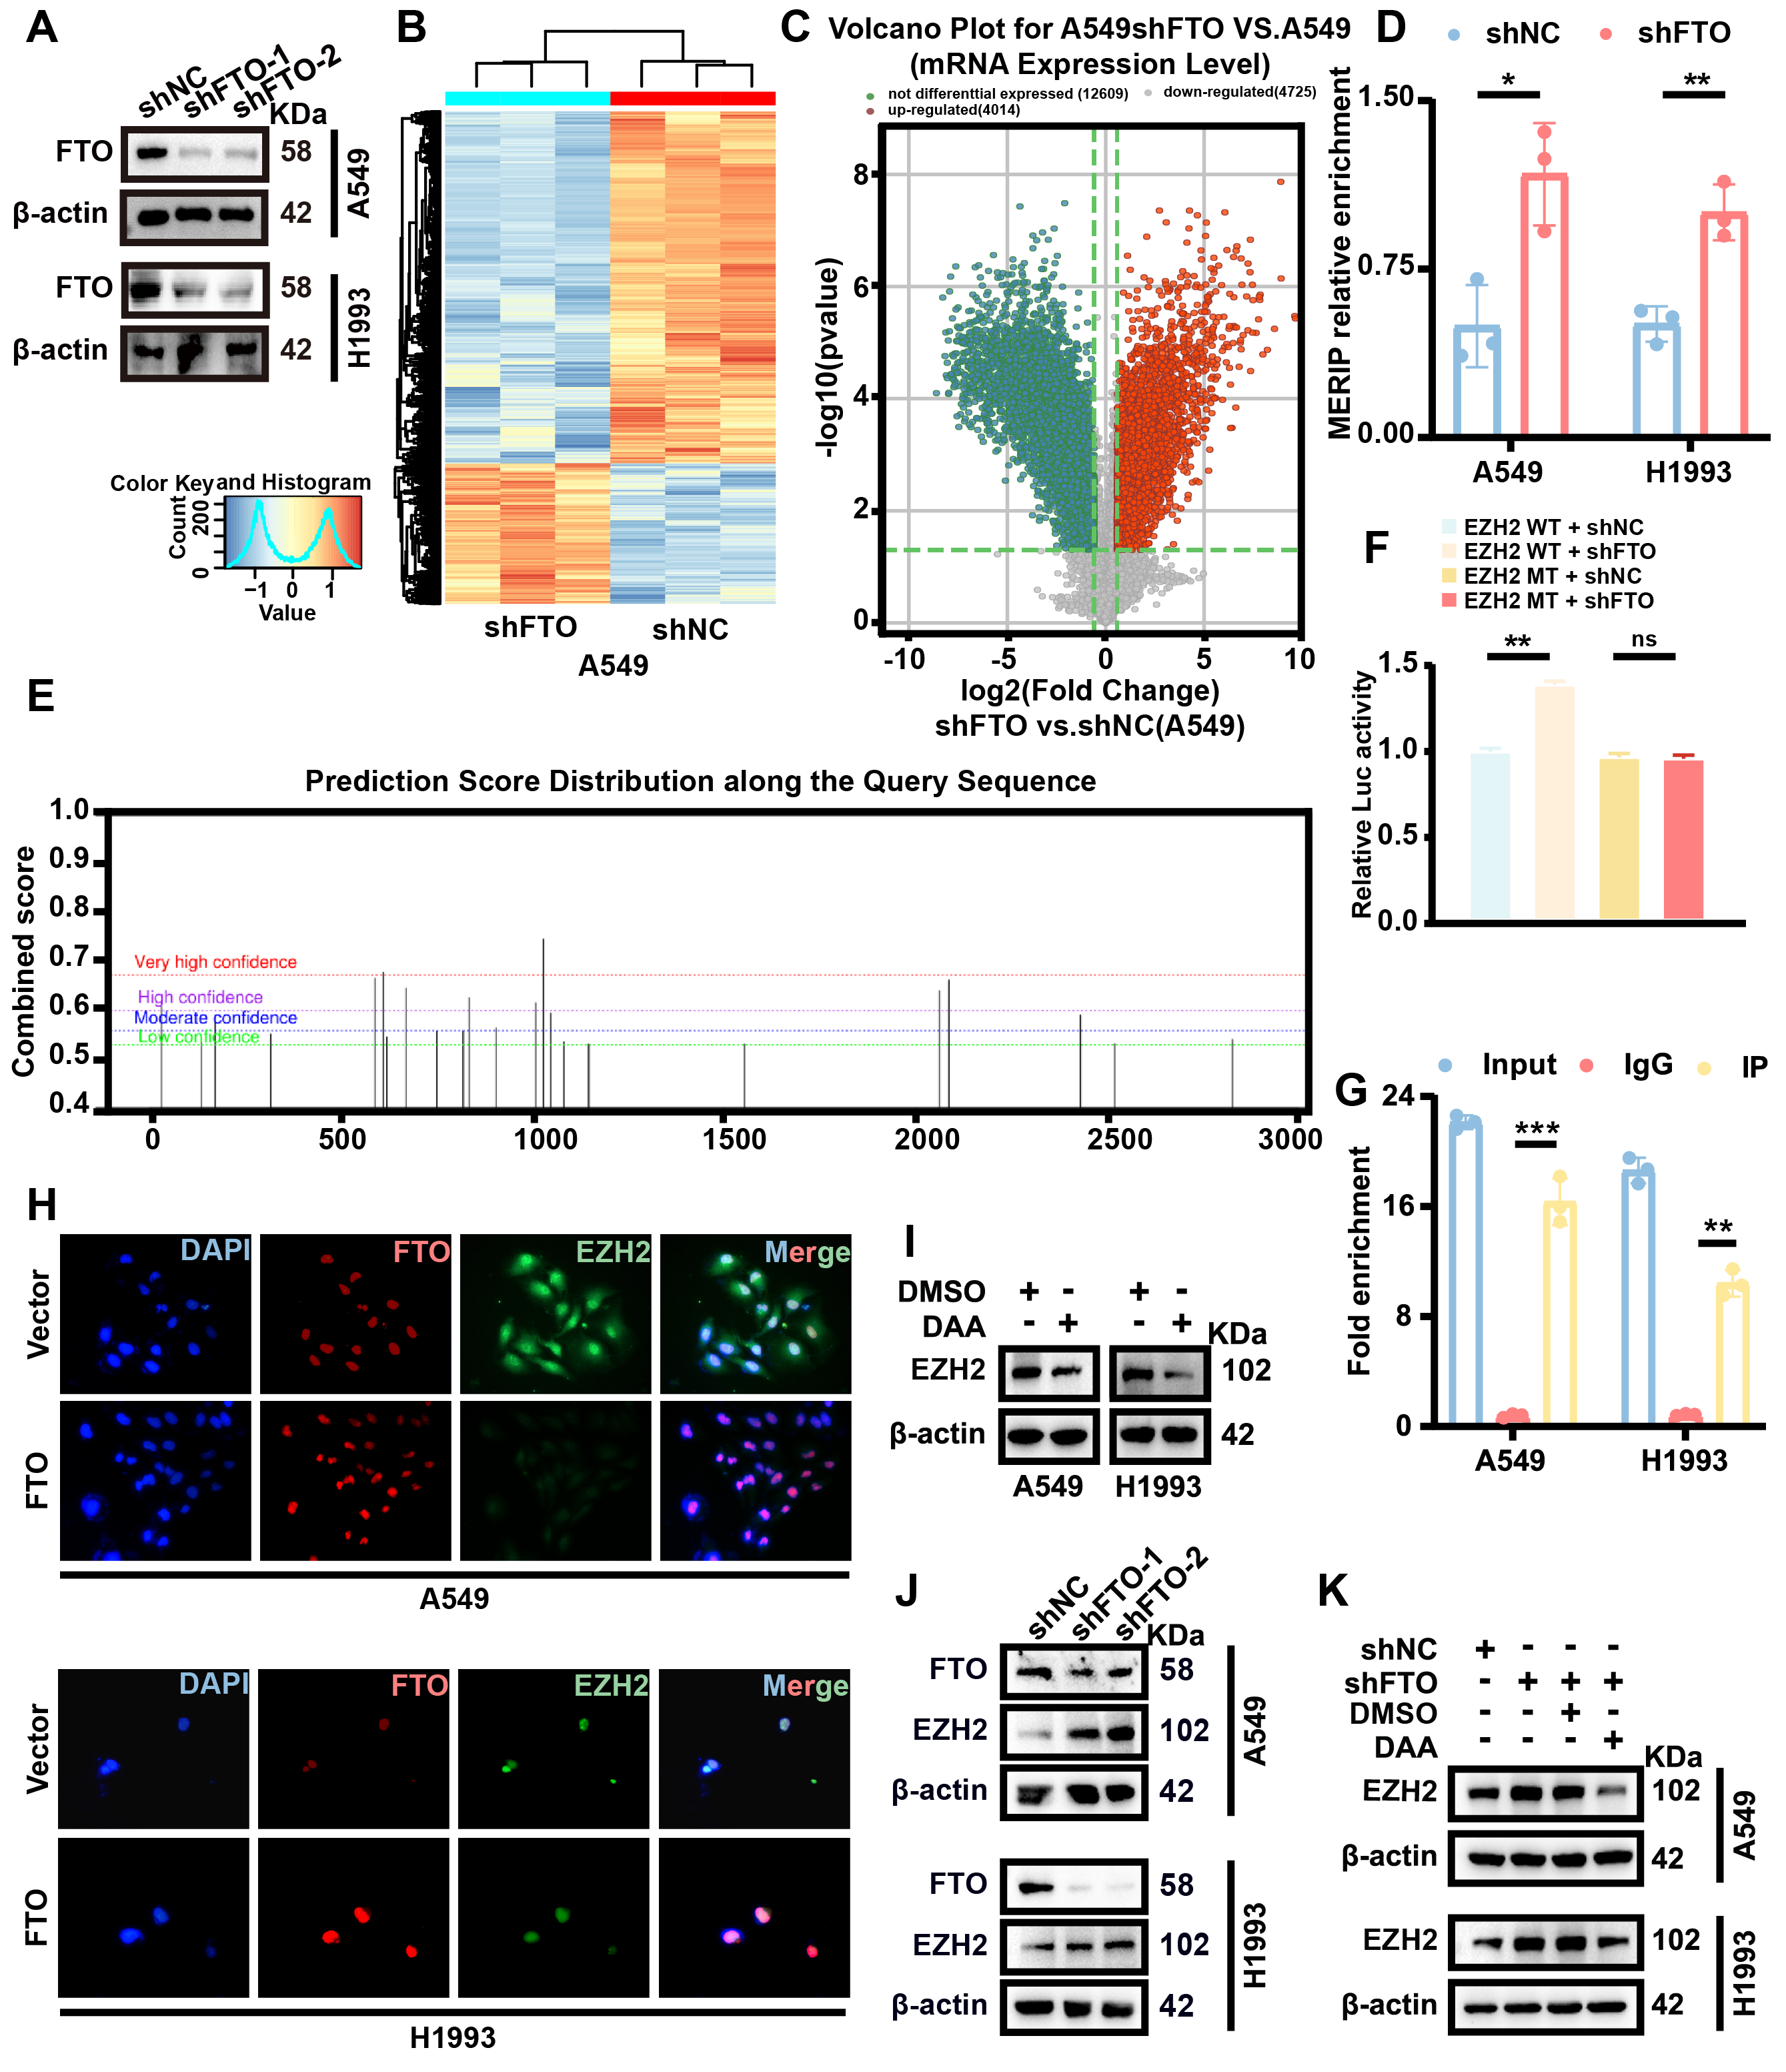
Figure S9. FTO mediates m⁶A modification of EZH2 in LUAD. A. Successfully constructed FTO knockout cell line. B. Heatmap of m⁶A-modified mRNA profiles in shFTO versus control cells (n = 3). C. Scatter plot of mRNA expression fold changes. D. m⁶A enrichment on EZH2 transcripts was detected by MeRIP-qPCR (n = 3). E. High-confidence m⁶A sites in EZH2 were predicted by the SRAMP dataset. F. Luciferase activity of wild-type (WT) and mutant (Mut) EZH2 reporters in shFTO cells. G. RIP showed that FTO bound to EZH2 mRNA (n = 3). H. Nuclear colocalization of FTO and EZH2 in LUAD cells after DAA treatment (20 μM) was analyzed by IF. I. EZH2 and FTO protein levels after DAA treatment were detected by Western blotting. J. EZH2 protein expression in shFTO cells was validated by Western blotting. K. EZH2 protein levels in shFTO cells treated with DAA (20 μM) were determined by Western blotting. Data were shown as mean ± SEM. Two-tailed t-tests. *p < 0.05; **p < 0.01; ***p < 0.001; ****p < 0.0001; ns not significant.
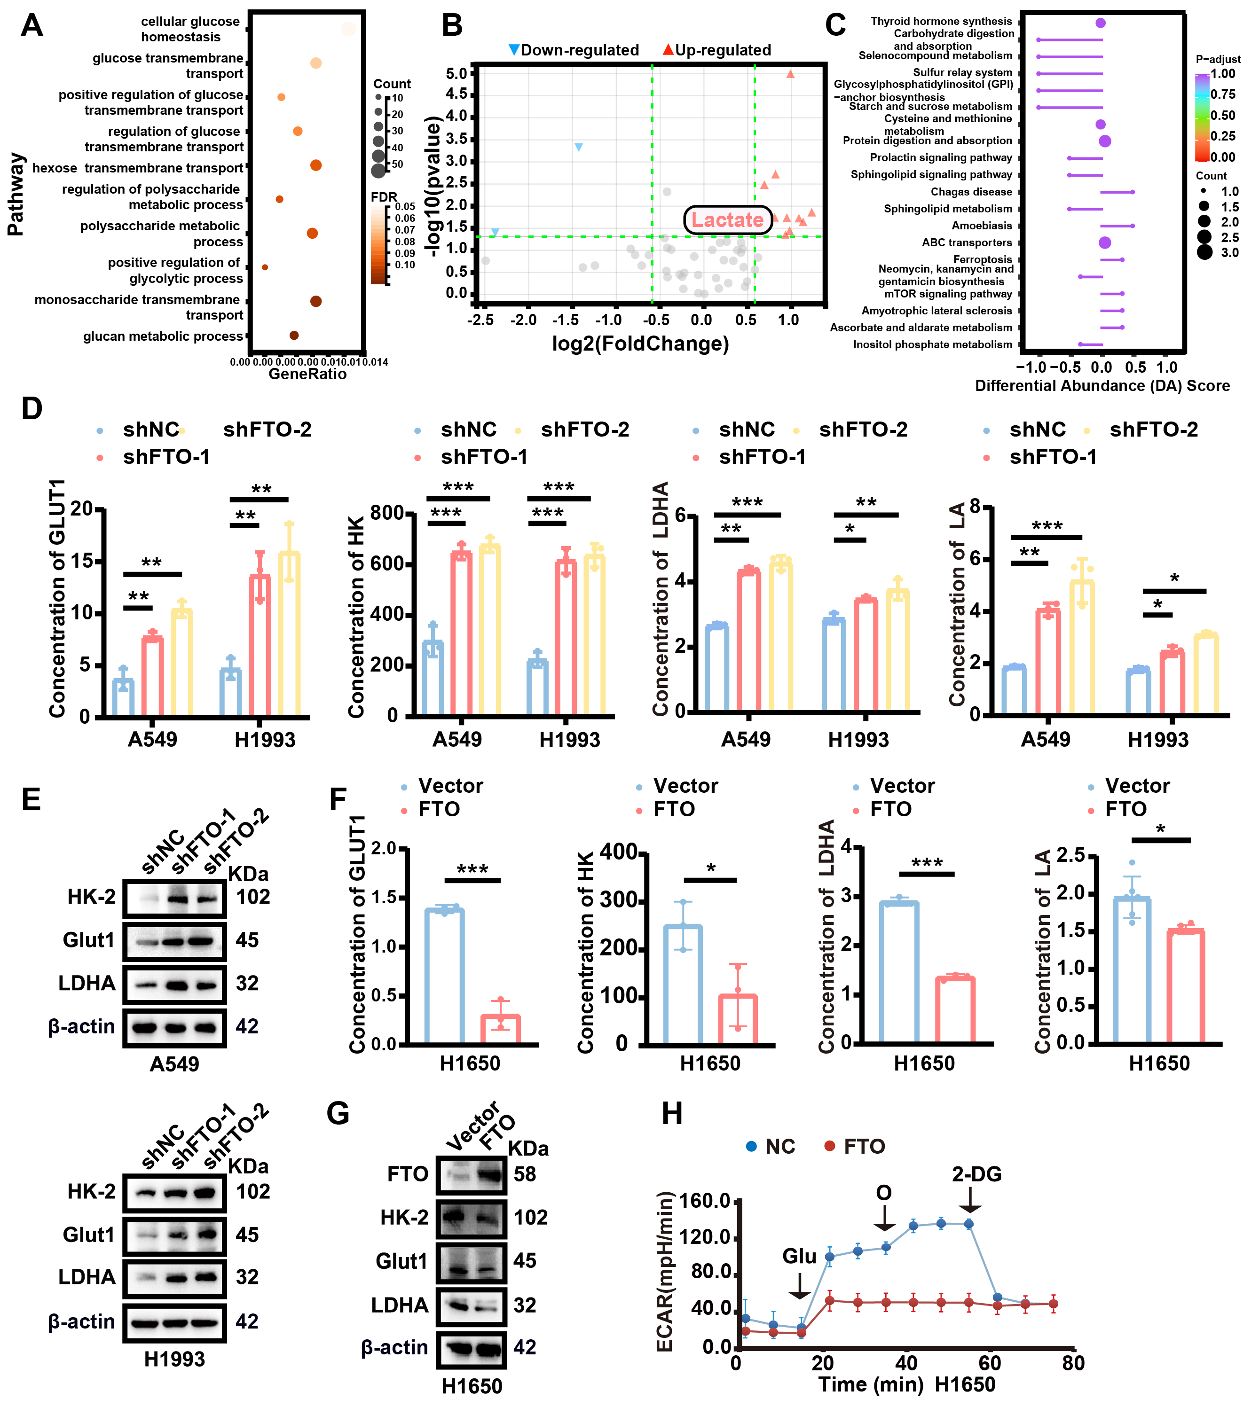
Figure S10. FTO regulates glycolysis in LUAD. A. GO analysis showed enrichment of the glycolysis pathway. B. Untargeted metabolomics analysis showed 12 differentially expressed metabolites (2 downregulated, 10 upregulated) in shFTO versus shNC groups. C. KEGG enrichment of central carbon metabolism pathways in differential metabolites. D. Levels of GLUT1, HK, LDHA, and LA in shFTO LUAD cells were detected by ELISA (n = 3). E. Protein levels of Glut1, HK-2, and LDHA in shFTO LUAD cells were detected by Western blotting. F. Levels of GLUT1, HK, LDHA, and LA in FTO-overexpressing H1650 cells were detected by ELISA (n = 3). G. Protein levels of Glut1, HK2, and LDHA, in FTO-overexpressing H1650 cells were detected by Western blotting. H. ECAR in FTO-overexpressing H1650 cells was measured using the Seahorse XF Analyzer. Data were shown as mean ± SEM. Two-tailed t-tests. *p < 0.05; **p < 0.01; ***p < 0.001; ****p < 0.0001.
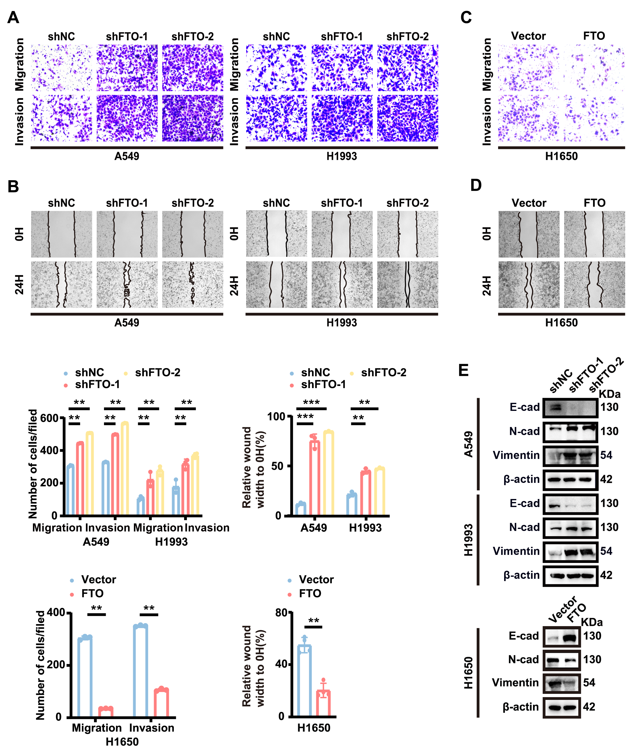
Figure S11. FTO regulates EMT-mediated metastasis in LUAD. A. Invasion ability of shFTO A549 and H1993 cells was evaluated by Transwell assay (n = 3). B. Migration capacity of FTO-knockdown (shFTO) A549 and H1993 cells was analyzed by wound healing assay (n = 3). C. Invasion ability of FTO-overexpressing H1650 cells was determined by Transwell assay (n = 3). D. Migration capacity of FTO-overexpressing H1650 cells was assessed by wound healing assay (n = 3). E. Protein expression of N-cadherin, Vimentin, and E-cadherin in shFTO or FTO-overexpressing LUAD cells was detected by Western blotting. Data were shown as mean ± SEM. Two-tailed t-tests. *p < 0.05; **p < 0.01; ***p < 0.001; ****p < 0.0001.
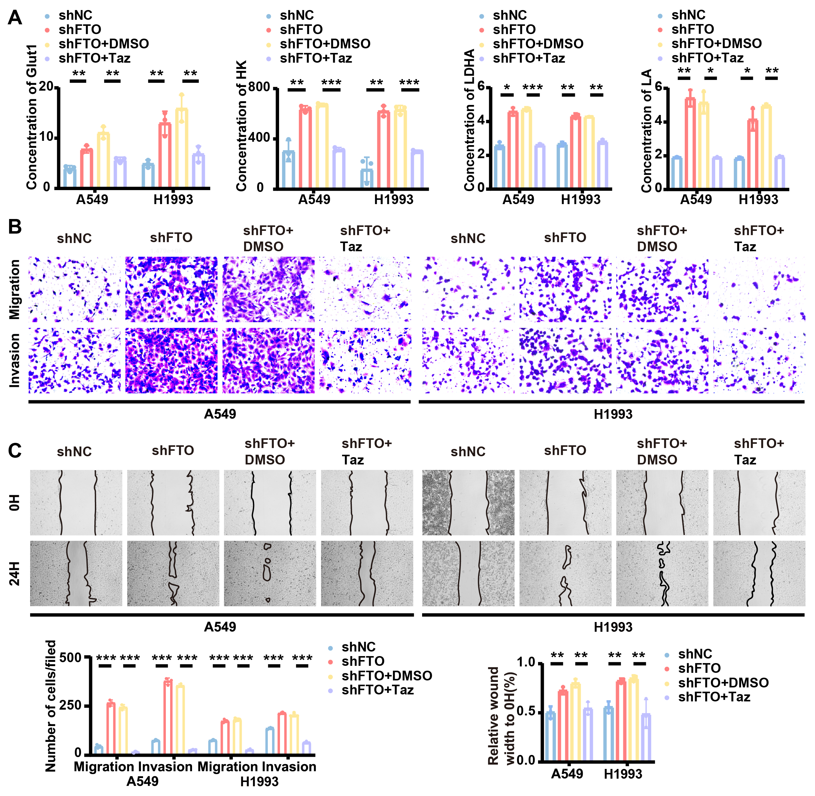
Figure S12. EZH2 inhibition reduces FTO deficiency-driven metastasis. A. GLUT1, HK, LDHA, and LA levels in shFTO LUAD cells treated with Tazemetostat (10 μM) were measured by ELISA (n = 3). B-C. Invasion capacity of shFTO LUAD cells treated with Tazemetostat (10 μM) was evaluated by wound healing and Transwell assays (n = 3). Data were shown as mean ± SEM. Two-tailed t-tests. *p < 0.05; **p < 0.01; ***p < 0.001; ****p < 0.0001.
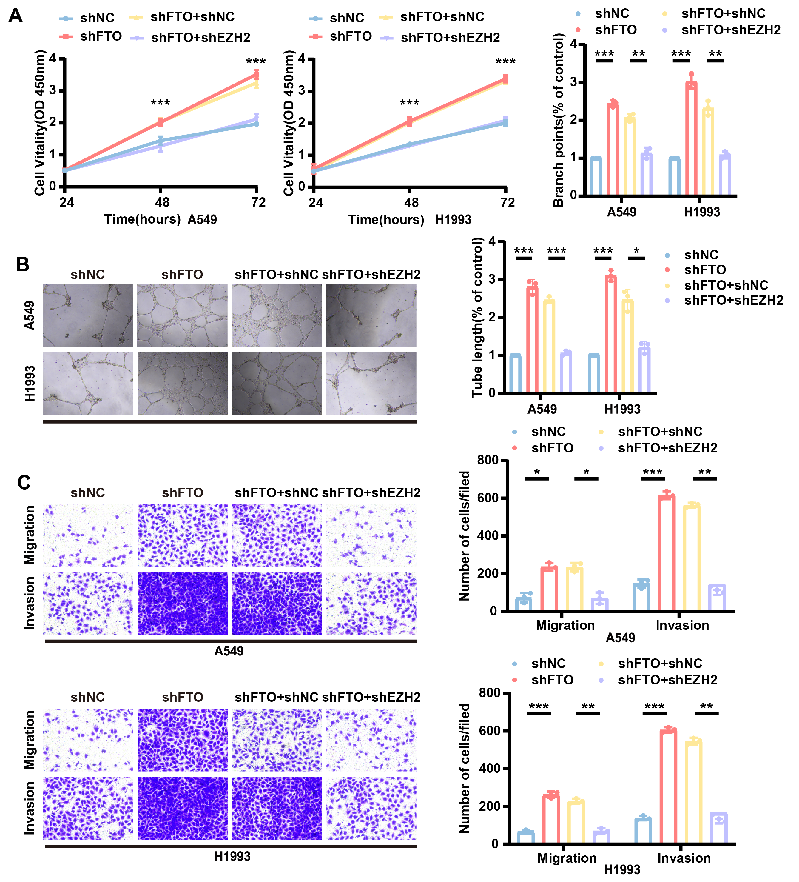
Figure S13. EZH2 promotes angiogenesis in LUAD. A. Proliferation of HUVECs co-cultured with shFTO-treated and shFTO-shEZH2-treated A549/H1993 cells was measured by CCK-8 assay B. Tube formation ability of HUVECs co-cultured with shFTO-treated and shFTO-shEZH2-treated A549/H1993 cells was determined by Matrigel assay (n = 3). C. Metastatic capacity of HUVECs co-cultured with shFTO-treated and shFTO-shEZH2-treated A549/H1993 cells was assessed by Transwell assay (n = 3). Data were shown as mean ± SEM. Two-tailed t-tests. *p < 0.05; **p < 0.01; ***p < 0.001; ****p < 0.0001.
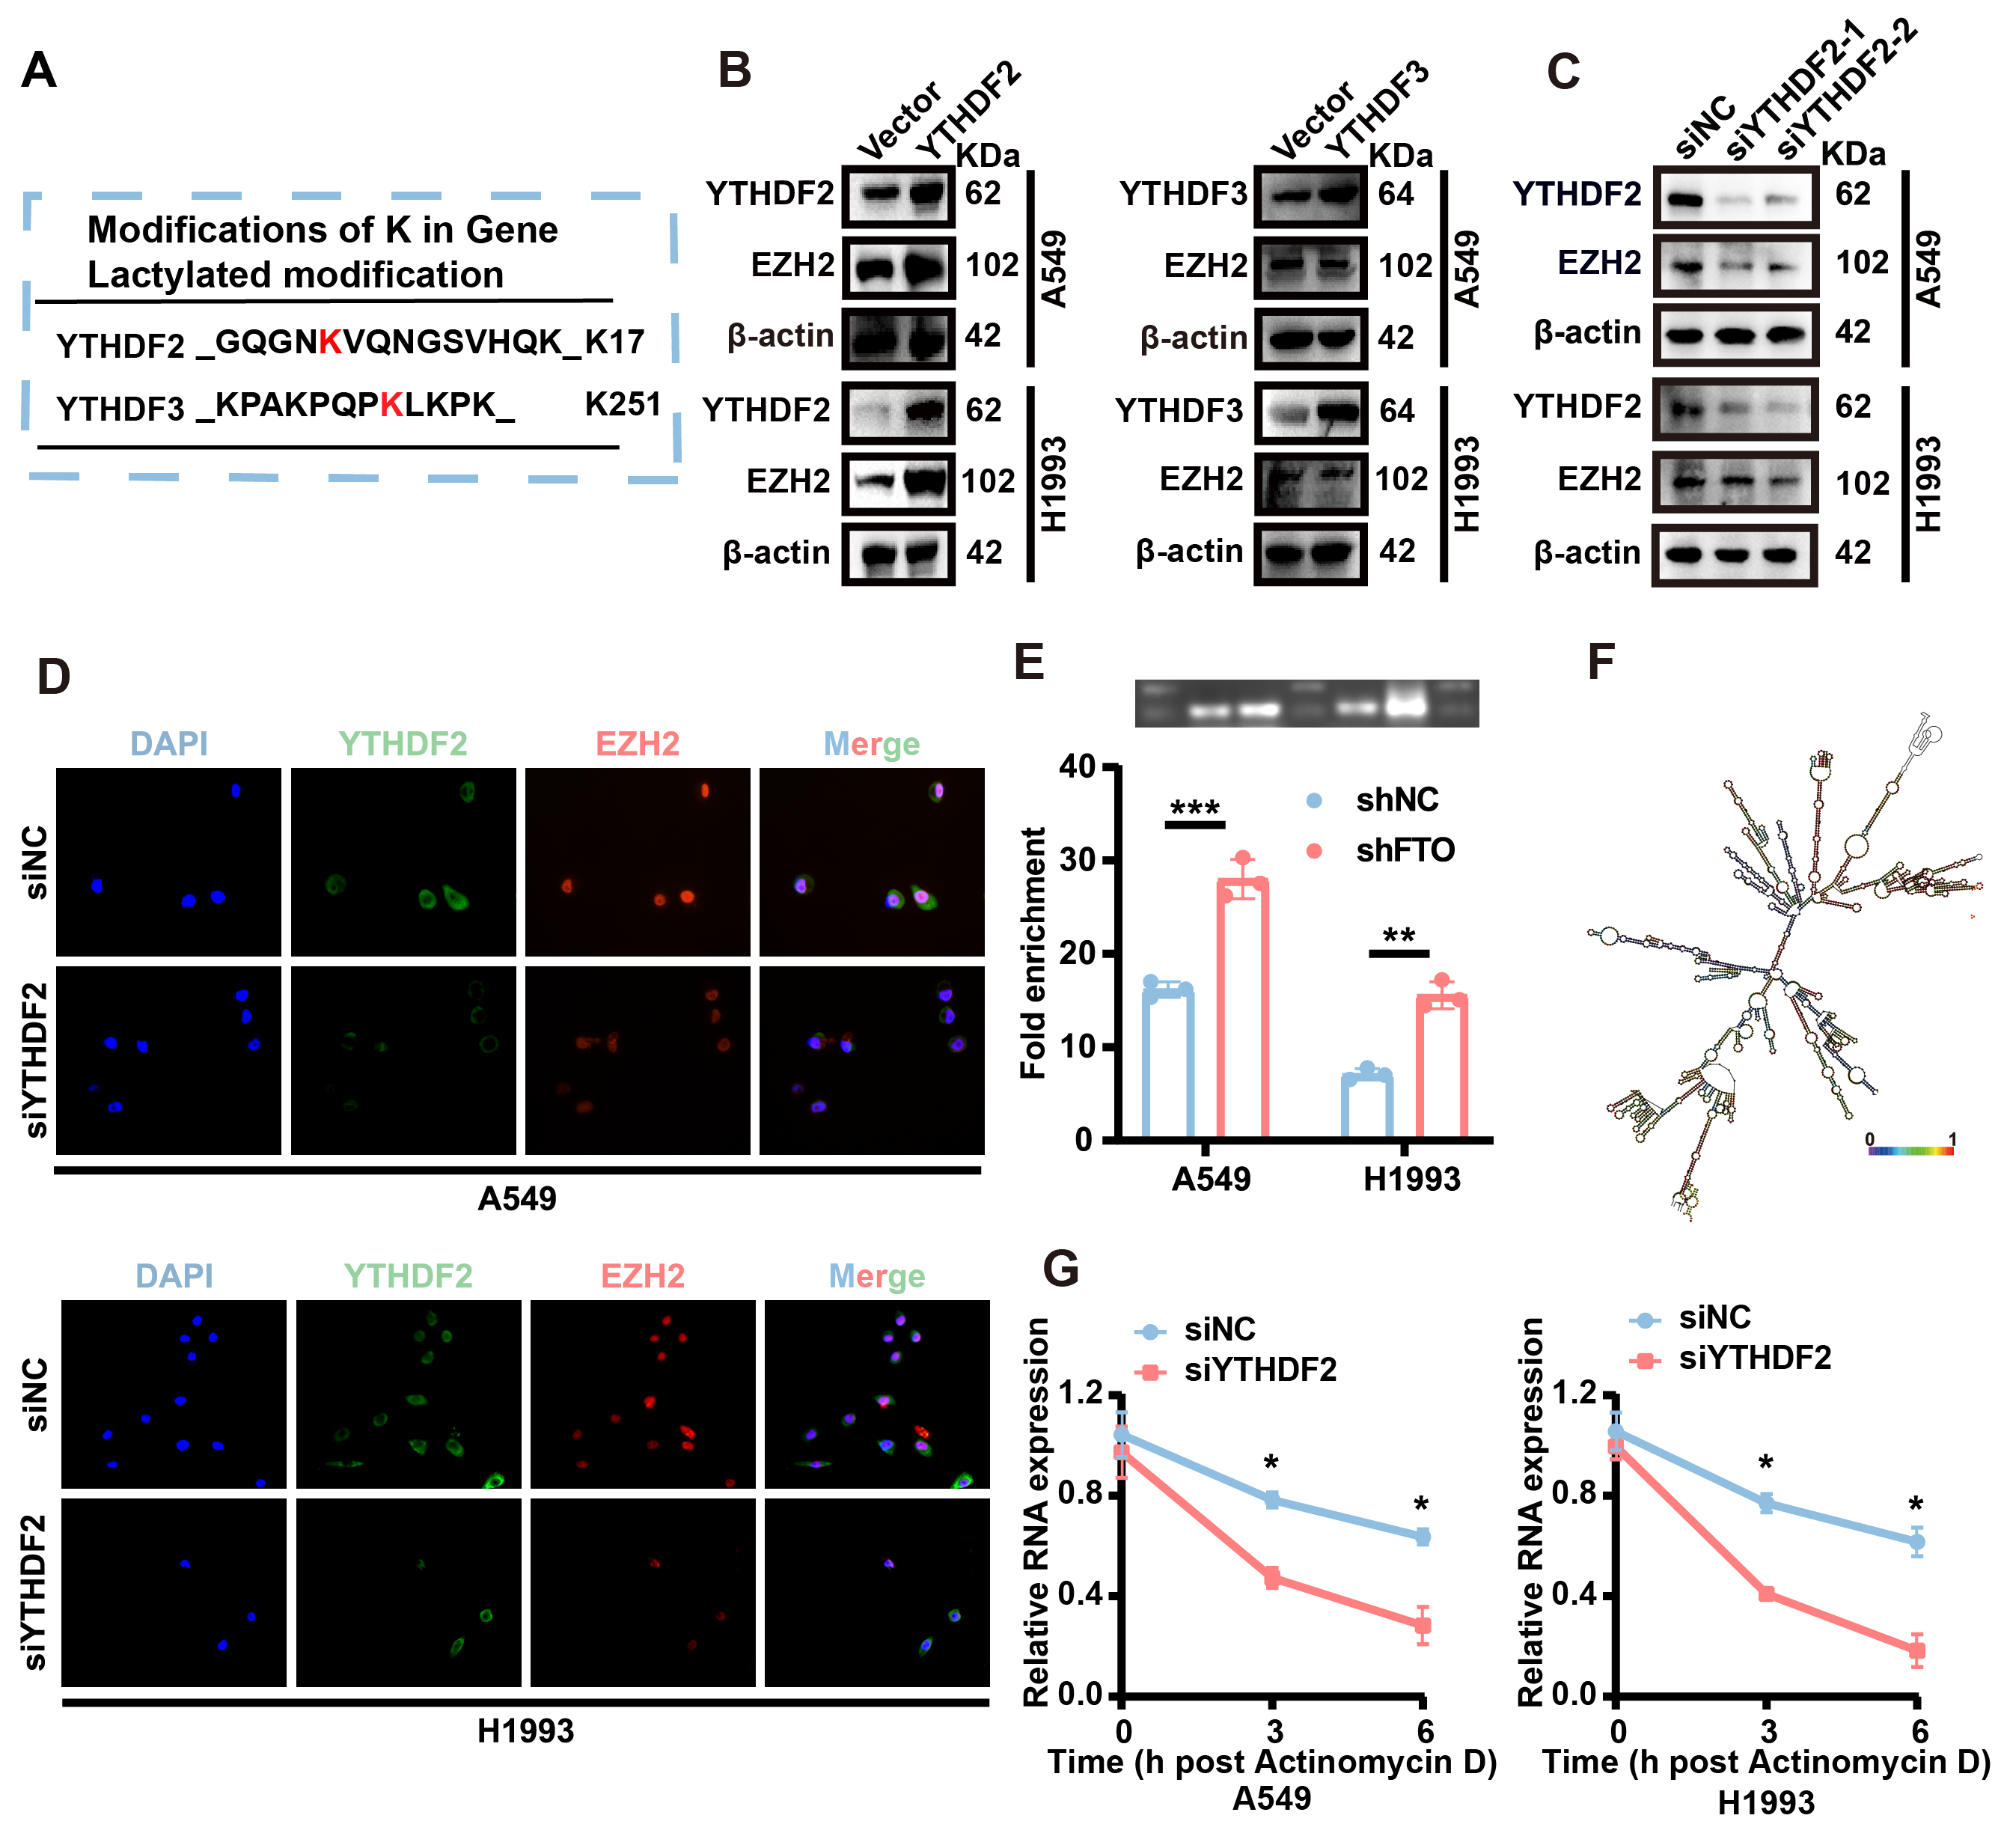
Figure S14. YTHDF2 lactylation drives EZH2 expression via m⁶A recognition. A. Mass spectrometry analysis of potential modifications of lysine (K) in YTHDF2 and YTHDF3. B. EZH2 protein expression in YTHDF2-overexpressing LUAD cells was analyzed by Western blotting. C. EZH2 protein levels in siYTHDF2 LUAD cells was analyzed by Western blotting. D. Subcellular localization of YTHDF2 in LUAD cells was visualized by IF. E. Binding of YTHDF2 to m⁶A-modified EZH2 transcripts in shFTO cells was measured by RIP-qPCR. F. RNA secondary structure prediction of the m⁶A motif in EZH2 mRNA. G. The half-life of EZH2 mRNA in shYTHDF2 LUAD cells was determined by RNA stability assay. Data are presented as means ± SEMs. *P < 0.05, **P < 0.01, ***P < 0.001, Two-tailed t-tests.
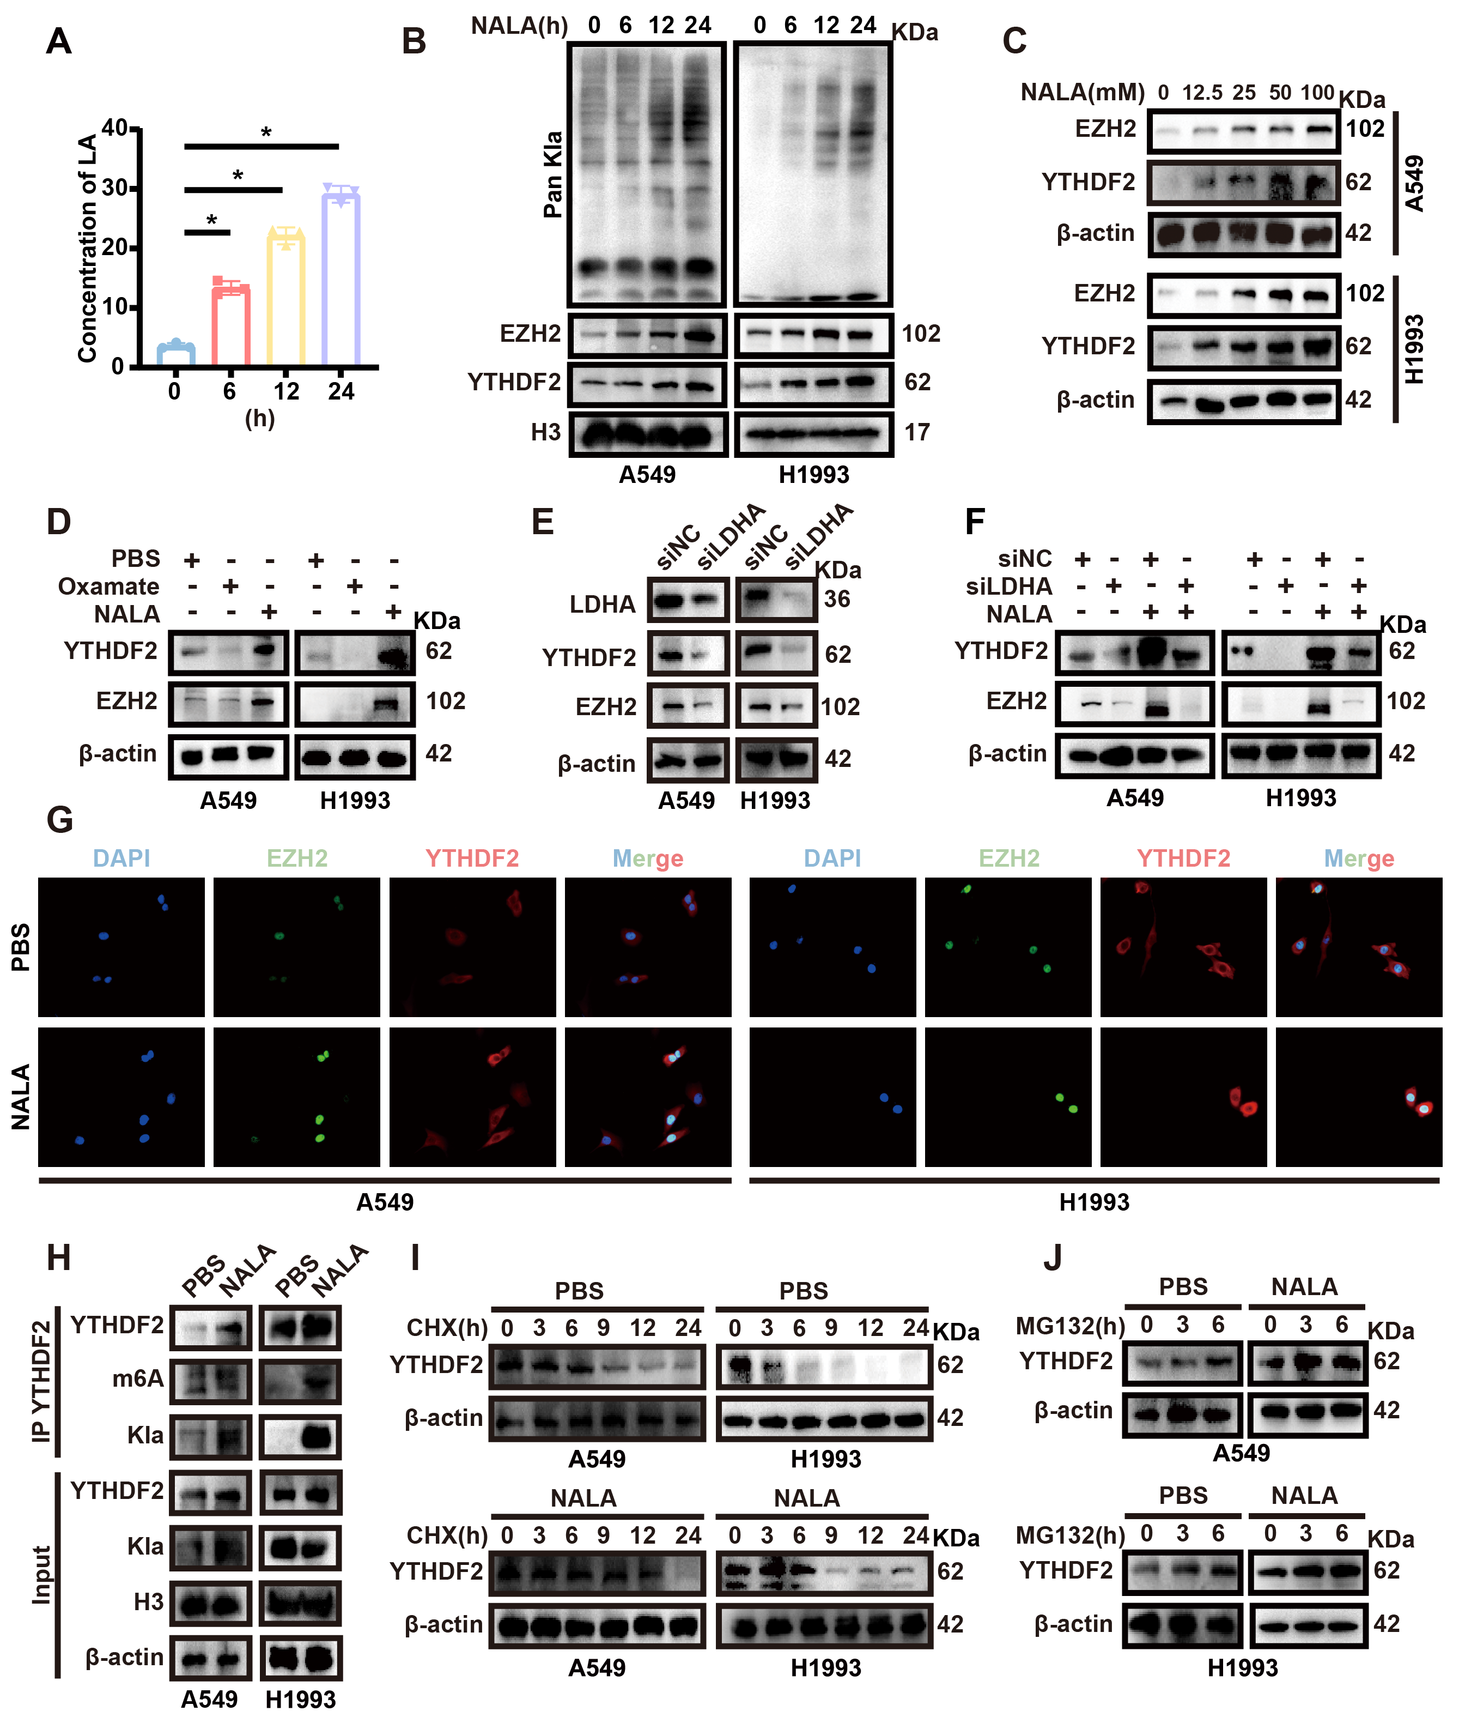
Figure S15. Lactate enhances YTHDF2 expression to promote m⁶A recognition. A. Lactate levels in Transwell co-culture systems were quantified by ELISA (n = 3). B. Protein expression levels of Pan Kla, YTHDF2, and EZH2 in A549 cells treated with NALA (25 mM) at 0, 6,12, and 24 hours were analyzed by Western blotting. C. Protein expression levels of YTHDF2 and EZH2 in A549 cells treated with NALA at 0, 12.5, 25, 50, and 100 mM were analyzed by Western blotting. D. Protein expression levels of YTHDF2 and EZH2 in A549 cells treated with or without Oxamate (10 mM) or NALA (25 mM) for 24 hours were analyzed by Western blotting. E. YTHDF2 protein levels in siLDHA LUAD cells were analyzed by Western blotting. F. Restoration of YTHDF2 expression in siLDHA cells treated with NALA (25 mM) were analyzed by Western blotting. G. The expression of YTHDF2 protein levels in siLDHA cells with or without NALA treatment was analyzed by IF. H. Co-IP assay in A549 and H1993 cells treated with or without NALA (25 mM) for 24 hours. I. Western blotting analysis of YTHDF2 in tumor cells treated with or without NALA (25 mM) followed by cycloheximide (CHX, 100μg/ml) for indicated durations. J. Western blotting analysis of YTHDF2 in tumor cells treated with or without NALA (25 mM) followed by MG132 (25 μM) for indicated durations. Data are presented as means ± SEMs. *P < 0.05, **P < 0.01, ***P < 0.001.
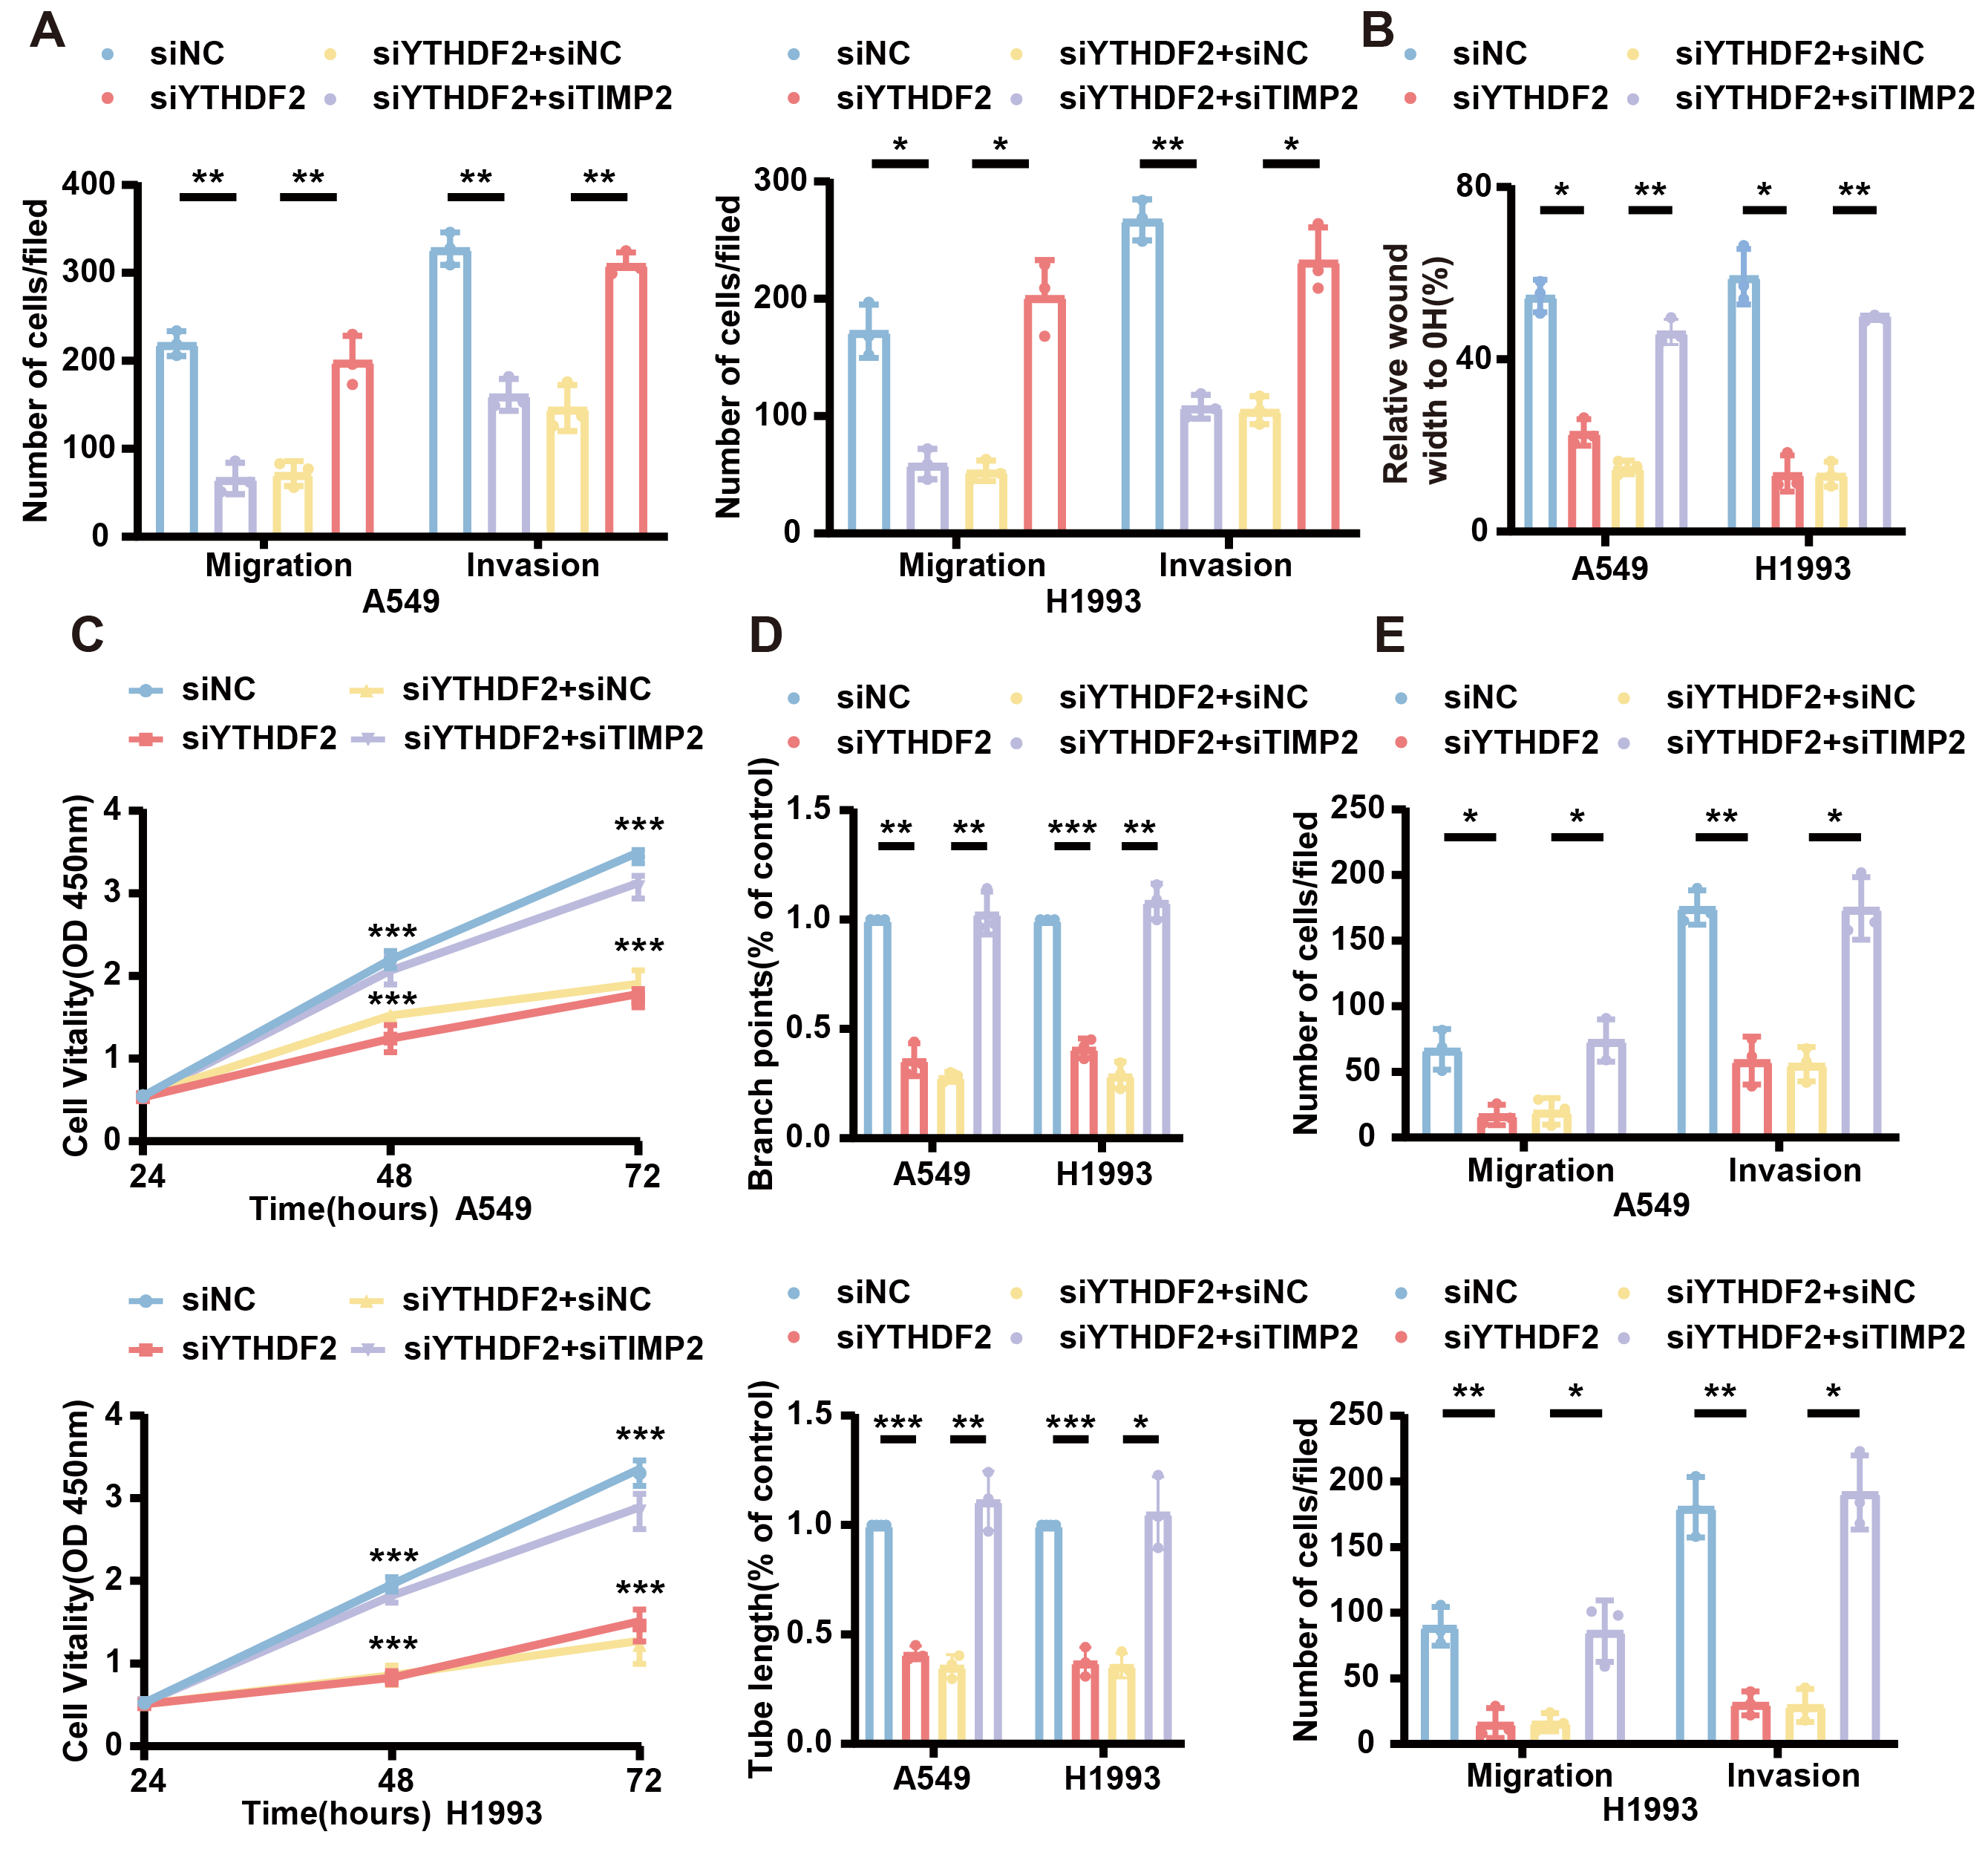
Figure S16. YTHDF2 nuclear translocation promotes LUAD metastasis. A-B. The metastatic ability of siYTHDF2+siTIMP2 double knock-down group was analyzed by Transwell experiment and wound healing experiment (n = 3). C-E. The proliferation (C), tube forming ability (D) and migration ability (E) of HUVEC in siYTHDF2+siTIMP2 double knock-down group were determined by endothelial function experiment. Data are presented as means ± SEMs. *P < 0.05, **P < 0.01, ***P < 0.001, Two-tailed t-tests.

