Supplementary Information

On the feasibility of a direct fluid exchange between the deep subsurface ocean and the shallow subsurface environment of Europa

Lujendra Ojha¹, Ankit Barik², Jacob Buffo³

¹Department of Earth and Planetary Sciences, Rutgers University, Piscataway, NJ, USA. ²Department of Earth and Planetary Sciences, Johns Hopkins University, Baltimore, MD, USA. ³Thayer School of Engineering, Dartmouth College, Hanover, NH, USA

Corresponding Author: (luju.ojha@rutgers.edu)

Text S1
Figure S1
Figure S2
Movie S1 Caption
Movie S2 Caption
Table S1

Text S1. Proposed formation mechanism for lenticulae and double-ridges on Europa
Lenticulae, distinguished by their generally low albedo, dark reddish hue, and quasi-elliptical shape, are ubiquitous on the surface of Europa^{1,2} (Figure. 1). The dark reddish hue of Lenticulae is often attributed to the radiolysis of endogenic surface materials³ as infrared spectra of these materials suggest the presence of hydrated sulfate or chloride salts^{4,5}. Lenticulae often superimpose other structures, suggesting they are among the youngest surface features on Europa⁶. Various forms of Lenticulae have been identified on Europa, including depressions known as pits; disrupted areas termed chaos terrains; uplifts called domes; or a combination of dome and chaos morphology^{2,7}.
Lenticulae have been interpreted to be surface manifestations of isostacy that occur due to water within the shell or localized shell thinning. Due to their similar shapes, sizes, morphology, and local clustering, all forms of lenticulae are postulated to share a common formation mechanism. The differences in their surface expressions (e.g., pits vs domes) are thought to represent various stages of their evolutionary development^{7,8}. Various geophysical processes have been proposed to explain their formation, including plumes and convection in the ocean⁹, plumes and convection in the ice shell¹⁰⁻¹², melt through^{7,13}, cryovolcanism¹⁴, and impacts^{8,15}. More recently, several works have proposed Lenticulae may result from sill emplacement and subsequent surface deformation due to the pressure differential arising from phase transitions¹⁶⁻²¹.
Another ubiquitous tectonic feature on the surface of Europa are double ridges, characterized by a central trough flanked by a ridge on each side^{22,23} (Figure. 1). The widths of the double ridges range from a few hundred meters to more than 4 km, and their lengths can extend up to around 1000 km. Double ridges stand out as Europa's most ubiquitous structural features and its most enduring, consistently emerging across the moon's geological history²³. They are the foundational elements of Europa's earliest ridged terrains but also appear in the most recently formed geological structures^{6,24}. This suggests that the forces driving their formation have been continuously active throughout the span of Europa's observed geological past. Like Lenticulae, the emplacement of sills in the shallow subsurface has been proposed as a potential formation mechanism of double-ridges on Europa¹⁹. Dombard et al. (2013) evaluated various formation mechanisms proposed for the formation of double ridges. They argue that only subsurface intrusion of a shallow cryomagmatic sill, approximately 1 to 2 kilometers beneath the ridge, could create a thermal anomaly capable of producing the observed flank fractures that typify double ridges.

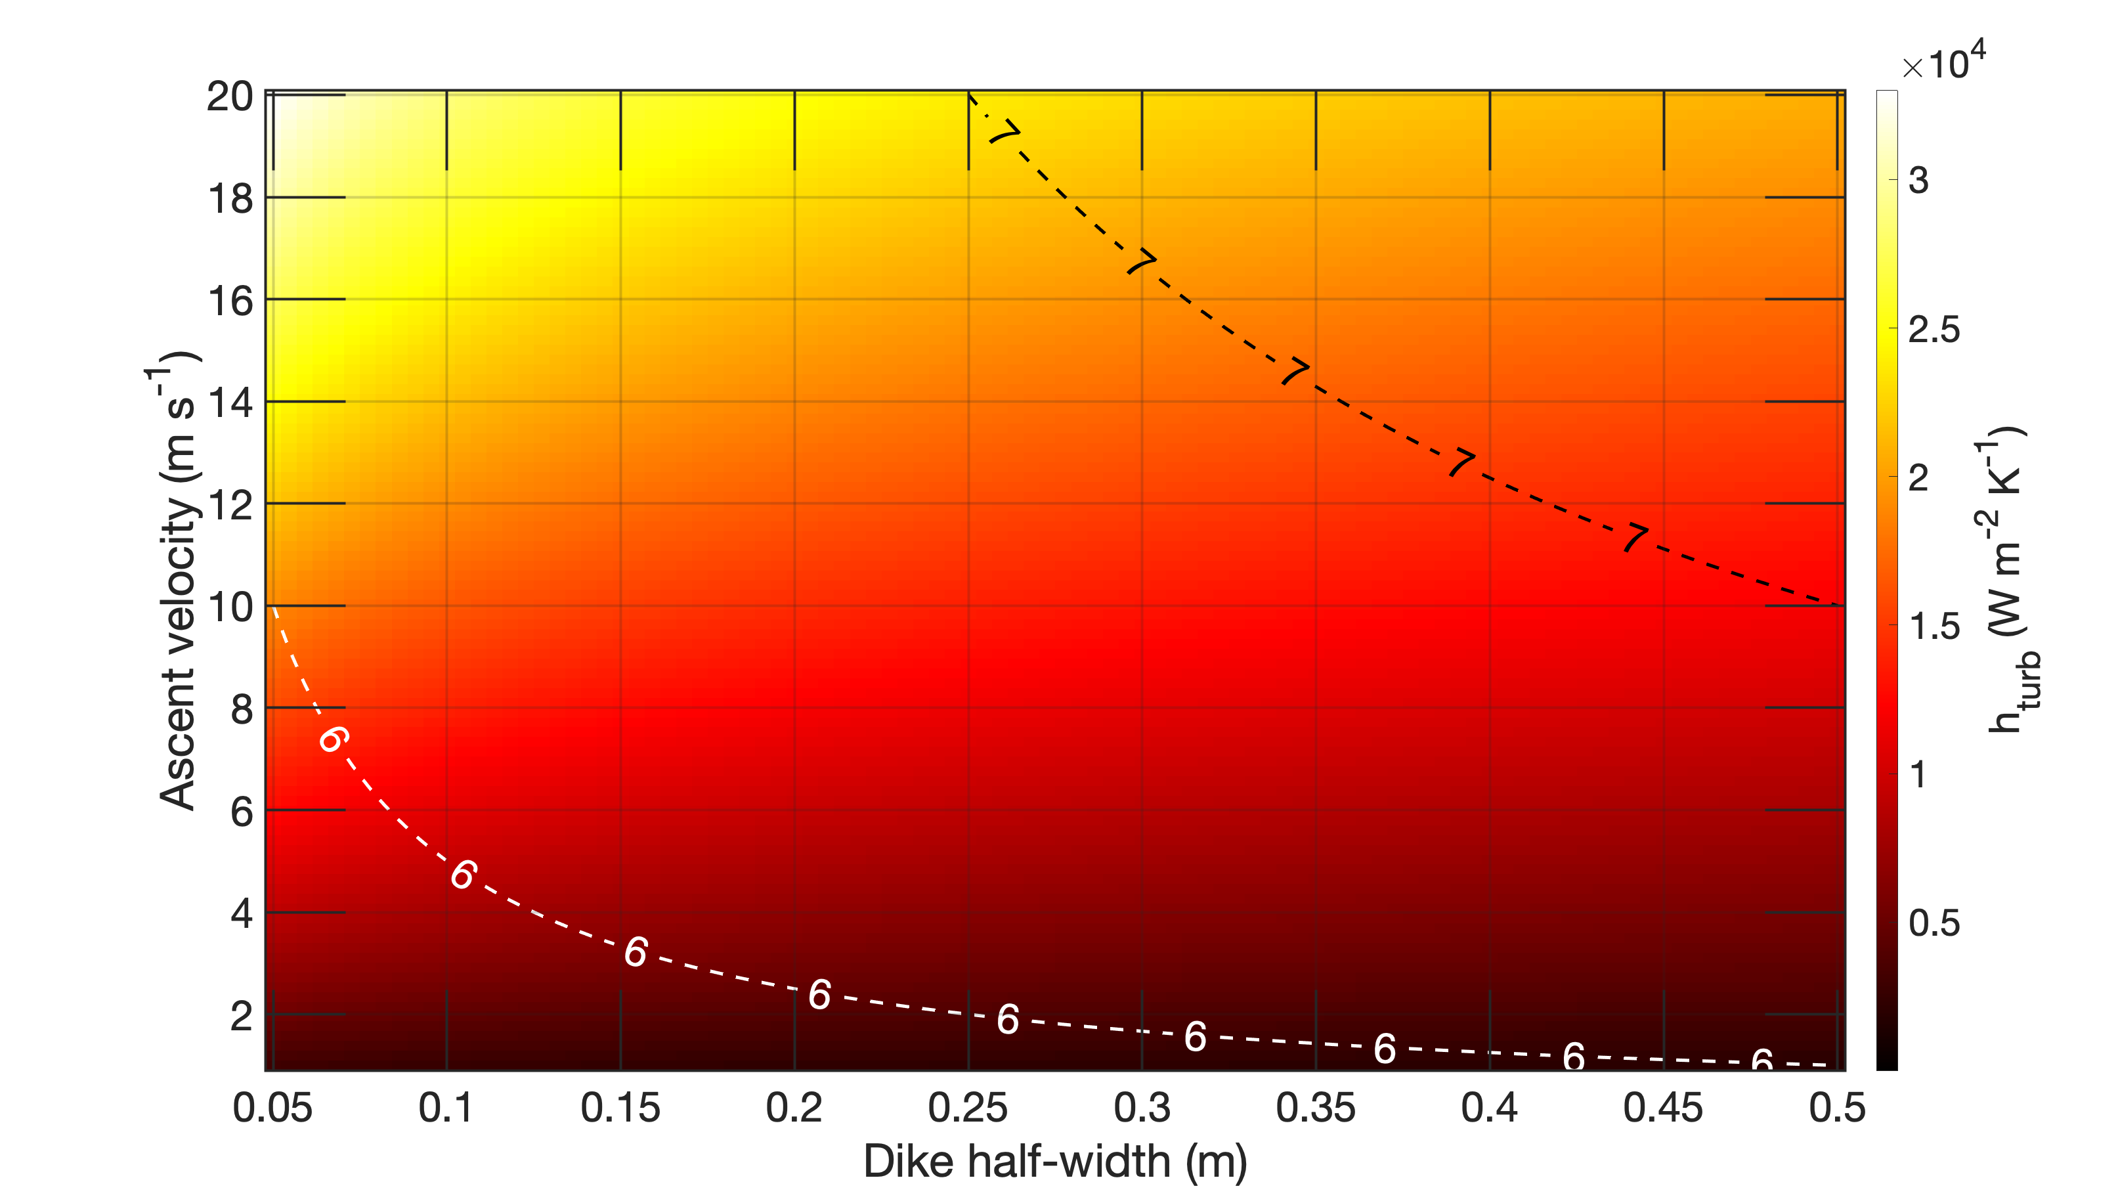
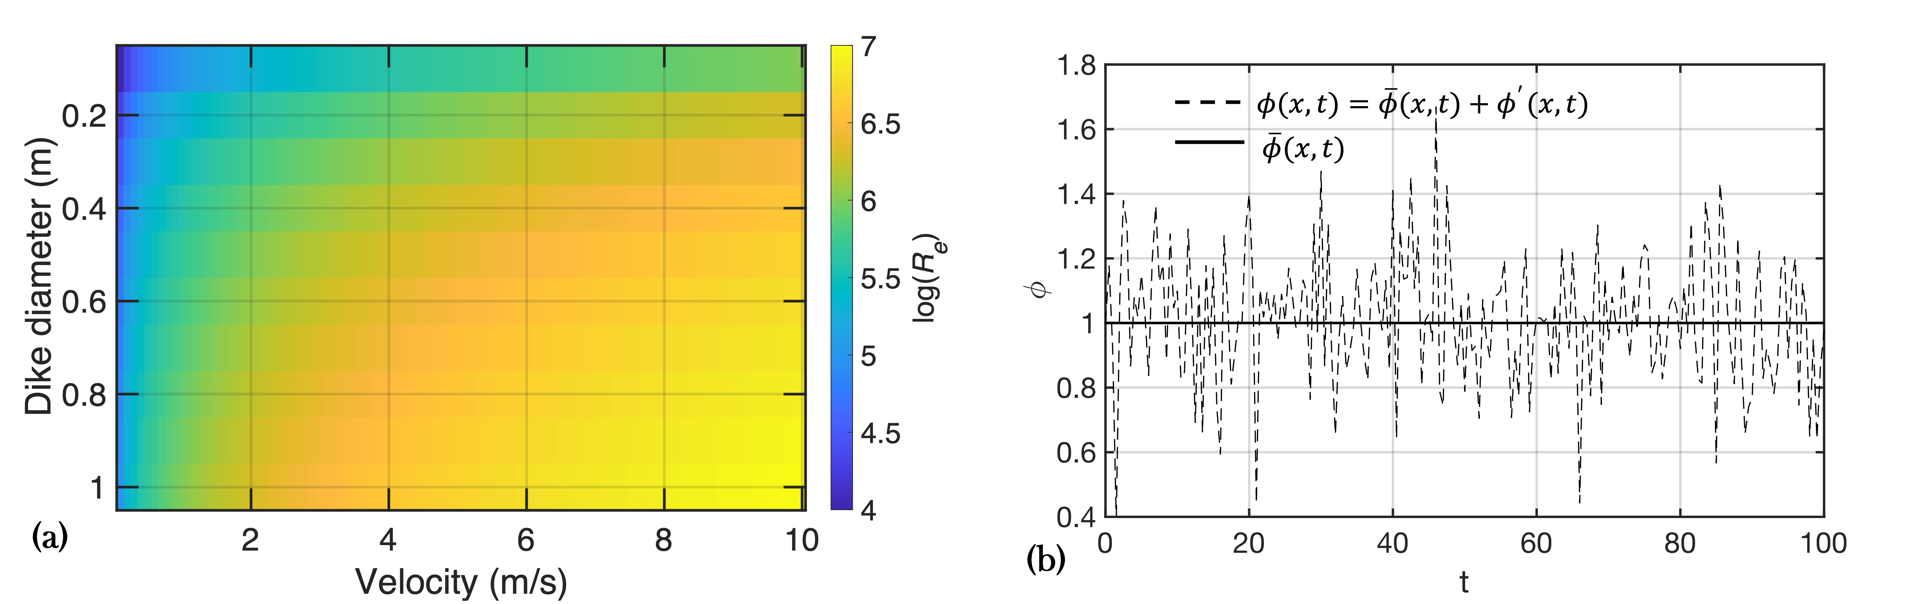
Figure S1. Reynolds number of liquid water ascending in a dike and RANS model schematic. (a) Reynolds number (in log₁₀) of liquid water upwelling in a dike as a function of dike width and ascending velocity. (b) An example illustrating fluctuation of some fluid property $ϕ$ with space and time in turbulent flow regime.

Figure S2. Heat map of the turbulent heat transfer coefficient (h) (in log₁₀) as a function of dike half-width and ascent velocity, computed using the Dittus–Boelter correlation for turbulent flow of water. Contour lines indicate the corresponding base-10 logarithm of the Reynolds number. For a given dike width, h_{turb} rises much more steeply with velocity because Nu ∝ Re⁰·⁸ and stronger turbulence enhances mixing.

Movie S1. Thermal evolution and narrowing of a 0.1 m-wide dike in ice at 200 K.
The simulation shows the time-dependent temperature field around a vertically ascending dike filled with liquid water initially at 273.20 K, flowing upward at 20 m·s⁻¹. Under laminar conditions (i.e., without convective mixing), heat loss to the surrounding ice causes progressive freezing at the dike margins. Over ~6 hours, the dike narrows to a final width of ~0.01 m, at which point water flux becomes negligible defining the dike closure timescale.
Table. S1 Parameters and their values used in our Multiphysics models.
Symbol | Units | Description | Value
Cp_{ice} | J kg⁻¹ K⁻¹ | Specific heat capacity of ice | 1600
Cp_{water} | J kg⁻¹ K⁻¹ | Specific heat capacity of water | 4200
k_{ice} | W m⁻¹ K⁻¹ | Thermal conductivity of ice | 567/T
k_{water} | W m⁻¹ K⁻¹ | Thermal conductivity of water | 0.6
ρ_{ice} | kg m⁻³ | Density of ice | 930
ρ_{water} | kg m⁻³ | Density of water | 1000
μ | Pa s | Dynamic viscosity of water | 10⁻³
ν | m² s⁻¹ | Kinematic viscosity | μ/ρ (calculated)
L_{f} | J kg⁻¹ | Latent heat of fusion | 334000
T_{m} | K | Liquidus (pure water) | 273.15
T_{m}, brine | K | Liquidus (brine) | 270
T_{ice} | K | Initial wall/ice temperature | 140–200 (laminar); 140, 200, 250 (turbulent)
T_{in} | K | Inlet liquid temperature | 273.20
T_{dike} | K | Initial cavity temperature | 273.20
h | W m⁻² K⁻¹ | Heat-transfer coefficient (generic) | Calculated
h_{turb} | W m⁻² K⁻¹ | Turbulent heat-transfer coefficient | Calculated from Dittus–Boelter (Eq. 14)
k_{T} | W m⁻¹ K⁻¹ | Turbulent thermal conductivity | Calculated
α_{T} | m² s⁻¹ | Turbulent thermal diffusivity | Calculated
k_{eff} | W m⁻¹ K⁻¹ | Effective thermal conductivity | Calculated
μ_{T} | Pa s | Turbulent (eddy) viscosity | Calculated
k | m² s⁻² | Turbulent kinetic energy | Calculated
ω | s⁻¹ | Specific dissipation rate of k | Calculated
Pr | - | Prandtl number (water) | 7
Pr_{T} | - | Turbulent Prandtl number | From Kays–Crawford (Eq. 11)
Pr_{T∞} | - | Asymptotic turbulent Prandtl | 0.85
v | m s⁻¹ | Inlet velocity | 5–20
Re | - | Reynolds number | Calculated
w | m | Dike full width | 0.1 or 1.0
L | m | Modeled vertical length | 10 m (laminar); 1000 m (turbulent)
T⁺ | - | Dimensionless temperature (wall function) | Eq. 13
y⁺ | - | Dimensionless wall distance | ≤ 1 (turbulence runs)
u* | m s⁻¹ | Friction (shear) velocity | Calculated
τ_{w} | Pa | Wall shear stress | Calculated
P_{out} | Pa | Outlet pressure | 0

References
1 Riley, J., Hoppa, G. V., Greenberg, R., Tufts, B. R. & Geissler, P. Distribution of chaotic terrain on Europa. Journal of Geophysical Research: Planets 105, 22599-22615 (2000).
2 Culha, C. & Manga, M. Geometry and spatial distribution of lenticulae on Europa. Icarus 271, 49-56 (2016).
3 Carlson, R., Anderson, M., Johnson, R., Schulman, M. & Yavrouian, A. Sulfuric acid production on Europa: The radiolysis of sulfur in water ice. Icarus 157, 456-463 (2002).
4 McCord, T. B. et al. Hydrated salt minerals on Europa's surface from the Galileo near‐infrared mapping spectrometer (NIMS) investigation. Journal of Geophysical Research: Planets 104, 11827-11851 (1999).
5 Trumbo, S. K., Brown, M. E. & Hand, K. P. Sodium chloride on the surface of Europa. Science advances 5, eaaw7123 (2019).
6 Doggett, T., Greeley, R. & Figueredo, P. (University of Arizona Press, 2009).
7 Greenberg, R. et al. Chaos on Europa. Icarus 141, 263-286 (1999).
8 Collins, G. & Nimmo, F. Chaotic terrain on Europa. Europa, 259-281 (2009).
9 Thomson, R. E. & Delaney, J. R. Evidence for a weakly stratified Europan ocean sustained by seafloor heat flux. Journal of Geophysical Research: Planets 106, 12355-12365 (2001).
10 McKinnon, W. B. Convective instability in Europa's floating ice shell. Geophysical Research Letters 26, 951-954 (1999).
11 Pappalardo, R. et al. Geological evidence for solid-state convection in Europa's ice shell. Nature 391, 365-368 (1998).
12 Rathbun, J. A., Musser Jr, G. S. & Squyres, S. W. Ice diapirs on Europa: Implications for liquid water. Geophysical research letters 25, 4157-4160 (1998).
13 Greenberg, R., Leake, M. A., Hoppa, G. V. & Tufts, B. Pits and uplifts on Europa. Icarus 161, 102-126 (2003).
14 Lesage, E., Massol, H. & Schmidt, F. Cryomagma ascent on Europa. Icarus 335, 113369 (2020).
15 Cox, R., Ong, L. C., Arakawa, M. & Scheider, K. C. Impact penetration of Europa's ice crust as a mechanism for formation of chaos terrain. Meteoritics & Planetary Science 43, 2027-2048 (2008).
16 Michaut, C. & Manga, M. Domes, pits, and small chaos on Europa produced by water sills. Journal of Geophysical Research: Planets 119, 550-573 (2014).
17 Manga, M. & Michaut, C. Formation of lenticulae on Europa by saucer-shaped sills. Icarus 286, 261-269 (2017).
18 Craft, K. L., Patterson, G. W., Lowell, R. P. & Germanovich, L. Fracturing and flow: Investigations on the formation of shallow water sills on Europa. Icarus 274, 297-313 (2016).
19 Dombard, A. J., Patterson, G. W., Lederer, A. P. & Prockter, L. M. Flanking fractures and the formation of double ridges on Europa. Icarus 223, 74-81 (2013).
20 Chivers, C., Buffo, J. & Schmidt, B. Thermal and chemical evolution of small, shallow water bodies in Europa's ice shell. Journal of Geophysical Research: Planets 126, e2020JE006692 (2021).
21 Fagents, S. A. Considerations for effusive cryovolcanism on Europa: The post‐Galileo perspective. Journal of Geophysical Research: Planets 108 (2003).
22 Prockter, L. M. & Patterson, G. W. Morphology and evolution of Europa’s ridges and bands. Europa, 237-258 (2009).
23 Kattenhorn, S. A. & Hurford, T. Tectonics of Europa. Europa, 199-236 (2009).
24 Figueredo, P. H. & Greeley, R. Resurfacing history of Europa from pole-to-pole geological mapping. Icarus 167, 287-312 (2004).

