The pH Gradient and persistence in Mycobacterium tuberculosis
Hassan E. Eldesouky¹, Kristin N. Adams¹, Justin K. Brache¹, Laarni Kendra T. Aguila¹, Mariana Garcia¹, Enming Xing^{2,} Pui-Kai Li², and David R. Sherman^{1*}

¹ Department of Microbiology, University of Washington, Seattle, WA 98109, United States
² Division of Medicinal Chemistry and Pharmacognosy, College of Pharmacy, The Ohio State University, Columbus, OH 43210, United States

*Correspondence: dsherman@uw.edu; Tel: +1(206)543-8152

Supplementary Table 1: Minimum inhibitory concentrations of different inhibitors against Mtb H37Rv strain.
MIC (μM)
Isoniazid (INH) | 0.25
Rifampicin (RIF) | 0.005
Ethambutol (EMB) | 0.25
Pyrazinamide (PZA) | > 1000
Amikacin (AMK) | 1
Linezolid (LZD) | 3
Moxifloxacin (MOX) | 0.15
Pretomanid (Pa) | 0.2
Bedaquiline (BDQ) | 0.5
Telacebec (Q203) | 0.004
Niclosamide (NCA) | 4
Carbonyl cyanide 3 chlorophenylhydrazone  (CCCP) | 8
Nigericin (NIG) | 8
Valinomycin (VAL) | 1

Supplementary Figure 1. Effect of niclosamide (NCA) on rifampicin (RIF)-mediated intracellular killing of Mtb. THP-1 cells were infected with M. tuberculosis H37Rv at a multiplicity of infection (MOI) of 1:1. Infected cells were then treated with RIF (1 μg/ml), NCA (0.25× MIC), or the combination of RIF and NCA. Data represent the mean percent survival of intracellular Mtb at day 4 post-infection ± standard deviation. Asterisks denote statistical significance; p-values were determined using a two-tailed Welch’s t-test (n=4).

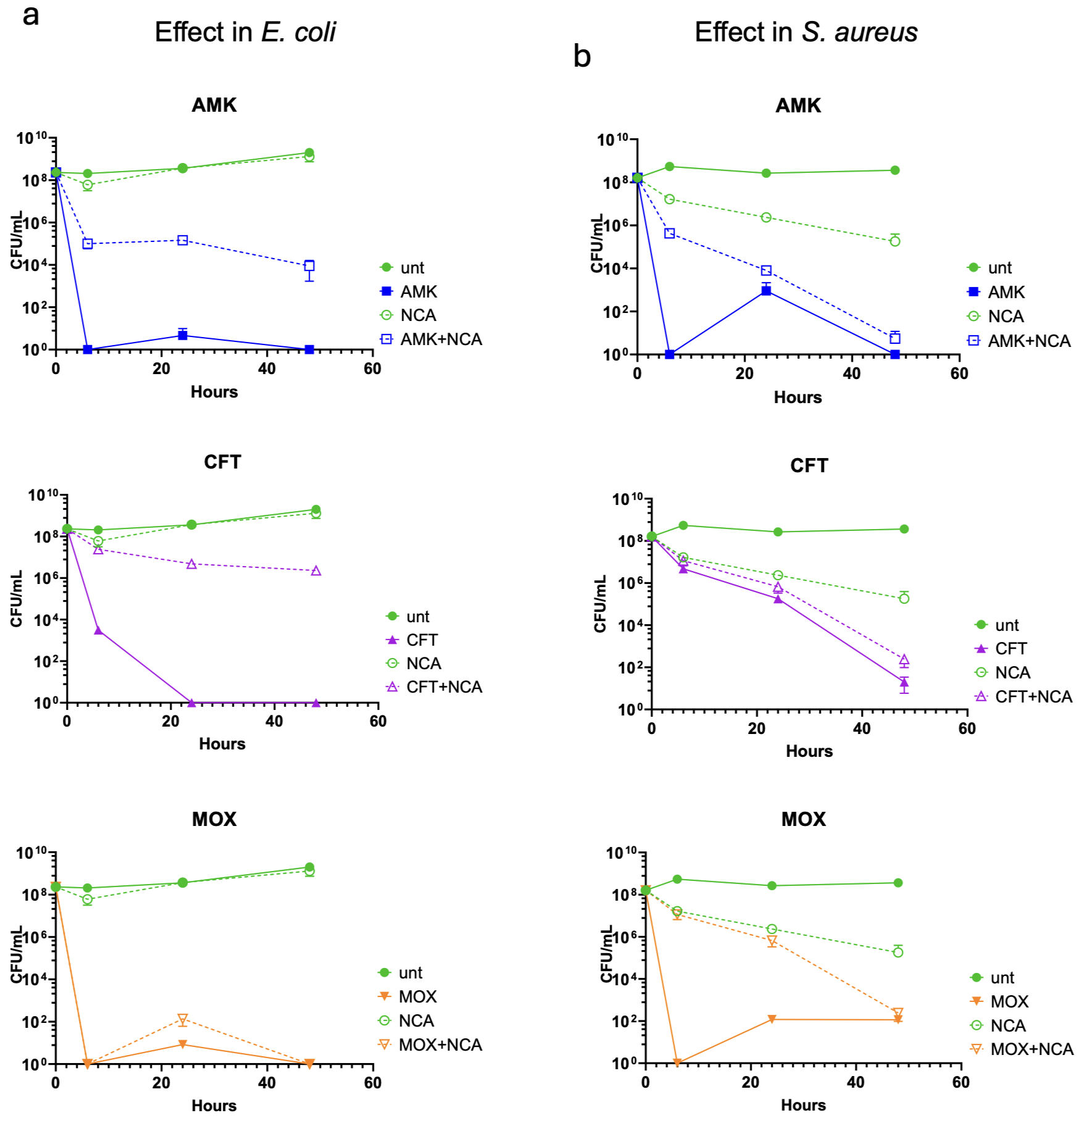

Supplementary Figure 2. Effect of NCA on antibiotic-mediated killing in other bacterial species. (a) E. coli and (b) S. aureus were exposed to NCA (10 µg/ml or 0.25 µg/ml, respectively) or left untreated, alongside 100× MIC of amikacin (AMK), ceftazidime (CFT), or moxifloxacin (MOX).

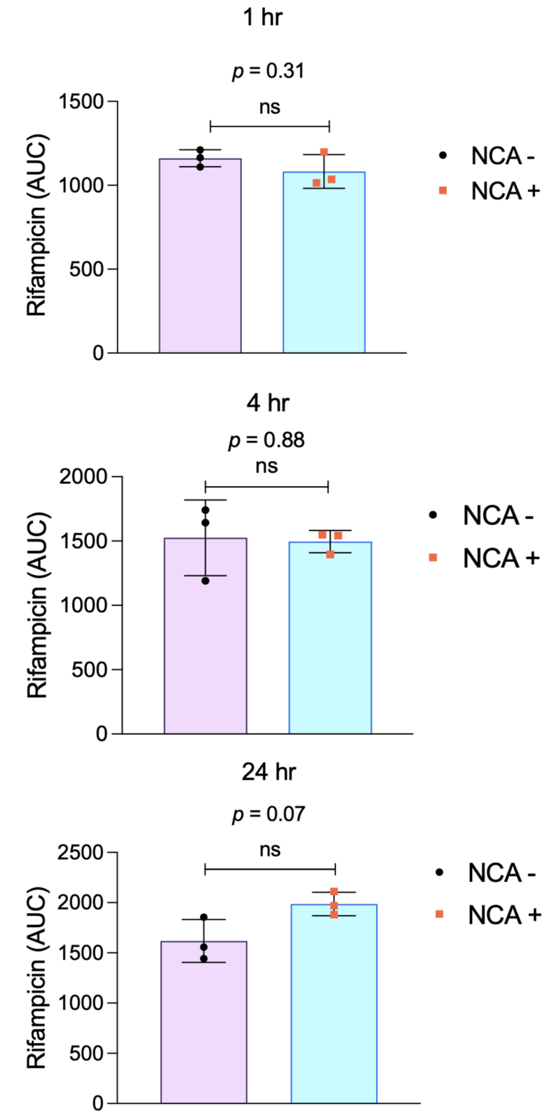
Supplementary Figure 3. Effect of niclosamide (NCA) on intracellular rifampicin (RIF) concentrations in M. tuberculosis H37Rv. Cells were treated with RIF (1 μg/ml) with or without NCA (2× MIC) for 1, 4, and 24 hours. Following treatment, cells were pelleted, washed twice with PBS, lysed by bead beating, and filter sterilized. Intracellular RIF levels were quantified by mass spectrometry. Asterisks indicate statistical significance; p-values were determined using a two-tailed Welch’s t-test (n=3).

Supplementary Table 2: Log2 fold changes of commonly regulated DEGs that were significantly altered (p < 0.02) by at least 2-fold in response to the tolerance-promoting inhibitors (NCA, CCCP, and NIG). Corresponding values from the VAL group are included for comparison, along with the average Log2 FC difference.
GENE_ID | Log2FC |  |  |  | Average Log2 FC difference relative to VAL
GENE_ID | NCA | CCCP | NIG | VAL | Average Log2 FC difference relative to VAL
Rv3290c | 3.91 | 2.58 | 3.28 | 0.72 | 2.53
Rv3289c | 3.64 | 2.33 | 3.08 | 0.54 | 2.48
Rv1057 | 2.80 | 1.05 | 1.52 | -0.87 | 2.66
MT2165.1 | 2.43 | 1.28 | 2.97 | -0.91 | 3.14
Rv2428 | 2.31 | 1.30 | 2.42 | 0.69 | 1.32
Rv2107 | 2.27 | 1.16 | 3.29 | -0.08 | 2.32
Rv2429 | 2.21 | 1.26 | 1.99 | 1.60 | 0.22
Rv0211 | 1.74 | 1.21 | 1.26 | 0.83 | 0.57
Rv1286 | 1.58 | 1.22 | 1.48 | 0.85 | 0.58
Rv1285 | 1.38 | 1.04 | 1.57 | 1.58 | -0.25
Rv0059 | -1.49 | -1.00 | -1.17 | 0.36 | -1.58
Rv0241c | -1.77 | -1.08 | -1.73 | 0.81 | -2.34
Rv0242c | -1.83 | -1.05 | -1.84 | 0.98 | -2.55
Rv0057 | -1.95 | -1.15 | -1.17 | 2.91 | -4.33
Rv2988c | -2.15 | -1.43 | -1.02 | 1.27 | -2.80
Rv2987c | -2.46 | -1.10 | -1.01 | 2.15 | -3.68

Supplementary Table 3. PAM sequences, sgRNA sequences, and forward/reverse primer sequences for CRISPRi knockdown of selected genes.

Gene ID | pam Sequence | SgRNA target sequence | Forward primer | Reverse primer
Rv3290c | CGAGAAC | ATCAGCCCGCGGC  CGCGCGGAT | GGGAATCAGCCCGC  GGCCGCGCGGAT | AAACATCCGCGCGGC  CGCGGGCTGAT
Rv3289c | GCAGAAA | GCACGCCATACCC  GGTAGGTGC | GGGAGCACGCCATA  CCCGGTAGGTGC | AAACACGCGAAGTCG  AGGCCAC
Rv1057 | TGGGAAA | ATTGCGTGGTG  GTGCCCGGCGCC | GGGAATTGCGTGG  TGGTGCCCGGCGCC | AAACGGCGCCGGG  CACCACCACGCAAT
Rv2428 | CTGGAAA | GGTCGTTGTGCTG  TGCACGCCA | GGGAGGTCGTTGTG  CTGTGCACGCCA | AAACGATCACACACG  CCCCAAAGTT
Rv2107 | AAAGAAC | GGTACTGCTGCCC  GTGGCTACT | GGGAGGTACTGCTG  CCCGTGGCTACT | AAACCGAACTATTCG  GCCGGCGTTTGC
Rv0059 | GTAGAAC | GCATGGGCGACC  GCGCCGCAAT | GGGAGCATGGGCG  ACCGCGCCGCAAT | AAACATTGCGGCGCG  GTCGCCCATGC
Rv0241c | ATGGAAA | GCCGGTCACCAAC  GACATCACCG | GGGAGCCGGTCACC  AACGACATCACCG | AAACCGGTGATGTCGT  TGGTGACCGGC
Rv0242c | CAGGAAT | ACGTAGGCCGACT  TGGCCGACAG | GGGAACGTAGGCC  GACTTGGCCGACAG | AAACCTGTCGGCCA  AGTCGGCCTACGT
Rv0057 | CAAGAAT | AACGCGACGCCG  TTTGTGTGGA | GGGAAACGCGACGCCG  TTTGTGTGGA | AAACTCCACACAAA  CGGCGTCGCGTT
Rv2988c | CAAGAAC | GTGGGTGCGTGCG  GACGACCACG | GGGAGTGGGTGCGTG  CGGACGACCACG | AAACCGTGGTCGTCC  GCACGCACCCAC
Rv2987c | TCAGAAA | AAACCGGTTCGGGT  GACCCGCT | GGGAAAACCGGTTCG  GGTGACCCGCT | AAACAGCGGGTCACCCGA  ACCGGTTT

