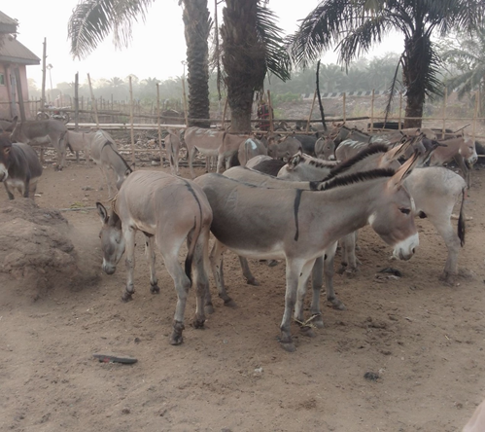

Additional figure 1: A cross section of donkeys in lairage in one of the donkey market in Ebonyi state

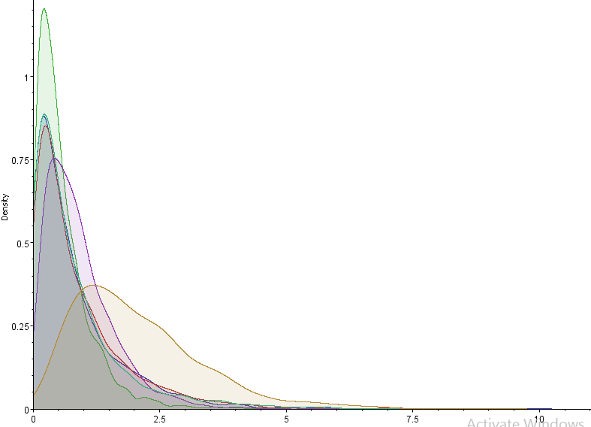
Additional Figure 2: Host type contribution to EI H3N8 spread. Distributions of posterior dispersal rate for each host (Green = Equus caballus (Ec); Red = Equus ferus caballus (Efc); Purple = Equus africanus asinus; Blue =Equus ferus przewalskii; Yellow = others generated via by the joint host analyses of the two clades.

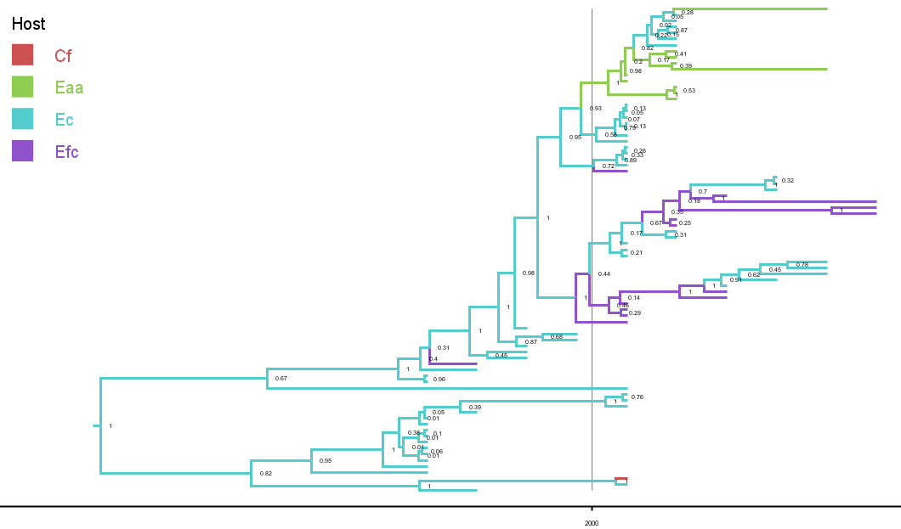
Additional Figure 3: Host rate maximum clade credibility (MCC) tree. The colour code of the branches represents the host rate transmission. Vertical continous line separates viruses of the earlier and recent epizootics.

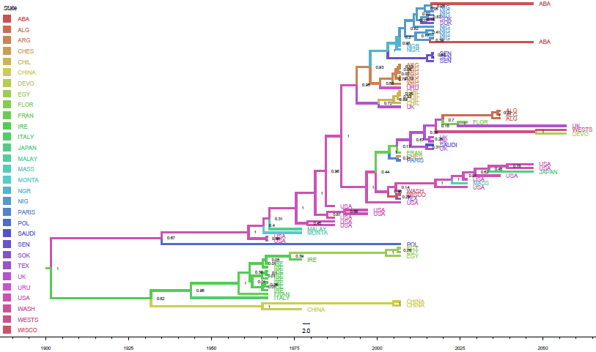
Additional Figure 4: Posterior maximum credibility clade (MCC) phylogeography tree of the EI H3N8 Fc-1 and Fc-2 reported in Africa between 2018-2023. The branch colours signify the most probable geographical regions of the progeny nodes
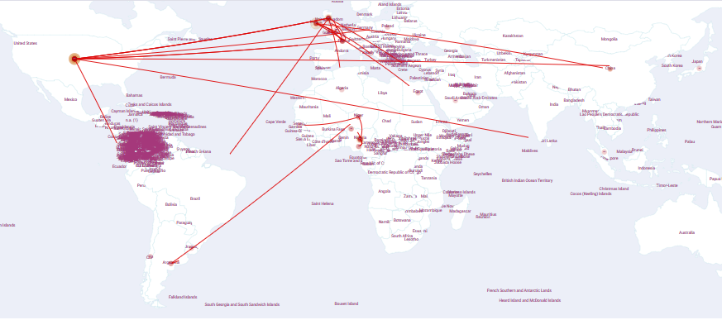
Additional Figure 5: Spatiotemporal spread of EI H3N8 Fc-1 and Fc-2 reported in Africa between 2018-2023 inferred using discrete phylogeography. Lines between locations represent branches in the MCC tree along which spatial spread occurs.
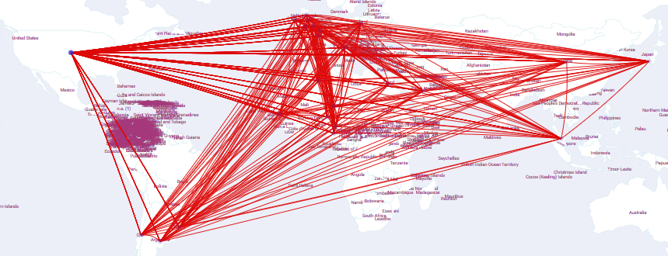
Additional Figure 6: Spread route of the EI H3N8 virus between Africa and other countries of the globe. The BSSVS were used to fit phylodynamic models to the HA gene and inferred geographic regions using Bayes factors. Maps showing statistically supported non-zero rates BF > 5 were plotted.
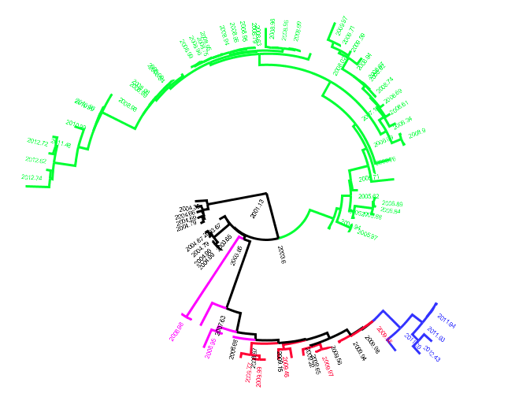
Additional Figure 7: Estimate of the rate and date of the most recent common ancestor of EI H3N8 that was reported in Africa between 2018-2023. Branches of the phylogeny were colored based on the rate and date of transmission. Blue colour represents Algeria/Abakaliki Nigeria 2021/2021 epizootic, red represents Senegal/Nigeria 2019, Purple represents Niger/Egypt 2018.

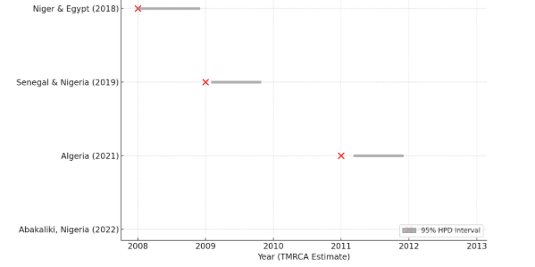
Additional Figure 8: The time to the most recent common ancestor (TMRCA) of the EI H3N8 that entered the African continent from 2018-2023. The red points indicate the estimated TMRCA for each introduction event, while the gray bars represent the 95% HPD intervals.
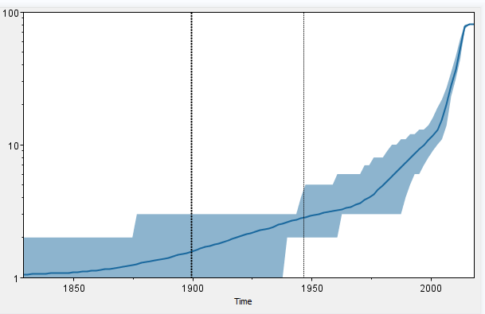
Additional Figure 9: Temporal variation in lineages through time in the EI H3N8 in Africa between 2018-2013.The dotted vertical lines represent the 95% HPD for the date of the root of the tree.

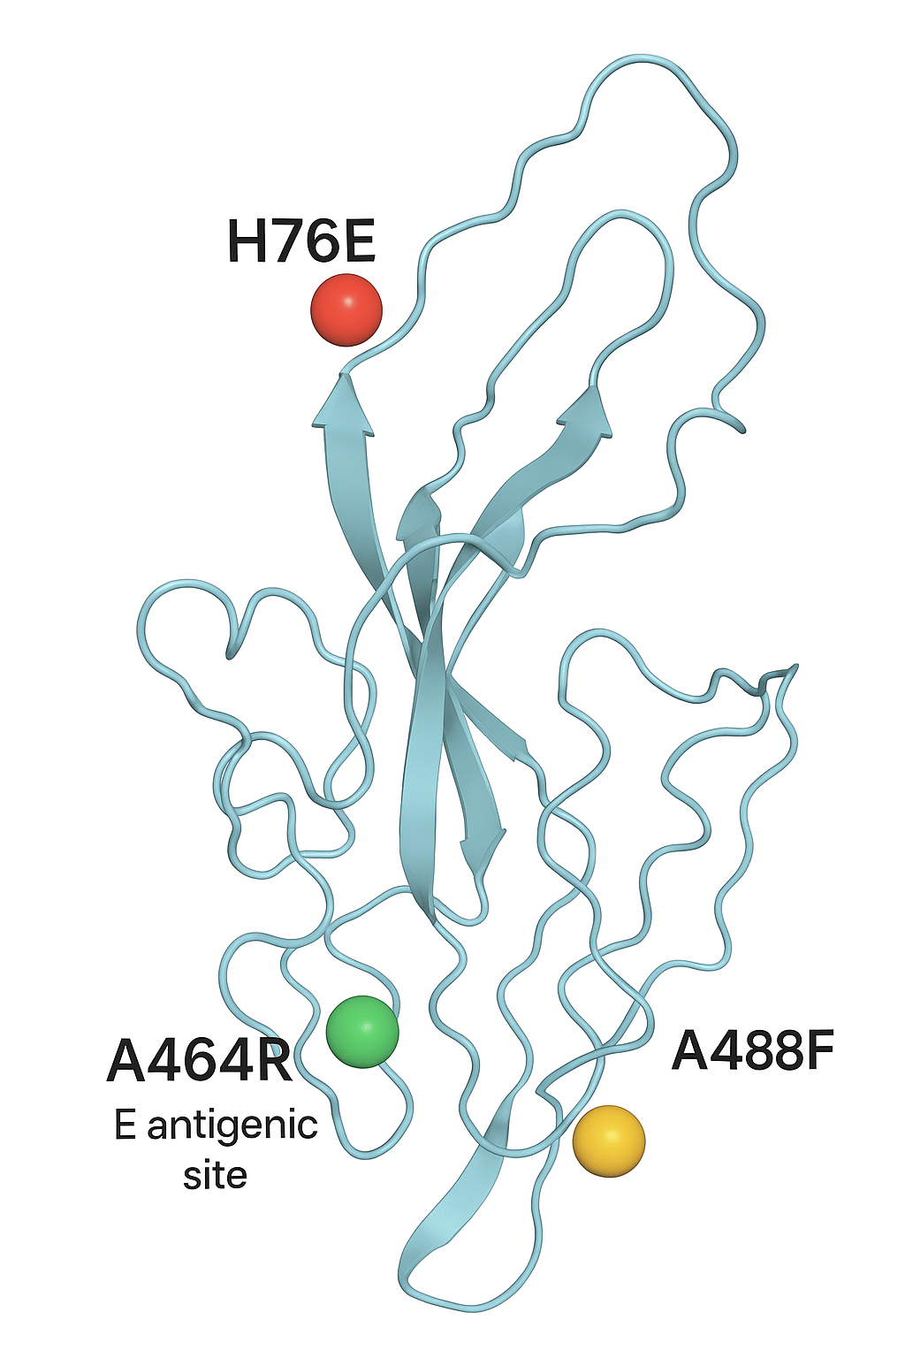
Additional Figure 10: monomeric structure mutation mapping diagram between sequences in the current study A/equine/Ebonyi/Nigeria/249/2022, A/equine/Ebonyi/Nigeria/250/2022 and WAOH EI H3N8 Fc-1 vaccine strains examined using PyMOL showing exactly where H76E, A464R, and A488F occur on the HA protein, with color-coding for their functional implications.

