SUPPLEMENTARY INFORMATION

[3-¹¹C]Pyruvate PET detects alterations in cardiac pyruvate metabolism induced by doxorubicin chemotherapy
Chul-Hee Lee^{1,2}, Thomas Ruan^{2,3}, Shuvra Debnath^{1,2}, Anja S. Wacker^{1,2}, Grace Figlioli³, John W. Babich,^{1,2,4,5,#} Sadek Nehmeh², Kayvan R. Keshari^{2,3}, James M. Kelly^{1,2,4,5*}
1 Molecular Imaging Innovations Institute (MI3), Weill Cornell Medicine, New York, NY 10021, USA
2 Department of Radiology, Weill Cornell Medicine, New York, NY 10021, USA
3 Department of Radiology and Molecular Pharmacology Program, Memorial Sloan Kettering Cancer Center, New York, NY 10065, USA
4 Citigroup Biomedical Imaging Center, Weill Cornell Medicine, New York, NY 10021, USA
5 Sandra and Edward Meyer Cancer Center, Weill Cornell Medicine, New York, NY 10021, USA
# Current address: Ratio Therapeutics, Boston, MA

Supplemental Figures
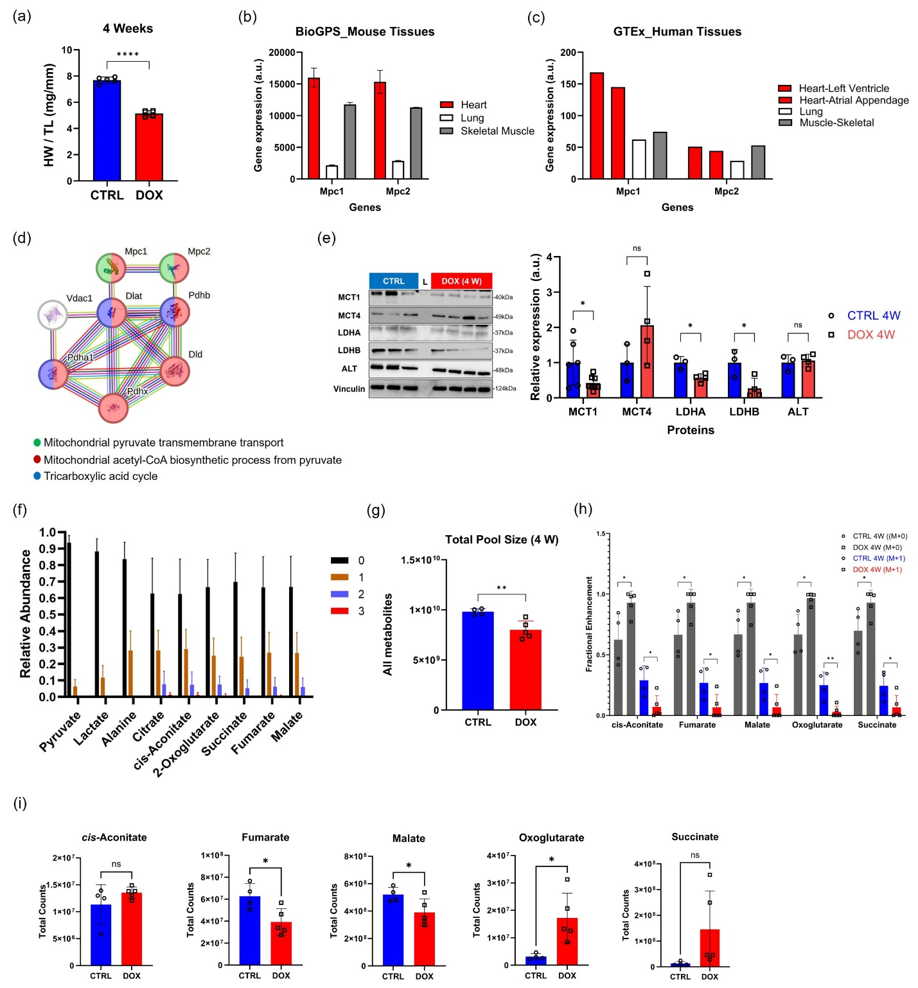
Supplemental Figure 1. DOX exposure reduces pyruvate metabolism in the mouse heart at 4 weeks. (a) HW/TL ratio at 4 weeks after DOX exposure. (b) Gene expression profiles of Mpc1 and Mpc2 in relevant mouse tissues were obtained from the BioGPS database. (c) Mpc1 and Mpc2 transcript levels in human tissues were obtained from the Genotype-Tissue Expression project (GTEx). Supplemental Table 3 displayed the numbers in detail. (d) STRING database from eight genes, including Mpc1/2 and their associated GO:BP = Acetyl-CoA biosynthetic process from pyruvate. (e) Western blot analysis of cardiac MCT1, MCT4, LDHA, LDHB, and ALT expression in the 4-week group. Vinculin was used as a reference. ROI quantification of each protein level was performed using ImageJ. (f) Incorporation of multiple isotopic labels into TCA cycle intermediates by ¹³C in healthy mouse hearts. (g) Comparison of the total metabolite pool size in the mice exposed to DOX with CTRL. (h) M+0 and M+1 fractional enrichments of other TCA cycle intermediates, including aconitate, fumarate, malate, oxoglutarate, and succinate. (i) Total pool size of cis-aconitate, fumarate, malate, oxoglutarate, and succinate in cardiac tissue collected at 4 W. Data are presented as the mean ± s.d. * p < 0.05; ** p < 0.01. Statistical analysis was performed using an unpaired t-test (a, g), multiple unpaired t-tests (e), or two-way ANOVA (h). HW/TL = heart weight-to-tibia length; MPC = mitochondrial pyruvate carrier; DOX = doxorubicin; CTRL = control; GO:BP = gene ontology:biological process; STRING = Search Tool for the Retrieval of Interacting Genes/Proteins; MCT = monocarboxylate transporter; LDH = lactate dehydrogenase; ALT = alanine aminotransferase. TCA = tricarboxylic acid;
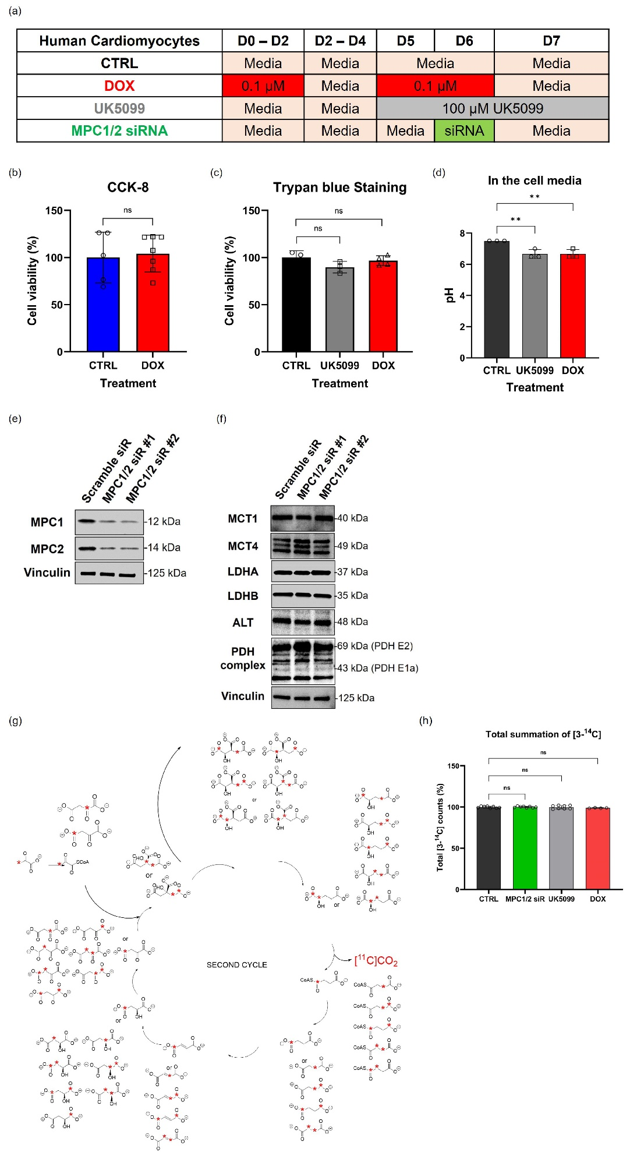
Supplemental Figure 2. DOX exposure impairs pyruvate uptake by downregulating MPC1/2 in HCM. (a) In vitro study design: HCMs were plated and assigned to control groups (vehicle or scramble siRNA) or experimental groups (DOX, UK5099, and MPC1/2 siRNA). Group conditions were optimized based on established protocol methods. (b) Cell viability according to DOX treatment was determined by the CCK-8 assay that detects the metabolic activity of cells. (c) Cell viability according to DOX or UK5099 treatment was determined by Trypan blue staining that detects the permeability of cell membranes from each of the cells. (d) The supernatant (cell media) from each group of cells treated according to the methods in Supplemental Fig. 2a was collected, and its pH was measured using pH-Test indicator strips to confirm lactate production. (e) Western blot analysis of MPC1/2 expression in HCMs treated with siRNA. #1 and #2 mean the different lipofectamine conditions. Vinculin was used as a reference. (f) Western blot analysis of MCT1, MCT4, LDHA, LDHB, ALT, and PDH complex expression in HCMs treated with siRNA. Vinculin was used as a reference. (g) Incorporation of ¹³C label into selected metabolites extracted from the hearts of healthy C57BL/6J mice administered [3-¹³C]pyruvate. Hearts were excised 10 min p.i. Colored bars represent the number of ¹³C labels per molecule and error bars represent standard deviations. (h) The total ¹⁴C counts of each group of cells, representing the sum of the [¹⁴C]CO2 captured, the cell-associated activity, and the remaining activity in the media. Data are presented as the mean ± s.d. * p < 0.05; ** p < 0.01. Statistical analysis was performed using unpaired t-tests (b) or one-way ANOVA (c, d, and h). HCM = human cardiomyocytes; PDH = pyruvate dehydrogenase.

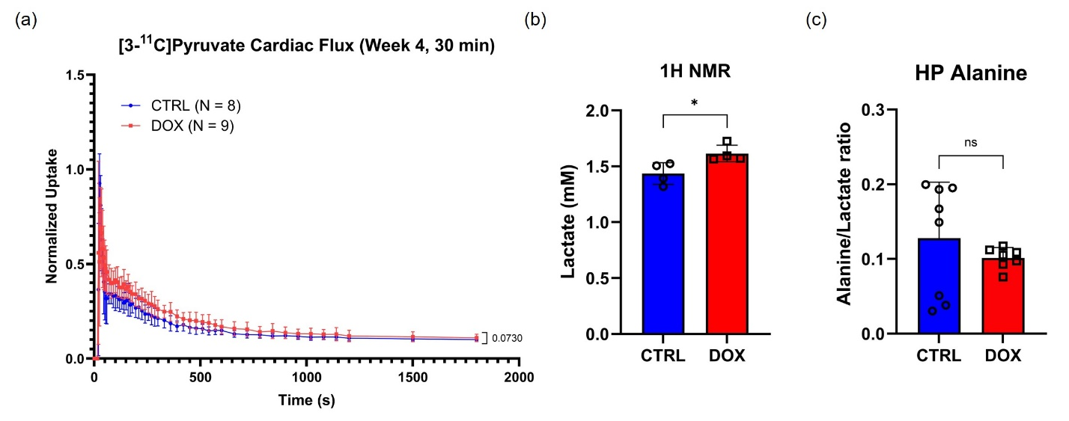
Supplemental Figure 3. [3-¹¹C]Pyruvate PET detects DOX-induced changes in cardiac pyruvate flux at 4 weeks. (a) Dynamic PET images during 30 minutes upon intravenous administration of [3-¹¹C]pyruvate. (b) Lactate pool in cardiac tissues from mice in the DOX group compared to the control group. ¹H NMR spectra of metabolite extract samples were acquired in a 14.1T spectrometer. Spectra were processed, and metabolite peaks were quantified with NMR software. (c) The alanine/lactate ratio from [1-¹³C] pyruvate MRI. Different colors within each group represent 3–4 independent measurements per mouse. Data are presented as the mean ± s.d. * p < 0.05. Statistical analysis was performed using unpaired t-tests (a-c). NMR = Nuclear Magnetic Resonance; HP = Hyperpolarized.

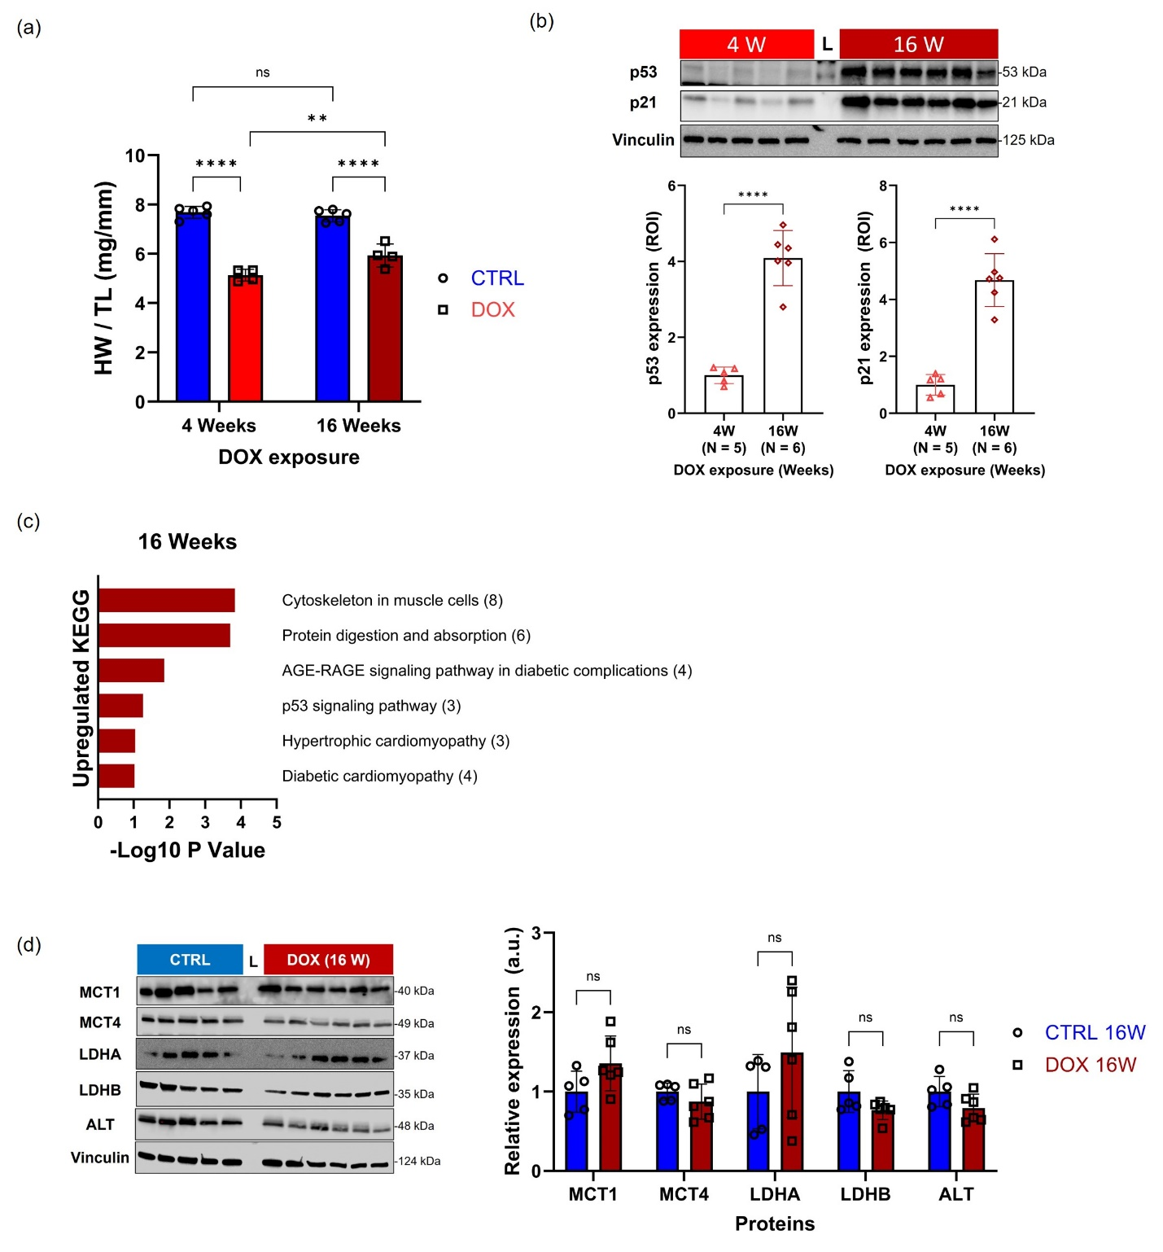
Supplemental Figure 4. Recovery of MPC1/2 expression is associated with accelerated cardiac growth. (a) HW/TL ratio in 4 and 16 weeks after DOX exposure. This graph was reorganized using the Supplementary Fig. 1a and Fig. 4a. (b) Western blot analysis of cardiac p53 and p21 expression in the 16-week group. Vinculin was used as a reference. ROI quantification of each protein level was performed using ImageJ. (c) Significantly upregulated selected-KEGG pathways at 16 weeks after DOX exposure. Parentheses of (c) indicate the number of identified genes of each KEGG pathway. (d) Western blot analysis of cardiac MCT1, MCT4, LDHA, LDHB, and ALT expression in the 16-week group. Vinculin was used as a reference. ROI quantification of each protein level was performed using ImageJ. Data are presented as the mean ± s.d. ** p < 0.01 and **** p < 0.0001. Statistical analysis was performed using two-way ANOVA (a), unpaired t-test (b), or multiple unpaired t-tests (d). HW/TL = heart weight-to-tibia length; KEGG = Kyoto Encyclopedia of Genes and Genomes; MCT = monocarboxylate transporter; LDH = lactate dehydrogenase; ALT = alanine aminotransferase.

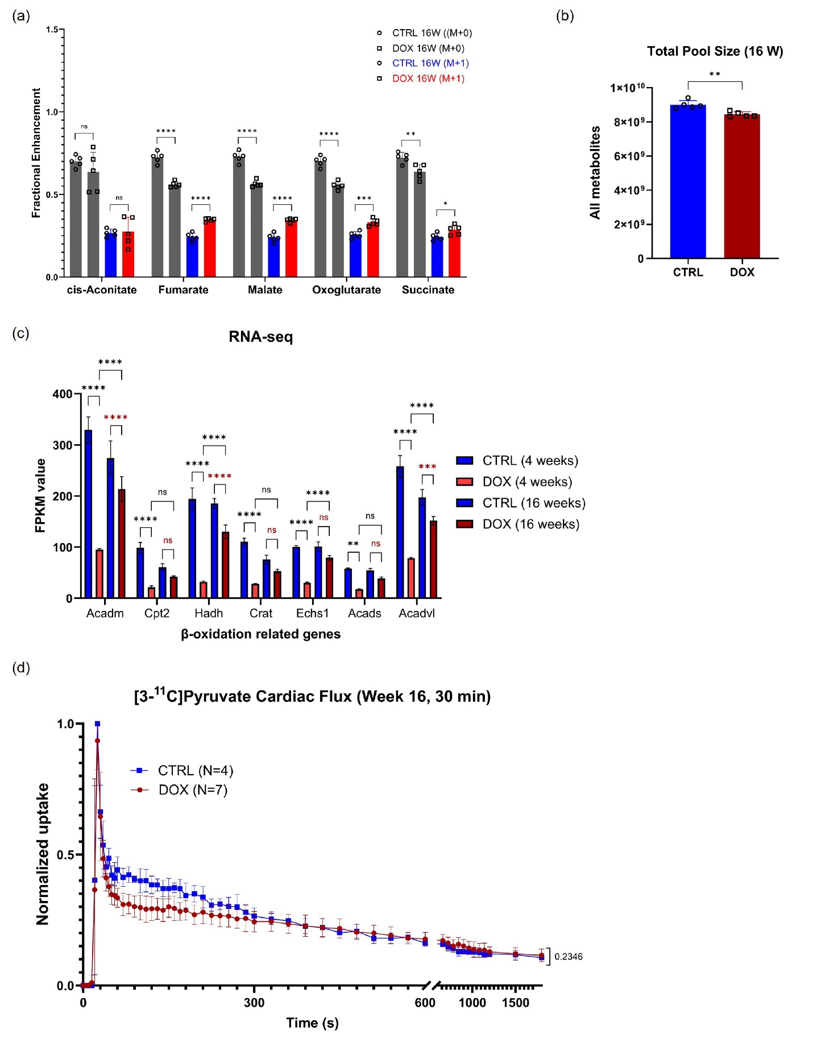
Supplemental Figure 5. Comparison between changes observed in [3-¹¹C]pyruvate PET imaging and shifts in pyruvate metabolism and β-oxidation components. (a) M+0 and M+1 fractional enrichments of other TCA cycle intermediates, including aconitate, fumarate, malate, oxoglutarate, and succinate at 16 weeks. (b) Comparison of the total metabolite pool size in the mice exposed to DOX with CTRL at 16 weeks. (c) Genes encoding key β-oxidation proteins were analyzed using RNA-seq-derived FPKM values from 4- and 16-week groups. (d) Dynamic PET images during 30 minutes upon intravenous administration of [3-¹¹C]pyruvate at 16 weeks. Data are presented as the mean ± s.d. ** p < 0.01; *** p < 0.001; **** p < 0.0001. Statistical analysis was performed using two-way ANOVA (a, c), or an unpaired t-test (b, d). FPKM = Fragments Per Kilobase of exon per Million mapped fragments.

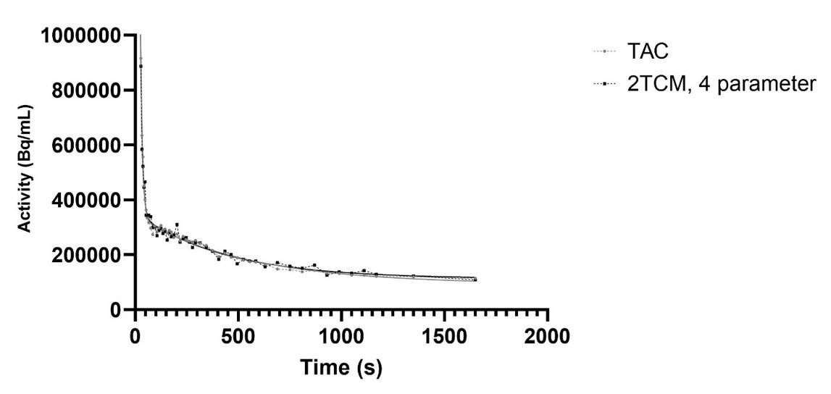
Supplemental Figure 6. Representative fit of the 2 tissue, 4 compartment model describing cardiac carbon-11 flux following intravenous administration of [3-¹¹C]pyruvate. Compartmental modeling was performed using Carimas. Lines of best fit are shown in bold with the data curves depicted with a dashed line.

Supplemental Tables

Supplemental Table 1. KEGG pathways by downregulated genes from the bulk RNA sequencing between CTRL and DOX of 4-week groups

KEGG_PATHWAY  (DOWN) | Term | Count | PValue | Genes
mmu01100 | Metabolic pathways | 241 | 7.1E-44 | PANK1, ENO3, GCSH, NAMPT, CHAC2, MLYCD, MMUT, ATP6V1E1, SEPHS2, MCCC2, PDHX, GSTK1, ACSL1, ENTPD5, OXSM, CMBL, ASRGL1, MTAP, ETHE1, HMBS, ACOT2, UQCRC1, ACOT1, SUCLG2, SUCLG1, LAP3, UQCRC2, ALG10B, LIPT2, HACD1, MGST3, PLA2G5, LDHB, LDHA, INPP5A, FDFT1, ST3GAL3, GSTM2, ACADSB, PRDX6, PAICS, CS, UCK2, ALDH6A1, ADI1, KYAT3, PDE3A, OGDH, ECHDC1, PPT2, GSTM7, GSTM5, PYGB, COX7B, HIBADH, GBE1, TECR, PIGP, ADK, HCCS, PYGM, GPT, PIGW, COX7C, GYS1, MCEE, ACADL, GUK1, IMPA2, SMPD1, RFK, ACADM, DLAT, ACADS, COX8A, COX8B, PCYT1A, TPI1, GSTO1, PGAM2, PLAAT3, HADHB, HADHA, ALDH5A1, BDH1, IVD, ADSSL1, L2HGDH, ALDOB, ALDOA, DLD, ECHS1, PRUNE1, DLST, HSD17B4, UQCR10, COX5B, HSD17B7, COX5A, SC5D, GPAT3, CBR4, NQO1, TIGAR, MDH1, CKM, MDH2, ATP5PB, PTGES2, GATC, COX6C, DHRS4, ALDH4A1, GPAM, NDUFAB1, ACAA2, NDUFA11, NDUFA12, NDUFA10, CPOX, HNMT, COX6A2, LCLAT1, ENPP4, KMT5A, HADH, DGAT2, SDHC, ACYP2, SDHD, SDHA, SDHB, COX6B1, PHOSPHO2, PGP, SMS, NDUFB10, UQCRB, NDUFB11, GLO1, AK1, GMPS, COX7A2, AK4, COX7A1, UQCRH, ACAT1, ESD, PGK1, COX11, SMYD1, CYC1, NDUFV3, NDUFV2, ATP6V1D, COX10, MPST, PDHA1, GOT1, EPHX2, IDH1, IDH2, GOT2, CRLS1, COQ5, QDPR, COQ3, AMACR, UQCRQ, CYCS, ACO2, NIT2, ACADVL, ALAS1, COX4I1, APIP, HK2, NADK2, GYG, DBT, ME1, IDH3B, UQCRFS1, ME3, HIBCH, PGM1, IDH3A, BCKDHA, PLA2G12A, GPX4, HMGCS1, BCKDHB, SORD, NDUFC2, NDUFC1, FH1, NDUFS8, PKM, ACOX1, NDUFS6, NDUFS5, EHHADH, CAT, NDUFS4, PCCB, NDUFS2, NDUFS1, GAPDH, DCTPP1, FBP2, NDUFB9, NDUFB8, NDUFB6, CARNMT1, NDUFB5, NDUFB4, NDUFB3, PDHB, HSD17B10, AGPAT3, CKMT2, UGP2, OXCT1, BPNT2, ACSS1, NDUFA9, NDUFA8, NDUFA7, DUT, FAHD1, IDH3G, NDUFA4, MMAB, NDUFA3, NDUFA1, SUOX, SUCLA2, NT5C1A, CHPT1, LPIN1, PFKM
mmu05415 | Diabetic cardiomyopathy | 76 | 1.3E-37 | RYR2, COX7B, NDUFA11, NDUFA12, COX4I1, NDUFA10, ATP2A2, SLC2A4, COX6A2, COX7C, PPP1CB, GYS1, CPT2, MPC1, MPC2, UQCRFS1, CD36, CTSD, PDK2, COX8A, COX8B, NDUFC2, SDHC, NDUFC1, SDHD, SDHA, SDHB, AGTR1A, COX6B1, NDUFS8, NDUFS6, NDUFS5, NDUFS4, UQCRC1, PPIF, VDAC2, NDUFS2, VDAC1, NDUFS1, UQCRC2, SLC25A5, SLC25A4, GAPDH, NDUFB9, NDUFB8, NDUFB6, UQCRB, NDUFB10, NDUFB11, NDUFB5, NDUFB4, NDUFB3, COX7A2, PDHB, UQCR10, COX5B, COX5A, COX7A1, UQCRH, PLN, TNNI3, CYC1, NDUFV3, NDUFV2, NDUFA9, NDUFA8, NDUFA7, PDHA1, ATP5PB, NDUFA4, NDUFA3, NDUFA1, COX6C, AGT, UQCRQ, NDUFAB1
mmu00190 | Oxidative phosphorylation | 60 | 1.4E-35 | COX7B, NDUFA11, NDUFA12, COX4I1, NDUFA10, COX6A2, COX7C, UQCRFS1, ATP6V1E1, COX8A, COX8B, NDUFC2, SDHC, NDUFC1, SDHD, SDHA, SDHB, COX6B1, NDUFS8, PPA2, PPA1, NDUFS6, NDUFS5, NDUFS4, UQCRC1, NDUFS2, NDUFS1, UQCRC2, NDUFB9, NDUFB8, NDUFB6, UQCRB, NDUFB10, NDUFB11, NDUFB5, NDUFB4, NDUFB3, COX7A2, UQCR10, COX5B, COX5A, COX7A1, UQCRH, COX11, CYC1, NDUFV3, NDUFV2, ATP6V1D, COX10, NDUFA9, NDUFA8, NDUFA7, ATP5PB, NDUFA4, NDUFA3, NDUFA1, COX6C, UQCRQ, NDUFAB1, CYCS
mmu01200 | Carbon metabolism | 53 | 5.3E-31 | GPT, ENO3, HK2, GCSH, MCEE, ME1, IDH3B, ME3, MMUT, DLAT, ACADS, HIBCH, IDH3A, TPI1, PGAM2, SDHC, SDHD, SDHA, SDHB, FH1, PKM, ACOX1, CAT, PCCB, PGP, SUCLG2, SUCLG1, ALDOB, ALDOA, DLD, GAPDH, FBP2, ECHS1, DLST, PDHB, ACAT1, ESD, PGK1, ACSS1, PDHA1, MDH1, GOT1, MDH2, IDH3G, IDH1, IDH2, GOT2, CS, ALDH6A1, SUCLA2, OGDH, ACO2, PFKM
mmu05208 | Chemical carcinogenesis - reactive oxygen species | 68 | 9.7E-29 | COX7B, NDUFA11, NDUFA12, COX4I1, NDUFA10, COX6A2, COX7C, AS3MT, UQCRFS1, COX8A, COX8B, GSTO1, NDUFC2, SDHC, NDUFC1, SDHD, SDHA, SDHB, COX6B1, NDUFS8, NDUFS6, NDUFS5, CAT, NDUFS4, UQCRC1, PPIF, VDAC2, NDUFS2, VDAC1, NDUFS1, UQCRC2, SLC25A5, SLC25A4, NDUFB9, NDUFB8, NDUFB6, UQCRB, NDUFB10, NDUFB11, NDUFB5, MGST3, NDUFB4, NDUFB3, COX7A2, UQCR10, COX5B, COX5A, COX7A1, UQCRH, CYC1, NDUFV3, NDUFV2, NDUFA9, NDUFA8, NQO1, GSTM2, NDUFA7, ATP5PB, NDUFA4, EPHX2, NDUFA3, NDUFA1, SOD2, COX6C, UQCRQ, NDUFAB1, GSTM7, GSTM5
mmu04260 | Cardiac muscle contraction | 37 | 4.2E-21 | RYR2, COX7B, UQCRB, COX4I1, ATP2A2, COX7A2, ATP1A1, UQCR10, COX5B, COX7A1, COX7C, COX5A, COX6A2, UQCRH, SLC8A1, CACNG6, UQCRFS1, TNNI3, CACNA1S, CYC1, COX8A, COX8B, CACNA2D1, TNNC1, TPM1, COX6C, ATP1B1, TRDN, COX6B1, ACTC1, UQCRQ, MYL2, MYL3, UQCRC1, CASQ2, HRC, UQCRC2
mmu00020 | Citrate cycle (TCA cycle) | 23 | 1.0E-19 | PDHA1, MDH1, MDH2, IDH3G, IDH1, IDH2, DLST, SDHC, PDHB, SDHD, SDHA, SDHB, FH1, CS, SUCLA2, OGDH, IDH3B, SUCLG2, SUCLG1, ACO2, DLAT, DLD, IDH3A
mmu00280 | Valine, leucine and isoleucine degradation | 25 | 1.2E-14 | ECHS1, ACAA2, HIBADH, HSD17B10, ACAT1, MCEE, OXCT1, DBT, ACADM, MMUT, HADH, ACADS, HIBCH, BCKDHA, MCCC2, HMGCS1, BCKDHB, ACADSB, HADHB, HADHA, ALDH6A1, EHHADH, IVD, PCCB, DLD
mmu01212 | Fatty acid metabolism | 21 | 5.9E-10 | ACADVL, HACD1, ECHS1, ACAA2, ACSL1, OXSM, TECR, HSD17B4, ACADSB, ACAT1, HADHB, HADHA, CPT2, ACADL, ACOX1, EHHADH, ACADM, PPT2, HADH, ACADS, CBR4
mmu00620 | Pyruvate metabolism | 16 | 3.7E-08 | PDHA1, MDH1, MDH2, GLO1, ACYP2, PDHB, FH1, ACAT1, LDHB, LDHA, PKM, ME1, ME3, DLAT, ACSS1, DLD

Supplemental Table 2. GO:BPs analysis by downregulated genes from the bulk RNA sequencing between CTRL and DOX of 4-week groups

GO:BP (DOWN) | Term | Count | PValue | Genes
GO:0032543 | Mitochondrial translation | 51 | 3.4E-39 | MRPS16, MRPS14, FASTKD2, MRPS12, MRPL39, MRPL36, MRPL34, MRPL35, MRPL32, MRPL41, MRPL4, MRPL42, MRPL2, MRPL1, MRPL9, CHCHD1, MRPS27, MRPS24, MRPS22, MRPS23, MRPL49, MRPS2, MRPS21, MRPL45, MRPS7, MRPL46, MRPL43, MRPL44, MRPS18C, MRPL50, MRPL51, NOA1, MRPS35, MRPL18, MRPL19, MRPS31, MRPL16, MRPL14, MRPL12, MRPL57, MRPL13, MRPL10, MRPL54, MRPL55, MRPL11, NDUFA7, GATC, MRPL28, MRPL21, MRPL22, MRPL30
GO:0032981 | Mitochondrial respiratory chain complex I assembly | 35 | 6.3E-27 | NDUFB9, NDUFB8, DMAC1, NDUFA11, NDUFB10, NDUFB6, NDUFB11, NDUFA12, NDUFB5, NDUFB4, NDUFA10, NDUFB3, NDUFB1, AIFM1, NDUFA9, NDUFA8, NDUFA3, NDUFA1, NDUFC2, NDUFC1, TIMM21, BCS1L, OXA1L, LYRM2, NDUFS8, NDUFS6, NDUFS5, NDUFAF4, NDUFS4, NDUFAB1, TMEM126A, NDUFS2, NDUFS1, NDUFAF1, TMEM126B
GO:0009060 | Aerobic respiration | 36 | 8.5E-27 | NDUFB9, NDUFB8, NDUFA11, NDUFB10, NDUFB6, NDUFB11, NDUFA12, NDUFB5, NDUFB4, NDUFA10, NDUFB3, NDUFB1, MTFR1L, NDUFV3, NDUFV2, COX10, NDUFA9, NDUFA8, NDUFA7, MDH2, NDUFA3, NDUFA1, NDUFC2, NDUFC1, SDHB, OXA1L, NDUFS8, NDUFS6, NDUFS5, CAT, NDUFS4, NDUFAB1, NDUFS2, MTFR1, NDUFS1, FXN
GO:0042776 | Mitochondrial ATP synthesis coupled proton transport | 33 | 6.8E-25 | NDUFB9, NDUFB8, NDUFA11, NDUFB10, NDUFB6, NDUFB11, NDUFA12, NDUFB5, NDUFB4, NDUFA10, NDUFB3, NDUFB1, NDUFV3, NDUFV2, NDUFA9, NDUFA8, NDUFA7, ATP5PB, NDUFA3, NDUFA1, NDUFC2, SDHC, NDUFC1, SDHD, SDHA, SDHB, NDUFS8, NDUFS6, NDUFS5, NDUFS4, NDUFAB1, NDUFS2, NDUFS1
GO:0006099 | Tricarboxylic acid cycle | 24 | 8.1E-22 | PDHA1, MDH1, MDH2, MRPS36, IDH3G, IDH1, IDH2, DLST, SDHC, PDHB, SDHD, SDHA, SDHB, FH1, CS, SUCLA2, NDUFS4, OGDH, IDH3B, SUCLG2, SUCLG1, ACO2, DLAT, IDH3A
GO:0006631 | Fatty acid metabolic process | 48 | 9.9E-19 | ACADVL, HACD1, PRKAA2, ECHS1, ACAA2, ECI1, TECR, HSD17B4, LPL, DBI, ABHD5, PLA2G5, ALKBH7, HSD17B10, ACAT1, CPT2, ACADL, UCP3, THEM4, CD36, ACADM, MLYCD, HADH, ACAD11, ACADS, CBR4, DECR1, LYPLA1, ACSL1, PTGES2, PNPLA8, OXSM, ECH1, ACADSB, ACSF2, HADHB, GNPAT, HADHA, AMACR, GPAM, ACOX1, NDUFS6, EHHADH, NDUFAB1, ACOT2, ACOT1, ECHDC3, CRAT
GO:0006120 | Mitochondrial electron transport, NADH to ubiquinone | 17 | 7.0E-15 | NDUFB9, NDUFA8, NDUFB8, NDUFA7, NDUFB6, BDNF, NDUFA10, NDUFC2, COQ9, DNAJC15, NDUFS8, NDUFS6, NDUFS2, NDUFS1, NDUFAF1, NDUFV2, DLD
GO:0006629 | Lipid metabolic process | 89 | 5.3E-14 | RAB7, ACADVL, LPGAT1, ACAA2, ECI1, TECR, HDLBP, VLDLR, LCLAT1, LACTB, AKR7A5, CPT2, ACADL, SMPD1, ACADM, MLYCD, HADH, ACAD11, ACADS, PLA2G12A, LYPLA1, DGAT2, PCYT1A, HMGCS1, GPX4, ACSL1, OXSM, BCKDHB, ECH1, PLAAT1, ACOT13, PLAAT3, PTGR2, HADHB, HADHA, BDH1, ACOX1, EHHADH, ACOT2, ACOT1, PLBD1, PLIN5, HACD1, PRKAA2, ECHS1, RETSAT, INSIG2, MGST3, HSD17B4, LPL, FITM1, FITM2, ABHD5, PLA2G5, HSD17B7, HSD17B10, AGPAT3, ACAT1, OXCT1, THEM4, SC5D, RDH14, GPAT3, SPTSSA, ACSS1, CBR4, COX10, DECR1, FDFT1, GSTM2, SLC16A1, PTGES2, PNPLA8, ADHFE1, EPHX2, CIDEA, CRLS1, ACADSB, PRDX6, ACSF2, NCEH1, GPAM, LPCAT3, NDUFAB1, ECHDC3, CHPT1, LPIN1, CRAT, NFE2L1
GO:0007005 | Mitochondrion organization | 24 | 1.2E-08 | EPM2A, RAB3A, PTCD2, MTFP1, MTX2, CHCHD10, PHB, BCS1L, SOD2, PHB2, HSD17B10, NIPSNAP2, PRDX3, PINK1, CHCHD2, OPA1, NOA1, DNAJA3, MFN2, MTFR1, TMEM126B, FXN, COX10, SLC25A46
GO:0006086 | Acetyl-CoA biosynthetic process from pyruvate | 8 | 3.1E-08 | PDHX, PDHA1, MPC1, MPC2, VDAC1, PDHB, DLAT, DLD

Supplemental Table 3. Bulk tissue gene expression in humans for Mpc1 (ENSG00000060762.19) and Mpc2 (ENSG00000143158.11). The data source was determined by GTEx Analysis Release V10 (dbGaP Accession phs000424.v10.p2) (TPM; Transcripts Per Million).
 | Mpc1  (median TPM) | Mpc2  (median TPM)
Heart-Left Ventricle (n = 452) | 168.3 | 50.95
Heart-Atrial Appendage (n = 461) | 145.0 | 44.37
Lung (n = 604) | 62.18 | 28.51
Muscle-Skeletal (n = 818) | 74.63 | 53.09

Supplemental Table 4. Observation of protein interaction using the STRING database from genes that consist of GO:BP (acetyl-CoA biosynthetic process from pyruvate)

#Term ID | Term description | Strength | False Discovery Rate (FDR) | Matching proteins  (Interesting targets)
GO:0006850 | Mitochondrial pyruvate transmembrane transport | 3.44 | 2.0E-04 | Mpc2, Mpc1
GO:0061732 | Mitochondrial acetyl-CoA biosynthetic process from pyruvate | 3.38 | 1.7E-18 | Pdhx, Pdhb, Mpc2, Pdha1, Dlat, Dld, Mpc1
GO:0006099 | Tricarboxylic acid cycle | 2.39 | 7.3E-05 | Pdhb, Pdha1, Dlat
GO:1990542 | Mitochondrial transmembrane transport | 1.98 | 9.1E-04 | Mpc2, Vdac1, Mpc1
GO:0009060 | Aerobic respiration | 1.81 | 7.7E-05 | Pdhb, Pdha1, Dlat, Dld
GO:0006006 | Glucose metabolic process | 1.80 | 2.8E-03 | Pdhb, Pdha1, Dlat
GO:0098656 | Anion transmembrane transport | 1.37 | 4.9E-02 | Mpc2, Vdac1, Mpc1

Supplemental Table 5. KEGG pathways by upregulated genes from the bulk RNA sequencing between CTRL and DOX of 16-week groups

KEGG_PATHWAY  (UP) | Term | Count | PValue | Genes
mmu04820 | Cytoskeleton in muscle cells | 8 | 1.5E-04 | COL3A1, COL5A3, ANKRD1, PKP2, BGN, COL4A5, COL9A2, MYH7
mmu04974 | Protein digestion and absorption | 6 | 2.0E-04 | COL3A1, COL14A1, COL22A1, COL5A3, COL4A5, COL9A2
mmu04933 | AGE-RAGE signaling pathway in diabetic complications | 4 | 1.4E-02 | TGFB2, COL3A1, MMP2, COL4A5
mmu04115 | p53 signaling pathway | 3 | 5.5E-02 | PERP, CYCT, BCL2L1
mmu05410 | Hypertrophic cardiomyopathy | 3 | 9.0E-02 | TGFB2, ACE, MYH7
mmu05415 | Diabetic cardiomyopathy | 4 | 2.0E-02 | TGFB2, COL3A1, ACE, MMP2

Supplemental Table 6. Comparison of k4 for DOX and control groups imaged at 4 weeks or 16 weeks after initial exposure to doxorubicin or saline. Data are presented as mean ± standard deviation. Statistical comparisons were performed by one-way ANOVA. Group sizes are indicated in parenthesis.

4 Weeks | DOX | 0.998 ± 0.989 (n = 8) | p = 0.457
4 Weeks | Control | 1.785 ± 1.133 (n = 7) | p = 0.457
16 Weeks | DOX | 1.383 ± 0.999 (n = 8) | p = 0.352
16 Weeks | Control | 2.322 ± 0.635 (n = 4) | p = 0.352

Supplemental Table 7. Comparison of the kinetic constants derived for the four groups using 2 tissue, 4 parameter kinetic modeling. Data are presented as mean ± standard deviation. Statistical comparisons were performed by one-way ANOVA.

4 Weeks | VA (mL/mL) | DOX | 0.923 ± 0.0400 | p = 0.187
4 Weeks | VA (mL/mL) | Control | 0.841 ± 0.115 | p = 0.187
4 Weeks | K1 (mL/(mL*min)) | DOX | 4.895 ± 2.968 | p = 0.910
4 Weeks | K1 (mL/(mL*min)) | Control | 4.173 ± 1.071 | p = 0.910
4 Weeks | k2 (/min) | DOX | 2.689 ± 0.777 | p = 0.988
4 Weeks | k2 (/min) | Control | 2.816 ± 0.452 | p = 0.988
4 Weeks | k3 (/min) | DOX | 0.210 ± 0.313 | p = 0.626
4 Weeks | k3 (/min) | Control | 0.440 ± 0.299 | p = 0.626
16 Weeks | VA (mL/mL) | DOX | 0.871 ± 0.0510 | p = 0.864
16 Weeks | VA (mL/mL) | Control | 0.904 ± 0.081 | p = 0.864
16 Weeks | K1 (mL/(mL*min)) | DOX | 3.078 ± 1.013 | p = 0.920
16 Weeks | K1 (mL/(mL*min)) | Control | 3.809 ± 2.197 | p = 0.920
16 Weeks | k2 (/min) | DOX | 2.546 ± 0.741 | p > 0.999
16 Weeks | k2 (/min) | Control | 2.524 ± 0.871 | p > 0.999
16 Weeks | k3 (/min) | DOX | 0.589 ± 0.376 | p = 0.871
16 Weeks | k3 (/min) | Control | 0.437 ± 0.425 | p = 0.871

Supplemental Table 8. Summary of target and housekeeping proteins for Western blot
Antibody name | Abbreviation | Dilution | Catalog # | Company
- Primary
MPC1 (D2L9I) Rabbit mAb | MPC1 | 1:1000 | 14462 | Cell Signaling Technology, USA
MPC2 (D4I7G) Rabbit mAb | MPC2 | 1:1000 | 46141 | Cell Signaling Technology, USA
MCT1 Monoclonal Antibody (P14612) | MCT1 | 1:500 | MA5-18288 | Thermo Fisher, USA
MCT4 SLC16A3 Antibody | MCT4 | 1:500 | A05510 | Boster Biological Technology
LDHA (C4B5) Rabbit mAb | LDHA | 1:1000 | 3582S | Cell Signaling Technology, USA
LDHB Polyclonal antibody | LDHB | 1:1000 | 14824-1-AP | Proteintech, USA
GPT (E-3), glutamate pyruvate transaminases GPT, also designated  alanine aminotransferases (ALT) | ALT | 1:500 | sc-374501 | Santa Cruz, USA
PDH Antibody Cocktail | PDH complex | 1:500 | 45-6799 | ThermoFisher, USA
p53 | p53 | 1:500 | sc-393031 | Santa Cruz, USA
p21 | p21 | 1:500 | sc-6246 | Santa Cruz, USA
Heat shock protein family D member 1 | HSP60 | 1:1000 | 12165 | Cell Signaling Technology, USA
Vinculin | Vinculin | 1:1000 | 4650 | Cell Signaling Technology, USA
- Secondary
Anti-mouse IgG, HRP-linked Antibody | Anti-mouse | 1:2000 | 7076 | Cell Signaling Technology, USA
Anti-rabbit IgG, HRP-linked Antibody | Anti-rabbit | 1:2000 | 7074 | Cell Signaling Technology, USA

