Appendix A
THYROID ULTRASOUND REPORTING TEMPLATE
GREY’S HOSPITAL RADIOLOGY DEPARTMENT

Patient name:
Hospital number:
Indication for study:

Findings:
For each thyroid nodule, please describe each feature as indicated or answer yes (Y) or no (N).

THYROID NODULE SONOGRAPHIC FEATURES | Thyroid Nodule 1 | Thyroid Nodule 2 | Thyroid Nodule 3
Size (Measured on transverse ultrasound probe orientation):

- Anteroposterior (AP) diameter

- Transverse (TV) diameter

Presence of intra-lesional vascularity:

Yes No
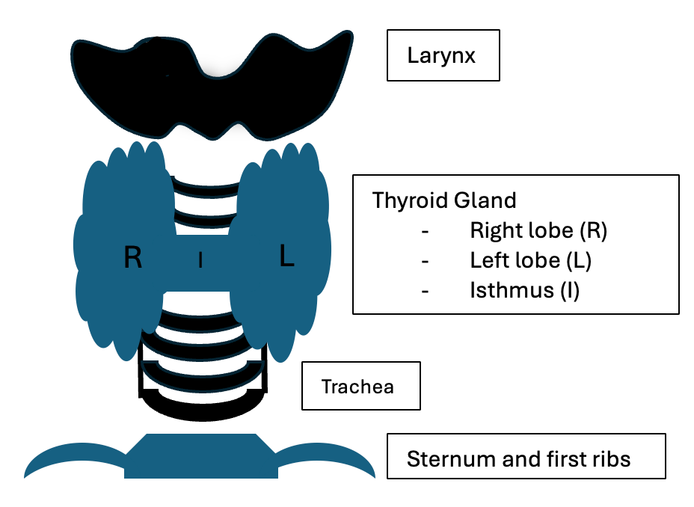
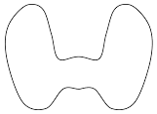
Location:
- Isthmus (I)
L
R
- Right thyroid lobe (R)
I
- Left thyroid lobe (L)
Composition:
- Cystic
- Spongiform
- Mixed cystic/solid
- Solid
Echogenicity:
- Anechoic
- Hyper- or Isoechoic
- Hypoechoic
- Very Hypoechoic
Shape:
- Wider-than-tall (TV >AP diameter)

- Taller-than-wide (AP > TV diameter)
Margin:
- Smooth

- Ill-defined

- Lobulated or irregular

- Extra-thyroidal extension
Presence of echogenic foci:
- None or large comet-tail artifacts
- Macrocalcifications
- Peripheral (rim) calcifications
- Punctate echogenic foci
ACR TI-RADS Level (1-5)
Ultrasound-guided biopsy or follow up ultrasound recommended

ASSOCIATED SONOGRAPHIC FEATURES
Presence of pathological lymph nodes (Left/Right)
Presence of mass effect on adjacent common carotid artery and internal jugular vein (Left/Right)
REPORTING RADIOLOGIST/SONOGRAPHER:
DATE:
TIME:

