Table 1: Nonprofit Hospital Cohort Characteristics, 2022
Characteristic¹ | Stratified random sample of hospitals, two per state and D.C. (n=102)
US Census Geographic Region % (n)
Northeast | 17.6 (18)
South | 33.3 (34)
Midwest | 23.5 (24)
West | 25.0 (26)
Hospital Characteristics % (n) ²
Major Teaching Hospital ³ | 14.7 (15)
High Disproportionate Share Hospital ³ | 14.7 (15)
High Uncompensated Care Burden | 15.7 (16)
Hospital Type % (n)
Private Non-profit | 69.6 (71)
Government Non-profit | 25.5 (26)
Church Operated | 4.9 (5)
1. Characteristics derived from the Agency for Healthcare Research and Quality (AHRQ) Compendium of United States Health Systems (hereafter, “Compendium”)
2. Disproportionate share (DSH) is defined as a measure of a hospital’s overall caseload of low-income insured patients. To qualify as high disproportionate share by the Compendium, a non-Federal general acute care system hospital was in the top quintile of DSH patient percentage among hospitals. Uncompensated care burden is defined as hospitals’ total unreimbursed and uncompensated care costs (including charity care for uninsured and insured patients). It is calculated as the ratio of uncompensated care to total operating expenses. A hospital is characterized as having a high uncompensated care burden by the Compendium if it is in the top quintile of uncompensated care burden. A hospital is considered a major teaching center if the system has at least one non-Federal general acute care hospital with a high (≥0.25) resident-to-bed ratio.
³The major teaching hospitals and high disproportionate share hospitals were not the same 16 hospitals.

Table 2: Codebook Domains, Descriptions, and IP Quality Analysis Findings
Domain, based on SMART goal framework (Specific, Measurable, Achievable, Relevant, Time-bound) | Domain Description | Example | Study Hospitals  (n = 102) | Study Hospitals with an IP (n = 97)
Presence of Community Health Needs Assessment (CHNA) | Hospital website contained easily discoverable document | N/A | 101 (99%) | N/A
Presence of Implementation Plan (IP) | Hospital website contained easily discoverable document | N/A | 97 (95%) | N/A
One quantifiable metric (Specific, Measurable, Relevant) | IP identified at least 1 discrete metric by which a strategy can be tracked | - Number of people served  - Hemoglobin A1c | 50 (49%) | 50 (52%)
Greater than 50% quantifiable metrics | At least 50% of strategies had a quantifiable metric | N/A | 35 (34%) | 35 (34%)
One numeric goal (Measurable, Achievable) | A quantifiable metric with associated target | - Organize 5 health fairs  - Increase spending by 20% | 34 (33%) | 34 (35%)
Greater than 50% numeric goals | At least 50% of strategies had numeric goals | N/A | 20 (20%) | 20 (21%)
Identification of Committed Resources |  | N/A | 76 (75%) | 76 (78%)
Identification of Collaborative Partners |  | N/A | 43 (42%) | 43 (44%)
New or expanding initiatives (Relevant) | Two new or clearly denoted expansions of existing initiatives (numeric goals above a baseline) | - Implement a task force  - Train 10 nurses (from prior baseline of 5) | 41 (40%) | 41 (42%)
CHNA evaluated prior IP (Time-bound) | Discussion of progress made on at least 1 prior implementation strategy of an IP | - “Successfully increased access to substance misuse treatment facilities” | 75 (74%) | N/A
Prior IP Evaluation with quantifiable metric (Time-bound) | Reporting of progress made on at least 1 prior implementation strategy of an IP | - 4 new psychiatrists hired | 59 (58%) | N/A
See Appendix A for detailed codebook criterion.

Table 3: Codebook Domains and Textual Examples
IP Domain | Notes and Textual Example
Quantifiable Metric | Implementation strategy without quantifiable metrics or specific objectives
Quantifiable Metric | 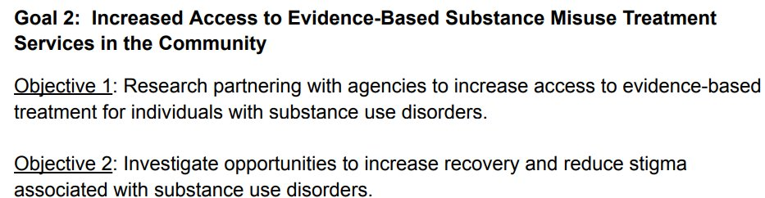
Quantifiable Metric | Implementation strategy with clear, yet unmeasurable objectives  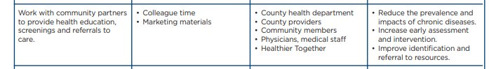
Quantifiable Metric | Implementation strategy with quantifiable metrics listed without a demonstrated goal  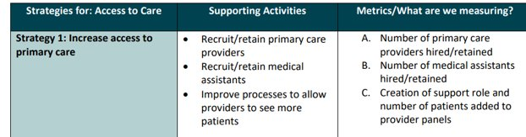
Numeric Goal | Some strategies contained goals but were not very ambitious. Note: These were also considered “expansion” by our definition
Numeric Goal | 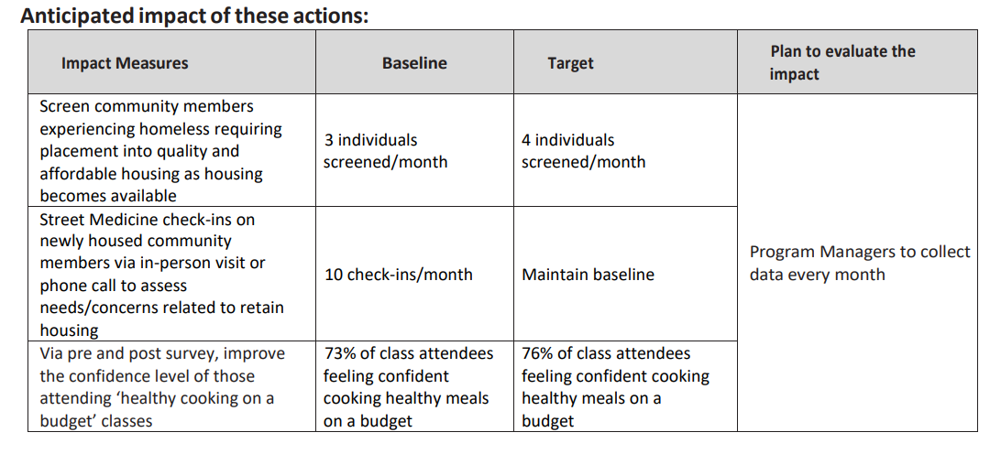
Numeric Goal | Implementation strategy with clear goals
IP Evaluation | This CHNA summarized actions taken for each implementation strategy with quantifiable metrics
IP Evaluation |   ***  ***  ***  ***  ***
IP Evaluation | This IP evaluation reported success or failure on certain metrics without reported quantifiable metrics or mention of actual activities taken
IP Evaluation | 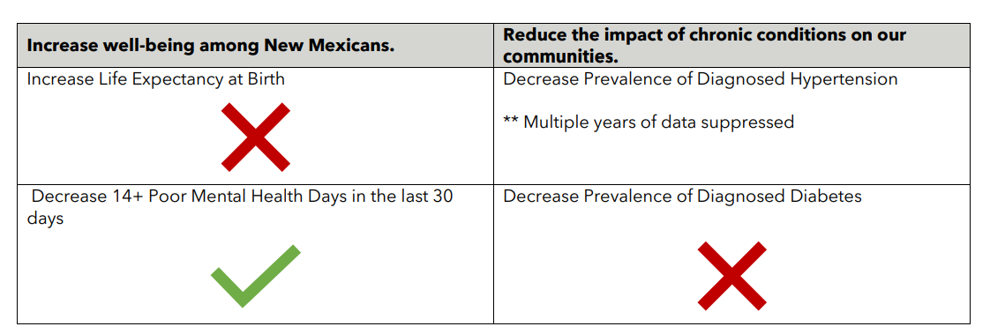
IP Evaluation | This IP evaluation listed activities but did not provide demonstration of impact  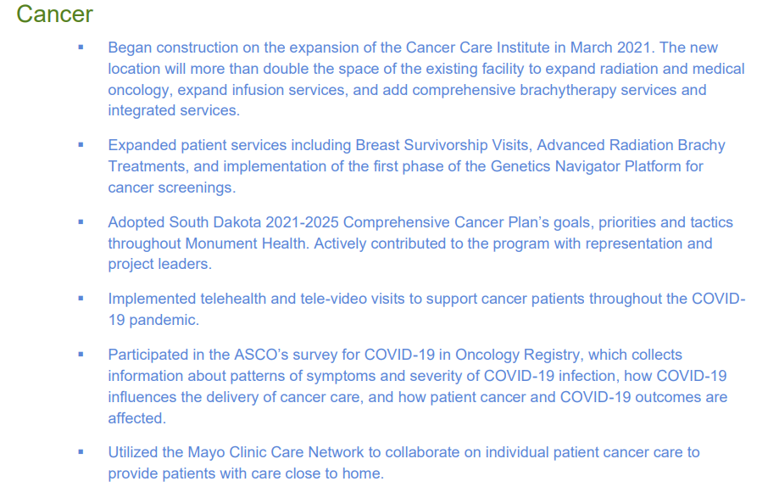  ***  ***
New/Expanded Activities
Clearly new or expansion of existing initiative | Clear goal setting over a baseline. Other key words like “implement” or “develop” usually implied new initiatives
Clearly new or expansion of existing initiative | 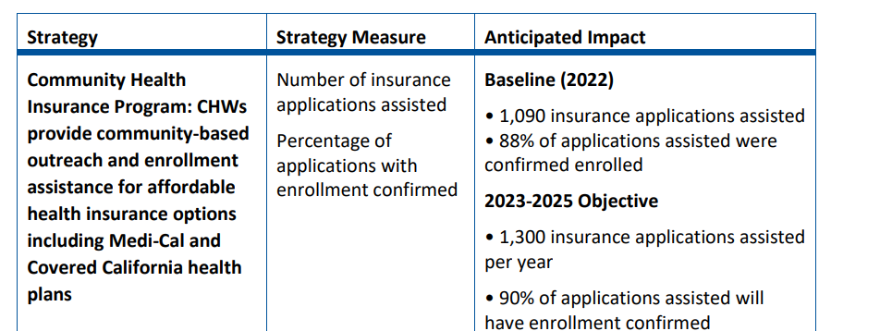
Unclear if new or expansion of existing initiative | Unclear if this is a new initiative; if not, there is no clearly delineated expansion of the program
Unclear if new or expansion of existing initiative | 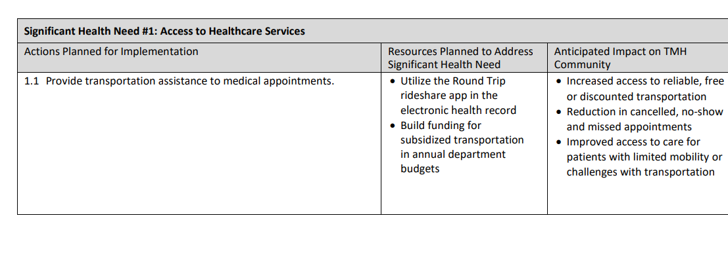  ***
Clearly not new nor expansion of existing initiative | Clear continuation of current initiative  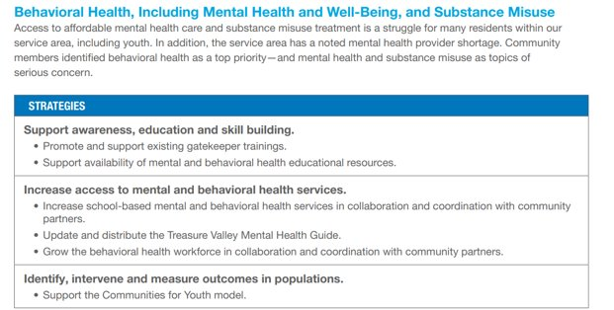  ***
***Community names and institutions redacted for anonymity

