Development of PLGA Nano-Triiodothyronine for Cardio-protection against Ischemic Insult and Targeted Delivery

Ozlem Ozen Karakus¹, Noureldien H. E. Darwish^{1,2}, Taher Salaheldin¹, P.C. Taylor Dickinson³, Brian Weil⁴, Shaker A. Mousa¹*
¹ The Pharmaceutical Research Institute, Albany College of Pharmacy and Health Sciences, Rensselaer, NY, USA
² Clinical Pathology (Hematology Section), Faculty of Medicine, Mansoura University, Mansoura, Egypt
³Pro-Al Medico Technologies Inc., Suffern, NY USA
⁴University at Buffalo and the VA WNY Healthcare System, Departments of Physiology & Biophysics, Biomedical Engineering, Medicine, Buffalo, NY

*Correspondence:
Shaker A. Mousa
The Pharmaceutical Research Institute
Albany College of Pharmacy and Health Sciences
1 Discovery Drive, Rensselaer, NY 12144
Phone: (518) 694-7397
Fax: (518) 694-7567
Email: shaker.mousa@acphs.edu

Table of Contents (figure for Compound 6 is missing)

Figure S1. ¹H-NMR spectrum of compound 2
Figure S2. ¹³C-NMR spectrum of compound 2
Figure S3. ¹H -NMR spectrum of compound 3
Figure S4. ¹³C-NMR spectrum of compound 3
Figure S5. ¹H -NMR spectrum of compound 4
Figure S6. ¹³C -NMR spectrum of compound 4
Figure S7. ¹H -NMR spectrum of compound 5
Figure S8. ¹³C -NMR spectrum of compound 5
Figure S9. ¹H -NMR spectrum of compound 7
Figure S10. Characterization of prepared nano capsules (a) particle size distribution of void nanoparticles showing average size of 150 nm; (b) particle size of PLGA-T3 NPs; (c) particle size of PLGA-T3/PCr NPs

You need to add C-NMR and H-NMR for Compound 6 and renumber all figures after that, both in the figures and in the text.

Figure S1: ¹H-NMR Spectrum of compound 2

Figure S2: ¹³C-NMR Spectrum of compound 2
Figure S3: ¹H-NMR Spectrum of compound 3
Figure S4: ¹³C-NMR Spectrum of compound 3
Figure S5: ¹H-NMR Spectrum of compound 4
Figure S6: ¹³C-NMR Spectrum of compound 4
Figure S7: ¹H-NMR Spectrum of compound 5

Figure S8: ¹³C-NMR Spectrum of compound 5

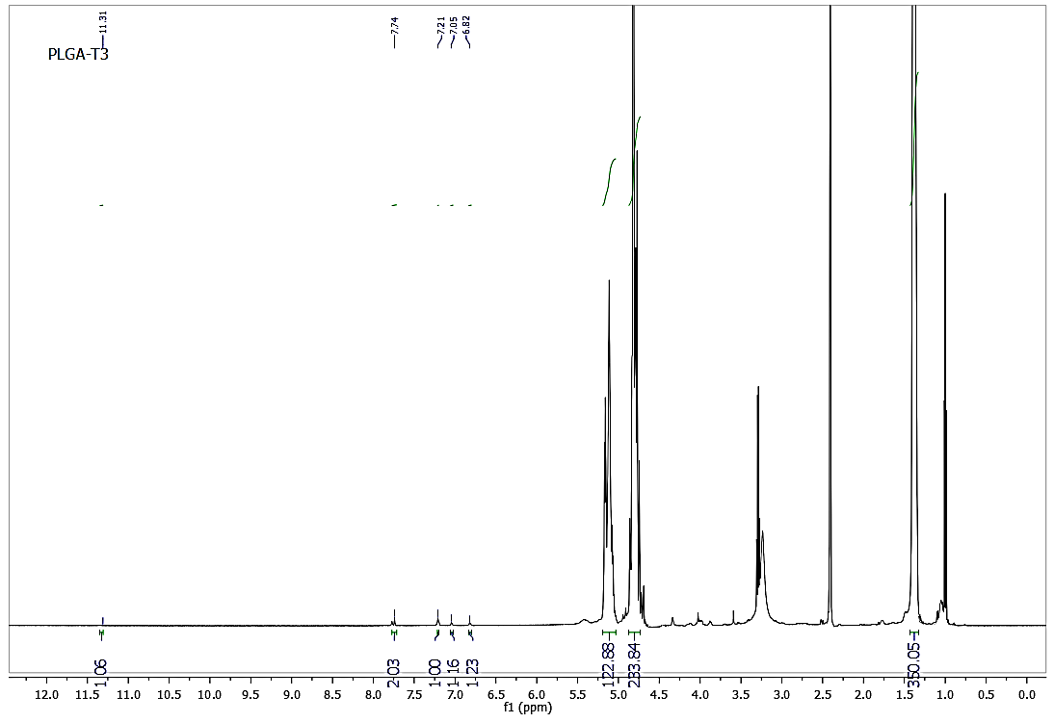
Figure S9: 1H-NMR Spectrum of compound 7

Figure S10. Characterization of prepared nano capsules (a) particle size distribution of void nanoparticles showing average size of 150 nm (250?); (b) particle size of PLGA-T3 NPs, size 175; (c) particle size of PLGA-T3/PCr NPs, size 187.

