Appendix A1
Specially, the data of videos includes a) the basics of videos, such as video title, uploading time, duration, and subcategory, b) the basics of corresponding uploader, such as ID number, identification, the number of followers and followings, and c) popularity indicators, such as the total number of views, likes, coins, danmaku comments and forum comments received by the video. The data of danmaku comments contains the calendar time of the danmaku comment and its content. The data of forum comments contains the calendar time of the forum comment, its content, and the identify of commenter. We excluded videos without any comments.

Appendix A2
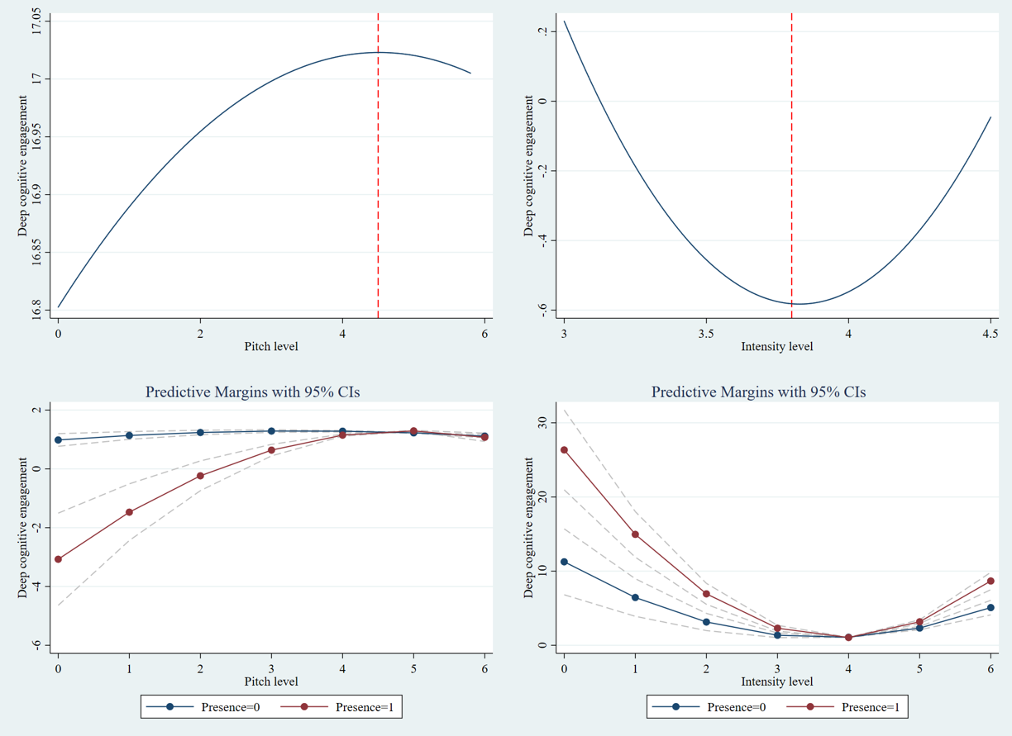
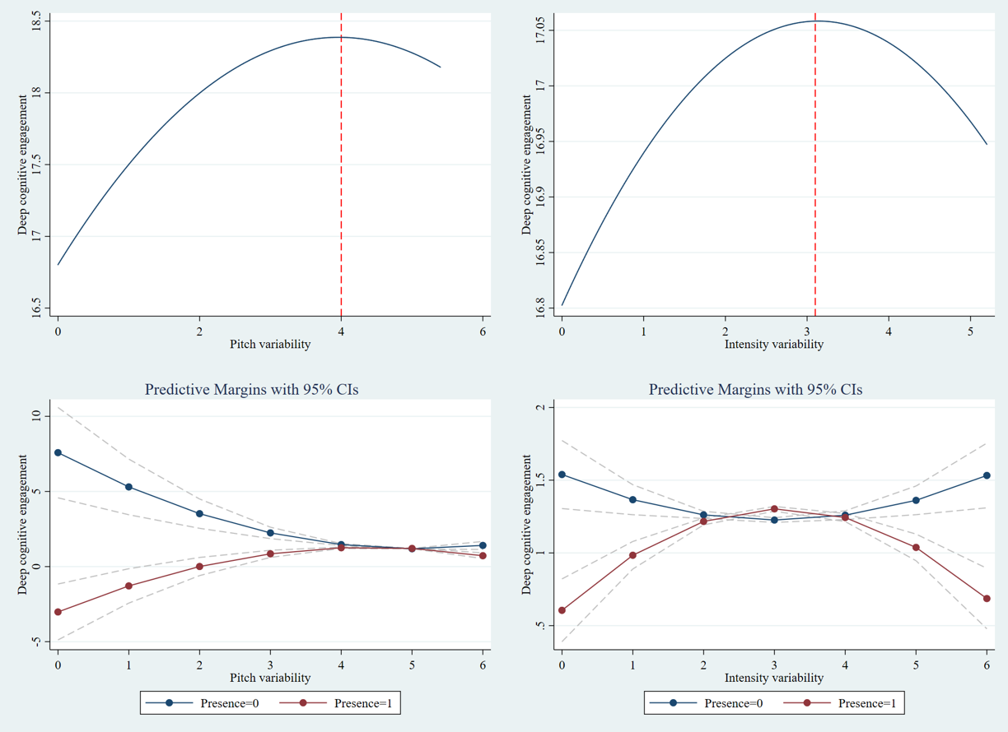
Fig. A1. Plots for Main and Interactions Effects

Appendix A3
Table A1. Regression results for alternative dependent variables
 | DV: Deep cognitive engagement measured by information entropy based on HDP results |  |  |  |  | DV: Deep cognitive engagement measured by the number of words in comments
 | Model 1 | Model 2 | Model 3 | Model 4 |  | Model 1 | Model 2 | Model 3 | Model 4
ln(Pit_{i}) |  | 0.114** | 0.133*** | 0.173*** |  |  | 0.123 | 0.158* | 0.293***
 |  | (2.381) | (2.766) | (3.391) |  |  | (1.381) | (1.769) | (3.067)
ln(Pit_{i})² |  | -0.009 | -0.012** | -0.021*** |  |  | -0.017 | -0.022** | -0.048***
 |  | (-1.623) | (-2.047) | (-3.219) |  |  | (-1.607) | (-2.031) | (-4.012)
ln(Int_{i}) |  | -8.204*** | -8.369*** | -4.151*** |  |  | -17.235*** | -17.543*** | -12.090***
 |  | (-9.832) | (-10.025) | (-3.837) |  |  | (-11.062) | (-11.255) | (-5.986)
ln(Int_{i})² |  | 1.076*** | 1.099*** | 0.580*** |  |  | 2.238*** | 2.279*** | 1.608***
 |  | (10.537) | (10.747) | (4.383) |  |  | (11.732) | (11.941) | (6.504)
ln(PitVar_{i}) |  | 0.817** | 0.780** | -3.654*** |  |  | 1.584** | 1.514** | -2.167*
 |  | (2.450) | (2.338) | (-5.674) |  |  | (2.542) | (2.430) | (-1.802)
ln(PitVar_{i})² |  | -0.115*** | -0.110*** | 0.360*** |  |  | -0.179*** | -0.170** | 0.215*
 |  | (-3.190) | (-3.055) | (5.183) |  |  | (-2.652) | (-2.517) | (1.663)
ln(IntVar_{i}) |  | 0.070 | 0.035 | -0.116 |  |  | 0.446*** | 0.380*** | -0.283*
 |  | (1.384) | (0.687) | (-1.485) |  |  | (4.700) | (3.975) | (-1.934)
ln(IntVar_{i})² |  | -0.010 | -0.004 | 0.024* |  |  | -0.069*** | -0.058*** | 0.045*
 |  | (-1.217) | (-0.490) | (1.880) |  |  | (-4.465) | (-3.707) | (1.895)
InstPre_{i} |  |  | -0.043*** | 8.188 |  |  |  | -0.081*** | -1.053
 |  |  | (-5.066) | (14.369) |  |  |  | (-5.064) | (11.837)
ln(Pit_{i})×InstPre_{i} |  |  |  | 0.922*** |  |  |  |  | 2.869***
 |  |  |  | (2.689) |  |  |  |  | (4.482)
ln(Pit_{i})²×InstPre_{i} |  |  |  | -0.087** |  |  |  |  | -0.276***
 |  |  |  | (-2.347) |  |  |  |  | (-3.965)
ln(Int_{i})×InstPre_{i} |  |  |  | -9.584*** |  |  |  |  | -10.496***
 |  |  |  | (-5.767) |  |  |  |  | (-3.383)
ln(Int_{i})²×InstPre_{i} |  |  |  | 1.184*** |  |  |  |  | 1.313***
 |  |  |  | (5.838) |  |  |  |  | (3.469)
ln(PitVar_{i})×InstPre_{i} |  |  |  | 6.127*** |  |  |  |  | 4.964***
 |  |  |  | (8.179) |  |  |  |  | (3.549)
ln(PitVar_{i})²×InstPre_{i} |  |  |  | -0.648*** |  |  |  |  | -0.524***
 |  |  |  | (-8.010) |  |  |  |  | (-3.466)
ln(IntVar_{i})×InstPre_{i} |  |  |  | 0.315*** |  |  |  |  | 1.292***
 |  |  |  | (2.903) |  |  |  |  | (6.383)
ln(IntVar_{i})²×InstPre_{i} |  |  |  | -0.057*** |  |  |  |  | -0.202***
 |  |  |  | (-3.248) |  |  |  |  | (-6.150)
Control variables | Included | Included | Included | Included |  | Included | Included | Included | Included
Constant | 1.707*** | 15.213*** | 15.638*** | 17.655*** |  | 2.811*** | 30.906*** | 31.700*** | 30.390***
 | (19.510) | (8.913) | (9.154) | (7.002) |  | (17.239) | (9.698) | (9.938) | (6.455)
Subcategory Dummies | Yes | Yes | Yes | Yes |  | Yes | Yes | Yes | Yes
N | 40742 | 40742 | 40742 | 40742 |  | 40742 | 40742 | 40742 | 40742
R² | 0.1430 | 0.1556 | 0.1561 | 0.1593 |  | 0.2171 | 0.2254 | 0.2259 | 0.2288
Notes: Standard errors in parentheses; *p < 0.10, **p < 0.05, ***p < 0.01

