Antibacterial And Antifungal Activity
Zone of Inhibition of ZnO and 5% Ni-ZnO Against Escherichia coli Staphylococcus aureus and Candida albicans
Test compound: Zno and 5% Ni-Zno
Test microorganism:
- Escherichia coli
- Staphylococcus aureus
- Candida albicans
Protocol:
- Sabouraud Dextrose Broth (15.6 gm) for fungus and nutrient broth for bacteria were dissolved in 1200 ml of sterile distilled water. After autoclaving at 121°C for 15 minutes, 0.1 ml of each pure fungus culture and bacterial culture was pipetted into the Sabouraud dextrose broth and nutrient broth.
- Each test fungi in Sabouraud dextrose broth and nutrient broth incubated for 12 hours at 37 ⁰C for the growth.
- Desired turbidity of each fungal suspensions and bacterial suspension was adjusted to 1.5 x10^8 CFU/mL using 0.5 McFarland standard.
- Sabouraud Dextrose Agar and nutrient agar plates were prepared with reference to the manufacturer's instructions.
- Sabouraud Dextrose Agar and nutrient agar was poured aseptically 20-25 ml into sterile Petri plates and allowed it to solidify.
- A sterile swab was dipped into the fungal suspension and bacterial suspension. The entire surface of the agar plate was then swabbed evenly to ensure a uniform lawn of fungal growth and bacterial growth.
- The process was repeated once more to ensure an even distribution of the inoculum. After the plates dried, they were divided into four equal quadrants. A hole was then bored at the center of each quadrant on the agar surface using a sterile cork borer.
- The test compounds were serially diluted and 0.1ml of each test solution is the added to the respective well. Without inverting, the petri plates were kept for incubation at the below given temperature and time.
- After the observation period of 48-72 hours of the plates for zones of inhibition, the diameter of the clear zone using a scale was measured
Results-
Sr.  No. | Concentration of samples | Zone observedZno against Escherichia coli(mm) | Zone observed5% Nizno against  Escherichia coli(mm)
1. | 1000mg | No Zone observed | No Zone observed
2. | 500mg | No Zone observed | No Zone observed
3. | 250mg | No Zone observed | No Zone observed
4. | 100mg | No Zone observed | No Zone observed
5. | 50mg | No Zone observed | No Zone observed
6. | 25µg | No Zone observed | No Zone observed
7. | 10µg | No Zone observed | No Zone observed
8. | 5µg | No Zone observed | No Zone observed
9. | Methicillin 5Mcg | 20 | 20

Sr.  No. | Concentration of samples | Zone observed ZnO against Staphylococcus aureus(mm) | Zone observed 5% Nizno against  Staphylococcus aureus(mm)
1. | 1000mg | 20 | 19
2. | 500mg | 19 | 15
3. | 250mg | 17 | 15
4. | 100mg | 18 | 15
5. | 50mg | No Zone observed | 14
6. | 25µg | No Zone observed | 14
7. | 10µg | No Zone observed | 13
8. | 5µg | No Zone observed | 13
9. | vancomycin 5Mcg | 20 | 20

Sr.  No. | Concentration of samples | Zone observedZno against against candida albicans(mm) | Zone observed 5% Nizno against  Against candida albicans(mm)
1. | 1000mg | 19 | 13
2. | 500mg | 16 | 13
3. | 250mg | 15 | 12
4. | 100mg | 11 | 12
5. | 50mg | 09 | 10
6. | 25µg | No Zone observed | 10
7. | 10µg | No Zone observed | 09
8. | 5µg | No Zone observed | 09
9. | Amphotericin B 5Mcg | 20 | 20

Observation- (ForZno aagainst Escherichia coli)
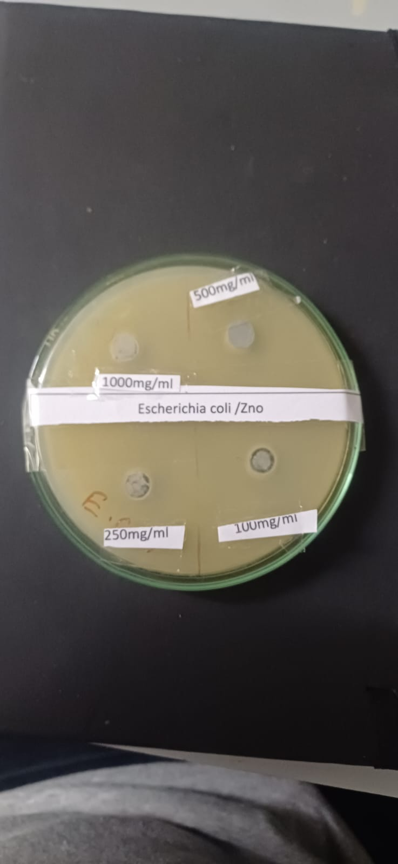
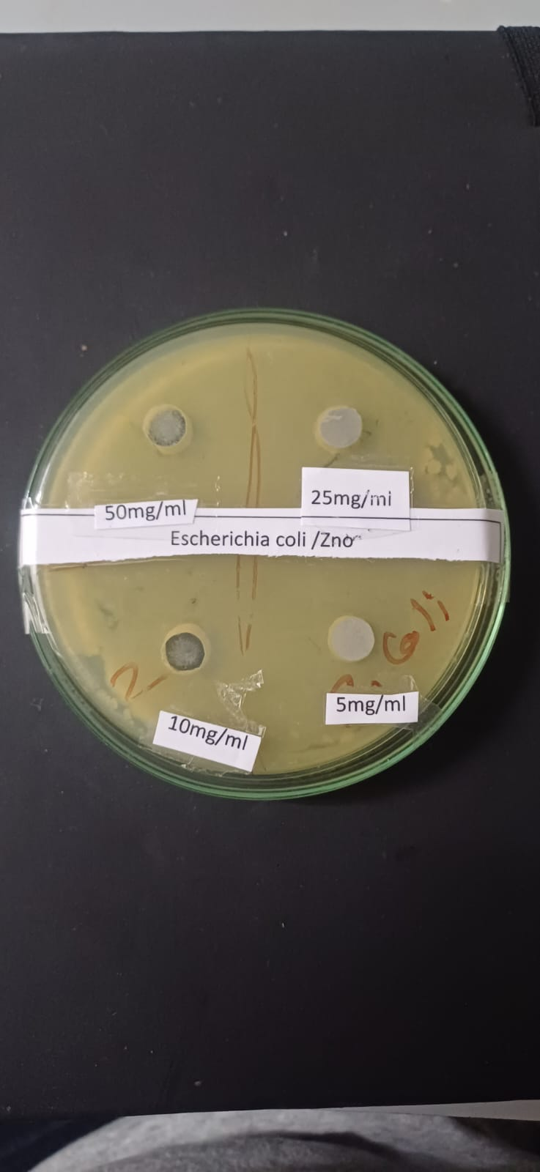

Concentration of at Zno aagainstEscherichia coli at 50mg, 25mg, 10mg, 5mg
Concentration of at Zno aagainst Escherichia coli 1000mg, 500mg,250mg, 100mg

Observation- (Foragainst 5% Ni-Zno against Escherichia coli)

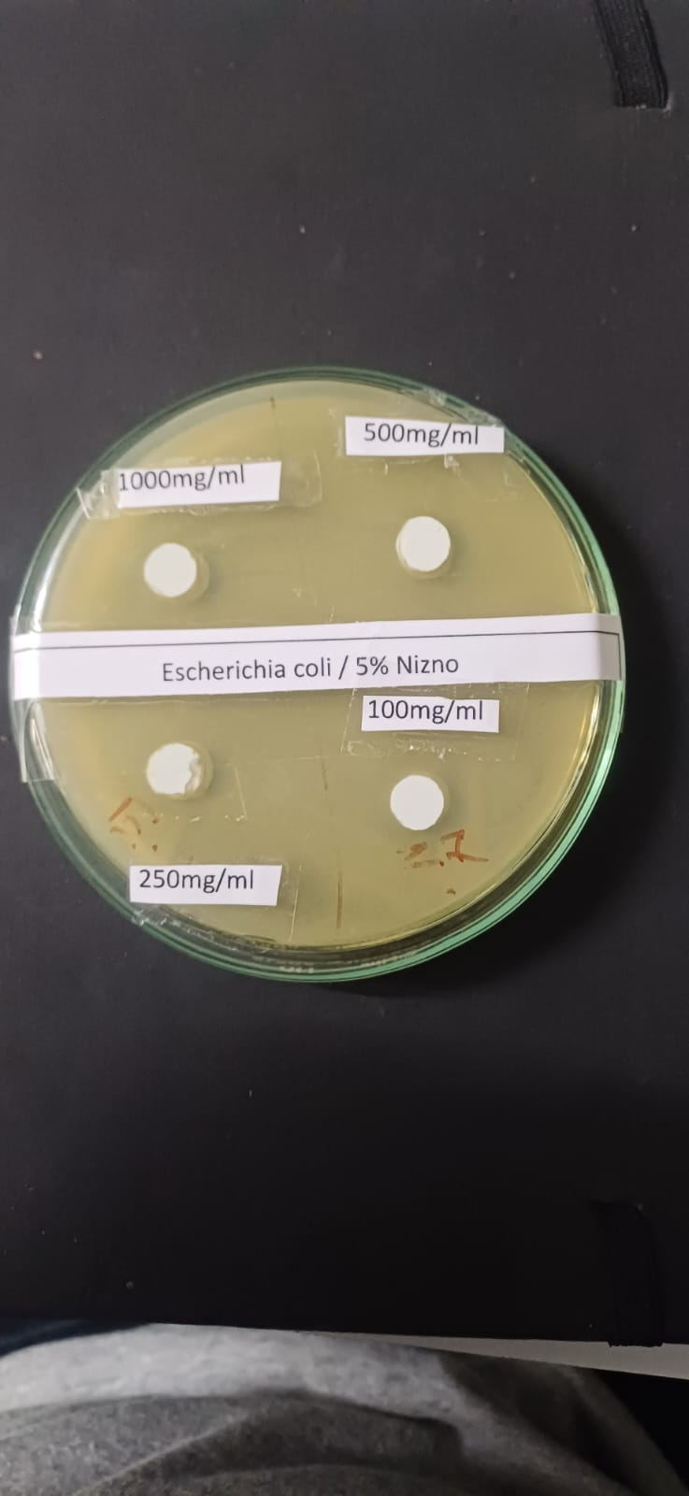
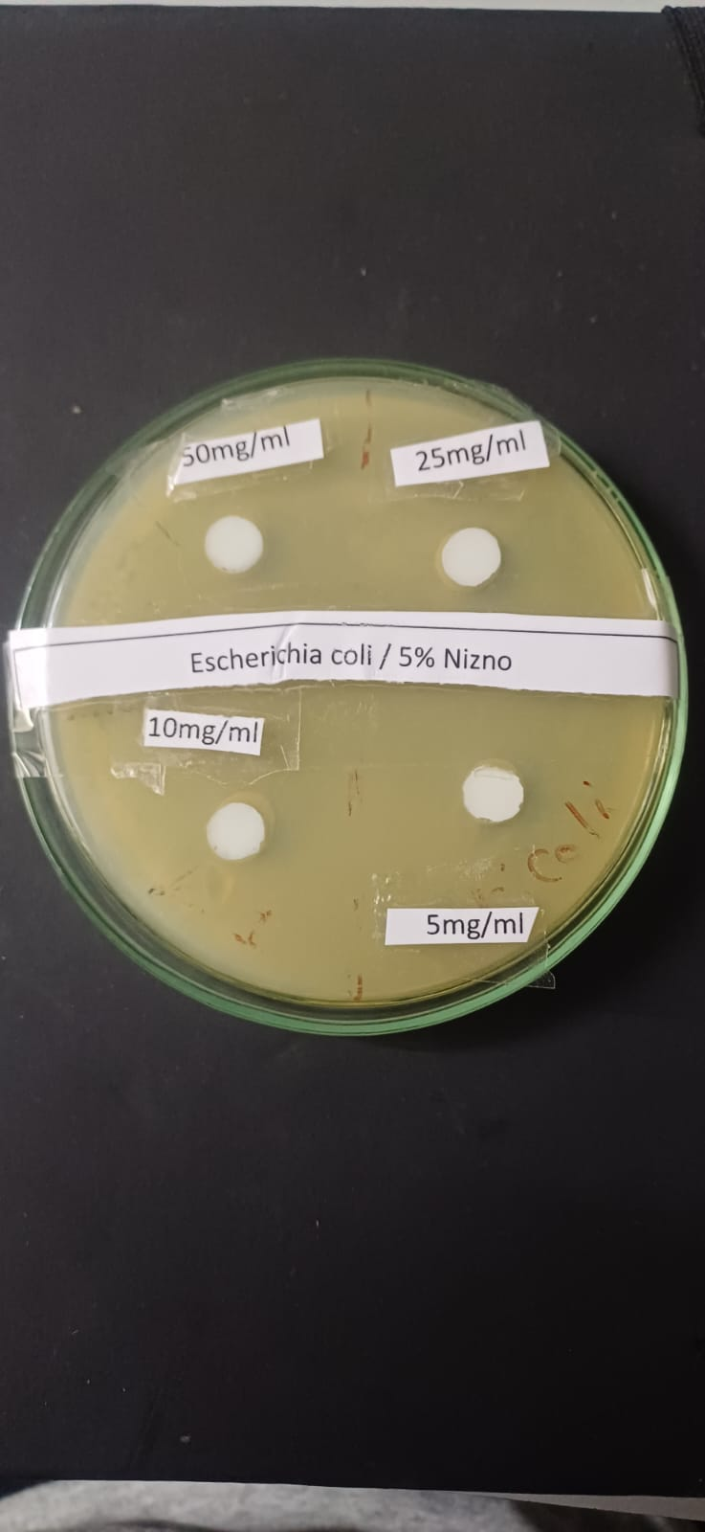

Concentration of 5% Ni-Zno against
Escherichia coli at 50mg, 25mg, 10mg, 5mg

Concentration of 5% Ni-Zno against
Escherichia coli at 1000mg, 500mg,250mg, 100mg

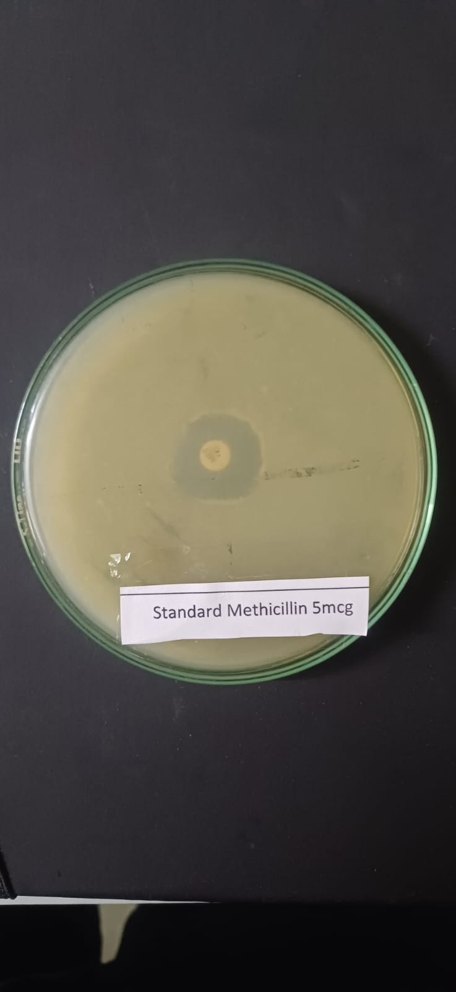

Standard Methicillin 5Mcg

Observation- (For Zno aagainst Staphylococcus aureus)
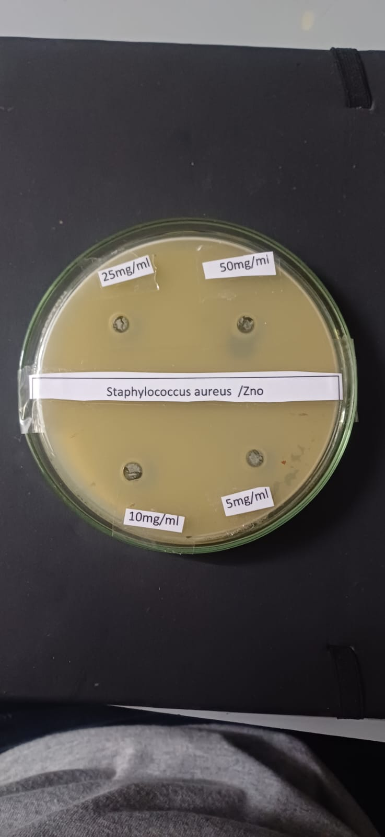
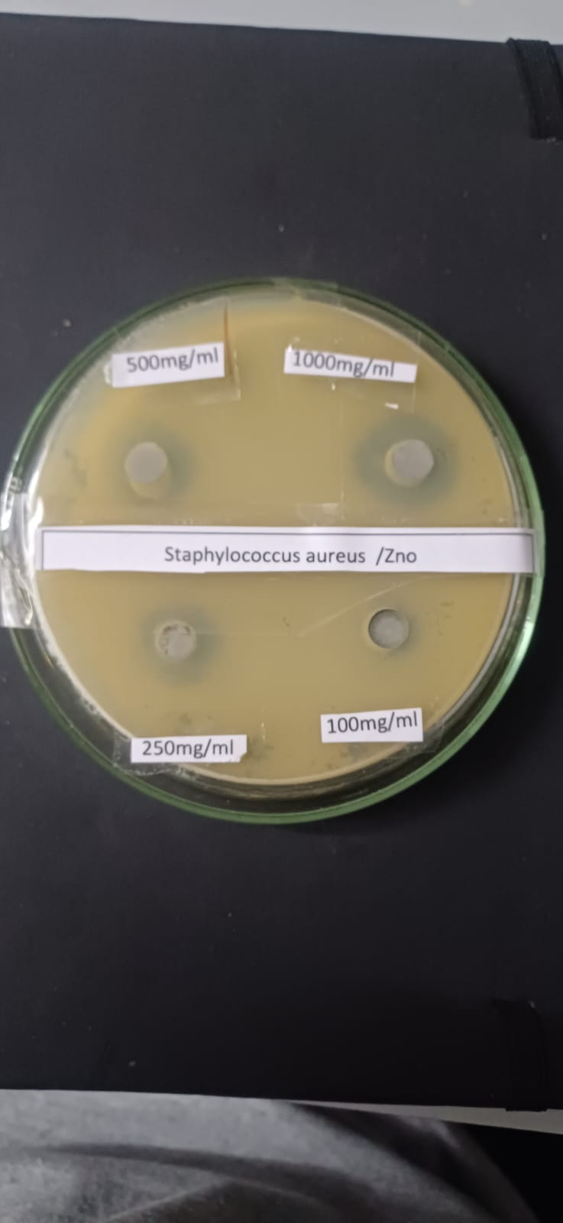

Concentration of ZnoaagainstStaphylococcus aureus at 50mg, 25mg, 10mg, 5mg

Concentration of ZnoaagainstStaphylococcus aureus 1000mg, 500mg,250mg, 100mg

Observation- (For 5% Ni-Zno against Staphylococcus aureus)
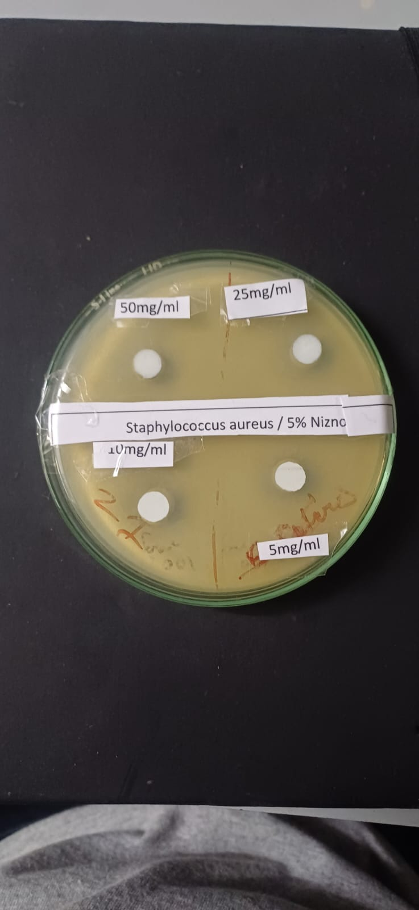
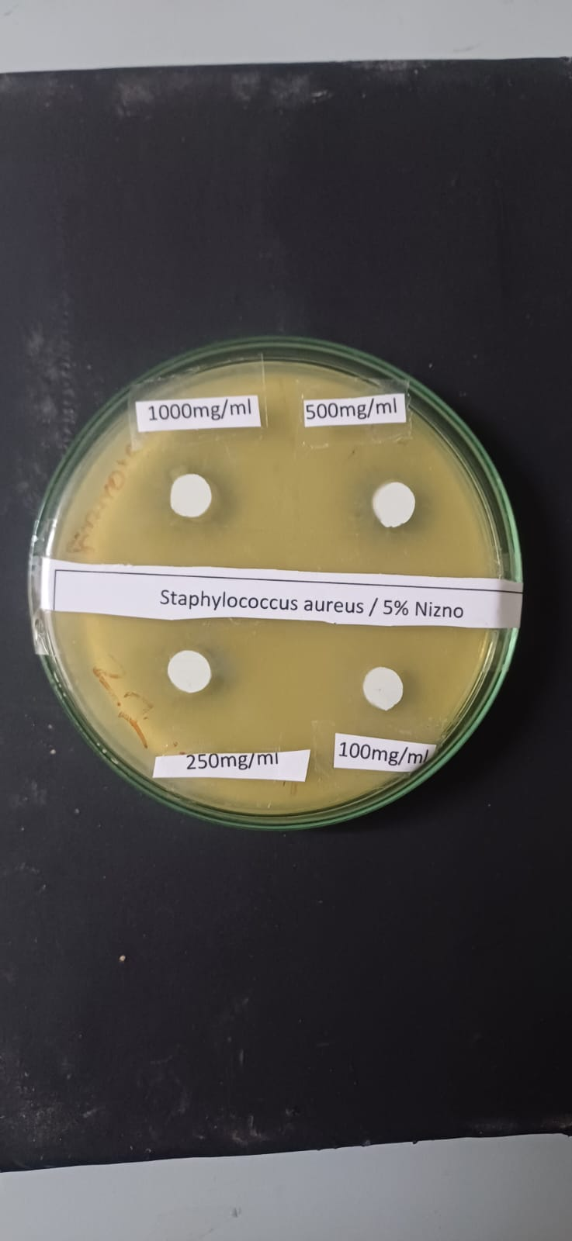

Concentration of 5% Ni-Zno against
Staphylococcus aureus at 1000mg, 500mg,250mg, 100mg

Concentration of 5% Ni-Zno against
Staphylococcus aureus at 50mg, 25mg, 10mg, 5mg

Standard Vancomycin 5Mcg
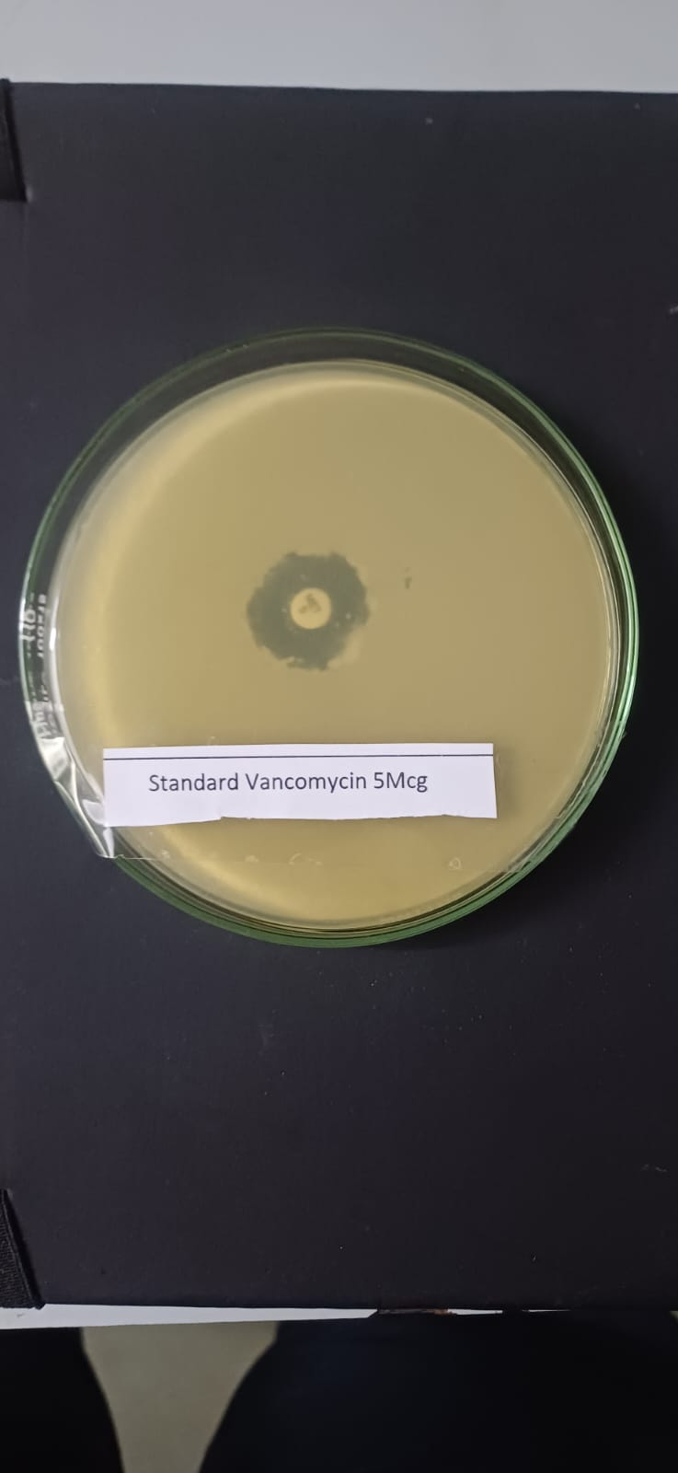

Observation-(ForZno aagainst Candida albicans)
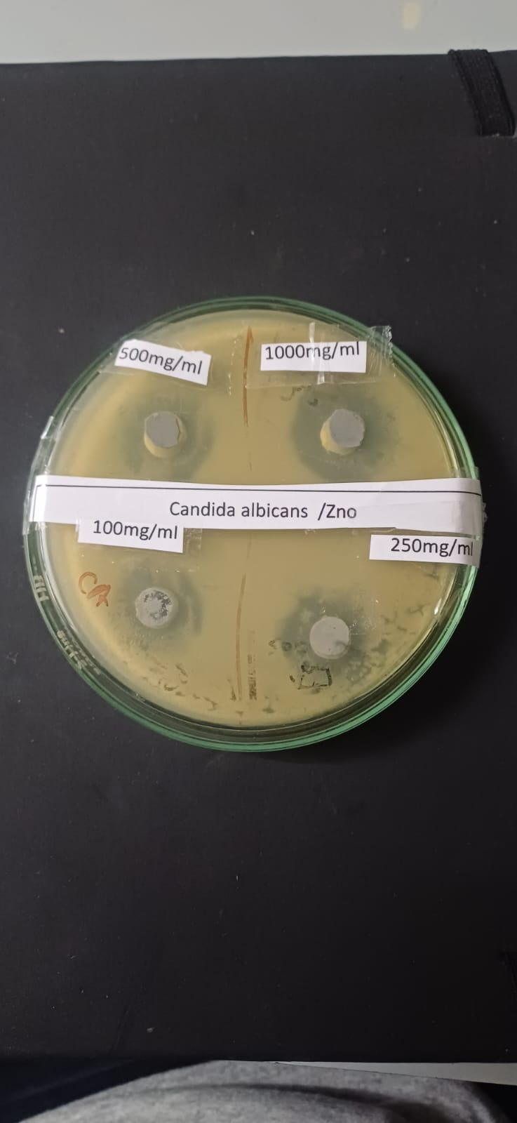
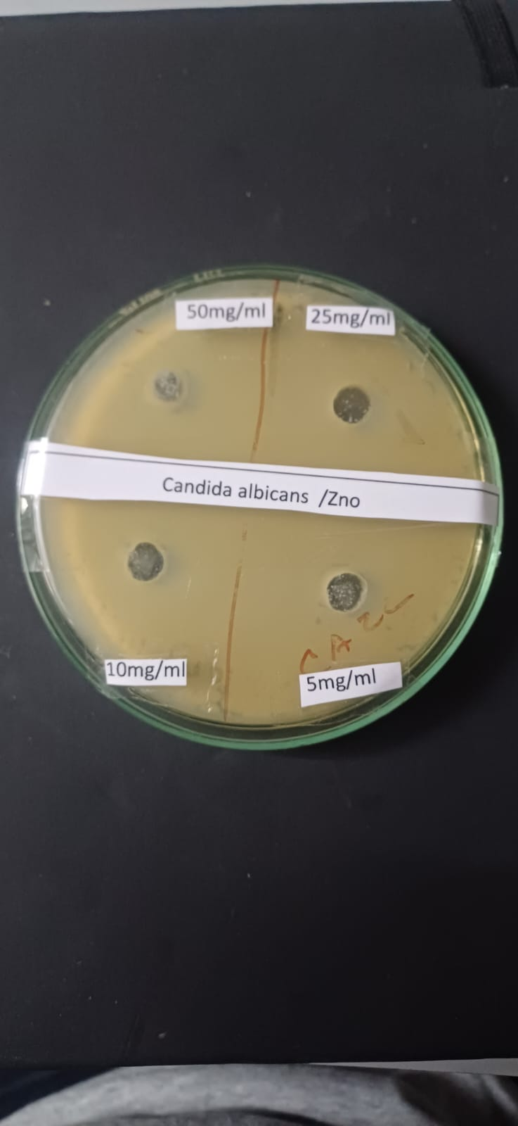

Concentration of at Znoaagainstcandida albicansat 50mg, 25mg, 10mg, 5mg
Concentration of at Znoaagainstcandida albicans1000mg, 500mg,250mg, 100mg

Observation- (Foragainst 5% Ni-Zno against Candida albicans)
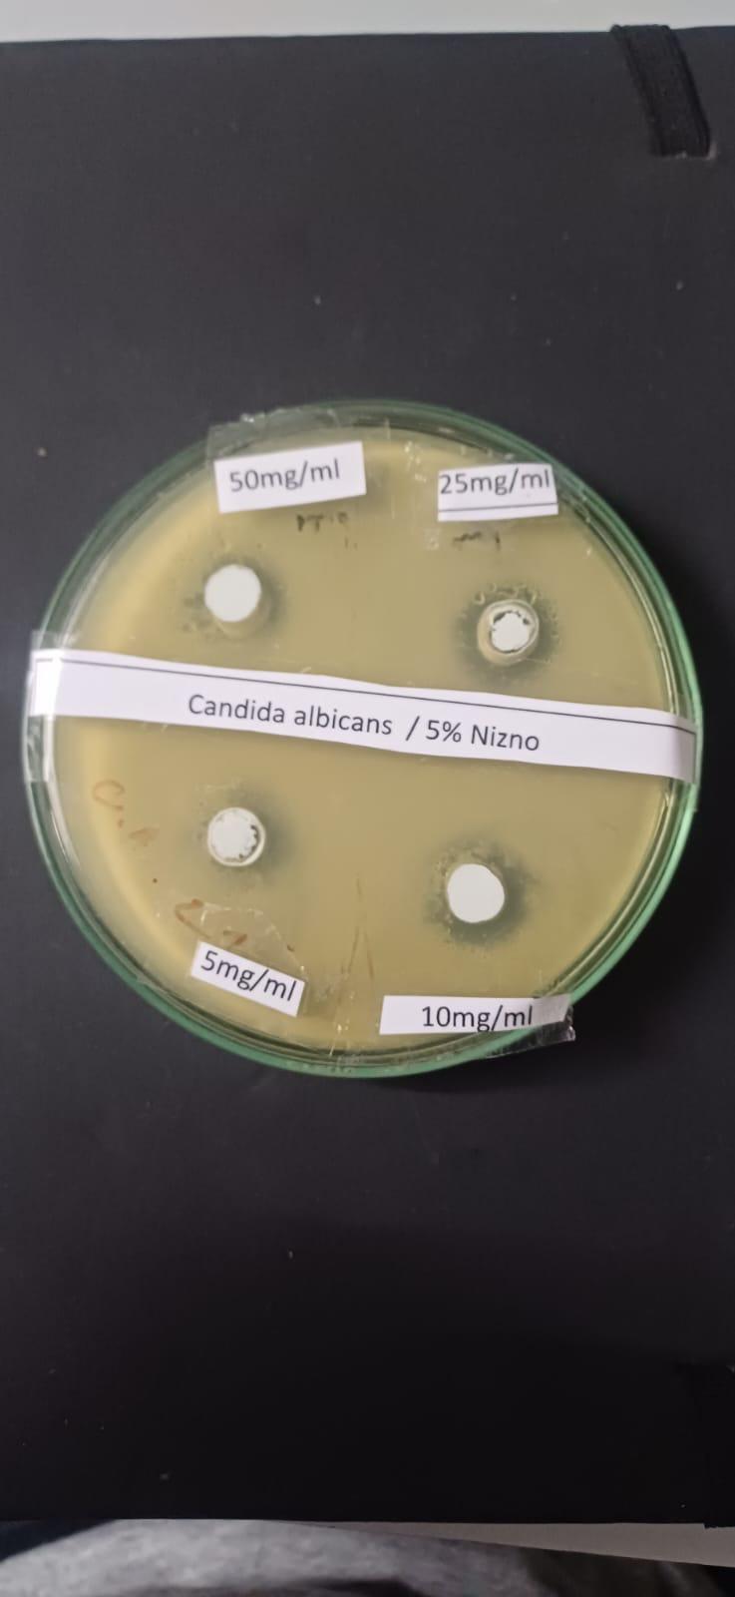
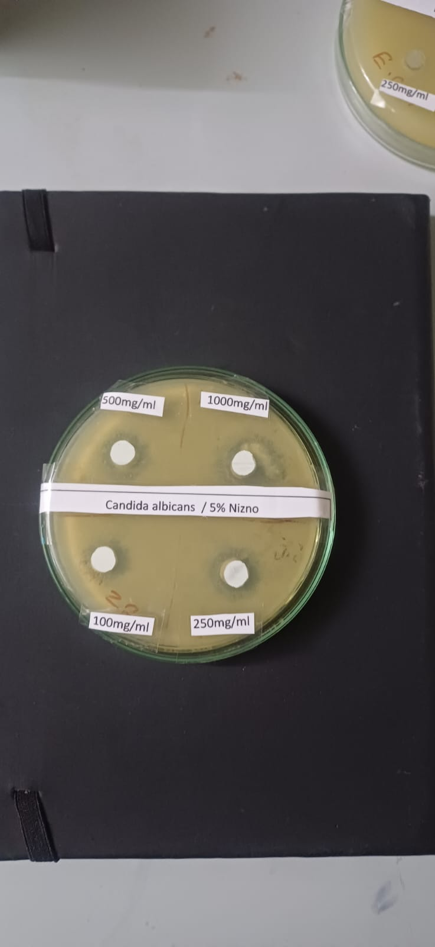

Concentration of 5% Nizno against
candida albicansat 50mg, 25mg, 10mg, 5mg

Concentration of 5% Nizno against
candida albicansat 1000mg, 500mg,250mg, 100mg

Standard Amphotericin 5Mcg




