Supplementary Information

Definable Two-Dimensional Mesoporous Polydopamine-Graphene Heterostructure as Multi-Functional Ion Redistributor for Ultrastable Sodium Metal Anodes
Qin et al.

Methods
Synthesis of 2D mPG heterostructures. Typically, 18 mg of GO prepared by modified Hummers method^{1, 2} was added into the polydiallyldimethylammonium chloride solution (0.2 wt%) of 75 mL and stirred for 24 h. Then, 100 mL monodisperse SiO₂ nanospheres solution (1.5 wt%) was slowly added into the mixture under stirring for 15 h. After centrifugation to remove excess SiO₂ nanospheres, the SiO₂-GO nanosheets were collected. Afterwards, as-obtained SiO₂-GO were dispersed in 150 mL water to pattern polydopmine layers by adding a certain amount of dopamine hydrochloride and 180 mg of Tris-base. Finally, 2D mPG heterostructures were obtained after hydrothermal treatment at 180 ºC for 12 h and etching SiO₂ by HF solution. According to the sizes of SiO₂ template with 7 nm, 12 nm and 22 nm, the addition amount of dopamine hydrochloride was 450 mg, 600 mg and 900 mg, and the as-synthesized mPG heterostructures were defined as mPG-7, mPG-12 and mPG-22 nanosheets, respectively. For comparison, the nPG nanosheets without mesopores were also synthesized without using SiO₂ template, while other steps kept same as mPG-12 nanosheets.
Fabrication of functional composite separators. The mPG-12 nanosheets and polyvinylidene difluoride (PVDF) binder with a mass ratio of 90:10 were mixed in N-methyl-2-pyrrolidinone (NMP) to form a viscous solution. Then, the as-prepared suspension was blade-coated onto one side of a commercial PP separator (Celgard 2400). After vacuum drying at 80 °C overnight and punching into disks with a diameter of 19 mm, the mPG-12@PP separator was successfully obtained.
Characterization. The morphology and composition of materials, separators, and electrodes were recorded by SEM (JSM-7800F), TEM (JEM-2100), AFM (Veeco nanoscope multimode II-D), nitrogen adsorption and desorption isotherm (Quadrasorb SI), FT-IR (Hyperion 3000), XPS (ESCALAB 250Xi) equipped with monochromatic Al Kα source of 1486.6 eV, and contact angle meter (DSA100).
Electrochemical measurement. All the batteries were assembled with CR2016 coin cells in an Ar-filled glovebox, and all the electrochemical measurements were conducted using a LAND CT2001A battery system at room temperature. The electrolyte used for Na deposition was 1 M NaPF₆ in diglyme (~40 µL), while the electrolyte applied to Na/NVP full cells was 1 M NaClO₄ in propylene carbonate with 5 wt% fluoroethylene carbonates (~100 µL). The Na/Cu cells were assembled with Cu foil as the working electrode, Na disc as the counter/reference electrode, and the coated side of functional separators toward Cu foil. The Na/Cu cells were precycled 5 cycles from 0.1 to 3 V to stabilize the SEI, and then evaluated the Coulombic efficiency of Na plating/stripping. EIS plots were measured with an AC amplitude of 5 mV over a frequency range of 0.01 to 10⁵ Hz using a CHI 760E electrochemical workstation. The Na/Na symmetric cells were prepared with as-deposited Na-Cu foil as the working electrode, Na disc as the counter/reference electrode, and the coated side of functional separators toward the working electrode. The symmetric cells were applied to evaluate the long-time cycling stability of Na metal anodes with functional separators. The Na/NVP full cells were assembled with NVP cathode (~1.0 mg cm⁻²), as-deposited Na-Cu anode (10 mAh g⁻¹) and functional separators combined with glass fiber. Specifically, NVP was prepared by a sol-gel method^{3, 4}. 0.02 mol ammonium metavanadate was dissloved in 40 mL of deionized water under stirring at 80 °C for 1 h. Then, 0.03 mol ammonium dihydrogen phosphate and 0.01 mol sodium citrate dehydrate were added with stirring for 2 h. When increasing the temperature to 120 °C, the solution gradually became gel. After drying and grinding, the precursor was annealed at 350 °C for 4 h and then 800 °C for 8 h in argon atmosphere to achieve target NVP powder. Furthermore, NVP cathode was prepared through mixing NVP, acetylene black and PVDF at a weight ratio of 80:10:10 in NMP and then pasting on a carbon-coated Al current collector. The electrochemical performance of Na/NVP full cells were measured between 2.5 to 3.8 V at varying current density (1 C = 117.6 mA g⁻¹).
Computational simulation. DFT calculation and FVM simulation were conducted to study sodiophilic nature and Na ion transportation behaviors of 2D mPG heterostructures. In the frame work of DFT, all the calculations were performed with Dmol³ code⁵⁻⁷. The generalized gradient approximation (GGA) combined with the Perdew-Burke-Enzerhof functional was employed to describe the exchange and correlation potential. The structural relaxations of polydopamine, graphene, PP, and Cu (111) models were carried out firstly, followed with the Na-adsorption simulation step. All the electrons were considered when tackling the electron-ion interactions for atoms in the whole system. For the convergence criteria, the SCF tolerance used was 1.0×10⁻⁵ Ha·atom⁻¹, and the maximum force and displacement were set as 2.0×10⁻⁵ Ha·Å⁻¹ and 5.0×10⁻³ Å, respectively. The binding energies of Na atom with different substrate models (C=O, OH, -NH- groups of polydopamine, graphene, PP, and Cu (111) surface) were defined as the energy difference between the substrate model with Na atom (E_{tot}) and the summation of Na atom (E₁) and substrate system (E₂): E_{ads} = E₁ + E₂ - E_{tot}.
For FVM simulation, OpenFOAM software was used to investigate the effect of mesopore size on Na ions distribution⁸. Two dimensional simulation was conducted to study Na ions concentration distribution through the different mPG layers. Migration of Na ions driven by electric field and diffusion flow was taken into account in the simulation, and the governing equation of Na ions movement was show below⁹:
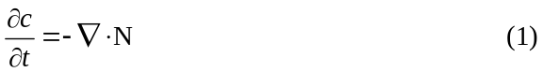
where φ is potential difference, E is electric filed, c is Na ion distribution, N is flux of Na ions, D is diffusion coefficient, µ is ionic mobility. In the simulation, the effect of pore size on Na ion distribution are compared. According to the SEM, TEM and AFM results, three different physical models with varying pore sizes were constructed. Fig. 3d in the mansucript shows an example of the two-dimensional physical model. In the models, twenty crisscross layers based on the SEM result were constructed to simulate movement of Na ions. In each layer, six or five holes were constructed, and symmetry conditions were set to two sides to show the axial distribution of Na ions. Between the nearby layers was layer spacing, the D and µ were regarded as same as mPG layers, and the simulated number were set to 3.0×10⁻¹⁰ m²·s⁻¹ and 3.0 × 10⁻¹² m²·s⁻¹·V⁻¹. In order to simulate the homogeneous distribution property of mPG layer, similar cosine function distribution of Na ions as shown in Fig. 3e in the manuscript was set in the entrance of different physical models. The electric field was set uniform in the whole simulation regime, and the value was set to 0.02 V m⁻¹ according to experimental result. The Na ion concentration of bottom boundary, i.e. outlet, was set to 0. The inner boundaries induced by holes were set to zero gradient. Notably, two different simulations based on the varying entrance conditions were conducted. In one simulation, the entrance distribution of Na ions possessed same amplitude and period. In another simulation, the amplitude of entrance distribution of Na ions were adjusted to ensure same fluctuation.

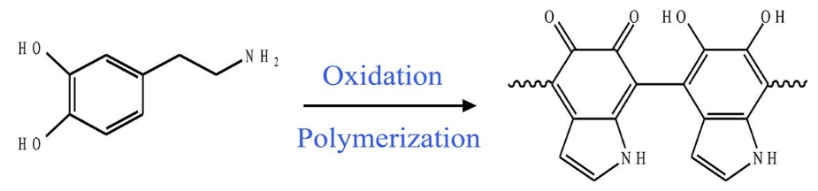
Supplementary Scheme 1. Synthesis and structure of polydopamine.

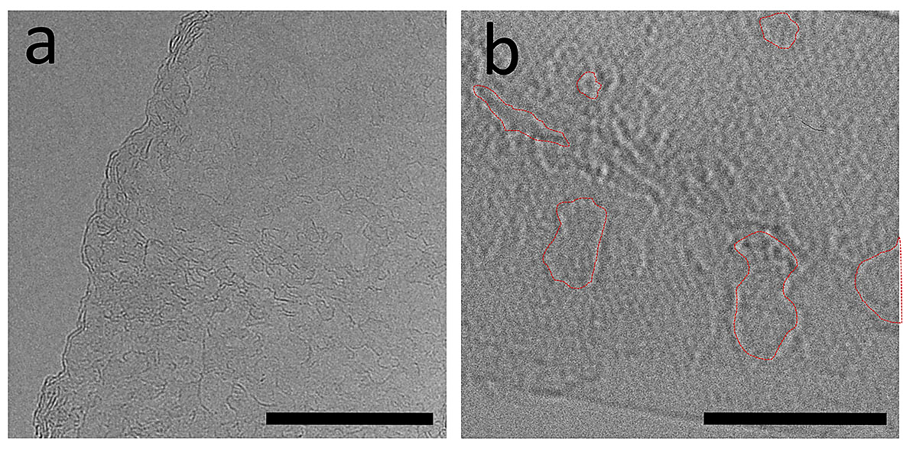
Supplementary Figure 1. HRTEM images of defective graphene nanosheets. Scale bars: (a) 20 nm, and (b) 5 nm

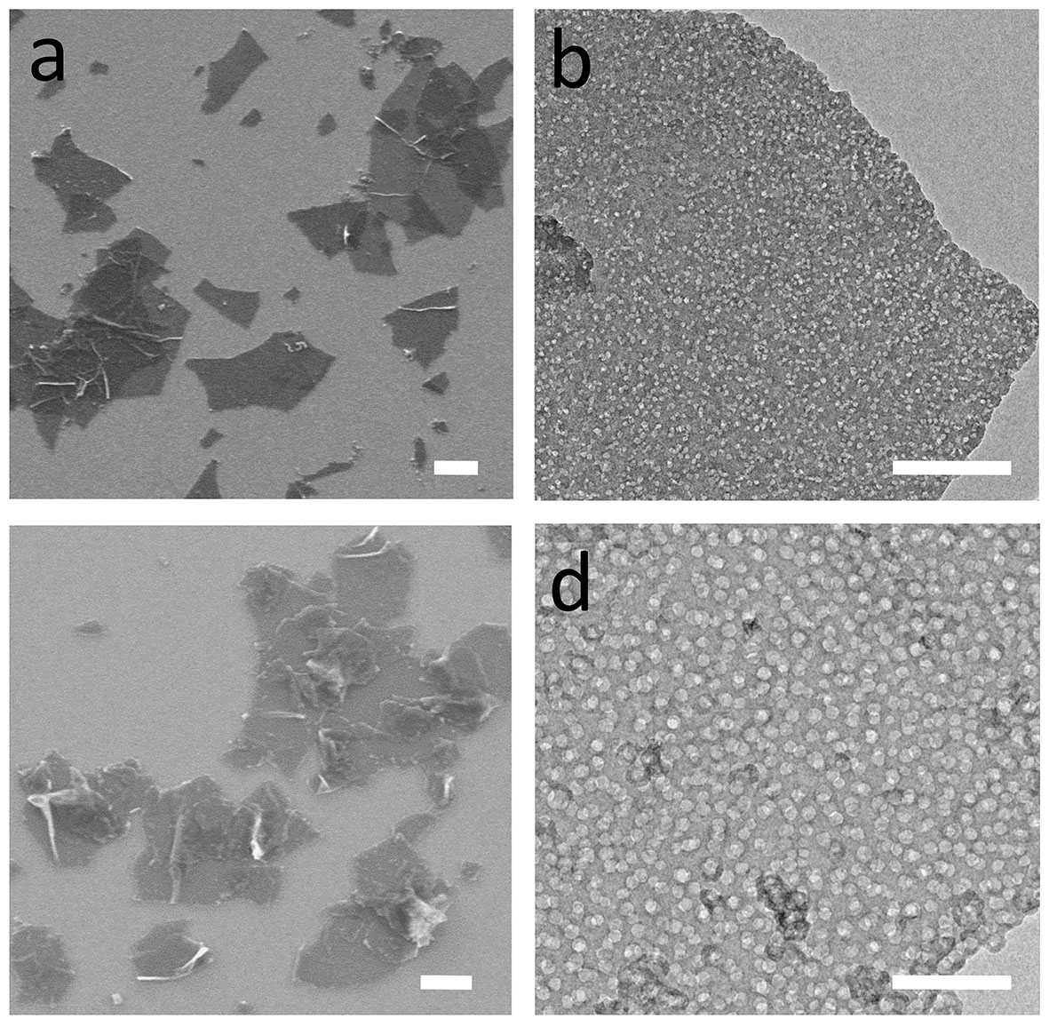
Supplementary Figure 2. Characterization of mPG-7 and mPG-22 nanosheets. (a) SEM image, and (b) TEM image of 2D mPG-7 nanosheets. (c) SEM image, and (d) TEM image of 2D mPG-22 nanosheets. Scale bars: (a, c) 1 μm, and (b, d) 200 nm

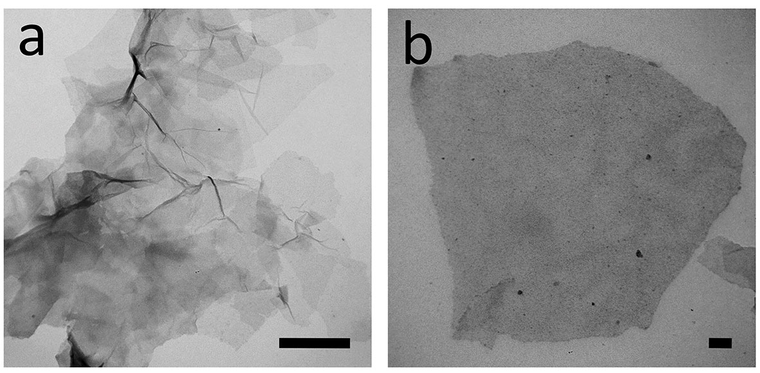
Supplementary Figure 3. TEM images of nPG nanosheets. Scale bars: (a) 500 nm, and (b) 100 nm

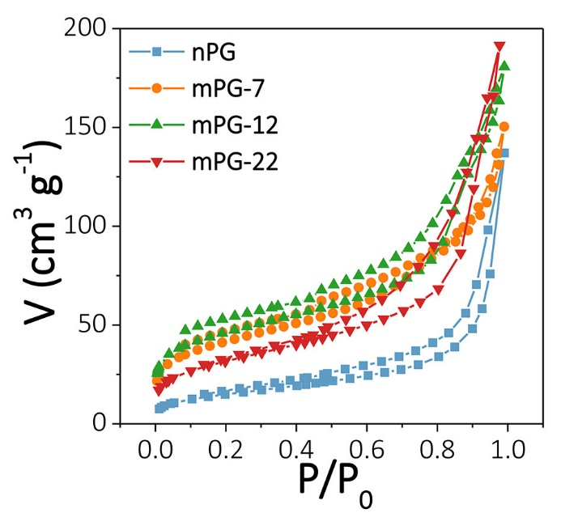
Supplementary Figure 4. N₂ adsorption and desorption isotherms of 2D mPG-7, mPG-12, mPG-22 and nPG nanosheets, respectively.

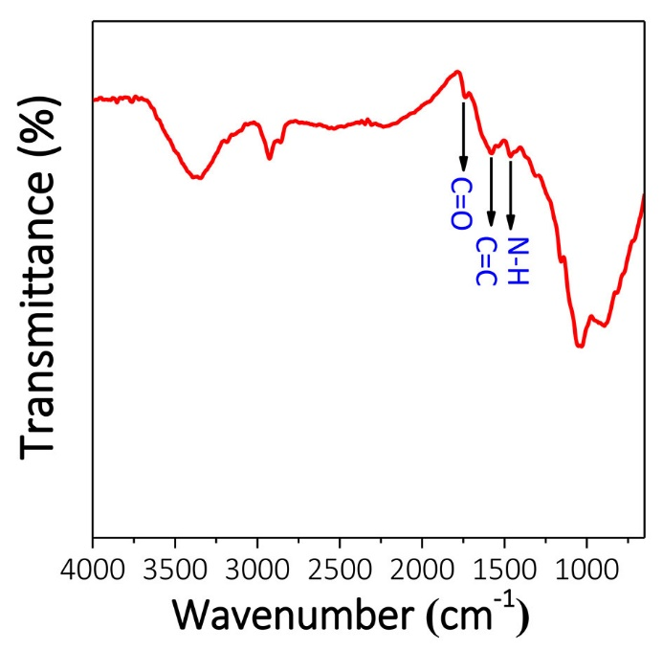
Supplementary Figure 5. FT-IR spectrum of 2D mPG-12 nanosheets.

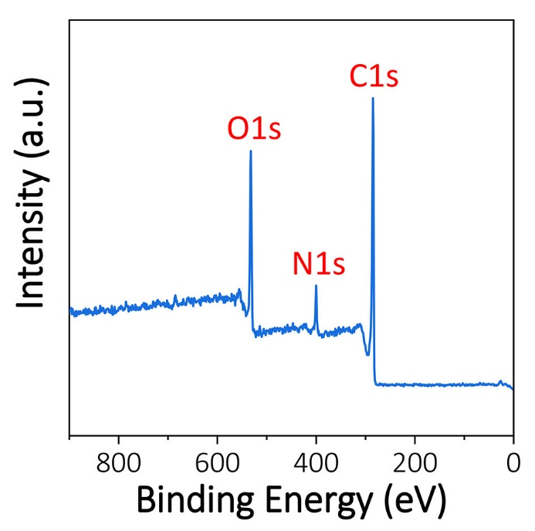
Supplementary Figure 6. XPS wide scan survey of 2D mPG-12 nanosheets.

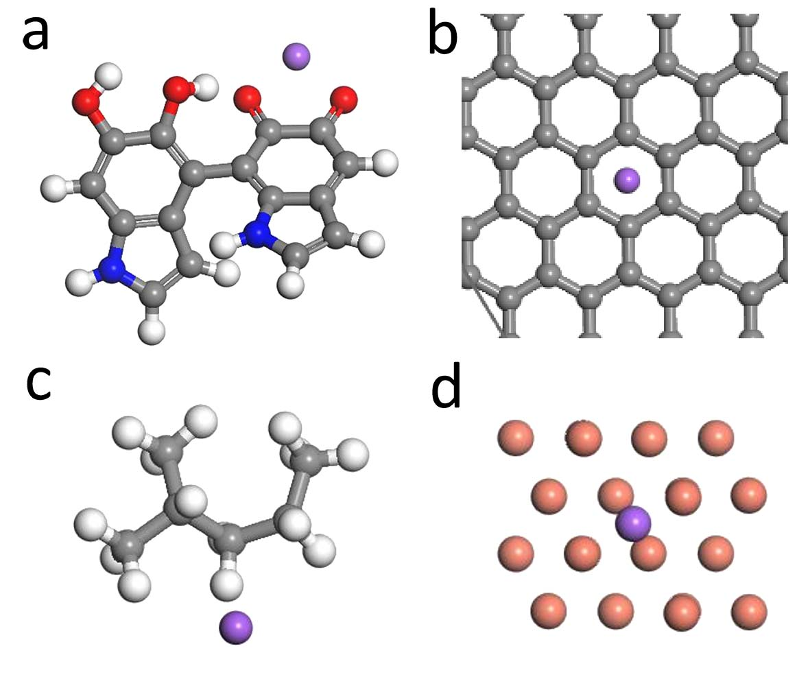
Supplementary Figure 7. Atomic models of (a) polydopamine, (b) graphene, (c) PP, and (d) Cu with Na atom used DFT calculations.

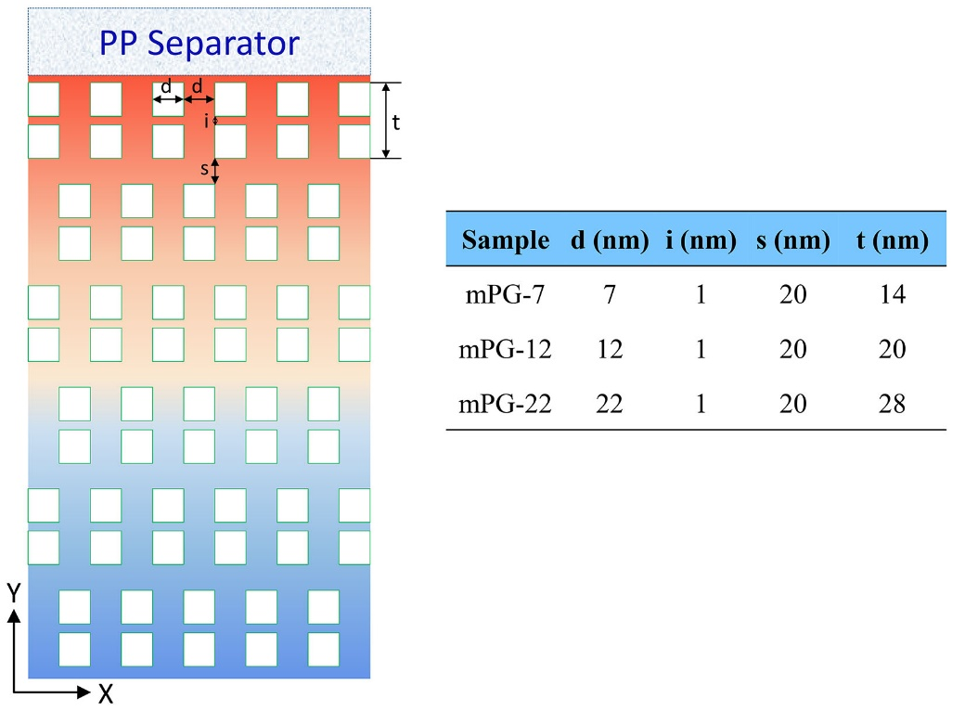
Supplementary Figure 8. FVM model parameters of Na ions through 2D mPG-7, mPG-12 and mPG-22 layers, respectively.

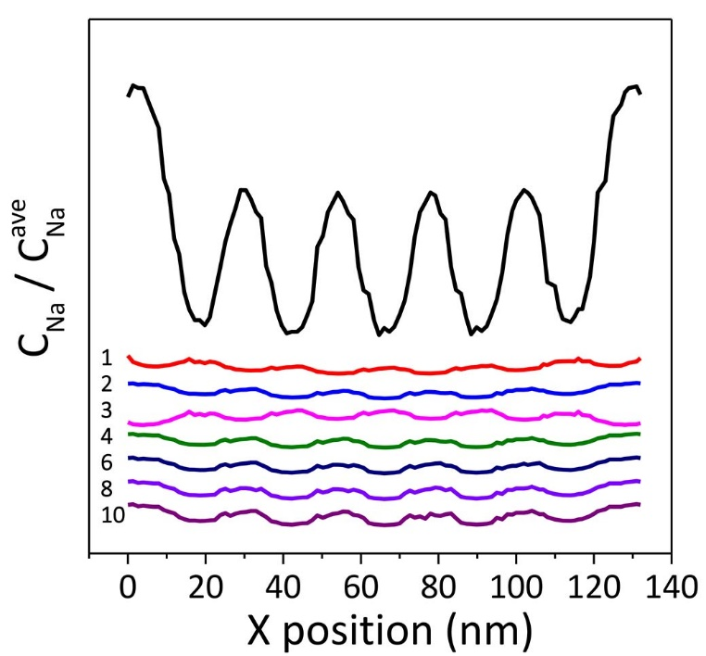
Supplementary Figure 9. The relative concentration of Na ions beneath different mPG layer with same fluctuation and period of Na ion distribution at the entrance.

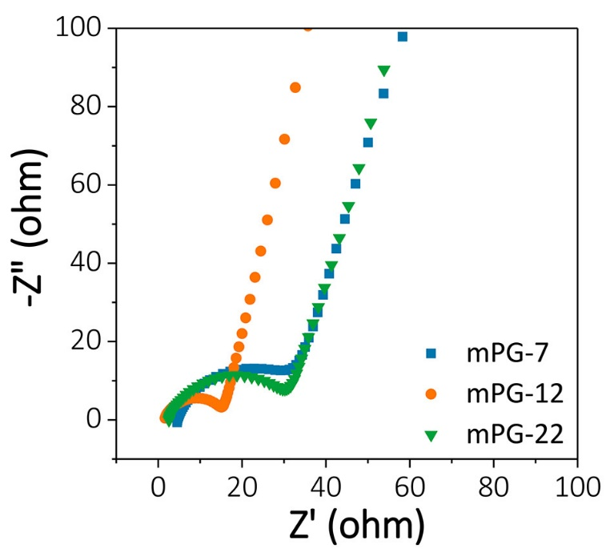
Supplementary Figure 10. EIS plots of Na/Cu cells with different mPG based separators.

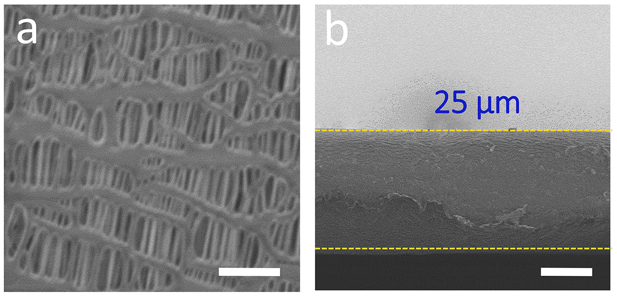
Supplementary Figure 11. Characterization of bare PP separator. (a) Top-view image, and (b) cross-section image of bare PP separator. Scale bars: (a) 1 μm, and (b) 10 μm

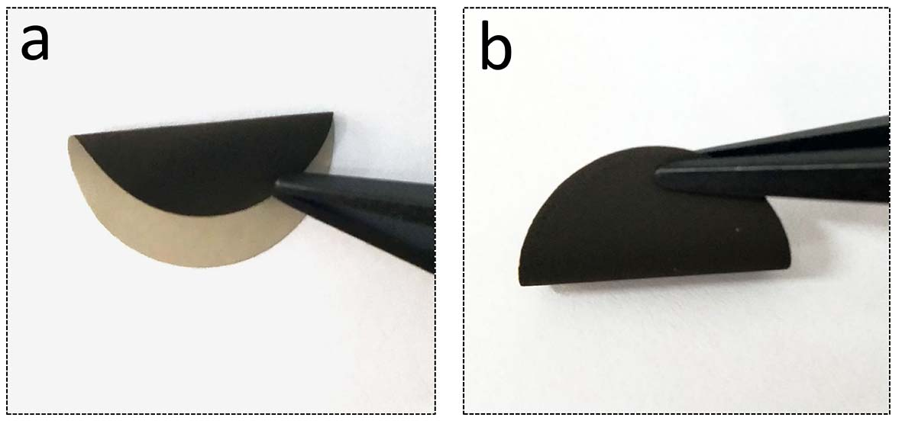
Supplementary Figure 12. (a, b) Digital photographs of mPG-12@PP separators with different bent states.

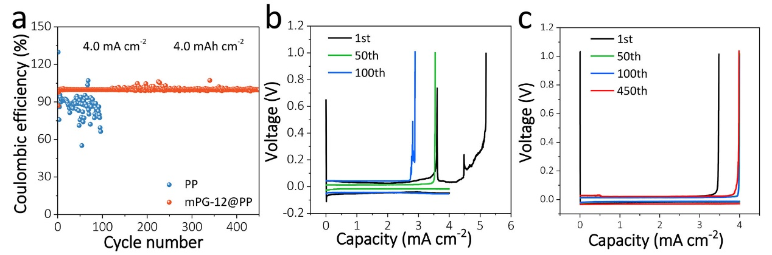
Supplementary Figure 13. Electrochemical performance of of Na/Cu cells with PP and mPG-12@PP separators at 4.0 mA cm⁻², 4.0 mAh cm⁻². (a) Coulombic efficiencies comparison. (b, c) Corresponding voltage profiles of Na/Cu cells with (b) PP, and (c) mPG-12@PP separator at different cycle.

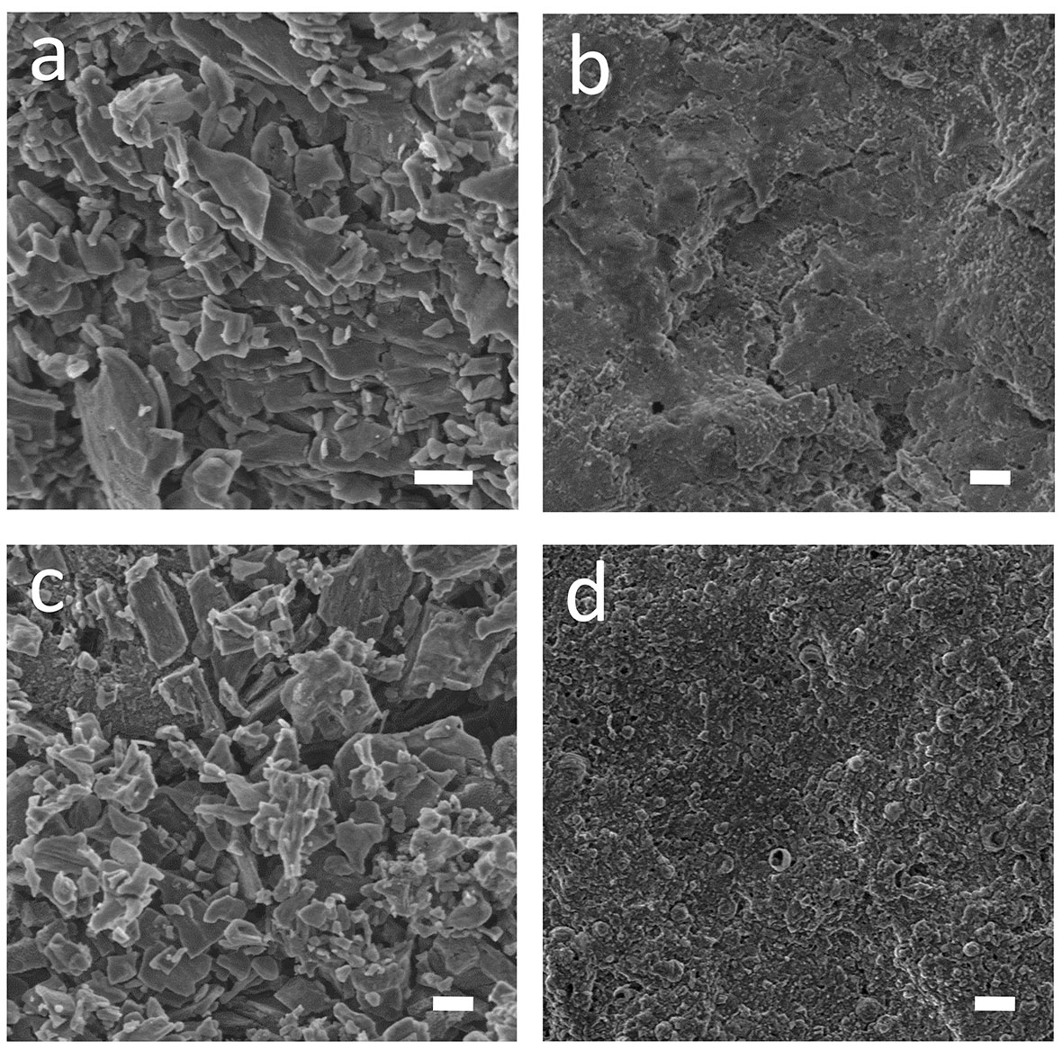
Supplementary Figure 14. Characterization of Na deposition with PP and mPG-12@PP separators. (a, b) Top-view SEM images of Na deposition with (a) PP, and (b) mPG-12@PP separators tested at 0.5 mA cm⁻², 1.0 mAh cm⁻². (c, d) Top-view SEM images of Na deposition with (c) PP, and (d) mPG-12@PP separators obtained at 0.5 mA cm⁻², 2.0 mAh cm⁻². Scale bars: 2 μm

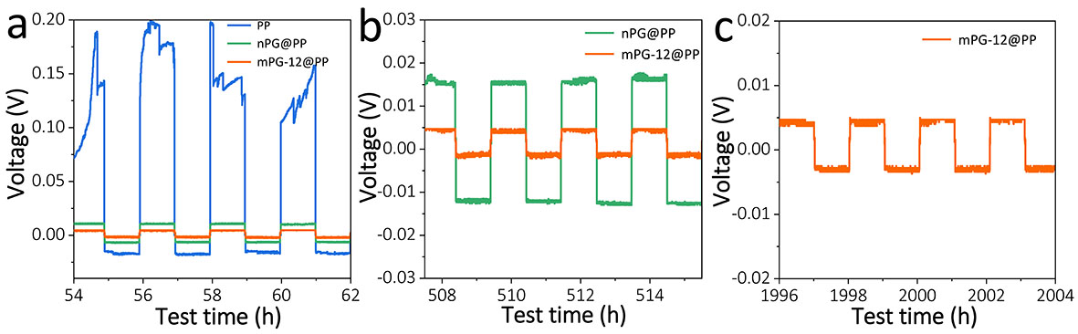
Supplementary Figure 15. Magnified voltage profiles of Na/Na cells with mPG-12@PP, nPG@PP and PP separators at different time. (a) ~60 h, (b) ~510 h, and (c) ~2000 h.

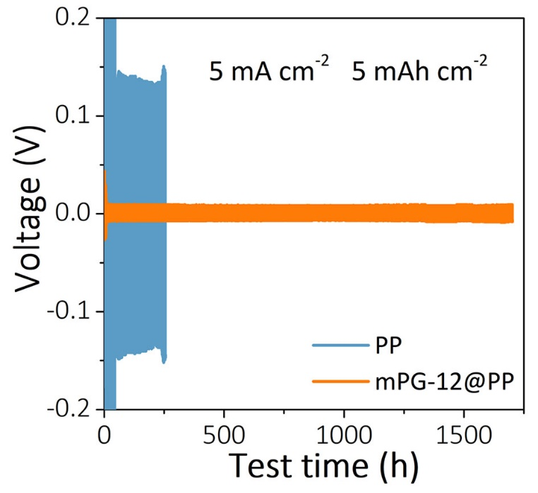
Supplementary Figure 16. Voltage-time profiles of Na/Na symmetric cells with mPG-12@PP and PP separators tested at 5 mA cm⁻², 5 mAh cm⁻².

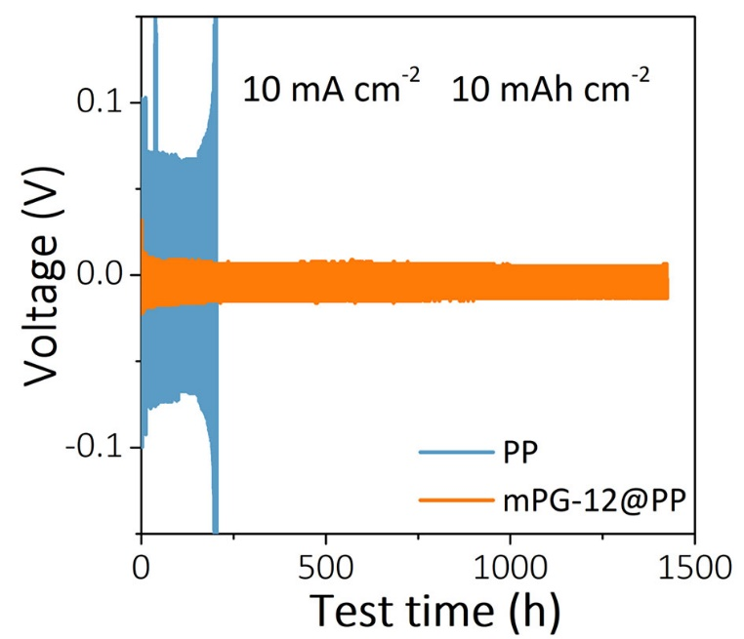
Supplementary Figure 17. Voltage-time profiles of Na/Na symmetric cells with mPG-12@PP and PP separators obtained at 10 mA cm⁻², 10 mAh cm⁻².

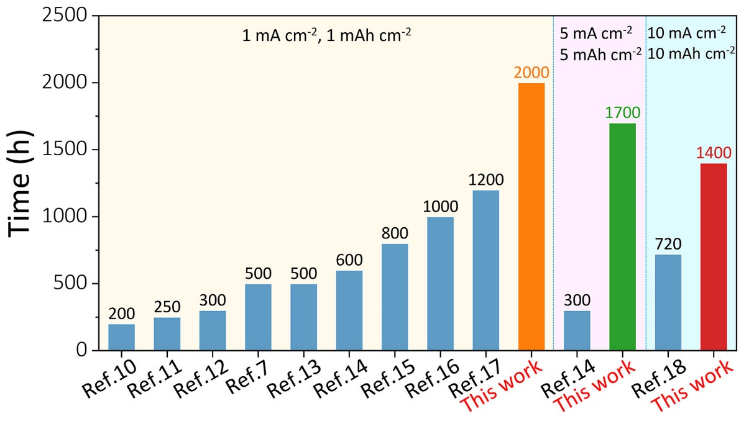
Supplementary Figure 18. Comparison of cycling stability of Na metal anodes with mPG-12@PP separator and those of previously reported Na anodes stabilized by various methods at the same current densities and capacity^{7, 10-18}.

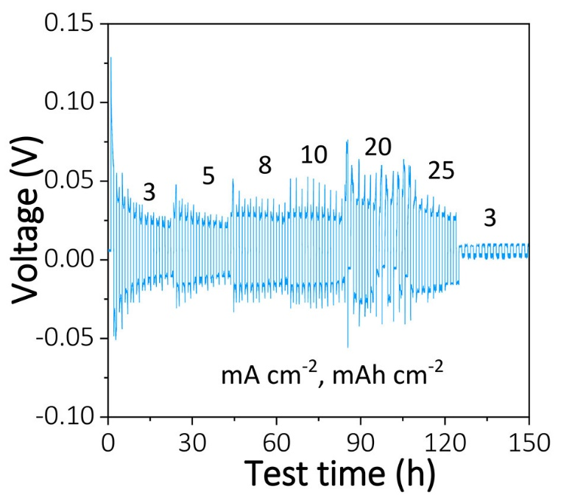
Supplementary Figure 19. Rate performance of Na/Na cells with PP separator at different current densities and capacity, respectively.

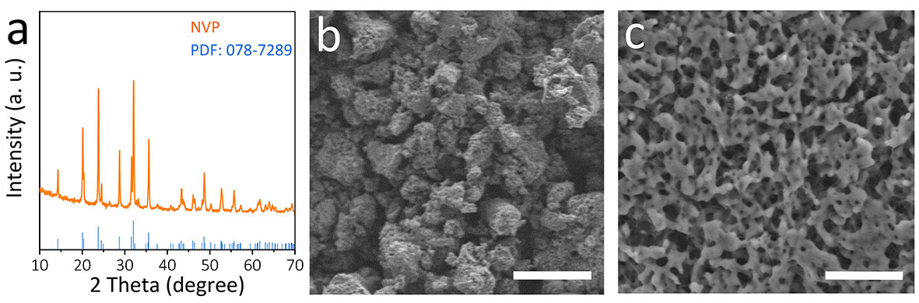
Supplementary Figure 20. Characterization of NVP. (a) XRD pattern, and (b, c) SEM images. Scale bars: (b) 10 μm, and (c) 1 μm

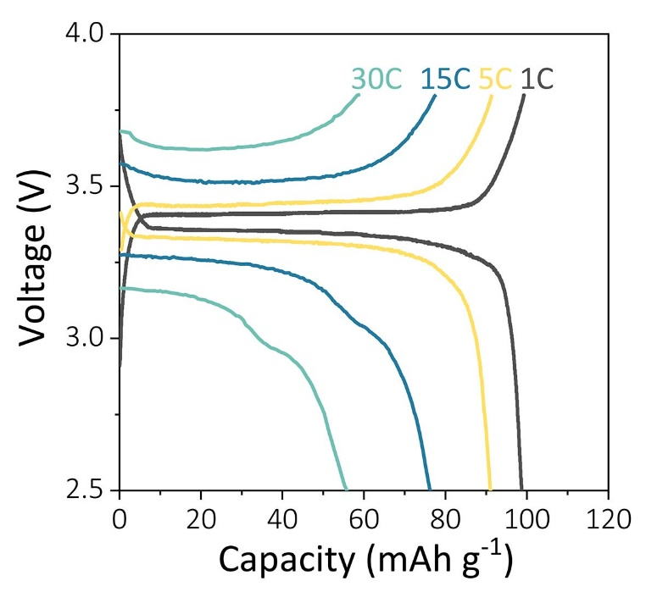
Supplementary Figure 21. Galvanostatic charge-discharge profiles of Na/NVP full cells with PP separator obtained at varying current densities.

Supplementary Table 1. Structural parameters of mPG-7, mPG-12, mPG-22 and nPG obtained by N₂ adsorption and desorption measurements.
Sample | Surface area  (m² g⁻¹) | Pore volume  (cm³ g⁻¹) | Pore size  (nm)
mPG-7 | 144 | 0.23 | 6.8
mPG-12 | 157 | 0.26 | 12.2
mPG-22 | 114 | 0.30 | 18.6
nPG | 54 | ~ | ~

Supplementary Table 2. Cycle life comparison of different Na metal anodes stabilized by various strategies.
Strategies of Na anode | Current density  (mA cm⁻²) | Areal capacity  (mAh cm⁻²) | Cycle time  (h) | Refs.
Na@3D MXene-MF | 10 | 10 | 720 | 18
Na@rGO | 5 | 5 | 300 | 14
Na@rGO | 1 | 1 | 600 | 14
Na@PVDF | 1 | 1 | 1200 | 17
Na@N-doped graphene | 1 | 1 | 1000 | 16
PhS₂Na₂ protection layer | 1 | 1 | 800 | 15
Na@carbonized wood | 1 | 1 | 500 | 13
N, S- doped CNTs interlayer | 1 | 1 | 500 | 7
Na@3D NVP | 1 | 1 | 300 | 12
Na@O-doped CNTs | 1 | 1 | 250 | 11
Na@porous Cu | 1 | 1 | 200 | 10
mPG-12@PP | 1 | 1 | 2000 | This work
mPG-12@PP | 5 | 5 | 1700 | This work
mPG-12@PP | 10 | 10 | 1400 | This work
MF: melamine foam; PhS₂Na₂: sodium benzenedithiolate.

Supplementary Table 3. Rate performance comparison of Na metal anode in this work with the recently reported works.
Strategies of Na anode | Current density  (mA cm⁻²) | Areal capacity  (mAh cm⁻²) | Ref.
Na@3D MXene-MF | 20 | 20 | 18
Na@Hg alloy | 8 | 8 | 19
Na@C@Sb | 5 | 1 | 20
Na@Sb₂MoO₆ | 10 | 8 | 21
Na@ 3D O-doped CNT | 10 | 2 | 6
Na@rGO aerogel | 5 | 5 | 22
Na@Sn²⁺ pillared Ti₃C₂ | 8 | 3 | 23
Na@porous Cu | 3 | 1 | 10
Na@3D carbon felt | 5 | 2 | 24
mPG-12@PP | 25 | 25 | This work

References
1. Dreyer D.R., Park S., Bielawski C.W., Ruoff R.S. The chemistry of graphene oxide. Chem. Soc. Rev. 39, 228-240 (2010).
2. Zhu Y., et al. Graphene and graphene oxide: synthesis, properties, and applications. Adv. Mater. 22, 3906-3924 (2010).
3. Yao Y., Jiang Y., Yang H., Sun X., Yu Y. Na₃V₂(PO₄)₃ coated by N-doped carbon from ionic liquid as cathode materials for high rate and long-life Na-ion batteries. Nanoscale 9, 10880-10885 (2017).
4. Zhang X., et al. Na₃V₂(PO₄)₃: an advanced cathode for sodium-ion batteries. Nanoscale 11, 2556-2576 (2019).
5. Wang H., Matios E., Luo J., Li W. Combining theories and experiments to understand the sodium nucleation behavior towards safe sodium metal batteries. Chem. Soc. Rev. 49, 3783-3805 (2020).
6. Ye L., et al. A sodiophilic interphase-mediated, dendrite-free anode with ultrahigh specific capacity for sodium-metal batteries. Angew. Chem. Int. Ed. 58, 17054-17060 (2019).
7. Sun B., et al. Dendrite-free sodium-metal anodes for high-energy sodium-metal batteries. Adv. Mater., e1801334 (2018).
8. Weller H.G., Tabor G., Jasak H., Fureby C. A tensorial approach to computational continuum mechanics using object-oriented techniques. Comput. Phy. 12, 620-631 (1998).
9. Zhao C.Z., et al. An ion redistributor for dendrite-free lithium metal anodes. Sci. Adv. 4, eaat3446 (2018).
10. Wang C., Wang H., Matios E., Hu X., Li W. A chemically engineered porous copper matrix with cylindrical core-shell skeleton as a stable host for metallic sodium anodes. Adv. Funct. Mater. 28, 1802282 (2018).
11. Chu C., et al. Uniform nucleation of sodium in 3D carbon nanotube framework via oxygen doping for long-life and efficient Na metal anodes. Energy Storage Mater. 23, 137-143 (2019).
12. Guo M., et al. Three dimensional frameworks of super ionic conductor for thermodynamically and dynamically favorable sodium metal anode. Nano Energy 70, 104479 (2020).
13. Luo W., et al. Encapsulation of metallic Na in an electrically conductive host with porous channels as a highly stable Na metal anode. Nano Lett. 17, 3792-3797 (2017).
14. Wang A., et al. Processable and moldable sodium-metal anodes. Angew. Chem. Int. Ed. 56, 11921-11926 (2017).
15. Zhu M., et al. Dendrite-free sodium metal anodes enabled by a sodium benzenedithiolate-rich protection layer. Angew. Chem. Int. Ed. 59, 6596-6600 (2020).
16. Bao C., et al. Sodiophilic decoration of a three-dimensional conductive scaffold toward a stable na metal anode. ACS Sustainable Chem. Eng. 8, 5452-5463 (2020).
17. Hou Z., et al. Poly(vinylidene difluoride) coating on Cu current collector for high-performance Na metal anode. Energy Storage Mater. 24, 588-593 (2020).
18. Shi H., et al. 3D flexible, conductive, and recyclable Ti₃C₂T_{x} MXene-melamine foam for high-areal-capacity and long-lifetime alkali-metal anode. ACS Nano 14, 8678-8688 (2020).
19. Zhang Q., Hu M., He J., Liu X.Z., He G., Ding Y. A thermodynamically stable quasi-liquid interface for dendrite-free sodium metal anodes. J. Mater. Chem. A 8, 6822-6827 (2020).
20. Wang G., et al. Core-shell C@Sb nanoparticles as a nucleation layer for high-performance sodium metal anodes. Nano Lett. 20, 4464-4471 (2020).
21. Lu X., et al. Enabling high-performance sodium metal anodes via a sodiophilic structure constructed by hierarchical Sb₂MoO₆ microspheres. Nano Energy 69, 104446 (2020).
22. Wu F., et al. Reduced graphene oxide aerogel as stable host for dendrite-free sodium metal anode. Energy Storage Mater. 22, 376-383 (2019).
23. Luo J., et al. Pillared MXene with ultralarge interlayer spacing as a stable matrix for high performance sodium metal anodes. Adv. Funct. Mater. 29, 1805946 (2019).
24. Chi S.-S., Qi X.-G., Hu Y.-S., Fan L.-Z. 3D flexible carbon felt host for highly stable sodium metal anodes. Adv. Energy Mater. 8, 1702764 (2018).

