Overexpression of bank vole PrP(I109) in mice induces a spontaneous atypical prion disease with sex-dependent onset, early NfL elevation, and universal prion strain permissiveness

Hasier Eraña^{1,2,3}, Enric Vidal^{4,5}, Natalia Fernández-Borges⁶, Jorge M. Charco^{1,2,3}, Carlos M. Díaz‑Domínguez¹, Cristina Sampedro-Torres-Quevedo^{1,2}, Maitena San-Juan-Ansoleaga¹, Eva Fernández-Muñoz¹, Josu Galarza-Ahumada¹, Miguel Ángel Pérez-Castro¹, Nuno Gonçalves-Anjo¹, Patricia Piñeiro¹, Laura Pirisinu⁷, Michele Angelo Di Bari⁷, Samanta Giler^{4,5}, Ilaria Raimondi⁸, Juan Carlos Espinosa⁶, Ilaria Vanni⁷, Claudia D’Agostino⁷, Juan Rodríguez-Cuesta¹, Laura Pasetto⁸, Valentina Bonetto⁸, Nora González-Martín⁹, Susana Teijeira¹⁰, Wen-Quan Zou¹¹, Mariví Geijo¹², Juan Maria Torres⁶, Roberto Chiesa⁸, Manuel A. Sánchez‑Martín^{9,13}, Romolo Nonno⁷, Jesús R. Requena¹⁴, and Joaquín Castilla^{1,2,15,*}

¹ Center for Cooperative Research in Biosciences (CIC BioGUNE), Basque Research and Technology Alliance (BRTA), Derio, Spain.
² Centro de Investigación Biomédica en Red de Enfermedades infecciosas (CIBERINFEC), Carlos III National Health Institute, Madrid, Spain.
³ ATLAS Molecular Pharma S. L., Derio, Spain.
⁴ IRTA. Programa de Sanitat Animal. Centre de Recerca en Sanitat Animal (CReSA). Campus de la Universitat Autònoma de Barcelona (UAB), Bellaterra, Catalonia. Spain.
⁵ Unitat mixta d’Investigació IRTA-UAB en Sanitat Animal. Centre de Recerca en Sanitat Animal (CReSA). Campus de la Universitat Autònoma de Barcelona (UAB), Bellaterra, Catalonia. Spain.
⁶ Centro de Investigación en Sanidad Animal (CISA), Consejo Superior de Investigaciones Científicas (CSIC), Instituto Nacional de Investigación y Tecnología Agraria y Alimentaria (INIA), Valdeolmos, Madrid, Spain.
⁷ Department of Food Safety, Nutrition and Veterinary Public Health, Istituto Superiore di Sanita, Rome, Italy.
⁸ Department of Neuroscience, Istituto di Ricerche Farmacologiche Mario Negri IRCCS, Milan, Italy.
⁹ Institute for Biomedical Research of Salamanca (IBSAL), University Hospital of Salamanca, University of Salamanca, Spanish National Research Council (CSIC), Salamanca, Spain.
¹⁰ Grupo de Enfermedades Raras y Medicina Pediátrica, Instituto de Investigación Sanitaria Galicia Sur (IISGS), Vigo, Spain.
¹¹ Institute of Neurology, Jiangxi Academy of Clinical Medical Sciences, The First Affiliated Hospital, Jiangxi Medical College, Nanchang University, Nanchang, Jiangxi, China.
¹² Animal Health Department, NEIKER-Basque Institute for Agricultural Research and Development. Basque Research and Technology Alliance (BRTA), Derio, Spain.
¹³ Transgenic Facility. Department of Medicine, University of Salamanca, 37007 Salamanca, Spain.
¹⁴ CIMUS Biomedical Research Institute, University of Santiago de Compostela-IDIS, Santiago, Spain.
¹⁵ IKERBASQUE, Basque Foundation for Science, Bilbao, Spain.

* Corresponding author: Joaquín Castilla, e-mail: jcastilla@cicbiogune.es

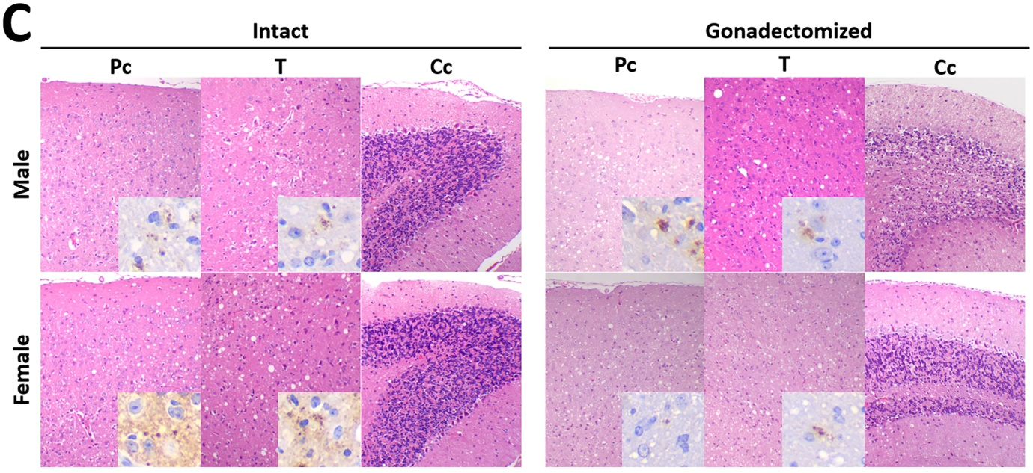
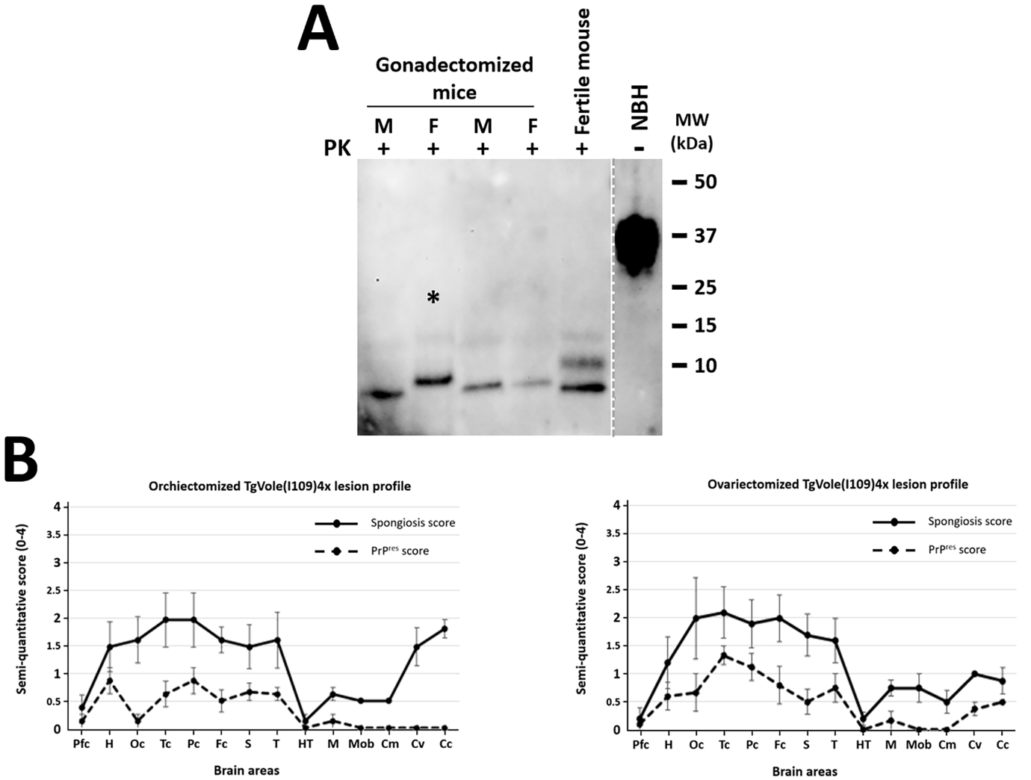
Supplementary figure 1. Biochemical and neuropathological analysis of brains from gonadectomized TgVole(I109)4x mice developing spontaneous prion disease. A) Biochemical characterization. Western blot analysis of proteinase K-resistant PrP from brain homogenates of gonadectomized TgVole(I109)4x mice. Brain homogenates (10% w/v) from two orchiectomized males (M) and two ovariectomized females (F) were processed using the modified Wenborn protocol and compared with PrP^{res} from an intact fertile mouse from the same line that also succumbed to spontaneous disease. All samples were digested with 10 μg/ml proteinase K (PK) and revealed a prominent low molecular weight fragment (~7-10 kDa) in all spontaneously ill animals without notable differences between sexes or compared to the intact fertile mouse. All samples showed a duplet of less intense higher molecular weight fragments. The sample marked with an asterisk (*) was sonicated prior to loading due to high viscosity that prevented proper migration in a previous run; its altered migration pattern likely reflects sample viscosity effects. An undigested brain homogenate from a healthy TgVole(I109)4x mouse (NBH, dashed line separation) serves as negative control. Detection was performed using 9A2 monoclonal antibody (1:4000). PK: proteinase K; M: male; F: female; NBH: normal brain homogenate; MW: molecular weight marker. B) Lesion profiles. Semi-quantitative scoring (0–4) of spongiosis (solid line) and PrP^{res} deposition (dashed line) across 14 brain regions in orchiectomized and ovariectomized mice shows overall profiles comparable to those previously observed in intact TgVole(I109)4x animals. The main difference is a higher spongiosis score in the cerebellar cortex of orchiectomized animals; the remaining regions display similar distributions and PrP^{res} loads, indicating that gonadectomy does not materially alter the biological features of the spontaneous strain in this line. Brain regions: Pfc (piriform cortex), H (hippocampus), Oc (occipital cortex), Tc (temporal cortex), Pc (parietal cortex), Fc (frontal cortex), S (striatum), T (thalamus), HT (hypothalamus), M (mesencephalon), Mob (medulla oblongata), Cm (cerebellar nuclei), Cv (cerebellar vermis), Cc (cerebellar cortex). C) Representative histopathology and anti-PrP immunohistochemistry. H&E sections from parietal cortex (Pc), thalamus (T) and cerebellar cortex (Cc) in intact and gonadectomized males and females illustrate the typical spontaneous disease phenotype in TgVole(I109)4x mice. Insets show anti-PrP immunohistochemistry (antibody and conditions as in Materials & Methods), highlighting granular/punctate PrP^{res} deposits where present. Consistent with panel B, overall lesion distribution and PrP^{res} deposition patterns are largely conserved between intact and gonadectomized animals, with a relatively higher spongiosis in the cerebellar cortex of orchiectomized males.
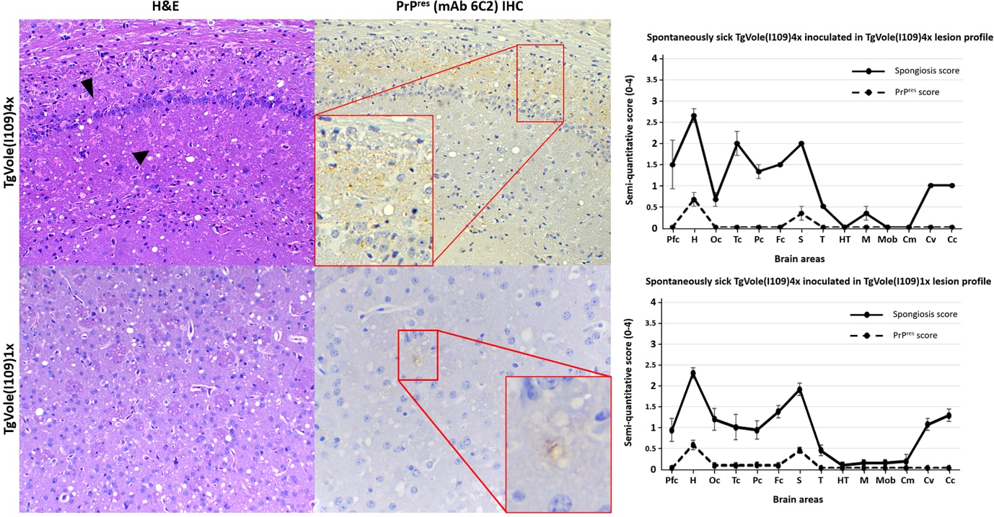
Supplementary Figure 2. Neuropathological analysis of TgVole(I109)4x and TgVole(I109)1x mice inoculated with brain homogenate from spontaneously ill TgVole(I109)4x mice. Representative histopathological and immunohistochemical analysis of mice inoculated intracerebrally with 1% brain homogenate from terminally ill TgVole(I109)4x mice. Images show hematoxylin and eosin (H&E) staining for spongiform lesion assessment and PrP^{res} immunohistochemistry using 6C2 monoclonal antibody (1:1000). Upper panels [TgVole(I109)4x]: Hippocampal region showing moderate to intense spongiosis, conspicuous astrogliosis (arrowheads), thinned pyramidal layer, and fine punctate PrP^{res} immunolabeled deposits in the stratum oriens. Lower panels [TgVole(I109)1x]: Striatal region displaying evident spongiform lesions and faint PrP^{res} labeling. The lesion profiles (right panels) demonstrate similar patterns between both models, which differ from spontaneously developed pathology in several key aspects: (1) absence of plaques in inoculated animals, (2) weak and focal immunostaining primarily restricted to hippocampus and striatum (with cortical involvement in one animal), (3) absence of thalamus involvement in inoculated animals, and (4) minimal brainstem involvement in both spontaneous and inoculated cases. The absence of plaques and weak immunostaining may reflect rapid disease progression preventing plaque formation or indicate that plaque development does not occur in this transmission context.

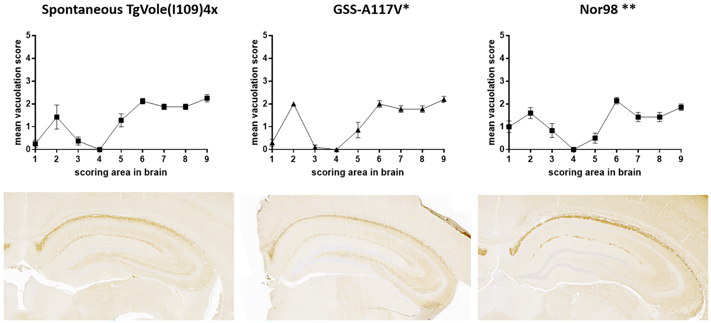

Supplementary figure 3. Histopathological analysis of bank voles inoculated with spontaneously ill TgVole(I109)4x brain homogenate. Bank voles expressing I109 polymorphic PrP^{C} were inoculated intracerebrally with 1% brain homogenate from spontaneously ill TgVole(I109)4x mice. Spongiform lesions and PrP^{res} deposition were evaluated through neuropathological analysis using hematoxylin and eosin (H&E) staining to characterize vacuolar degeneration in nine gray-matter brain regions: (1) medulla, (2) cerebellum, (3) superior colliculus, (4) hypothalamus, (5) thalamus, (6) hippocampus, (7) septum, (8) retrosplenial and adjacent motor cortex, and (9) cingulate and adjacent motor cortex. Upper panels: Lesion profiles showing mean vacuolation scores (0-4 scale) across the nine brain regions. The lesion profile of spontaneously generated TgVole(I109)4x prions was highly similar to that observed in TgVole(I109)4x and TgVole(I109)1x mice inoculated with the same prion strain, and strikingly resembled patterns previously observed upon inoculation of GSS-A117V and Nor98 atypical scrapie isolates in the same animal species. Lower panels: Representative immunohistochemical analysis using SAF84 monoclonal antibody for PrP^{res} detection. The PrP^{res} deposition pattern was indistinguishable from that observed for GSS-A117V and Nor98 inoculations in bank voles. Comparative immunohistochemical data for GSS and Nor98 inoculations in bank voles have been published previously: *GSS-A117V (inoculum #1-A117V) from Vanni et al., 2016 [2]; **Nor98 (inoculum Sh-N3) from Pirisinu et al., 2022 [1] .

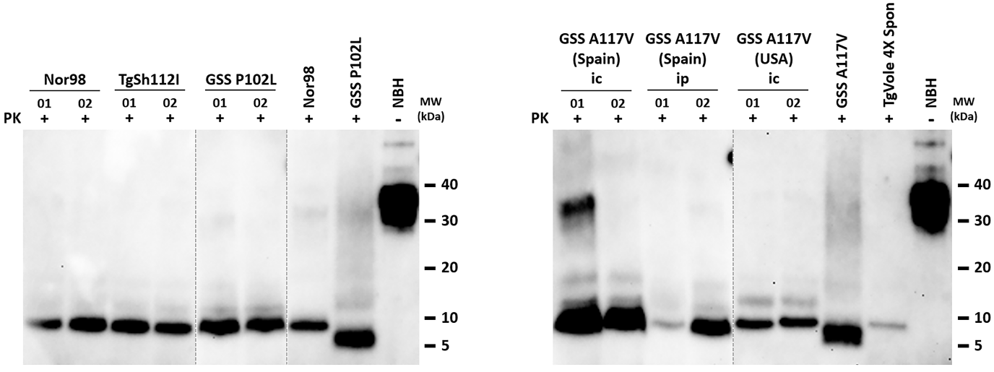

Supplementary Figure 4. Biochemical analysis of proteinase K-resistant PrP from TgVole(I109)4x mice inoculated with atypical prions from diverse origins. A panel of atypical prion isolates characterized by a predominant 7-10 kDa PrP^{Sc} fragment was selected for inoculation into TgVole(I109)4x mice. Brain homogenates (1% w/v) containing atypical scrapie (Nor98), TgShI112-derived prions, GSS-P102L, and two GSS-A117V isolates from Spanish and American origins were inoculated intracerebrally (ic). Additionally, the Spanish GSS-A117V isolate was inoculated intraperitoneally (ip). Brain homogenates (10% w/v) from TgVole(I109)4x mice showing neurological impairment were processed using the modified Wenborn protocol and digested with 10 μg/ml proteinase K (PK). Western blot analysis was performed using 9A2 monoclonal antibody (1:4000). All analyzed animals showed the expected 7-10 kDa PK-resistant predominant fragment, demonstrating the capacity of this model to propagate atypical prions from diverse origins. The predominant fragment was identical in molecular weight to the original Nor98 isolate (control) and the fragment found in spontaneously ill TgVole(I109)4x mice (TgVole 4x Spon, size reference in right gel). For GSS inoculations, the predominant PrP^{res} fragment in TgVole(I109)4x mice differed in size from the original human isolates (GSS-P102L and GSS-A117V), both showing lower molecular weight bands. This may indicate structural adaptation of prions propagated in this model or reflect species-specific differences not necessarily altering the biological properties of the strain. Samples from GSS-P102L-inoculated animals were run on a separate gel (left, indicated by dashed lines) along with Nor98, GSS-P102L, and undigested healthy TgVole(I109)4x brain homogenate (NBH) controls. Samples from Spanish GSS-A117V-inoculated animals were run separately from American isolate samples (right gel) with their respective controls: GSS-A117V (Spanish isolate), TgVole 4x Spon, and NBH. PK: proteinase K; ic: intracerebral; ip: intraperitoneal; MW: molecular weight marker; NBH: normal brain homogenate.

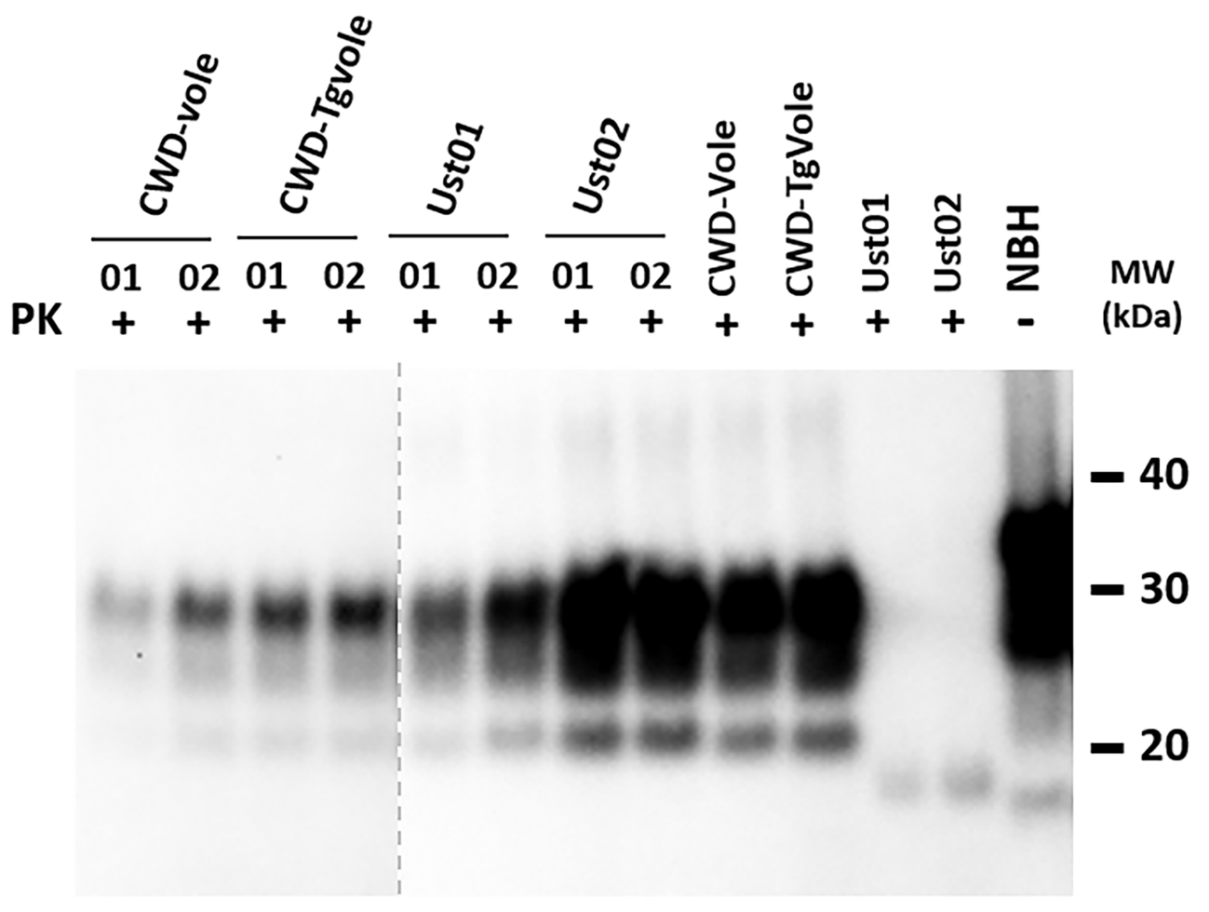

Supplementary Figure 5. Biochemical characterization of classical and recombinant prion strains propagated in TgVole(I109)4x mice. Western blot analysis of proteinase K (PK)-digested brain homogenates from TgVole(I109)4x mice inoculated with various classical and recombinant prion strains. All samples were processed using standard PK digestion conditions and show the characteristic three-band pattern of classical prion strains. CWD-vole: chronic wasting disease strain adapted to bank voles; CWD-TgVole: CWD-vole strain passaged through TgVole(I109)1x mice; Ust01 and Ust02: recombinant prion strains generated spontaneously in vitro from recombinant bank vole PrP. Numbers 01 and 02 represent individual mouse samples from each experimental group. The first four lanes (CWD-vole and CWD-TgVole samples, separated by dashed line) were exposed 6-fold longer to achieve signal intensity comparable to the remaining samples. The four samples on the right represent the original inocula used for propagation in the TgVole(I109)4x model, serving as strain controls. Note that recombinant strains Ust01 and Ust02 do not exhibit glycosylated forms. NBH: normal brain homogenate (negative control, undigested). Western blot analysis was performed using Sha31 monoclonal antibody (1:4000). All infected samples display the expected PrP^{res} migration pattern with molecular weights between 20-40 kDa, confirming successful propagation and conservation of classical prion strain characteristics in the TgVole(I109)4x model. PK: proteinase K; MW: molecular weight markers (kDa).

Supplementary tables (Raw Data used to generate the plots shown in the main Manuscript file)

Supplementary table 1. Age of male and female TgVole(I109)4x animals at terminal disease stage observed along three different breeding periods. All animals were culled at terminal stage of disease with clear signs of neurological impairment in accordance with the endpoint criteria defined in Materials & Methods section, and age at death in days was registered as equivalent to the age at terminal disease.
Breeding period (years) | Sex | Age at death, terminal disease (days)
2011-2013  (n= 40) | Male  (n=20) | 217
2011-2013  (n= 40) | Male  (n=20) | 222
2011-2013  (n= 40) | Male  (n=20) | 212
2011-2013  (n= 40) | Male  (n=20) | 232
2011-2013  (n= 40) | Male  (n=20) | 238
2011-2013  (n= 40) | Male  (n=20) | 188
2011-2013  (n= 40) | Male  (n=20) | 224
2011-2013  (n= 40) | Male  (n=20) | 235
2011-2013  (n= 40) | Male  (n=20) | 215
2011-2013  (n= 40) | Male  (n=20) | 210
2011-2013  (n= 40) | Male  (n=20) | 224
2011-2013  (n= 40) | Male  (n=20) | 224
2011-2013  (n= 40) | Male  (n=20) | 169
2011-2013  (n= 40) | Male  (n=20) | 218
2011-2013  (n= 40) | Male  (n=20) | 219
2011-2013  (n= 40) | Male  (n=20) | 184
2011-2013  (n= 40) | Male  (n=20) | 179
2011-2013  (n= 40) | Male  (n=20) | 215
2011-2013  (n= 40) | Male  (n=20) | 197
2011-2013  (n= 40) | Male  (n=20) | 217
2011-2013  (n= 40) | Female  (n=20) | 166
2011-2013  (n= 40) | Female  (n=20) | 160
2011-2013  (n= 40) | Female  (n=20) | 160
2011-2013  (n= 40) | Female  (n=20) | 196
2011-2013  (n= 40) | Female  (n=20) | 169
2011-2013  (n= 40) | Female  (n=20) | 198
2011-2013  (n= 40) | Female  (n=20) | 189
2011-2013  (n= 40) | Female  (n=20) | 177
2011-2013  (n= 40) | Female  (n=20) | 156
2011-2013  (n= 40) | Female  (n=20) | 174
2011-2013  (n= 40) | Female  (n=20) | 166
2011-2013  (n= 40) | Female  (n=20) | 174
2011-2013  (n= 40) | Female  (n=20) | 173
2011-2013  (n= 40) | Female  (n=20) | 186
2011-2013  (n= 40) | Female  (n=20) | 131
2011-2013  (n= 40) | Female  (n=20) | 132
2011-2013  (n= 40) | Female  (n=20) | 189
2011-2013  (n= 40) | Female  (n=20) | 141
2011-2013  (n= 40) | Female  (n=20) | 166
2011-2013  (n= 40) | Female  (n=20) | 198
2015-2018  (n=60) | Male  (n=30) | 222
2015-2018  (n=60) | Male  (n=30) | 208
2015-2018  (n=60) | Male  (n=30) | 174
2015-2018  (n=60) | Male  (n=30) | 209
2015-2018  (n=60) | Male  (n=30) | 195
2015-2018  (n=60) | Male  (n=30) | 195
2015-2018  (n=60) | Male  (n=30) | 206
2015-2018  (n=60) | Male  (n=30) | 248
2015-2018  (n=60) | Male  (n=30) | 193
2015-2018  (n=60) | Male  (n=30) | 242
2015-2018  (n=60) | Male  (n=30) | 234
2015-2018  (n=60) | Male  (n=30) | 228
2015-2018  (n=60) | Male  (n=30) | 212
2015-2018  (n=60) | Male  (n=30) | 179
2015-2018  (n=60) | Male  (n=30) | 238
2015-2018  (n=60) | Male  (n=30) | 222
2015-2018  (n=60) | Male  (n=30) | 196
2015-2018  (n=60) | Male  (n=30) | 196
2015-2018  (n=60) | Male  (n=30) | 199
2015-2018  (n=60) | Male  (n=30) | 245
2015-2018  (n=60) | Male  (n=30) | 214
2015-2018  (n=60) | Male  (n=30) | 211
2015-2018  (n=60) | Male  (n=30) | 218
2015-2018  (n=60) | Male  (n=30) | 218
2015-2018  (n=60) | Male  (n=30) | 209
2015-2018  (n=60) | Male  (n=30) | 210
2015-2018  (n=60) | Male  (n=30) | 200
2015-2018  (n=60) | Male  (n=30) | 198
2015-2018  (n=60) | Male  (n=30) | 189
2015-2018  (n=60) | Male  (n=30) | 171
2015-2018  (n=60) | Female  (n=30) | 122
2015-2018  (n=60) | Female  (n=30) | 201
2015-2018  (n=60) | Female  (n=30) | 209
2015-2018  (n=60) | Female  (n=30) | 166
2015-2018  (n=60) | Female  (n=30) | 209
2015-2018  (n=60) | Female  (n=30) | 188
2015-2018  (n=60) | Female  (n=30) | 201
2015-2018  (n=60) | Female  (n=30) | 201
2015-2018  (n=60) | Female  (n=30) | 166
2015-2018  (n=60) | Female  (n=30) | 191
2015-2018  (n=60) | Female  (n=30) | 156
2015-2018  (n=60) | Female  (n=30) | 133
2015-2018  (n=60) | Female  (n=30) | 125
2015-2018  (n=60) | Female  (n=30) | 146
2015-2018  (n=60) | Female  (n=30) | 173
2015-2018  (n=60) | Female  (n=30) | 186
2015-2018  (n=60) | Female  (n=30) | 159
2015-2018  (n=60) | Female  (n=30) | 204
2015-2018  (n=60) | Female  (n=30) | 197
2015-2018  (n=60) | Female  (n=30) | 209
2015-2018  (n=60) | Female  (n=30) | 159
2015-2018  (n=60) | Female  (n=30) | 172
2015-2018  (n=60) | Female  (n=30) | 158
2015-2018  (n=60) | Female  (n=30) | 132
2015-2018  (n=60) | Female  (n=30) | 200
2015-2018  (n=60) | Female  (n=30) | 200
2015-2018  (n=60) | Female  (n=30) | 204
2015-2018  (n=60) | Female  (n=30) | 194
2015-2018  (n=60) | Female  (n=30) | 210
2015-2018  (n=60) | Female  (n=30) | 211
2019-2022  (n=62) | Male  (n=32) | 203
2019-2022  (n=62) | Male  (n=32) | 192
2019-2022  (n=62) | Male  (n=32) | 162
2019-2022  (n=62) | Male  (n=32) | 207
2019-2022  (n=62) | Male  (n=32) | 210
2019-2022  (n=62) | Male  (n=32) | 221
2019-2022  (n=62) | Male  (n=32) | 213
2019-2022  (n=62) | Male  (n=32) | 204
2019-2022  (n=62) | Male  (n=32) | 175
2019-2022  (n=62) | Male  (n=32) | 161
2019-2022  (n=62) | Male  (n=32) | 221
2019-2022  (n=62) | Male  (n=32) | 197
2019-2022  (n=62) | Male  (n=32) | 196
2019-2022  (n=62) | Male  (n=32) | 209
2019-2022  (n=62) | Male  (n=32) | 182
2019-2022  (n=62) | Male  (n=32) | 171
2019-2022  (n=62) | Male  (n=32) | 206
2019-2022  (n=62) | Male  (n=32) | 221
2019-2022  (n=62) | Male  (n=32) | 221
2019-2022  (n=62) | Male  (n=32) | 170
2019-2022  (n=62) | Male  (n=32) | 217
2019-2022  (n=62) | Male  (n=32) | 194
2019-2022  (n=62) | Male  (n=32) | 205
2019-2022  (n=62) | Male  (n=32) | 226
2019-2022  (n=62) | Male  (n=32) | 198
2019-2022  (n=62) | Male  (n=32) | 180
2019-2022  (n=62) | Male  (n=32) | 191
2019-2022  (n=62) | Male  (n=32) | 191
2019-2022  (n=62) | Male  (n=32) | 200
2019-2022  (n=62) | Male  (n=32) | 238
2019-2022  (n=62) | Male  (n=32) | 181
2019-2022  (n=62) | Male  (n=32) | 194
2019-2022  (n=62) | Female  (n=30) | 134
2019-2022  (n=62) | Female  (n=30) | 178
2019-2022  (n=62) | Female  (n=30) | 179
2019-2022  (n=62) | Female  (n=30) | 170
2019-2022  (n=62) | Female  (n=30) | 185
2019-2022  (n=62) | Female  (n=30) | 132
2019-2022  (n=62) | Female  (n=30) | 188
2019-2022  (n=62) | Female  (n=30) | 157
2019-2022  (n=62) | Female  (n=30) | 138
2019-2022  (n=62) | Female  (n=30) | 164
2019-2022  (n=62) | Female  (n=30) | 151
2019-2022  (n=62) | Female  (n=30) | 134
2019-2022  (n=62) | Female  (n=30) | 183
2019-2022  (n=62) | Female  (n=30) | 155
2019-2022  (n=62) | Female  (n=30) | 191
2019-2022  (n=62) | Female  (n=30) | 141
2019-2022  (n=62) | Female  (n=30) | 203
2019-2022  (n=62) | Female  (n=30) | 166
2019-2022  (n=62) | Female  (n=30) | 163
2019-2022  (n=62) | Female  (n=30) | 177
2019-2022  (n=62) | Female  (n=30) | 197
2019-2022  (n=62) | Female  (n=30) | 158
2019-2022  (n=62) | Female  (n=30) | 174
2019-2022  (n=62) | Female  (n=30) | 199
2019-2022  (n=62) | Female  (n=30) | 198
2019-2022  (n=62) | Female  (n=30) | 174
2019-2022  (n=62) | Female  (n=30) | 188
2019-2022  (n=62) | Female  (n=30) | 184
2019-2022  (n=62) | Female  (n=30) | 149
2019-2022  (n=62) | Female  (n=30) | 173

Supplementary table 2. List of TgVole(I109)4x animals subjected to gonadectomy procedures and monitored for the development of spontaneous prion disease.
Sex | Animal ID | Age at death, terminal disease (days)
Female | 303F | 166
Female | 304F | 157
Female | 306F | 140
Female | 494F | 159
Female | 499F | 137
Male | 293E | 170
Male | 299E | 234
Male | 378E | 219
Male | 379E | 211
Male | 381E | 227

Supplementary table 3. List of TgVole(I109)4x animals and NfL levels measured in the course of the spontaneous disease.
Age group | Age (at culling) | Sex | Plasma NfL concentration (pg/ml)
20 days | 22 | Male | 99
20 days | 22 | Male | 113
20 days | 20 | Male | 176
20 days | 20 | Male | 129
20 days | 20 | Male | 114
20 days | 20 | Female | 93
20 days | 20 | Female | 190
20 days | 20 | Female | 117
20 days | 20 | Female | 211
20 days | 20 | Female | 105
20 days | 20 | Female | 119
40 days | 40 | Male | 242
40 days | 40 | Male | 359
40 days | 42 | Male | 851
40 days | 42 | Male | 542
40 days | 43 | Male | 205
40 days | 40 | Female | 238
40 days | 42 | Female | 350
40 days | 43 | Female | 297
40 days | 37 | Female | 119
40 days | 36 | Female | 112
60 days | 57 | Male | 422
60 days | 61 | Male | 128
60 days | 60 | Male | 356
60 days | 59 | Male | 506
60 days | 59 | Male | 228
60 days | 60 | Female | 625
60 days | 60 | Female | 450
60 days | 60 | Female | 333
60 days | 60 | Female | 625
60 days | 60 | Female | 415
80 days | 72 | Male | 355
80 days | 80 | Male | 935
80 days | 80 | Male | 804
80 days | 80 | Male | 383
80 days | 81 | Male | 277
80 days | 80 | Female | 3327
80 days | 80 | Female | 488
80 days | 80 | Female | 626
80 days | 80 | Female | 499
80 days | 80 | Female | 465
80 days | 80 | Female | 548
100 days | 101 | Male | 740
100 days | 101 | Male | 775
100 days | 100 | Male | 4977
100 days | 100 | Male | 680
100 days | 100 | Male | 453
100 days | 101 | Female | 779
100 days | 101 | Female | 431
100 days | 100 | Female | 1253
100 days | 100 | Female | 632
100 days | 93 | Female | 763
100 days | 93 | Female | 1251
100 days | 102 | Female | 2224
120 days | 118 | Male | 387
120 days | 120 | Male | 419
120 days | 120 | Male | 837
120 days | 119 | Male | 520
120 days | 121 | Male | 379
120 days | 119 | Female | 292
120 days | 114 | Female | 2588
120 days | 121 | Female | 5016
120 days | 118 | Female | 721
120 days | 118 | Female | 305
120 days | 117 | Female | 4715
Clinical signs (191 days in average) | 196 | Male | 5689
Clinical signs (191 days in average) | 216 | Male | 1355
Clinical signs (191 days in average) | 186 | Male | 2369
Clinical signs (191 days in average) | 222 | Male | 2914
Clinical signs (191 days in average) | 219 | Male | 660
Clinical signs (191 days in average) | 235 | Male | 2351
Clinical signs (191 days in average) | 189 | Male | 1240
Clinical signs (191 days in average) | 231 | Male | 1436
Clinical signs (191 days in average) | 259 | Male | 895
Clinical signs (191 days in average) | 95 | Male | 481
Clinical signs (191 days in average) | 179 | Male | 1085
Clinical signs (191 days in average) | 162 | Female | 3580
Clinical signs (191 days in average) | 191 | Female | 3111
Clinical signs (191 days in average) | 216 | Female | 1619
Clinical signs (191 days in average) | 236 | Female | 2760
Clinical signs (191 days in average) | 131 | Female | 4040
Clinical signs (191 days in average) | 134 | Female | 2903
Clinical signs (191 days in average) | 147 | Female | 4143
Clinical signs (191 days in average) | 180 | Female | 2203
Clinical signs (191 days in average) | 184 | Female | 3905
Clinical signs (191 days in average) | 209 | Female | 714
Clinical signs (191 days in average) | 174 | Female | 3148

REFERENCES

1. Pirisinu L, Bari MAD, D’Agostino C, Vanni I, Riccardi G, Marcon S, Vaccari G, Chiappini B, Benestad SL, Agrimi U, Nonno R (2022) A single amino acid residue in bank vole prion protein drives permissiveness to Nor98/atypical scrapie and the emergence of multiple strain variants. PLoS Pathog 18:e1010646. doi: 10.1371/journal.ppat.1010646
2. Vanni I, Migliore S, Cosseddu GM, Bari MAD, Pirisinu L, D’Agostino C, Riccardi G, Agrimi U, Nonno R (2016) Isolation of a Defective Prion Mutant from Natural Scrapie. PLoS Pathog 12:e1006016. doi: 10.1371/journal.ppat.1006016

