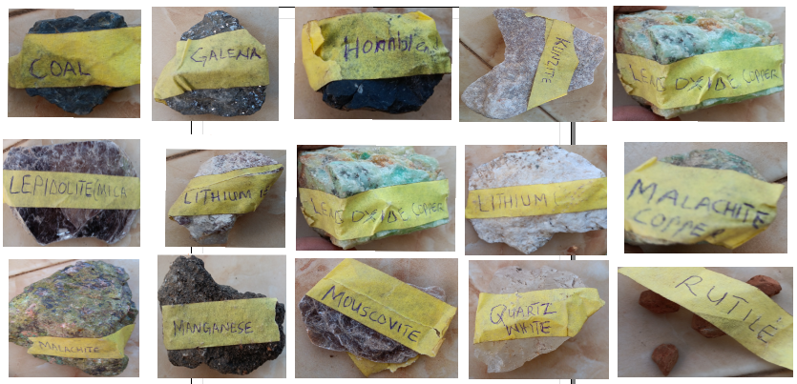
Plate 1: Shows the samples of oxides that were taking for XRF analysis

