Supplementary Figures S1-S5

Dissection of context-dependent RNA colocalization landscapes from subcellular spatial transcriptomics data
Xu Chen^{1,2}, Runze Li^{1,2}, Yuanyuan Zeng¹, Xuerui Yang^{1*}

¹ MOE Key Laboratory of Bioinformatics, Center for Synthetic & Systems Biology, School of Life Sciences, Tsinghua University, Beijing, China
² These authors contributed equally to this work
*Correspondence: Xuerui Yang, School of Life Sciences, Tsinghua University, Beijing 100084, China. Email: yangxuerui@tsinghua.edu.cn

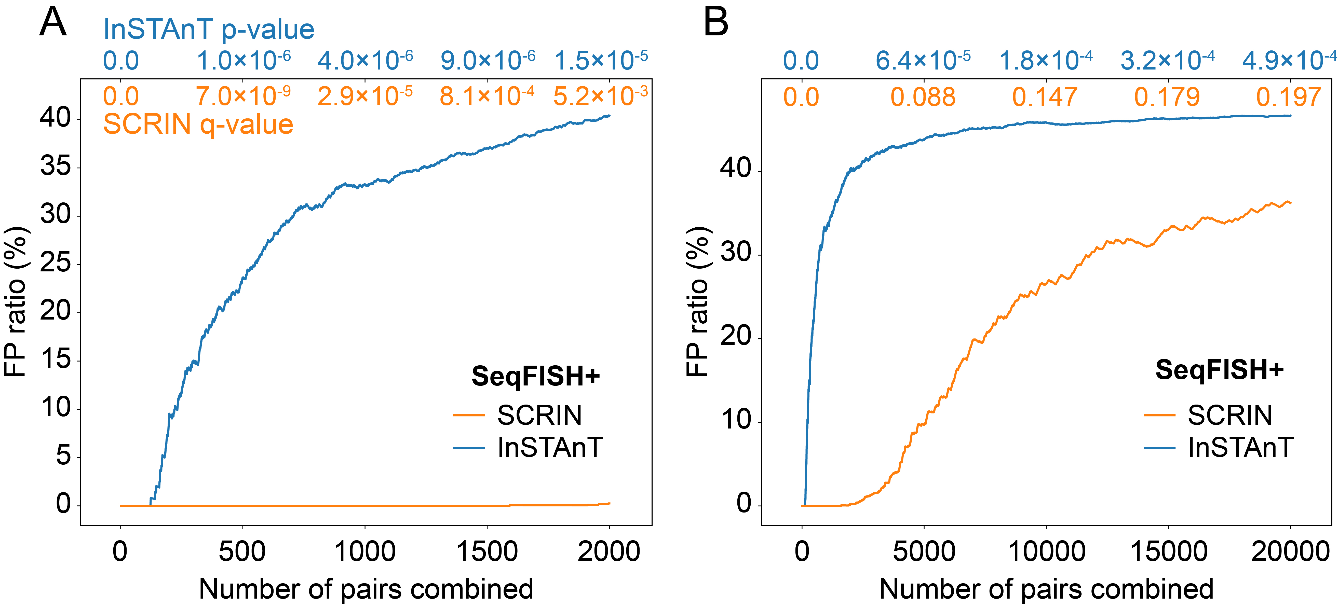
Figure S1. Comparison of false positive rates by SCRIN and InSTAnT.
(A) False positive rates (FPRs) of the top 2000 combined pairs calculated using the NIH/3T3 fibroblast SeqFISH+ dataset. Permuted datasets were generated by shuffling gene labels within each cell. Real and permuted results were combined and ranked by significance (q-value for SCRIN; p-value for InSTAnT). FPR at each rank cutoff was defined as the fraction of top-ranked pairs originating from the permuted data.
(B) FPRs of the top 20,000 combined pairs calculated using the same dataset and methods as in (A).

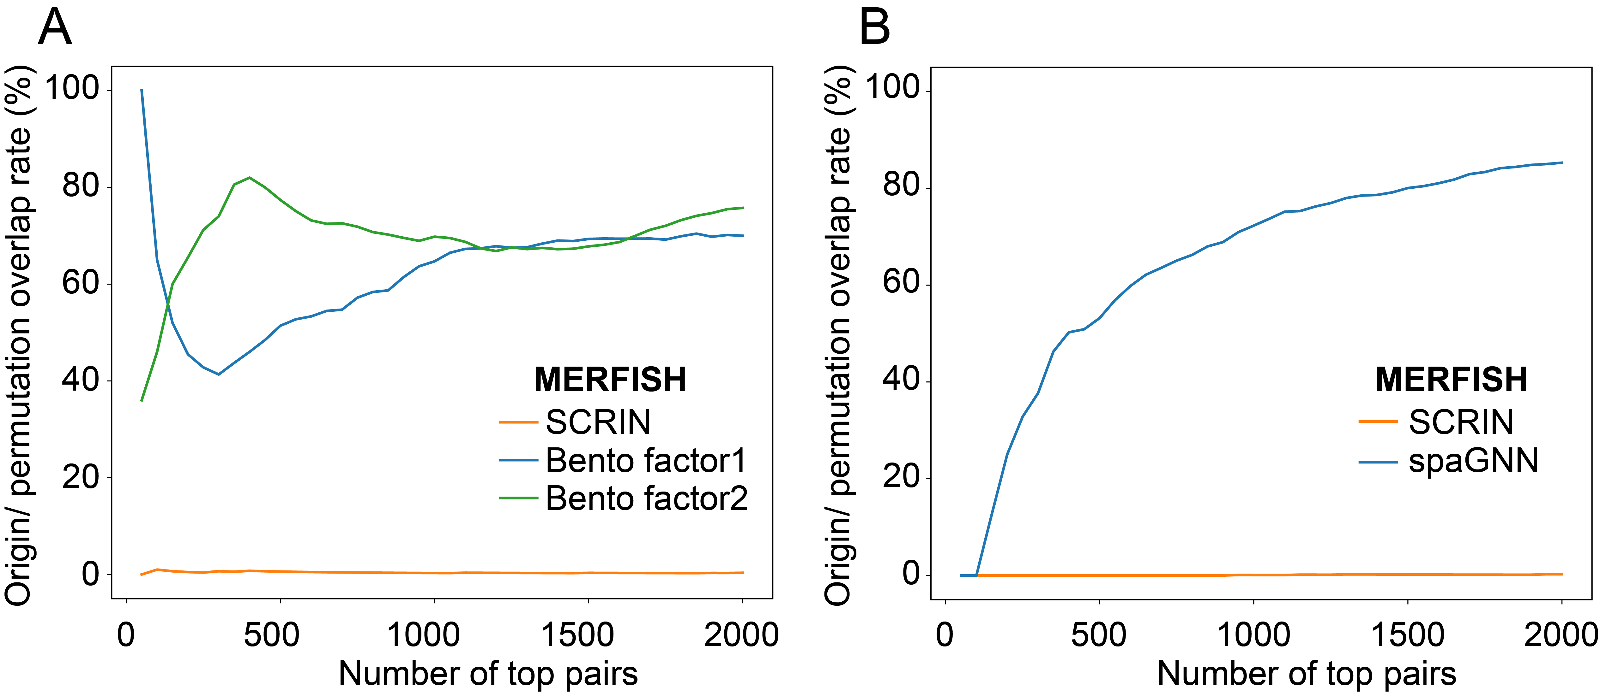
Figure S2. Overlapping rates of top-ranked pairs from original and permuted datasets.
(A, B) Overlap rates for the MERFISH U2-OS dataset. Bento results include colocalized gene pairs derived from two distinct tensor decomposition factors. The overlap rate was defined as the proportion of shared gene pairs among the top N ranked pairs from real versus permuted datasets.

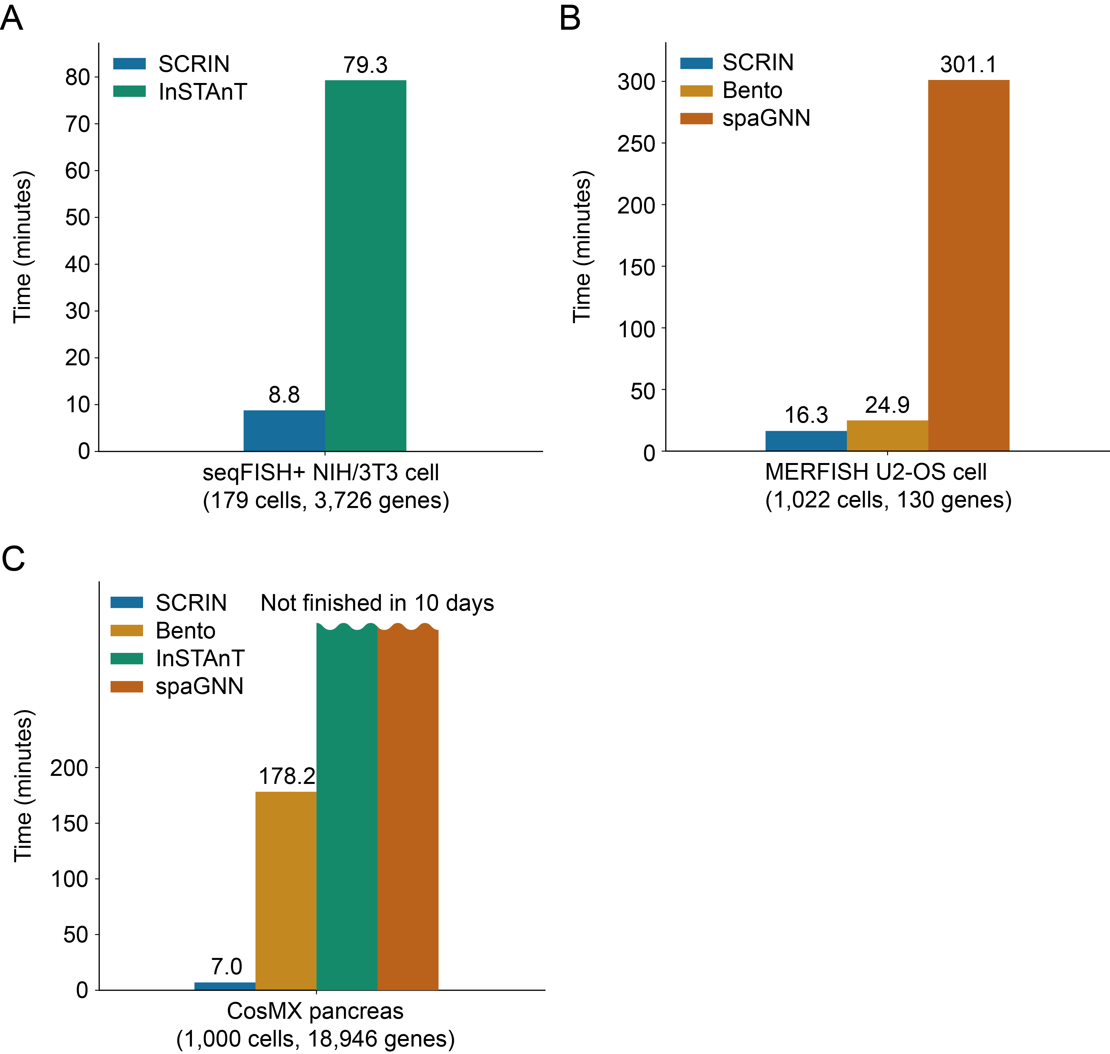
Figure S3. Computational costs of different methods across multiple spatial transcriptomics datasets.
(A) Runtime comparison between SCRIN and InSTAnT using the SeqFISH+ NIH/3T3 dataset.
(B) Runtime comparison between SCRIN, Bento, and spaGNN using the MERFISH U2-OS dataset.
(C) Runtime benchmarking of SCRIN, Bento, InSTAnT, and spaGNN on the CosMX pancreas dataset (1000 sampled cells, 18946 genes).

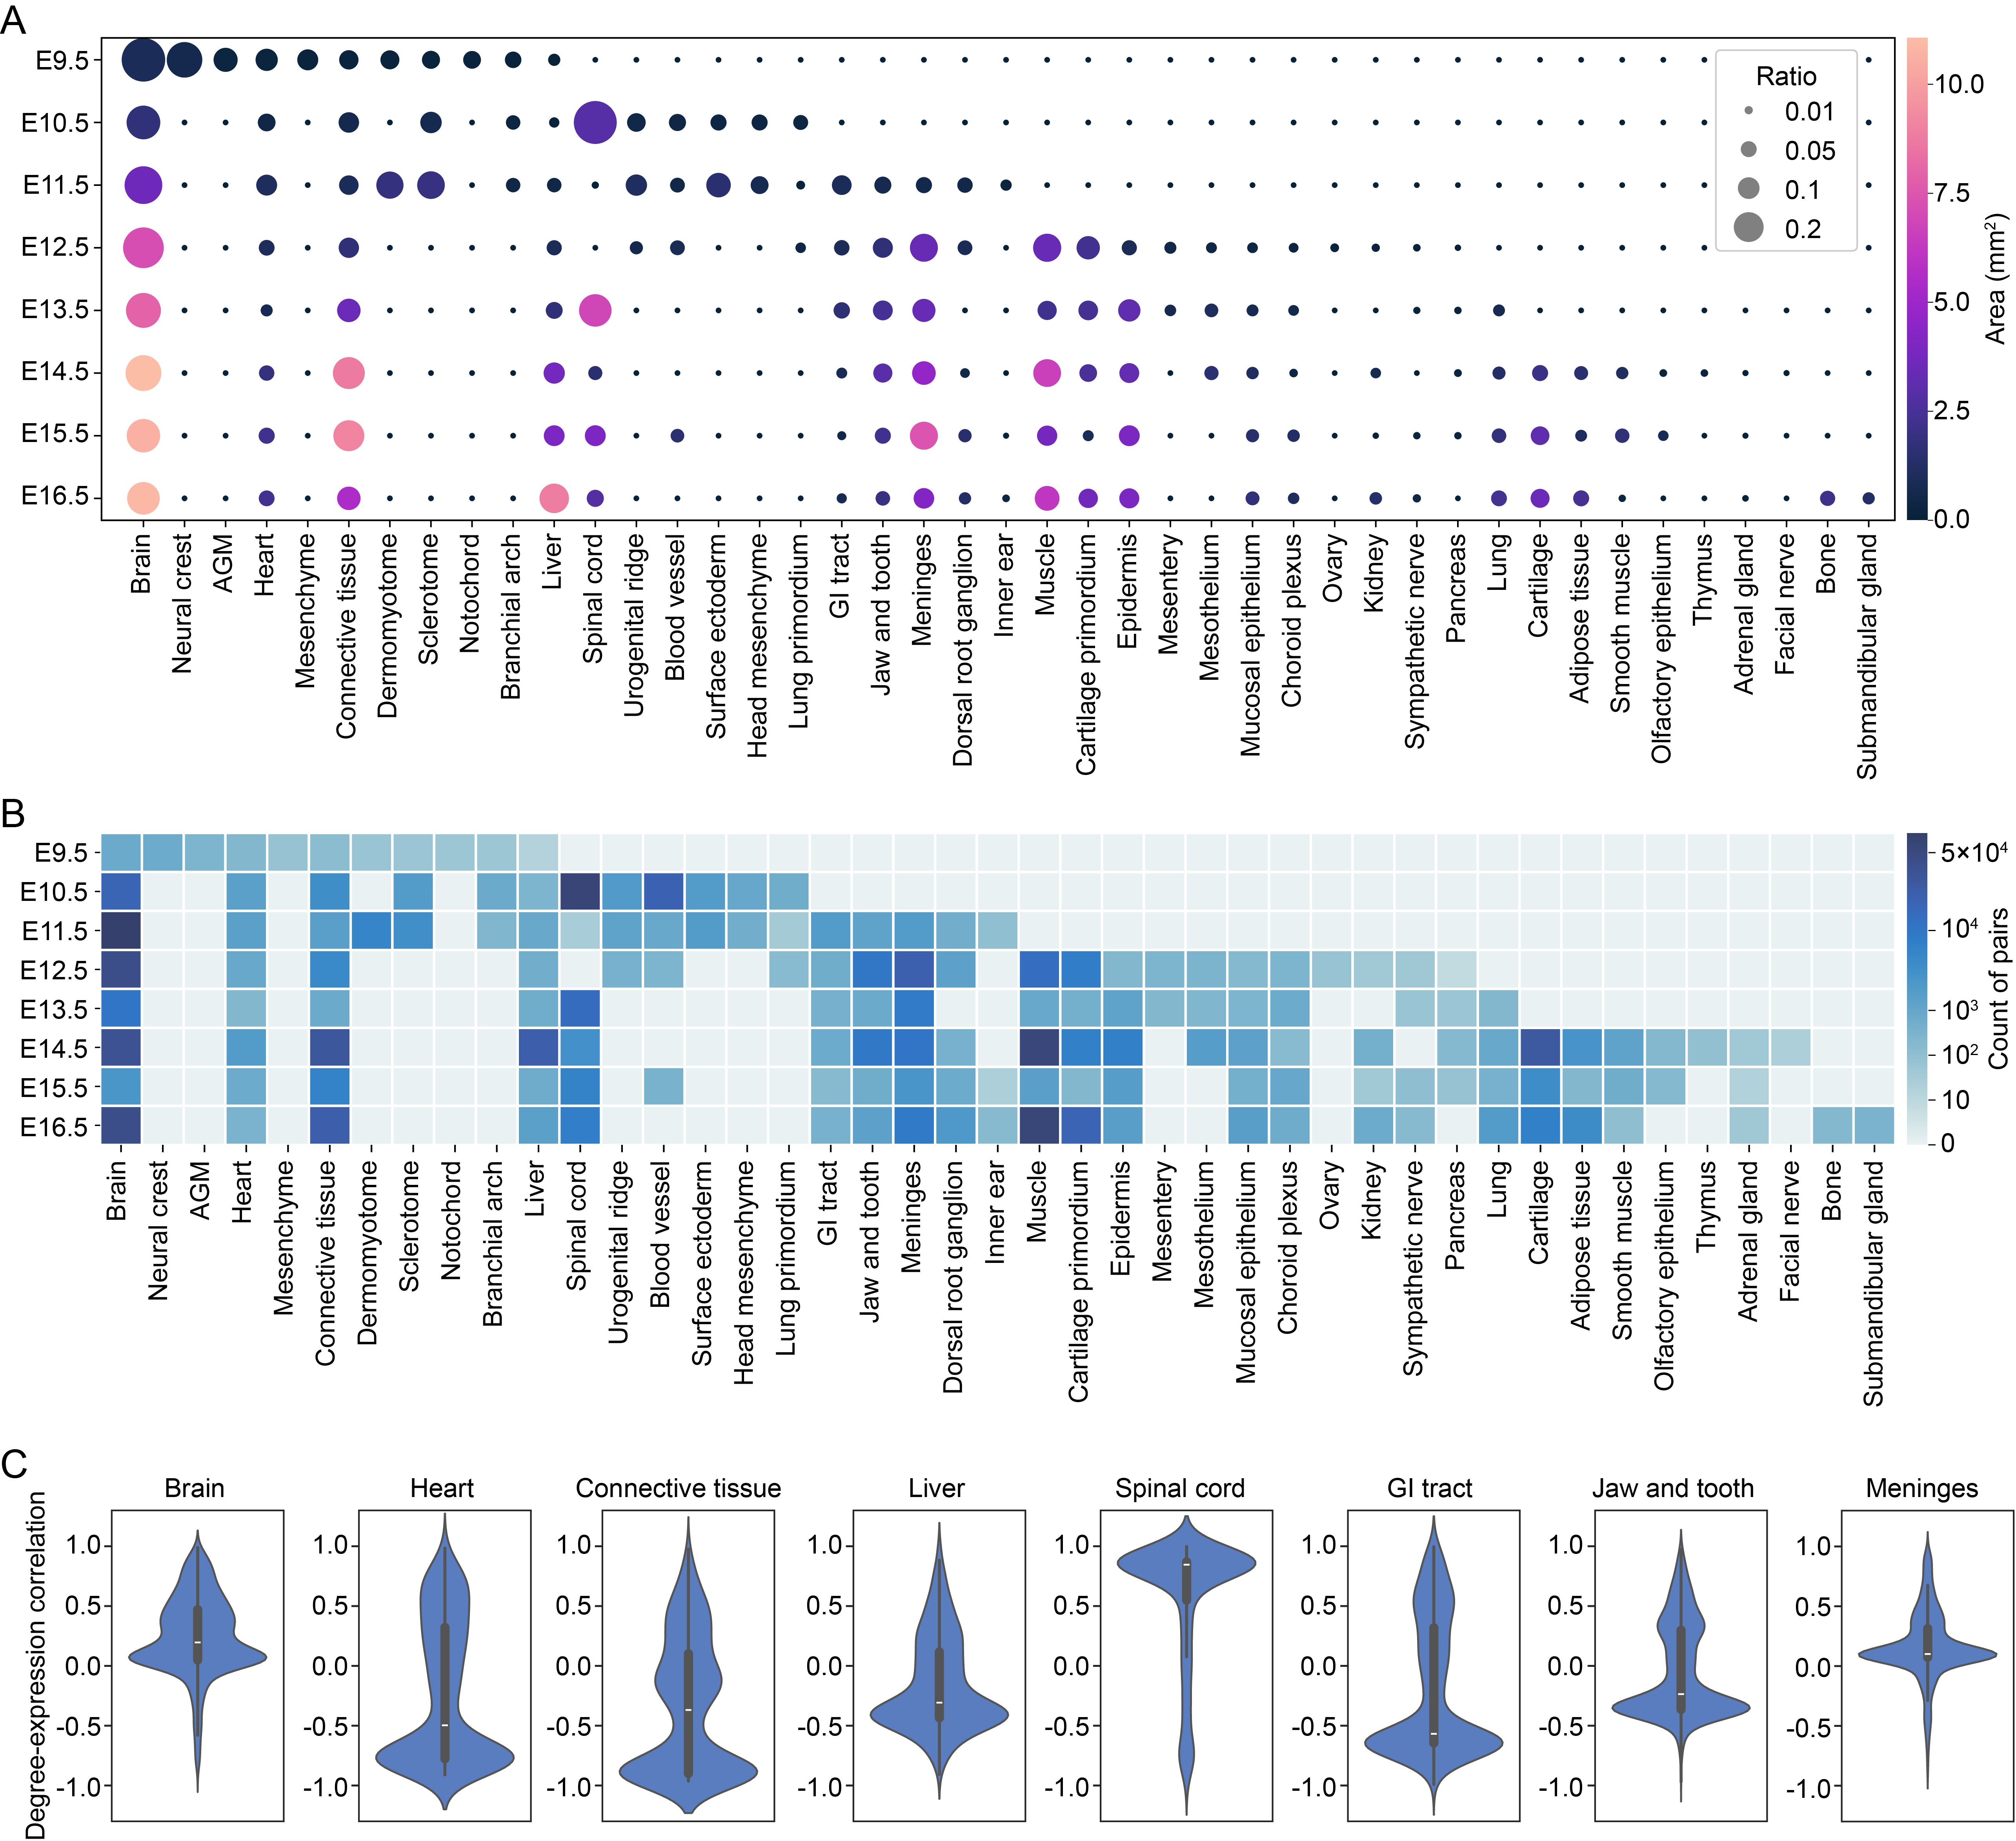
Figure S4. Analysis of RNA colocalization networks during mouse embryonic tissue development.
(A) Bubble plot shows tissue area composition across eight embryonic stages (E9.5-E16.5) on the Stereo-seq dataset. Bubble size represents relative area proportion within each stage, and bubble color indicates absolute tissue area.
(B) Heatmap showing the number of SCRIN-detected colocalized gene pairs per tissue across eight embryonic stages (E9.5-E16.5; Stereo-seq dataset).
(C) Distribution of Pearson correlation coefficients between gene expression and colocalization degree. Correlations were calculated using stage-matched expression and degree values for genes maintaining degree ≥1 across all stages. Only tissues present in ≥6 stages were included.

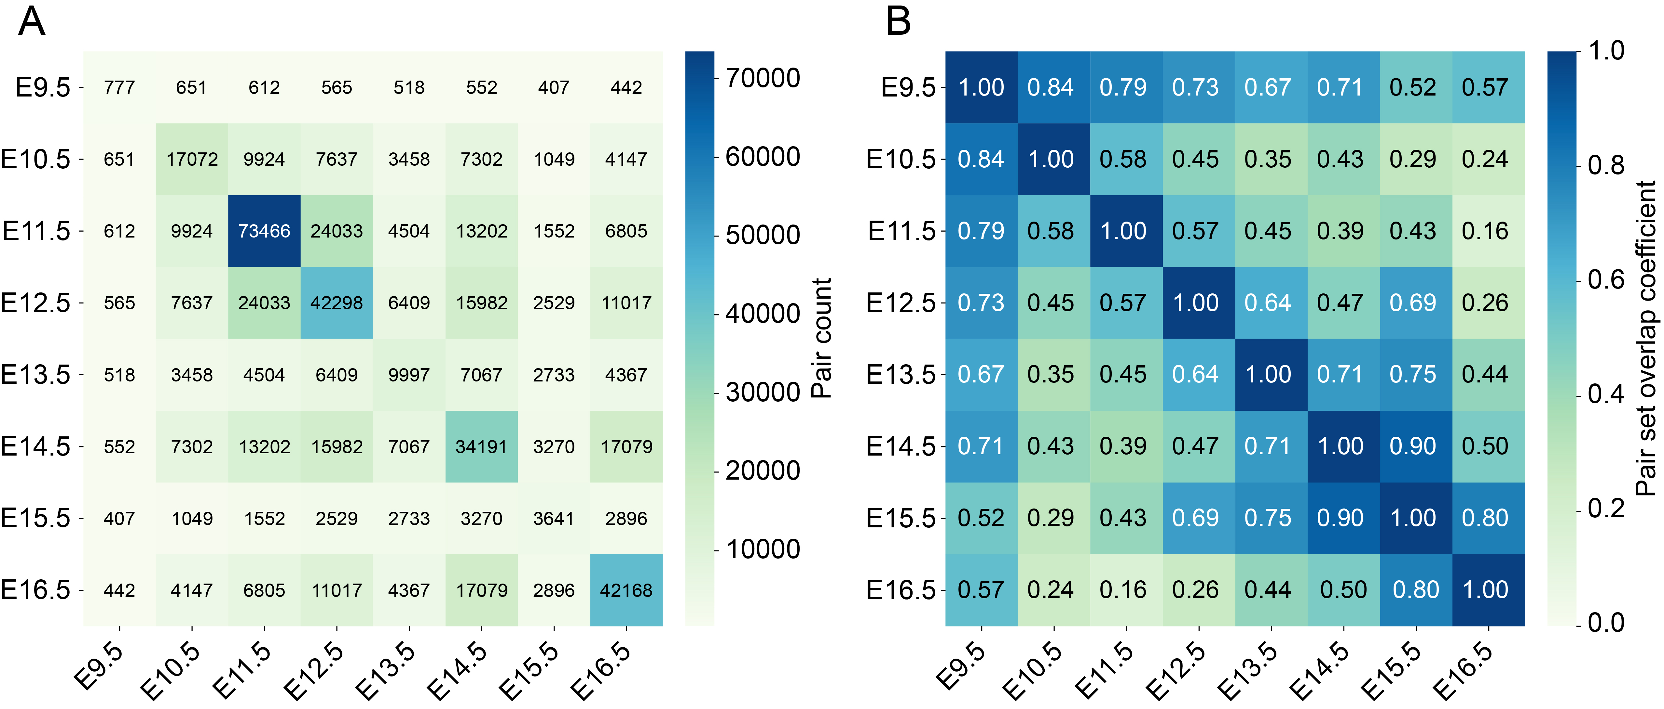
Figure S5. Stage-wise overlap of RNA colocalization patterns during mouse embryonic brain development.
(A) Counts of overlap colocalized gene pairs between all eight developmental stages.
(B) Overlap coefficients of colocalized gene pairs between eight stages.

