MatterGPT: A Generative Transformer for Multi-Property Inverse Design of Solid-State Materials
Yan Chen^{1*}, Xueru Wang^{1,2}, Xiaobin Deng², Yilun Liu¹, Xi Chen², Jun Zhang³, Yunwei Zhang⁴, Lei Wang^{5,6*}, Hang Xiao^{2*}

¹ Laboratory for multiscale mechanics and medical science, SV LAB, School of Aerospace, Xi'an Jiaotong University, Xi'an 710049, China
² School of Interdisciplinary Studies, Lingnan University, Tuen Mun, Hong Kong SAR, China
³Institute of Systems and Physical Biology, Shenzhen Bay Laboratory, Shenzhen 518055, China
⁴ State Key Laboratory of Optoelectronic Materials and Technologies, School of Physics, Sun Yat-Sen University, Guangzhou 510275, China
⁵ National Laboratory of Solid-State Microstructures, School of Physics, Nanjing University, Nanjing 210093, China
⁶ Collaborative Innovation Center of Advanced Microstructures, Nanjing University, Nanjing 210093, China

E-mail: yanchen@xjtu.edu.cn; leiwang@nju.edu.cn; hangxiao@ln.edu.hk.

This PDF file includes:

Supplementary Text
Figs. S1 to S10
Tables S1 to S4

Supplementary Text
S1 Symmetry Handling
In the main text, we primarily adopt a delegated symmetry approach where the model samples crystal systems according to their natural distribution in the training dataset. This strategy enables representative exploration across all crystallographic systems while maintaining consistency with the underlying data distribution. However, the prevalence of the P1 space group remains elevated in generated structures, which can be attributed to the inherent sensitivity of SLICES representation to crystallographic symmetry operations.
Beyond the delegated approach, the MatterGPT framework supports targeted symmetry control through explicit [SYM] token conditioning. To evaluate the effectiveness of this symmetry-constrained generation, we conducted systematic experiments using the multi-property trained model to generate structures with specific crystallographic system requirements. We performed targeted generation experiments using dual-property conditioning (formation energy and band gap) while incorporating explicit symmetry constraints through [SYM] tokens. A total of 10,000 structures were generated across two property targets.
The experimental results demonstrate significant enhancement in targeted symmetry generation capabilities (table S1). Most notably, hexagonal systems show a 13.6-fold increase from 1.4% to 19.1%, while cubic systems exhibit a 5.4-fold enhancement from 7.9% to 43.0%. These improvements validate the effectiveness of explicit symmetry conditioning through [SYM] tokens, enabling practical control over crystallographic system selection during generation. The substantial improvement in low-frequency systems (hexagonal, cubic) particularly demonstrates MatterGPT's ability to overcome training data imbalances through targeted conditioning.
While the current [SYM] token approach provides effective coarse-grained symmetry control at the crystallographic system level, more sophisticated symmetry manipulation would require finer-grained encoding methods. Future developments may incorporate space group-specific representations, such as Wyckoff position encoding ²⁰, to achieve precise control over crystallographic space groups beyond the seven fundamental systems. Additionally, the elevated prevalence of P1 space group structures suggests that SLICES representation may benefit from enhanced symmetry-aware encoding strategies to better preserve crystallographic symmetry information during the tokenization process.
The symmetry control experiments demonstrate that MatterGPT's flexible conditioning architecture enables effective manipulation of crystallographic system distributions through explicit [SYM] token constraints. This capability extends the model's utility for applications requiring specific symmetry properties while maintaining the overall generation quality and chemical diversity observed in unconstrained generation scenarios.

Supplementary Figures

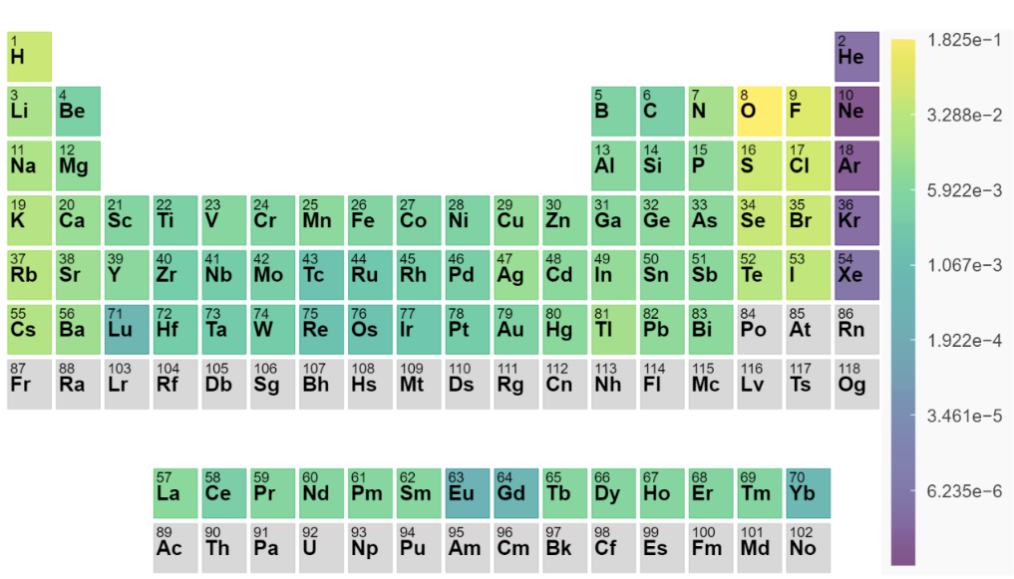
Fig. S1 | Elemental composition distribution in the Alex-20 dataset. Comprehensive analysis of 83 elements across 306,533 crystal structures, showing the frequency distribution that guides MatterGPT's chemical knowledge acquisition. The distribution reflects the natural abundance and stability of elements in crystalline materials, with common structure-forming elements (O, F, Cl, S) showing highest frequencies while maintaining representation across the periodic table for diverse chemical exploration.

Fig. S2 | Statistical analysis of SLICES string lengths in the Alex-20 dataset. Distribution showing sequence length requirements for crystal representation, with the majority of structures requiring ~100 tokens for complete encoding. Inset crystal structures demonstrate representative examples corresponding to typical SLICES lengths, illustrating the relationship between structural complexity and sequence length requirements for model training optimization.

Fig. S3 | Electronic energy band structures of representative generated crystals in Fig. 3. a-d Computed band structures at the PBE level for novel crystals targeting E_{g}=1.0, 2.0, 3.0, 4.0 eV, respectively.

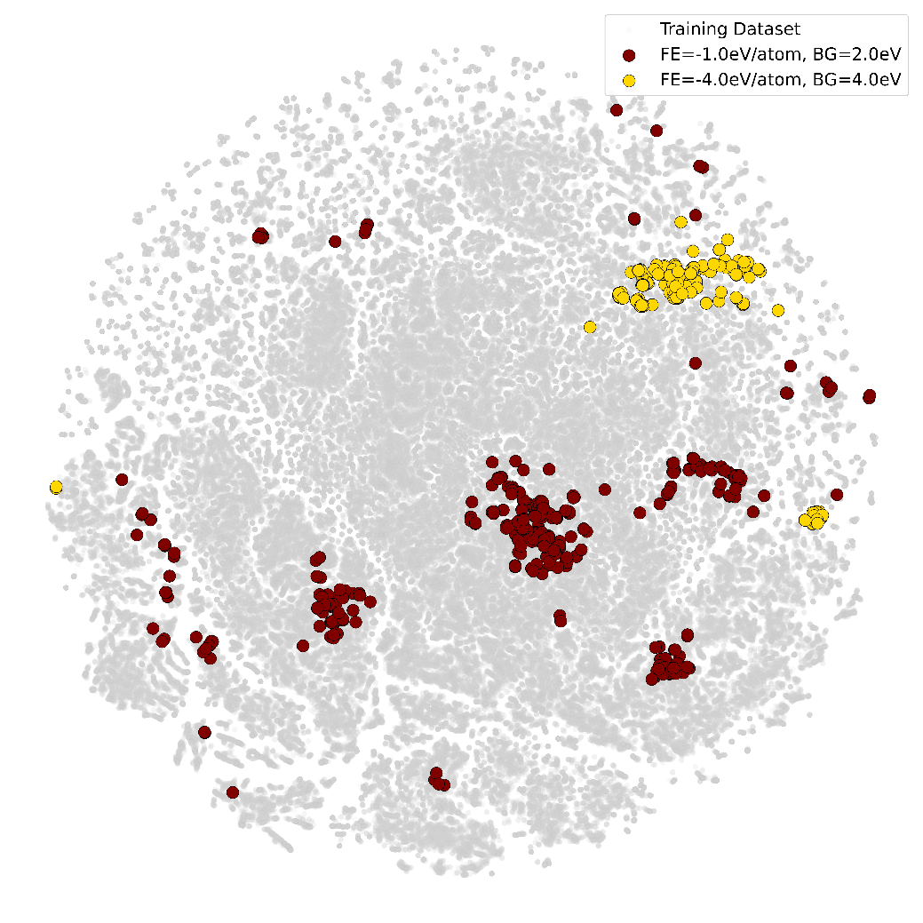
Fig. S4 | t-SNE visualization of crystal embeddings for dual-property (E_{g}, E_{f}) targeting. Multi-objective generation maintains the same comprehensive chemical space exploration observed in single-property cases. The uniform distribution across the embedding space confirms that additional property constraints do not lead to mode collapse or restricted exploration.

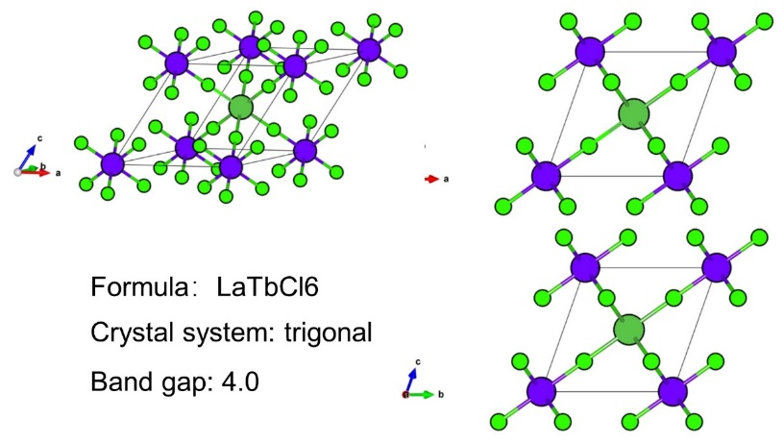
Fig. S5 | Representative case study for attention mechanism analysis. Crystal structure and generation parameters for LaTbCl₆ used in detailed attention weight analysis, achieving precise band gap targeting (E_{g} = 3.99 eV vs. target 4.0 eV).

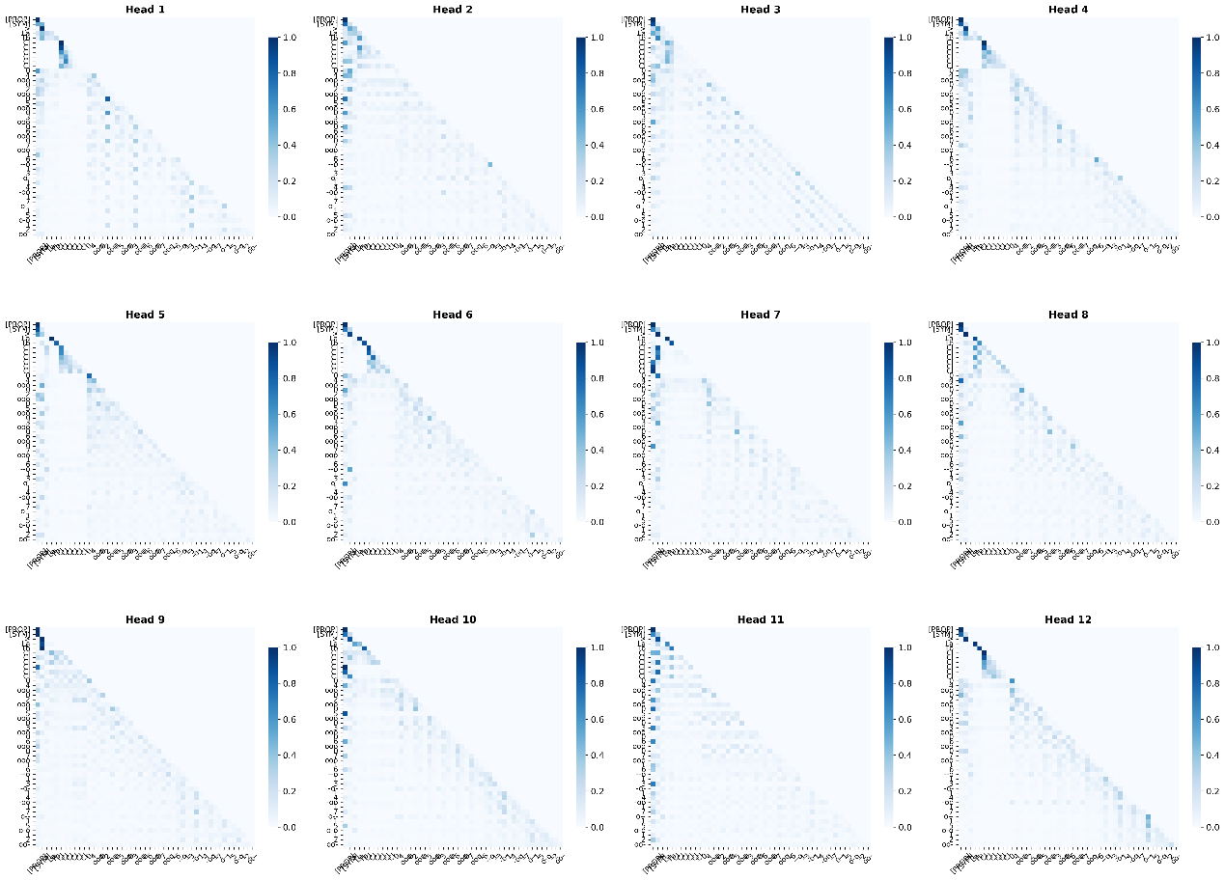
Fig. S6 | Layer 1 attention head analysis. Individual attention head patterns in the first Transformer layer of MatterGPT, showing concentrated, localized attention with substantial functional overlap across heads. The attention patterns focus on three primary aspects, including immediate token neighborhoods corresponding to local chemical bonding relationships within SLICES sequences, sustained attention to property conditioning [PROP] tokens that guide structure-property targeting, and attention to crystal system [SYM] tokens that enforce symmetry constraints during generation. The high-intensity, localized attention patterns (peak weights ~0.85) reflect the model's early-stage processing of fundamental chemical and physical constraints that govern crystal formation.
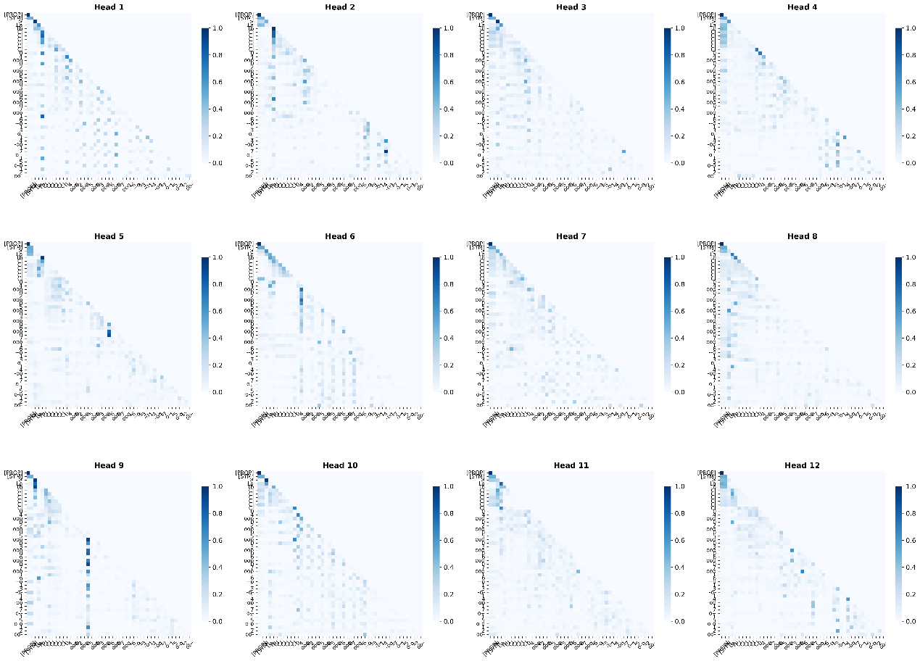
Fig. S7 | Layer 12 attention head analysis. Individual attention head patterns in the final Transformer layer, demonstrating clear functional specialization where different heads focus on distinct aspects of structure generation. Unlike Layer 1, the attention patterns show distributed processing across: (1) global structural topology and long-range crystallographic relationships, (2) integrated property-structure correlations for precise targeting, and (3) symmetry-aware structural assembly. The lower-intensity, distributed attention patterns (max ~0.4) reflect the model's mature integration of chemical, physical, and geometric constraints for coherent crystal structure completion.

Fig. S8 | Layer-wise averaged attention patterns across all heads. Triangular attention distribution confirming proper autoregressive masking with distinct layer-dependent attention behaviors. a Layer 1 shows concentrated attention to property conditioning [PROP] and crystal system [SYM] tokens throughout generation, indicating direct processing of conditioning constraints during early-stage token prediction. b Layer 12 exhibits reduced direct attention to [PROP] and [SYM] tokens during structural token generation, suggesting that conditioning information has been integrated into higher-level representations rather than requiring sustained explicit attention. This evolution from direct constraint attention to integrated processing demonstrates the model's progression from explicit conditioning to implicit constraint satisfaction through learned representations.

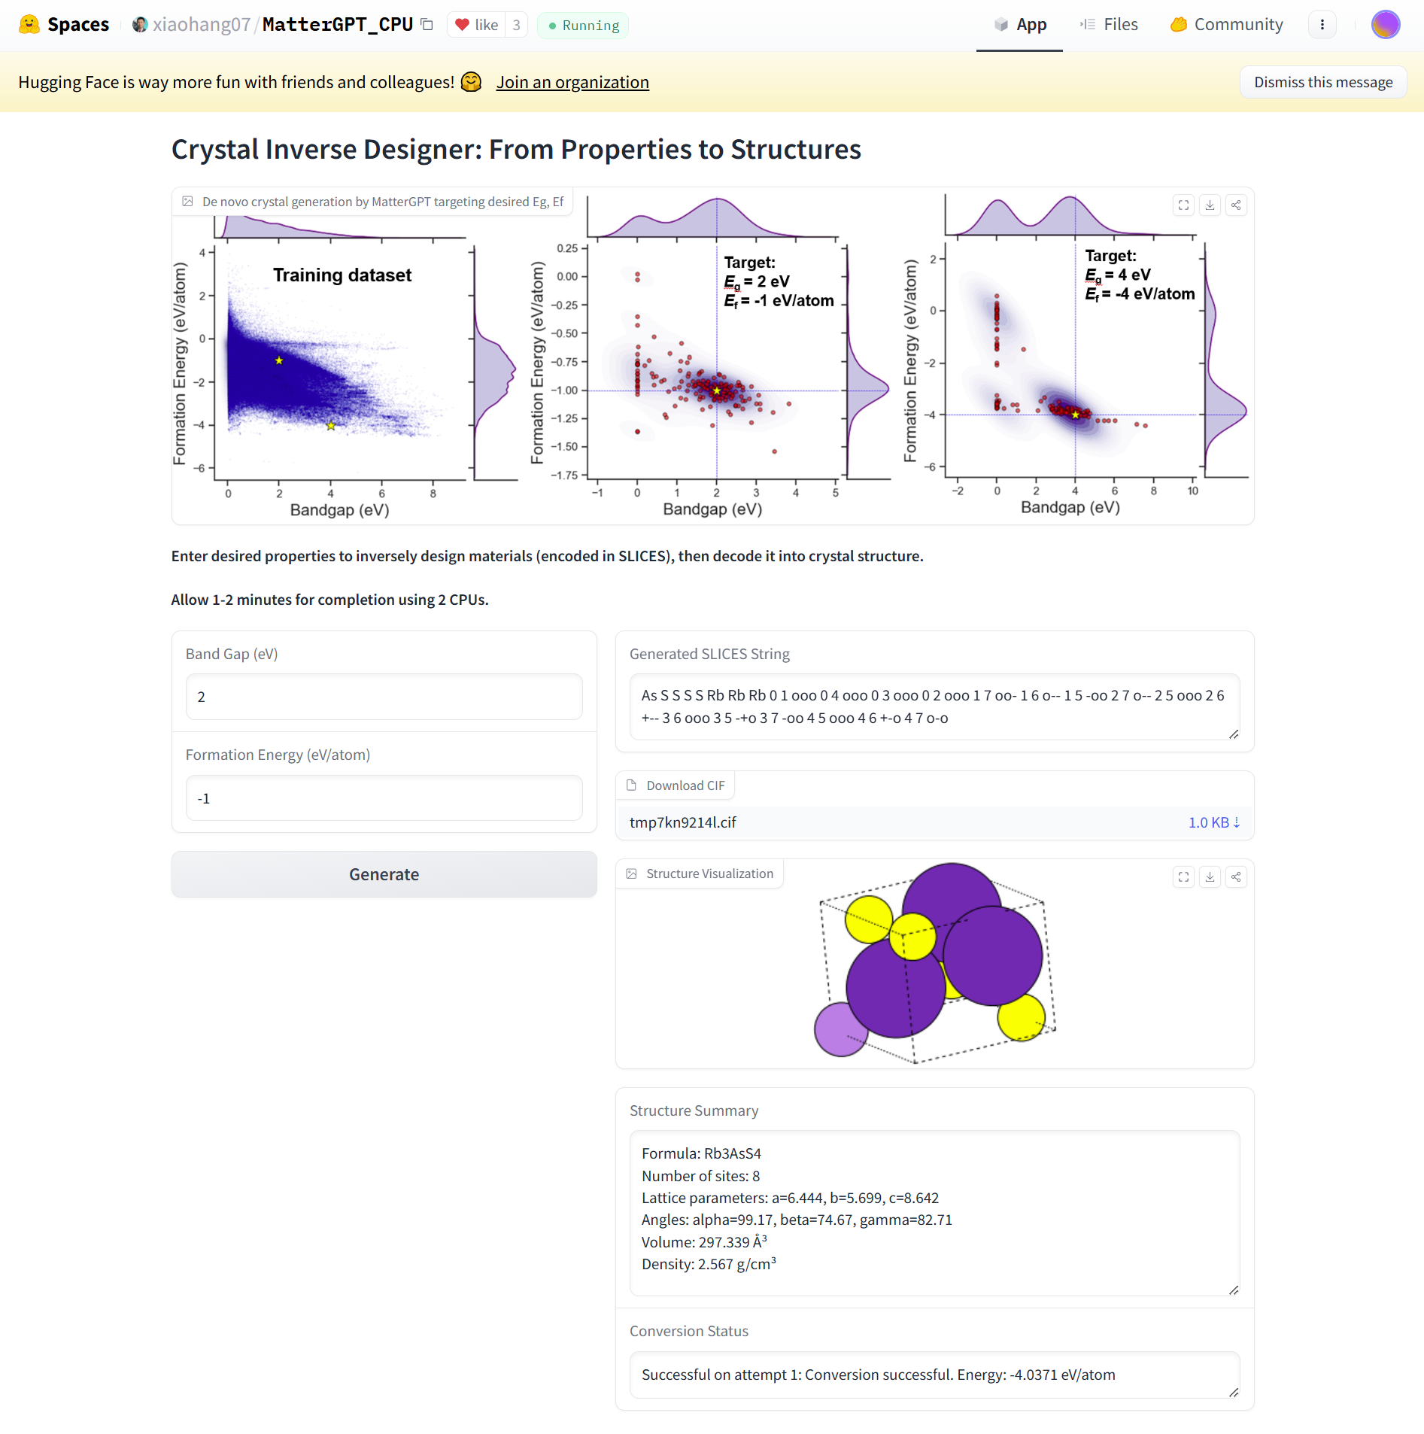
Fig. S9 | MatterGPT web interface for interactive crystal generation. Screenshot of the HuggingFace Spaces implementation providing accessible inference capabilities for trained MatterGPT models. The interface enables users to specify target properties and generate SLICES representations with subsequent conversion to crystal structure files.

Fig. S10 | MatterGPT Hub integrated computational platform. Comprehensive workflow automation system encompassing (a) data preprocessing, (b) model training and guided structure generation, and (c) post-processing. The platform provides production-ready deployment capabilities for materials researchers, enabling property-targeted crystal generation without requiring extensive machine learning expertise.

Supplementary Tables

Table S1. Crystallographic System Distribution: Training Dataset vs. Symmetry-Constrained Generation
Crystal System | Training Dataset (%) | Symmetry-Constrained Generation (%) | Enhancement Factor
Triclinic | 8.8 | 86.1 | 9.8
Monoclinic | 33.0 | 49.2 | 1.5
Orthorhombic | 13.5 | 35.2 | 2.6
Tetragonal | 13.4 | 31.8 | 2.4
Trigonal | 22.1 | 67.0 | 3.0
Hexagonal | 1.4 | 19.1 | 13.6
Cubic | 7.9 | 43.0 | 5.4

Table S2. Summary of 132 tokens for MatterGPT.
Atomic symbols | Ag, Al, Ar, As, Au, B, Ba, Be, Bi, Br, C, Ca, Cd, Ce, Cl, Co, Cr, Cs, Cu, Dy, Er, Eu, F, Fe, Ga, Gd, Ge, H, He, Hf, Hg, Ho, I, In, Ir, K, Kr, La, Li, Lu, Mg, Mn, Mo, N, Na, Nb, Nd, Ne, Ni, O, Os, P, Pb, Pd, Pm, Pr, Pt, Rb, Re, Rh, Ru, S, Sb, Sc, Se, Si, Sm, Sn, Sr, Ta, Tb, Tc, Te, Ti, Tl, Tm, V, W, Xe, Y, Yb, Zn, Zr
Edge labels | ---, +--, -+-, --+, ++-, +-+, -++, +++, ++o, +o-, +-o, -+o, +o+, +oo, o--, -o-, --o, o+-, o-+, -o+, o++, o+o, oo-, o-o, -oo, oo+, ooo
Node indices | 0, 1, 2, 3, 4, 5, 6, 7, 8, 9, 10, 11, 12, 13, 14, 15, 16, 17, 18, 19
Special tokens | ‘>’, ‘<’

Table S3. The hyperparameters of MatterGPT model.
Optimizer | AdamW
Learning rate | 0.0001
Batch size | 60
Embedding dropout | 0.1
Attention dropout | 0.1
Output projection dropout | 0.1
Embedding size | 768
Feedforward size | 3072
Block size (N) | 440
Attention heads | 12
Number of layers | 12

Table S4. Computational efficiency comparison between MatterGPT and MatterGen Models.
Model | Model parameters | Training (one epoch) | Sampling (one crystal)
MatterGen | 53.0M | ~395 s | ~20.85s
MatterGPT | 80.2M | ~198 s | ~1.71s

