Supporting Information
Lipid-glycoadjuvant@AuNPs inhibits tumor growth and regulates tumor microenvironments by tumor-specific CTL-derived IFNγ

Xiaojing Xu, Cheng Yi, Youzhen Ge, Tianyun Feng, Mengjie Liu, Cenhao Wu, Xiang Chen, Jun Zou*, Weidong Zhang*, Lixiang Zhao*

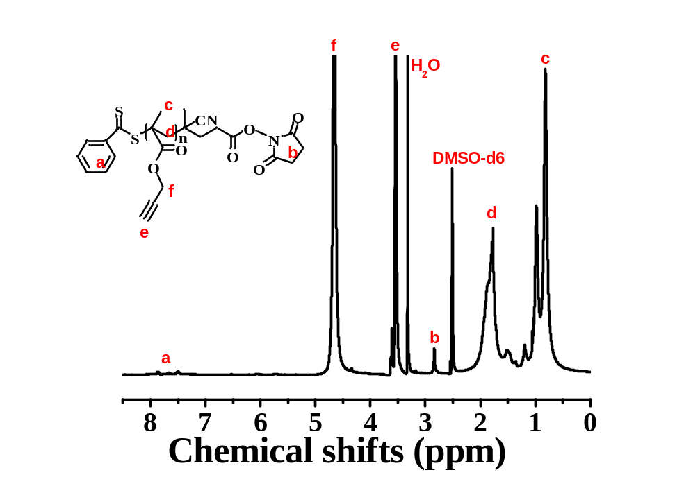
Figure S1. The ¹H-NMR spectrum of PPgMA obtained by RAFT polymerization (M_{n(NMR)} =10000 g/mol).

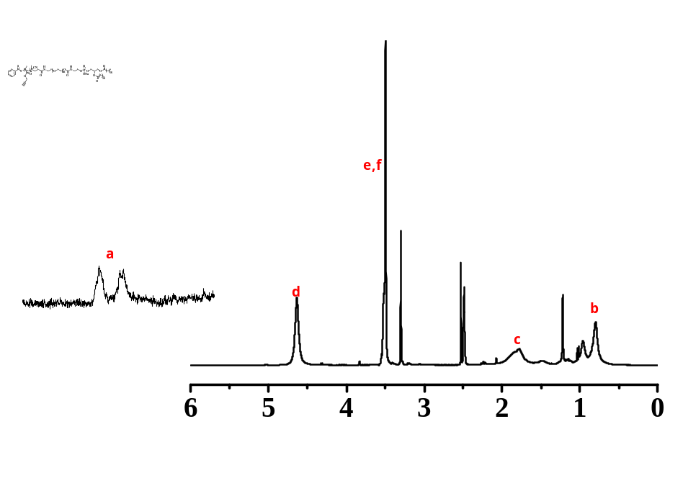
Figure S2. The ¹H-NMR spectrum of PPgMA-lipid obtained by NHS-ester reaction (M_{n(NMR)} =12000 g/mol) in DMSO-d6.

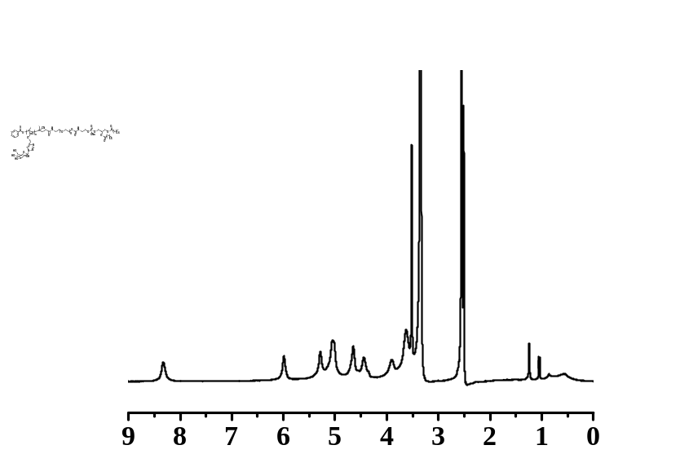
Figure S3. The ¹H-NMR spectrum of lipid-glycopolymer with mannose units fabricated by CuAAC reaction (M_{n(NMR)} =28000 g/mol).
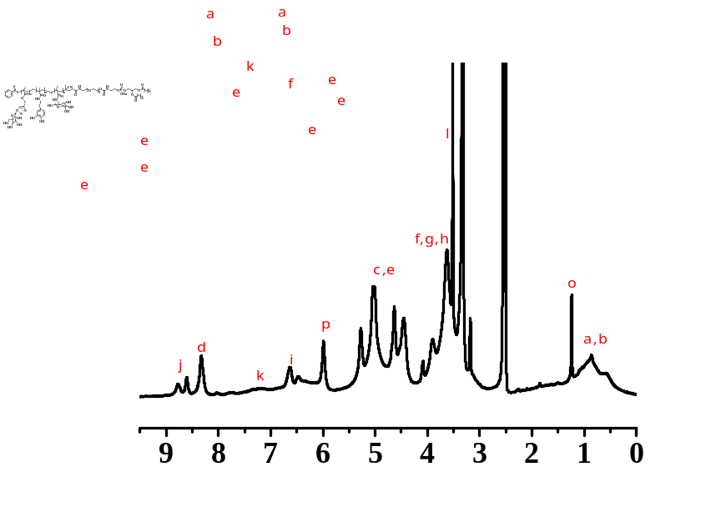
Figure S4. The ¹H-NMR spectrum of lipid-glycopolymer with mannose and glucose as well as dopamine units fabricated by chain extension experiment (M_{n(NMR)} =28000 g/mol).

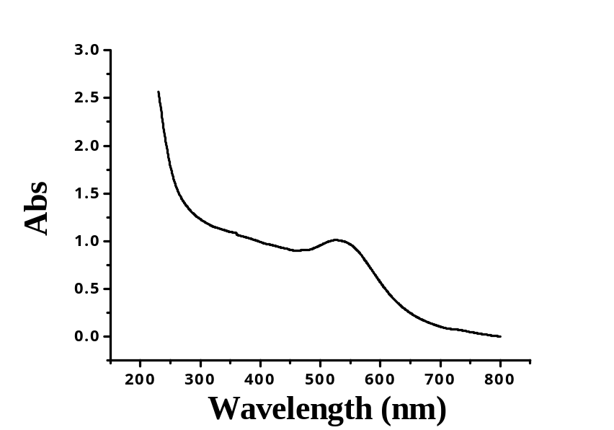
Figure S5. The UV-vis absorption spectrum of the lipid-glycoadjuvant@AuNPs.
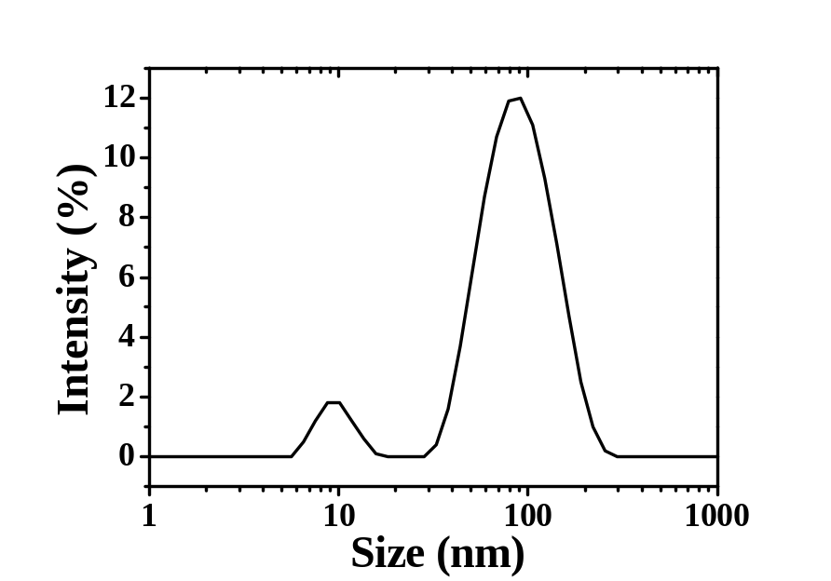
Figure S6. The particle size of lipid-glycoadjuvant@AuNPs by dynamic light scattering (DLS).

Figure S7. TEM image of lipid-glycoadjuvant@AuNPs.

