Alnabati, Flandi et al.,
The Mannose Receptor on Sinusoidal Lining Cells Mediates Two-Step Bacterial Clearance in the Human Spleen.

SUPPLEMENTARY MATERIALS

Methodology | 2
Table S1 | 8
Table S2 | 8
Table S3 | 9
Table S4 | 10
Table S5 | 11
Figure S1 | 12
Figure S2 | 13
Figure S3 | 14
Figure S4 | 15
References | 16

Methodology

Ethics
Ethical authorisation for a clinical trial of ex vivo normothermic human spleen perfusion (Tissue models of invasive disease TIMID) was obtained from the UK Health Research Authority (HRA REC 18/EM/0057)¹. The trial was sponsored by the University of Leicester with chief investigator M.R. Oggioni and the study was conducted at the University Hospitals of Leicester NHS Trust (Clinical Trials gov Identifier NCT04620824) with principal investigator A. Dennison. Informed consent was obtained from each study participant, and each spleen was numbered (i.e. HSP1, HSP2, etc.). The organs were transferred to the research lab fully anonymised, and no patient related data are available for any analysis in this study. Spleen samples for additional cell culture experiments were obtained from a similar clinical trial for ex vivo normothermic liver and spleen perfusion in Italy. The trial authorisation was obtained from the Comitato Etico Area Vasta Emilia Centro della Regione Emilia-Romagna (CE-AVEC) (CE 668/2023/Sper/AOUBo of 19/10/2023). The latter trial is sponsored by the University of Bologna with chief investigator M. Ravaioli and M.R. Oggioni as scientific responsible.

Ex vivo human spleen perfusion
Human spleens were obtained from consented patients undergoing splenectomy for left-sided pancreatic oncological conditions at the Hepato-Pancreato-Biliary (HPB) unit, University Hospitals of Leicester NHS Trust¹. Immediately post-resection, the splenic artery was cannulated and flushed with 1L of heparinized Soltran preservative solution (Baxter, IL, USA). Spleens were surrounded by Soltran and transported on ice to the research laboratory, with efforts to minimize cold ischemic time. Upon arrival, spleens were flushed again with 500 mL saline supplemented with 25,000 IU heparin (Sigma, St. Louis, MO, USA) to remove clots, before connection to a custom-built perfusion circuit (Medtronic, Dublin, Ireland). Perfusion was initiated using 500 mL of a haemoglobin-based oxygen carrier, either Hemopure or Oxyglobin (HbO₂ Therapeutics, USA), or a customized polymerised haemoglobin prepared at the University of Parma (itHBOC) (Tab. S1)^{1,2}. The perfusate was supplemented with either human serum or Dulbecco’s Modified Eagle Medium (DMEM, Thermo Fisher), and 10 mg/L colistin sulphate salt (Sigma). The temperature was maintained at 37°C using a water bath, and oxygen was continuously delivered at 1 L/min. Additional infusions included 5% glucose (w/v) at 30 mL/h, saline supplemented with 500 µg Flolan (vasodilatator, epoprostenol sodium; GlaxoS- mithKline, Brentford, UK), and saline containing 5,000–15,000 IU of heparin (Sigma, St. Louis, MO, USA). Perfusion pressure was maintained at 80 mmHg, and adjustments to glucose levels or oxygenation were made based on hourly monitoring of pH, pO₂, glucose, and lactate using the Epoc Blood Analysis System (Siemens Healthineers). Once the flow rate stabilized (10-15 minutes), spleens were challenged with S. pneumoniae (Table S1) diluted in 20 mL of serum-rich liquid obtained from the first wash-through of the organ with anticoagulant. In particular, the six infected spleens analysed for the mannose work described in this paper (HSP45, HSP47, HSP50, HSP51, HSP67 and HSP70) were infected with a mix of five pneumococcal strains of different serotype (type 2 strain D39, type 4 TIGR4, type 5 PMEN19, type 6A SP6-BS73, type 19F G54) (Tables S1, S2). The cumulative challenge doses for the five strains, 1x10⁸ CFU (high-dose perfusions) and 1x10⁷ CFU (low-dose perfusions), were introduced directly into the circuit or into the perfusate reservoir (Tab. S2). Perfusate and tissue biopsies were collected hourly (and for the first hour every 15 minutes) for bacterial enumeration, microscopy, immunofluorescence and ELISAs. Biopsies were embedded in OCT (CellPath, UK), immediately frozen in dry-ice ethanol and stored at -80°C. Control experiments used perfusate alone or included polystyrene microspheres (Fluoresbrite YG 0.5 µm and BB 1.0 µm). Warm ischemic time ranged from 4–20 minutes, cold ischemic time from 60–150 minutes, and stabilization time prior to infection from 10–40 minutes. For mannose receptor inhibition studies, 5 mM mannose was added to the perfusate, and in selected cases, a monoclonal antibody against CD206 was included (5 μg/mL; 321102, BioLegend). In these experiments, bacterial challenge occurred 30 minutes after perfusion began with the mannose-supplemented solution.

Bacterial strains and cultures
In the TIMID trial spleen perfusion experiments (Tab. S1), infections were carried out using S. pneumoniae. Initial infections employed serotype 2 strain D39 and serotype 4 strain TIGR4, either individually or in combination¹. For the detailed analyses presented in this study, spleens were infected with a panel of five S. pneumoniae strains representing different serotypes and antibiotic resistance profiles, enabling differentiation by selective plating (Tab. S2). Strains were cultured on brain heart infusion (BHI) agar supplemented with 3% (v/v) defibrinated horse blood (Thermo Scientific) or in BHI broth at 37 °C, 5% CO₂ until reaching an optical density of 0.3 at 600 nm (OD₆₀₀). Bacterial mixtures were prepared in 10% glycerol stocks and stored at –80 °C. Colony-forming units (CFU) were verified before use, and separate aliquots were used for each infection experiment.

Sample preparation and immunofluorescence (IF) staining
Frozen spleen samples embedded in OCT were sectioned at a thickness of 10 µm using a Leica cryostat (Leica Biosystems, Wetzlar, Germany) and mounted onto polylysine-coated microscopy slides (Thermo Scientific). Sections were fixed in 4% (v/v) formaldehyde in PBS (Sigma) for 15 minutes at room temperature (RT), followed by washing with phosphate-buffered saline (PBS, Sigma). Permeabilization was performed using 0.1% (v/v) Triton X-100 (Sigma), after which tissues were incubated for 1 hour at RT in blocking solution containing 3% (w/v) bovine serum albumin (BSA, Sigma) and 0.05% (v/v) Tween-20 (Sigma) in PBS. Slides were incubated overnight at 4 °C with primary antibodies diluted 1:100 in blocking solution. After two PBS washes, sections were incubated with secondary antibodies (1:500) for 1 hour at RT (Tab. S4), followed by two additional PBS washes. Nuclear staining was performed using DAPI (3 μg/mL; Thermo Fisher) for 10 minutes, followed by PBS and a final rinse in deionized water. Slides were mounted using ProLong Gold Antifade Mountant (Thermo Scientific, Waltham, MA, USA) and sealed with clear nail polish.

Scanning and image analysis
Fluorescently labelled spleen tissue sections were imaged using the Vectra Polaris Automated Quantitative Imaging System (Akoya Biosciences, MA, USA). Imaging was performed at 40x magnification (NA = 0.75) in fluorescence mode. The Vectra Polaris, accessed via the Core Biotechnology Services Advanced Imaging Facility at the University of Leicester, was used for automated whole-slide scanning of our human spleen biopsy samples. Exposure times were optimized for each antibody channel. Fluorescence channels corresponded to Alexa Fluor filter equivalents: AF488 = Opal520 (green), AF568 = Opal620 (red), AF647 = Opal690 (magenta), and AF750 = Opal780 (cyan). Image processing began with spectral unmixing in Phenochart (v1.1), after which 6–8 representative image regions ("stamps") were exported using InForm software (v2.5.1, Akoya Biosciences). All images were saved in .tiff format and analysed quantitatively in Fiji (v1.53)³. Regions of interest (ROIs) were defined using the Image > Adjust > Threshold function for each cell population. These ROIs were then applied to the bacterial fluorescence channels to assess bacterial association to macrophages and sinusoidal littoral cells through particle analysis.

Human primary splenic cell isolation
Human spleen biopsies for the isolation of primary splenic macrophages and sinusoidal cells were obtained following informed consent, in compliance with ethical regulations. This study was conducted as part of a clinical trial (TIMID) at the University of Leicester (ClinicalTrials.gov Identifier: NCT04620824) and supplemented by a parallel trial (MOSIE) (ID: CE 668/2023/Sper/AOUBo) coordinated by the University of Bologna. Primary splenic cells were isolated using a modified version of a previously published protocol⁴. Upon collection, spleen biopsies were placed in cold high-glucose Dulbecco’s Modified Eagle Medium (DMEM; Merck). The tissue was roughly chopped and washed several times with cold PBS (Merck) to remove residual blood. Spleen fragments were then injected with 1 mL of an enzymatic digestion cocktail composed of 60% DMEM, 30% Collagenase D (10 mg/mL; Merck), and 10% DNase I (10 mg/mL; Merck), followed by incubation at 37 °C for 15 minutes. After this initial digestion, the tissue was minced with scissors and transferred to 10 mL of the same enzymatic solution for an additional 15-minute incubation. Following enzymatic digestion, the tissue suspension was passed through a 100 µm strainer (Merck) into a 50 mL tube containing a stop solution (80% DMEM and 20% fetal bovine serum, FBS; Euroclone). The cell suspension was centrifuged at 200 × g for 10 minutes at 4 °C, and the resulting pellet was resuspended in 1 mL of 1X Red Blood Cell (RBC) Lysis Buffer (Thermo Fisher). After a 5-minute incubation on ice, the solution was diluted with 9 mL of cold PBS and centrifuged again at 200 × g for 5 minutes at 4 °C. This RBC lysis step was repeated until no visible red blood cell pellet remained. The final cell pellet was resuspended in complete culture medium consisting of DMEM/F12 (Merck) supplemented with 10% (v/v) FBS, 2% (v/v) penicillin-streptomycin (1X; Fisher Scientific), and 1% (v/v) L-glutamine (200 mM; Fisher Scientific). Cells were then counted, seeded onto collagen-coated wells (PureCol Type I Bovine Collagen solution, Advanced BioMatrix) and maintained overnight for downstream infection assays and microscopy.

In vitro phagocytosis assay
Freshly isolated primary human splenic cells were seeded immediately after isolation onto collagen-coated surfaces at densities of 2 x10⁵ cells per well in 96-well plates and 1x10⁶ cells per well in 8-well chamber-slides (Ibidi), coated with PureCol Type I Bovine Collagen solution (Advanced BioMatrix). Cells were incubated overnight at 37 °C with 5% CO₂ to allow adherence. The following day, cells were washed with PBS and infected at a multiplicity of infection (MOI) of 10 with the following bacterial strains: S. pneumoniae D39 (serotype 2) and TIGR4 (serotype 4); K. pneumoniae GMR151 (ST25, K2); and E. coli UTI89 (K1) (Tab. S2). Infections were performed at 37 °C with 5% CO₂ for 30 minutes, followed by a 5-minute incubation on ice to halt further infection and phagocytosis. After infection, 10 μL of the supernatant was collected, serially diluted, and plated on BHI agar to quantify extracellular bacteria. Cells were then washed once with PBS and lysed using 0.1% (w/v) saponin (Merck) to release both adherent and intracellular bacteria. Lysates were serially diluted and plated on BHI agar for CFU enumeration. For S. pneumoniae, BHI agar plates were supplemented with 3% (v/v) defibrinated blood. For immunohistochemistry (IHC), infected chamber slides were fixed in 4% (v/v) formaldehyde (Fisher Scientific) for 20 minutes immediately post-infection and subsequently prepared for microscopic analysis. For CD206 inhibition, cells were pre-treated in DMEM supplemented with 5 mM mannose, 5 µg/mL of anti-CD206 primary antibody (5µg/ml), or a combination of both. The inhibition was carried out for 30 minutes at 37 °C in 5% CO₂. Following incubation, cells were washed with PBS to remove the inhibition medium and subsequently infected with bacteria as previously described.

Primary cells immunohistochemistry
Primary human splenic cells seeded on collagen-coated chamber slides were fixed with 4% (v/v) formaldehyde (Fisher Scientific) in PBS (Sigma) for 15 minutes at room temperature (RT), either the day after isolation or immediately following bacterial challenge. Following fixation, cells were washed with phosphate-buffered saline (PBS; Sigma). Permeabilization was carried out using 0.1% (v/v) Triton X-100 (Sigma) in PBS for 10 minutes. Cells were then incubated for 1 hour at RT in a blocking solution composed of 5% (w/v) bovine serum albumin (BSA; Sigma) in PBS. Subsequently, cells were incubated with primary antibodies (1:100 dilution in blocking solution) for 1 hour at RT in the dark. After two washes with PBS, cells were incubated with fluorophore-conjugated secondary antibodies (1:500) for 1 hour at RT in the dark (Tab. S4). Nuclei were counterstained using DAPI (3 μg/mL; Thermo Fisher) for 10 minutes. Finally, slides were washed once with PBS and rinsed in deionized water prior to imaging.

Confocal microscopy imaging
Confocal images of spleen tissue and primary cells were acquired using an Olympus FV1000 confocal laser scanning microscope with 40x (UPlanFLN 40x/NA = 1.3) and 60x (UPlan-SAPO 60x/NA = 1.35) objectives. Image processing was performed using Fiji (v2.0.0-rc69/1.52p). For 3D visualization, multi-plane Z-stack images were deconvolved using Huygens Essential deconvolution software (v18.04.1p0 64-bit; SVI, Hilversum, Netherlands) and reconstructed using Imaris 3D rendering software. Image and colocalization analysis between cellular markers and bacteria were performed using Fiji (ImageJ), following the same methodology previously described for tissue sections.

Human spleen perfusion liquid ELISAs
Human spleen perfusates were analysed for the presence of pro-inflammatory and anti-inflammatory cytokines using Human DuoSet ELISA kits (R&D Systems) following the manufacturer’s recommendations. Assay ranges are TNF-α: 15.6 – 1,000 pg/mL, IL-1β: 3.9 – 250 pg/mL, IL-10: 31.2 – 2,000 pg/mL, and IL-6: 9.4 – 600 pg/mL. Anti-pneumococcal antibodies in human spleen homogenates were tested against whole bacterial cells (type 2 D39, type 4 TIGR4) and, in perfusion liquid, against pneumococcal polysaccharides (types 2, 4, 19F; SSI Diagnostica). Wells were coated overnight at 4 °C with either 100 μl of 0.2 OD₆₀₀ bacterial suspension in PBS or CPS (1 μg/ml in PBS/0.02% NaN₃). Plates were washed (PBS/0.1% Tween-20), blocked with 5% BSA/0.1% Tween-20 for 1 h, and samples (1:4 in blocking buffer, duplicates) were added, alongside positive control sera (Statens Serum Institute). After overnight incubation at 4 °C, plates were washed and incubated 1 h at RT with anti-human HRP-IgG (1:1000) for samples/negatives or anti-rabbit HRP-IgG (1:5000) for positives. Detection used TMB (Sigma-Aldrich) substrate for 30 min in the dark at RT, stopped with 2 N H₂SO₄, and read at 450/630 nm (FLUOstar Omega). Cut-off values were the mean OD₄₅₀ of negative controls per dilution; samples above the cut-off were considered positive, titres (Tab. S3) were the reciprocal of the last positive dilution.

Statistical analysis
Statistical analysis was made by one-way ANOVA using Kruskal-Wallis test with Dunn’s multiple comparisons. In addition, a t-test was used to compare two sets of values. The means and standard deviation were also calculated by GraphPad, and the significant P values (ns P > 0.05, * P ≤ 0.05, ** P ≤ 0.01, *** P ≤ 0.001, and **** P ≤ 0.0001) were determined.
Supplementary tables

Table S1: All ex vivo spleen perfusions performed under the TIMID trial
Number | Date | Weight (g) | CI time (min) | WI time (min) | Perfusate | Challenge | Dose | Comment | Reference
HSP1 | 08/09/2018 |  |  |  | Hemopure | D39 | 10^8 CFU |  | 1
HSP2 | 28/08/2018 | 254 |  |  | Hemopure | D39 | 10^7 CFU |  | 1
HSP3 | 16/10/2018 |  |  |  | Hemopure | Control |  |  | 1
HSP4 | 12/04/2018 |  |  |  | Hemopure | Control |  |  | 1
HSP5 | 26/02/2019 |  |  |  | Hemopure | TIGR4 | 10^7 CFU |  | 1
HSP6 | 04/02/2019 |  |  |  | Hemopure | D39-TIGR4 | 10^7 CFU each |  | 1
HSP7 | 16/04/2019 | 312 |  |  | Hemopure | D39-TIGR4 | 10^7 CFU each |  | 1
HSP8 | 13/08/2019 |  |  |  | Hemopure | TIGR4 | 10^7 CFU |  | 1
HSP12 | 08/07/2020 | 150 |  |  | Hemopure | D39-TIGR4 | 10^7 CFU each |  | 1
HSP24 | 12/02/2022 |  |  |  | Hemopure | D39-TIGR4 | 10^7 CFU each | α-type 4 | 1
HSP45 | 17/08/2022 | 214 |  |  | Oxyglobin | MIX1* | 10^7 CFU |  | This work
HSP46 | 25/08/2022 | 151 |  |  | Oxyglobin | D39-TIGR4 | 10^7 CFU each | α-type 2
HSP47/9 | 28/10/2022 | 115 |  |  | Oxyglobin | MIX1 | 10^7 CFU |  | This work
HSP50 | 11/11/2022 | 218 |  |  | Oxyglobin | MIX1 | 10^8 CFU |  | This work
HSP51 | 02/02/2023 | 143 |  |  | Oxyglobin | MIX1 | 10^8 CFU |  | This work
HSP55 | 01/04/2023 | 130 | 120 | 10 | ITHBOC | microbeads |  |  | This work
HSP56 | 12/04/2023 | 211 | 120 | 15 | Oxyglobin | microbeads |  |  | This work
HSP61 | 23/08/2023 | 311 | 110 | 20 | Oxyglobin | microbeads |  |  | This work
HSP62 | 08/09/2023 | 201 | 150 | 20 | ITHBOC | S. aureus, K. pneumoniae | 10^7 CFU each
HSP63 | 21/09/2023 | 152 | 155 | 20 | ITHBOC | control |  |  | This work
HSP64 | 14/11/2023 | 189 | 85 | 2 | ITHBOC | S. aureus, K. pneumoniae | 10^7 CFU each | 20mg/L Gentamicin
HSP65 | 13/10/2023 | 119 | 106 | 8 | ITHBOC | Poly A tail D39 | 10^7 CFU | 9h total
HSP66 | 31/10/2023 | 92 | 85 | 10 | Oxyglobin | MIX1 + mAb + Mannose | 10^8 CFU | Mannose mAb, 9h total
HSP67 | 22/11/2023 | 121 | 113 | 15 | ITHBOC | MIX1 + Mannose | 10^8 CFU | Mannose | This work
HSP70 | 03/04/2024 | 130 | 133 | 15 | ITHBOC | MIX1 + Mannose | 10^7 CFU | Mannose | This work
HSP71 | 05/06/2024 | 131 | 166 | 20 | ITHBOC | Mix1 | 10^8 CFU | Infect at 6h, 12h total | This work
HSP72 | 13/06/2024 | 90 | 121 | 30 | ITHBOC | Mix1 | 10^8 CFU | Infect at 6h, 12h total | This work
HSP74 | 07/08/2024 | 134 | 115 | 15 | ITHBOC | Mix1 | 10^8 CFU | Infect at 6h, 12h total | This work
* MIX1 type 2 D39, type 4 TIGR4, type 5 PMEN19, type 6A SP6-BS73, type 19F G54. CI cold ischemic time, Wi warm ischemic time

Table S2: Strains
Species | Strain | Serotype | Sequence type (ST) | Antibiotic resistance gene(s) | Reference
S. pneumoniae | TIGR4 | 4 | 205 | zmpC::aad9 | 5
S. pneumoniae | D39 | 2 | 595 | rpsL | 6
S. pneumoniae | PMEN19 | 5 | 289 | cat, tetM | 7
S. pneumoniae | G54 | 19F | 63 | tetM, ermB | 8
S. pneumoniae | SP6-BS73 | 6A | 460 | mefA, dfr, pbp2x | 9
K. pneumoniae | GMR151 | K2 | 25 |  | 10
E. coli | UTI89 | K1 | 95 |  | 11

Table S3: Antibody titres
Perfusion | Antibody titres to whole bacteria in tissue homogenates |  | Capsule specific antibody titres in the perfusion liquid
 | type 2 | type 4 | type 2 CPS* | type 4 CPS | type 19F CPS
HSP1** | 64 | 64 | 32 | 16 | 256
HSP2 | 128 | 64 | neg | 16 | neg
HSP3 | 512 | 256 | 32 | 64 | 256
HSP4 | 512 | 512 | 64 | 16 | 256
HSP5 | 512 | 128 | 128 | 256 | neg
HSP6 | 256 | 256 | neg | neg | neg
HSP7 | 4096 | 8192 | 128 | 256 | neg
HSP15 | 256 | 128 | 64 | - | -
HSP45 | 256 | 128 | 64 | - | -
HSP46 | - | - | 8 | 256 | 4
HSP49 | - | - | neg | neg | neg
HSP50 | - | - | 8 | 64 | neg
HSP51 | - | - | neg | neg | neg
HSP55-74 | - | - | - | - | -
* CPS capsular polysaccharide, ** HSP human spleen perfusion

Table S4 Antibodies: primary and secondary antibodies
Primary antibodies

Antibody | Specificity | Target | Host | Conjugated | Clone | Working conc. | Catalogue | Supplier
type serum 2 | Streptococcus pneumoniae | Type 2 capsule | Rabbit | - | - | 1:500 | 16745 | Statents Serum Institut
type serum 4 | S. pneumoniae | Type 4 capsule | Rabbit | - | - | 1:500 | 16747 | Statents Serum Institut
type serum 5 | S. pneumoniae | Type 5 capsule | Rabbit | - | - | 1:500 | 16748 | Statents Serum Institut
group serum 6 | S. pneumoniae | Type 6A, 6B, 6C capsules | Rabbit | - | - | 1:500 | 16900 | Statents Serum Institut
group serum 19 | S. pneumoniae | Type 19F, 19A, 19B, 19C capsules | Rabbit | - | - | 1:500 | 16911 | Statents Serum Institut
Omni Serum | S. pneumoniae | All 91 serotype capsules | Rabbit | - | - | 1:500 | 2438 | Statents Serum Institut
Anti-K2 serum | Klebsiella pneumoniae | K2 capsule | Rabbit | - | - | 1:500 | - | Statents Serum Institut
Anti-CD163 | Human | CD163 | Mouse | - | EDHu-1 | 1:100 | NB110-40686 | Novus Biologicals
CD163 Antibody, anti-human, REAfinity | Human, Monkey | CD163 | Human Recombinat | Alkaline phosphatase | REA812 | 1:100 | 130-112-129 | Miltenyi Biotec
Human Siglec-1/CD169 Antibody | Human | CD169 | Sheep | - | - | 1:100 | AF5197 | R&D Systems
anti-human CD68 | Human | CD68 | Mouse | - | PG-M1 | 1:100 | M087601-2 | Dako
anti-human CD206 (MMR) Antibody | Human | CD206 | Mouse | - | 15-2 | 1:100 | 321102 | BioLegend
Human MMR/CD206 Antibody | Human | CD206 | Mouse | AlexaFluor 750 | 685641 | 1:100 | FAB25342S-100UG | R&D Systems
Human CD31/PECAM-1 Antibody | Human | CD31 | Sheep | - | - | 1:100 | AF806 | R&D Systems
Human LYVE-1 Antibody, Novus Biologicals | Human | LYVE-1 | Mouse | AlexaFluor 488 | 1072614 | 1:100 | 30130429 | FisherScientific
Cleaved Caspase 3 p17 Monoclonal Antibody | Human, mouse, rat | Cleaved caspase-3 | Mouse | - | 2F7B8 | 1:100 | 68773-1-IG | ThermoFisher
Caspase-3 Antibody | Human, mouse, rat, pig, chicken, hamster | Pro and active caspase-3 | Mouse | AlexaFluor 488 | 31A1067 | 1:100 | NB100-56708AF488 | Novus Biologicals
Anti-LAMP1 antibody | Human | LAMP-1 | Rat | - | 1D4B | 1:100 | ab25245 | Abcam
Secondary antibodies

Donkey anti-rabbit IgG (H+L), Alexa Fluor 488 | Rabbit | Rabbit IgG | Donkey | AlexaFluor 488 | - | - | A-21206 | Invitrogen
Donkey anti-Mouse IgG (H+L), Secondary Antibody, Alexa Fluor 488 | Mouse | Mouse IgG | Donkey | AlexaFluor 466 | - | - | A-21202 | Invitrogen
Donkey anti-sheep IgG (H+L), Alexa Fluor 568 | Sheep | Sheep IgG | Donkey | AlexaFluor 568 | - | - | A-21099 | Invitrogen
Goat anti-Mouse IgG (H+L), Alexa Fluor 568 | Mouse | Mouse IgG | Goat | AlexaFluor 568 | - | - | A-11004 | Invitrogen
Donkey anti-Rat IgG (H+L), Alexa Fluor 568 | Rat | Rat IgG | Donkey | AlexaFluor 568 | - | - | A-78946 | Invitrogen
Donkey anti-sheep IgG (H+L), Alexa Fluor 647 | Sheep | Sheep IgG | Donkey | AlexaFluor 647 | - | - | A-21448 | Invitrogen
Donkey anti-Mouse IgG (H+L), Alexa Fluor 647 | Mouse | Mouse IgG | Donkey | AlexaFluor 647 | - | - | A-31571 | Invitrogen
Goat anti-Rat IgG (H+L), Alexa Fluor 647 | Rat | Rat IgG | Goat | AlexaFluor 647 | - | - | A-21247 | Invitrogen
Goat anti-Rabbit IgG (H+L), Secondary Antibody, Alexa Fluor 750 | Rabbit | Rabbit IgG | Goat | AlexaFluor 750 | - | - | A-21039 | Invitrogen
Goat anti-Mouse IgG (H+L), Antibody, Alexa Fluor 750 | Mouse | Mouse IgG | Goat | AlexaFluor 750 | - | - | A-21037 | Invitrogen

Table S5: List of spleen perfusion samples used to generate figures
Figure | Human spleen (HSP)
Figure 1 A | HSP63
Figure 1 B | HSP63
Figure 1 C | HSP51, 50, 45, 62
Figure 1 D-F | HSP1, 2, 3, 6, 7, 8, 12, 15, 24, 50, 51, 54, 55, 56, 63, 66, 67, 70, 71
Figure 2 A | HSP50
Figure 2 B | HSP51
Figure 2 C | HSP67
Figure 2 D | HSP45
Figure 2 E | HSP49
Figure 2 F | HSP70
Figure 3 A | HSP50, 51 (no mannose); HSP66, 67 (mannose)
Figure 3 B1 | HSP66
Figure 3 B2 | HSP50
Figure 3 C | HSP66
Figure 3 D | HSP50, 51, 24 (no mannose); HSP66, 67 (mannose)
Figure 3 E | HSP50, 51, 24 (no mannose); HSP66, 70 (mannose)
Figure 5 A | HSP54, 55, 56 (light-red and light-blue bars); HSP50, 51 (red and blue bars)
Figure 5 B | HSP1, 2, 6, 7, 8
Figure 5 C | HSP 50, 51, 66, 67, 70 (black bars); HSP3, HSP63 (white bars)
Figure 5 D | HSP3 (white bars); 50, 51 (red and blue bars); 54, 55, 56 (light-red and light blue bars)
Figure 5 E | HSP3, 63 (white bars); 50 (red and blue bars); 54, 55, 56 (light-red and light-blue bars).
Figure 5 F | HSP3, 71 (white bars); 51, 66, 67, 70, 71 (red and blue bars)
Figure S3 | HSP54
Figure S1 A-B | HSP70
Figure S1 C | HSP50, 51, 67
Figure S1 D1-E | HSP3, 50, 51, 63, 66, 67
Figure S2 A | HSP50, 51, 66, 67
Figure S2 B-C3 | HSP67
Figure S2 D1-E2 | HSP3, 71 (white bars); 51, 66, 67, 70 (red and blue bars)
Figure S3 | HSP54
Figure S4 A-B | HSP2, 3, 4, 5, 6, 7, 12, 15, 24, 45, 46, 49, 50, 51, 57, 62, 63, 64, 65, 66, 67, 70, 71, 72, 74
Figure S4C | HSP4, 50, 51, 66, 67, 70, 71, 72, 74

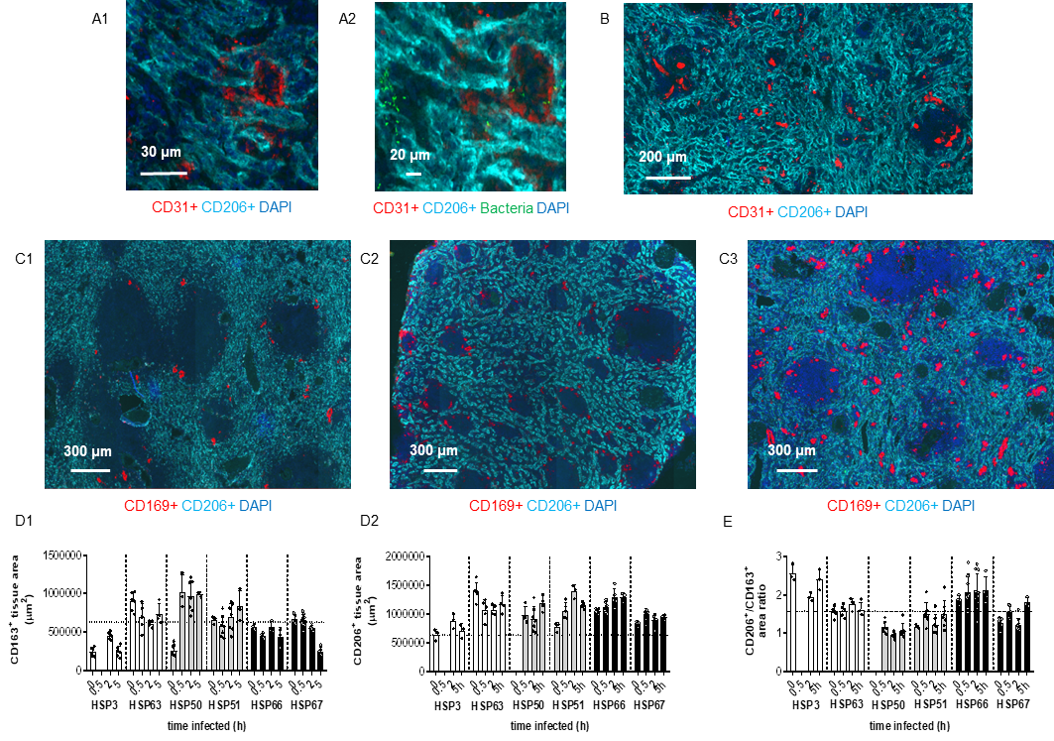

Figure S1: Cellular markers expression in the human spleen. A1) High-content scanning microscopy of a human spleen section. CD31⁺ endothelial cells in red and CD206⁺ sinusoidal cells in cyan. Nuclei shown in DAPI staining (blue). A2) Preferential localization of bacteria (green) on the sinusoidal cells (cyan) rather than on CD31⁺ cells (red). B) Low magnification images showing distinct distribution of CD206 (cyan) and CD31 (red) markers in the human spleen. Images (panels A-B) are representative of two independent staining (different time points of infection) of the same human spleen (HSP70) and they summarize the general situations found within the two independent biopsies. C1-C3) Inter-individual variability distribution of the CD169 marker between spleens (C1: HSP51; C2: HSP50; C3: HSP66). Cyan: CD163⁺ RPMs (C1) or sinusoidal cells CD206⁺ (C2-C3); Red: CD169⁺ PCSAMs. Cell nuclei are shown in DAPI staining (blue). D1-D2) Quantification of marker-positive area in μm² occupied by the CD163⁺ RPMs (D1) and CD206⁺ sinusoidal cells (D2) during the entire duration of the perfusion. E) Relative ratio in tissue area (μm²) between the CD206⁺ sinusoidal cells and the CD163⁺ macrophages. (D1-E) White bars indicate control human spleens (HSP3, HSP63), grey bars represent infected spleen (HSP50, HSP51) and the black bars represent spleen with mannose supplementation before infection (HSP66, HSP67). Time is expressed in hour (h). Dotted lines indicate the overall average for the area covered by each marker in tissues. Spleens analysed in these panels are listed in Tab. S5.

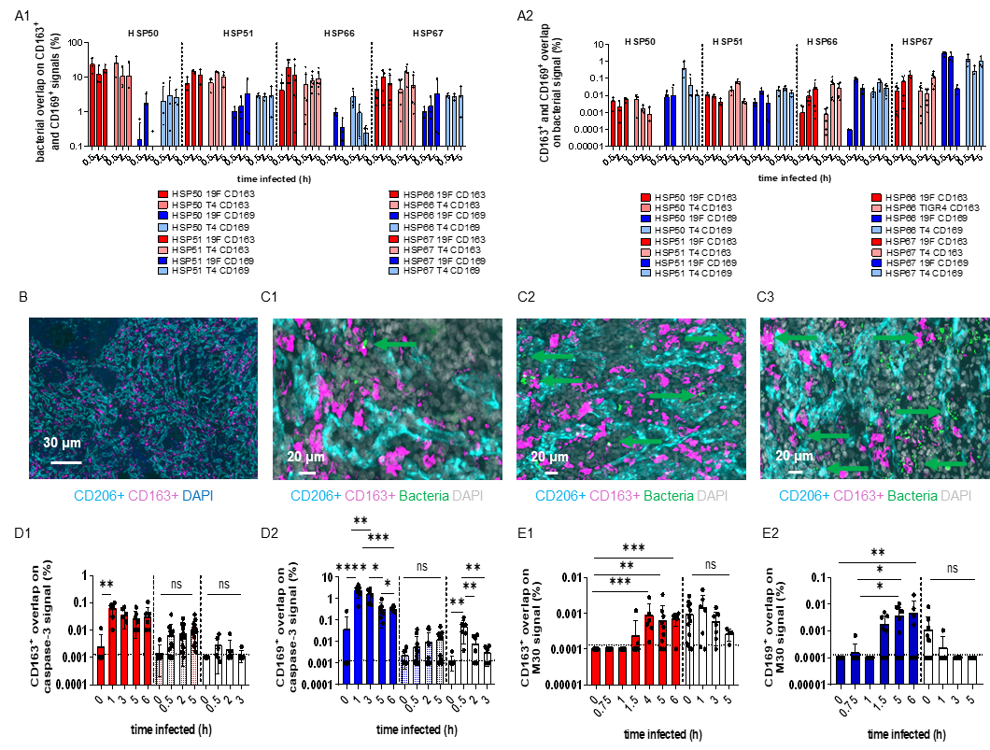

Figure S2: Bacterial distribution in the human spleen and macrophages positive areas to caspase-3 and M30. A1) Association of 3 different pneumococcal serotypes (D39: type 2; TIGR4 (T4): type 4 and 19F: type 19) with CD163⁺ RPMs (red) and CD169⁺ PCSAMs in four different human spleen (HSP50, HSP51, HSP66, HSP67) throughout infection (hour). B-C3) Splenic sinuses draining the open circulation of the human splenic red pulp are lined by sinusoidal lining cells (CD206+, LYVE-1). B) Bacteria reach the open circulation of the splenic red pulp from the bloodstream. C1-C3) Images from spleens collected at 30 min (C1), 2h (C2) and 5h (C3) after challenge show bacteria in the red pulp associated to sinusoidal cells (cyan) or macrophages (magenta), but not in the draining sinuses (CD206: cyan; CD163: magenta; CD169: red; DAPI: blue and grey). Images (panels B and C) are representative of three independent spleens (HSP66, 67, 70) and they summarize the general situations found within the time points of infection in each field of view. D1, D2) Quantification of the macrophage area occupied by the activated caspase-3 signal over time. CD163⁺ are shown in red bars (D1) and CD169⁺ in blue bars (D2). In contrast, beads-perfused spleens are indicated by light-red and light-blue bars (D1-D2). F1, F2) M30-positive macrophage area quantification (CD163⁺: red bars; CD169⁺: blue bars). Uninfected perfused spleens are shown with white bars (D1-E2). Dotted lines represent our limit of detection (D1, D2: 0.0013%; E1, E2: 0.00013%). Statistical significance was determined by ordinary one-way ANOVA with Kruskal-Wallis post-hoc (ns: P>0.05; *: P≤0.05; **: P≤0.01; ***: P≤0.001; ****: P≤0.0001). Spleens analysed in these panels are listed in Tab. S5.

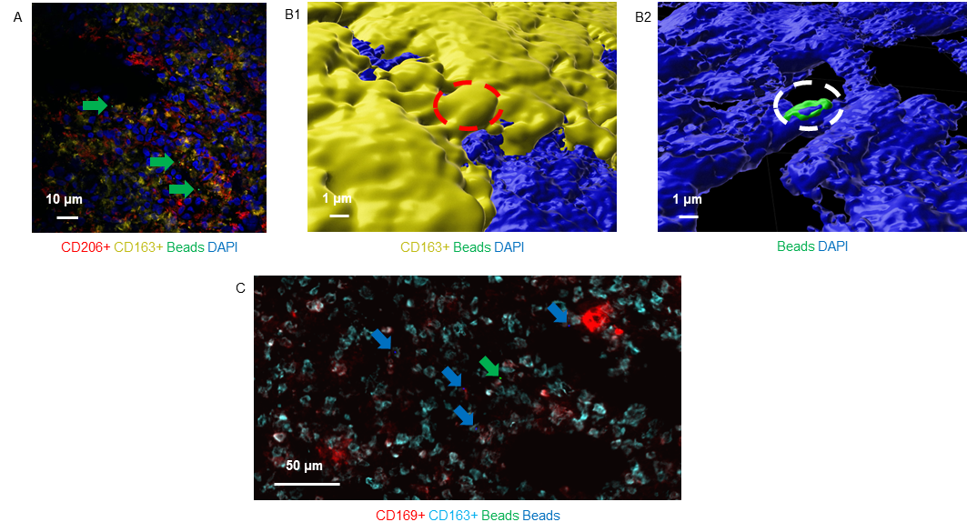

Figure S3: Micro-beads uptake by human spleen macrophages during the ex vivo organ perfusion: A) High-content confocal image of a spleen section showing fluorescent micro beads (green), CD163⁺ RPMs (yellow) and CD206⁺ sinusoidal cells (cyan). 3D confocal reconstruction of bead (green) uptake by RPMs (yellow). The red and white dashed circles indicate the bead localization within the macrophage. C) High-content scanning microscopy of a spleen section containing fluorescent micro-beads (blue), CD163⁺ RPMs (cyan) and CD169⁺ PCSAMs (red). Nuclei are shown in DAPI staining (blue). Spleens analysed in these panels are listed in Tab. S5.

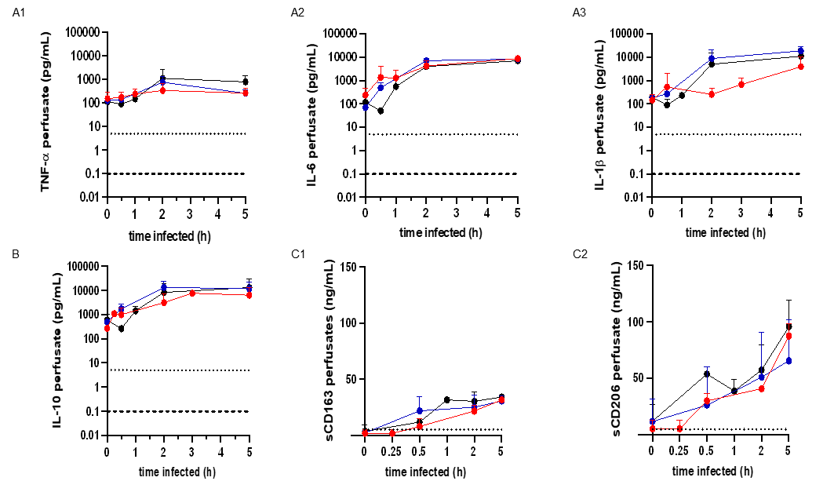

Figure S4: Cytokine quantification in human spleen perfusate samples over time of perfusion. A1-A2) Quantification of the pro-inflammatory cytokines TNFα (A1), IL-6 (A2) and IL-1β (A3). B1-B2) Quantification of the anti-inflammatory cytokines and IL-10 (B2). C1-C2) ELISAs for soluble-CD163 (C1) and soluble-sCD206 (C2). Time refers to hours (h) of infection. Dashed lines indicate the limit of detection (A1-B2: 0.1 pg/mL; C1-C2: 5 ng/mL). A1-B2) Dotted lines show the cytokine normal serum concentration (5 pg/mL). Blue lines: pooled control spleens; red lines: pooled infected spleens; black lines: pooled mannose spleens. Spleens analysed in these panels are listed in Tab. S5.

References
- Carreno D, Wanford JJ, Jasiunaite Z, Hames RG, Chung WY, Dennison AR and Oggioni MR (2021). Splenic macrophages as the source of bacteraemia during pneumococcal pneumonia. EBioMedicine, 72.
- Rampino T, Gregorini M, Germinario G, Pattonieri EF, Erasmi F, Grignano MA, Ravaioli M. (2022). Extracellular vesicles derived from mesenchymal stromal cells delivered during hypothermic oxygenated machine perfusion repair ischemic/reperfusion damage of kidneys from extended criteria donors. Biology, 11(3), 350.
- Schindelin J, Arganda-Carreras I, Frise E, Kaynig V, Longair M, Pietzsch T and Cardona A. (2012). Fiji: an open-source platform for biological-image analysis. Nature methods, 9(7), 676-682.
- Andreata F, Blériot C, Di Lucia P, De Simone G, Fumagalli V, Ficht X and Iannacone M. (2021). Isolation of mouse Kupffer cells for phenotypic and functional studies. STAR protocols, 2(4), 100831.
- Tettelin H, Nelson KE, Paulsen IT, Eisen JA, Read TD, Peterson S and Fraser CM. (2001). Complete genome sequence of a virulent isolate of Streptococcus pneumoniae. Science, 293(5529), 498-506.
- Lanie JA, Ng WL, Kazmierczak KM, Andrzejewski TM, Davidsen TM, Wayne KJ and Winkler ME. (2007). Genome sequence of Avery's virulent serotype 2 strain D39 of Streptococcus pneumoniae and comparison with that of unencapsulated laboratory strain R6. Journal of bacteriology, 189(1), 38-51.
- McGee L, McDougal L, Zhou J, Spratt BG, Tenover FC, George R and Klugman KP. (2001). Nomenclature of major antimicrobial-resistant clones of Streptococcus pneumoniae defined by the pneumococcal molecular epidemiology network. Journal of Clinical microbiology, 39(7), 2565-2571.
- Pozzi G, Masala L, Iannelli F, Manganelli R, Havarstein LS, Piccoli L and Morrison DA. (1996). Competence for genetic transformation in encapsulated strains of Streptococcus pneumoniae: two allelic variants of the peptide pheromone. Journal of Bacteriology, 178(20), 6087-6090.
- Hiller NL, Janto B, Hogg JS, Boissy R, Yu S, Powell E and Hu FZ. (2007). Comparative genomic analyses of seventeen Streptococcus pneumoniae strains: insights into the pneumococcal supragenome. Journal of Bacteriology, 189(22):8186-95.
- Wanford JJ, Hames RG, Carreno D, Jasiunaite Z, Chung WY, Arena F and Oggioni MR. (2021). Interaction of Klebsiella pneumoniae with tissue macrophages in a mouse infection model and ex-vivo pig organ perfusions: an exploratory investigation. The Lancet Microbe, 2(12), e695-e703.
- Hunstad DA, Justice SS, Hung CS, Lauer SR and Hultgren SJ. (2005). Suppression of bladder epithelial cytokine responses by uropathogenic Escherichia coli. Infection and immunity, 73(7), 3999-4006.

