SUPPLEMENTARY INFORMATION
Gated MoS₂/SiN Nanochannel for Tunable Ion Transport and Protein Translocation

Shukun Weng ^{1,2*}; Ali Douaki ^{1,3}; Makusu Tsutsui ⁴, German Lanzavecchia ^{1,3}, Anastasiia Sapunova ^{1,2}, Lorenzo Iannetti⁵, Alberto Giacomello⁵, Roman Krahne ¹, and Denis Garoli ^{1,3*}

¹ Optoelectronics Research Line, Instituto Italiano di Tecnologia, 16163 Genova, Italy
² Department of Materials Science, University of Milano-Bicocca, Via R. Cozzi 55, I-20125 Milano, Italy
³ Dipartimento di Scienze e Metodi dell’Ingegneria, Universitàdegli Studi di Modena e Reggio Emilia, Via Amendola, 2, 43122 Reggio Emilia, Italy
⁴ The Institute of Scientific and Industrial Research, Osaka University, Mihogaoka 8-1, Ibaraki, Osaka, 567-0047, Japan
⁵ Dipartimento di Ingegneria Meccanica e Aerospaziale, Sapienza Università di Roma, Via Eudossiana, 18, 00184 Roma, Italy

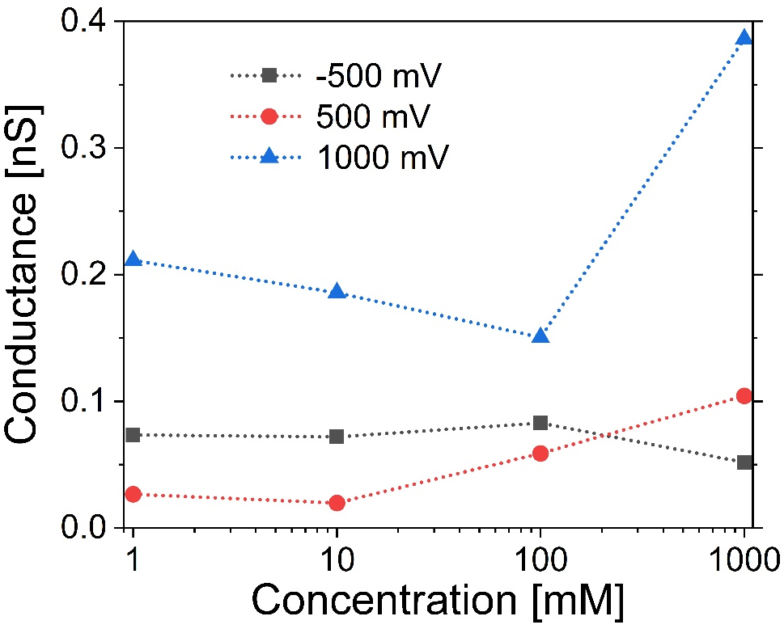
Fig. S1. The conductance of MoS2/SiN nanochannel within different concentration under -500, 500 and 1000 mV potential.

Fig. S2. Ion current traces of low voltage scanning to remove the potential contamination inside the MoS₂/SiN channel. (a) 1st to 10th scan; (b) 11th to 268th scan.
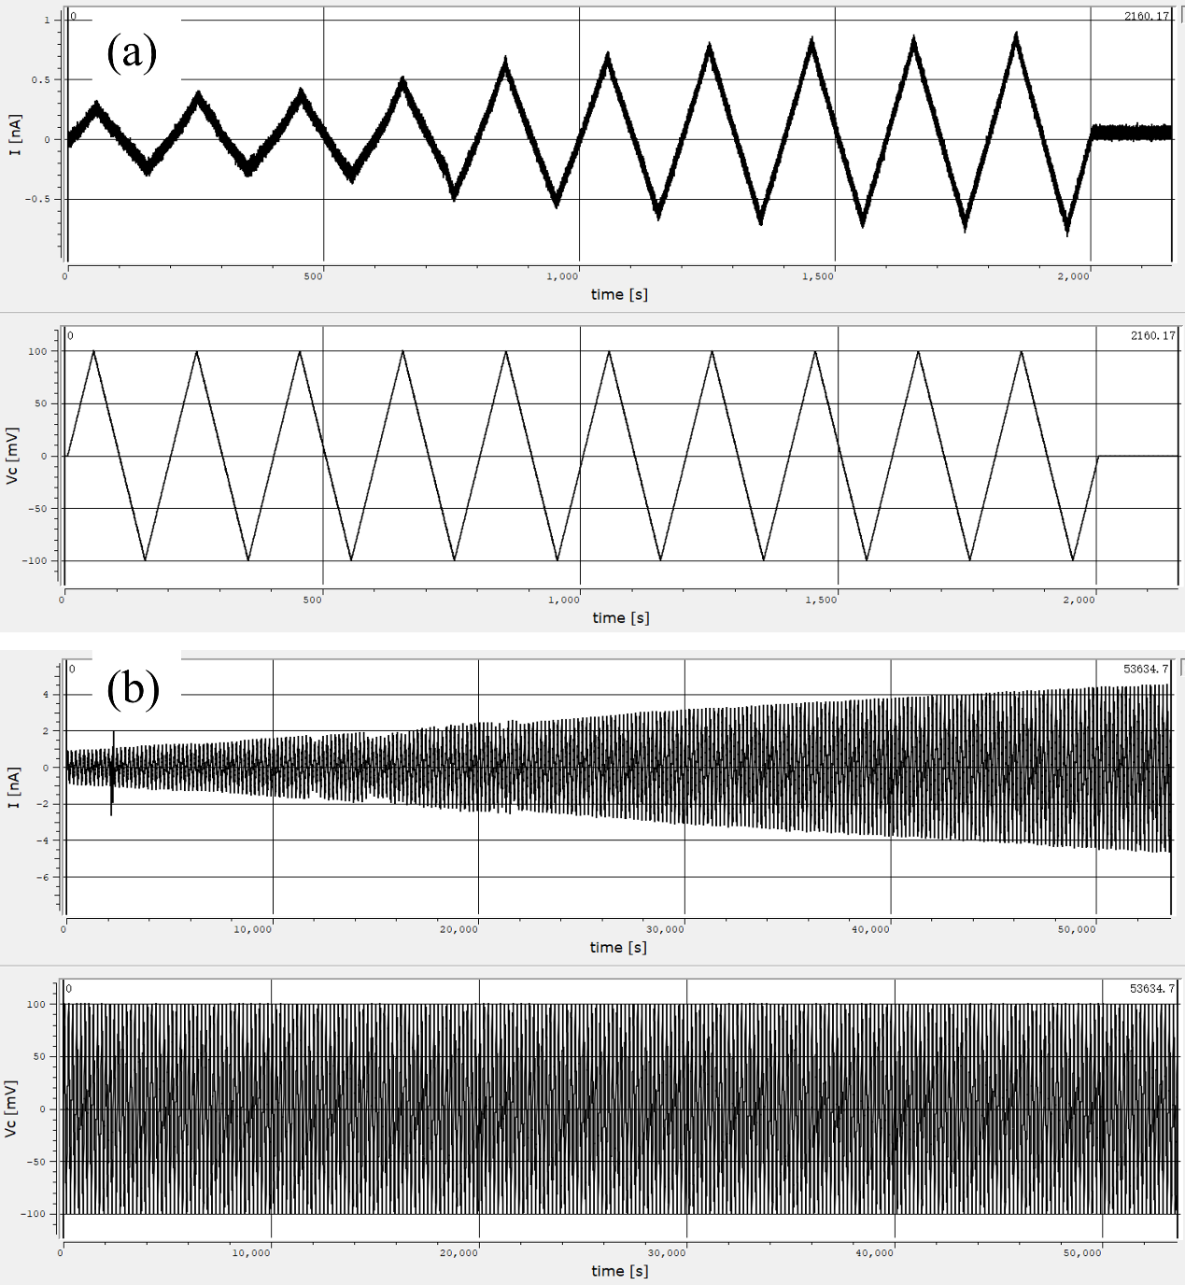

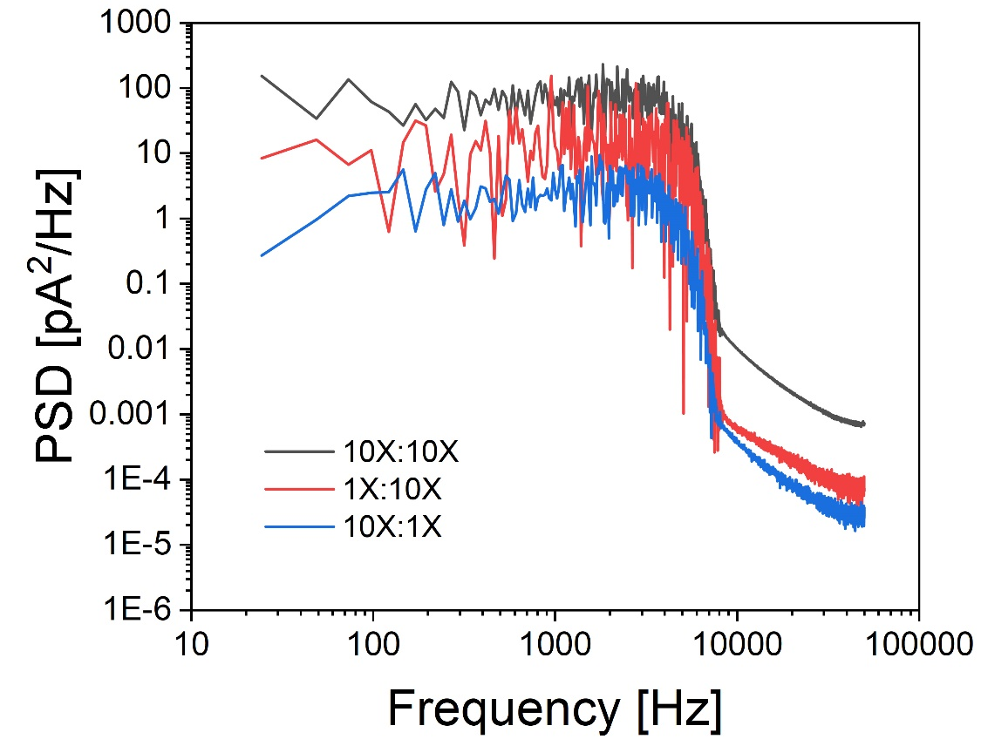
Fig. S3. Power Spectrum Density of nanopore measurement under different electrolyte gradients.

Fig. S4. Scaling of the osmotic power of MoS₂/SiN nanochannel.

Fig. S5. BSA translocation events during 2 min recording.
