Examining the Variability in Adrenal Cortical Suppression Among Patients Receiving Etomidate for General Anesthesia in Morning vs. Evening Sessions: A Randomized Clinical Trial
Lingli Zhu^{1,2}, YulongWang¹, Yuefeng Wang¹, Jiankang He¹, Qiubo Wang¹, Tao Wang¹, Chuchu Du¹, Mengjuan Dong¹, Ling Guo¹, Hao Cheng¹, Wei Chen^{1,*}, Yongquan Chen^{1,*}

Lingli Zhu, YulongWang and Yuefeng Wang contributed equally to this work.
¹Department of Anesthesiology, The First Affiliated Hospital of Wannan Medical College, Wuhu, 241000, China,
²Department of Anesthesiology, Sir Run Run Shaw Hospital, Zhejiang University School of Medicine (Ningguo Branch) & Ningguo People's Hospital, Ningguo, 242300, China
*Corresponding author, Email: Wei chen, 874277327@qq.com; Yongquan Chen, chenyq263@163.com
Conflicts of Interests/Financial Disclosures: None

Table S1. The effect of etomidate on the levels of adrenal cortex-related hormones in Elderly patients
Outcome | Group M (n = 19) | Group E (n = 17) | P value
Cortisol | 26.8%±13.9% | 39.9%±16.4% | 0.0136
Aldosterone | 23.2% ±28.7% | 46.2% ±23.5% | 0.0133
ACTH | -17.8% [-52.2%, 23.8%] | -33.3% [-209.6%, 4.3%] | 0.1234
Cortisol and Aldosterone were presented as mean with standard deviation (mean ± SD); ACTH was expressed as medians with interquartile range [median (Q1, Q3)]. ACTH, adrenocorticotropic hormone. Elderly patient (≥ 65 years).

Table S2. Postoperative recovery status of the study Elderly patients
Outcome | Group M (n = 19) | Group E (n = 17) | P value
Emergence time (min) | 20.0±8.4 | 23.4±9.0 | 0.249
Extubation time (min) | 20.6±8.6 | 24.8±10.9 | 0.206
PACU stay time (min) | 53.1±10.0 | 57.4±14.1 | 0.294
Postoperative Stay (day) | 5 (3, 7) | 5 (4, 6) | 0.626
PONV score ≥3
PoH 6 | 5 (26.3) | 3 (17.7) | 0.532
PoD 1 | 3 (15.8) | 1 (5.9) | 0.345
PoD 3 | 1 (5.3) | 0 (0) | 0.337
Pain score
PoH 6 | 2 (2, 4) | 2 (2, 3.5) | 0.926
PoD 1 | 2 (2, 2) | 2 (2, 2) | 0.343
PoD 3 | 1 (1, 1) | 1 (1, 1) | ＞0.999
QoR-15 scores on PoD 3 | 95±12 | 98±15 | 0.443
Postoperative complications | 1 (5.3) | 3 (17.7) | 0.238
Emergence and extubation time, PACU stay time and QoR-15 scores on PoD 3 were presented as mean with standard deviation (mean±SD); Postoperative stay and pain scores were expressed as medians with interquartile range [median (Q1, Q3)]; POVN scores, as well as postoperative complications, count with percent [n (%)]. Elderly patient (≥ 65 years); PACU presents as Postanesthesia Care Unit; PoH as Postoperative Hour; PoD as Postoperative Day; PONV as Postoperative Nausea and Vomiting; QoR as Quality of Recovery-15.

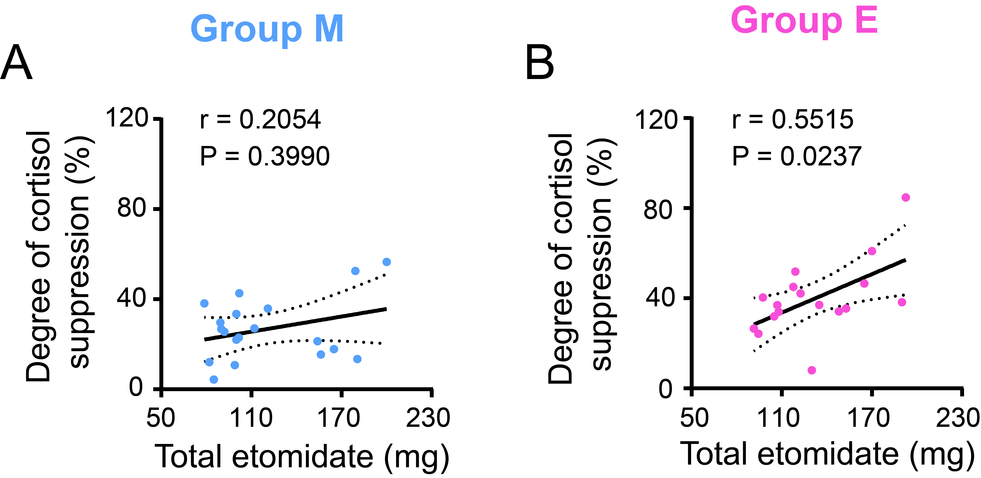
Figure S1. The correlation between degree of cortisol suppression and the total etomidate administered. Spearman r test was used; M, morning; E, evening.

