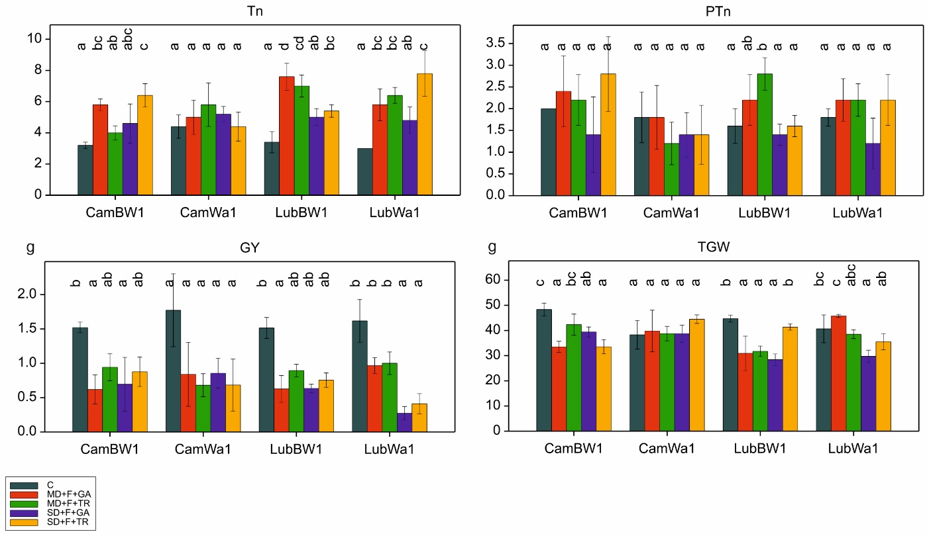
Figure S12. Distribution of traits associated with tillering process and grain yield. Letters indicate statistically similar mean values at p < 0.05 according to the Fisher least significant difference test

