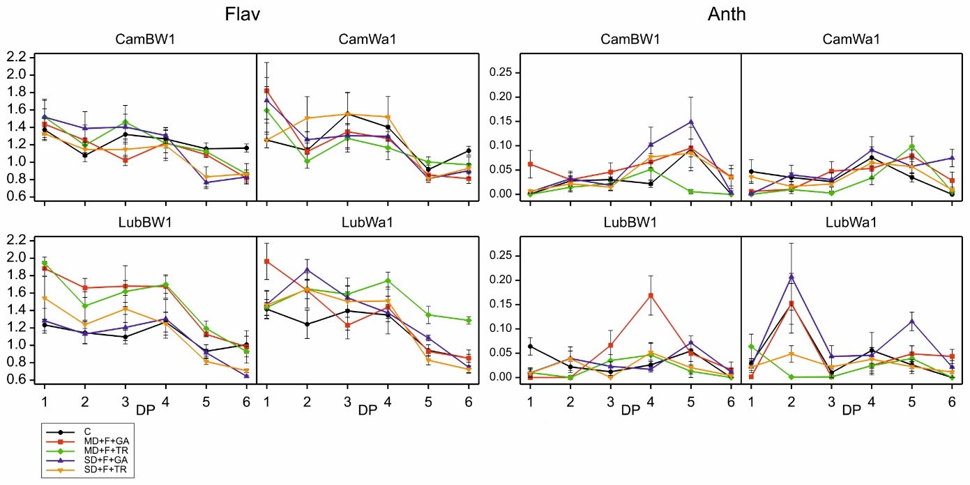
Figure S11. Flavonol index (Flav) and anthocyanin index (Anth) (measured in six development points - after exposure to drought and subsequent recovery) of the studied genotypes grown under optimal water conditions and subjected to stress combinations. Data (mean values with standard errors) are presented in arbitrary units

