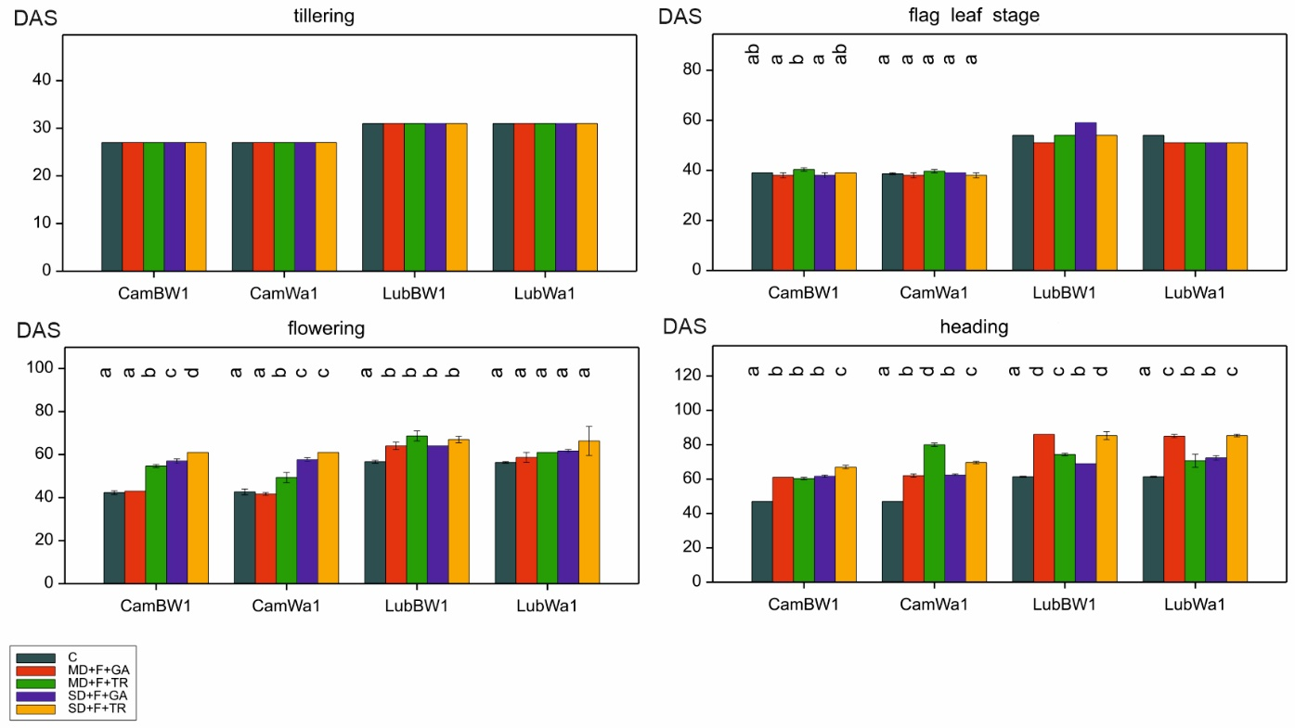
Figure S2. Mean values (with standard errors) of phenological traits for the studied genotypes grown under five treatments: control and combinations of drought (MD – mild; SD – severe) and foliar spray (GA – gibberellic acid, TR – trinexapac ethyl), DAS: days after sowing. Letters indicate statistically similar mean values at p < 0.05 according to the Fisher least significant difference test

