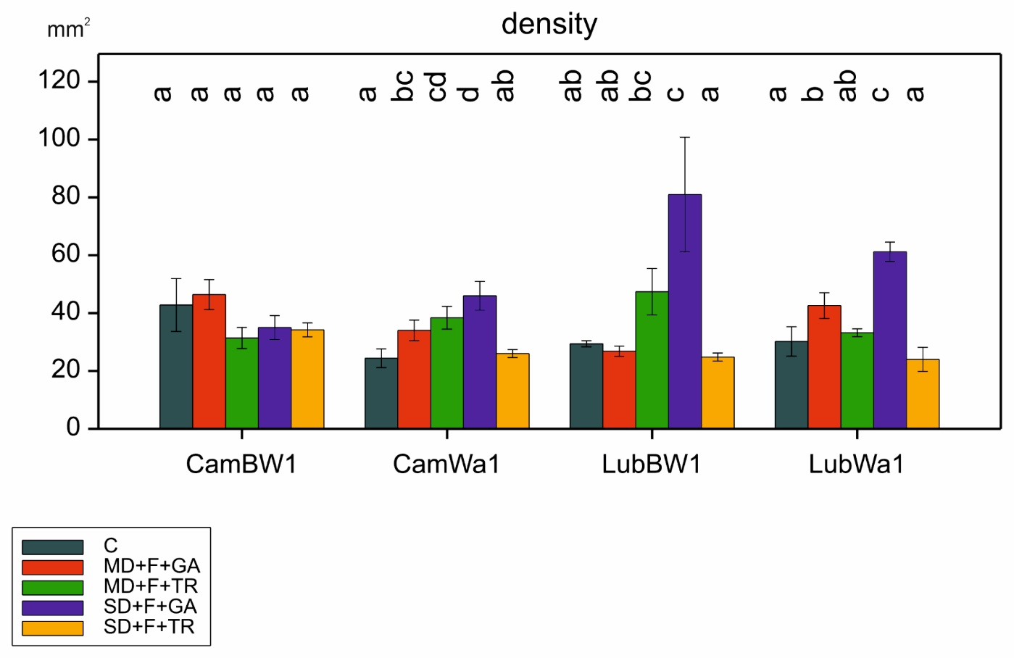
Figure S4. Variability of trichome density observed for the four genotypes. Letters indicate statistically similar mean values at p < 0.05 according to the Fisher least significant difference test

