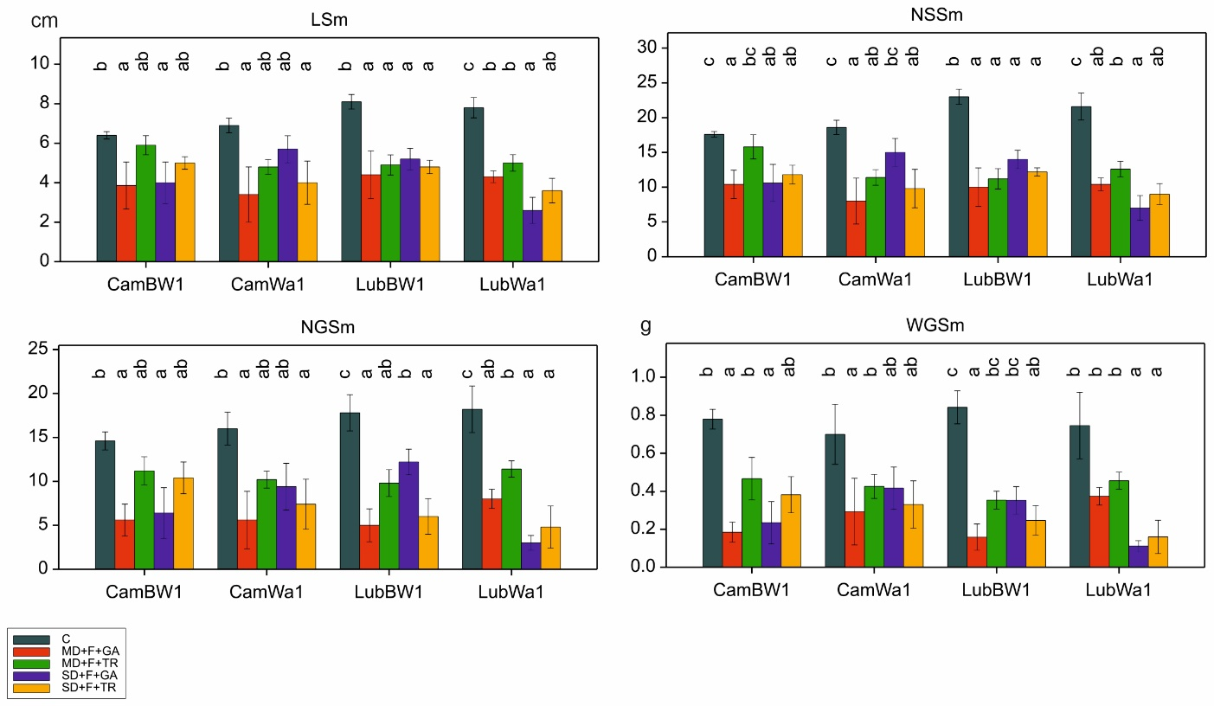
Figure S13. Distribution of traits associated with main spike morphology. Letters indicate statistically similar mean values at p < 0.05 according to the Fisher least significant difference test

