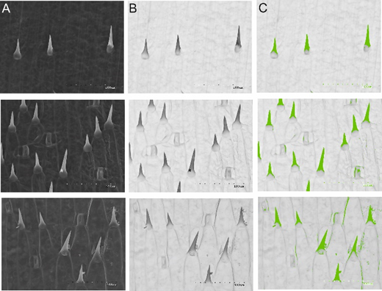
Figure S1. Image acquisition and processing. The analysis was performed by using scanning electron micrographs at ×100 magnification. Image preprocessing steps: the images were converted from SEM microphotographs (A) to binary images (B); the processed image was subjected to auto calculation commend by Image Analyzing System Motic Images Plus 3.0 (C)

