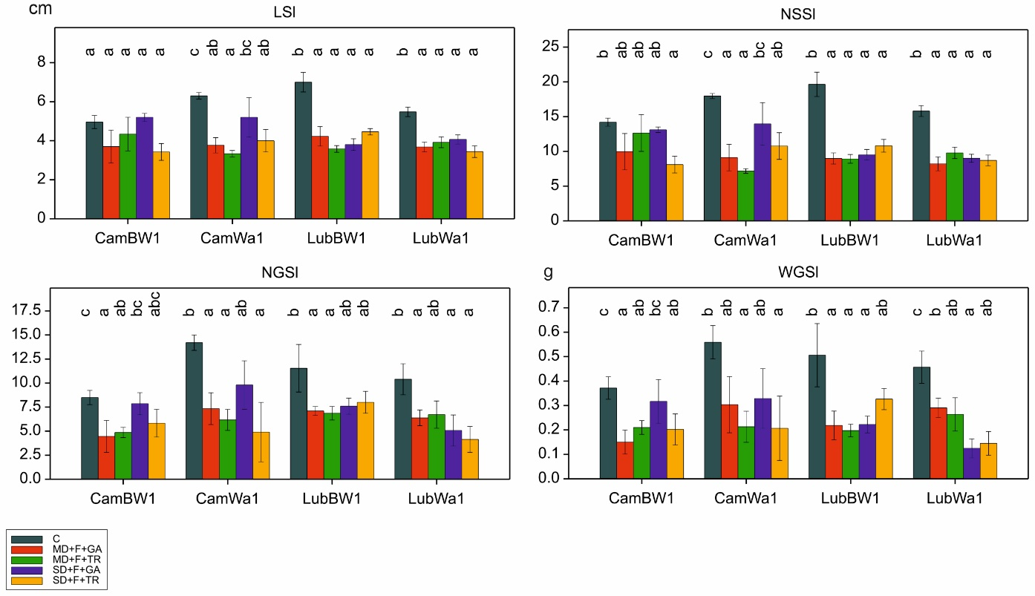
Figure S14. Distribution of traits associated with lateral spike morphology. Letters indicate statistically similar mean values at p < 0.05 according to the Fisher least significant difference test

