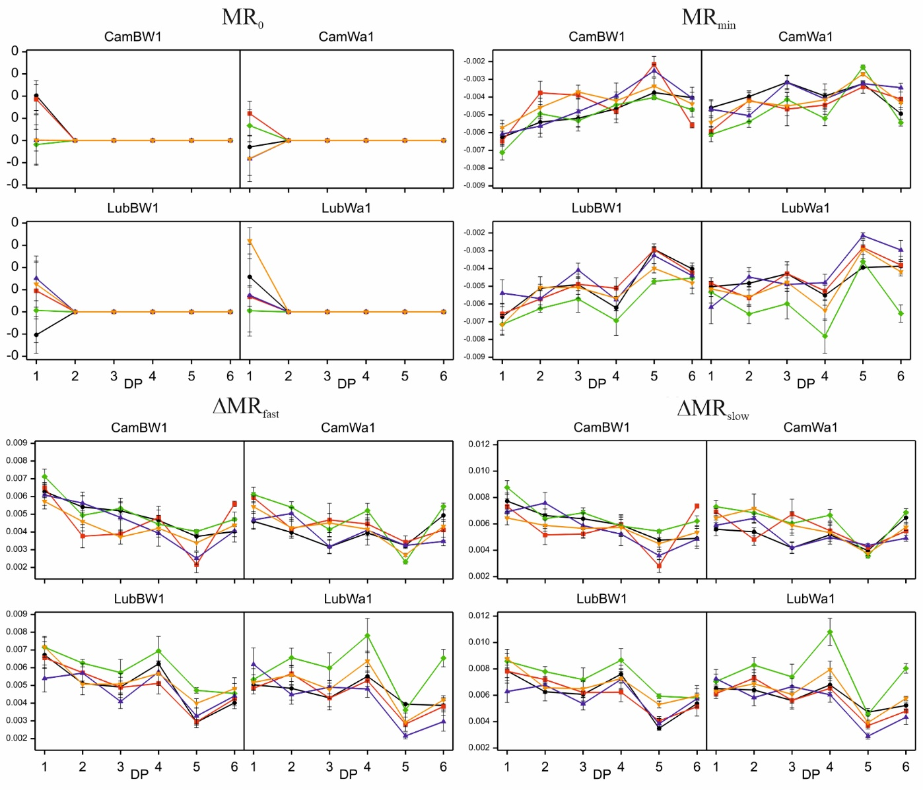
Figure S10. Kinetics of modulated light reflection at 820 nm of the studied genotypes grown under optimal water conditions and subjected to stress combinations. Data (mean values with standard errors) are presented in arbitrary units. Treatments: black – control condition; red – MD+F+GA; green – MD+F+TR; purple – SD+F+GA; yellow – SD+F+TR

