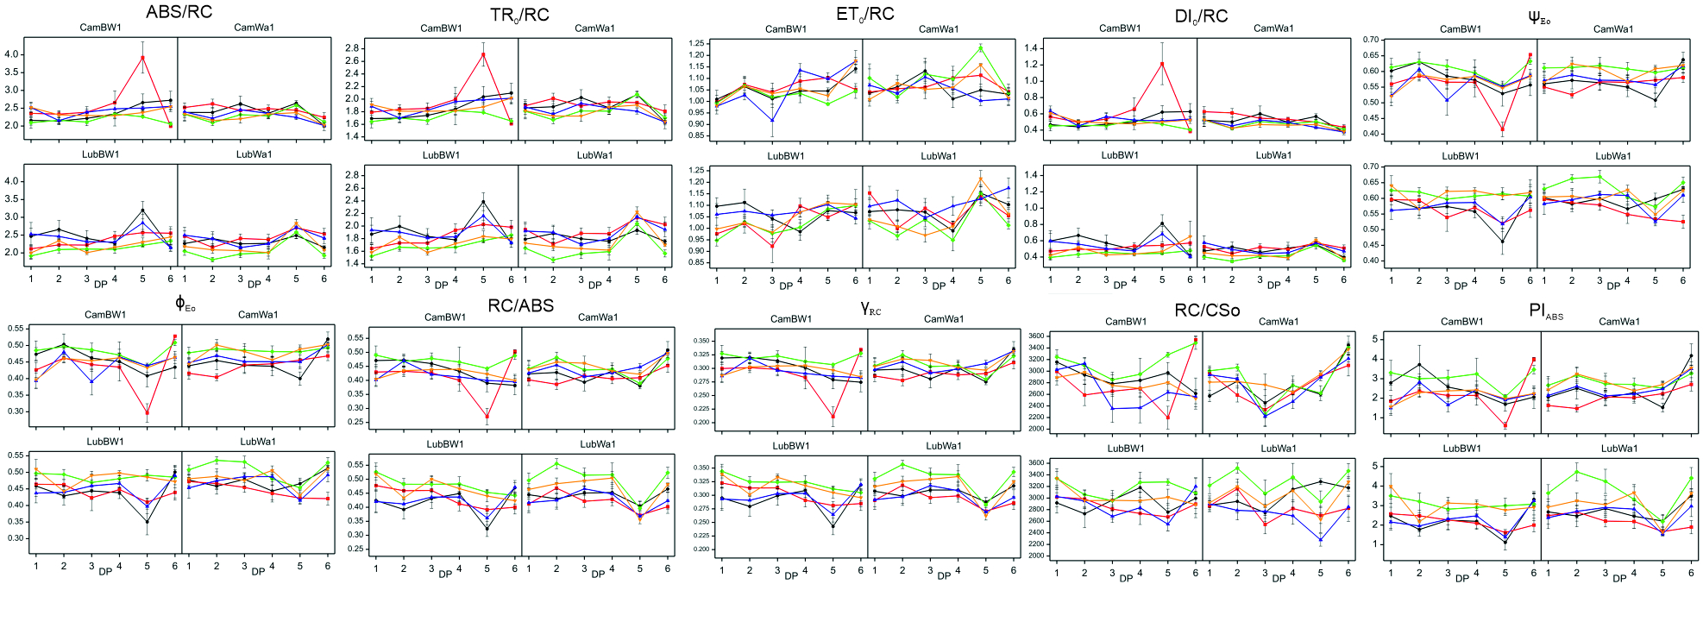Figure S8. The variability of OJIP-derived parameters (measured in six development points - after exposure to drought and subsequent recovery) that characterize PSII functioning in four barley genotypes subjected to different treatments. Data (mean values with standard errors) are presented in arbitrary units. Treatments: black – control condition; red – MD+F+GA; green – MD+F+TR; purple – SD+F+GA; yellow – SD+F+TR

