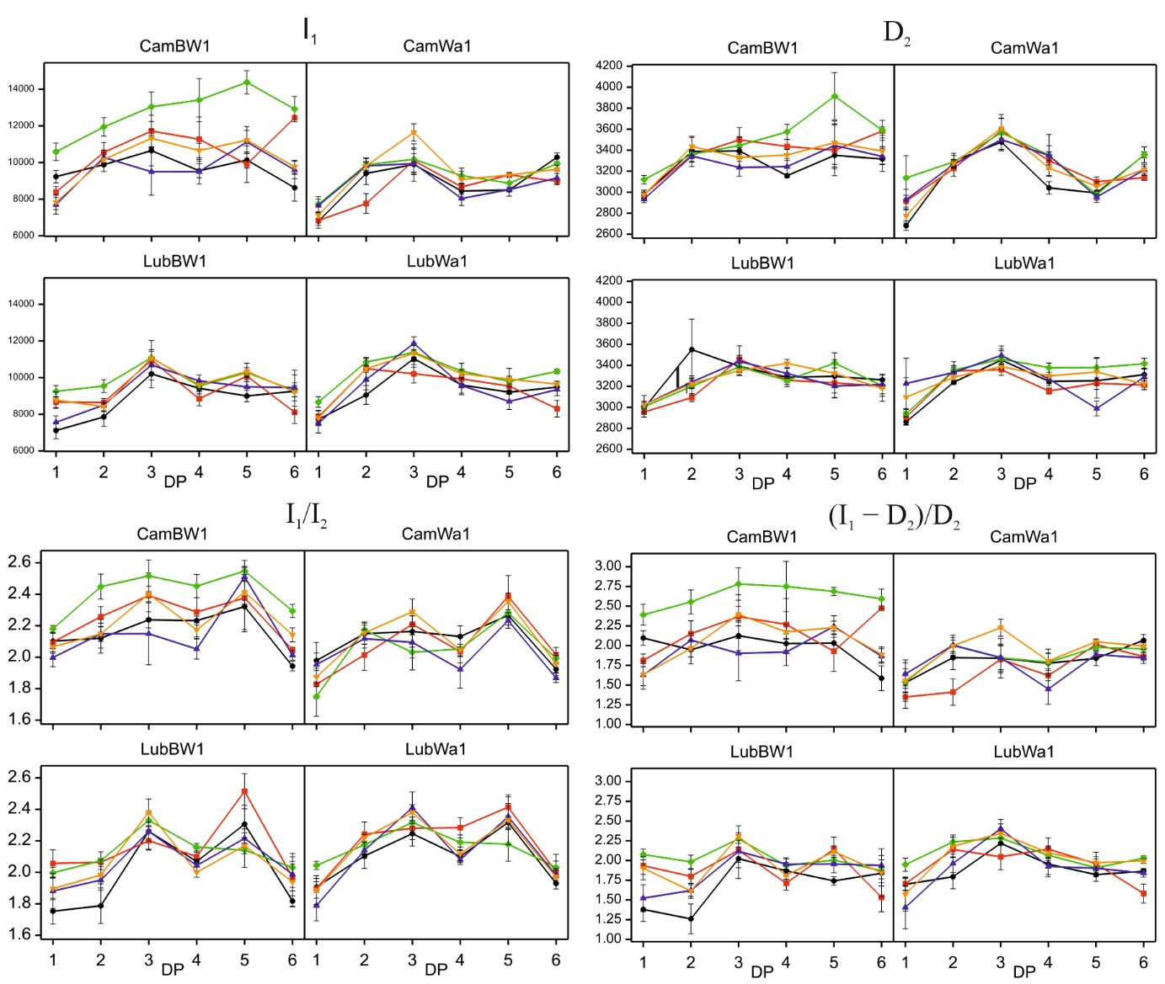
Figure S9. Delayed fluorescence induction curves of the studied genotypes grown under optimal water conditions and subjected to stress combinations. Data (mean values with standard errors) are presented in arbitrary units. Treatments: black – control condition; red – MD+F+GA; green – MD+F+TR; purple – SD+F+GA; yellow – SD+F+TR

