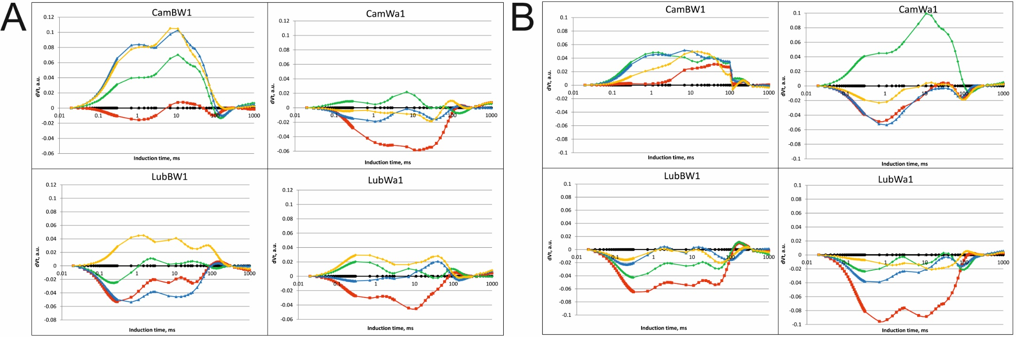
Figure S5. Differential curves of ∆Vt (double normalization) of four studied barley genotypes under different stress treatments at two development stages—DP_1 (A), DP_2 (B). The colors in the diagrams represent experimental conditions: black – control condition; red – MD+F+TR; green – MD+F+GA; blue – SD+F+TR; yellow – SD+F+GA. a.u. - arbitrary units

