Supplementary data
Figure S1. Aging protocol
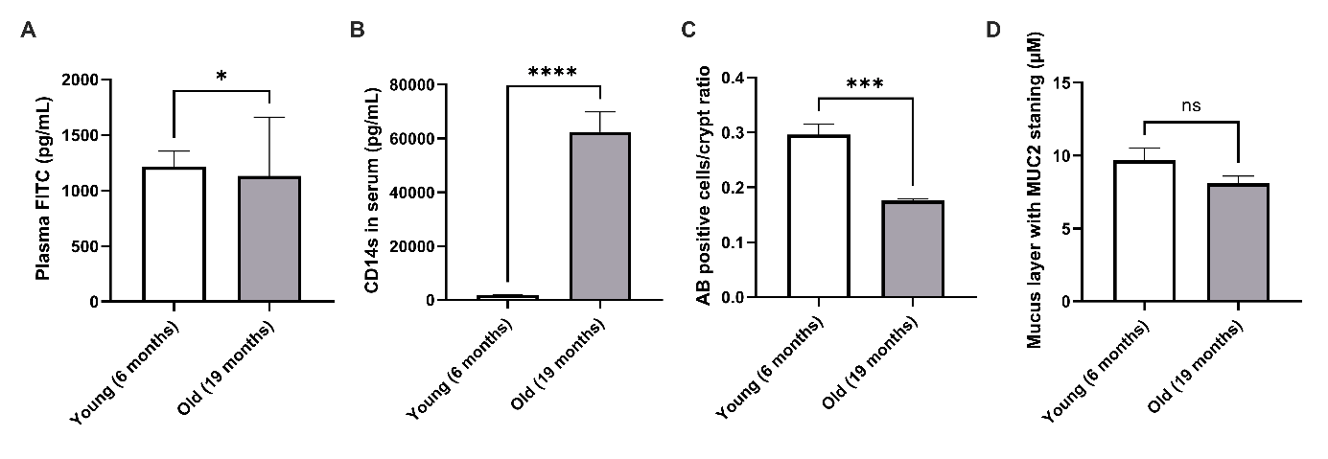
Figure S2. Permeability and mucus production comparison in young vs old mice
FITC-Dextran (A) and CD14s (B) in serum measured at T5, AB positive cells (C) and mucus production (D).
Results of t-test student followed by a Mann Whitney test comparing young (6 months) and old (19 months) mice.
*p < 0.05, **p < 0.01, ***p < 0.001, ****p < 0.0001.
Figure S3. Assessment of intestinal permeability in serum
FITC-Dextran in serum (A) measured at each month and CD14s in serum at T5 (B).
Results of two-way anova followed by a Tukey’s multiple comparison test comparing all groups.
*p < 0.05, **p < 0.01, ***p < 0.001, ****p < 0.0001.

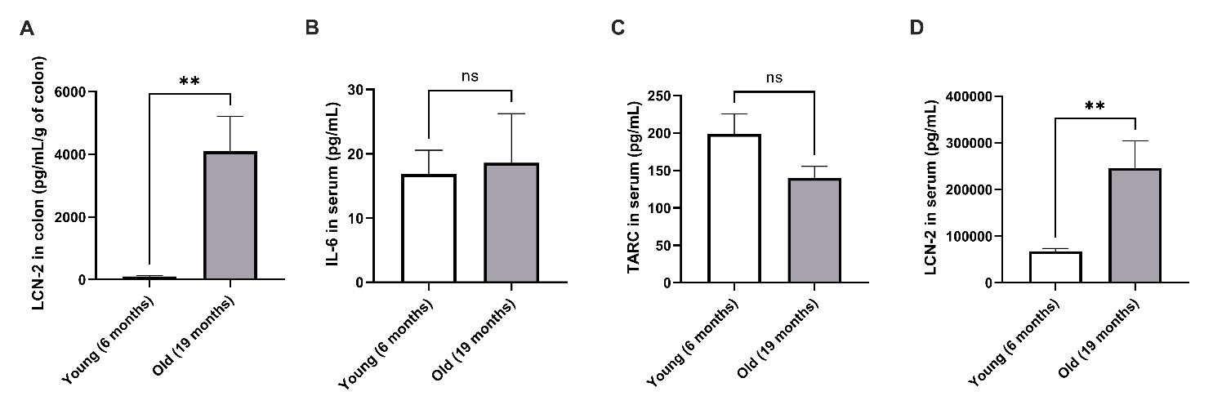
Figure S4. Comparison between young and old mice inflammatory response in colon and serum
LCN-2 in colon (A); IL-6 (B), TARC (C) and LCN-2 (D) cytokines in serum.
Results of t-test student followed by a Mann Whitney test comparing young (6 months) and old (19 months) mice.
*p < 0.05, **p < 0.01, ***p < 0.001, ****p < 0.0001.

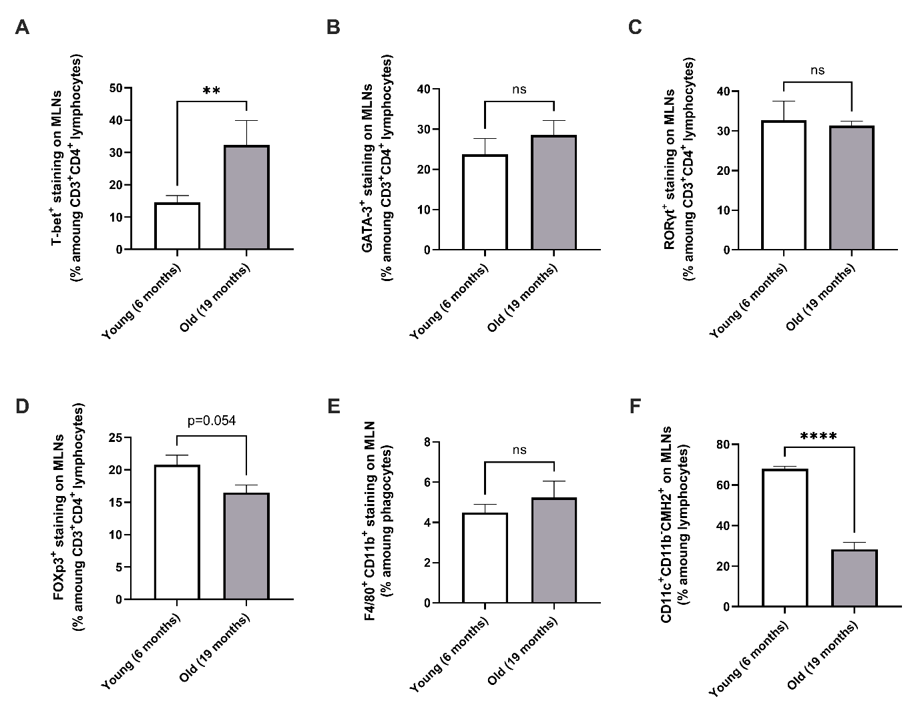

Figure S5. Adaptative et innate immune system at systemic levels on MLNs
Th1 (A), Th2 (B), Th17 (C), Treg (D) population; macrophages (E) and DCs (F) staining on MLN lymphocyte and phagocyte cells.
Results of t-test student followed by a Mann Whitney test comparing young (6 months) and old (19 months) mice.
*p < 0.05, **p < 0.01, ***p < 0.001, ****p < 0.0001.
Figure S6. NK cells in MLNs
Precursor stage of NK cells (A); total (B), immature (C), early mature (D), terminally mature (E) NK cells; B cells (F) staining in MLNs.
Results of t-test student followed by a Mann Whitney test comparing young (6 months) and old (19 months) mice.
*p < 0.05, **p < 0.01, ***p < 0.001, ****p < 0.0001.

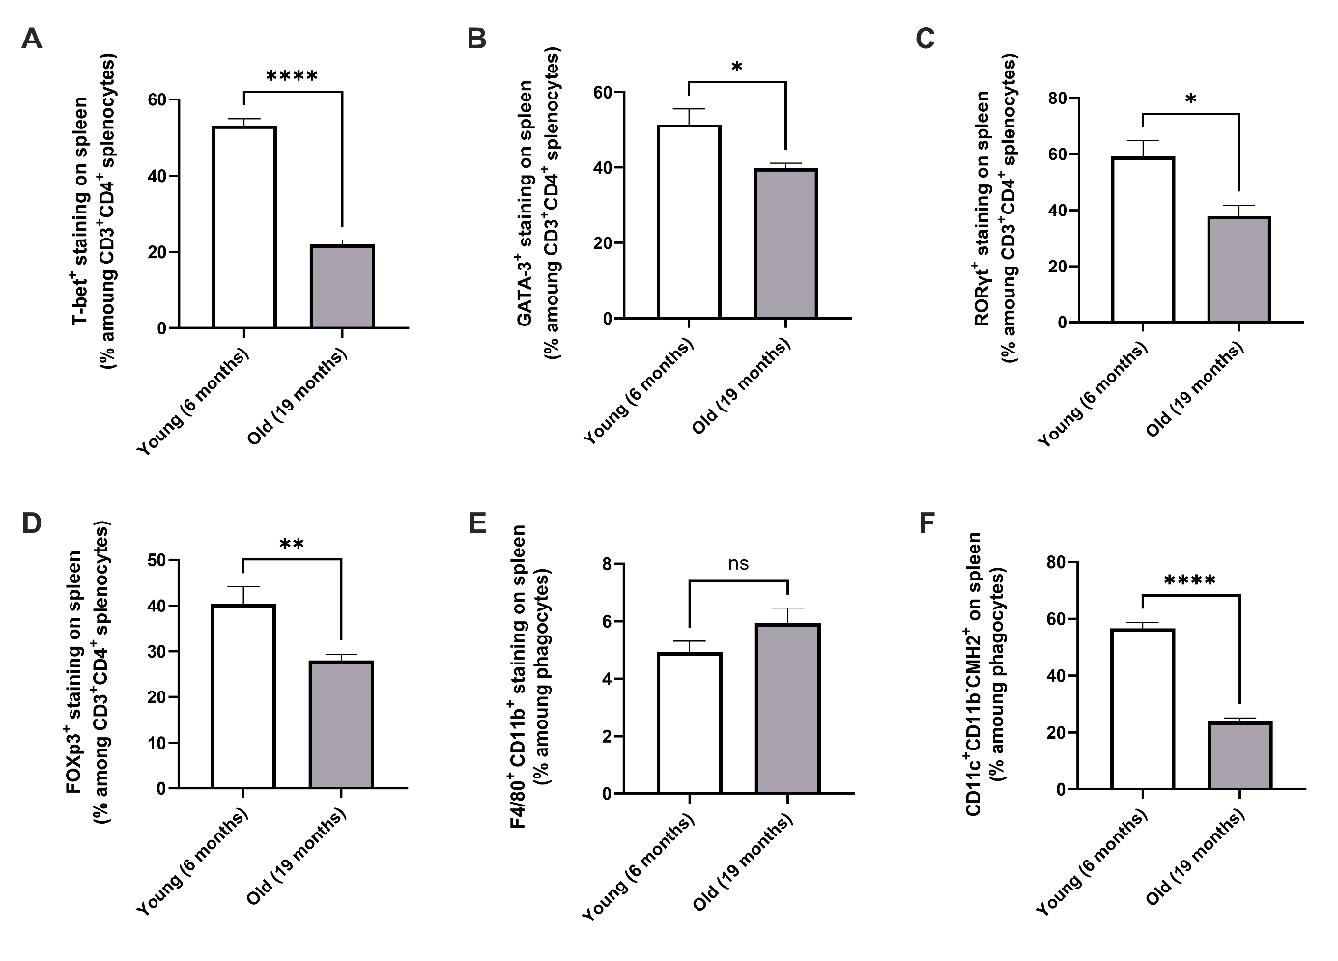

Figure S7. Adaptative and innate staining on young and old mouse splennocytes
Th1 (A), Th2 (B), Th17 (C), Treg (D) population; macrophages (E) and DCs (F) staining on splennocytes.
Results of t-test student followed by a Mann Whitney test comparing young (6 months) and old (19 months) mice.
*p < 0.05, **p < 0.01, ***p < 0.001, ****p < 0.0001.

Figure S8. NK cell maturation modifications between young and old mice in splennocytes
Precursor stage of NK cells (A); total (B), immature (C), early mature (D), terminally mature (E) NK cells; B cells (F) staining in spleen.
Results of t-test student followed by a Mann Whitney test comparing young (6 months) and old (19 months) mice.
*p < 0.05, **p < 0.01, ***p < 0.001, ****p < 0.0001.

B
A

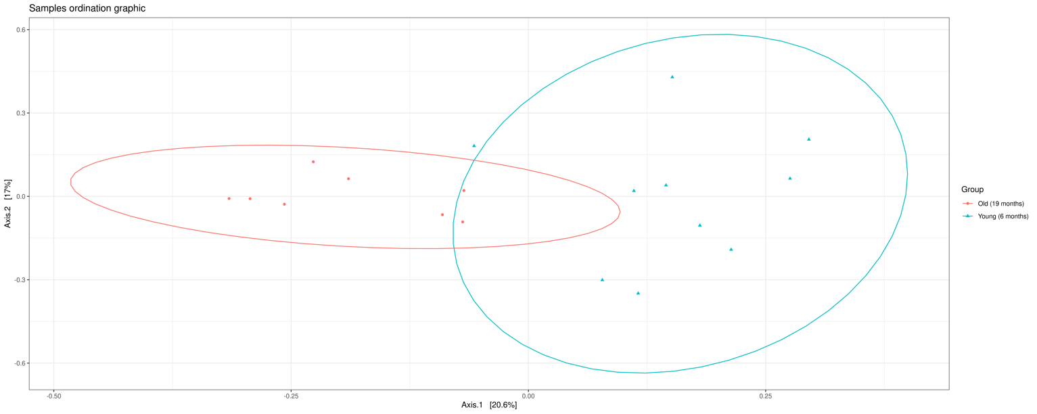
Figure S9. α- and β- diversity in gut microbiota population between young and old mice
Shannon index (p=0.044, *) (A) and bray-curtis dissimilarity (p=0.003, ***) (B) diversity in the gut microbiota.
Results of one-way anova performed in Easy16S software.
*p < 0.05, **p < 0.01, ***p < 0.001, ****p < 0.0001.

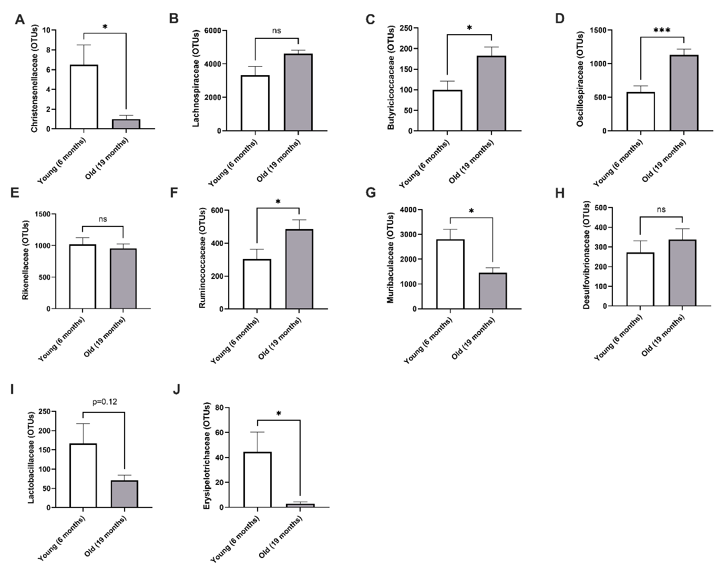
Figure S10. Microbiota differences between young and old mice
Christensenellaceae (A), Lachnospiraceae (B), butyricicoccaceae (C), Muribaculaceae (D), Rikenellaceae (E), Desulfovibrionaceae (F), Oscillospiraceae(G), Lactobacillaceae (H), Erysipelotrichaceae (I) and Ruminococcaceae (J) families in feces at T5.
Results of t-test student followed by a Mann Withney test comparing young (6 months) and old (19 months) mice.
*p < 0.05, **p < 0.01, ***p < 0.001, ****p < 0.0001.
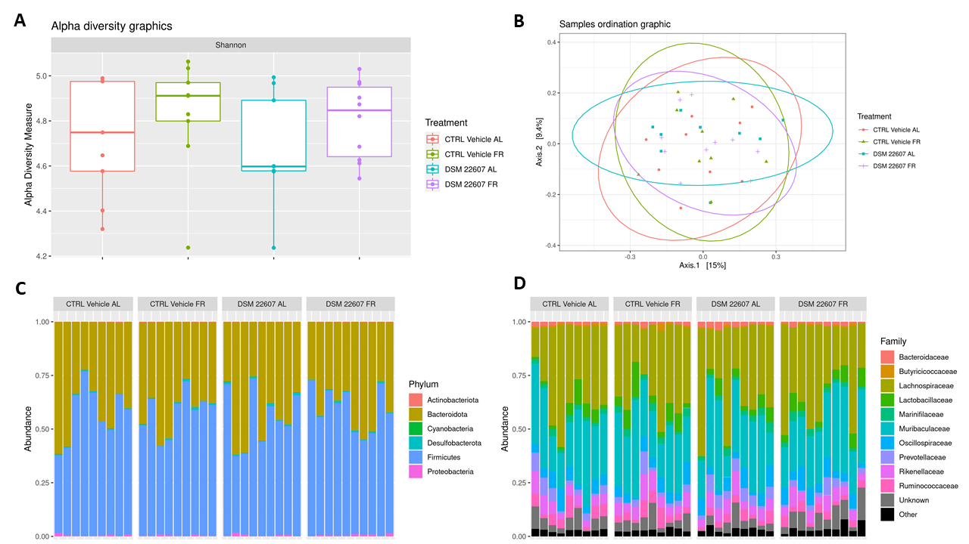

Figure S11. Gut microbiota differences at the beginning of the experiment
α-diversity measure with Shannon index (A); β-diversity with Bray-curtis measure (B); phylum (C) and family abundance (D) in feces at T0.
Results of two-way anova followed by a Tukey’s multiple comparison test comparing all groups.
*p < 0.05, **p < 0.01, ***p < 0.001, ****p < 0.0001

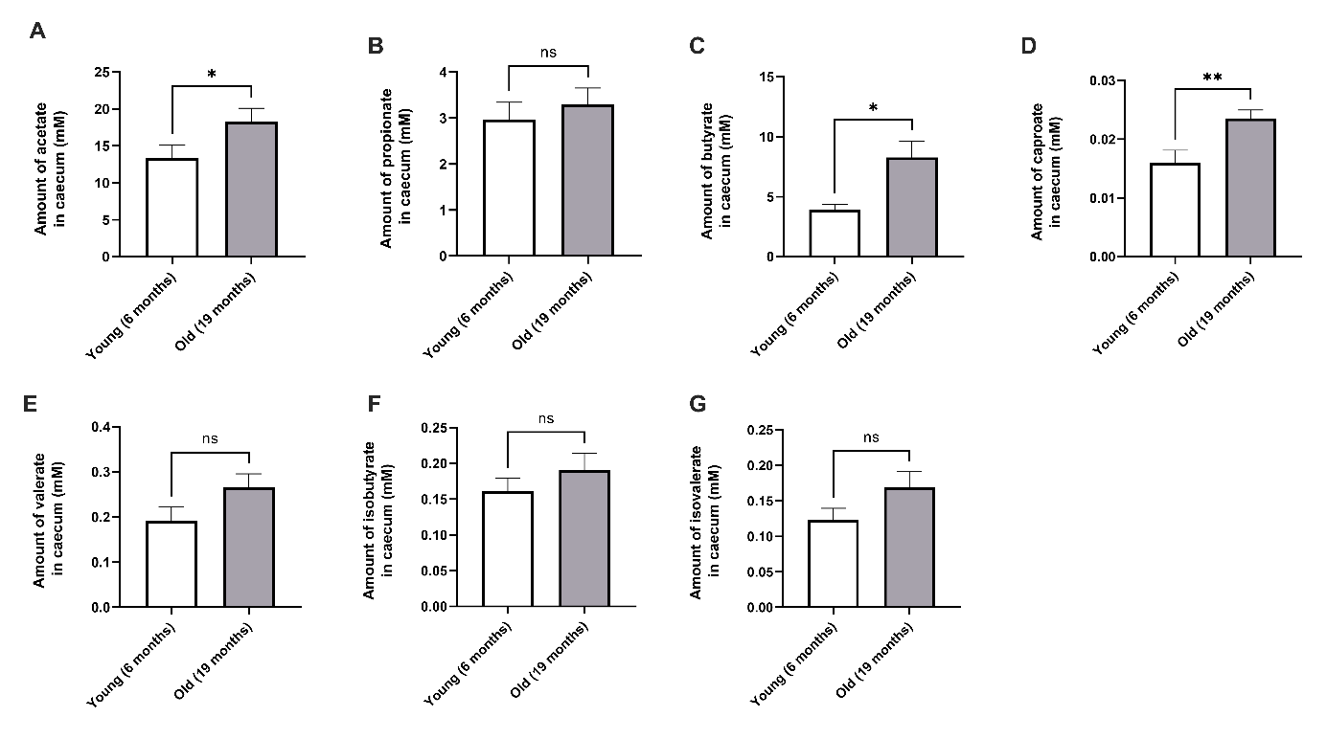
Figure S12. Amount of SCFAs in caecum between young and old mice
Acetate (A), propionate (B), butyrate (C), caproate (D), valerate (E), isobutyrate (F) and isovalerate (G) in caecum.
Results of t-test student followed by a Mann Whitney test comparing young (6 months) and old (19 months) mice.
*p < 0.05, **p < 0.01, ***p < 0.001, ****p < 0.0001.

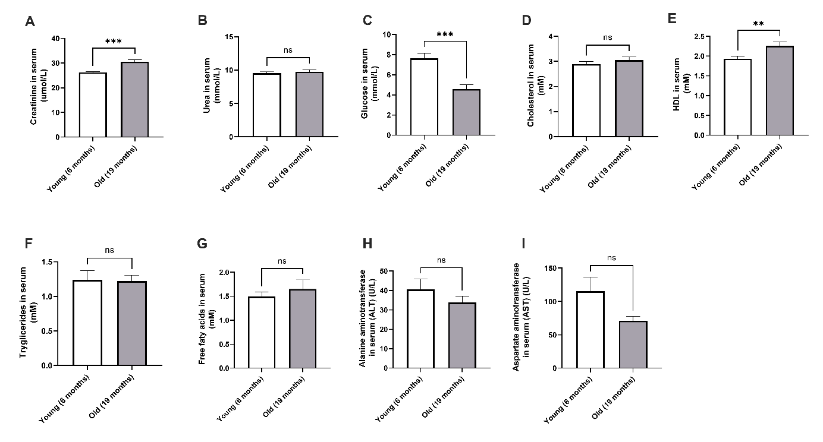
Figure S13. Metabolic parameter differences between young and old mice
Creatinine (A), urea (B), glucose (C), cholesterol (D), HDL (E), triglyceride (F), free fatty acids (G), ALT (H) and AST (I) in serum.
Results of t-test student followed by a Mann Whitney test comparing young (6 months) and old (19 months) mice.
*p < 0.05, **p < 0.01, ***p < 0.001, ****p < 0.0001.
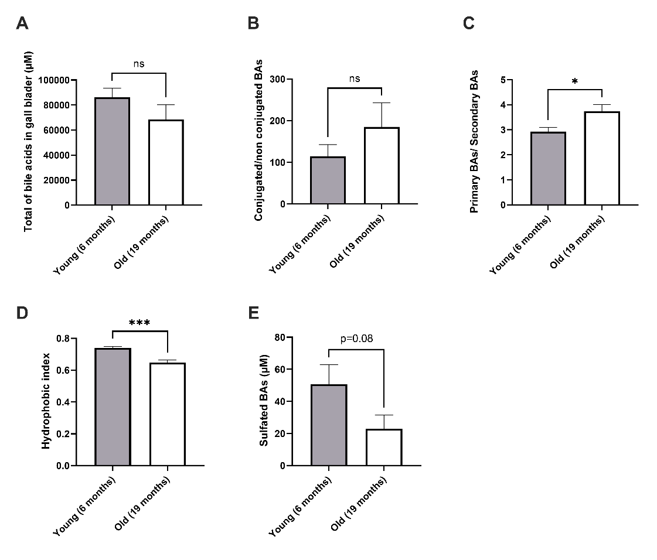

Figure S14. BA composition in gallbladder between young and old mice
Total BA (A), conjugated to non-conjugated BA ratio (B), primary to secondary BA ratio (C), hydrophobic index (D) and sulfated BAs (E) in gallbladder after 3.30 hours of fasting.
Results of t-test student followed by a Mann Whitney test comparing young (6 months) and old (19 months) mice.
*p < 0.05, **p < 0.01, ***p < 0.001, ****p < 0.0001.

