Supplementary Figures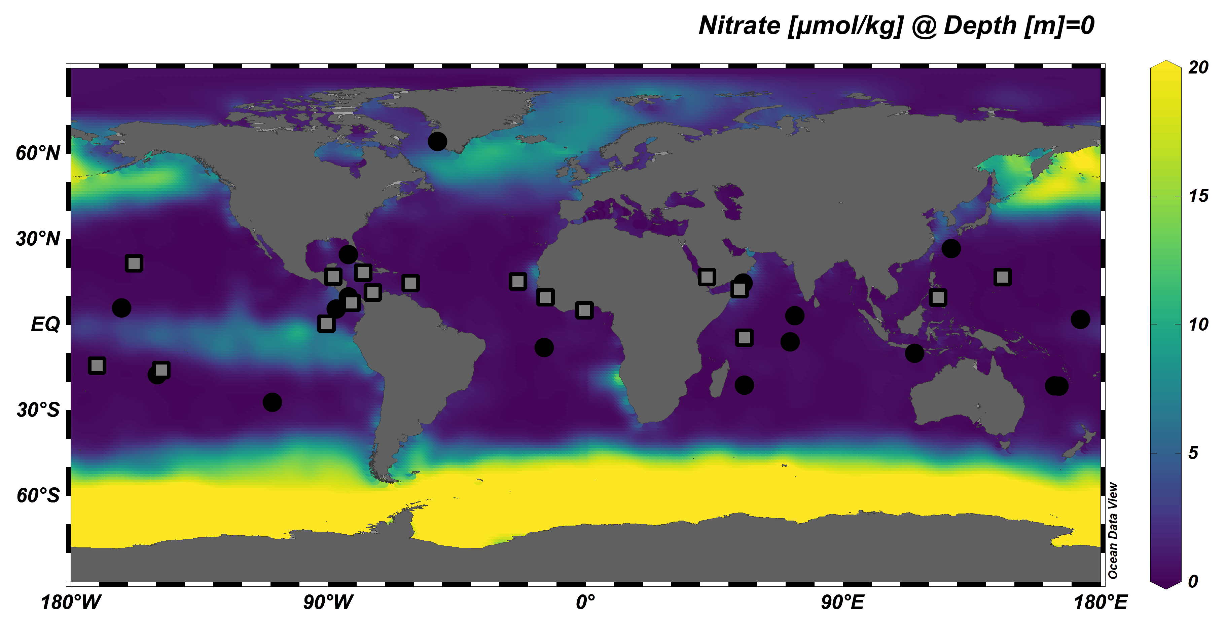
Supplementary Figure 1. Average surface nitrate concentration with respect to sampling locations. Globally interpolated color-coded map of average surface nitrate concentration (in µmol kg⁻¹) with respect to the sampling locations of coralline algae-coral pairs (squares) or locations where only coralline algae were obtained (dots).

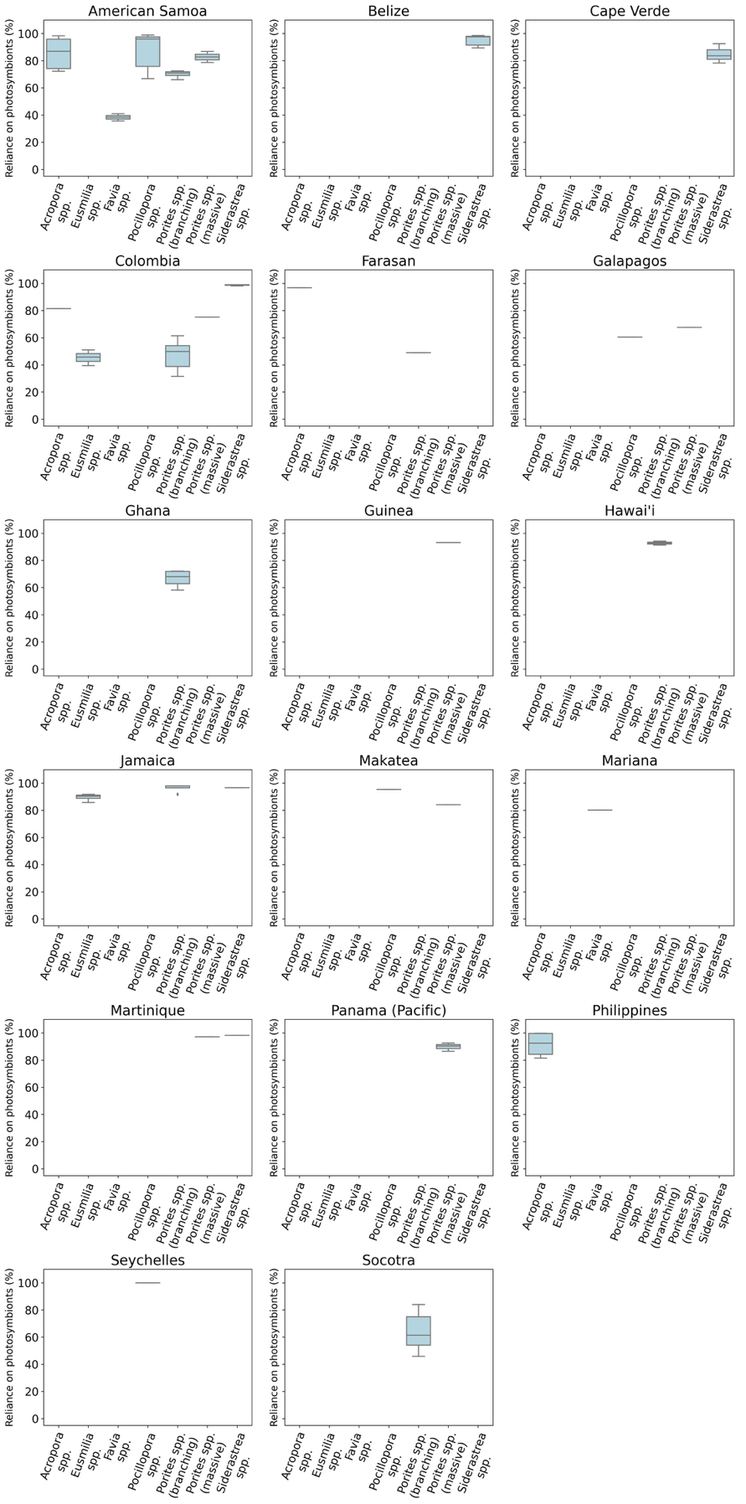
Supplementary Figure 2. Estimated ranges of photosymbiont reliance across coral genera. Estimates of photosymbiont reliance plasticity for corals from across our 17 sample locations. Boxplots show the variability in photosymbiont reliance (in %) for each taxon across distinct geographic regions, illustrating the extent of trophic flexibility of taxa within and between locations. Only taxa with representation at more than one site were included in the photosymbiont reliance plasticity estimation.
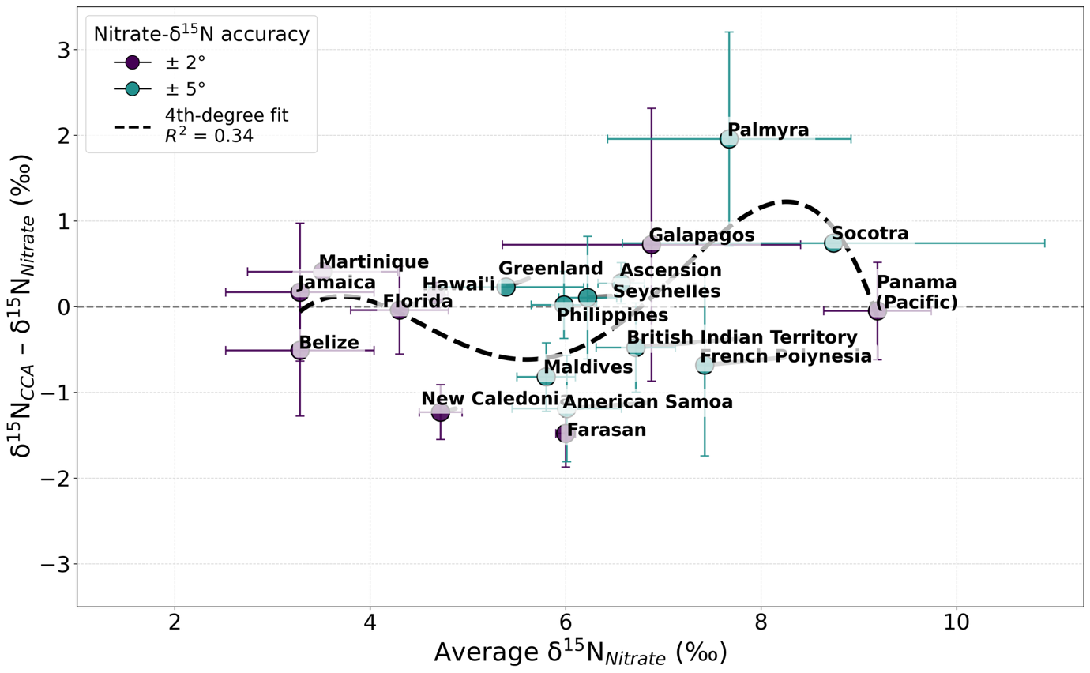
Supplementary Figure 3. Nitrogen isotopic difference between crustose coralline algae and nitrate. Nitrogen isotopic difference between crustose coralline algae (CCA) and subsurface nitrate (δ¹⁵N_{CCA} – δ¹⁵N_{Nitrate} in ‰) across sampled reef sites spanning a gradient of oceanographic regimes. In oligotrophic regions characterized by lower δ¹⁵N<sub>Nitrate</sub> values, δ¹⁵N_{CCA} closely matches nitrate, reflecting direct assimilation from the inorganic nitrogen pool with minimal offset. In contrast, sites with higher δ¹⁵N_{Nitrate} – indicative of enhanced nitrate recycling or proximity to denitrification zones – exhibit a consistent negative offset of approximately -1‰, suggesting a contribution from lower δ¹⁵N nitrogen sources such as ammonium. Notably, in regions adjacent to active denitrification zones, δ¹⁵N_{CCA} can slightly exceed δ¹⁵N_{Nitrate}.

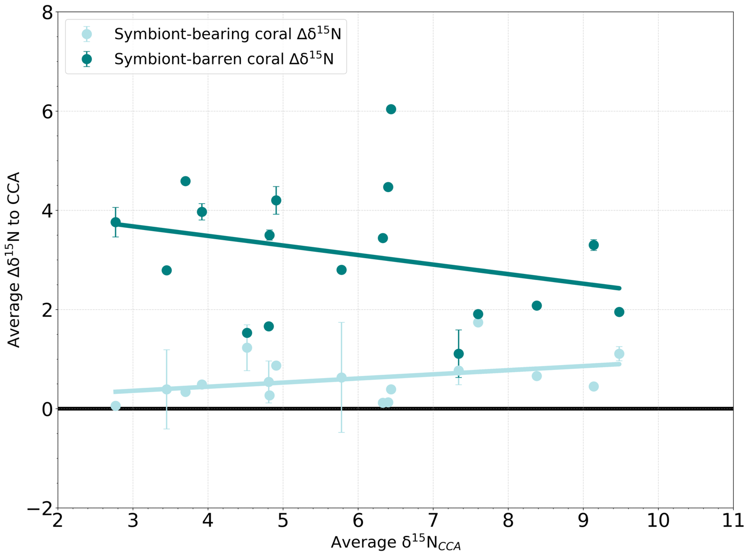
Supplementary Figure 4. Average δ¹⁵N deviation with respect to CCA-δ¹⁵N. Coralline algae-standardized deviations of symbiont-bearing and symbiont-barren coral BB-δ¹⁵N values. Coralline algae can be used as a reliable ‘baseline’ recorder in the absence of nitrate-δ¹⁵N values. Symbiont-bearing and CCA can be used interchangeably while symbiont-barren corals are more variable.

