Supporting Information
For
Diazo-Chalcone Enhanced Cyclotriphosphazene Photodiode Systems: Their Structure–Property Relationships, Photophysical and Electrical Performance

Table of Contents

Synthesis and Characterization of Amino chalcone derivatives | S2
Synthesis and characterization of 4-methoxy amino chalcone | S2
Synthesis and characterization of 4-phenyl amino chalcone | S4
Synthesis and characterization of 4-methyl amino chalcone | S6
Synthesis of Diazo-Chalcone compounds | S9
Synthesis and Characterization of Cyclotriphosphazene (CRG) | S14
Synthesis and Characterization of CRG-OMe | S18
Synthesis and Characterization of CRG-Me | S22
Synthesis and Characterization of CRG-Phe | S26

1. Synthesis and Characterization of Amino Chalcone Derivatives
After dissolving the amino acetophenone (AAF) compound (1.0 equivalent) in ethanol at room temperature, an aqueous solution of 30% NaOH is added to the reaction medium and after about 15 minutes the corresponding aromatic aldehyde (1.03 equivalent) is added to the reaction mixture. The reaction is monitored by thin layer chromatography. Approximately 80% of the solvent of the finished reaction is removed in a rotary evaporator. The residue is added to a 400 ml beaker containing distilled water (250 ml). The pH of the medium is adjusted to 6-7 with 1 N HCl to allow the product to precipitate. The precipitated part is separated by filtration and left to dry in a vacuum oven.
Scheme 1. General synthesis scheme of amino chalcone compounds (AAF-chalcone)1.1. Synthesis and characterization of 4-methoxy amino chalcone
After dissolving the amino acetophenone (AAF) compound (1.0 equivalent) in a reaction flask containing ethanol at room temperature, an aqueous solution of 30% NaOH was added to the reaction medium and after about 15 minutes 4-methoxy benzaldehyde (1.03 equivalent) was added to the reaction mixture. The reaction was monitored by thin layer chromatography (ethylacetate (3):hexane (5)). Approximately 80% of the solvent of the terminated reaction was removed in a rotary evaporator. The residue was added to a 400 ml beaker containing distilled water (250 ml). The solid formed in the water was separated by filtration and placed in a vacuum oven to dry. The structure of the final product (white solid) was elucidated using spectroscopic methods.

Scheme S2. Synthesis of 4-methoxy chalcone
Figure S1. The numbered chemical structure of 4-methoxy amino chalcone compound

Figure S2. ¹H NMR spectrum of 4-methoxy amino chalcone

Figure S3. ¹³C APT NMR spectrum of 4-methoxy amino chalcone

¹H NMR (400 MHz, DMSO-d₆) δ 7.99 – 7.89 (m, 2H), 7.83 – 7.70 (m, 3H), 7.67 – 7.56 (m, 1H), 7.03 – 6.93 (m, 2H), 6.69 – 6.58 (m, 2H), 6.21 – 6.07 (m, 2H), 3.84 – 3.73 (m, 3H). ¹³C NMR (101 MHz, DMSO) δ 55.75, 113.19, 114.77, 120.33, 126.01, 128.25, 130.74, 131.47, 141.86, 154.19, 161.29, 186.37.
1.2. synthesis and characterization of 4-phenyl amino chalcone
After dissolving the amino acetophenone (AAF) compound (1.0 equivalent) in a reaction flask containing ethanol at room temperature, an aqueous solution of 30% NaOH was added to the reaction medium and after about 15 minutes 4-phenyl benzaldehyde (1.03 equivalent) was added to the reaction mixture. The reaction was monitored by thin layer chromatography (ethylacetate (3):hexane (5)). Approximately 80% of the solvent of the terminated reaction was removed in a rotary evaporator. The residue was added to a 400 ml beaker containing distilled water (250 ml). The solid formed in the water was separated by filtration and placed in a vacuum oven to dry. The structure of the final product (light yellow colored substance) is currently under structural analysis using ¹H, ¹³C NMR and FT-IR spectroscopic methods.
Scheme S3. Synthesis of 4-phenyl amino chalcone
Figure S4. The numbered chemical structure of 4-phenyl amino chalcone

Figure S5. ¹H NMR spectrum of 4-phenyl amino chalcone

Figure S6. ¹³C APT NMR spectrum of 4-pheenyl amino chalcone

¹H NMR (400 MHz, DMSO-d₆) δ 7.99 – 7.89 (m, 5H), 7.79 – 7.72 (m, 4H), 7.68 (d, J = 15.5 Hz, 1H), 7.51 (t, J = 7.5 Hz, 2H), 7.41 (t, J = 7.9 Hz, 1H), 6.66 (d, J = 8.8 Hz, 2H), 6.16 (s, 2H). ¹³C NMR (101 MHz, DMSO) δ 39.62, 39.83, 40.04, 40.25, 40.46, 113.25, 122.93, 125.90, 127.17, 127.50, 128.35, 129.49, 131.61, 134.83, 139.83, 141.37, 141.95, 154.38, 186.33.

1.3. Synthesis and characterization of 4-methyl amino chalcone
After dissolving the amino acetophenone (AAF) compound (1.0 equivalent) in a reaction flask containing ethanol at room temperature, an aqueous solution of 30% NaOH was added to the reaction medium and after about 15 minutes 4-methylbenzaldehyde (1.03 equivalent) was added to the reaction mixture. The reaction was monitored by thin layer chromatography (ethylacetate (3):hexane (5)). Approximately 80% of the solvent of the terminated reaction was removed in a rotary evaporator. The residue was added to a 400 ml beaker containing distilled water (250 ml). The solid part formed in water was separated by filtration and placed in a vacuum oven to dry. The structure of the final product obtained (light yellow colored substance) is under structure analysis using ¹H, ¹³C NMR and FT-IR spectroscopic methods.
Scheme S4. Synthesis of 4-methyl amino chalcone
Figure S7. The numbered chemical structure of 4-methyl amino chalcone
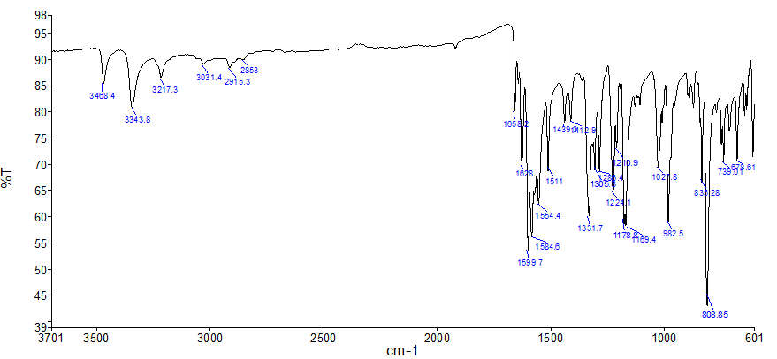
Figure S8. FT-IR spectrum of p-methyl amino chalcone
Figure S9. ¹H NMR spectrum of p-methyl amino chalcone

Figure S10. ¹³C NMR spectrum of p-methyl amino chalcone

FT-IR (ATR): v_{NH} 3488, 3343; v_{C-H(Aromatik)} 3217; v_{C-H(Alifatik)} 2951, 2853; v_{C=O} 1658; v_{C=C} 1628, 1599, 1584. ¹H NMR (400 MHz, DMSO-d₆) δ 7.93 (d, J = 8.5 Hz, 2H), 7.82 (d, J = 15.6 Hz, 1H), 7.74 (d, J = 7.8 Hz, 2H), 7.60 (d, J = 15.5 Hz, 1H), 7.27 (d, J = 7.7 Hz, 3H), 6.63 (d, J = 8.4 Hz, 2H), 6.15 (s, 2H), 2.37 (d, J = 7.2 Hz, 3H). ¹³C NMR (101 MHz, DMSO) δ 21.52, 113.19, 121.83, 125.88, 128.98, 129.53, 129.94, 130.48, 131.53, 132.92, 140.35, 144.26, 154.30, 162.71, 186.35.

2. Synthesis of Diazo-Chalcone compounds
2.1. Synthesis and characterization of diazo-4-methoxy chalcone
500 mg of amino chalcone compound was dissolved in HCl-water (10 mL) at a ratio of 3:8 by volume and the solution was cooled in an ice bath. To this mixture, aqueous solution of NaNO2 (10 mL) was added cold with a dropping funnel. Phenol was dissolved in freshly prepared 30% NaOH solution (10 mL) and added slowly to the reaction medium with a cold dropping funnel. The reaction was terminated after 8 hours and diluted with water and neutralized with 4 N HCl solution. The precipitate was filtered, washed with distilled water and dried at room temperature. In order to remove the impurities in this product, it was dissolved in ethyl alcohol and heated to 60oC. The insoluble impurities were filtered off and the filtrate was concentrated and precipitated again in distilled water. The red colored product was obtained pure.
Scheme S5. Synthesis of diazo-4-methoxy chalcone
Figure S11. ¹H NMR spectrum of diazo-4-methoxy chalcone
Figure S12. ¹³C NMR spectrum of diazo-4-methoxy chalcone

¹H NMR (400 MHz, DMSO-d₆) δ 8.34 (d, J = 8.0 Hz, 2H), 7.96 (d, J = 7.9 Hz, 2H), 7.94 – 7.85 (m, 5H), 7.79 (d, J = 15.6 Hz, 1H), 7.09 – 7.03 (m, 2H), 7.02 – 6.95 (m, 2H), 3.85 (s, 3H). ¹³C NMR (101 MHz, DMSO) δ 55.9, 114.9, 116.6, 120.0, 122.7, 125.9, 127.7, 130.2, 131.4, 139.2, 144.8, 145.9, 154.9, 162.0, 162.3, 188.8.

2.4. Synthesis and characterization of diazo-4-phenyl chalcone
Scheme S6. Synthesis of diazo-4-phenyl chalcone
500 mg of amino chalcone compound was dissolved in HCl-water (10 mL) at a ratio of 3:8 by volume and the solution was cooled in an ice bath. To this mixture, aqueous solution of NaNO₂ (10 mL) was added cold with a dropping funnel. Phenol was dissolved in freshly prepared 30% NaOH solution (10 mL) and added slowly to the reaction medium with a cold dropping funnel. The reaction was terminated after 8 hours and diluted with water and neutralized with 4 N HCl solution. The precipitate was filtered, washed with distilled water and dried at room temperature. In order to remove the impurities in this product, it was dissolved in ethyl alcohol and heated to 60 ºC. The insoluble impurities were filtered off and the filtrate was concentrated and precipitated again indistilled water.
Figure S13. ¹H NMR spectrum of diazo-4-phenyl chalcone

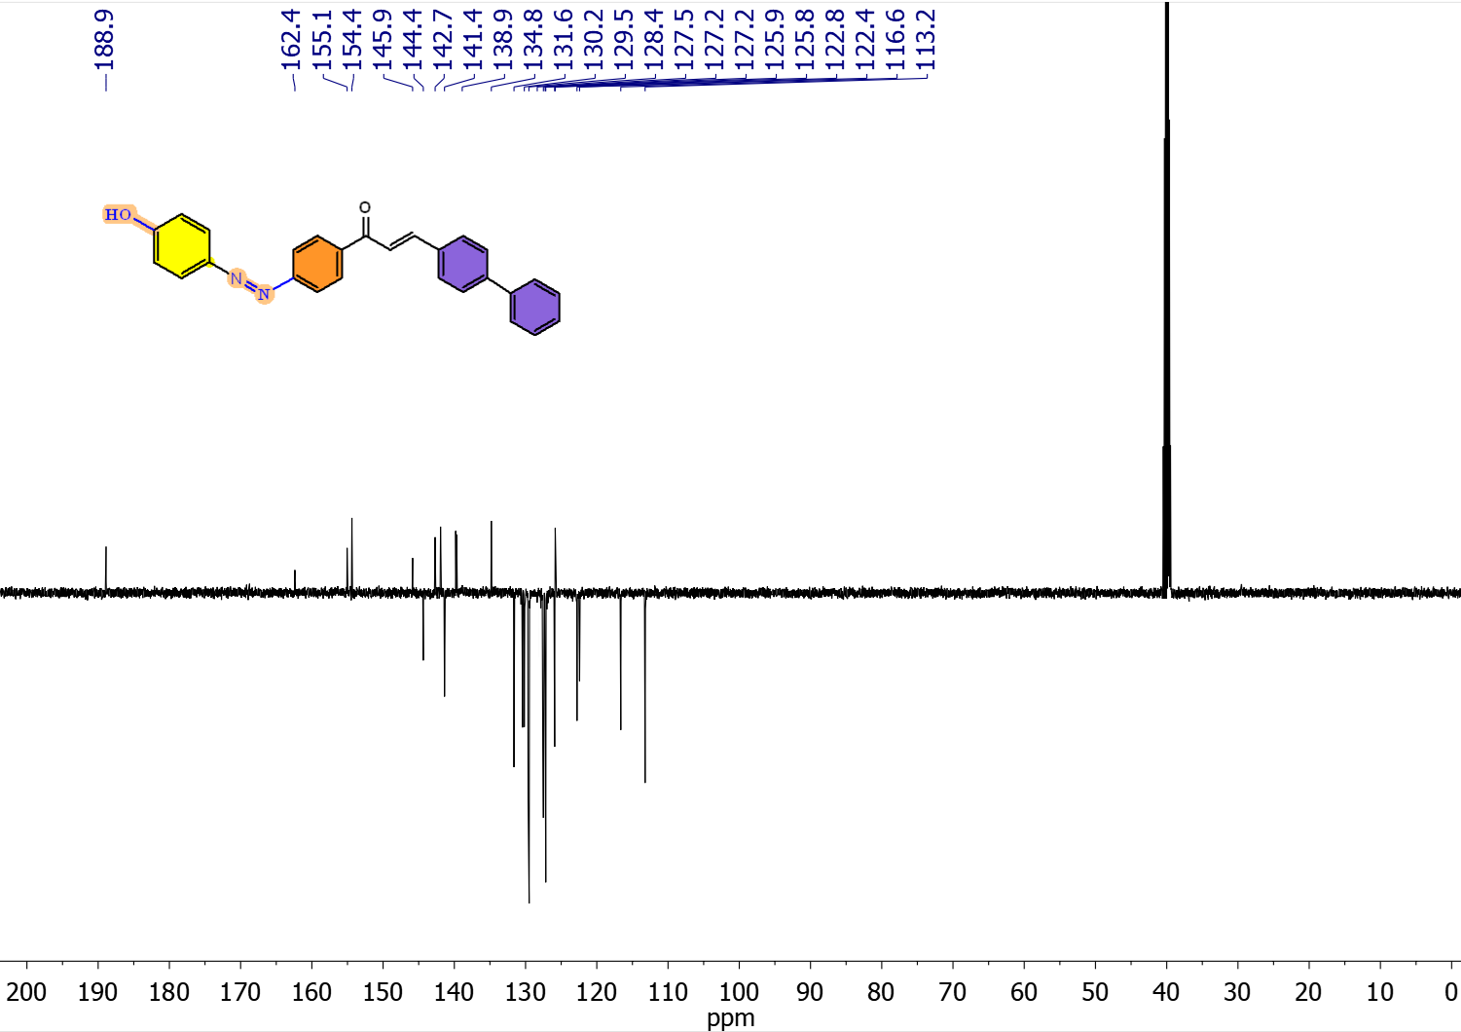
Figure S14. ¹³C NMR spectrum of diazo-4-phenyl chalcone
¹H NMR (500 MHz, DMSO-d₆) δ 8.37 (d, J = 8.2 Hz, 1H), 8.06 – 8.01 (m, 1H), 7.99 – 7.92 (m, 3H), 7.90 (d, J = 5.6 Hz, 1H), 7.87 (d, J = 4.3 Hz, 1H), 7.80 (d, J = 8.0 Hz, 1H), 7.79 – 7.72 (m, 3H), 7.67 (d, J = 15.5 Hz, 1H), 7.50 (q, J = 7.1 Hz, 2H), 7.41 (q, J = 7.7 Hz, 1H), 6.98 (d, J = 8.3 Hz, 1H), 6.64 (d, J = 8.3 Hz, 1H), 6.17 (s, 1H). ¹³C NMR (101 MHz, DMSO) δ 113.2, 116.6, 122.4, 122.8, 125.8, 125.9, 127.2, 127.2, 127.5, 128.4, 129.5, 130.2, 131.6, 134.8, 138.9, 141.4, 142.7, 144.3, 145.9, 154.4, 155.0, 162.4, 188.9.
2.5. Synthesis and characterization of diazo-4-Methyl chalcone
Scheme S7. Synthesis of diazo-4-methyl chalcone
500 mg of amino chalcone compound was dissolved in HCl-water (10 mL) at a ratio of 3:8 by volume, and the solution was cooled in an ice bath. To this mixture, an aqueous solution of NaNO2 (10 mL) was added cold with a dropping funnel. Phenol was dissolved in freshly prepared 30% NaOH solution (10 mL) and added slowly to the reaction medium with a cold-dropping funnel. The reaction was terminated after 8 hours and diluted with water and neutralized with 4 N HCl solution. The precipitate was filtered, washed with distilled water, and dried at room temperature. In order to remove the impurities in this product, it was dissolved in ethyl alcohol and heated to 60 ºC. The insoluble impurities were filtered off, and the filtrate was concentrated and precipitated again in distilled water.

Figure S15. ¹H NMR spectrum of diazo-4-methyl chalcone
Figure S16. ¹³C NMR spectrum of diazo-4-methyl chalcone

¹H NMR (400 MHz, DMSO-d₆) δ 10.40 (s, 1H), 8.33 (d, J = 6.9 Hz, 2H), 7.95 (d, J = 7.3 Hz, 2H), 7.91 – 7.85 (m, 2H), 7.78 (d, J = 15.9 Hz, 4H), 7.34 – 7.22 (m, 2H), 7.00 (d, J = 7.3 Hz, 2H), 2.37 (s, 3H). ¹³C NMR (101 MHz, DMSO) δ 21.59, 116.60, 121.48, 122.75, 125.87, 129.48, 129.95, 130.30, 132.42, 138.99, 141.32, 144.87, 145.91, 155.00, 162.30, 188.90.

3. Synthesis and Characterization of 2,2-Dichloro-4,4,4,6,6,-bis[spiro(2',2“-dioxy-1',1”-biphenyl)cyclotriphosphazene (CRG)
After preparation of the argon airless reaction system, 144.80 mmol K₂CO₃ was added to a three-mouth flask containing 150 mL acetone. 57.49 mmol of 2,2'-biphenol was added, and the reaction medium was cooled to 0 ºC with ice. The mixture was stirred for 5-10 min, and the reaction was initiated by adding 29.38 mmol of hexachlorocyclotrifosphazene (HCCP). The reaction was continued at room temperature and in an argon atmosphere for 2 hours and stopped. The solvent of the reaction, acetone, was removed with a rotary evaporator under vacuum. The solid remaining in the flask was extracted with dichlormethane (5x50 mL). Dichloromethane was removed with a rotary evaporator, and white solid was obtained. After crystallization of BIF compound in acetone, 14.32 g (CRG) compound was obtained (yield 85%). The molecular weight of the obtained CRG compound (C₂₄H₁₆O₄Cl₂N₃P₃) is 574.23 g/mol.
Scheme S8. Synthesis of CRG
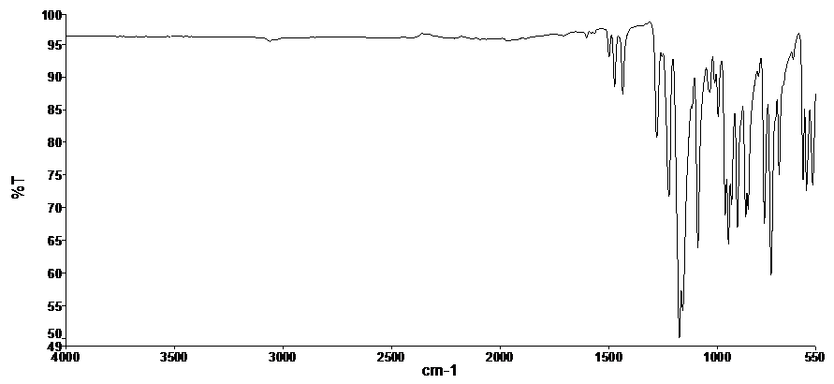
Figure S17. FT-IR Spectrum of CRG (ATR)
Figure S18. ³¹P NMR Spectrum of CRG

Figure S19. ¹H-NMR Spectrum of CRG (Choloform-d)

Figure S20. ¹³C-NMR Spectrum of CRG (Choloform-d)

Table S1. Characterization data of CRG

³¹P-NMR (ppm) | ¹H-NMR (ppm) | ¹³C–APT NMR (ppm)
28.71-29.69 (1P, t, PB((PCl₂)),  19.22-19.71 (2P, d, PA((P(O₂C₁₂H₈))₂),  A₂X Spin System | 7.55 (d, 2H, H²³), 7.45 (t, 2H, H²⁵), 7.37 (m, 4H, H²⁴, H²⁶).  chloroform-d₁ :  7.29 ve 77 ppm | 147.56 C²¹, 126.36 C²², 128.38 C²³, 129.59 C²⁴, 129.83 C²⁵, 121.63 C²⁶
FT-IR (cm⁻¹) | Elemental Analysis (%)
ν_{C-H(Aromatic)} ν_{P-O-C}  3030, 3061 949  ν_{C=C} ν_{P=N}  1436, 1474, 1499 1160, 1175, 1223 | N₃P₃C₂₄H₁₆C₂O₄ (Mw: 574.23 g/mol)  Theoretical: C, 50.20; H, 2.81; N, 7.32  Experimental: C, 50.23; H, 2.84; N, 7.36

4. Synthesis and Characterization of Dyspirocyclotriphosphazene with Diazo-Chalcone Side Group
The detailed synthesis procedure is given only for the compound CRG-OMe, since the synthesis of dyspirocyclotrifosphazene compounds bearing diazo-chalcone side groups was obtained by applying a similar procedure.
4.1. Synthesis and Characterization of CRG-OMe
35 mL acetone was added into a single neck 100 mL flask. 174.15 µmol CRG was added and stirred. Then 522.44 µmol of Diazo-4OMe-Chal compound was added to the reaction medium. Finally, 522.44 µmol Cs₂CO₃ was added to the reaction and the reaction was stirred for 1 day. The reaction was then refluxed. The salt formed in the reaction medium was removed by filtration through a fast filter paper. The filtrate (acetone) was evaporated in rotaride. The substance remaining in the flask was dissolved in chloroform (about 10-15 ml) and tested for precipitation in hexane and observed to precipitate. 200 ml of hexane was added to the flask and the substance was slowly added with a pipette in a magnetic stirrer and precipitated. The precipitated solid was separated by filtration and dried. Yield 85%. Molecular weight (C₆₈H₅₀O₁₀N₇P₃): 1218.11 g/mol.
Scheme S9. Synthesis of CRG-OMe
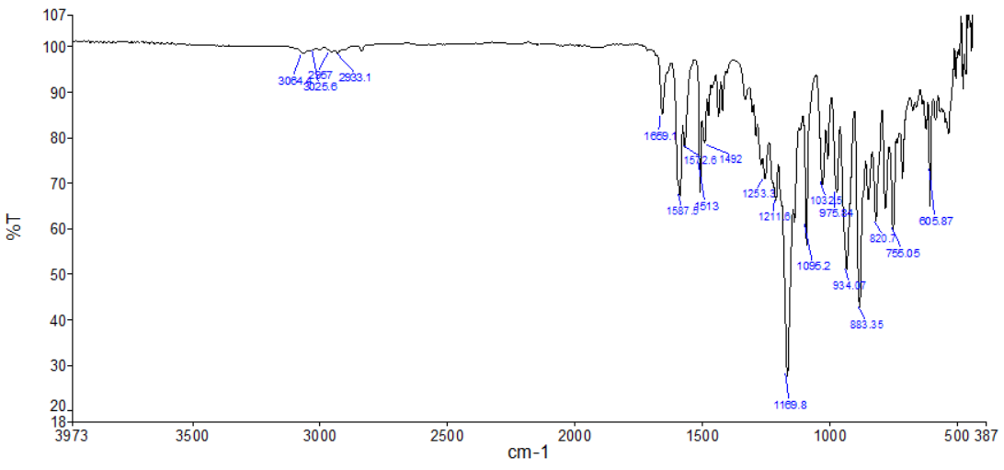
FigureS21. FT-IR Spectrum of CRG-OMe

Figure S22. ³¹P-NMR Spectrum of CRG-OMe (DMSO-d₆)
Figure S23. ¹H-NMR Spectrum of CRG-OMe (DMSO-d₆)

Figure S24. ¹³C-APT NMR Spectrum of CRG-OMe(DMSO-d₆)
Figure S25. HETCOR (2D) NMR Spectrum of CRG-OMe

Table S2. Characterization data of CRG-OMe

³¹P-NMR (ppm) | ¹H-NMR (ppm) | ¹³C–APT NMR (ppm)
9.10-10.25 (1P, t, PB),  24.77-25.35 (2P, d, PA),  A₂X Spin system | ¹H NMR (400 MHz, DMSO-d₆) δ 8.37 (d, J = 8.4 Hz, 3H), 8.19 (d, J = 8.7 Hz, 4H), 8.06 (d, J = 8.3 Hz, 4H), 7.91 (d, J = 8.5 Hz, 4H), 7.87 (s, 2H), 7.81 (s, 1H), 7.77 (s, 1H), 7.71 (d, J = 7.5 Hz, 4H), 7.65 (d, J = 8.6 Hz, 4H), 7.55 (t, J = 7.6 Hz, 4H), 7.47 (t, J = 7.5 Hz, 4H), 7.27 (d, J = 7.9 Hz, 4H), 7.06 (d, J = 8.5 Hz, 4H), 3.86 (s, 6H). | ¹³C NMR (101 MHz, DMSO) δ 55.9, 120.0, 122.5, 122.5, 125.4, 127.2, 127.7, 128.3, 130.3, 131.5, 140.2, 145.1, 147.6, 150.1, 152.9, 154.5, 162.1, 188.9.
FT-IR (cm⁻¹) | Elemental Analysis (%)
ν_{C-H(Aromatic)} ν _{C-H(Aliphatic)}  3024, 3064 2933  ν_{C=O} ν_{P=N}  1659 1169, 1211 | C₆₈H₅₀N₇O₁₀P₃ (Mw: 1218.11 g/mol)  Theoretical:C, 67.05; H, 4.14; N, 8.05;  Experimental: C, 67.10; H, 4.16; N, 8.06

When the ¹³C NMR spectrum was examined, the presence of the chalcone carbonyl peak at 188.9 ppm and the presence of the methoxy (-OCH₃) carbon peak at 55.9 ppm and the aromatic -CH peaks by the structure indicate that the compound was formed. In the FT-IR spectrum, the clear presence of the carbonyl (C=O) peak at 1659 cm⁻¹ together with the aromatic peak at 3024 cm⁻¹ and aliphatic peak at 2933 cm⁻¹ can be shown as another evidence.

4.2. Synthesis and Characterization of CRG-Me
This compound was obtained by a similar procedure as CRG-OMe, Yield: 75%.
Scheme S10. Synthesis of CRG-Me
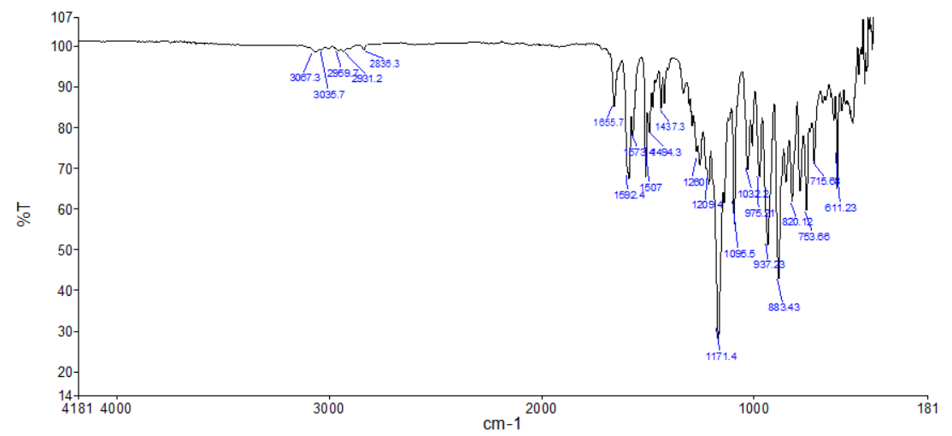
Figure S26. FT-IR Spectrum of CRG-Me
Figure S27. ³¹P-NMR Spectrum of CRG-Me (DMSO-d₆)

Figure S28. ¹H-NMR Spectrum of CRG-Me (DMSO-d₆)
Figure S29. ¹³C-APT NMR Spectrum of CRG-Me (DMSO-d₆)

Table S3. Characterization data of CRG-Me

³¹P-NMR (ppm) | ¹H-NMR (ppm) | ¹³C–APT NMR (ppm)
9.10-10.29 (1P, t, PB),  24.79-25.37 (2P, d, PA),  A₂X Spin System | ¹H NMR (400 MHz, DMSO-d₆) δ 8.38 (d, J = 8.5 Hz, 2H), 8.21 – 8.14 (m, 3H), 8.06 (d, J = 8.3 Hz, 2H), 8.00 – 7.89 (m, 3H), 7.86 – 7.76 (m, 5H), 7.74 – 7.62 (m, 8H), 7.58 – 7.52 (m, 4H), 7.46 (t, J = 7.2 Hz, 4H), 7.29 (dd, J = 15.3, 7.7 Hz, 8H), 2.38 (s, 6H). | ¹³C NMR (101 MHz, DMSO) δ 21.6, 120.8, 121.5, 122.1, 122.4, 123.3, 125.4, 127.2, 128.3, 129.3, 129.5, 130.1, 130.4, 130.4, 130.8, 132.4, 139.9, 141.4, 145.2, 147.6, 150.1, 152.9, 154.6, 189.0
FT-IR (cm⁻¹) | Elemental Analysis (%)
ν_{C-H(Aromatic)} 3067, 3035 ν _{C-H(Aliphatic)} 2959, 28931  ν_{C=O} ν_{P=N}  1655 1171, 1209 | C₆₈H₅₀N₇O₈P₃ (Mw: 1186.11 g/mol)  Theoretical: C, 68.86; H, 4.25; N, 8.27;  Experimental: C, 68.88; H, 4.28; N, 8.29

.
In ¹³C NMR spectrum, the -CH₃ (methyl) peak at 21.6 ppm and the chalcone peak at 189.0 ppm are the most characteristic peaks. In addition, the presence of a six-proton singlet peak at 2.38 ppm in ¹H NMR spectrum can be shown as another proof that the structure is successfully attached to the phosphazene ring. In addition, the presence of one triplet and one doublet peak in ³¹P NMR spectrum indicates that the diazo compound is doubly bonded to the phosphazene ring.

4.3. Synthesis and Characterization of CRG-Phe
This compound was obtained by following a similar procedure as CRG-OMe. Yield: 60%.

Scheme S11. Synthesis of CRG-Phe
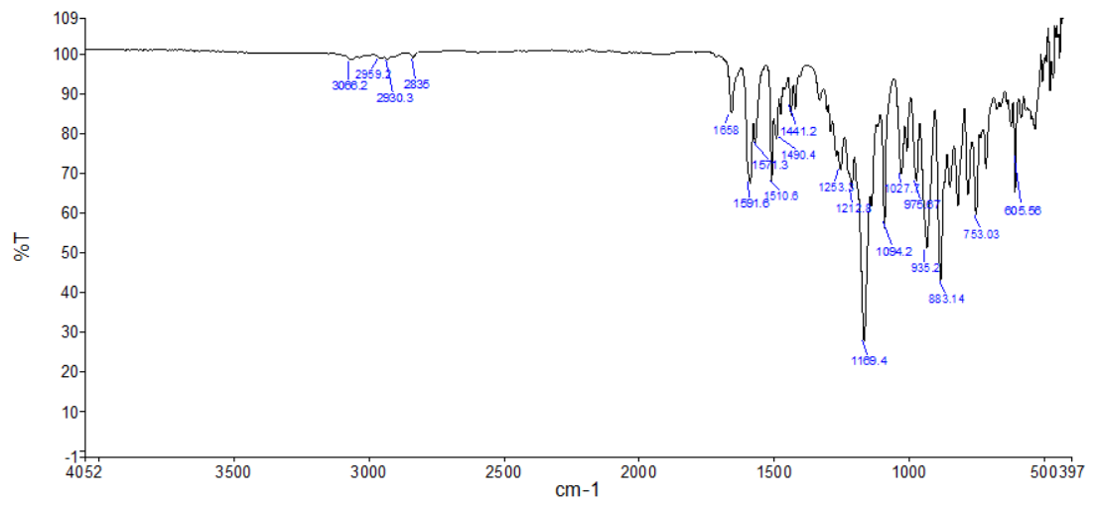
Figure S30. FT-IR Spectrum of CRG-Phe

Figure S31. ¹H NMR Spectrum of CRG-Phe

Figure S32. ³¹P NMR Spectrum of CRG-Phe

Figure S33. ¹³C-APT NMR Spectrum of CRG-Phe

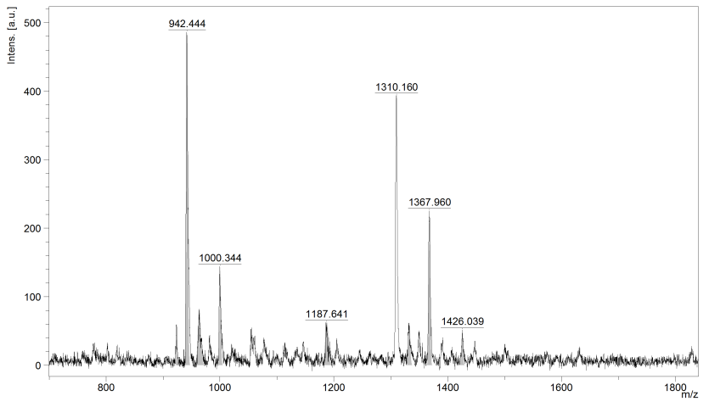
Figure S34. MALDI-TOF MS Spectrum of CRG-Phe

Table S4. Characterization data of CRG-Phe
³¹P-NMR (ppm) | ¹H-NMR (ppm) | ¹³C–APT NMR (ppm)
9.65-10.11 (1P, t, PB),  24.52-25.37 (2P, d, PA),  A₂X spin system | ¹H NMR (400MHz, DMSO-d₆) δ 7.97 – 7.89 (m, 12H), 7.75 (dd, J = 8.0, 4.4 Hz, 10H), 7.67 (d, J = 15.6 Hz, 5H), 7.50 (t, J = 7.4 Hz, 8H), 7.42 (dt, J = 14.9, 7.2 Hz, 6H), 6.64 (d, J = 8.4 Hz, 5H). | ¹³C NMR (101 MHz, DMSO) δ 113.3, 122.86, 125.9, 127.2, 127.5, 128.4, 129.5, 129.6, 131.6, 134., 139.81, 141.4, 141.9, 151.1, 154.3, 186.3
FT-IR (cm⁻¹) | Mass Analysis
ν_{C-H(Aromatic)} ν _{C-H(Aliphatic)}  3067, 3035 2959, 28931  ν_{C=O} ν_{P=N}  1655 1171, 1209 | C₇₈H₅₄N₇O₈P₃ (Mw: 1310.25 g/mol)  Theoretical: 1310.25 g/mol  Calculated: [M⁺]: 1310.16  [M-Bipheyl] 942.44

When ¹³C NMR spectrum of the CRG-Phe compound is examined, the peak at 186.3 ppm of the chalcone compound and the number of other aromatic -CH carbon peaks seen at the bottom of the baseline are compatible, indicating that the compound is formed. The presence of the molecular ion peak (1310.16) and the peak (942.44) formed as a result of the separation of biphenyl groups in the mass spectrum indicates the formation of the structure.

