Supplementary Materials

Supplementary Figure S1. Patient Selection Process
Supplementary Figure S2. Representative Cases of Visual Assessment
Supplementary Figure S3. Representative Cases of Residual Tumor Segmentation
Supplementary Figure S4. Visual Assessment Results of Pre-operative Glioblastomas
Supplementary Table S1. MRI Parameters of the training cohort of Seoul St. Mary’s hospital
Supplementary Table S2. Data preprocessing and Model Development
Supplementary Methods

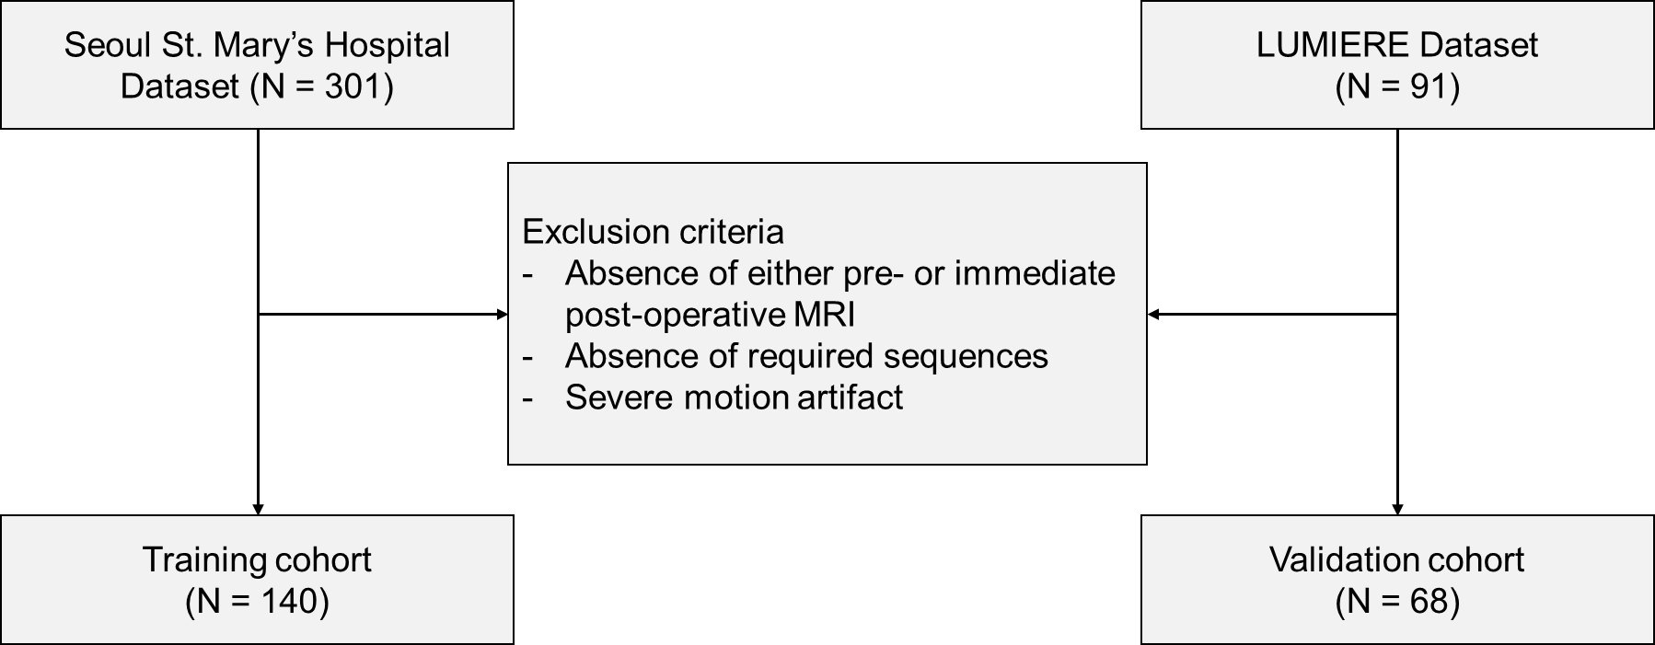
Supplementary Figure S1. Patient Selection Process

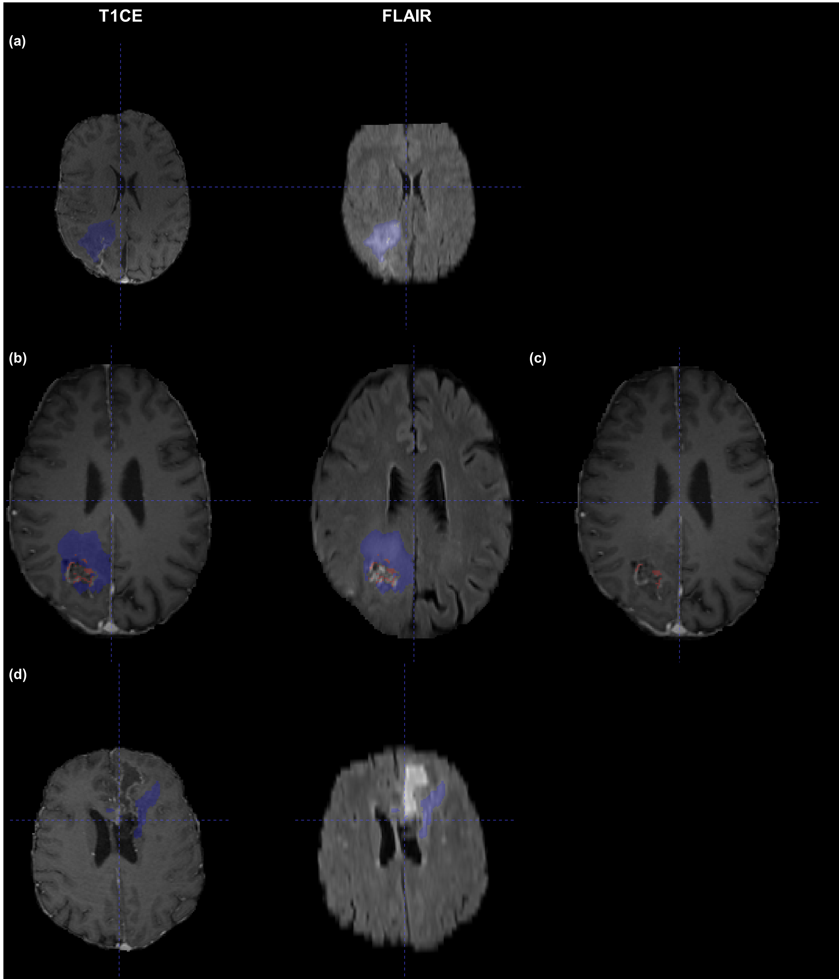
Supplementary Figure S2. Representative Cases of Visual Assessment. Shown are the representative cases of post-operative tumor segmentations and their corresponding quality ratings. (a) A GTR case rated 5/5 for both T1CE and FLAIR segmentations. (b) An STR case where T1CE segmentation was rated 3 due to inclusion of non-pathologic voxels. (c) Ground truth segmentation for the case shown in (b), provided for reference. (d) A GTR case where the FLAIR segmentation was rated 2 due to missing pathologic voxels. Blue denotes peritumoral edema and red enhancing tumor.
GTR, gross total resection; STR, subtotal resection

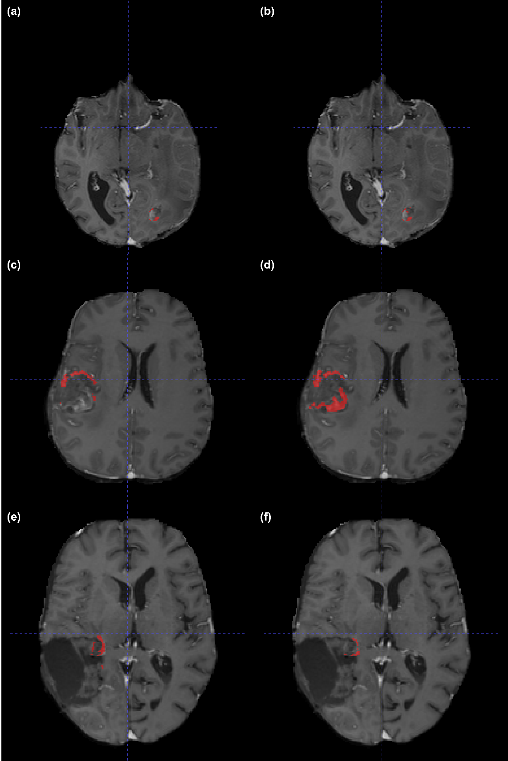
Supplementary Figure S3. Representative Cases of Residual Tumor Segmentation. The upper panels show segmentations for patient 77 by (a) the ground truth annotator and (b) Dynapex BT (DSC 0.8253, precision 0.7097, and recall 0.9858). The middle panels present segmentations for patient 52 by (c) the ground truth annotator and (d) DeepBraTumIA (DSC 0.4625, precision 0.3249, and recall 0.8023). The lower panels show segmentations for patient 5 by (e) the ground truth annotator and (f) an untrained annotator.
DSC, dice similarity score

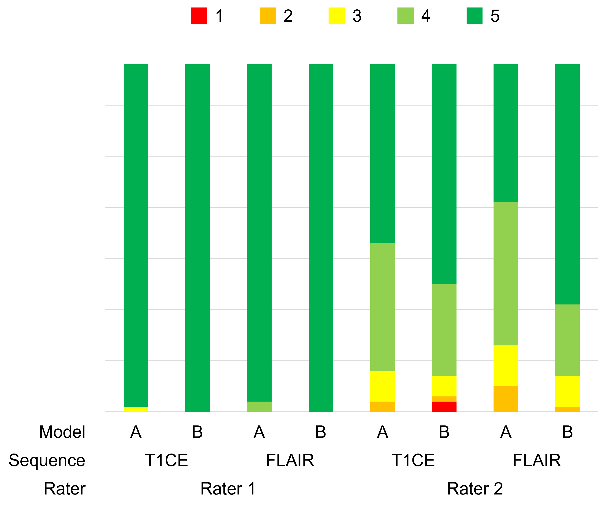
Supplementary Figure S4. Visual Assessment Results of Pre-operative Glioblastomas

Supplementary Table S1. MRI Parameters of the training cohort of our institution
Pulse sequence | Training cohort
FLAIR image
Repetition time (ms) | 8000 - 10000
Echo Time (ms) | 99 - 132
Inversion time (ms) | 2370
Pixel size | 0.67 – 1
Slice thickness (mm) | 4-5
Contrast enhanced T1-weighted and Precontrast T1-weighted images | 3D GRE  (MPRAGE, TFE) | 2D Spin Echo | 3D FSE (SPACE)
Repetition time (ms) | 1600-2300  or 5-12 | 400-500 | 650-700
Echo Time (ms) | 2-6 | 8-16 | 8-12
Inversion time (ms) | 920-1040 | NA | NA
Pixel size (mm) | 0.7-1 | 0.75-0.94 | 0.72
Slice thickness (mm) | 1 | 4-5 | 0.7

Supplementary Table S2. Data preprocessing and Model Development
Parameter name | Value
Loss function | A combination of Dice and Cross-Entropy loss
Optimizer | Stochastic Gradient Descent (SGD) with weight decay and Nesterov momentum
Initial Learning rate | 0.01
Weight decay | 3e-5
Momentum | 0.99
Data augmentation | Spatial (rotation & scaling) transform, Gaussian noise, Gaussian blur, brightness/contrast/gamma adjustments, and mirror transform
Batch size | 2
Patch size | 112 x 160 x 128 voxels

Supplementary Methods
Pretrained model development
The model was trained using the nnU-Net v2 framework, employing its standard 3D full-resolution configuration. The architecture is a PlainConvUNet, a standard U-Net design featuring instance normalization, LeakyReLU activation, and deep supervision at the decoder levels. The model utilizes a patch-based learning scheme and outputs segmentation masks for the background, enhancing tumor (ET), tumor core (TC), and edema (ED). Model parameters were initialized using Kaiming (He) initialization. No pretrained weights were used; all parameters were optimized from scratch. Key training parameters are summarized in Supplementary Table S2.
Five models from a 5-fold cross-validation were ensembled via softmax probability averaging. The final segmentation map was derived by applying an argmax function to the averaged outputs. This ensembling strategy was applied consistently across all test sets to minimize fold-specific variance. The final model was selected based on the highest average Dice score across the validation set for the three tumor classes (ET, TC, and ED). No early stopping was applied.
The model was implemented in Python 3.11.3, utilizing PyTorch 2.0.1 and the official nnU-Net v2 package. Key supporting libraries included NiBabel, SimpleITK, and Scikit-learn. Both training and inference were performed on an Ubuntu 22.04 system with CUDA 12.1.

Data preprocessing and annotation
MRI scans (T1NE, T1CE and FLAIR) were converted to NIfTI format, resampled to 1 mm³ isotropic resolution, and aligned using affine registration. Institutional data were anonymized via DICOM tag stripping and re-identification with randomized study-specific codes. This process complied with HIPAA standards. Subjects missing required modalities or segmentation labels were excluded. Minor inconsistencies in metadata were accepted unless critical (e.g., pixel spacing). No imputation was performed. As the model was intended for validation on an unseen dataset from a public open-source data, all available data was used for training without a separate validation set during the training phase. The same preprocessing pipeline was applied to the training of the pretrained model using the BraTS and Asan Medical Center datasets.

