Vamp3-dependent secretion of endocytic BDNF from astrocytes
Jeongho Han¹, Sungryeong Yoon², and Hyungju Park^{1,2*}
¹Research Group of Neurovascular Unit, Korea Brain Research Institute (KBRI), Daegu, 41062, South Korea
²Department of Brain and Cognitive Sciences, DGIST, Daegu, 42988, South Korea

*Corresponding author:
Hyungju Park, Ph.D. (phj2@kbri.re.kr)

Supplementary Figures (Fig. S1~S2)

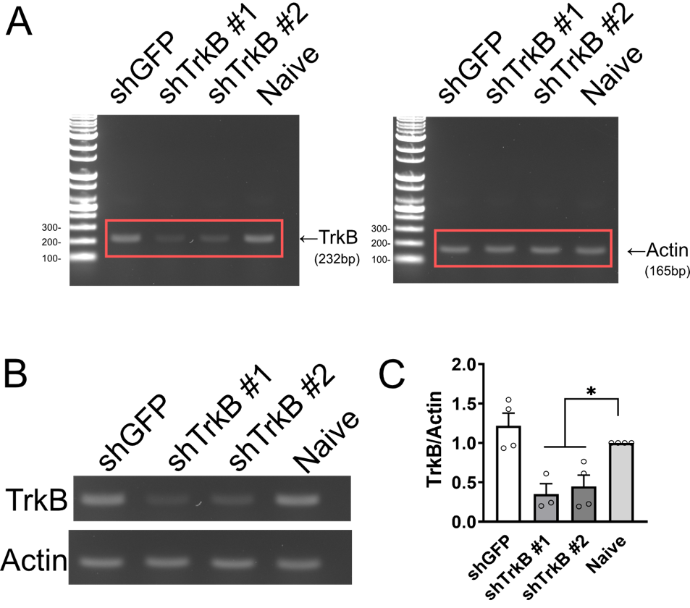
Figure S1. Genetic KD of TrkB by shRNA delivery
A. Representative full-length RT-PCR results showing the TrkB mRNA (left) and β-actin (actin) mRNA level (right) in shRNA-treated cultured cortical neurons. shGFP: shRNA targeting the EGFP coding sequence. B. Cropped RT-PCR results from A (red boxes) showing TrkB and actin mRNA levels in each condition. C. Normalized TrkB mRNA level in shRNA-treated cultured cortical neurons. *P < 0.05. N= 3 culture batches.

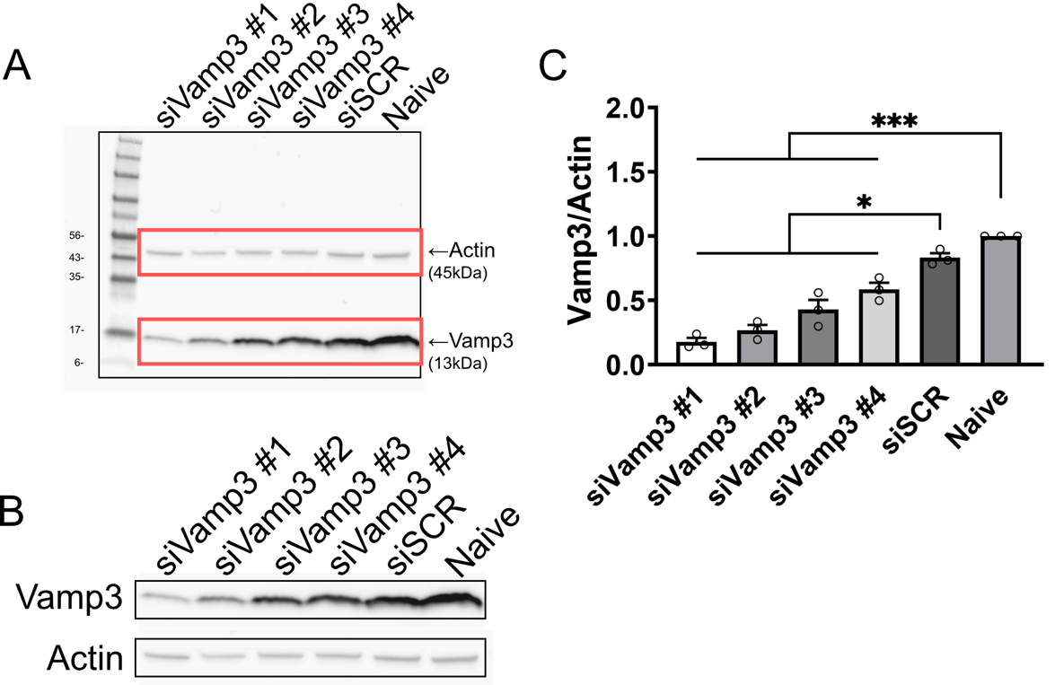
Figure S2. Genetic KD of Vamp3 by siRNA delivery
A. Representative full-length western blot results showing the β-actin or Vamp3 protein level in siRNA-treated C8-D1A cells. siSCR: scrambled siRNA. B. Cropped western blot results from A (red boxes) showing Vamp3 and actin protein levels in each condition. C. Normalized Vamp3 protein levels in siRNA-treated C8-D1A cells. *P < 0.05, ***P < 0.001. N= 3 culture batches.

