Measuring the deforestation that did not happen – a global perspective

Supplementary Glossary, Tables, Figures, and Methods

Table of contents

Supplementary Glossary
Supplementary Tabs. 1-9
Supplementary Figs. 1-12
Supplementary Methods

Supplementary Glossary
Term | Explanation | Source | Comment
Additional deforestation | Observed, remotely sensed deforestation exceeding the profit-oriented counterfactual deforestation | Our definition | Comprised of deforestation resulting from drivers beyond agricultural profits, leakage on the same continent, and transcontinental deforestation leakage
Deforestation rate | Permanent conversion of natural forest to any other land use (gross deforestation) in hectares per year | Prendrill et al.¹ | Derived from tree cover losses reported by Hansen et al.², using a canopy cover threshold of 30% and subtracting temporary clearing with subsequent replanting under forestry and fires
Deforestation displacement | Spatial shift of deforestation, when an attribution to forest conservation interventions is not clearly possible | Meyfroidt et al.³
Deforestation reduction | Purposeful decrease (or mitigation) of deforestation in comparison to the simulated profit-oriented counterfactual, because deforestation reduction mechanisms | Our definition
Deforestation reduction mechanism | Forest conservation interventions, such as forest policies (e.g., strategic planning programs and legislation), land-tenure reforms, protected areas, credit schemes and market mechanisms, payments for ecosystem services, forest certification, awareness building, but also self-organisation for sustainable governance in community management | Bertsky et al.⁴  Ostroom⁵
Forest transition | According to this theory, rates of change in forest cover follow a specific pattern: starting with moderate levels (fragmentation phase) in highly forested countries, they increase after some natural forest has been lost (deforestation and degradation phase), while deforestation rates may decline as natural forests become scarcer. After a certain point, forest recovery (restoration and reafforestation phase) can increase forest cover. | Gracia et al.⁶
Leakage | Displacement of deforestation to regions with less strong forest conservation interventions due to forest conservation interventions in other regions or countries | Meyfroidt et al.³  Streck⁷
Profit-oriented counterfactual deforestation | Dynamic (here simulated) development of deforestation, if land managers had made unconstrained, purely agricultural profit-oriented land-use decisions (considering the availability of natural forest cover) | Knoke et al.⁸ | This counterfactual trajectory accounts for 80% of the changes in the total business-as-usual deforestation in our study
Business-as-usual deforestation scenario | Forms a baseline against which the development of the observed deforestation can be assessed. It estimates the expected deforestation in our study, without any additional deforestation-reduction interventions. A basic assumption is that all impacts of additional deforestation reduction interventions which were not already in place during the reference period (2001-2004) are excluded | Brown et al.⁹  Gifford¹⁰ | 1) We define our profit-oriented counterfactual deforestation as a conservative business-as-usual scenario, which considers only agricultural profits as drivers of deforestation. 2) In addition, we estimate a more inclusive scenario that accounts for deforestation drivers beyond agricultural profits, using a revised counterfactual deforestation scenario that seeks to exclude only the additional deforestation reduction mechanisms. This business-as-usual scenario is less conservative and reveals higher deforestation reductions than the only profit-oriented counterfactual. Most of the comparisons in the main text, however, refer to the conservative business-as-usual scenario
Robust deforestation reduction | Remotely sensed deforestation is lower than the profit-oriented counterfactual deforestation by at least 3 x SE of the counterfactual | Our definition
Reference period | Generally, 2001–2004 (but 1997–2000 for Indonesia). The reference period corresponds to the advent of reliable public remote sensing data. It is used for calibration and to calculate the change of deforestation from a pre-existing status quo | Our definition

Supplementary Table 1. Comparison of different annual deforestation rate estimates (global scale).
 | Gross deforestation rate [million hectares per year]
Period | Total remotely sensed tree cover losses from Hansen et al.², reduced by forestry and fires (=permanent forest losses) | Remotely sensed deforestation rate for countries included in our study (simulated counterfactual rates in parentheses) | FAO Remote Sensing Survey | FAO Forest Resource Assessment 2020¹¹ | FAO Forest Resource Assessment 2025¹² | Curtis et al.¹³, commodity-driven deforestation | Pendrill et al.¹
1990-2000 |  |  |  | 16.0 | 17.6
2000-2010 | 7.2 | 6.5 (7.3) | 11.0 | 15.0 |  | 4.8
2000-2015 |  | 6.9 (7.6) |  |  | 13.6
2011-2015 | 8.9 | 7.7 (8.1) |  | 12.0 |  | 5.2 | 6.5-9.5
2011-2018 | 9.9 | 8.3 (8.2) | 7.8
2015-2020 |  | 8.6 (8.2) |  | 10.0
2015-2025 |  |  |  |  | 10.9

Supplementary Table 2. Aggregated changes of the profit-oriented counterfactual and remotely sensed deforestation from 2005 to 2023 compared with the reference period deforestation. To calculate the increase/reduction relative to the reference-period deforestation rate, the reference-period rate was subtracted from the counterfactual and remotely sensed rates, and the resulting differences were summed (see Methods Differences). The reference period is 2001 to 2004 (1997 to 2000 for Indonesia).
 | Deforestation 2005 to 2023 [1,000 hectares] |  |  |  | Additional deforestation or deforestation reduction compared with the reference period deforestation rate [1,000 hectares]
Country | Sum |  | Per annum
 | Profit-oriented counter-factual | Remotely sensed | Profit-oriented counter-factual | Remotely sensed | Profit-oriented counterfactual | Remotely sensed
Latin America
Argentina | 3942 | 4651 | 207 | 245 | 489 | 1197
Bolivia | 5275 | 5218 | 278 | 275 | 2385 | 2329
Brazil | 53239 | 36536 | 2802 | 1923 | 380 | -16322
Colombia | 4079 | 4018 | 215 | 211 | 694 | 633
Ecuador | 1102 | 782 | 58 | 41 | 594 | 274
Mexico | 1880 | 3171 | 99 | 167 | -566 | 725
Nicaragua | 714 | 1574 | 38 | 83 | -50 | 809
Paraguay | 4291 | 5519 | 226 | 290 | 615 | 1843
Peru | 3213 | 3559 | 169 | 187 | 1642 | 1989
Venezuela | 1076 | 1429 | 57 | 75 | -416 | -62
Sum | 78812 | 66459 | 4148 | 3498 | 5767 | -6586
Africa
Angola | 2981 | 3598 | 157 | 189 | 1668 | 2285
Cameroon | 1698 | 1904 | 89 | 100 | 1158 | 1364
Cote d'Ivoire | 2867 | 3485 | 151 | 183 | 998 | 1616
DR Congo | 16049 | 17534 | 845 | 923 | 8316 | 9801
Ethiopia | 699 | 448 | 37 | 24 | 451 | 201
Madagascar | 3111 | 4212 | 164 | 222 | 1549 | 2650
Mozambique | 2921 | 3870 | 154 | 204 | 1265 | 2214
Nigeria | 698 | 1209 | 37 | 64 | 230 | 741
R Congo | 482 | 825 | 25 | 43 | 100 | 443
Tanzania | 4200 | 2829 | 221 | 149 | 2776 | 1406
Zambia | 1439 | 2254 | 76 | 119 | 753 | 1567
Sum | 37145 | 42168 | 1955 | 2219 | 19264 | 24287
Asia
Cambodia | 1930 | 1715 | 102 | 90 | 1269 | 1054
Indonesia | 29849 | 22747 | 1298 | 989 | -11091 | -18193
Lao People's DR | 2303 | 2571 | 121 | 135 | 1661 | 1929
Malaysia | 3433 | 6198 | 181 | 326 | -926 | 1839
Thailand | 643 | 1023 | 34 | 54 | 128 | 508
Viet Nam | 1197 | 1639 | 63 | 86 | 703 | 1146
Myanmar | 3671 | 4464 | 193 | 235 | 2343 | 3136
Sum | 43025 | 40356 | 1991 | 1916 | -5914 | -8583
Total | 158982 | 148983 | 8094 | 7633 | 19117 | 9118

Supplementary Table 3. Robust reductions and additional remotely sensed deforestation rates compared with simulated profit-oriented counterfactual deforestation. To obtain robust differences, only years in which remotely sensed deforestation fell outside ±3 SE of the simulated counterfactual trajectory were considered. Countries with robust overall reductions in deforestation are in bold.
Year | 2001 | 2002 | 2003 | 2004 | 2005 | 2006 | 2007 | 2008 | 2009 | 2010 | 2011 | 2012 | 2013 | 2014 | 2015 | 2016 | 2017 | 2018 | 2019 | 2020 | 2021 | 2022 | 2023 | Sum | Reduc-tions | Addi-tional
Latin America
Argentina | 0 | 0 | 0 | 0 | 0 | 0 | 0 | 235 | 0 | 146 | 235 | 218 | 80 | 0 | 0 | 0 | 0 | 0 | 0 | 0 | 0 | 0 | 0 | 914 | 0 | 914
Bolivia | 0 | 0 | 0 | 0 | 0 | 0 | 0 | 154 | 0 | 0 | 0 | 0 | 0 | 0 | -182 | 0 | 48 | -70 | 0 | -143 | 0 | 60 | 146 | 13 | -395 | 409
Brazil | 0 | 0 | 0 | 0 | 0 | 0 | 0 | -958 | -1620 | -820 | -1463 | 0 | -1147 | -626 | -1171 | -305 | -402 | -700 | -854 | -1029 | -1380 | -1076 | -1643 | -15191 | -15191 | 0
Colombia | 0 | 0 | 0 | 0 | 0 | 0 | 0 | 0 | 0 | 0 | 0 | 0 | -55 | 0 | -68 | 0 | 190 | 112 | 0 | 0 | 0 | 0 | -18 | 161 | -141 | 302
Ecuador | 0 | 0 | 0 | 0 | 0 | -47 | 0 | 0 | -45 | -47 | 0 | 0 | 0 | -39 | 0 | 0 | 28 | 0 | -27 | 0 | 0 | 0 | 0 | -177 | -205 | 28
Mexico | 0 | 0 | 0 | 0 | 0 | 0 | 0 | 0 | 97 | 0 | 64 | 0 | 0 | 0 | 0 | 121 | 121 | 120 | 118 | 150 | 0 | 0 | 75 | 867 | 0 | 867
Nicaragua | 0 | 0 | 0 | 0 | 55 | 0 | 47 | 0 | 42 | 177 | 0 | 0 | 0 | 35 | 0 | 91 | 155 | 29 | 37 | 69 | 46 | 0 | 71 | 855 | 0 | 855
Paraguay | 0 | 0 | 0 | 0 | 64 | -83 | 238 | 143 | 138 | 136 | 232 | 338 | 115 | 125 | 0 | 0 | 80 | 0 | 0 | 0 | 0 | -120 | -144 | 1262 | -347 | 1609
Peru | 0 | 0 | 0 | 0 | 81 | 70 | 0 | 96 | 69 | 0 | 0 | 0 | 0 | 0 | 0 | 0 | 0 | 0 | 0 | 74 | 0 | 0 | 0 | 390 | 0 | 390
Venezuela | 0 | 0 | 0 | 0 | 37 | 0 | 48 | 0 | 65 | 0 | 0 | 0 | 0 | 0 | 0 | 0 | 84 | 0 | 0 | 36 | -47 | -63 | 0 | 159 | -110 | 269
Sum | 0 | 0 | 0 | 0 | 237 | -505 | -343 | -329 | -1252 | -407 | -932 | 556 | -1007 | -505 | -1421 | -92 | 304 | -509 | -726 | -842 | -1380 | -1198 | -1512 | -10747 | -16390 | 5643
Africa
Angola | 0 | 0 | 0 | 0 | 0 | 0 | 66 | 0 | 0 | 0 | 0 | 0 | 0 | 0 | 0 | 0 | 0 | 0 | 0 | 0 | 0 | 0 | 108 | 173 | 0 | 173
Cameroon | 0 | 0 | 0 | 0 | 0 | 0 | 0 | 0 | 0 | 0 | 0 | 0 | 0 | 0 | -70 | 0 | 0 | 0 | 0 | 110 | 84 | 49 | 106 | 278 | -70 | 348
Cote d'Ivoire | 0 | 0 | 0 | 0 | -46 | 0 | 0 | 0 | 0 | 0 | 0 | 0 | 0 | 0 | -14 | 57 | 189 | 160 | 78 | 102 | 32 | 22 | 42 | 621 | -61 | 682
DR Congo | 0 | 0 | 0 | 0 | 0 | 0 | 0 | 0 | 246 | 0 | 0 | 0 | 0 | 0 | 0 | 0 | 407 | 0 | 0 | 0 | 0 | 0 | 0 | 653 | 0 | 653
Ethiopia | 0 | 0 | 0 | 0 | 0 | 0 | 0 | 0 | 0 | 0 | -21 | 0 | 0 | 0 | -21 | -31 | 0 | -19 | 0 | -28 | -49 | -48 | 0 | -216 | -216 | 0
Madagascar | 0 | 0 | 0 | 0 | 0 | 0 | 81 | 0 | 0 | 0 | 0 | 0 | 0 | 0 | 99 | 184 | 281 | 144 | 0 | 47 | 0 | 43 | 97 | 976 | 0 | 976
Mozambique | 0 | 0 | 0 | 0 | 0 | 83 | 0 | 106 | 143 | 0 | 0 | 0 | 0 | 0 | 77 | 79 | 180 | 0 | 0 | 0 | 0 | 0 | 0 | 669 | 0 | 669
Nigeria | 0 | 0 | 0 | 0 | 0 | 0 | 0 | 0 | 0 | 0 | 0 | 0 | 0 | 35 | 0 | 0 | 128 | 84 | 33 | 67 | 62 | 73 | 49 | 530 | 0 | 530
R Congo | 0 | 0 | 0 | 0 | 0 | 0 | 0 | 0 | 0 | 27 | 0 | 0 | 33 | 47 | 16 | 53 | 35 | 19 | 39 | 31 | 0 | 16 | 25 | 341 | 0 | 341
Tanzania | 0 | 0 | 0 | 0 | -155 | -153 | -114 | -82 | -78 | -59 | -66 | -100 | 0 | 0 | -81 | -74 | 0 | 0 | -88 | -59 | -75 | -81 | 0 | -1266 | -1266 | 0
Zambia | 0 | 0 | 0 | 0 | 0 | 0 | 0 | 0 | 68 | 97 | 0 | 54 | 0 | 39 | 0 | 59 | 64 | 77 | 0 | 83 | 116 | 80 | 90 | 826 | 0 | 826
Sum | 0 | 0 | 0 | 0 | -202 | -70 | 33 | 24 | 379 | 64 | -87 | -46 | 33 | 122 | 5 | 328 | 1284 | 464 | 62 | 351 | 170 | 154 | 517 | 3586 | -1613 | 5199
Asia
Cambodia | 0 | 0 | 0 | 0 | 0 | 16 | 20 | 25 | 40 | 0 | 0 | 0 | 0 | 0 | 0 | 0 | -52 | -60 | -48 | -27 | 0 | -55 | -39 | -181 | -282 | 101
Indonesia | -986 | -1117 | -1309 | -593 | -615 | -376 | -467 | -430 | 0 | -499 | 0 | 373 | -444 | 0 | 230 | 460 | 0 | 0 | 0 | -311 | -387 | -360 | 0 | -6832 | -7895 | 1063
Lao People's DR | 0 | 0 | 0 | 0 | 0 | 39 | 45 | 0 | 51 | 0 | 0 | 0 | 0 | 0 | 0 | 61 | 0 | 0 | 73 | 0 | 0 | -72 | 0 | 198 | -72 | 270
Malaysia | 0 | 0 | 0 | 0 | 87 | 0 | 100 | 97 | 296 | 150 | 175 | 282 | 61 | 306 | 150 | 235 | 196 | 185 | 131 | 69 | 63 | 52 | 87 | 2723 | 0 | 2723
Thailand | 0 | 0 | 0 | 0 | 0 | 0 | 0 | 0 | 24 | 21 | 0 | 17 | 0 | 33 | 25 | 42 | 46 | 28 | 23 | 24 | 18 | 0 | 29 | 329 | 0 | 329
Viet Nam | 0 | 0 | 0 | 0 | 26 | 15 | 23 | 29 | 42 | 0 | 0 | 0 | 0 | 0 | 70 | 85 | 52 | 0 | 0 | 0 | 0 | 0 | 0 | 343 | 0 | 343
Myanmar | 0 | 0 | 0 | 0 | 0 | 43 | 0 | 0 | 92 | 0 | 0 | 0 | 0 | 0 | 0 | 0 | 127 | 0 | 0 | 0 | 77 | 0 | 0 | 340 | 0 | 340
Sum | -986 | -1117 | -1309 | -593 | -501 | -263 | -278 | -279 | 546 | -328 | 175 | 672 | -383 | 339 | 475 | 883 | 369 | 153 | 179 | -244 | -230 | -435 | 76 | -3080 | -8249 | 5169
Total | -986 | -1117 | -1309 | -593 | -466 | -838 | -588 | -584 | -327 | -671 | -844 | 1182 | -1357 | -44 | -941 | 1119 | 1956 | 108 | -485 | -736 | -1440 | -1479 | -919 | -11360 | -26251 | 16010

Supplementary Table 4. Fixed effect coefficients for the Bayesian Regression GLMM estimating the expected deforestation rate in millions of hectares. Predictions shown in Fig. 2C, main text. L is the profit-oriented counterfactual, R distinguishes countries with (R=+1) and without deforestation reductions (R=-1 for all countries in which the sum of all deforestation reductions surpasses deforestation increases in Supplementary Tab. 2), and A is an index quantifying the country’s area size (as an index normalising all countries’ land areas with the average of all countries). The variable ‘year’ was used as the random effect grouping variable. RMSE ±149,000 hectares, or ±53%; relative bias
-1.6%.

 | Mean | 95% credible interval
 |  | Lower | Upper
Constant | 0.006 | -0.012 | 0.023
Profit-oriented  counterfactual, $L$ | 0.955 | 0.830 | 1.079
With or without  deforestation reduction, $R$ (+1 or -1) | 0.033 | 0.011 | 0.055
Relative Country Area, $A$ | 7.644×10⁻⁴ | -0.024 | 0.027
$$L x R$$ | 0.173 | 0.097 | 0.250
$$L x A$$ | -0.025 | -0.050 | 0.001
$$R x A$$ | -0.005 | -0.037 | 0.027

Supplementary Table 5. Fixed effect coefficients of the Bayesian Regression GLMM estimating the expected deforestation rate in millions of hectares for countries with achieved robust deforestation reductions. L is the profit-oriented counterfactual, and A is an index quantifying the country’s size (as an index normalising all countries’ natural forest areas with the average of all countries). The variable ‘year’ was used as the random effect grouping variable.

 | Mean | 95% credible interval
 |  | Lower | Upper
Constant | -0.015 | -0.040 | 0.010
Profit-oriented  counterfactual, $L$ | 0.849 | 0.714 | 0.984
Relative Country Area, $A$ | 0.001 | -0.041 | 0.043
$$L x A$$ | -0.027 | -0.049 | -0.004

Supplementary Table 6. Impact of annual deforestation reductions (six countries) on aggregated deforestation rates in other countries without net reductions. The tables display coefficients from Bayesian GLMMs predicting the expected additional deforestation in a year following deforestation reductions for all countries without such reductions (n = 63). In 2017, deforestation was heavily influenced by El Niño in many countries and is not considered here. Aside from the fixed effect variable ‘profit-oriented counterfactual deforestation rate’, we controlled for possible impacts of ‘continent’ or ‘year’ using these variables as random effects for grouping of the data sets.

A. Aggregated additional deforestation in countries without deforestation reductions in response to deforestation reductions in other countries on the same continent (continental leakage).
 | Mean | 95% credible interval
 |  | Lower | Upper
Constant | -87.413 | -343.074 | 145.418
Deforestation reduction in year t-1 | -0.195 | -0.380 | -0.009
Profit-oriented  counterfactual, $L$ | 0.247 | -0.261 | 0.789

B. Aggregated additional deforestation in countries without deforestation reduction in response to deforestation reductions in countries on another continent (transcontinental leakage).
 | Mean | 95% credible interval
 |  | Lower | Upper
Constant | 262.469 | -160.844 | 629.975
Deforestation reduction in year t-1 | -0.236 | -0.574 | 0.100
Profit-oriented  counterfactual, $L$ | 0.144 | -0.445 | 0.930

Supplementary Table 7. Estimation of continental and transcontinental displacement (leakage). The achieved reduction [1] in deforestation (only for countries with overall robust deforestation reductions) was multiplied by the bold coefficients in Supplementary Tables 6A and B to estimate possible continental-level leakage (shifts within a continent) [2] and transcontinental leakage [3] of deforestation from countries with deforestation reductions to countries without such reductions.

A. All reductions in deforestation.
 | Deforestation changes [million hectares]
 | [1] | [2] | [3] | [4]
 | Reductions compared with the profit-oriented counterfactual | Displaced deforestation in countries on the same continent (19.5% of reductions, see Suppl. Tab. 6A) | Displaced deforestation in countries on another continent (23.6% of reductions, see Suppl. Tab. 6B) | Estimated net reductions in deforestation  [1]-[2]-[3]
Brazil | 16.700 | 3.257 | 3.941 | 9.502
Ecuador | 0.320 | 0.062 | 0.076 | 0.182
Ethiopia | 0.250 | 0.049 | 0.059 | 0.142
Tanzania | 1.370 | 0.267 | 0.323 | 0.780
Cambodia | 0.220 | 0.043 | 0.052 | 0.125
Indonesia | 7.100 | 1.385 | 1.676 | 4.040
Sum | 25.960 | 5.062 | 6.127 | 14.771

B. Robust reductions in deforestation (only years when the remotely sensed deforestation rate fell outside +/- 3 SE of the profit-oriented counterfactual and only countries with overall deforestation reduction).
 | Deforestation changes [million hectares]
 | [1] | [2] | [3] | [4]
 | Reductions compared with the profit-oriented counterfactual | Displaced deforestation in countries on the same continent (19.5% of reductions, see Suppl. Tab. 6A) | Displaced deforestation in countries on another continent (23.6% of reductions, see Suppl. Tab. 6B) | Estimated net reductions in deforestation  [1]-[2]-[3]
Brazil | 15.191 | 2.962 | 3.585 | 8.644
Ecuador | 0.177 | 0.035 | 0.042 | 0.101
Ethiopia | 1.266 | 0.247 | 0.299 | 0.720
Tanzania | 0.216 | 0.042 | 0.051 | 0.123
Cambodia | 6.832 | 1.332 | 1.612 | 3.887
Indonesia | 0.181 | 0.035 | 0.043 | 0.103
Sum | 23.863 | 4.653 | 5.632 | 13.578

Supplementary Table 8. Applying the simulated profit-oriented counterfactuals to independent remotely sensed deforestation rates. We used data for five countries covered by tropical moist forests¹⁴. Our counterfactuals explain approximately 80% of the variation in the independent remotely sensed deforestation data. The reduction in deforestation, based on the alternative data in ref.¹⁴, was 23%, compared to only 8% based on data from ref.², underlying our study for these five countries.

 | Difference between remotely sensed deforestation minus profit-oriented counterfactual in 1,000 hectares (only robust differences were summed)
 | Independent data from Vancutsem et al.¹⁴ | Data from Hansen et al.² | Sum of profit-oriented counterfactual deforestation
Colombia | 173 | 241 | 4792
Peru | -1466 | 238 | 3784
Indonesia | -9733 | -6832 | 29839
Malaysia | 635 | 2622 | 4350
R Congo | 270 | 341 | 564
Sum | -10121 | -3390 | 43329

Supplementary Table 9. Estimates of conservation payments needed to reduce profit-oriented deforestation to almost zero (<1,000 hectares per annum).
 | (1) | (2) | (3) | (4) | (5) | (6) | (7) | (8) | (9) | (10) | (11)
 | Conservation payments |  | Management benefit | Conservation benefit | Opportunity costs | Average profit-oriented deforestation rate 2020-2023 | Area under deforestation pressure | Total conser-vation cost (billion) | GDP 2023 | Conser-vation payments | Recent defores-tation rate
 | Zero profit-oriented deforestation | Deforestation <1000 ha | Profit from natural forest management | Conservation payment plus profit | Expected profit from deforestation |  | 20 times column 6 |  |  | In per cent of GDP | Average 2001-2023
Country | US$ per hectare per year |  |  |  |  | million hectares |  | billion US$ |  |  | million hectares
Latin America
Argentina | 340 | 340 | 106 | 446 | 245 | 0.207 | 4.1 | 1.4 | 589 | 0.24% | 0.165
Bolivia | 520 | 510 | 106 | 616 | 364 | 0.360 | 7.2 | 3.7 | 40 | 9.29% | 0.368
Brazil | 320 | 320 | 106 | 426 | 253 | 2.838 | 56.8 | 18.2 | 1961 | 0.93% | 1.556
Colombia | 440 | 440 | 106 | 546 | 336 | 0.233 | 4.7 | 2.0 | 357 | 0.57% | 0.217
Ecuador | 200 | 170 | 106 | 276 | 224 | 0.032 | 0.6 | 0.1 | 111 | 0.10% | 0.039
Mexico | 380 | 380 | 106 | 486 | 292 | 0.088 | 1.8 | 0.7 | 1330 | 0.05% | 0.148
Nicaragua | 650 | 490 | 106 | 596 | 412 | 0.033 | 0.7 | 0.3 | 15 | 2.12% | 0.082
Paraguay | 430 | 410 | 106 | 516 | 319 | 0.269 | 5.4 | 2.2 | 44 | 4.99% | 0.179
Peru | 300 | 290 | 106 | 396 | 161 | 0.186 | 3.7 | 1.1 | 222 | 0.49% | 0.213
Venezuela | 500 | 450 | 106 | 556 | 349 | 0.056 | 1.1 | 0.5 | 102 | 0.49% | 0.031
Africa
Angola | 190 | 170 | 107 | 277 | 168 | 0.188 | 3.8 | 0.6 | 86 | 0.74% | 0.268
Cameroon | 590 | 550 | 107 | 657 | 422 | 0.092 | 1.8 | 1.0 | 42 | 2.42% | 0.179
Cote d'Ivoire | 480 | 440 | 107 | 547 | 347 | 0.147 | 2.9 | 1.3 | 72 | 1.80% | 0.197
DR Congo | 280 | 280 | 107 | 387 | 220 | 1.147 | 22.9 | 6.4 | 57 | 11.29% | 1.229
Ethiopia | 420 | 400 | 107 | 507 | 471 | 0.061 | 1.2 | 0.5 | 113 | 0.43% | 0.023
Madagas-car | 410 | 380 | 107 | 487 | 312 | 0.177 | 3.5 | 1.3 | 14 | 9.66% | 0.231
Mozambi-que | 400 | 400 | 107 | 507 | 325 | 0.204 | 4.1 | 1.6 | 21 | 7.95% | 0.248
Nigeria | 340 | 330 | 107 | 437 | 372 | 0.033 | 0.7 | 0.2 | 551 | 0.04% | 0.095
R Congo | 290 | 250 | 107 | 357 | 294 | 0.026 | 0.5 | 0.1 | 10 | 1.24% | 0.047
Tanzania | 670 | 670 | 107 | 777 | 616 | 0.238 | 4.8 | 3.2 | 71 | 4.51% | 0.179
Zambia | 700 | 680 | 107 | 787 | 517 | 0.088 | 1.8 | 1.2 | 28 | 4.34% | 0.180
Asia
Cambodia | 240 | 230 | 126 | 356 | 196 | 0.119 | 2.4 | 0.5 | 36 | 1.50% | 0.084
Indonesia | 330 | 330 | 126 | 456 | 224 | 0.851 | 17.0 | 5.6 | 1179 | 0.48% | 0.607
Lao People's DR | 494 | 474 | 126 | 600 | 461 | 0.227 | 4.5 | 2.2 | 20 | 10.61% | 0.203
Malaysia | 290 | 280 | 126 | 406 | 199 | 0.139 | 2.8 | 0.8 | 402 | 0.19% | 0.206
Myanmar | 300 | 290 | 126 | 416 | 239 | 0.227 | 4.5 | 1.3 | 64 | 2.06% | 0.290
Thailand | 250 | 230 | 126 | 356 | 239 | 0.035 | 0.7 | 0.2 | 459 | 0.04% | 0.055
Vietnam | 560 | 500 | 126 | 626 | 431 | 0.069 | 1.4 | 0.7 | 379 | 0.18% | 0.085
Total |  |  |  |  |  |  |  | 59.0 | 8373.5 | 0.70%

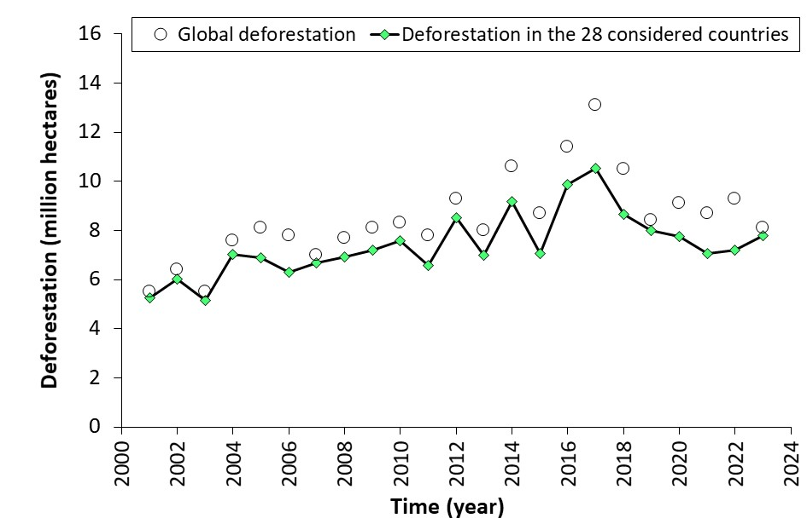
Supplementary Figure 1. Global gross deforestation rates based on tree cover losses (Forest Monitoring, Land Use & Deforestation Trends | Global Forest Watch), reduced by temporary losses from forestry and fires. The line shows the fraction of global deforestation attributable to the 28-country sample, relative to total global deforestation (represented by the circles). The sample accounts for 87% of total global deforestation during the study period.

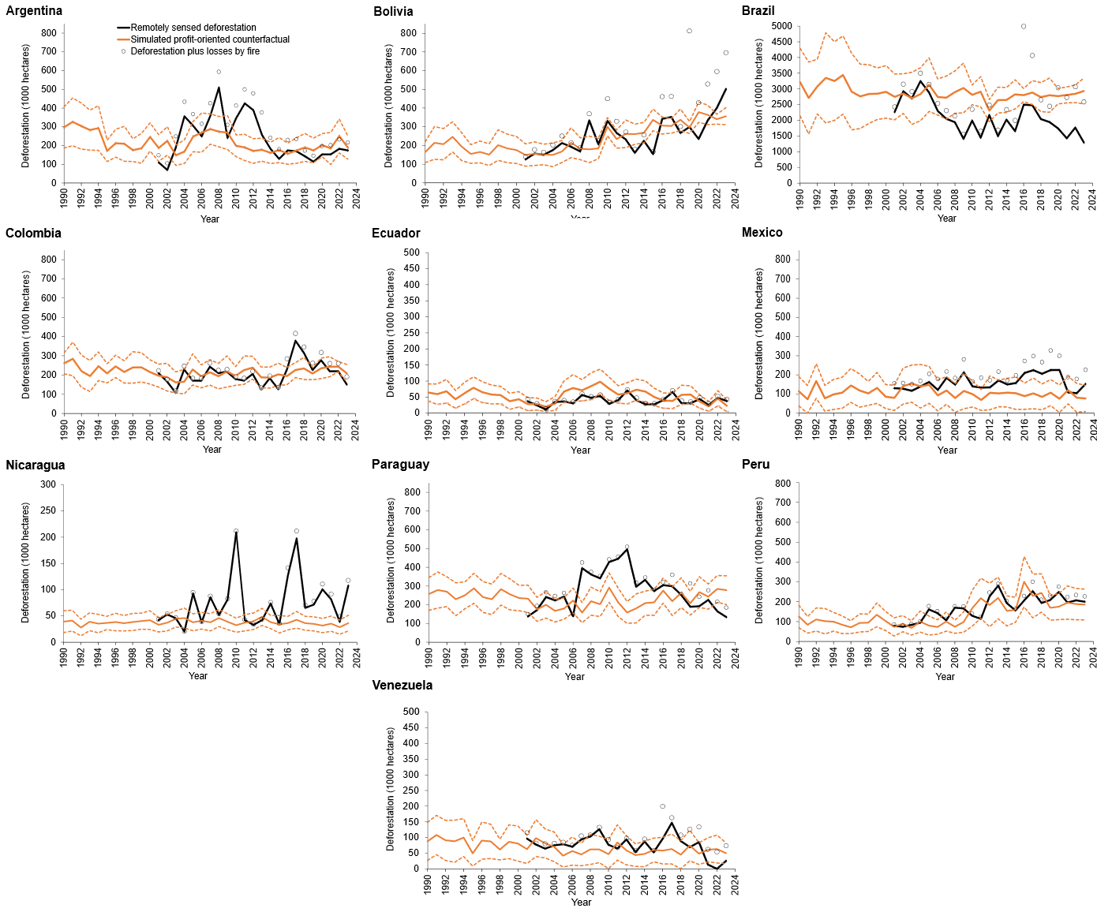
Supplementary Figure 2. Annual remotely sensed and profit-oriented counterfactual deforestation for ten Latin American countries. Dashed lines represent the error margins of the deforestation baselines, comprising ±3 SE (standard errors from Monte Carlo simulations). Note that we forced the mean profit-oriented counterfactual deforestation rate during the calibration period (2001-2004) to equal the mean remotely sensed deforestation rate. To achieve this, we used the mean difference between the two as a static correction applied to the entire time series of counterfactual deforestation rates.

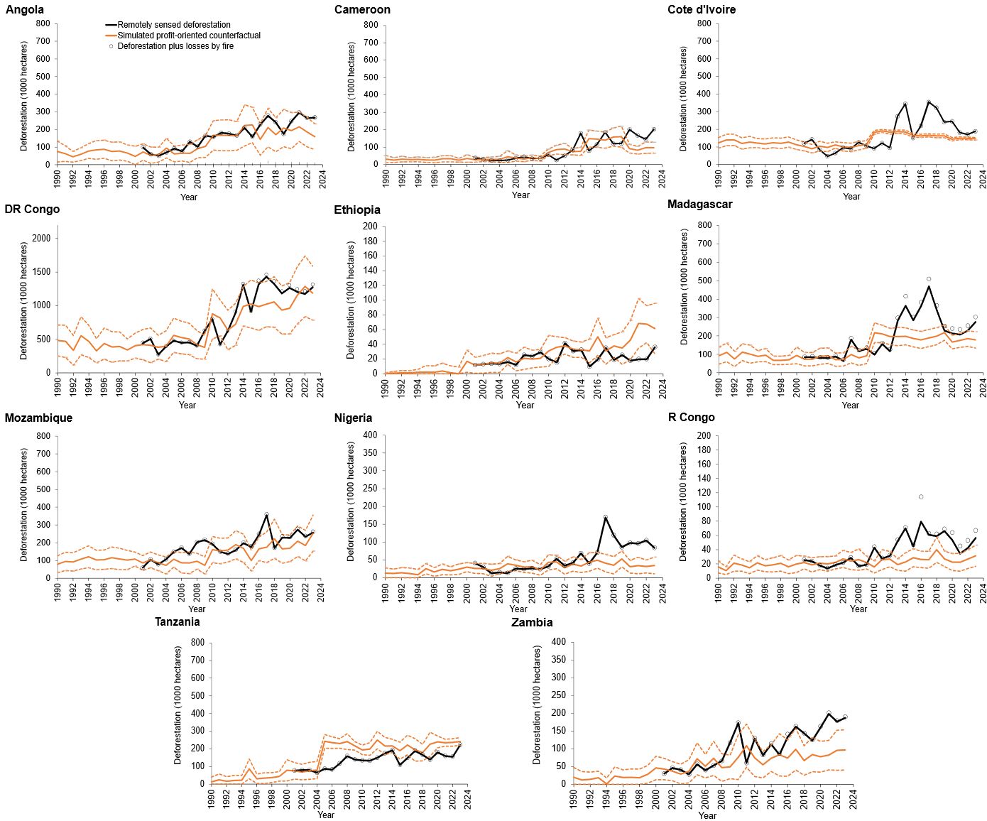
Supplementary Figure 3. Annual remotely sensed and profit-oriented counterfactual deforestation for eleven African countries. Dashed lines represent the error margins of the deforestation baselines, comprising ±3 SE (standard errors from Monte Carlo simulations). Note that we forced the mean profit-oriented counterfactual deforestation rate during the calibration period (2001-2004) to equal the mean remotely sensed deforestation rate. To achieve this, we used the mean difference between the two as a static correction applied to the entire time series of counterfactual deforestation rates.

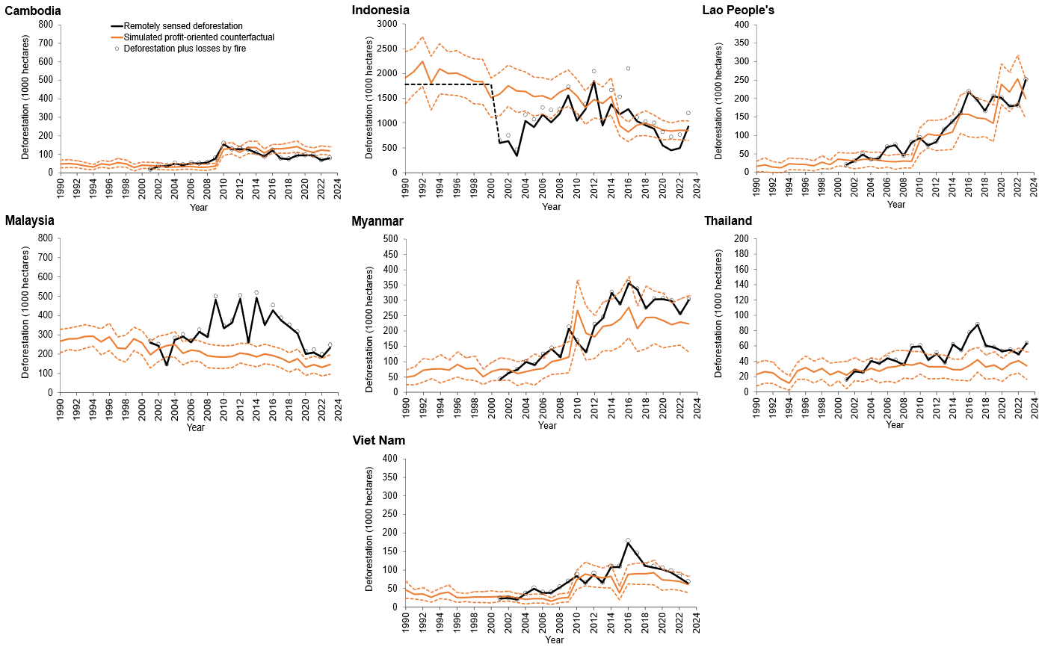
Supplementary Figure 4. Annual remotely sensed and profit-oriented counterfactual deforestation for seven Asian countries. Dashed lines represent the error margins of the deforestation baselines, comprising ±3 SE (standard errors from Monte Carlo simulations). For Indonesia, reliable observed deforestation data from Hansen et al.¹⁵ were available before 2001, with data from 1997 to 2000 used for calibration (dashed black line in Supplementary Fig. 4b). Note that we forced the mean profit-oriented counterfactual deforestation rate during the calibration period (2001-2004) to match the mean remotely sensed deforestation rate. To achieve this, we used the mean difference between the two as a static correction applied to the entire time series of counterfactual deforestation rates.

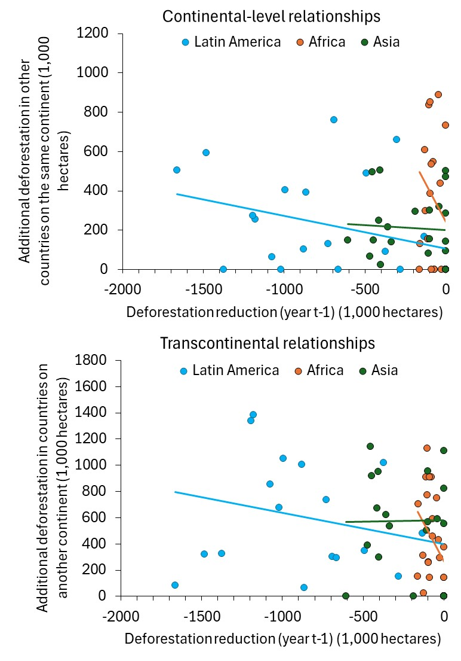

Supplementary Figure 5. Relationships between reduced and additional deforestation.

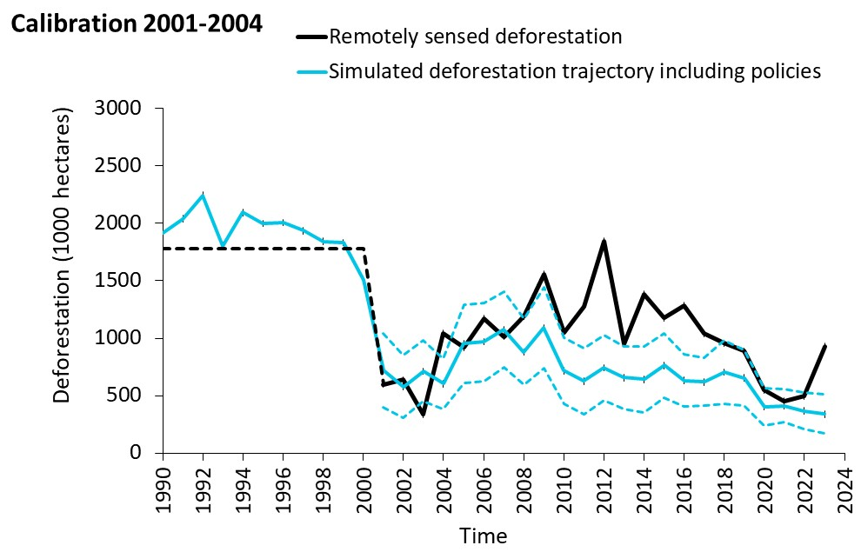
Supplementary Figure 6. Simulated deforestation trajectories using a period with strong deforestation reductions for calibration. Such a reference trajectory would likely be biased downwards. Reliable observed deforestation data from Hansen et al.¹⁷ is indicated by the dashed black line.

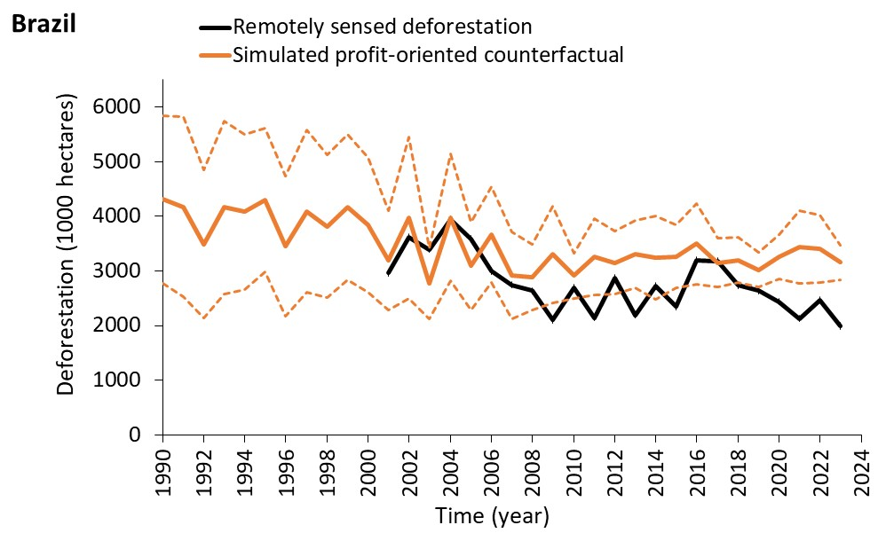
Supplementary Figure 7. Simulated profit-oriented counterfactual for Brazil, calibrated with remotely sensed deforestation rates, 700,000 hectares higher than the actual data reported for Brazil. Such a counterfactual shows a stronger declining trend and a higher uncertainty than the original counterfactual (shown in Supplementary Fig. 2c).

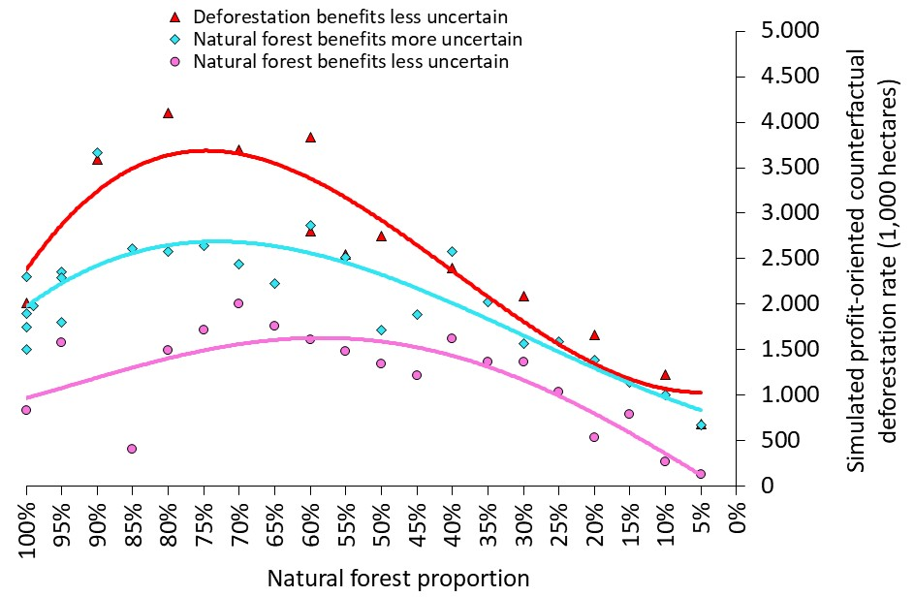
Supplementary Figure 8. Dependency of simulated profit-oriented counterfactual deforestation rates on the proportion of the natural forest. Simulations for Brazil (period 1995-1999), either using a coefficient of variation of ±48% instead of ±50% for deforestation combined with ±30% for natural forest benefits (deforestation less uncertain), or ±30%, with ±50% for deforestation (natural benefits more uncertain) or ±20%, with ±50% for deforestation (natural benefits less uncertain) to model the financial benefit expectations of either deforestation or natural forests.
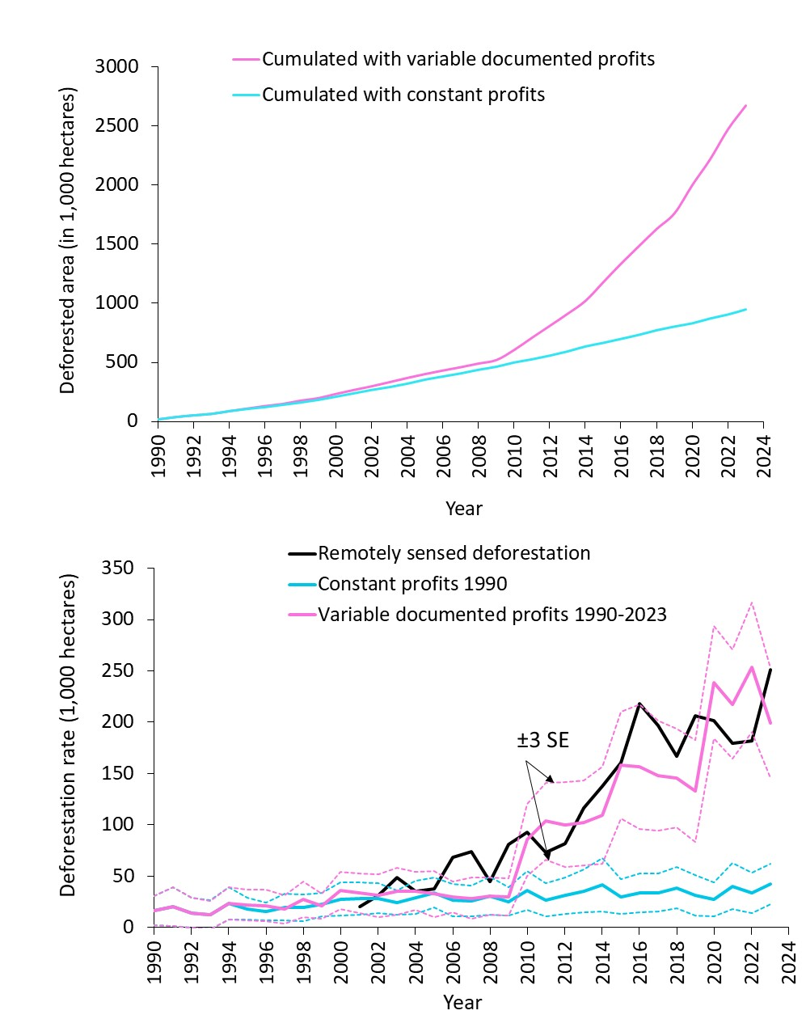

Supplementary Figure 9. Impact of variable (increasing) profits on deforestation rates. The illustration is for the Lao People's DR, where steeply increasing profits (~5% p.a.) underpin the modelling. In the Lao People's DR, a second calibration was necessary due to the improved deforestation detection success after 2011, when recording tree cover losses¹⁶. However, we observe a strong impact of the profit increases from 2010 to 2023, even if we disregard the change between 2009 and 2010.

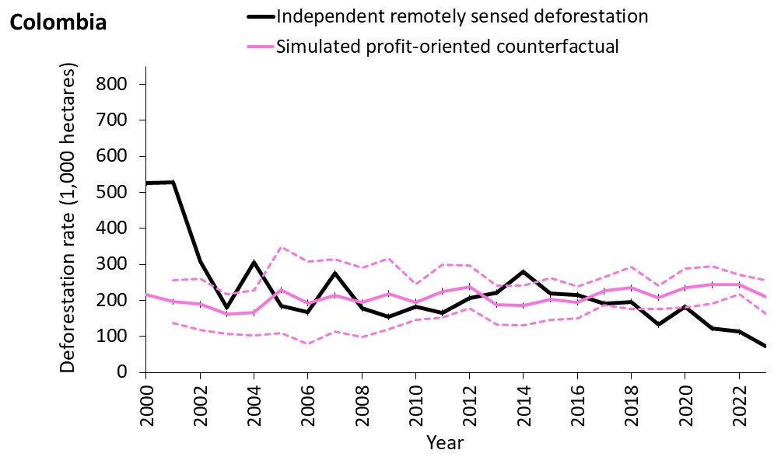
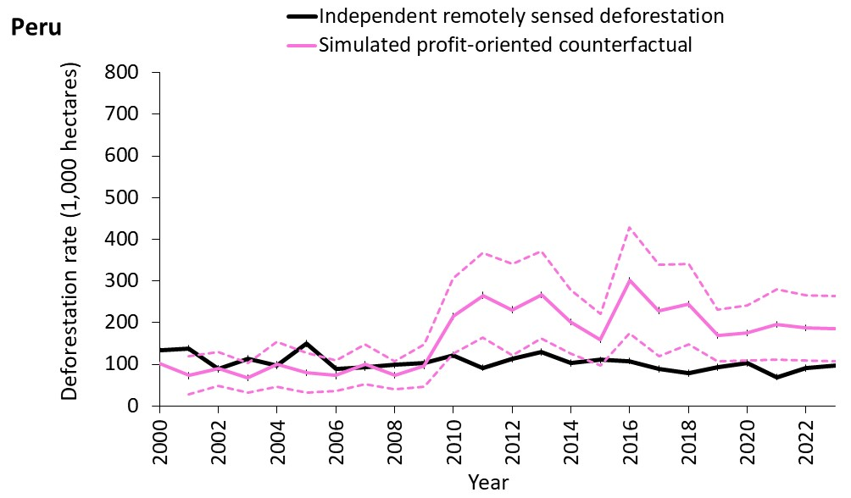
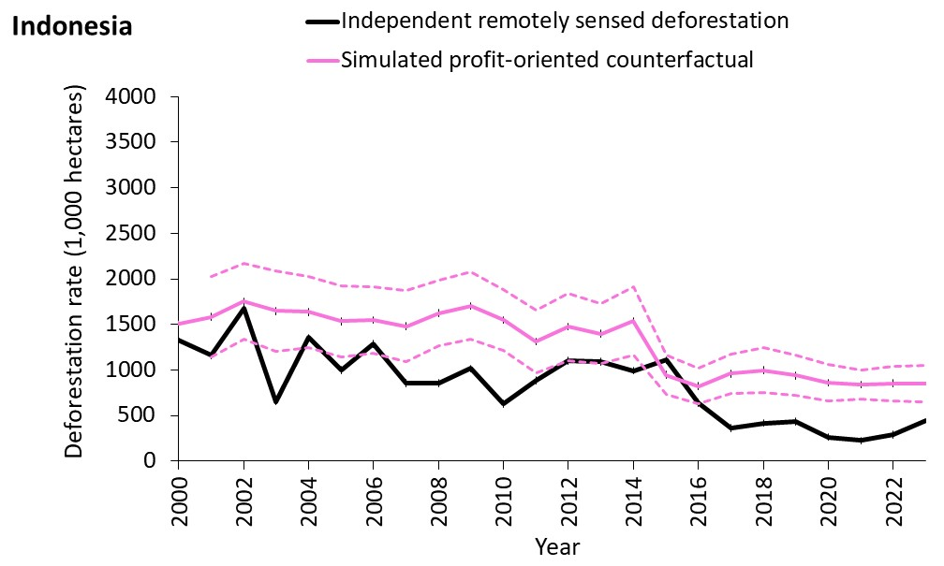

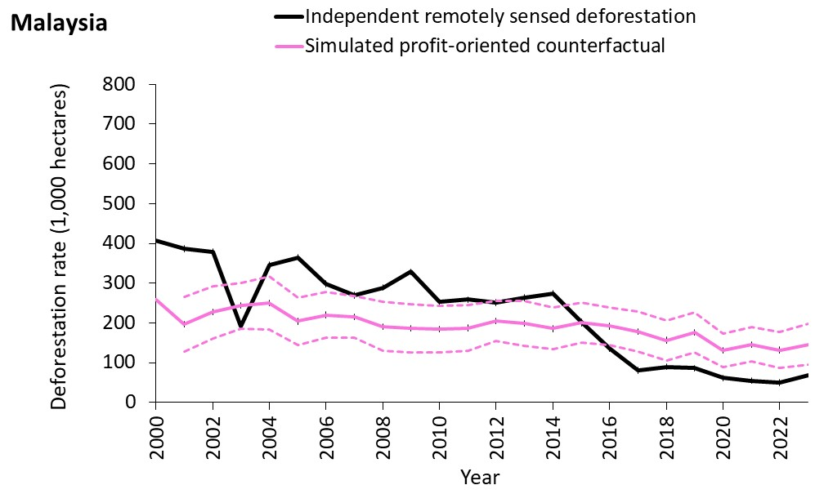
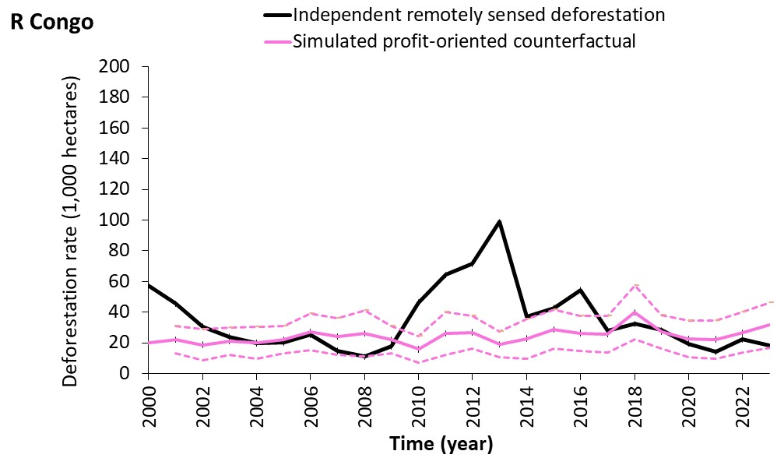
Supplementary Figure 10. Comparing the simulated profit-oriented counterfactuals with independent remotely sensed deforestation rates. We applied our counterfactuals to independent data for five countries, all of which are covered by tropical moist forests, as described in Vancutsem et al.¹⁴ Despite being calibrated to Hansen et al.², our model still accounts for approximately 80% of the variation in the Vancutsem et al. ¹⁵ data. The reduction in deforestation, based on the alternative data in Vancutsem et al.¹⁴, was 23%, compared to only 8% when using data from Hansen et al.².

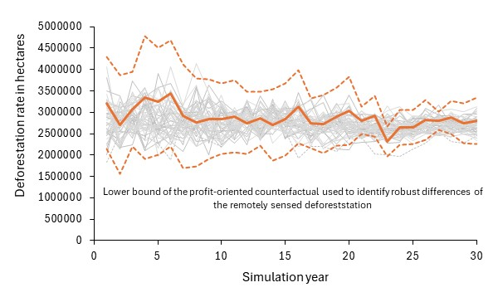

Supplementary Figure 11. Comparison of the applied counterfactual for Brazil with 50 post-hoc created profit-oriented counterfactuals. When using the counterfactual deforestation rates from these repeated post-hoc simulations as a reference trajectory, we obtain, on average, 99% (±19%) of the robust reduction in deforestation achieved with our counterfactual.

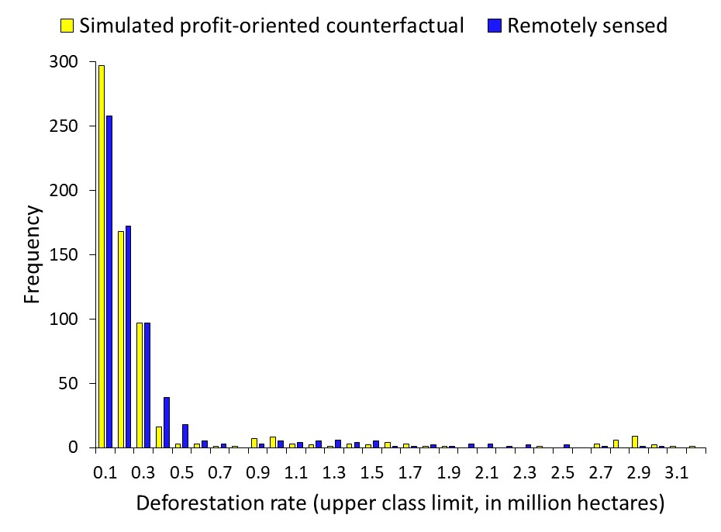
Supplementary Figure 12. Frequencies of deforestation rates. 648 counterfactual and observed rates for 28 countries.
Supplementary Methods
Selected countries, land-use/land-cover types, and their profits
We pre-selected 26 countries based on FAO data (FAOSTAT), sorted by descending deforestation areas as compiled in ref.⁸. These countries together accounted for approximately 90% of the documented net deforestation, referring to changes of the FAO category ‘naturally regenerating forests’. To ensure data reliability and consistency, five African countries were subsequently excluded due to irregularities (e.g., high deforestation rates despite having few substantial areas of natural forest) and data gaps: Sudan, Chad, Somalia, Namibia, and Botswana. We replaced these countries with seven alternative countries from Africa and Asia for which more consistent data were available. The final selection included 28 countries (Supplementary Fig. 3 and Supplementary Tab. 1), which collectively accounted for 87% of global gross deforestation of natural forests from 2001 to 2023, as reported in ref.¹⁷ (Supplementary Fig. 1). This coverage ensures a comprehensive and geographically diverse representation of global deforestation dynamics while maintaining a high standard of data quality for model calibration and analysis. The individual-based land-change model utilises historical agricultural profits and initial land-use/land-cover data from the FAOSTAT database for the simulations. To derive the land-use profits per country, we used the main agricultural products reported for the simulated country-specific land-use/land-cover types during the calibration period, as reported in FAOSTAT (see Extended Data Table 1). Beyond the four land-use/land-cover types mentioned, we considered ‘permanent meadows’ (pastures), ‘new deforestation’, and ‘natural forest’. Profits from agriculture were derived from economic production (output) values published by FAOSTAT (in 2014-2016 US$), reduced by direct production costs (for labour and other inputs), per hectare of the corresponding land-use type⁸. The profits were fit with a trend line to obtain profit averages for seven considered subperiods (1990-1994, 1995-1999, …, 2015-2019, 2020-2023). The trend lines’ root mean square errors were divided by the mean predicted profit to obtain the profits’ coefficient of variation ($vc$). We used the $vc$ to construct lower (minus 2 to 3 standard deviations; see Extended Data Table 3) and upper bounds of profit intervals (plus 0 to 1 standard deviations). From these asymmetric intervals (see Extended Data Table 1), which resemble the possible uncertainty perception, we randomly drew land-use profits that informed our land allocation optimisations, which we simulated for land manager groups.
Bayesian Regression
Given the distribution of deforestation rates (Supplementary Fig. 12) and the heteroskedasticity of the resulting frequency-based regression models, we parameterised a Bayesian GLMM to separate countries that achieved robust deforestation reductions from those that did not (see Supplementary Tabs. 2, 4). The model revealed a regression coefficient for the counterfactual deforestation variable $L$ of nearly 1.
$\hat{D}=0.006+0.955∙L+0.033∙R+0.0007644∙A+0.173∙L∙R-0.025∙L∙A-0.005∙R∙A$
We use $\hat{D}$ [in millions of hectares] to describe the expected remotely sensed deforestation, $L$ for the profit-oriented counterfactual, $R$ to distinguish countries with ($R=+1$) and without deforestation reductions ($R=-1)$ (which show robust overall reduction in deforestation, see Tab. S2), and $A$ as an index quantifying the country’s land area (normalising each country's land area with the average of all countries). The variable ‘year’ was used as a random grouping effect. Our software used the default prior distribution settings of the rstanarm R package (applying normal(location = 0, scale = 2.5) prior distributions on scaled and centered model coefficients).

Deforestation leakage
We further calculated two Bayesian GLMMs, one for continental and another for transcontinental leakage (Supplementary Tab. 6). Both models considered the variables ‘continent’ and ‘year’ as random effect grouping variables and the ‘profit-oriented counterfactual deforestation rate’ as a covariate. The reduction in deforestation in the six countries that were successful in forest conservation was used as a predictor variable, lagged by 1 year. We thus considered the impact of deforestation reductions in the previous year on the additional deforestation in the current year. Reductions and additional deforestation refer to the difference between remotely sensed and profit-oriented counterfactual annual deforestation. For the first model, we regressed additional deforestation and deforestation reductions on the same continent. In contrast, for the second model, we regressed the additional deforestation in two continents on the achieved deforestation reductions in the remaining continent.
Standard errors
To estimate the upper and lower error bounds of the profit-oriented counterfactual deforestation trajectories, we used the standard errors based on $n=50$ repeated simulation-optimisation runs with alternative profit scenarios per country $c$ and per year.
To obtain the standard errors $SE\left(∆\right)$ of the aggregated deforestation differences between remotely sensed and profit-oriented counterfactual deforestation, we summed all covariances across the investigated countries for all pairs of countries $c1$ and $c2$.
$SE\left(∆\right)=\sqrt{\sum_{c1∈C}{\sum_{c2∈C}{cov(∆_{c1},∆_{c2})}}}$
This equation implies that all covariances are represented twice and that $cov\left(∆_{c1},∆_{c1}\right):=var\left(∆_{c1}\right),$ if $c1=c2$. With this formulation, we implicitly include the diagonal of the variance-covariance matrix. Considering covariances mostly increased the standard errors compared with considering only variances.
Importance of endogeneity impacts on counterfactuals
Crop price increases after forest conservation initiatives could potentially have led to overstated counterfactuals However, we consider it unlikely that endogeneity effects have led to overstated reductions in deforestation. For example, another study¹⁸ showed a policy-related reduction in deforestation in the Brazilian Amazon alone (covering about 60% of Brazil’s territory) of 7.3 million hectares from 2004 to 2008 (corresponding to a 56% reduction), using an observational model. Our study confirms a reduction in deforestation of 1.9 ± 0.6 million hectares (or 13% compared with the counterfactual) for the total territory of Brazil and the same period. Without going into the details of the differences, which could possibly be attributed to domestic leakage, as well as the different counterfactual approaches, we can conclude from this example that our method is unlikely to overstate the counterfactual. Our profit-oriented counterfactuals are generally conservative.
Calibration
We demonstrate the sensitivity of our results concerning the calibration for the example of Indonesia, where we also calibrated the counterfactual using low remotely sensed deforestation rates for the period 2001-2004; for our study, because of available remotely sensed deforestation data for Indonesia before 2001, we used 1997-2000 as the period of calibration. The alternative, the 2001-2004 calibrated counterfactual, is biased downwards (Supplementary Fig. 6), making it impossible to identify clear reductions in deforestation from 2000 to 2005. Similarly, but in the opposite direction, we refer to the possibility of large-scale land acquisitions during the recalibration period. As mentioned above, we recalibrated our profit-oriented counterfactuals to account for improved deforestation detection in remotely sensed imagery between 2010 and 2014. If that were the case, our counterfactual would be biased upwards. Such an effect might have occurred for Cambodia, see ref.¹⁹. However, we assume that both possible effects will have cancelled out across the 28 countries we have included.
Forest transitions
Declining deforestation, in the absence of effective mechanisms to reduce it, underlies some phases of the theoretically expected forest transition. This theory predicts that forest cover losses will automatically decrease as forests become scarcer²⁰, as natural forest availability shrinks, and countries become more developed. We modelled forest cover changes and updated the land-use/land-cover composition every five years²¹ to account for such effects, considering that declining availability of natural forests would reduce deforestation rates.

References
1. Pendrill, F. et al. Disentangling the numbers behind agriculture-driven tropical deforestation. Science (New York, N.Y.) 377, eabm9267; 10.1126/science.abm9267 (2022).
2. Hansen, M. C. et al. High-resolution global maps of 21st-century forest cover change. Science 342, 850–853; 10.1126/science.1244693 (2013).
3. Meyfroidt, P. et al. Focus on leakage and spillovers: informing land-use governance in a tele-coupled world. Environ. Res. Lett. 15, 90202; 10.1088/1748-9326/ab7397 (2020).
4. Bertzky, M. et al. Evidence Review on Forest Conservation – An Evidence Gap Map (2025).
5. Ostrom, E. A general framework for analyzing sustainability of social-ecological systems. Science (New York, N.Y.) 325, 419–422; 10.1126/science.1172133 (2009).
6. Garcia, C. A. et al. The Global Forest Transition as a Human Affair. One Earth 2, 417–428; 10.1016/j.oneear.2020.05.002 (2020).
7. Streck, C. REDD+ and leakage: debunking myths and promoting integrated solutions. Climate Policy 21, 843–852; 10.1080/14693062.2021.1920363 (2021).
8. Knoke, T. et al. Trends in tropical forest loss and the social value of emission reductions. Nat Sustain 6, 1373–1384; 10.1038/s41893-023-01175-9 (2023).
9. Brown, S. et al. Baselines for land-use change in the tropics: application to avoided deforestation projects. Mitig. Adapt. Strat. Glob. Change 12, 1001–1026; 10.1007/s11027-006-9062-5 (2007).
10. Gifford, L. “You can’t value what you can’t measure”: a critical look at forest carbon accounting. Climatic Change 161, 291–306; 10.1007/s10584-020-02653-1 (2020).
11. Food and Agricultural Organisation of the UN. Global Forest Resources Assessment 2020 (FAO, 2020).
12. Food and Agriculture Organization of the United Nations. FAOSTAT. Available at https://www.fao.org/faostat/en/#data/QV (2025).
13. Curtis, P. G., Slay, C. M., Harris, N. L., Tyukavina, A. & Hansen, M. C. Classifying drivers of global forest loss. Science (New York, N.Y.) 361, 1108–1111; 10.1126/science.aau3445 (2018).
14. Vancutsem, C. et al. Long-term (1990-2019) monitoring of forest cover changes in the humid tropics. Sci. Adv. 7; 10.1126/sciadv.abe1603 (2021).
15. Hansen, M. C. et al. Quantifying changes in the rates of forest clearing in Indonesia from 1990 to 2005 using remotely sensed data sets. Environ. Res. Lett. 4, 34001; 10.1088/1748-9326/4/3/034001 (2009).
16. Wuepper, D., Oluoch, W. A. & Hadi, H. Satellite Data in Agricultural and Environmental Economics: Theory and Practice. Agricultural Economics 56, 493–511; 10.1111/agec.70006 (2025).
17. Global Forest Watch. Global Deforestation Rates & Statistics by Country | GFW. Available at https://www.globalforestwatch.org/dashboards/global/ (2025).
18. Assunção, J., Gandour, C. & Rocha, R. Deforestation slowdown in the Brazilian Amazon: prices or policies? Environ. Dev. Econ. 20, 697–722; 10.1017/S1355770X15000078 (2015).
19. Davis, K. F., Yu, K., Rulli, M. C., Pichdara, L. & D’Odorico, P. Accelerated deforestation driven by large-scale land acquisitions in Cambodia. Nature Geosci. 8, 772–775; 10.1038/ngeo2540 (2015).
20. Dezécache, C., Salles, J.-M. & Hérault, B. Questioning emissions-based approaches for the definition of REDD+ deforestation baselines in high forest cover/low deforestation countries. Carbon Balance Manage 13, 21; 10.1186/s13021-018-0109-1 (2018).
21. Knoke, T. et al. Accounting for multiple ecosystem services in a simulation of land-use decisions: Does it reduce tropical deforestation? Glob. Chang. Biol. 26, 2403–2420; 10.1111/gcb.15003 (2020).

