Global deforestation rates deviate from a profit-oriented baseline

Supplementary Figures, Tables, and Text

Table of contents

Supplementary Tab. 1-2
Supplementary Figs. 1-8
Supplementary Text 1-3

Supplementary Table 1. Aggregated baseline and observed deforestation from 2001 to 2023. To calculate the increase/reduction against the 2001 deforestation rate, the simulated baseline and observed deforestation have been reduced by the 2001 observed deforestation rate, and the differences have been summed (see Methods in main text).
 | Deforestation 2001 to 2023 [1000 hectares] |  |  |  | Increase/reduction compared to the 2001 observed deforestation rate [1000 hectares]
Country | Sum |  | Per annum
 | Baseline | Observed | Baseline | Observed | Baseline | Observed
Latin America
Argentina | 4948 | 5378 | 215 | 234 | 2410 | 2840
Bolivia | 6383 | 5827 | 278 | 253 | 3501 | 2944
Brazil | 69071 | 47665 | 3003 | 2072 | 17012 | -4394
Colombia | 5171 | 4731 | 225 | 206 | 345 | -95
Ecuador | 851 | 889 | 37 | 39 | 9 | 47
Mexico | 2712 | 3686 | 118 | 160 | -286 | 688
Nicaragua | 913 | 1735 | 40 | 75 | -53 | 769
Paraguay | 5414 | 6293 | 235 | 274 | 2249 | 3128
Peru | 4358 | 3890 | 189 | 169 | 2544 | 2076
Venezuela | 1759 | 1743 | 76 | 76 | -459 | -475
Sum | 101580 | 81837 | 4417 | 3558 | 27272 | 7528
Africa
Angola | 3579 | 3875 | 156 | 168 | 1326 | 1622
Cameroon | 2161 | 2017 | 94 | 88 | 1291 | 1147
Cote d'Ivoire | 3203 | 3879 | 139 | 169 | 434 | 1110
DR Congo | 17289 | 19143 | 752 | 832 | 7113 | 8968
Ethiopia | 808 | 500 | 35 | 22 | 536 | 228
Madagascar | 3535 | 4541 | 154 | 197 | 1586 | 2591
Mozambique | 3381 | 4219 | 147 | 183 | 2018 | 2856
Nigeria | 958 | 1307 | 42 | 57 | 19 | 369
R Congo | 628 | 905 | 27 | 39 | 46 | 323
Tanzania | 4561 | 3129 | 198 | 136 | 2804 | 1372
Zambia | 1919 | 2398 | 83 | 104 | 1231 | 1710
Sum | 42022 | 45913 | 1827 | 1996 | 18404 | 22296
Asia
Cambodia | 2185 | 1854 | 95 | 81 | 1774 | 1444
Indonesia | 29840 | 22747 | 1297 | 989 | 16074 | 8981
Lao People's DR | 2584 | 2706 | 112 | 118 | 2113 | 2235
Malaysia | 4287 | 7116 | 186 | 309 | -1678 | 1151
Thailand | 828 | 1132 | 36 | 49 | 466 | 769
Viet Nam | 1371 | 1743 | 60 | 76 | 838 | 1210
Myanmar | 4326 | 4743 | 188 | 206 | 3341 | 3759
Sum | 45421 | 42041 | 1975 | 1828 | 22928 | 19549
Total | 189023 | 169791 | 8218 | 7382 | 68604 | 49373

Supplementary Table 2. Aggregated robust increases and reductions of the observed deforestation against the simulated baseline deforestation for the period 2001 to 2023. To obtain robust differences, only years when observed deforestation fell outside of ± 3 SE of the simulated baseline deforestation trajectory were considered. Most important contributions to deforestation reductions in bold and italics.
 | Sum of robust deforestation changes from 2001 to 2003 against the simulated baseline in 1000 hectares
Country | Increases | Reductions | Robust difference
Latin America
Argentina | 1050 | 231 | 819
Bolivia | 352 | 607 | -255
Brazil | 0 | 21265 | -21265
Colombia | 383 | 141 | 242
Ecuador | 155 | 165 | -10
Mexico | 770 | 0 | 770
Nicaragua | 839 | 26 | 813
Paraguay | 1187 | 512 | 675
Peru | 74 | 152 | -78
Venezuela | 120 | 110 | 10
Sum | 4930 | 23209 | -18279
Africa
Angola | 108 | 0 | 108
Cameroon | 452 | 529 | -77
Cote d'Ivoire | 1015 | 342 | 673
DR Congo | 1180 | 396 | 784
Ethiopia | 0 | 216 | -216
Madagascar | 1230 | 254 | 976
Mozambique | 506 | 0 | 506
Nigeria | 545 | 204 | 341
R Congo | 341 | 50 | 291
Tanzania | 0 | 1328 | -1328
Zambia | 759 | 159 | 600
Sum | 6136 | 3478 | 2658
Asia
Cambodia | 18 | 305 | -286
Indonesia | 1063 | 7891 | -6828
Lao People's DR | 135 | 72 | 63
Malaysia | 2828 | 101 | 2727
Myanmar | 305 | 0 | 305
Thailand | 256 | 0 | 256
Vietnam | 309 | 185 | 124
Sum | 4914 | 8554 | -3639
Total | 15980 | 35240 | -19260

Supplementary Table 3. Random effect coefficients for the GLM equation $\hat{D}=17.598+1.036∙L-0.0001277∙L^{2}$. $\hat{D}$ is the statistical estimate of the observed deforestation (in 1000 hectares) based on the simulated profit-oriented baseline deforestation $L$, used as a predictor.
Year: Random Effect Estimates
Year |  | (Intercept)
2001 |  | -15.909
2002 |  | -5.262
2003 |  | -17.473
2004 |  | 16.375
2005 |  | -16.036
2006 |  | -19.665
2007 |  | -21.284
2008 |  | -16.011
2009 |  | -11.734
2010 |  | -3.163
2011 |  | -21.362
2012 |  | 23.787
2013 |  | -9.150
2014 |  | 27.031
2015 |  | -8.051
2016 |  | 42.903
2017 |  | 54.369
2018 |  | 16.323
2019 |  | 7.486
2020 |  | 4.497
2021 |  | -13.681
2022 |  | -14.304
2023 |  | 0.314

Country: Random Effect Estimates
Country | (Intercept)
Angola |  | -3.487
Argentina |  | 1.277
Bolivia |  | -27.908
Brazil |  | 88.576
Cambodia |  | -22.710
Cameroon |  | -16.947
Colombia |  | -25.602
Cote d'Ivoire |  | 8.120
DR Congo |  | 87.045
Ecuador |  | -10.655
Ethiopia |  | -21.318
Indonesia |  | -99.545
Madagascar |  | -8.627
Malaysia |  | 18.401
Mexico |  | 74.646
Mozambique |  | 17.362
Myanmar |  | 13.180
Nicaragua |  | 0.593
Nigeria |  | 13.416
Paraguay |  | -1.023
Peru |  | 15.230
R Congo |  | -26.729
Tanzania |  | -3.134
Thailand |  | -56.357
Venezuela |  | -2.503
Zambia |  | -12.878
Lao People‘s DR |  | -0.740
Viet Nam |  | 2.317

Supplementary Table 4. Comparison of different annual deforestation estimates (global scale)
 | Deforestation rate [million hectares per annum]
Period | Total tree cover losses from Global Forest Watch¹, reduced by forestry and unintended fires | Observed deforestation rate for countries included in our study (simulated baseline rate in parentheses) | FAO Remote Sensing Survey² | FAO Forest Resource Assessment 2020³ | Curtis et al.⁴, commodity-driven deforestation | Pendrill et al.⁵
1990-2000 |  |  |  | 16.0
2000-2010 | 7.2 | 6.5 (8.2) | 11.0 | 15.0 | 4.8
2011-2015 | 8.9 | 7.7 (8.1) |  | 12.0 | 5.2 | 6.5-9.5
2011-2018 | 9.9 | 8.3 (8.2) | 7.8
2015-2020 |  |  |  | 10.0

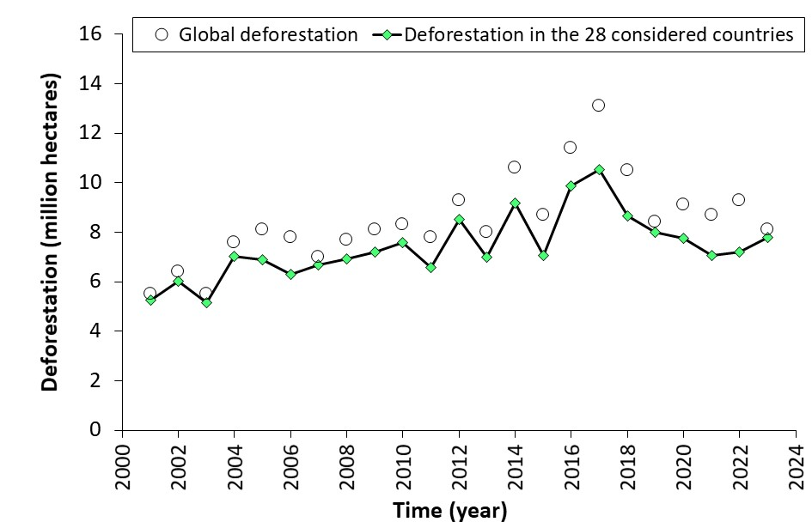
Supplementary Figure 1. Global deforestation is based on tree cover losses¹, reduced by temporary losses from forestry and unintended fires. The line shows 87% of the global deforestation represented by the 28 countries considered in the current study, in comparison to total global deforestation (circles).

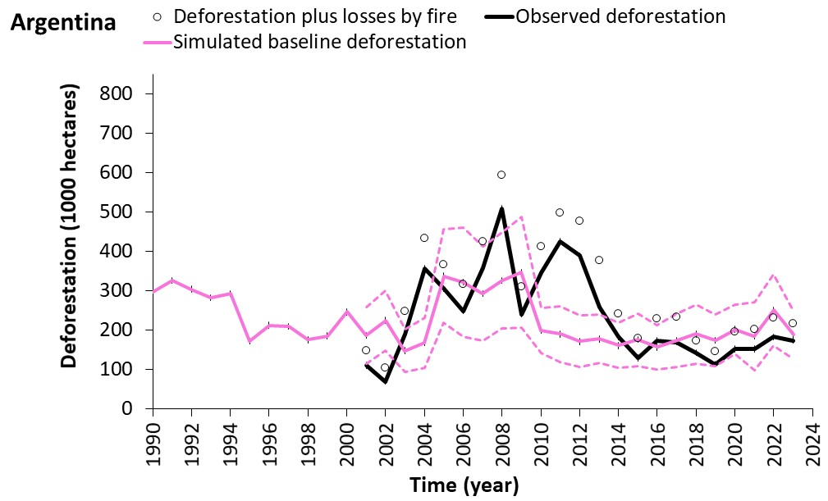
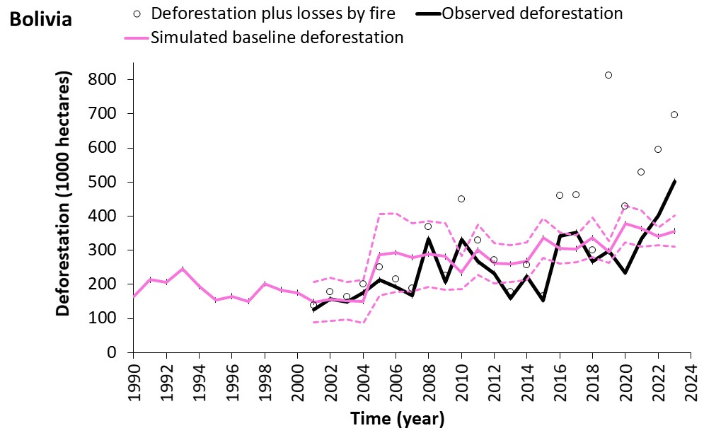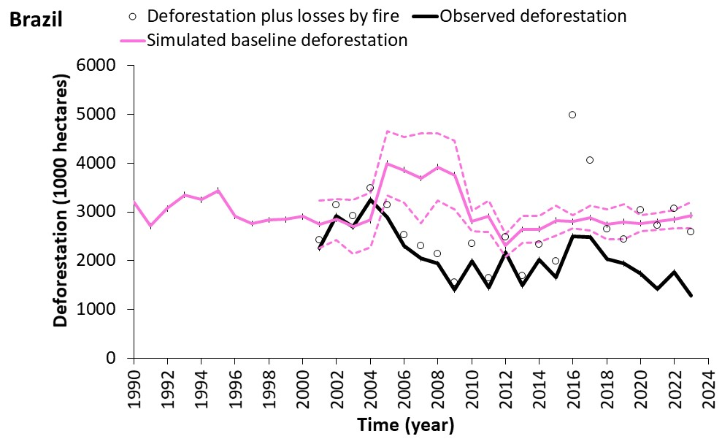
b
b
c
a
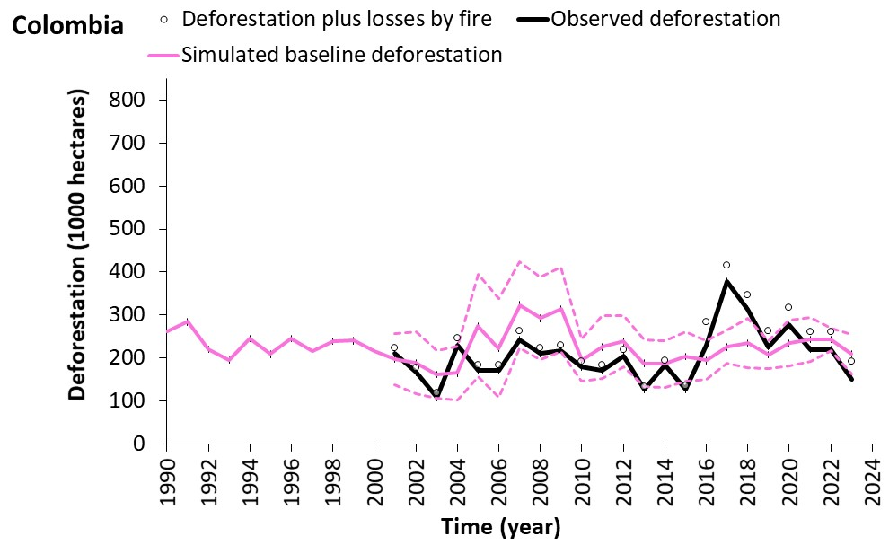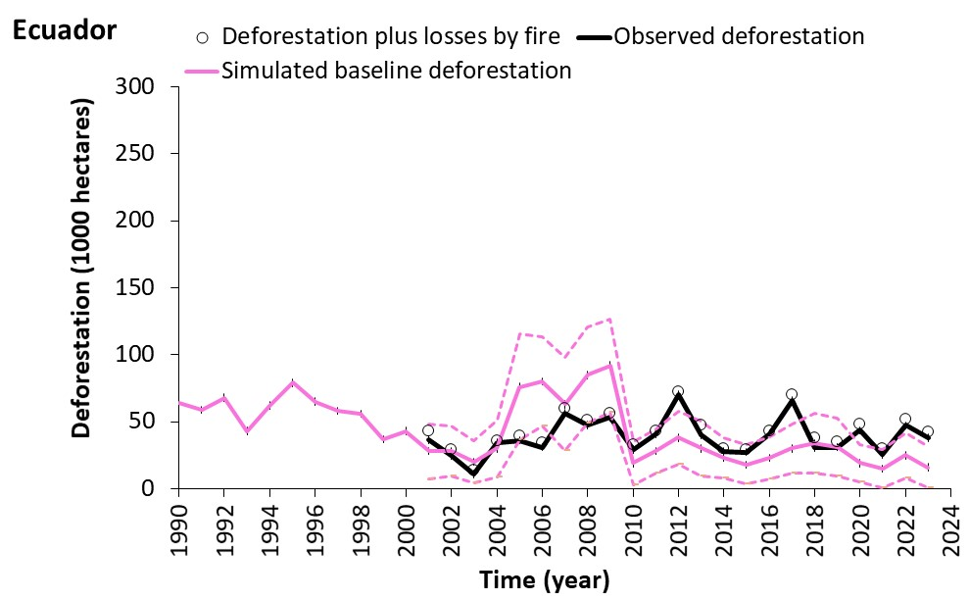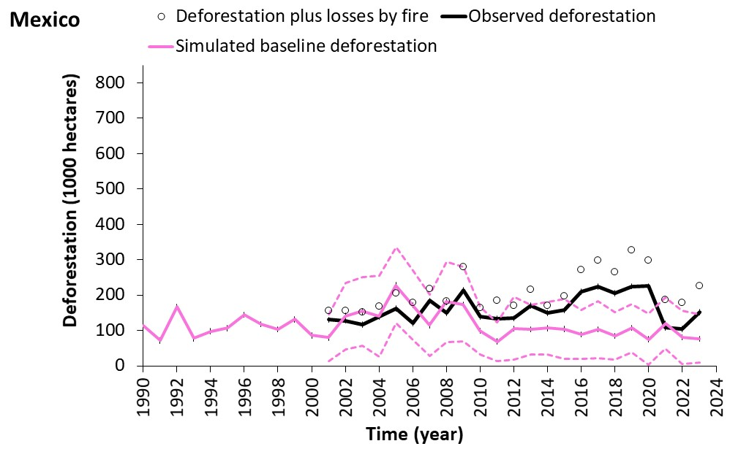
d
e
f
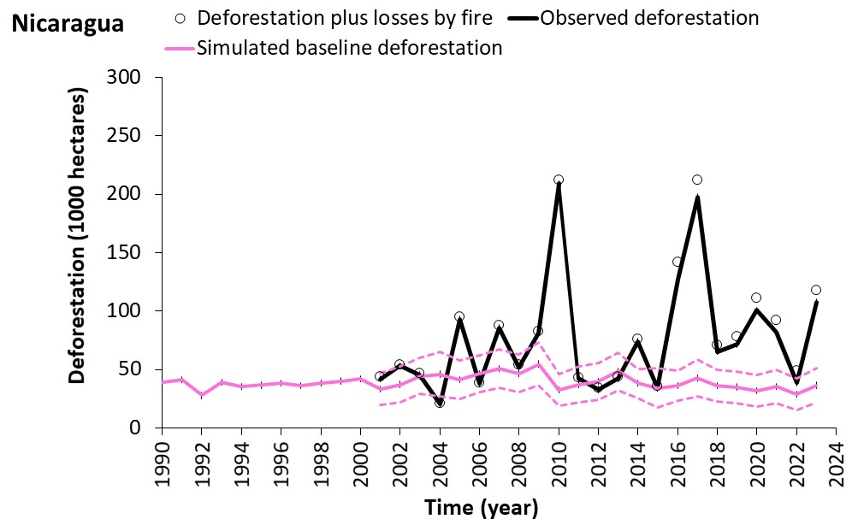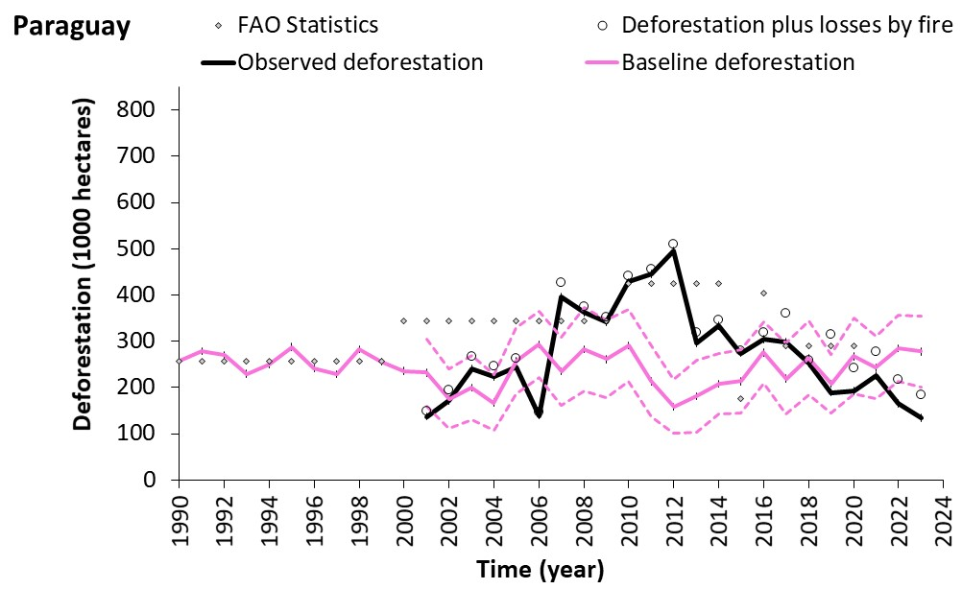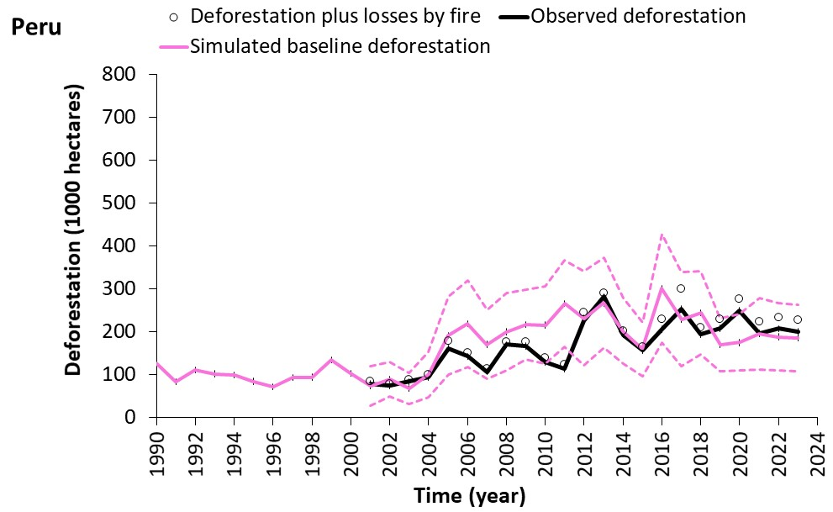
i
h
g
j
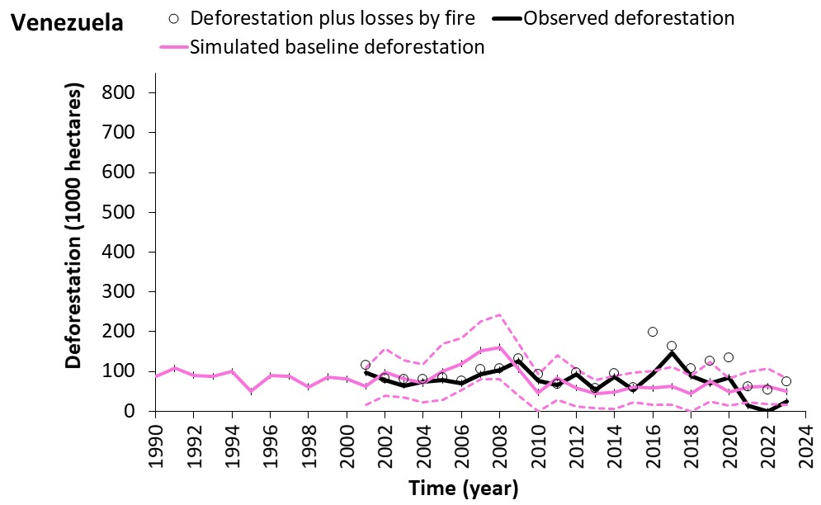
Supplementary Figure 2. Annual observed and profit-oriented baseline deforestation for ten Latin American countries. Magenta dashed lines represent error margins of the deforestation baselines, comprising ±3 SE (standard errors from Monte-Carlo simulations). Note that we forced the mean baseline deforestation rate in the calibration period (2001 to 2004) to equal the mean observed deforestation rate. To achieve this, we used the mean difference between the two to correct the whole time series of baseline deforestation rates.

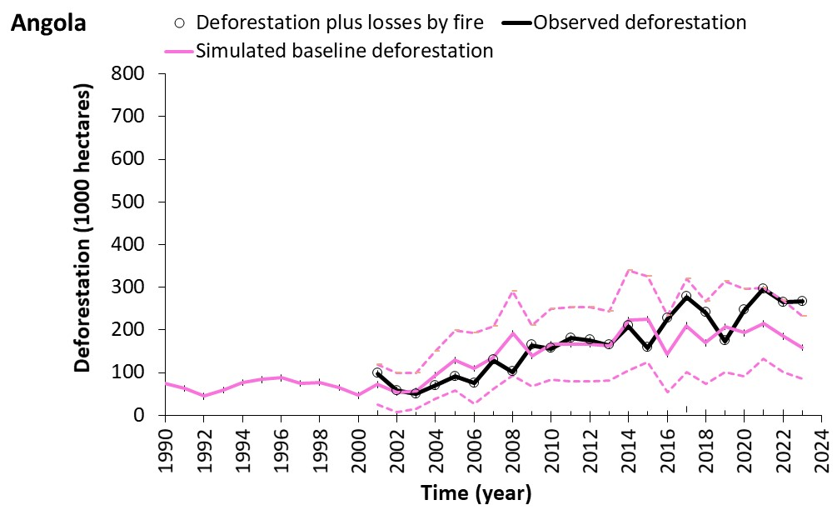
a
b
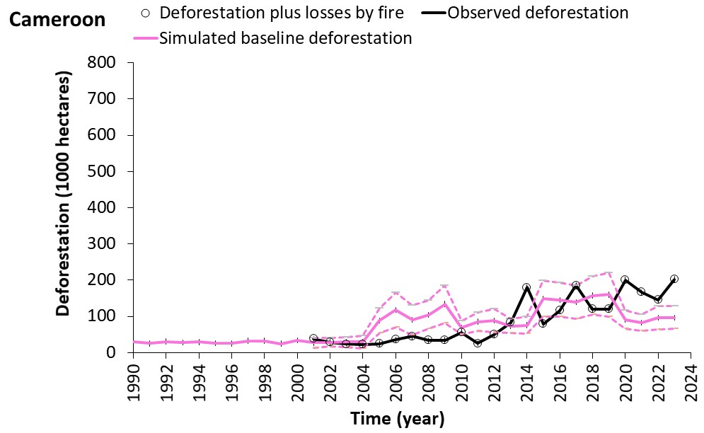
c
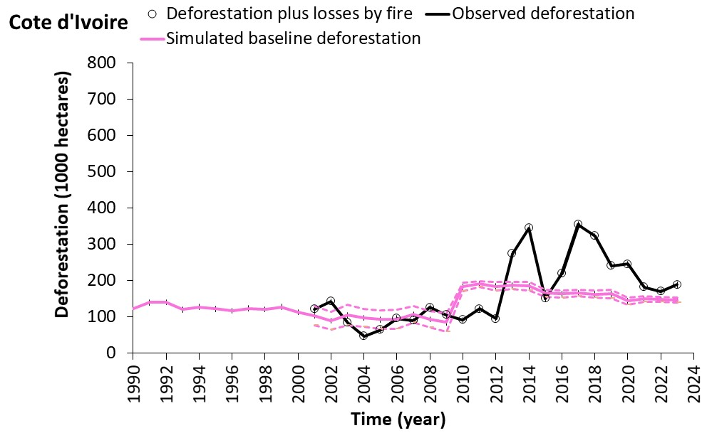
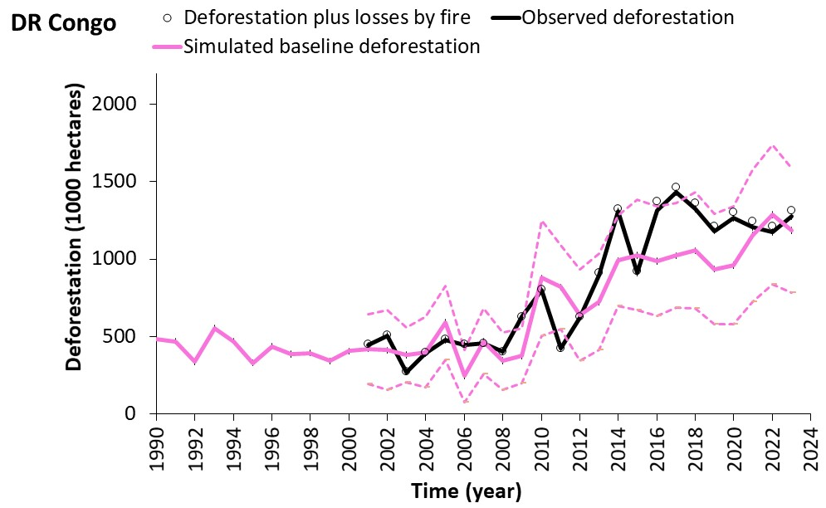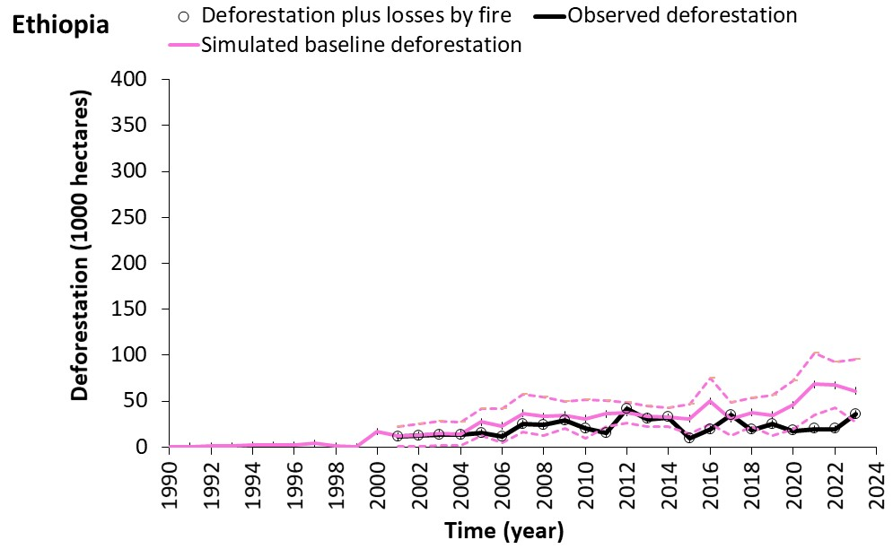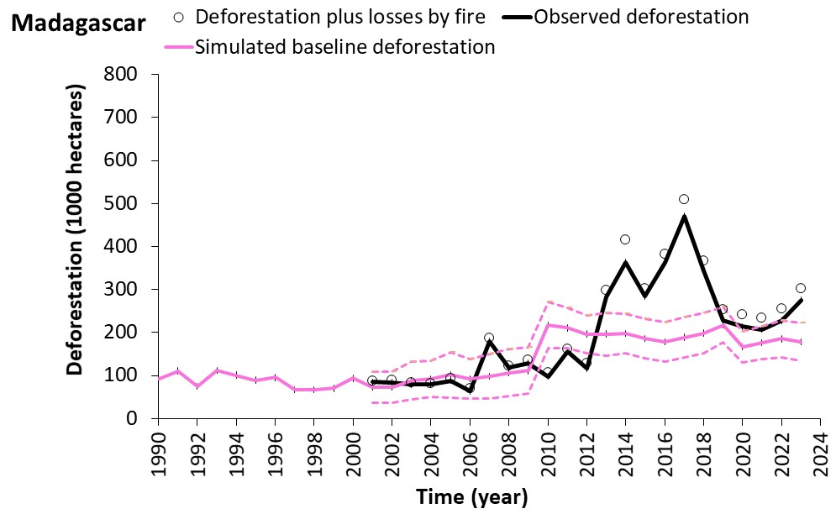
f
e
d
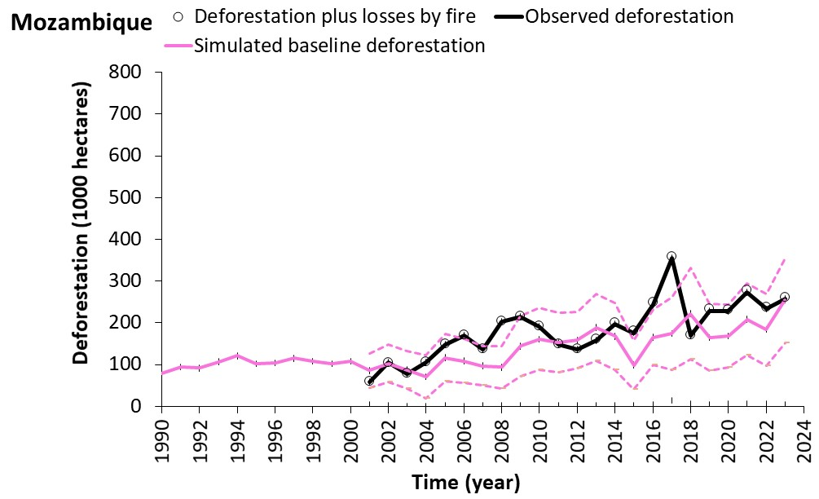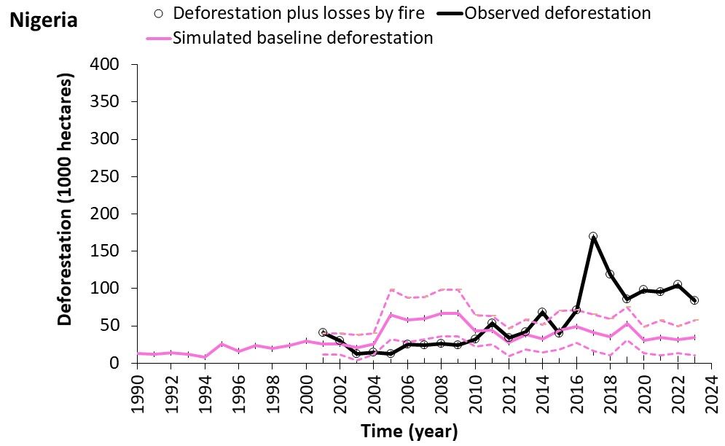
i
g
h
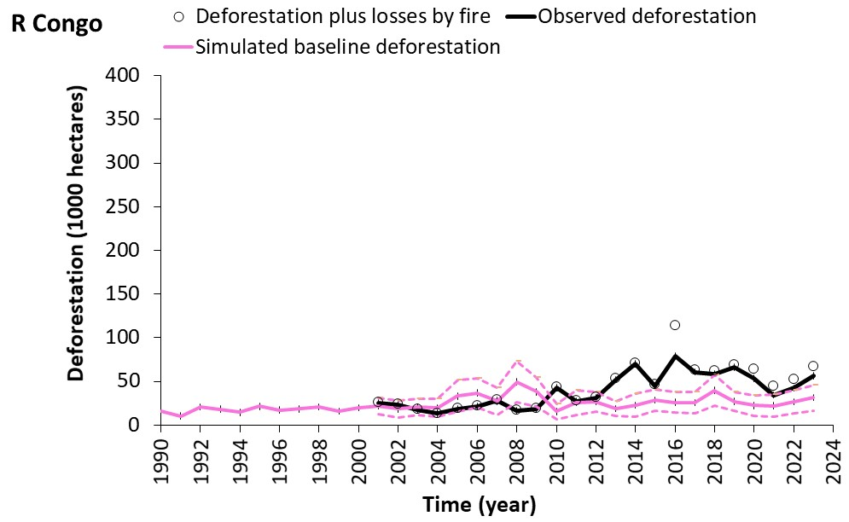
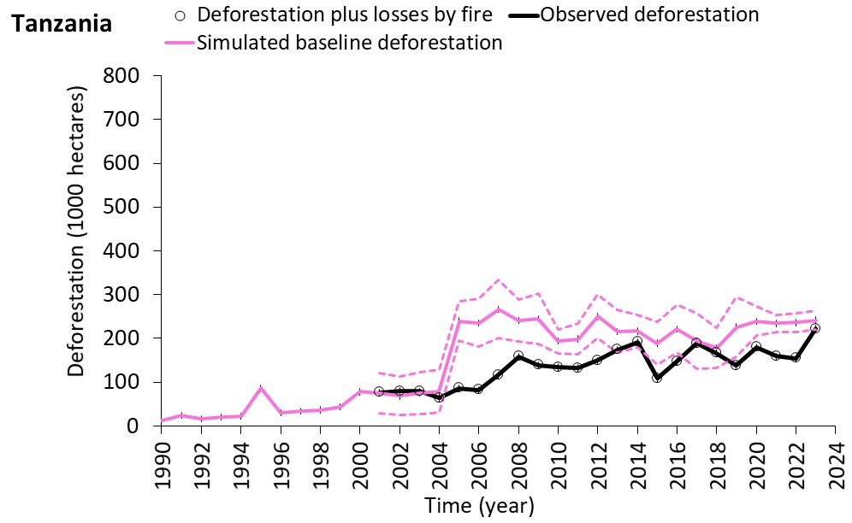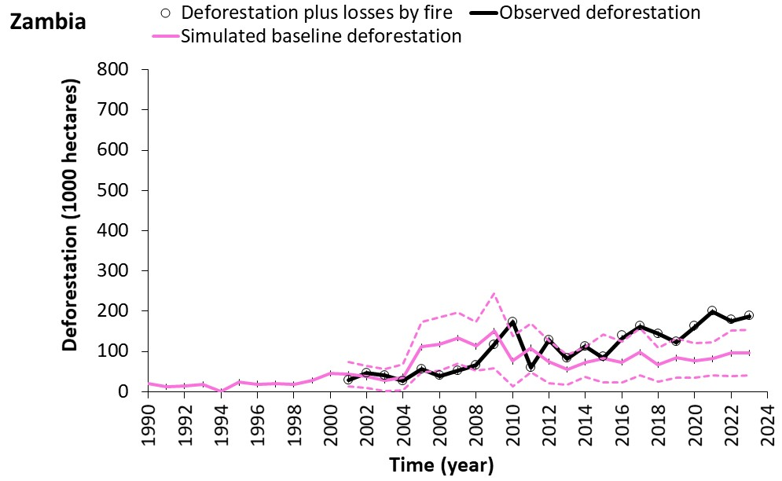
j
k
Supplementary Figure 3. Annual observed and profit-oriented baseline deforestation for eleven African countries. Magenta dashed lines represent error margins of the deforestation baselines, comprising ±3 SE (standard errors from Monte-Carlo simulations). Note that we forced the mean baseline deforestation rate in the calibration period (2001 to 2004) to equal the mean observed deforestation rate. To achieve this, we used the mean difference between the two to correct the whole time series of baseline deforestation rates.

a

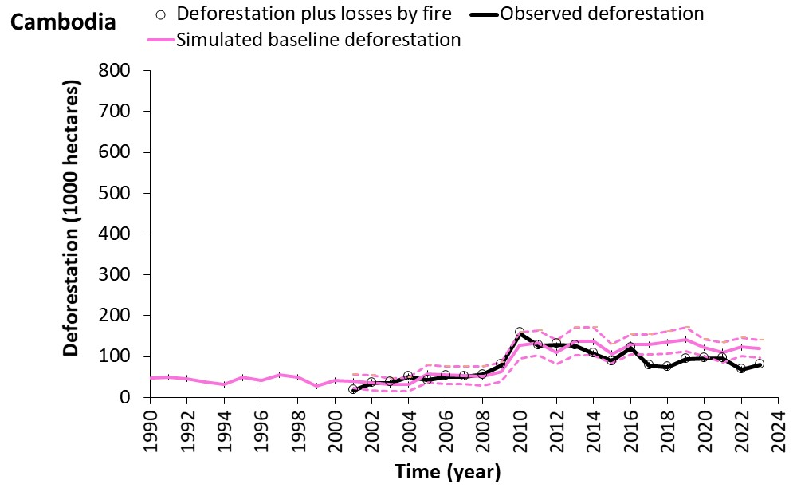
b
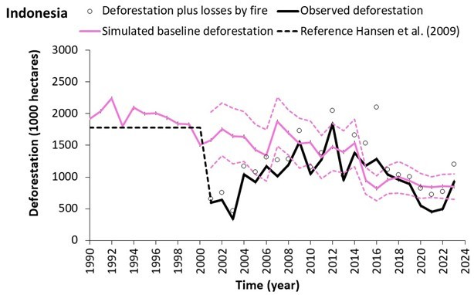
c
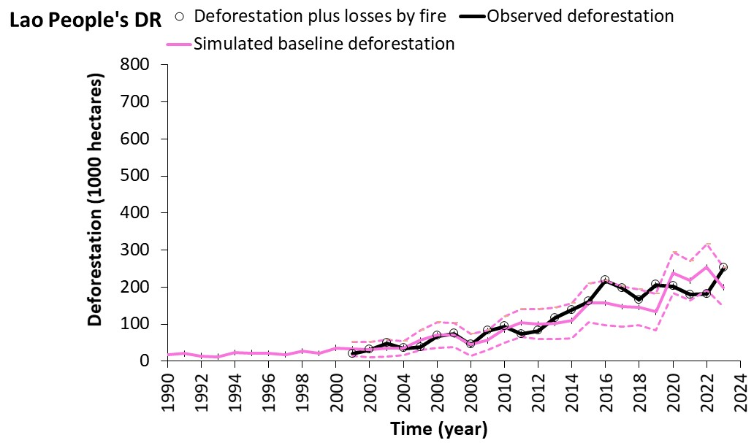

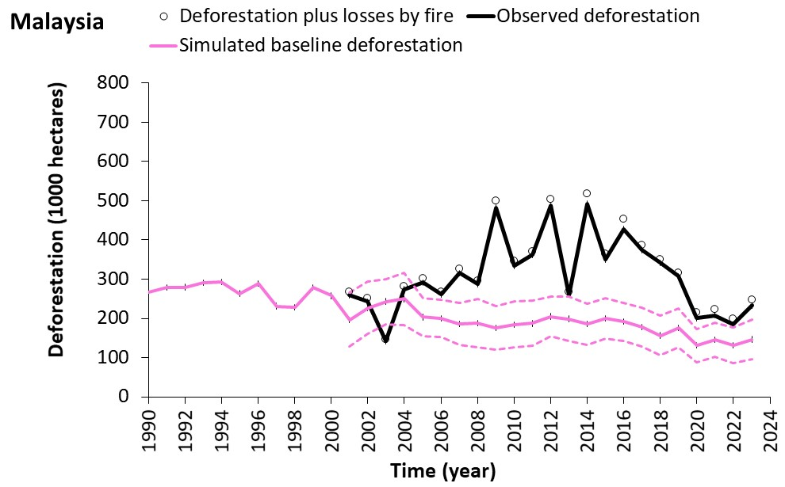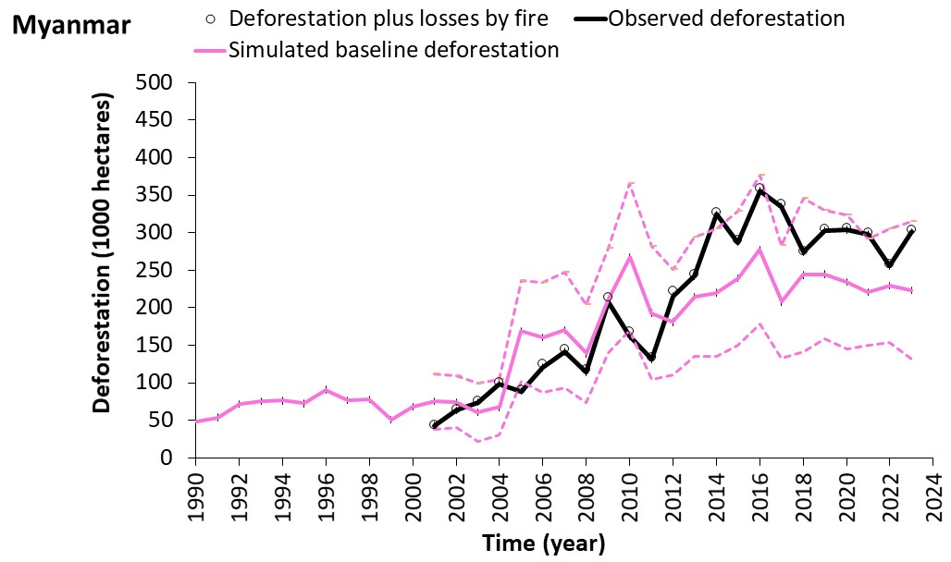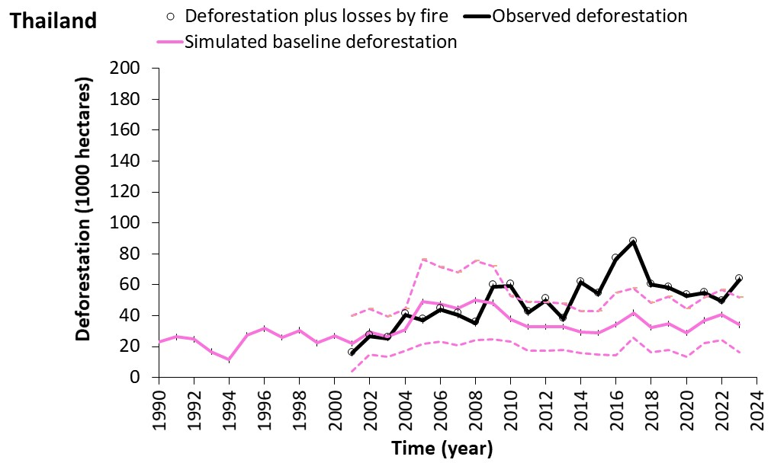
f
e
d
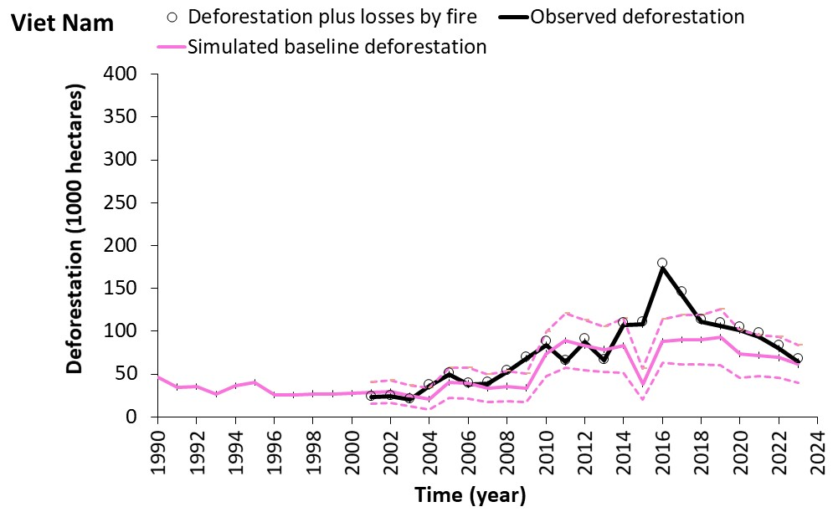
g
Supplementary Figure 4. Annual observed and profit-oriented baseline deforestation for seven Asian countries. Magenta dashed lines represent error margins of the deforestation baselines, comprising ±3 SE (standard errors from Monte-Carlo simulations). For Indonesia, reliable observed deforestation data from Hansen et al.² were available before 2001 for calibration, see Supplementary Fig. 6. Note that we forced the mean baseline deforestation rate in the calibration period (2001 to 2004) to equal the mean observed deforestation rate. To achieve this, we used the mean difference between the two to correct the whole time series of baseline deforestation rates.

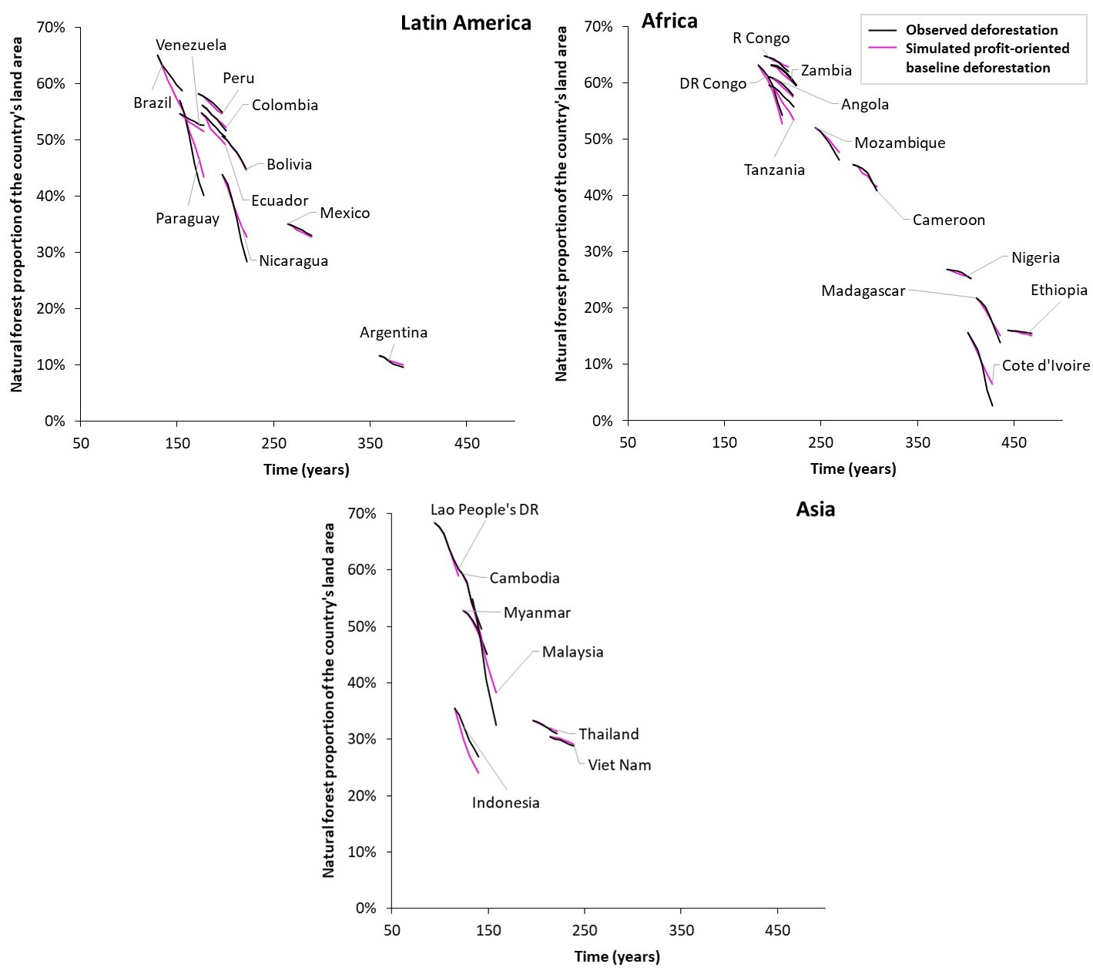
Supplementary Figure 5. Observed and simulated profit-oriented baseline forest cover trajectories for 28 countries in the period 2001-2023. The trajectories show how the proportion of natural forest declined over 23 years in each country and how it would have declined under simulated profit-oriented deforestation. To obtain the starting point for the natural forest proportion trajectories, the theoretical time a country has been undergoing deforestation was derived from the proportion of land without natural forest in 2001, divided by the average annual reduction of forest area in per cent across all countries. The starting point of the trajectories on the y-axis thus shows the hypothetical time in years a country has undergone deforestation or forest transition, if it was once covered by 100% forest.

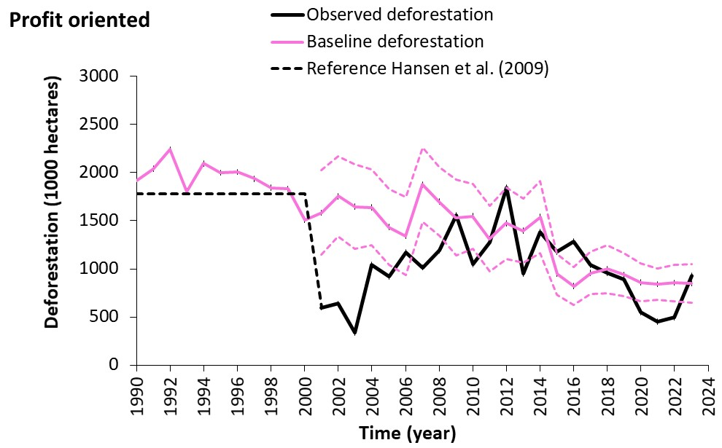
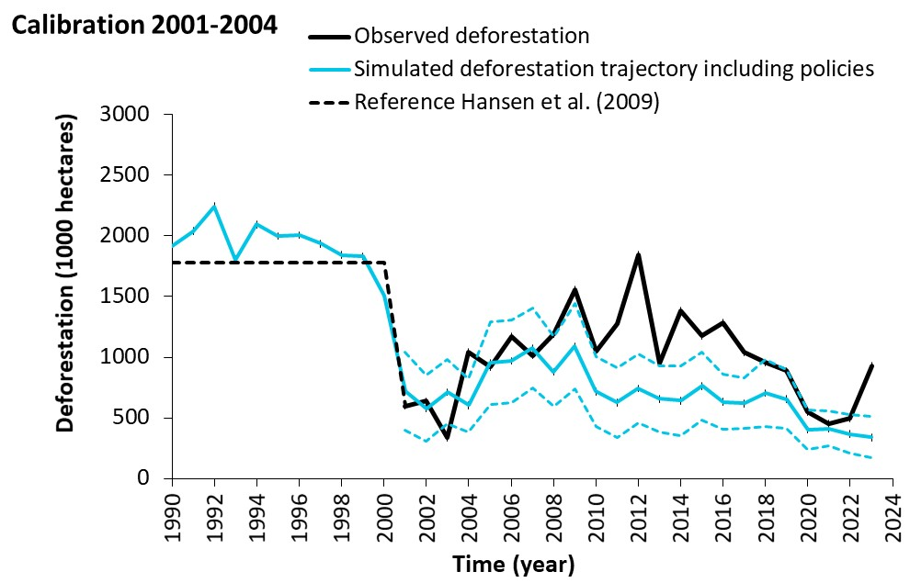
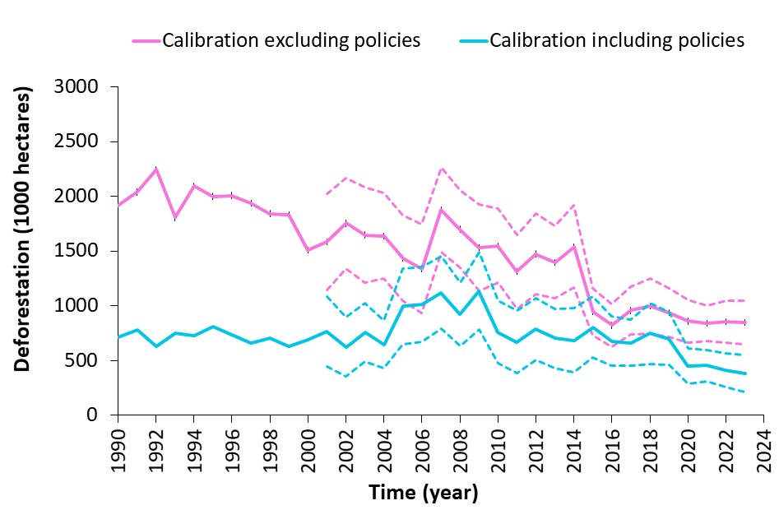
Calibration 1997-2000

Figure 6. Simulated deforestation trajectories either excluding (top) or including policies (middle) and their comparison (bottom). Only the baseline deforestation on top is a profit-oriented baseline.

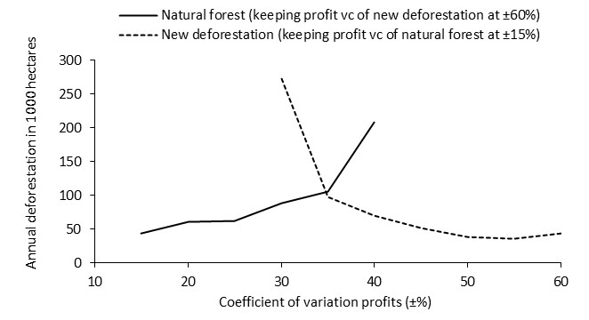

Figure 7. Sensitivity of predicted deforestation to the variation coefficients (vc) of the ‘New deforestation’ and ‘Natural forest’ profits (example data).

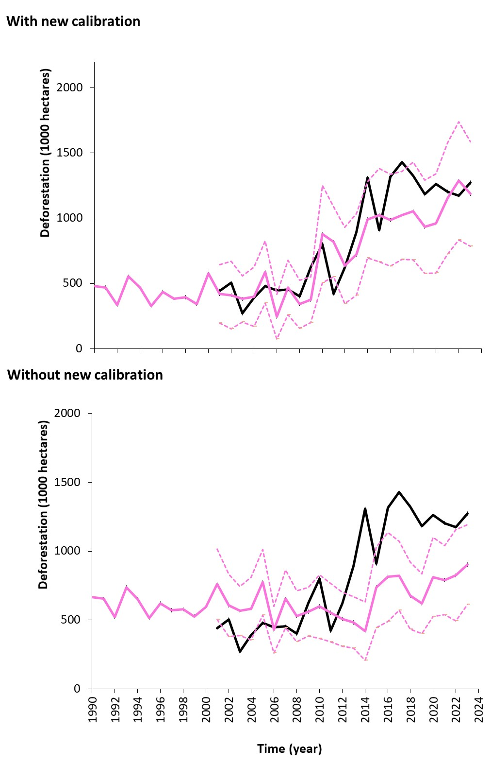

Supplementary Figure 8. Example for a required second calibration because of more sensitive deforestation detection algorithms⁵ from 2010 onwards. ‘Without a new calibration’ shows a baseline deforestation trajectory derived in Knoke et al.⁶, who tested a prototype version of the model for three countries, which we advanced and applied to 28 countries in the current study.

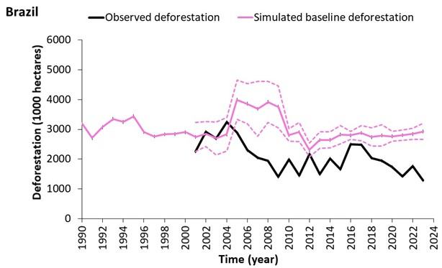

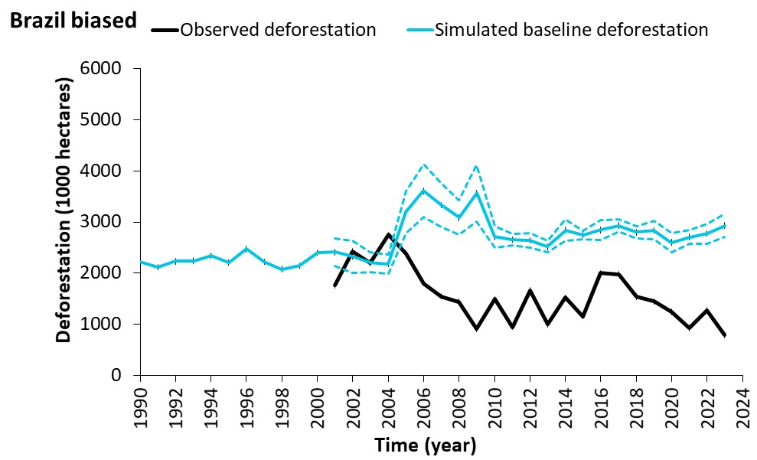

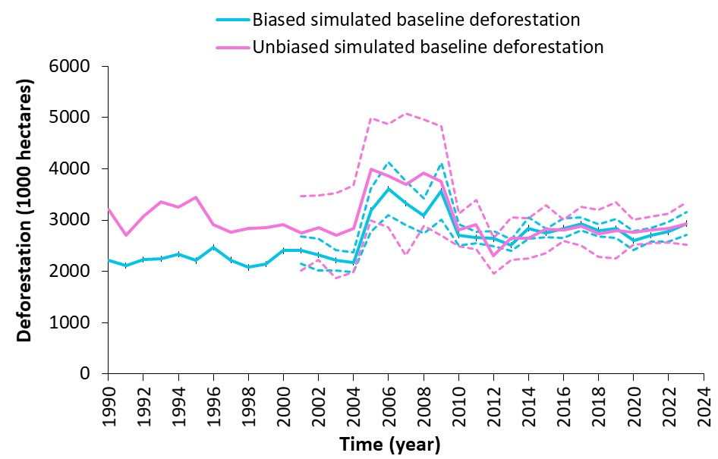

Supplementary Figure 9. Possible impact of underestimating observed deforestation. We assumed a systematic bias of the observed deforestation rate of -500 thousand hectares per year (bottom). While the baseline calibrated with the biased data shows a similar dynamic as the unbiased baseline (top), the estimated deforestation reduction is much higher: -28.4 million hectares under the biased observed deforestation versus -21.4 million hectares for the unbiased case. So, the unbiased baseline suggests a 25% lower deforestation reduction than the biased baseline.

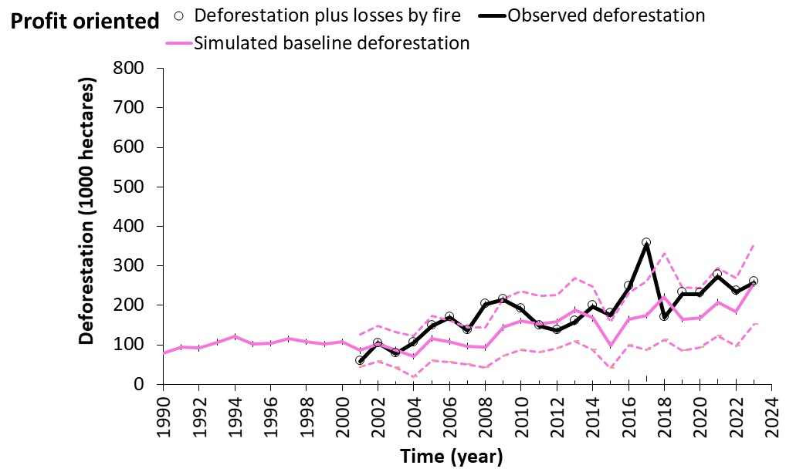

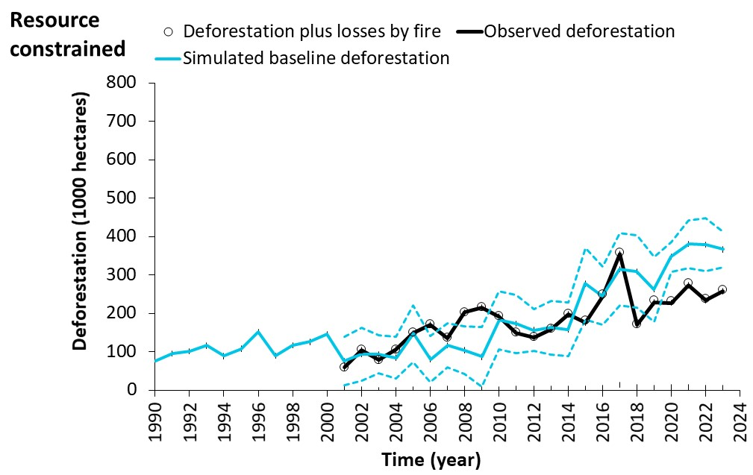

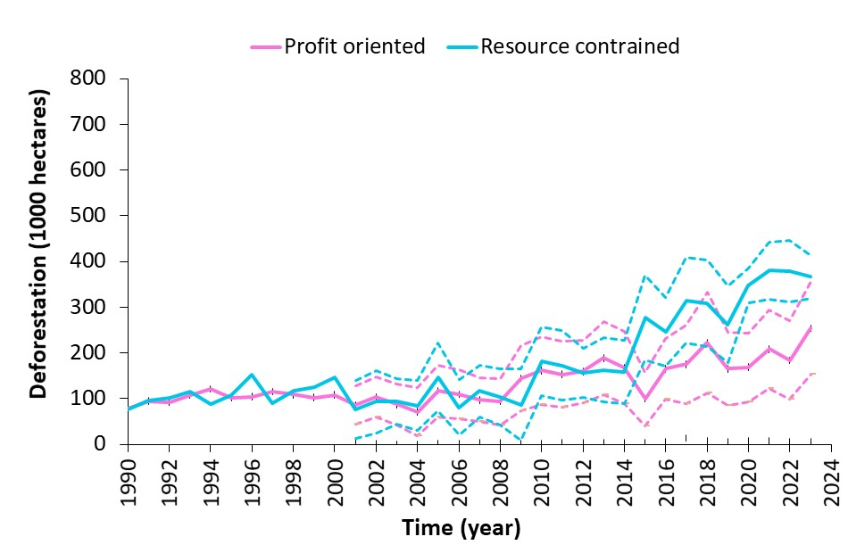

Supplementary Figure 10. Comparison of profit-oriented and resource-constrained baselines. The resource-constrained baseline increases more steeply. To model the resource-constrained baseline, we integrated the required labour force as a second criterion (to be minimised) in addition to the profits and assumed reduced benefits from permanent croplands, which require high, but in this scenario, unavailable monetary investments for maximum benefits (see Supplementary Text 3).

Supplementary Text
1 The global deforestation baseline
The profit-oriented baseline deforestation showed a strong increase from 2005 to 2009, when Latin America faced steeply rising producer prices⁷, leading to the so-called “Tortilla crisis”. The observed deforestation roughly followed the suggested increases of the simulated baseline deforestation rates in this period, for example, in Argentina, Bolivia, Colombia, Mexico, Paraguay, and Peru (Supplementary Figs. 3a, b, d, f, h, i). However, the observed deforestation in Brazil decreased despite increasing market pressure from 2005 to 2009, so that the average observed deforestation did not follow the profit-oriented baseline trajectory in Latin America. The trend in the Latin American baseline finally influenced the global baseline trajectory substantially.
2 Country-level considerations
Examples of deforestation reduction
Brazil, Tanzania, and Indonesia accounted for most deforestation reductions, contributing a proportion of 87% (Fig. 3, Supplementary Tab. 1), while Ethiopia and Cambodia also achieved consistent deforestation reductions relative to the simulated baseline. Indonesia showed a mixed pattern. At the beginning of the analysed period, it achieved substantial deforestation reductions, but later the Indonesian forests suffered from increased deforestation against the simulated baseline, thus leading to both deforestation reductions and increases over time.
Brazil achieved the highest and most persistent deforestation reduction against the baseline (Supplementary Fig. 2c). Its average simulated baseline deforestation rate (counterfactual) was 3.00 million hectares annually, and the observed deforestation was 2.07 million hectares annually (Supplementary Tab. 1), which corresponds to a reduction of 31%. Brazil was one of the very few countries in our analysis where observed deforestation not only fell below the simulated profit-oriented deforestation baseline, but also showed a marked decrease compared to its historical 2001 observed deforestation level (other countries were Colombia and Venezuela). Brazil contributed -21.3 ± 2.3 million hectares (Fig. 3A) to the identified total deforestation reductions, making it the single largest driver of avoided forest loss. Despite concerns over weakened forest protection policies since 2012⁸ and global events such as the COVID pandemic⁹, our analysis showed a persistent positive forest conservation outcome in Brazil. This conservation success was facilitated by various government efforts, most prominently, the Action Plan for the Prevention and Control of Deforestation in the Legal Amazon (PPCDAm)^{8,10}, which introduced a multi-sectoral and multi-level governance framework, supported by satellite monitoring technologies and law enforcement mechanisms. In addition, international pressure, such as the soy and beef moratoria^{11,12}, may have had an impact as well.
Indonesia represented the second largest deforestation reduction, with an average simulated baseline deforestation rate of 1.30 million hectares annually, compared to an observed rate of 0.99 million hectares annually. This represents a reduction against the baseline of 23%, mainly achieved between 2001 and 2010. For Indonesia, strong deforestation reductions between 2000 and 2005 can be attributed to political changes (Supplementary Fig. 4b). For example, more stringent permitting rules and new export tax regulations were introduced after a change in the government, limiting the expansion of palm oil plantations¹³.
In Tanzania, observed deforestation averaged 0.14 million hectares annually, compared to the simulated profit-oriented baseline rate of 0.20 million hectares annually, indicating a reduction of 30%. Tanzania holds one of the highest shares of protected areas in Africa, with 38% of its territory under formal protection¹⁴. This extensive network likely contributed to the observed reduction. However, unlike Brazil, the effectiveness of Tanzania’s deforestation reduction appears to be less consistent over time (Supplementary Fig. 3j).
Deforestation reductions in Ethiopia (Supplementary Fig. 3e) and Cambodia (Supplementary Fig. 4a) can be attributed to local forest-dependent communities, who are successful in protecting their forests¹⁵. For example, forest communities in Cambodia successfully safeguard their forests against illegal logging¹⁶.
Examples of deforestation increase
Years with deforestation exceeding the simulated baseline were more pronounced in Malaysia, Paraguay, Madagascar, and Argentina (see Fig. 3 for the spatial distribution of such increases). A wide range of factors beyond agricultural profitability can drive deforestation exceeding the profit-oriented baseline. For example, especially in regions experiencing rapid population growth, factors such as high subsistence demand for agricultural land^{17,18}, the legal and often also illegal exploitation of valuable timber¹⁹, mining²⁰, or crises⁹ (e.g., the COVID pandemic) are drivers of deforestation beyond agricultural profits. In some cases, policy effects themselves can be counterproductive. Unclear land rights²¹, incentives to clear forests to obtain land titles²², anticipative pre-emptive clearing when forest protection policies are announced²³, or election promises²⁴ can boost deforestation. This underscores the need for more comprehensive policy frameworks that consider both agricultural and non-agricultural factors of land-use change. Below, we describe some country examples where factors driving deforestation can be identified more specifically.
Colombia’s observed deforestation follows the simulated baseline pattern, with only one increase between 2016 and 2020 (Supplementary Fig. 2d). This increase can be attributed to the peace agreement in 2016 between the government and the Colombian armed revolutionary forces (FARC). Following this agreement, the FARC left the forest that had been used as their hideaway, and civilians moved in, associated with an increase in deforestation²⁵.
The 2010 deforestation spike in Nicaragua (Supplementary Fig. 2g) was attributed to conflicts concerning the assignment of land titles to native ethnic groups and the expansion of the road system²⁶. Another spike of forest losses in 2016 was partly caused by hurricane Otto, with an estimated damaged forest area of about 167 kha²⁷. Such hurricane damage is of a similar nature to an unintended fire and would not count as deforestation. However, because we could not use any systematic analysis of hurricanes or other wind-driven disturbances on natural forests, we did not account for tree cover losses caused by hurricane events.
In Paraguay, a ‘Zero-Deforestation’ law was established in 2004, but only in the Eastern region²⁸. This law, although possibly effective in Eastern Paraguay, could not avoid excessive deforestation in the whole country from 2007 onwards, possibly also because of leakage. This dynamic signalling stricter forest conservation likely supported substantial increases in deforestation, mainly in the regions without restrictions, which in sum exceeded the simulated baseline (Supplementary Fig. 2h).
The decline of deforestation after 2011 in Argentina was attributed to an efficient law enforcement²⁹. However, the deforestation level observed up until 2014 was still higher than suggested by the simulated baseline, and it remained like this since then (Supplementary Fig. 2a). This suggests the likely absence of a positive additional policy impact.
For Côte d’Ivoire, our model came to its limit. We generally assumed a transition time or planning horizon of one generation (30 years) from the current proportion of natural forest to the profit-increasing future proportion derived through optimisation. This implies a maximum deforestation of $3.3\overline{3}\%$ per annum, which was achieved by the optimisations for Côte d’Ivoire in most random iterations from 2010 onwards (Supplementary Figure 3c). This was also indicated by the small standard error of the baseline simulations. Still, the observed deforestation was much higher than the simulated close-to-maximum baseline deforestation.
Similar to Paraguay, we identified increased deforestation beyond the expected baseline deforestation in Malaysia from 2004 onwards, possibly driven by excessive logging³⁰. Observed and profit-oriented baseline deforestation rates matched in Malaysia only from 2020 to 2023 (Supplementary Fig. 4d). This reversal back to the simulated profit-oriented deforestation level led to ‘business-as-usual’ deforestation as per our definition. The phase of increased deforestation in Malaysia was also supported by the expansion of illegal and unmapped road networks³¹. Although Malaysia’s deforestation exceeded the profit-oriented counterfactual in many years, a recent assessment used data from the period of deforestation exceeding the profit-oriented counterfactual as a reference deforestation level (2018-2020). Based on such an elevated reference level, the Forest Declaration Assessment³², has likely drawn a too optimistic picture of the actual deforestation reduction achieved. The more recent Malaysian deforestation was still beyond the profit-oriented baseline.
Similarly, most of the ten countries which the Forest Declaration Assessment classified as having drastically reduced deforestation actually showed deforestation higher than our profit-oriented baseline suggested during the historical reference period from 2018 to 2020³². Such a reference deforestation level does not allow for conclusions on deforestation reduction policies. In conclusion, any quick interpretation of deforestation levels falling over time as a success of forest protection policies should be considered with care.
3 Methodological considerations
Modelling resource-constrained land managers
One can argue that the counterfactual baseline should ideally consider all factors influencing deforestation, excluding only the policy impact. For example, one could approach the observed deforestation rates as closely as possible with our model in countries where one would not expect any forest conservation policies. In this context, we can show the impact of assuming resource-constrained land managers for the case of Mozambique (Supplementary Fig. 10). We hypothesise that such resource-constrained land managers show higher rates of deforestation than profit-oriented land managers³³. To simulate such land managers’ decisions, we integrated the demand for labour force associated with the land-use/land-cover types (estimated based on Ibarrola-Rivas et al.³⁴) as a second decision criterion (in addition to the profits) into the simulations, using 1,000 random scenarios for labour requirement of the land-use/land-cover types per optimisation. Labour is a limited resource on smallholder farms³⁵. In addition, we assumed that access to financial capital is also limited so that the maximum profit potential cannot be achieved for permanent croplands, which were represented by producing coconuts and bananas in the case of Mozambique (see Supplementary Coefficients). We thus reduced the expected profits from permanent croplands to 40% of the original value in this experiment. These assumptions helped model the strong deforestation increase from 2015 onwards better than assuming pure profit-oriented deforestation for Mozambique. The used assumptions enhanced the dependency of the land managers on new land, represented by new low-input land-use types, which can be gained by deforestation. Under such assumptions, we achieved a better alignment of the observed deforestation and the simulated baseline. However, we also needed more assumptions and increasingly used observed deforestation outside the original calibration periods to assess and modify the counterfactual trajectories, risking not being able to identify and quantify the differences we were interested in. Consequently, we abstained from better aligning observed and simulated deforestation in countries where the observed deforestation exceeds the simulated profit-oriented counterfactual.
Calibration
An appropriate calibration of the simulated baseline is of high importance. Indonesia stood out as a country where forest protection policies were already strongly in effect during the calibration period from 2001 to 2004. Therefore, we used an earlier calibration period for Indonesia, which was facilitated by the availability of exceptionally early deforestation data (Supplementary Fig. 6 shows the alternative calibration with deforestation data from 2001 to 2004).
In addition, the uncertainty surrounding the observed deforestation data can be problematic, especially since some published estimates of observed deforestation differ across sources^{5,36}. The deforestation rates reported by FAO^{2,3} from 2000 to 2010 are higher than other estimates^{4,5}. After 2010, the available deforestation data tended to converge more closely, which suggests an improving reliability of the available deforestation information (Supplementary Tab. 4). We show the relevance of correct observed deforestation data for Brazil, where a hypothetical systematic underestimation of the observed deforestation rate by 0.5 million hectares annually lead to a severe overestimation of the achieved deforestation reductions (Supplementary Fig. 9). In this scenario, the apparent impact of forest conservation would be inflated by 25% compared to an unbiased estimate. Although the modelled biased and unbiased baselines appear to converge after some decades (Supplementary Figs. 6 and 9), these examples show that care is needed to achieve a sound calibration of the simulated baseline and accurate observed deforestation rates. In this light, we used data published by Global Forest Watch³⁷, which has been intensively reviewed³⁸ and forms the basis of several previous publications with high-quality standards^{4,5,13,39,40}.

References
1. Global Forest Watch. Forest Monitoring, Land Use & Deforestation Trends | Global Forest Watch. Available at https://www.globalforestwatch.org/ (2025).
2. FAO. FRA 2020 Remote Sensing Survey (FAO, 2022).
3. Food and Agricultural Organisation of the UN. Global Forest Resources Assessment 2020 (FAO, 2020).
4. Curtis, P. G., Slay, C. M., Harris, N. L., Tyukavina, A. & Hansen, M. C. Classifying drivers of global forest loss. Science (New York, N.Y.) 361, 1108–1111; 10.1126/science.aau3445 (2018).
5. Pendrill, F. et al. Disentangling the numbers behind agriculture-driven tropical deforestation. Science (New York, N.Y.) 377, eabm9267; 10.1126/science.abm9267 (2022).
6. Knoke, T. et al. Trends in tropical forest loss and the social value of emission reductions. Nat Sustain 6, 1373–1384; 10.1038/s41893-023-01175-9 (2023).
7. Robles, M. & Torero, M. Understanding the Impact of High Food Prices in Latin America. Economía 10, 117–164; 10.1353/eco.2010.0001 (2010).
8. Silva Junior, C. H. L. et al. The Brazilian Amazon deforestation rate in 2020 is the greatest of the decade. Nat Ecol Evol 5, 144–145; 10.1038/s41559-020-01368-x (2021).
9. Brancalion, P. H. S. et al. Emerging threats linking tropical deforestation and the COVID-19 pandemic. Perspectives in Ecology and Conservation 18, 243–246; 10.1016/j.pecon.2020.09.006 (2020).
10. West, T. A. & Fearnside, P. M. Brazil’s conservation reform and the reduction of deforestation in Amazonia. Land Use Policy 100, 105072; 10.1016/j.landusepol.2020.105072 (2021).
11. Boucher, D., Roquemore, S. & Fitzhugh, E. Brazil's Success in Reducing Deforestation. Tropical Conservation Science 6, 426–445; 10.1177/194008291300600308 (2013).
12. Carvalho, W. D. et al. Deforestation control in the Brazilian Amazon: A conservation struggle being lost as agreements and regulations are subverted and bypassed. Perspectives in Ecology and Conservation 17, 122–130; 10.1016/j.pecon.2019.06.002 (2019).
13. Hansen, M. C. et al. Quantifying changes in the rates of forest clearing in Indonesia from 1990 to 2005 using remotely sensed data sets. Environ. Res. Lett. 4, 34001; 10.1088/1748-9326/4/3/034001 (2009).
14. Gizachew, B., Shirima, D. D., Rizzi, J., Kukunda, C. B. & Zahabu, E. Conservation and Avoided Deforestation: Evidence from Protected Areas of Tanzania. Forests 15, 1593; 10.3390/f15091593 (2024).
15. Gebreegziabher, Z., Mekonnen, A., Gebremedhin, B. & Beyene, A. D. Determinants of success of community forestry: Empirical evidence from Ethiopia. World Dev. 138, 105206; 10.1016/j.worlddev.2020.105206 (2021).
16. Singh, M. et al. Evaluating the ability of community-protected forests in Cambodia to prevent deforestation and degradation using temporal remote sensing data. Ecology and Evolution 8, 10175–10191; 10.1002/ece3.4492 (2018).
17. Kovacic, Z. & Viteri Salazar, O. The lose - lose predicament of deforestation through subsistence farming: Unpacking agricultural expansion in the Ecuadorian Amazon. J. Rural Stud. 51, 105–114; 10.1016/j.jrurstud.2017.02.002 (2017).
18. Jayathilake, H. M., Prescott, G. W., Carrasco, L. R., Rao, M. & Symes, W. S. Drivers of deforestation and degradation for 28 tropical conservation landscapes. Ambio 50, 215–228; 10.1007/s13280-020-01325-9 (2021).
19. Tnah, L. H., Lee, S. L., Ng, K. K. S., Faridah, Q.-Z. & Faridah-Hanum, I. Forensic DNA profiling of tropical timber species in Peninsular Malaysia. For. Ecol. Manage. 259, 1436–1446; 10.1016/j.foreco.2010.01.017 (2010).
20. Sonter, L. J. et al. Mining drives extensive deforestation in the Brazilian Amazon. Nat Commun 8, 1013; 10.1038/s41467-017-00557-w (2017).
21. Zaehringer, J. G. Land Rights in Sustainability. One Earth 1, 155–158; 10.1016/j.oneear.2019.09.005 (2019).
22. Pohle, P., Gerique, A., López, M. F. & Spohner, R. Current Provisioning Ecosystem Services for the Local Population: Landscape Transformation, Land Use, and Plant Use. In Ecosystem services, biodiversity and environmental change in a tropical mountain ecosystem of South Ecuador, edited by J. Bendix (Springer, Heidelberg, 2013), pp. 219–234.
23. Llopis, J. C. et al. Evidence of anticipatory forest use behaviours under policy introduction: a systematic map protocol. Environmental evidence 12, 20; 10.1186/s13750-023-00307-0 (2023).
24. Cisneros, E., Kis-Katos, K. & Nuryartono, N. Palm oil and the politics of deforestation in Indonesia. J. Environ. Econ. Manag. 108, 102453; 10.1016/j.jeem.2021.102453 (2021).
25. Prem, M., Saavedra, S. & Vargas, J. F. End-of-conflict deforestation: Evidence from Colombia’s peace agreement. World Dev. 129, 104852; 10.1016/j.worlddev.2019.104852 (2020).
26. Rivera & Isaac Javier. Vectors of dispossession: an assessment of land titling and deforestation in eastern Nicaragua (2018).
27. Jordan, C. A., Hoover, B., Dans, A. J., Schank, C. & Miller, J. A. The Impact of Hurricane Otto on Baird’s Tapir Movement in Nicaragua’s Indio Maíz Biological Reserve. In Movement ecology of neotropical forest mammals. Focus on social animals, edited by R. Reyna-Hurtado & C. Chapman. 1st ed. (Springer, Cham, 2019), pp. 5–19.
28. Salinas Romero, S. G. et al. Impacts of national governments on the forest cover loss in Paraguayan Chaco between 1999 and 2021. Journal for Nature Conservation 75, 126472; 10.1016/j.jnc.2023.126472 (2023).
29. Volante, J. N. & Seghezzo, L. Can't See the Forest for the Trees: Can Declining Deforestation Trends in the Argentinian Chaco Region be Ascribed to Efficient Law Enforcement? Ecol. Econ. 146, 408–413; 10.1016/j.ecolecon.2017.12.007 (2018).
30. Pandong, J., Gumal, M., Aton, Z. M., Sabki, M. S. & Koh, L. P. Threats and lessons learned from past orangutan conservation strategies in Sarawak, Malaysia. Biological Conservation 234, 56–63; 10.1016/j.biocon.2019.03.016 (2019).
31. Hughes, A. C. Have Indo-Malaysian forests reached the end of the road? Biological Conservation 223, 129–137; 10.1016/j.biocon.2018.04.029 (2018).
32. Forest Declaration Assessment Partners. Off track and falling behind: Tracking progress on 2030 forest goals. Climate Focus (coordinator and editor). Available at https://www.forestdeclaration.org/resources/forest-declaration-assessment-2023 (2023).
33. Araujo, C., Combes, J.-L. & Féres, J. G. Determinants of Amazon deforestation: the role of off-farm income. Envir. Dev. Econ. 24, 138–156; 10.1017/S1355770X18000359 (2019).
34. Ibarrola-Rivas, M., Kastner, T. & Nonhebel, S. How Much Time Does a Farmer Spend to Produce My food? An International Comparison of the Impact of Diets and Mechanization. Resources 5, 47; 10.3390/resources5040047 (2016).
35. Knoke, T., Gosling, E. & Reith, E. Understanding and modelling the ambiguous impact of off-farm income on tropical deforestation. J. Land Use Sci. 17, 658–676; 10.1080/1747423X.2022.2146220 (2022).
36. Keenan, R. J. et al. Dynamics of global forest area: Results from the FAO Global Forest Resources Assessment 2015. Forest Ecology and Management 352, 9–20; 10.1016/j.foreco.2015.06.014 (2015).
37. Global Forest Watch. Global Deforestation Rates & Statistics by Country | GFW. Available at https://www.globalforestwatch.org/dashboards/global/ (2025).
38. Di Zhang, Wang, H., Wang, X. & Lü, Z. Accuracy assessment of the global forest watch tree cover 2000 in China. International Journal of Applied Earth Observation and Geoinformation 87, 102033; 10.1016/j.jag.2019.102033 (2020).
39. Tyukavina, A. et al. Global Trends of Forest Loss Due to Fire From 2001 to 2019. Front. Remote Sens. 3; 10.3389/frsen.2022.825190 (2022).
40. Harris, N. L. et al. Global maps of twenty-first century forest carbon fluxes. Nat. Clim. Chang. 11, 234–240; 10.1038/s41558-020-00976-6 (2021).

