Supplementary data
Manuscript title: Affection of Exposure to Per- and Polyfluoroalkyl Substances Mixture with Peripheral Blood Cells in Colorectal Cancer Patients
Authors: Jian Cui ª, Lei He ^{b}, Zuyao Wang ^{c}, Jinxin Shi ª, Chunlong Wang ^{d}, Tianyi Yu ^{e}, Qi An ª, Chunhong Yu ^{f}, Xundong Wei ^{g}
Address: ª Department of General Surgery, Beijing Hospital, National Center of Gerontology; Institute of Geriatric Medicine, Chinese Academy of Medical Sciences, Beijing, 100730, China
^{b} Department of Pathology, Beijing Hospital, National Center of Gerontology; Institute of Geriatric Medicine, Chinese Academy of Medical Sciences, Beijing 100730, China
^{c} Clinical Medicine School of Jining Medical University, Jining, Shandong 272067, China
^{d} Department of Pathophysiology, Institute of Basic Medical Sciences, Chinese Academy of Medical Sciences & Peking Union Medical College, Beijing 100730, China
^{e} School of Artificial Intelligence, Beijing University of Posts and Telecommunications, Beijing, 100191, China.
^{f} School of Engineering Medicine, Beihang University, Beijing 100191, China.
^{g} Center of Biotherapy, Beijing Hospital, National Center of Gerontology; Institute of Geriatric Medicine, Chinese Academy of Medical Sciences, Beijing 100730, China.

No. of texts: 2
No. of tables: 5
No. of figures: 2
No. of pages: 16

Contents
Text S1. Sample preparation
Text S2. Instrumental analysis
Table S1. Basic characteristics of participants in this study
Table S2. Full name, abbreviations, molecular formula and CAS of PFASs in this study
Table S3. Detection rate of target object
Table S4. Recoveries of the surrogate standards in human serum samples
Table S5. Recoveries of the target compounds in human serum samples
Table S6. Associations between exposure to PFAS and HGB in single-pollution models by different models, degrees of freedom, and populations
Table S7. Associations between exposure to PFAS and neutrophils in single-pollution models by different models, degrees of freedom, and populations
Table S8. Associations between exposure to PFAS and lymphocyte in single-pollution models by different models, degrees of freedom, and populations
Figure S1. Spearman rank correlation coefficients between serum PFAS and alternatives analyzed in study participants

Text S1. Sample preparation
Put 1 mL 0.5 mol L⁻¹ tetrabutylammonium hydrogen sulfate (97% purity), 2 mL 0.25 mol L⁻¹ NaHCO₃/Na₂CO₃ buffer solution (pH = 10), and 4 mL methyl tert-butyl ether into a 15 mL polypropylene centrifuge tube. Then, add 500 μL serum sample, 10 μL surrogate standards in this tube, stir the mixture for 2 minutes by a scroll machine. subsequently, the mixture centrifuged at 6000 rpm for 15 minutes at 4 °C. The supernatant (organic fraction) was transferred into a new polypropylene centrifuge tube, repeating the extraction procedure twice. All supernatants were combined after centrifugation and then evaporated under a gentle stream of nitrogen. Finally, the extracted sample was collected in a brown polypropylene cell bottles as well as dissolved at 0.5 mL with methanol. Throughout the experiment, neither fluorine nor glass materials were used. The final extracts were spiked with the internal standards before being analyzed by high-performance liquid chromatography (HPLC).

Text S2. Instrumental analysis
A Shimadzu LC-20AD high performance liquid chromatography (HPLC) coupled to a Triple Quad LCMS-8050 mass spectrometer (Tokyo, Japan) was used to determine the concentrations of the target PFASs in the negative mode. Chromatographic separation was provided by an Ascentis 5 cm × 2.1 mm (particle size: 3 μm) C18 column (Bellefonte, PA, USA). Acetonitrile (A) and 2 mM ammonium acetate in water (B) were the mobile phases flowing at a rate of 0.2 mL min⁻¹. The column and ion source temperatures were maintained at 40 ºC and 450 ºC, respectively. Each sample of 3 μL was injected by autosampler (SIL-20A/20AC).

Table S1. Basic characteristics of participants in this study
Characteristic | Total (n = 287)
Sex; n (%)
Female | 113 (39.4)
Male | 174 (60.6)
Age (years); mean (SD) | 66.7 (11.8)
BMI (kg m⁻²); mean (SD) | 24.2 (3.4)
Educational attainment; n (%)
Illiteracy/primary school | 45 (15.7)
Middle school | 134 (46.7)
College/above | 108 (37.6)
Smoking; n (%)
No | 206 (71.8)
Yes | 81 (28.2)
Drinking; n (%)
No | 214 (74.6)
Yes | 73 (25.4)
Comorbidity condition*; n (%)
No | 164 (57.1)
Yes | 123 (42.9)
WBC (10⁹ L⁻¹); mean (SD) | 6.2 (2.1)
HGB (g L⁻¹); mean (SD) | 121.3 (24.8)
Neutrophils (10⁹ L⁻¹); mean (SD) | 4.2 (5.3)
Lymphocyte (10⁹ L⁻¹); mean (SD) | 1.7 (0.5)
PFOA (μg L⁻¹); median (IQR) | 1.7 (2.1)
PFNA (μg L⁻¹); median (IQR) | 0.3 (0.6)
PFOS (μg L⁻¹); median (IQR) | 7.0 (8.2)
6:2 Cl-PFESA (μg L⁻¹); median (IQR) | 0.8 (1.1)
FOSA (μg L⁻¹); median (IQR) | 3.5 (3.9)
Note: * Comorbidity condition includes hypertension, diabetes, coronary heart disease, and cerebrovascular disease

Table S2. Full name, abbreviations, molecular formula and CAS of PFASs in this study
category | Full name | abbreviation | molecular formula | CAS NO.
Target Standards，TS
PFCAs | Perfluoro-n-butanoic acid | PFBA | C₄HF₇O₂ | 375-22-4
PFCAs | Perfluoro-n-pentanoic acid | PFPeA | C₅HF₉O₂ | 2706-90-3
PFCAs | Perfluoro-n-hexanoic acid | PFHxA | C₆HF₁₁O₂ | 307-24-4
PFCAs | Perfluoro-n-heptanoic acid | PFHpA | C₇HF₁₃O₂ | 375-85-9
PFCAs | Perfluoro-n-octanoic acid | PFOA | C₈HF₁₅O₂ | 335-67-1
PFCAs | Perfluoro-n-nonanoic acid | PFNA | C₉HF₁₇O₂ | 375-95-1
PFCAs | Perfluoro-n-decanoic acid | PFDA | C₁₀HF₁₉O₂ | 335-76-2
PFCAs | Perfluoro-n-undecanoic acid | PFUA | C₁₁HF₂₁O₂ | 2058-94-8
PFCAs | Perfluoro-n-dodecanoic acid | PFDoA | C₁₂HF₂₃O₂ | 307-55-1
PFCAs | Perfluoro-n-tridecanoic acid | PFTrDA | C₁₃HF₂₅O₂ | 72629-94-8
PFSAs | Perfluorobutanesulfonic acid | PFBS | C₄HF₉SO₃ | 375-73-5
PFSAs | Perfluorohexane sulfonic acid | PFHxS | C₆HF₁₃SO₃ | 355-46-4
PFSAs | Perfluorooctanesulfonic acid | PFOS | C₈HF₁₇O₃ | 1763-23-1
FOSA | Perfluorooctane sulfonamide | FOSA | C₈H₂F₁₇ NO₂S | 754-91-6
Emerging PFASs | 6:2 Cl-polyfluorinated ether sulfonate | 6:2 Cl-PFESAs | C₈F₁₆CISO₄K | 73606-19-6
Emerging PFASs | 8:2 Cl-polyfluorinated ether sulfonate | 8:2 Cl-PFESAs | C₁₀F₂₀CISO₄K | 83329-89-9
Emerging PFASs | 2,3,3,3-Tetrafluoro-2-(1,1,2,2,3,3,3-heptafluoropropoxy)-propanoic acid | HFPO-DA | C₈HF₁₁O₃ | 13252-13-6
Internal Standards, IS | Perfluoro-n-[¹³C₈] octanoic acid | M8PFOA | ¹³C₈HF₁₅O₂ | 1350614-84-4
Internal Standards, IS | Sodium perfluoro-1-[¹³C₈] octanesulfonate | M8PFOS | ¹³C₈F₁₇SO₃Na | Not available
Surrogate Standards, SS | Perfluoro-n-[1,2-¹³C₂] hexanoic acid | MPFHxA | ¹³C₂¹²C₄HF₁₁O₂ | Not available
Surrogate Standards, SS | Sodium perfluoro-1-[1,2,3,4-¹³C₄] octanesulfonate | MPFOS | ¹³C₄¹²C₄F₁₇SO₃Na | 960315-53-1

Table S3. Detection rate of target object.
 | Total (n = 287)
 | DR% | Mean (SD%) | Median (IQR)
PFOA | 99.7 | 2.4 (2.1) | 1.7 (2.1)
PFNA | 85.6 | 0.5 (0.6) | 0.3 (0.6)
PFOS | 100.0 | 9.8 (9.7) | 7.0 (8.2)
6:2 Cl-PFESA | 97.4 | 1.3 (2.4) | 0.8 (1.1)
FOSA | 99.0 | 4.9 (4.8) | 3.5 (3.9)

Table S4. Recoveries of the surrogate standards in human serum samples.
 | Surrogate Standard Recovery (mean ± SD, %)
Surrogate Standard | Serum Sample | Procedural Blank | Spike Blank | Spiked Matrix
MPFHxA | 81 ± 3 | 83 ± 9 | 92 ± 6 | 92 ± 9
MPFOS | 83 ± 11 | 87 ± 4 | 85 ± 16 | 96 ± 11

Table S5. Recoveries of the target compounds in human serum samples.
 | Surrogate Standard Recovery (mean ± SD, %)
Target Analyte | Solvent Spike | Matrix Spike
PFBA | 87 ± 15 | 81 ± 17
PFPeA | 81 ±11 | 104 ± 2
PFHpA | 96 ± 8 | 105 ± 11
PFOA | 85 ± 15 | 90 ± 16
PFNA | 104 ± 14 | 84 ± 4
PFDA | 88 ± 12 | 85 ± 6
PFUA | 82 ± 14 | 79 ± 19
PFHxA | 82 ± 12 | 86 ± 11
PFDoA | 86 ± 11 | 89 ± 18
PFTrDA | 89 ± 11 | 85 ± 9
PFBS | 103 ± 10 | 94 ± 5
PFHxS | 95 ± 17 | 85 ± 19
PFOS | 92 ± 8 | 96 ± 3
HFPO-DA | 85 ± 11 | 85 ± 15
6:2Cl-PFESA | 89 ± 6 | 77 ± 18
8:2Cl-PFESA | 84 ± 17 | 120 ± 11
FOSA | 97 ± 3 | 92 ± 7

Table S6. Associations between exposure to PFAS and HGB in single-pollution models by different models, degrees of freedom, and populations
β (95%CI) | Degree of freedom |  |  | Type of models |  |  | Exclusion of coronary heart disease patients ^{c}
β (95%CI) | 3 df | 4 df |  | Crude models ª | Adjusted models ^{b} |  | No | Yes
HGB (g L⁻¹)
PFOA
75th vs. threshold | 16.8 (7.3, 26.2) | 17.5 (7.9, 27.1) |  | 21.4 (11.4, 31.4) | 16.8 (7.3, 26.2) |  | 16.8 (7.3, 26.2) | 24.6 (13.8, 35.5)
95th vs. threshold | 12.3 (1.6, 22.0) | 11.7 (0.9, 21.5) |  | 16.3 (4.9, 26.7) | 12.3 (1.6, 22.0) |  | 12.3 (1.6, 22.0) | 18.6 (6.0, 30.1)
PFNA
75th vs. threshold | 11.8 (4.5, 19.2) | 12.8 (5.2, 20.5) |  | 12.8 (4.9, 20.6) | 11.8 (4.5, 19.2) |  | 11.8 (4.5 19.2) | 14.0 (6.0, 22.1)
95th vs. threshold | 11.4 (2.6, 19.1) | 12.4 (3.5, 20.4) |  | 12.2 (2.9, 20.5) | 11.4 (2.6, 19.1) |  | 11.4 (2.6, 19.1) | 13.6 (3.8, 22.4)
PFOS
75th vs. threshold | 15.0 (-10.8, 40.8) | 5.2 (-24.9, 35.3) |  | 18.2 (-9.4, 45.8) | 15.0 (-10.8, 40.8) |  | 15.0 (-10.8, 40.8) | 17.4 (-9.7, 44.4)
95th vs. threshold | 16.6 (-10.1, 42.4) | 6.7 (-24.3, 36.7) |  | 19.6 (-9.0, 47.1) | 16.6 (-10.1, 42.4) |  | 16.6 (-10.1, 42.4) | 18.1 (-10.3, 45.4)
6:2 Cl-PFESA
75th vs. threshold | -0.1 (-0.7, 0.5) | -0.8 (-2.0, 0.4) |  | 0.0 (-0.7, 0.7) | -0.1 (-0.7, 0.5) |  | -0.1 (-0.7, 0.5) | -0.1 (-0.7, 0.5)
95th vs. threshold | -3.0 (-8.0, 1.1) | -2.0 (-7.1, 2.1) |  | -2.5 (-7.9, 1.8) | -3.0 (-8.0, 1.1) |  | -3.0 (-8.0, 1.1) | -3.7 (-9.8, 1.4)
FOSA
75th vs. threshold | 20.6 (0.2, 41.0) | 19.0 (-3.2, 41.2) |  | 27.2 (5.5, 48.9) | 20.6 (0.2, 41.0) |  | 20.6 (0.2, 4.1) | 22.0 (0.8, 43.1)
95th vs. threshold | 22.5 (1.0, 43.1) | 21.0 (-2.2, 43.2) |  | 28.7 (5.8, 50.5) | 22.5 (1.0, 43.1) |  | 22.5 (1.0, 43.1) | 23.2 (0.8, 44.6)
Note:
a Unadjusted for any covariates.
b Adjusted for age, sex, BMI, educational attainment, smoking, alcohol consumption and comorbid condition.
c There are 45 participants with coronary heart disease patient.

Table S7. Associations between exposure to PFAS and neutrophils in single-pollution models by different models, degrees of freedom, and populations
β (95%CI) | Degree of freedom |  |  | Type of models |  |  | Exclusion of coronary heart disease patients ^{c}
β (95%CI) | 3 df | 4 df |  | Crude models ª | Adjusted models ^{b} |  | No | Yes
Neutrophils (10⁹ L⁻¹)
PFOA
75th vs. threshold | -0.55 (-1.99, 0.88) | -0.95 (-2.52, 0.63) |  | -0.63 (-2.04, 0.78) | -0.55 (-1.99, 0.88) |  | -0.55 (-1.99, 0.88) | -0.57 (-2.29, 1.15)
95th vs. threshold | -1.26 (-3.18, -0.35) | -1.23 (-3.15, -0.32) |  | -1.11 (-2.99, -0.23) | -1.26 (-3.18, -0.35) |  | -1.26 (-3.18, -0.35) | -1.39 (-3.72, -0.07)
PFNA
75th vs. threshold | -1.00 (-2.73, 0.74) | -1.22 (-3.13, 0.68) |  | -1.20 (-2.90, 0.51) | -1.00 (-2.73, 0.74) |  | -1.00 (-2.73, 0.74) | -1.31 (-3.40, 0.77)
95th vs. threshold | -1.45 (-3.37, -0.53) | -1.64 (-3.73, -0.56) |  | -1.26 (-3.14, -0.39) | -1.45 (-3.37, -0.53) |  | -1.45 (-3.37, -0.53) | -1.68 (-3.96, -0.40)
PFOS
75th vs. threshold | -0.68 (-2.30, 0.94) | -0.63 (-2.26, 1.01) |  | -0.87 (-2.45, 0.70) | -0.68 (-2.30, 0.94) |  | -0.68 (-2.30, 0.94) | -0.85 (-2.77, 1.07)
95th vs. threshold | -1.39 (-3.25, -0.53) | -1.37 (-3.25, -0.49) |  | -1.38 (-3.22, -0.55) | -1.39 (-3.25, -0.53) |  | -1.39 (-3.25, -0.53) | -1.62 (-3.84, -0.41)
6:2 Cl-PFESA
75th vs. threshold | -1.04 (-2.50, 0.41) | -0.98 (-2.43, 0.47) |  | -1.01 (-2.45, 0.43) | -1.04 (-2.50, 0.41) |  | -1.04 (-2.50, 0.41) | -1.24 (-2.97, 0.48)
95th vs. threshold | -1.66 (-3.58, -0.74) | -1.66 (-3.60, -0.72) |  | -1.42 (-3.31, -0.54) | -1.66 (-3.58, -0.74) |  | -1.66 (-3.58, -0.74) | -1.90 (-4.18, -0.61)
FOSA
75th vs. threshold | -0.82 (-2.54, 0.89) | -0.79 (-2.54, 0.95) |  | -1.03 (-2.68, 0.61) | -0.82 (-2.54, 0.89) |  | -0.82 (-2.54, 0.89) | -1.03 (-3.06, 1.01)
95th vs. threshold | -1.55 (-3.50, -0.59) | -1.54 (-3.53, -0.55) |  | -1.54 (-3.46, -0.62) | -1.55 (-3.50, -0.59) |  | -1.55 (-3.50, -0.59) | -1.75 (-4.02, -0.48)
Note:
a Unadjusted for any covariates.
b Adjusted for age, sex, BMI, educational attainment, smoking, alcohol consumption and comorbid condition.
c There are 45 participants with coronary heart disease patient.

Table S8. Associations between exposure to PFAS and lymphocyte in single-pollution models by different models, degrees of freedom, and populations
β (95%CI) | Degree of freedom |  |  | Type of models |  |  | Exclusion of coronary heart disease patients ^{c}
β (95%CI) | 3 df | 4 df |  | Crude models ª | Adjusted models ^{b} |  | No | Yes
Lymphocyte (10⁹ L⁻¹)
PFOA
75th vs. threshold | 0.27 (-0.25, 0.80) | 0.45 (-0.16, 1.06) |  | 0.31 (-0.21, 0.83) | 0.27 (-0.25, 0.80) |  | 0.27 (-0.25, 0.80) | 0.27 (-0.35, 0.88)
95th vs. threshold | 0.37 (-0.20, -0.07) | 0.51 (-0.11, 0.12) |  | 0.41 (-0.15, -0.02) | 0.37 (-0.20, -0.07) |  | 0.37 (-0.20, -0.07) | 0.34 (-0.33, 0.01)
PFNA
75th vs. threshold | 0.04 (-0.14, 0.21) | 0.04 (-0.14, 0.22) |  | 0.06 (-0.11, 0.23) | 0.04 (-0.14, 0.21) |  | 0.04 (-0.14, 0.21) | 0.05 (-0.14, 0.23)
95th vs. threshold | 0.29 (0.08, -0.50) | 0.29 (0.08, -0.50) |  | 0.30 (0.10, -0.50) | 0.29 (0.08, -0.50) |  | 0.29 (0.08, -0.50) | 0.33 (0.10, -0.44)
PFOS
75th vs. threshold | 0.15 (-0.46, 0.76) | 0.05 (-0.67, 0.76) |  | 0.22 (-0.39, 0.83) | 0.15 (-0.46, 0.76) |  | 0.15 (-0.46, 0.76) | 0.00 (-0.64, 0.64)
95th vs. threshold | 0.23 (-0.41, -0.14) | 0.12 (-0.61, -0.14) |  | 0.29 (-0.34, -0.07) | 0.23 (-0.41, -0.14) |  | 0.23 (-0.41, -0.14) | 0.08 (-0.59, -0.25)
6:2 Cl-PFESA
75th vs. threshold | 0.09 (-0.21, 0.38) | 0.12 (-0.21, 0.45) |  | 0.11 (-0.18, 0.40) | 0.09 (-0.21, 0.38) |  | 0.09 (-0.21, 0.38) | 0.02 (-0.30, 0.35)
95th vs. threshold | 0.15 (-0.16, -0.55) | 0.19 (-0.18, -0.45) |  | 0.16 (-0.14, -0.53) | 0.15 (-0.16, -0.55) |  | 0.15 (-0.16, -0.55) | 0.09 (-0.25, -0.57)
FOSA
75th vs. threshold | 0.06 (-0.12, 0.23) | 0.05 (-0.12, 0.23) |  | 0.04 (-0.13, 0.21) | 0.06 (-0.12, 0.23) |  | 0.06 (-0.12, 0.23) | 0.09 (-0.10, 0.28)
95th vs. threshold | 0.14 (-0.06, -0.66) | 0.13 (-0.07, -0.67) |  | 0.12 (-0.08, -0.68) | 0.14 (-0.06, -0.66) |  | 0.14 (-0.06, -0.66) | 0.16 (-0.05, -0.62)
Note:
a Unadjusted for any covariates.
b Adjusted for age, sex, BMI, educational attainment, smoking, alcohol consumption and comorbid condition.
c There are 45 participants with coronary heart disease patient.

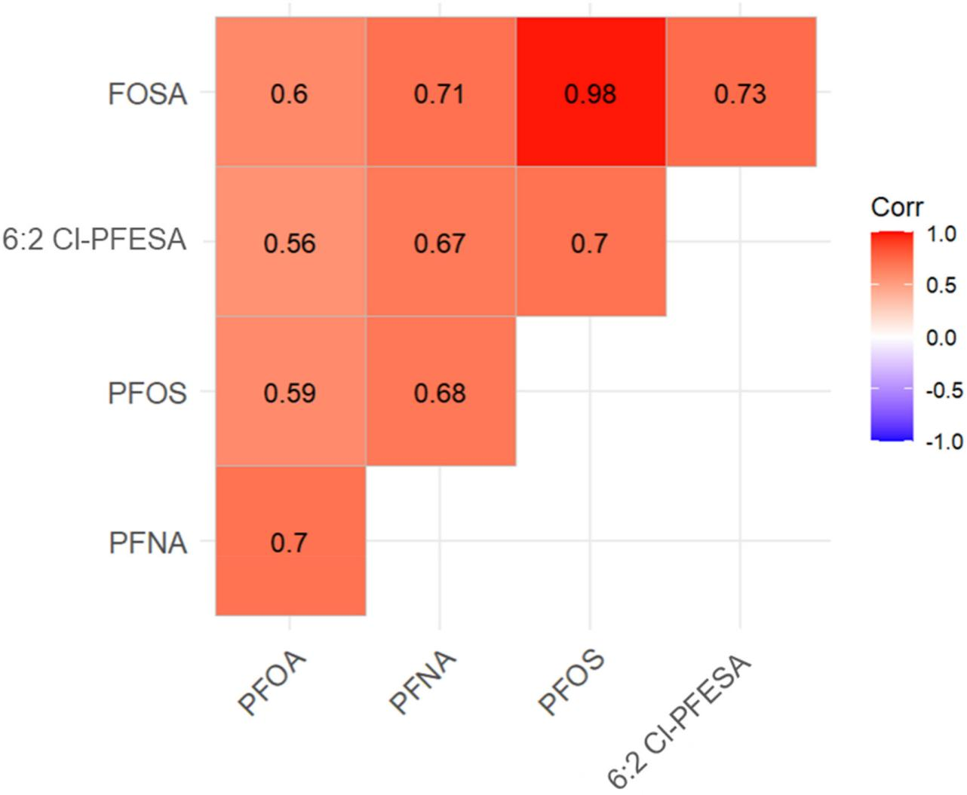
Figure S1. Spearman rank correlation coefficients between serum PFAS and alternatives analyzed in study participants.
Note: P-value for all correlation coefficients < 0.01.

