Supporting information for
A novel method for efficient electrochemical treatment of actual dyeing wastewater with energy saving
Jiachao Yao¹, Sini Lv², Zeyu Wang³, Liyong Hu², Jun Chen¹*
¹ College of Biology and Environmental Engineering, Zhejiang Shuren University, Hangzhou 310015, China
² College of Environment, Zhejiang University of Technology, 310014 Hangzhou, China
³ Interdisciplinary Research Academy, Zhejiang Shuren University, Hangzhou, 310015, China

*Corresponding author
E-mail address: bec@zjut.edu.cn
Table S1. Levels of factors selected for Box-Behnken design in this study.
Variable | Level
Variable | −1 | 0 | +1
A | 15 | 17.5 | 20
B | 12.5 | 15 | 17.5
C | 10 | 12.5 | 15

Table S2. The experimental data of target response for each combination of factor levels.
Run | A (mA/cm²) | B (mA/cm²) | C (mA/cm²) | COD removal (%) | Energy consumption (kWh/m³)
1 | 20.0 | 17.5 | 12.5 | 74.5 | 28.8
2 | 17.5 | 15.0 | 12.5 | 73.9 | 17.8
3 | 17.5 | 12.5 | 15.0 | 68.7 | 18.1
4 | 17.5 | 12.5 | 10.0 | 66.0 | 14.6
5 | 17.5 | 15.0 | 12.5 | 72.5 | 17.4
6 | 20.0 | 12.5 | 12.5 | 67.8 | 18.7
7 | 17.5 | 15.0 | 12.5 | 73.4 | 16.6
8 | 15.0 | 15.0 | 10.0 | 66.1 | 16.8
9 | 20.0 | 15.0 | 15.0 | 74.0 | 27.2
10 | 17.5 | 17.5 | 10.0 | 69.0 | 22.2
11 | 17.5 | 15.0 | 12.5 | 70.2 | 16.7
12 | 15.0 | 12.5 | 12.5 | 62.4 | 17.5
13 | 15.0 | 15.0 | 15.0 | 66.5 | 20.2
14 | 20.0 | 15.0 | 10.0 | 73.0 | 20.5
15 | 17.5 | 17.5 | 15.0 | 71.5 | 24.1
16 | 17.5 | 15.0 | 12.5 | 69.3 | 18.6
17 | 15.0 | 17.5 | 12.5 | 64.7 | 18.9

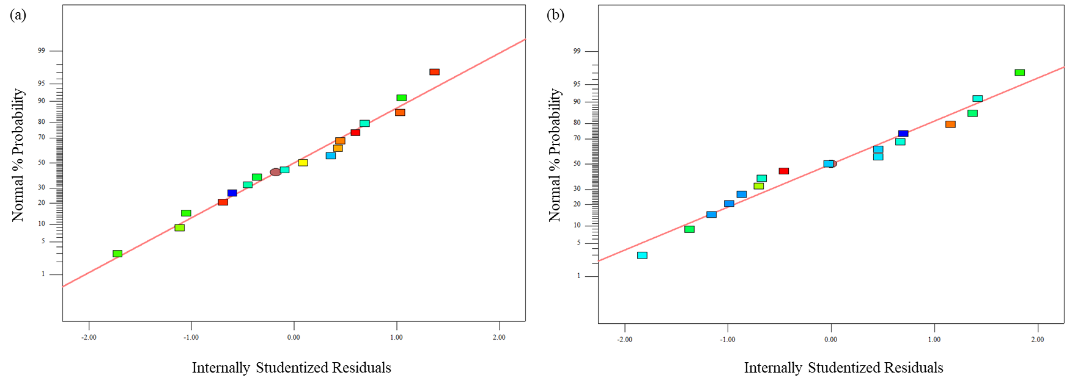
Fig. S1. Normal probability plots of residuals for (a) COD removal efficiency and (b) energy consumption.

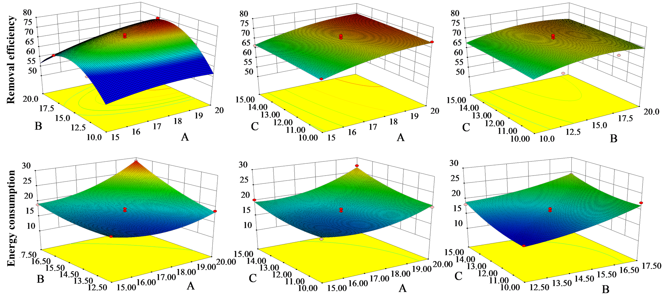
Fig. S2. Response 3D surface diagrams of Box-Behnken designs for the variation of current density (A, B, and C) on the COD removal and energy consumption. The first and second row in the figure refer to the removal efficiency and energy consumption, respectively. The change of color from blue to red means the increasing of removal efficiency/energy consumption.

