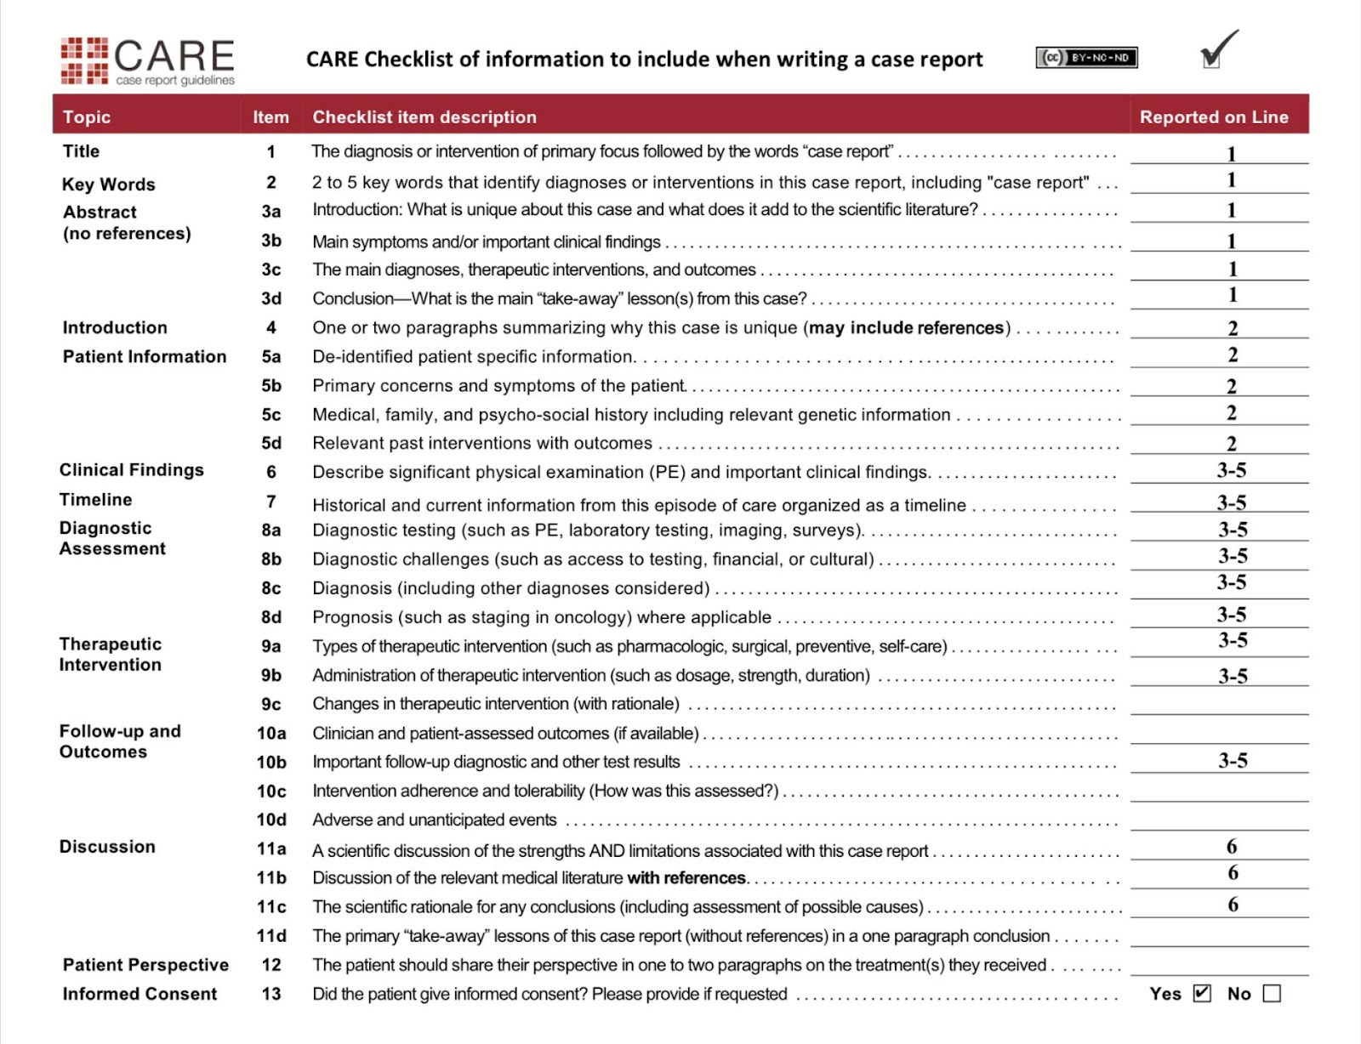

Authors
- Dr. Prabhat Kaphle, MBBS, National Health Action Force Nepal, kaphleprabhat77@gmail.com ORCID ID: 0009-0001-4834-9354
- Dr. Maya Upadhyaya, MBBS, National Health Action Force Nepal, mayaupadhyaya10@gmail.com ORCID ID: 0009-0009-7082-0235
- Dr. Sanjay Rana Magar, MBBS, Bhojpur District Hospital, sanjaymagar@pahs.edu.np
- Dr. Amrita Shrestha, MBBS, Bhojpur District Hospital,
shresthaamrita2@gmail.com
- Dr. Dhanlaxmi Giri, MBBS, National Health Action Force Nepal, dhanlaxmi.giri@gmail.com
ORCID: 0009-0008-9542-9964
- Dr. Liladhar Ojha, MBBS, National Health Action Force Nepal, ojhaliladhar94@gmail.com
ORCID: 0009-0006-2932-3008

The corresponding author for this manuscript is:
Dr. Prabhat Kaphle, MBBS
National Health Action Force Nepal
Benighat-Rorang 03, Dhading.
ORCID ID: 0009-0001-4834-9354
Contact: +977-9861049500
Email: kaphleprabhat77@gmail.com

