Supplementary Information for

Programmable electric hysteresis in MoS₂/graphene heterojunctions through twisting
Zhaokuan Yu^{1, 2}, Juntai Wu^{2, 3}, Yuqing He^{2, 3}, Wei Cao^{4, *}, Xin Lu¹, Ni Zhong⁵, and Ming Ma^{2, 3, 6, *}
¹Center for Correlated Matter, School of Physics, Zhejiang University, Hangzhou 310058, China
²Center for Nano and Micro Mechanics, Tsinghua University, Beijing 100084, China
³State Key Laboratory of Tribology in Advanced Equipment (SKLT) Department of Mechanical Engineering, Tsinghua University, Beijing 100084, China
⁴ State Key Laboratory of Materials-Oriented Chemical Engineering, College of Chemical Engineering, Nanjing Tech University, Nanjing 210009, China
⁵Key Laboratory of Polar Materials and Devices (Ministry of Education), Shanghai Center of Brain-Inspired Intelligent Materials and Devices, Department of Electronics, East China Normal University, Shanghai 200241, China
⁶Institute of Superlubricity Technology, Research Institute of Tsinghua University in Shenzhen, Shenzhen 518057, China
E-mail: M. Ma(mingma16@tsinghua.edu.cn), W. Cao(weicao@njtech.edu.cn)

Section 1. Current noise measurements in the AFM system
To detect the current noise of the AFM (NT-MDT) current measurements, we adopted the same structure as in Fig. 1, used the AFM tip static contact with the graphite flake, and the measured current noise I_{noise} is shown in Fig. S3a, where the x-axis is 256 data points collected in each cycle (the frequency is 1Hz), and the y-axis corresponds to the scanning line of each cycle. We further averaged the 256 data points of each cycle to obtain the relationship between the average current noise I_{noise} and time t (Fig. S3b). It can be seen that the noise in current was maintained at the order of 1 pA, which was much smaller than the measured current in Fig. 2 and illustrated the reliability of the measured current.

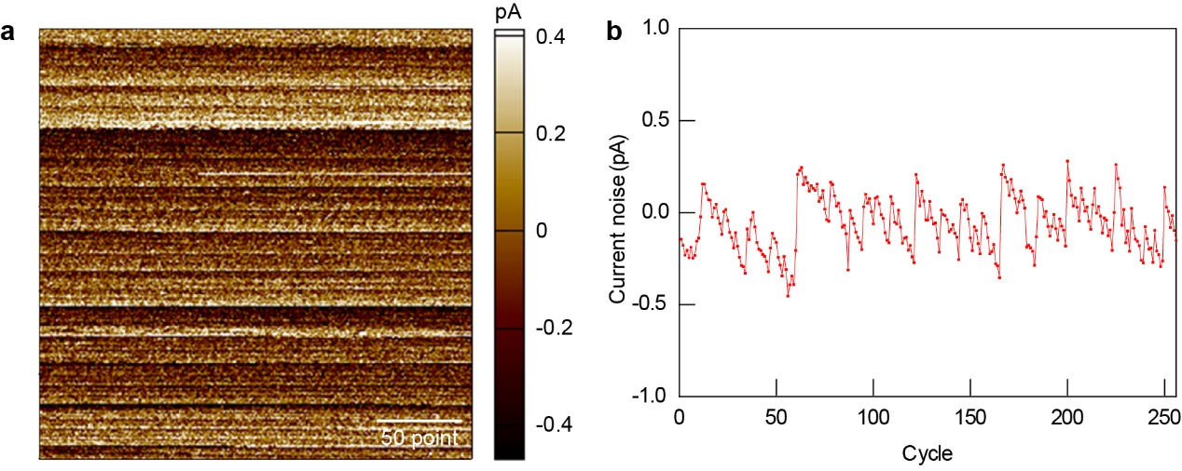
Fig. S1. Current noise measurements for AFM (NT-MDT) system. (a) Current noise I_{noise} map for 256 cycles (the frequency is 1Hz). Each cycle collects 256 data points. (b) Relationship between the average current noise I_{noise} and time t.

Section 2. Domination of interfacial resistance.
The current measured in Fig. 2 is predominantly influenced by the interface of structural superlubric microscale graphite/MoS₂ contacts. For the entire experimental system depicted in Fig. 1d, the total resistance ($R_{tot}$) can be expressed as the sum of the contact resistance between the AFM tip and the Au cap ($R_{tip-cap}$), the resistance of the upper flake ($R_{upper}$), the resistance of the graphite /MoS₂ contact’s interface ($R_{int}$), and the resistance of the MoS₂ substrate ($R_{bottom}$). Specifically, $R_{int}$ is the combination of the contact resistance between the upper graphite flake and the bottom MoS₂ flake.
The value of $R_{tip-cap}$ is measured at approximately 10⁴$Ω$. $R_{upper}$ originates from three parts: the first part is the resistance of the Au cap, the second part is the spreading resistance of the Au cap on the graphite regions in the upper flake, and the third part is the resistance of the graphite regions in the upper flake. The first part is calculated to be less than 1$Ω$. The second part is estimated at approximately 8$Ω$, based on the results in Ref. 7[16]. The third part is determined using the formula of $ρ_{gra}\frac{h}{S}$, where $ρ_{gra}$ is the c-axis conductivity of graphite (3.8$×$10⁻³ $Ω m$)[16], $h$ is the height of the graphite regions in the upper flake, and $S$ is the section area of the upper graphite flake. With $h$= 100 nm and $S$ = 16 ${μm}^{2}$, the third part is calculated at approximately 24 $Ω$. Similarly, $R_{bottom}$ is the sum of the resistance of the MoS₂ which is 4×10⁵ $Ω$.
Consequently，the sum of $R_{tip-cap}$, $R_{upper}$, and$R_{bottom}$ is less than 4.1×10⁵ $Ω$. Furthermore, combing that $R_{tot}$ approximately ranges from 10⁷$Ω$ to 10¹⁰$Ω$ in Fig. 1d, it is reasonable to consider that $R_{int}$ is approximately equal to $R_{tot}$.

Section 3. Effective Removal of Surface Contaminants on MoS₂ through UHV Annealing and Graphite Flake Sliding.
To eliminate interface and surface contaminants, several methods were employed. First, MoS₂ was annealed in an Ultra-High Vacuum (UHV) environment, and Scanning Kelvin Probe Microscopy (SKPM) scans before and after annealing indicated a reduction in surface potential by 0.13 V, suggesting that UHV annealing effectively removed adsorbed surface contaminants. Additionally, sliding a top-layer graphite flake across the surface helped to clean contaminants, as shown in Fig. S4a, where the potential in the sliding regions is lower than in the non-sliding areas. The yellow line in Fig. S4b illustrates a potential difference of 0.15 V between areas with and without contaminants. Furthermore, as seen in Fig. S4c, a FIB cross-section of the cleaned structure was imaged by TEM, confirming that no contaminants remain at the interface.
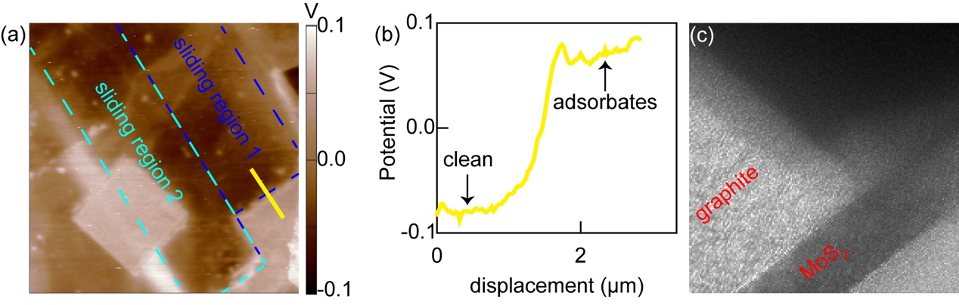
Fig. S2. (a) SKPM scan of MoS₂ surface before and after UHV annealing showing regions with sliding and without sliding. (b) Potential profile across the MoS₂ surface, with a 0.15 V difference between clean and contaminated areas. (c) TEM image of the cleaned interface after FIB slicing, confirming the absence of contaminants at the MoS₂/graphite interface.

