Supplementary Information

Synthesis and Characterization of a Nitrophenol Disubstituted BODIPY Halochromic Probe
Riccardo Ossanna¹,² Elise Michel², Rachel Meallet¹ Gilles Clavier²

¹ Université Paris-Saclay, CNRS, Institut des Sciences Moléculaires d’Orsay, 91405 Orsay, France;
² Université Paris-Saclay, ENS Paris-Saclay, CNRS, PPSM, 91190 Gif-sur-Yvette, France;

Content
Supplementary Information 1
1. NMR and HRMS spectra 2
2. DFT 9
3. UV–vis absorption and emission spectra of 4 16
4. Solvatochromism 26
5. References 30

NMR and HRMS spectra
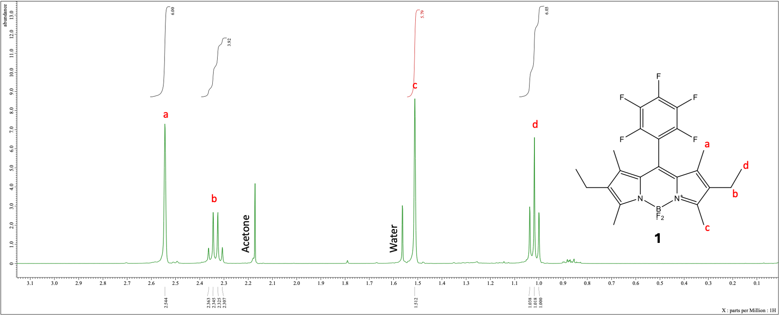
Fig. S1 Bodipy (1) ¹H-NMR (400 MHz, CHLOROFORM-D) δ 2.54 (s, 6H), 2.34 (q, J = 7.5 Hz, 4H), 1.51 (s, 6H), 1.02 (t, J = 7.6 Hz, 6H)
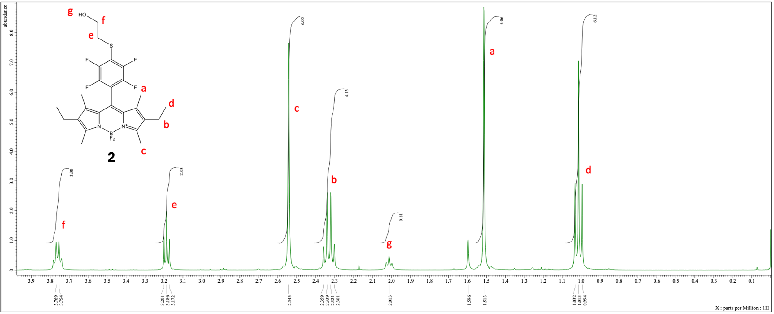
Fig. S2 Bodipy (2) ¹H-NMR (400 MHz, CHLOROFORM-D) δ 3.76 (d, J = 6.0 Hz, 2H), 3.19 (t, J = 5.7 Hz, 2H), 2.54 (s, 6H), 2.33 (q, J = 7.6 Hz, 4H), 2.01 (t, 1H), 1.51 (s, 6H), 1.01 (t, J = 7.6 Hz, 6H)
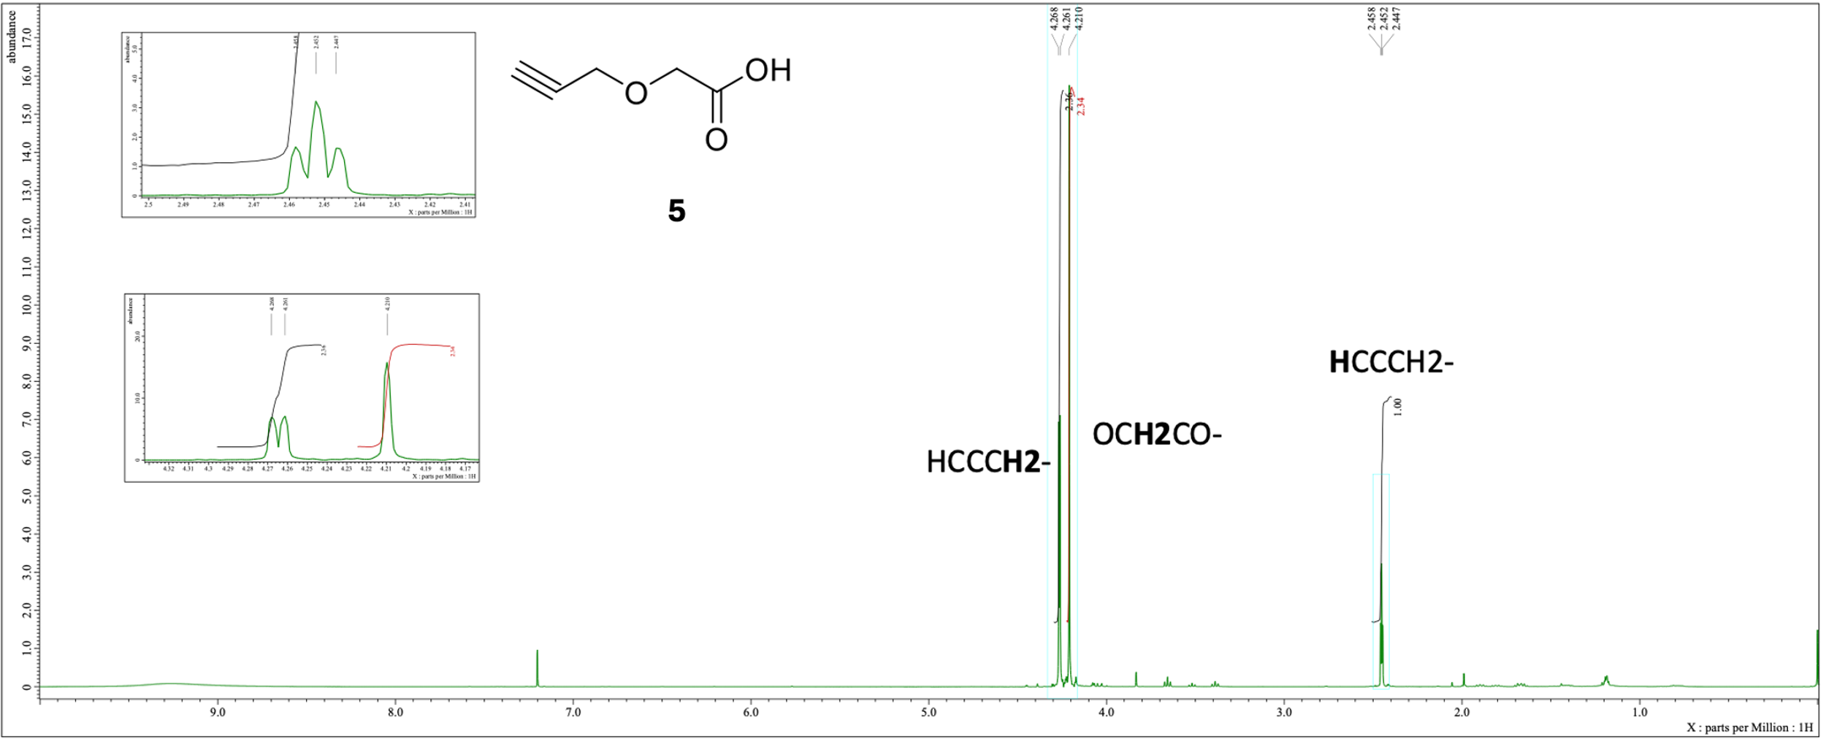
Fig. S3 (Propargyloxy)acetic acid (5) ¹H-NMR (400 MHz, CHLOROFORM-D) δ 4.26 (d, J = 2.7 Hz, 2H), 4.21 (s, 2H), 2.45 (t, J = 2.3 Hz, 1H)
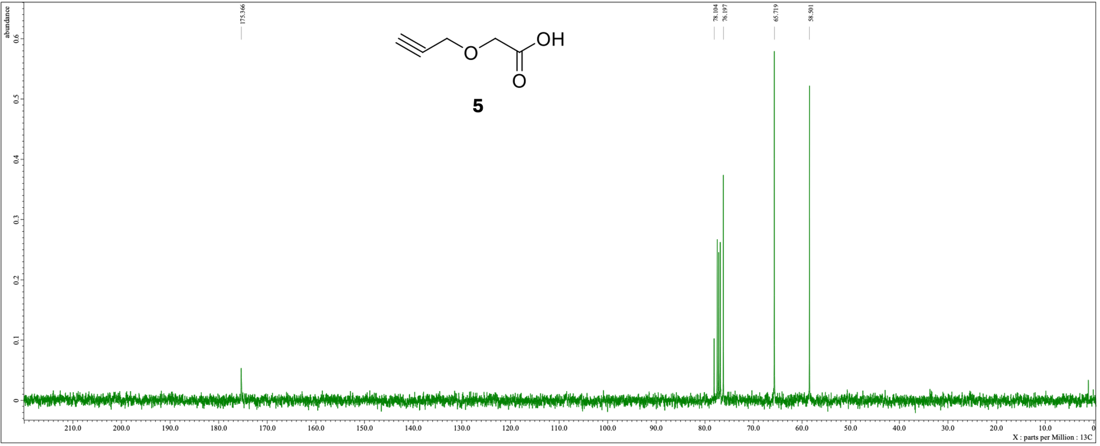
Fig. S4 (Propargyloxy)acetic acid (5) ¹³C-NMR (101 MHz, CHLOROFORM-D) δ 175.4, 78.1, 76.2, 65.7, 58.5
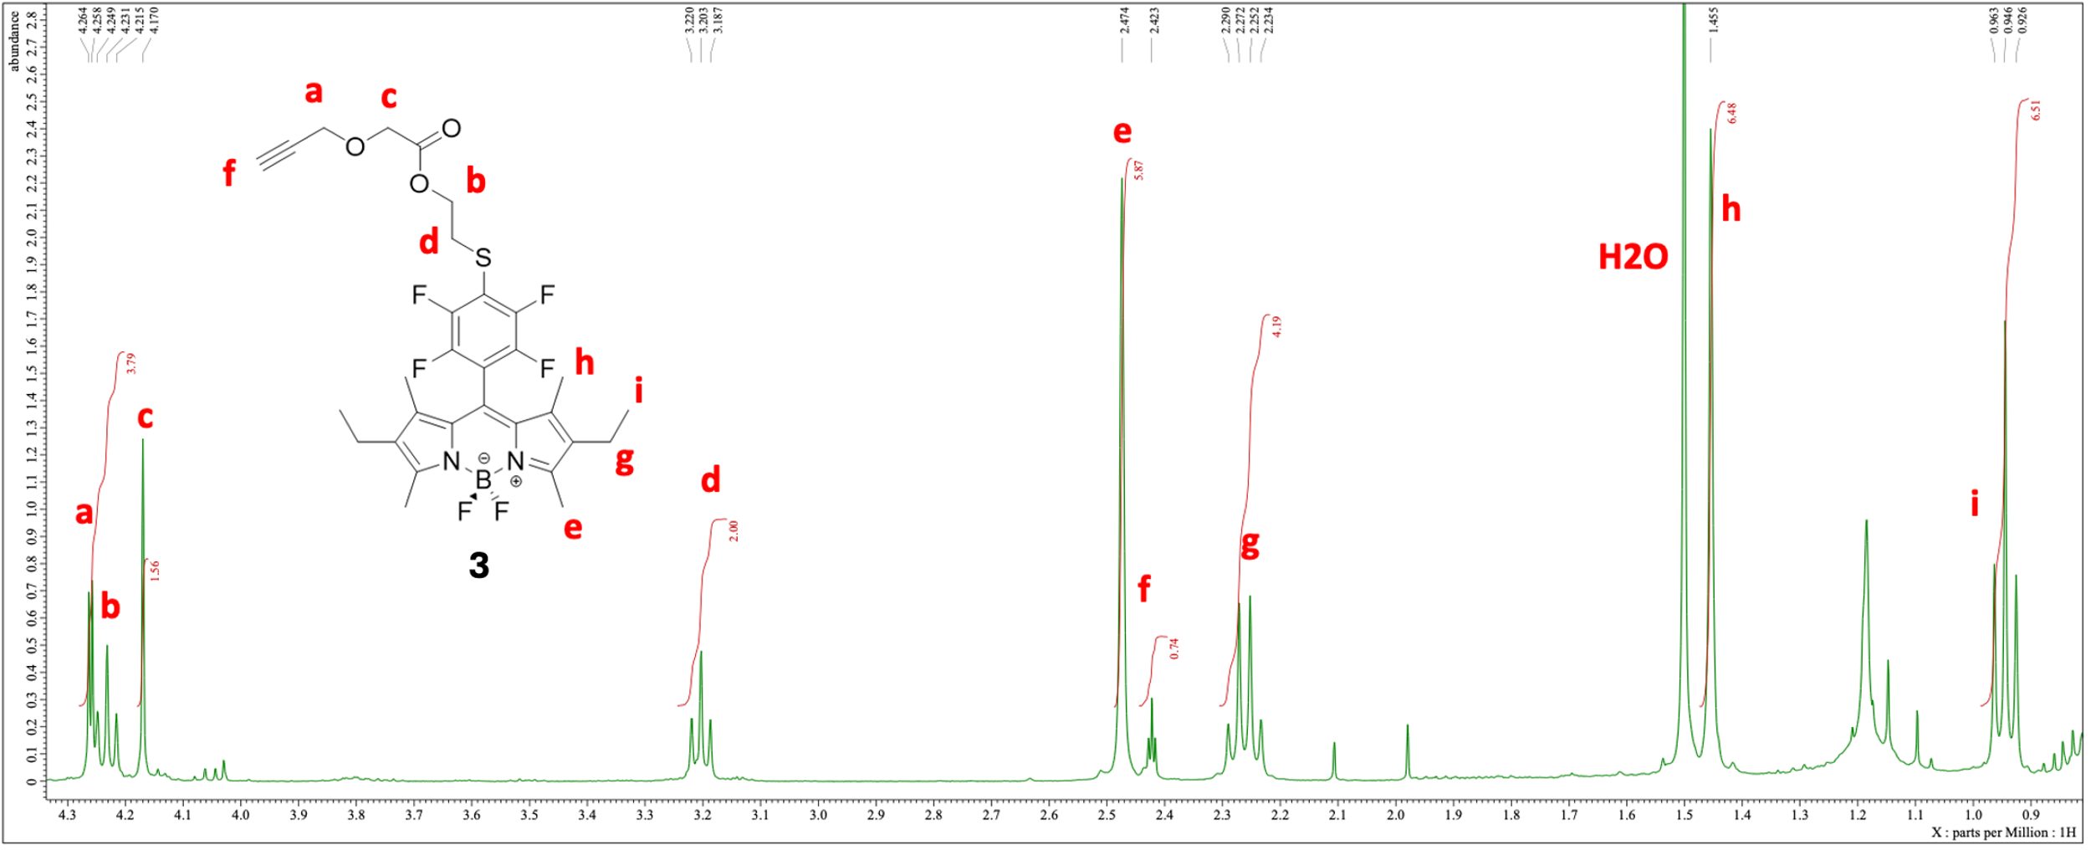
Fig. S5 Bodipy (3) ¹H-NMR (400 MHz, CHLOROFORM-D) δ 4.26-4.22 (d+t overlapping signals, 4H), 4.17 (s, 2H), 3.20 (t, J = 6.6 Hz, 2H), 2.47 (s, 6H), 2.42 (t, 1H), 2.26 (q, J = 7.5 Hz, 4H), 1.45 (s, 6H), 0.94 (t, J = 7.6 Hz, 7H)
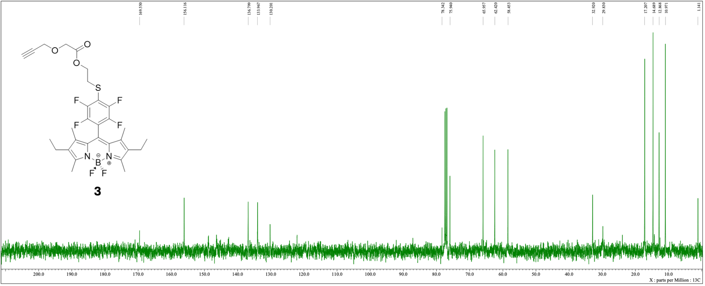
Fig. S6 Bodipy (3) ¹³C-NMR (101 MHz, CHLOROFORM-D) δ 169.6, 156.1, 136.8, 134.0, 130.2, 78.3, 75.9, 66.0, 62.4, 58.5, 32.9, 29.8, 17.2, 14.7, 12.9, 11.0, 1.1
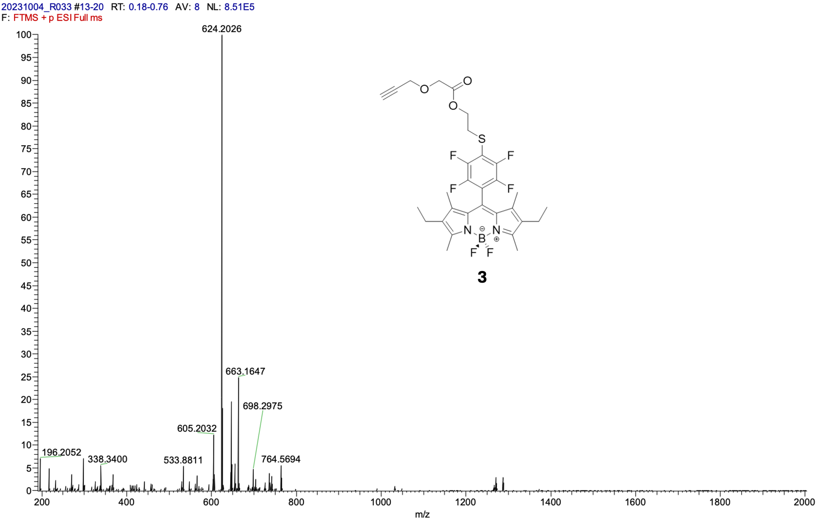
Fig. S7 Bodipy (3) Mass spectrum acquired by direct infusion using an LTQ-Orbitrap Velos Pro (ThermoFisher). Sample analyzed in acetonitrile (ACN) under positive ESI mode (ESI⁺), using FTMS;
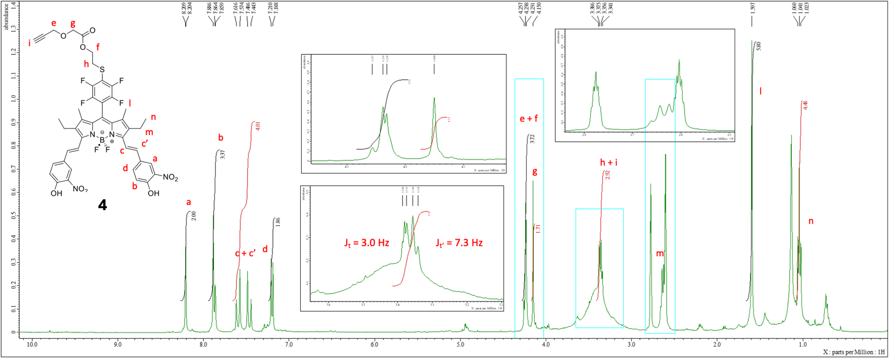
Fig. S8 Bodipy (4) ¹H-NMR (400 MHz, DMF-D7) δ 8.21 (d, J = 1.8 Hz, 2H), 7.87 (t, J = 5.3 Hz, 3H), 7.53 (dd, 4H), 7.20 (d, J = 8.7 Hz, 2H), 4.24 (d+t overlapping, J_{d} = 3.0 Hz, 4H), 4.15 (s, 2H), 3.36 (t + t overlapping, J_{t} = 3.0 Hz, J_{t’} = 7.3 Hz, 3H), 1.60 (s, 6H), 1.04 (t, J = 7.3 Hz, 4H) (-CH₂CH₃ covered by DMF-D7 quintet)
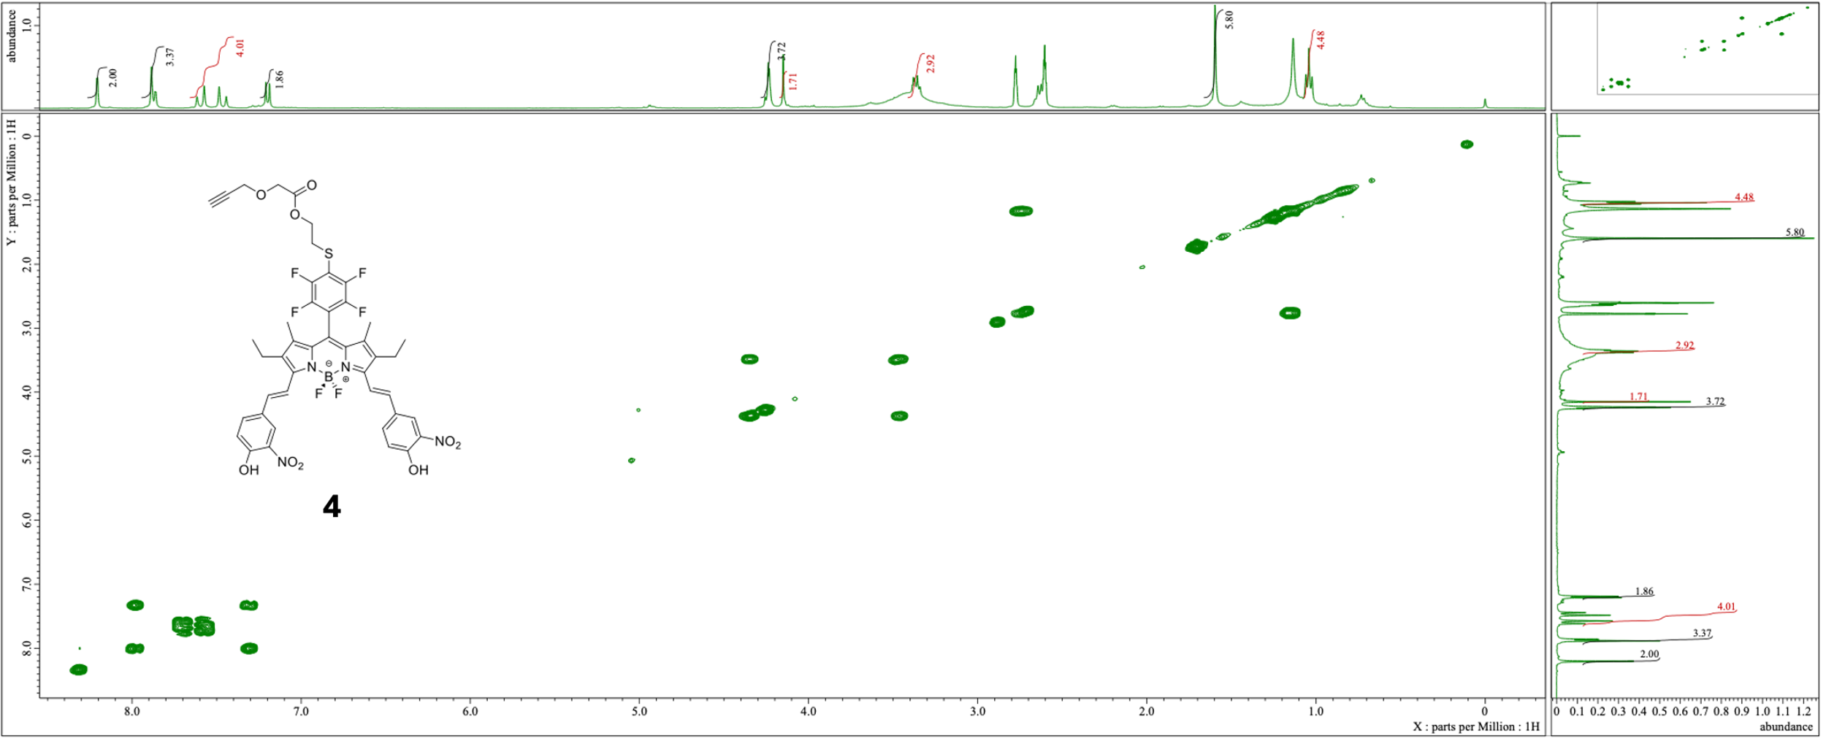
Fig. S9 Bodipy (4) COSY-NMR
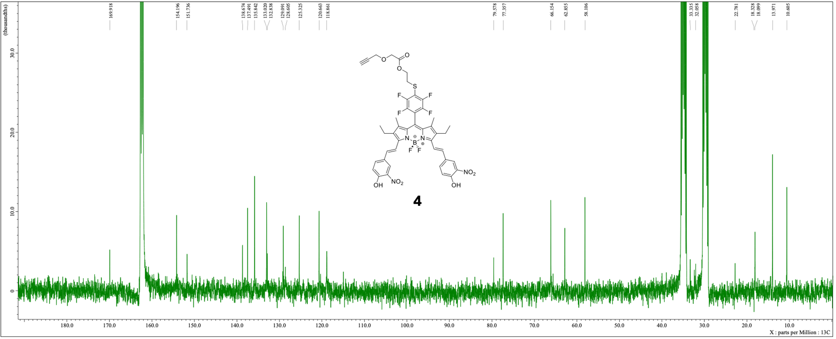
Fig. S10 Bodipy (4) ¹³C-NMR (101 MHz, DMF-D7) δ 169.9, 154.2, 151.7, 138.7, 137.5, 135.8, 133.0, 132.8, 129.1, 128.6, 125.3, 120.7, 118.9, 79.6, 77.4, 66.2, 62.9, 58.1, 33.3, 32.1, 22.8, 18.3, 18.1, 14.0, 10.6
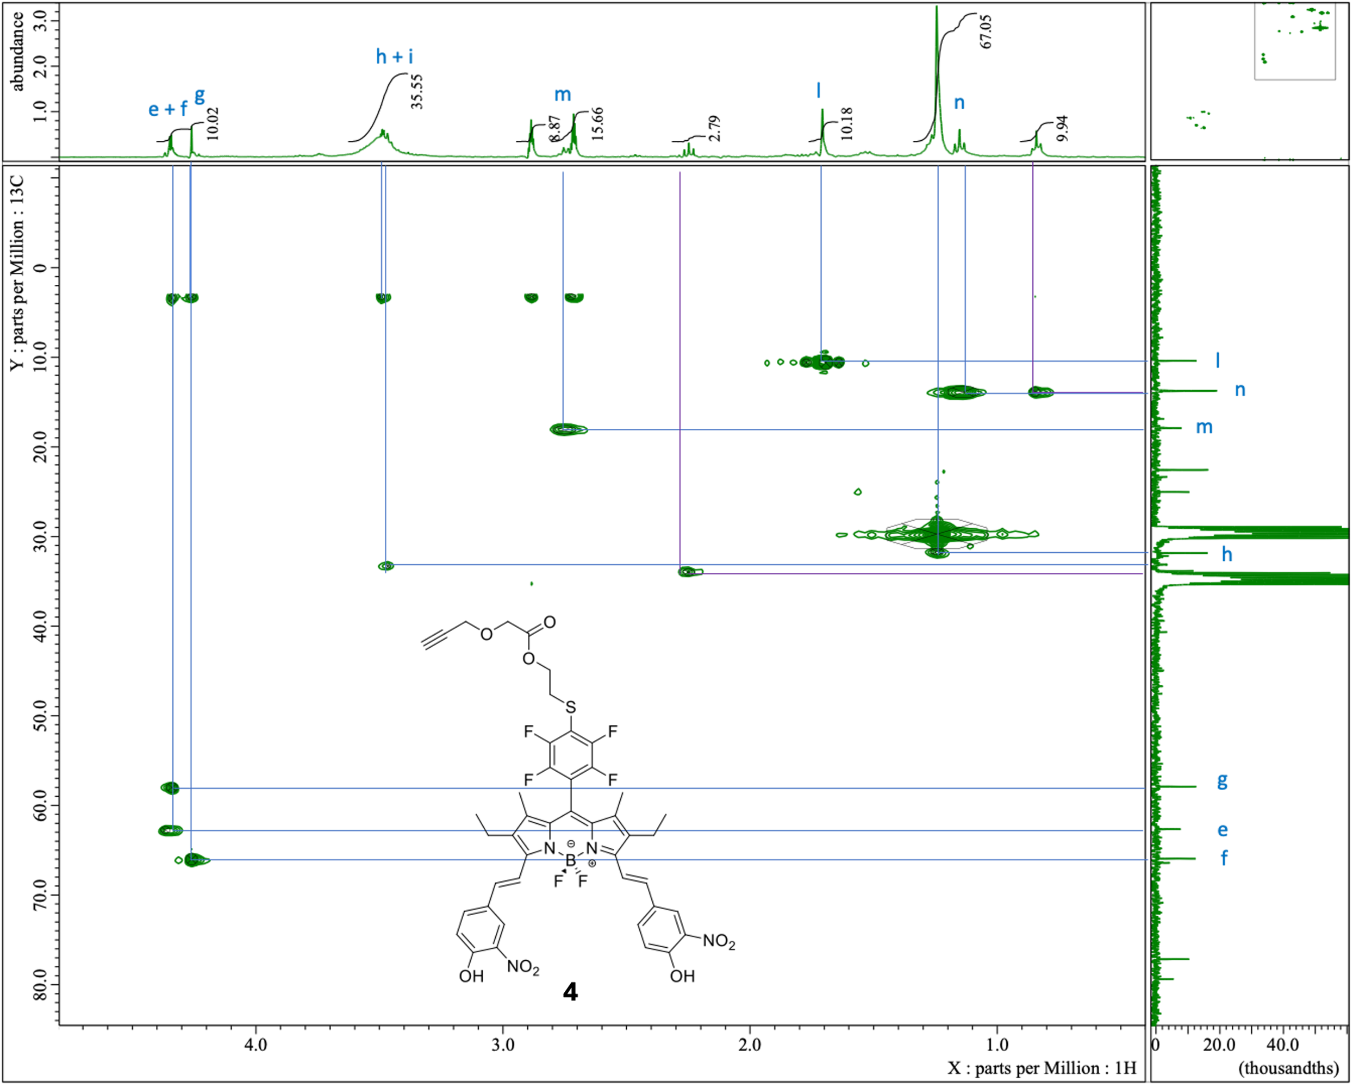
Fig. S11 Bodipy (4) HMQC DMF-d7 range 0.0 - 5-0 ppm
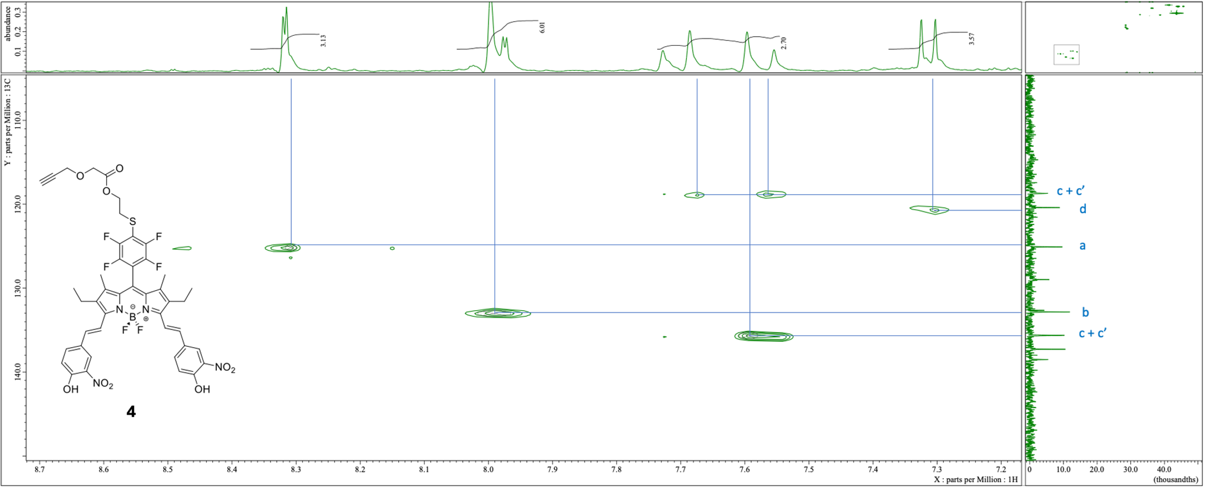
Fig. S12 Bodipy (4) HMQC DMF-d7 range 7.1 - 8.7

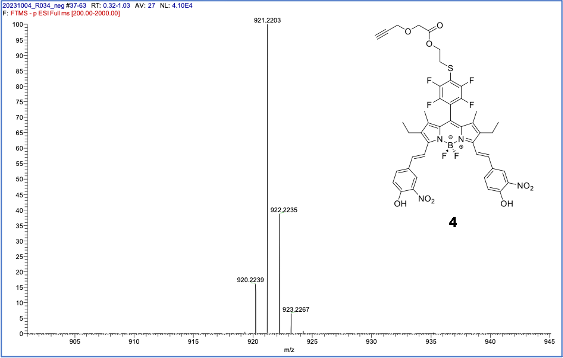
Fig. S13 Bodipy (4) Mass spectrum acquired by direct infusion using an LTQ-Orbitrap Velos Pro (ThermoFisher). Sample analyzed in an acetonitrile and tetrahydrofuran solution (ACN/THF) under ESI mode (ESI+/-);

DFT

Molecular orbitals
Fig. S14 Frontiers molecular orbitals of BODIPY 4 (isovalue 0.02)

Cartesian coordinates of the calculated structures
4-H₂
Total energy E=-2820.9653 Hartree
Imaginary Frequency: 0
Tag | Symbol | X | Y | Z
1 | C | -2.775081 | 2.570953 | -0.294079
2 | C | -1.64926 | 3.38662 | -0.380311
3 | C | -0.500507 | 2.534751 | -0.282496
4 | N | -0.918897 | 1.243401 | -0.152072
5 | C | -2.306436 | 1.219548 | -0.142508
6 | C | -2.30639 | -1.219591 | 0.142472
7 | C | -2.774983 | -2.571013 | 0.294055
8 | N | -0.918849 | -1.243396 | 0.151988
9 | C | -1.64913 | -3.386641 | 0.380245
10 | C | -0.50041 | -2.534731 | 0.282395
11 | C | -2.99208 | -0.000033 | -0.000006
12 | B | 0.001073 | 0.000019 | -0.000054
13 | F | 0.816495 | -0.142125 | -1.136677
14 | F | 0.81652 | 0.142191 | 1.136545
15 | C | -4.195376 | -3.05623 | 0.360487
16 | H | -4.773593 | -2.548903 | 1.139881
17 | H | -4.723501 | -2.910796 | -0.58937
18 | H | -4.224774 | -4.126403 | 0.580182
19 | C | -4.195493 | 3.056122 | -0.360462
20 | H | -4.773719 | 2.548778 | -1.139839
21 | H | -4.723581 | 2.910667 | 0.589411
22 | H | -4.224934 | 4.126295 | -0.580154
23 | C | -1.652155 | -4.878671 | 0.587584
24 | H | -2.506863 | -5.152503 | 1.217976
25 | H | -0.766059 | -5.171487 | 1.16144
26 | C | -1.724834 | -5.695053 | -0.7186
27 | H | -1.702667 | -6.770458 | -0.505364
28 | H | -2.649472 | -5.476737 | -1.264963
29 | H | -0.890243 | -5.462967 | -1.3902
30 | C | -1.652343 | 4.87865 | -0.587652
31 | H | -2.507079 | 5.15245 | -1.218018
32 | H | -0.766274 | 5.171495 | -1.161536
33 | C | -1.725008 | 5.695031 | 0.718533
34 | H | -1.702882 | 6.770437 | 0.505294
35 | H | -2.649622 | 5.476686 | 1.264925
36 | H | -0.890389 | 5.462972 | 1.390107
37 | C | 0.911917 | 2.831675 | -0.348869
38 | C | 1.505234 | 4.037476 | -0.163456
39 | H | 1.537566 | 1.969449 | -0.548621
40 | H | 0.905392 | 4.901283 | 0.103745
41 | C | 0.912027 | -2.831601 | 0.348721
42 | C | 1.505386 | -4.037376 | 0.163268
43 | H | 1.537645 | -1.969356 | 0.548484
44 | H | 0.90556 | -4.90121 | -0.103881
45 | C | 2.93973 | 4.30403 | -0.248326
46 | C | 3.4094 | 5.584011 | 0.048812
47 | C | 3.902713 | 3.32735 | -0.622219
48 | C | 4.775889 | 5.892283 | -0.013916
49 | H | 2.723718 | 6.372535 | 0.338294
50 | C | 5.249536 | 3.621672 | -0.686238
51 | H | 3.581582 | 2.320526 | -0.869933
52 | C | 5.729759 | 4.911972 | -0.383318
53 | C | 2.93989 | -4.303891 | 0.248114
54 | C | 3.902877 | -3.327139 | 0.621807
55 | C | 3.40956 | -5.583927 | -0.048787
56 | C | 5.249698 | -3.621457 | 0.685896
57 | H | 3.581764 | -2.320232 | 0.86921
58 | C | 4.776041 | -5.892206 | 0.01405
59 | H | 2.72388 | -6.372492 | -0.338168
60 | C | 5.729918 | -4.911817 | 0.383225
61 | C | -4.486836 | -0.000058 | 0.00002
62 | C | -5.218453 | 0.216571 | 1.170589
63 | C | -5.218487 | -0.216712 | -1.170523
64 | C | -6.611322 | 0.218692 | 1.185535
65 | F | -4.575745 | 0.4331 | 2.330839
66 | C | -6.611356 | -0.21888 | -1.18542
67 | F | -4.575813 | -0.433219 | -2.330795
68 | C | -7.310597 | -0.000105 | 0.00007
69 | F | -7.280681 | 0.430669 | 2.326724
70 | F | -7.280748 | -0.430877 | -2.326586
71 | F | -8.647416 | -0.000127 | 0.000093
72 | H | 5.977499 | 2.869912 | -0.974447
73 | O | 7.047971 | 5.121399 | -0.468136
74 | H | 7.214414 | 6.06521 | -0.227447
75 | N | 5.185165 | 7.242993 | 0.308443
76 | O | 6.407782 | 7.517844 | 0.255405
77 | O | 4.334552 | 8.070907 | 0.620506
78 | H | 5.977654 | -2.86967 | 0.974051
79 | N | 5.185303 | -7.242978 | -0.308093
80 | O | 6.40788 | -7.517941 | -0.25468
81 | O | 4.334704 | -8.070861 | -0.620288
82 | O | 7.048143 | -5.121195 | 0.467976
83 | H | 7.214567 | -6.065101 | 0.227652

4-H⁻
Total energy E=-2820.4557 Hartree
Imaginary Frequency: 0
Tag | Symbol | X | Y | Z
1 | C | -2.840263 | 2.440189 | -0.20402
2 | C | -1.763451 | 3.299737 | -0.255724
3 | C | -0.552536 | 2.495608 | -0.166665
4 | N | -0.931155 | 1.176982 | -0.074995
5 | C | -2.316931 | 1.090689 | -0.083831
6 | C | -2.214214 | -1.356483 | 0.1108
7 | C | -2.628042 | -2.717081 | 0.214913
8 | N | -0.835966 | -1.319542 | 0.118949
9 | C | -1.460831 | -3.495559 | 0.27454
10 | C | -0.354696 | -2.606982 | 0.206433
11 | C | -2.957864 | -0.140268 | 0.00817
12 | B | 0.030167 | -0.034766 | 0.033885
13 | F | 0.873301 | -0.095708 | -1.093937
14 | F | 0.832353 | 0.081335 | 1.190198
15 | C | -4.027991 | -3.267402 | 0.259671
16 | H | -4.640762 | -2.803176 | 1.040676
17 | H | -4.558763 | -3.139328 | -0.692612
18 | H | -4.009428 | -4.341559 | 0.466347
19 | C | -4.284874 | 2.849162 | -0.267467
20 | H | -4.826573 | 2.338108 | -1.07111
21 | H | -4.812558 | 2.636602 | 0.670152
22 | H | -4.375446 | 3.923613 | -0.446835
23 | C | -1.408153 | -4.992893 | 0.426527
24 | H | -2.264019 | -5.32826 | 1.026567
25 | H | -0.521173 | -5.272865 | 1.006501
26 | C | -1.418167 | -5.762405 | -0.909746
27 | H | -1.357764 | -6.845268 | -0.739577
28 | H | -2.337709 | -5.5568 | -1.470428
29 | H | -0.57691 | -5.469215 | -1.548221
30 | C | -1.844886 | 4.796949 | -0.403581
31 | H | -2.765467 | 5.055046 | -0.940384
32 | H | -1.032058 | 5.153183 | -1.044735
33 | C | -1.832754 | 5.560037 | 0.936733
34 | H | -1.865921 | 6.643316 | 0.766825
35 | H | -2.700459 | 5.283011 | 1.547054
36 | H | -0.935507 | 5.335252 | 1.5234
37 | C | 0.813503 | 2.858054 | -0.186482
38 | C | 1.350399 | 4.135764 | -0.142779
39 | H | 1.504645 | 2.025153 | -0.218997
40 | H | 0.68137 | 4.984371 | -0.051925
41 | C | 1.068491 | -2.840869 | 0.25427
42 | C | 1.733655 | -4.014059 | 0.090629
43 | H | 1.651829 | -1.945051 | 0.433955
44 | H | 1.189634 | -4.923224 | -0.14415
45 | C | 2.726004 | 4.484407 | -0.181639
46 | C | 3.081393 | 5.852558 | -0.094882
47 | C | 3.805361 | 3.53884 | -0.302881
48 | C | 4.392511 | 6.283498 | -0.100393
49 | H | 2.300232 | 6.601828 | -0.005886
50 | C | 5.104394 | 3.944811 | -0.339167
51 | H | 3.576601 | 2.478567 | -0.373414
52 | C | 5.524308 | 5.350277 | -0.258818
53 | C | 3.183347 | -4.18579 | 0.170238
54 | C | 4.090826 | -3.123031 | 0.442377
55 | C | 3.736806 | -5.451069 | -0.030148
56 | C | 5.455917 | -3.322847 | 0.506502
57 | H | 3.709712 | -2.119688 | 0.604243
58 | C | 5.124837 | -5.665483 | 0.035117
59 | H | 3.101334 | -6.30342 | -0.241919
60 | C | 6.017029 | -4.598341 | 0.306089
61 | C | -4.449016 | -0.209695 | 0.001518
62 | C | -5.200396 | -0.054758 | 1.170809
63 | C | -5.169498 | -0.453576 | -1.172033
64 | C | -6.591289 | -0.13131 | 1.180929
65 | F | -4.582766 | 0.180519 | 2.34138
66 | C | -6.559947 | -0.534914 | -1.192117
67 | F | -4.520431 | -0.617091 | -2.337543
68 | C | -7.274298 | -0.373413 | -0.00796
69 | F | -7.278943 | 0.026415 | 2.324884
70 | F | -7.217224 | -0.768647 | -2.340881
71 | F | -8.613741 | -0.449161 | -0.012781
72 | H | 5.914923 | 3.228215 | -0.443273
73 | O | 6.717577 | 5.67218 | -0.361195
74 | N | 4.613507 | 7.711044 | 0.037479
75 | O | 5.685323 | 8.10478 | 0.501952
76 | O | 3.692892 | 8.482001 | -0.303649
77 | H | 6.133852 | -2.500391 | 0.712656
78 | N | 5.618464 | -7.002442 | -0.17978
79 | O | 6.860504 | -7.198647 | -0.123245
80 | O | 4.82455 | -7.913727 | -0.410374
81 | O | 7.351588 | -4.718085 | 0.386118
82 | H | 7.567076 | -5.667549 | 0.219772

4²⁻
Total energy E=-2819.8776 Hartree
Imaginary Frequency: 0
Tag | Symbol | X | Y | Z
1 | C | -2.569169 | -2.621446 | -0.275324
2 | C | -3.394976 | -1.503263 | -0.339196
3 | C | -2.557939 | -0.336269 | -0.223625
4 | N | -1.254516 | -0.761091 | -0.111657
5 | C | -1.222411 | -2.148271 | -0.123939
6 | C | 1.222958 | -2.147921 | 0.123935
7 | C | 2.569849 | -2.620719 | 0.27531
8 | N | 1.254671 | -0.760732 | 0.111651
9 | C | 3.395341 | -1.502304 | 0.339186
10 | C | 2.557976 | -0.335546 | 0.223619
11 | C | 0.000373 | -2.834635 | -0.000001
12 | B | -0.000053 | 0.156083 | -0.000004
13 | F | 0.09977 | 0.971325 | -1.1435
14 | F | -0.100111 | 0.971299 | 1.14349
15 | C | 3.044704 | -4.04559 | 0.366939
16 | H | 2.510459 | -4.620058 | 1.13245
17 | H | 2.933384 | -4.584551 | -0.583166
18 | H | 4.107504 | -4.079162 | 0.624255
19 | C | -3.043636 | -4.046446 | -0.366969
20 | H | -2.50923 | -4.620764 | -1.132479
21 | H | -2.932182 | -4.585383 | 0.583134
22 | H | -4.106424 | -4.080301 | -0.624296
23 | C | 4.886094 | -1.536901 | 0.55644
24 | H | 5.137747 | -2.397331 | 1.191046
25 | H | 5.198126 | -0.656886 | 1.12804
26 | C | 5.714446 | -1.635556 | -0.740798
27 | H | 6.789981 | -1.633795 | -0.520073
28 | H | 5.477325 | -2.559031 | -1.28342
29 | H | 5.505555 | -0.798331 | -1.415809
30 | C | -4.885717 | -1.53829 | -0.556463
31 | H | -5.137112 | -2.39879 | -1.191077
32 | H | -5.198001 | -0.658364 | -1.128061
33 | C | -5.714053 | -1.637203 | 0.740766
34 | H | -6.789586 | -1.635747 | 0.520032
35 | H | -5.476672 | -2.560619 | 1.283376
36 | H | -5.505408 | -0.79993 | 1.415794
37 | C | -2.889151 | 1.056678 | -0.250209
38 | C | -4.144394 | 1.597892 | -0.106785
39 | H | -2.046599 | 1.727761 | -0.374134
40 | H | -4.976404 | 0.931702 | 0.097094
41 | C | 2.888811 | 1.057489 | 0.2502
42 | C | 4.143914 | 1.599029 | 0.10678
43 | H | 2.046081 | 1.728349 | 0.37412
44 | H | 4.976098 | 0.933052 | -0.097088
45 | C | -4.526935 | 2.981351 | -0.167723
46 | C | -5.878251 | 3.313657 | 0.015041
47 | C | -3.619269 | 4.068347 | -0.414036
48 | C | -6.354078 | 4.624875 | -0.023629
49 | H | -6.601035 | 2.526 | 0.202749
50 | C | -4.057827 | 5.358399 | -0.471718
51 | H | -2.562047 | 3.857112 | -0.558016
52 | C | -5.458606 | 5.762567 | -0.295219
53 | C | 4.526096 | 2.982588 | 0.167716
54 | C | 3.618147 | 4.06935 | 0.414018
55 | C | 5.877328 | 3.315241 | -0.015035
56 | C | 4.056371 | 5.359515 | 0.4717
57 | H | 2.560979 | 3.857842 | 0.557992
58 | C | 6.352816 | 4.626582 | 0.023635
59 | H | 6.600317 | 2.527771 | -0.202731
60 | C | 5.457046 | 5.764045 | 0.295203
61 | C | 0.000599 | -4.32734 | 0.000002
62 | C | -0.262275 | -5.066781 | 1.158152
63 | C | 0.263713 | -5.066706 | -1.158141
64 | C | -0.265126 | -6.459798 | 1.172756
65 | F | -0.523559 | -4.43754 | 2.316548
66 | C | 0.267 | -6.459722 | -1.172736
67 | F | 0.52481 | -4.43739 | -2.316539
68 | C | 0.001044 | -7.159919 | 0.000012
69 | F | -0.522254 | -7.136338 | 2.308526
70 | F | 0.524345 | -7.136189 | -2.308501
71 | F | 0.001256 | -8.504976 | 0.000016
72 | H | -3.366715 | 6.175687 | -0.66291
73 | O | -5.79287 | 6.957567 | -0.404087
74 | N | -7.765467 | 4.806424 | 0.191432
75 | O | -8.210799 | 5.940715 | 0.412495
76 | O | -8.510606 | 3.795062 | 0.158323
77 | H | 3.365047 | 6.176625 | 0.662885
78 | N | 7.764162 | 4.808491 | -0.191403
79 | O | 8.209215 | 5.942899 | -0.412431
80 | O | 8.509554 | 3.797314 | -0.158302
81 | O | 5.791 | 6.959131 | 0.40408

TDDFT results
4-H₂
No. | Energy  (cm⁻¹) | Wavelength  (nm) | f | Major contributionss
1 | 15847 | 631 | 1.1231 | HOMO->LUMO (100%)
2 | 17201 | 581 | 0.0009 | HOMO->L+1 (99%)
3 | 17247 | 580 | 0.004 | HOMO->L+2 (98%)
4 | 23869 | 419 | 0.368 | H-1->LUMO (89%), HOMO->L+3 (10%)
5 | 23956 | 417 | 0.0371 | H-2->LUMO (98%)
6 | 25519 | 392 | 0.06 | H-1->L+1 (90%)
7 | 25572 | 391 | 0.0035 | H-1->L+2 (88%)
8 | 26046 | 384 | 0.0235 | H-3->LUMO (98%)
9 | 28166 | 355 | 1.6052 | H-1->LUMO (10%), HOMO->L+3 (86%)
10 | 28189 | 355 | 0.0047 | H-4->LUMO (85%)
11 | 29324 | 341 | 0.0058 | H-2->L+1 (90%)
12 | 29337 | 341 | 0.0034 | H-2->L+2 (88%)

4-H⁻
No. | Energy  (cm-1) | Wavelength  (nm) | f | Major contributions
1 | 12732 | 785 | 0.0803 | HOMO->LUMO (89%), HOMO->L+1 (10%)
2 | 13891 | 720 | 1.2248 | HOMO->LUMO (10%), HOMO->L+1 (90%)
3 | 20218 | 495 | 0.0729 | H-1->LUMO (94%)
4 | 20680 | 484 | 0.1086 | H-1->L+1 (41%), HOMO->L+2 (54%)
5 | 20882 | 479 | 0.2304 | H-1->L+1 (48%), HOMO->L+2 (42%)
6 | 24922 | 401 | 0.0341 | H-3->LUMO (26%), H-3->L+1 (67%)
7 | 25134 | 398 | 0.0059 | H-2->LUMO (26%), H-2->L+1 (66%)
8 | 25429 | 393 | 0.9251 | HOMO->L+3 (81%)
9 | 25869 | 387 | 0.0696 | HOMO->L+4 (93%)
10 | 26665 | 375 | 0.0223 | H-4->LUMO (73%)
11 | 27166 | 368 | 0.0775 | H-5->LUMO (16%), H-5->L+1 (37%), H-2->L+2 (14%), H-1->L+2 (13%)
12 | 27209 | 368 | 0.1391 | H-5->L+1 (10%), H-2->L+2 (52%), H-1->L+2 (12%)

4²⁻
No. | Energy  (cm-1) | Wavelength  (nm) | f | Major contributions
1 | 12767 | 783 | 1.3499 | HOMO->LUMO (101%)
2 | 18334 | 545 | 0.5059 | H-1->LUMO (91%)
3 | 19619 | 510 | 0.1503 | HOMO->L+1 (91%)
4 | 19853 | 504 | 0.0558 | HOMO->L+2 (98%)
5 | 23559 | 424 | 0.0261 | H-2->LUMO (88%)
6 | 23827 | 420 | 0.0049 | HOMO->L+3 (98%)
7 | 24960 | 401 | 0.0608 | H-1->L+1 (78%)
8 | 25265 | 396 | 0 | H-4->L+1 (10%), H-3->LUMO (17%), H-1->L+2 (52%)
9 | 25575 | 391 | 0.0286 | H-4->LUMO (75%), H-1->L+1 (10%)
10 | 25599 | 391 | 0.0912 | H-3->LUMO (57%), H-1->L+2 (18%), HOMO->L+4 (16%)
11 | 25790 | 388 | 0.0285 | H-5->LUMO (85%)
12 | 25923 | 386 | 0.6509 | H-3->LUMO (16%), HOMO->L+4 (58%)

Total electronic density differences
Fig. S15 Total electronic density difference Sn-S0 of BODIPY 4 (isovalue 0.0004); Blue = decrease of electronic density, Orange = increase of electronic density

Calculated spectra
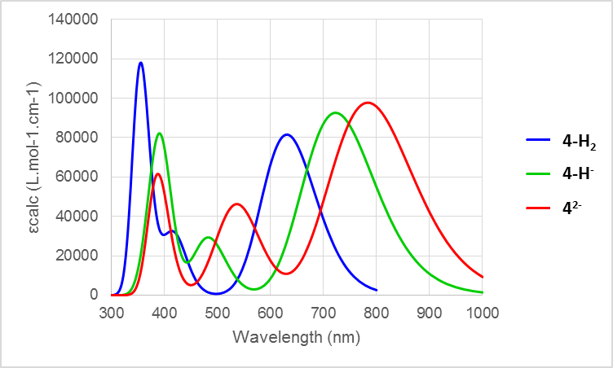
Fig. S16 Calculated electronic spectra at the PBE0/6-311+g(d,p) with dichoromethane solvent effect (IEFPCM)

UV–vis absorption and emission spectra of 4
Fig. S17 Normalized absorption and fluorescence emission spectra of BODIPY 4 in 1,1,2,2-tetrachloroethane.
Fig. S18 Normalized absorption, fluorescence emission and excitation spectra of BODIPY 4 in n-hexane.
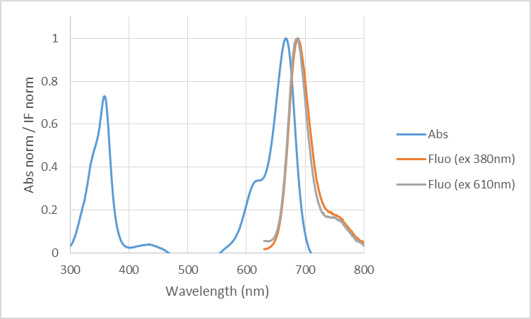
Fig. S19 Normalized absorption and fluorescence emission spectra of BODIPY 4 in chloroform.
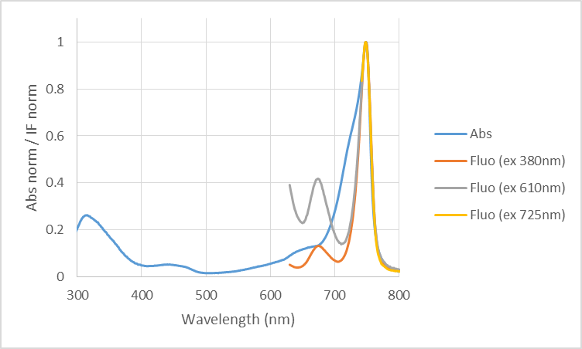
Fig. S20 Normalized absorption, fluorescence emission and excitation spectra of BODIPY 4 in n-pentane.
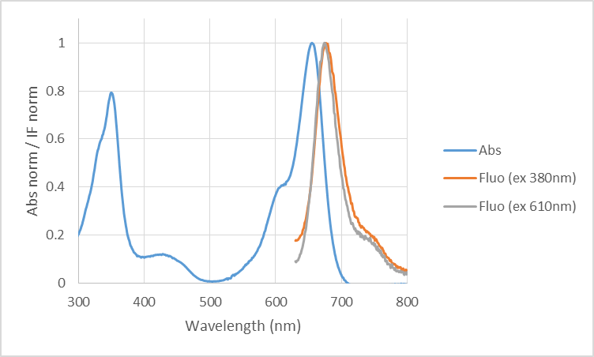
Fig. S21 Normalized absorption and fluorescence emission spectra of BODIPY 4 in 2,2,2-trifluoroethanol.
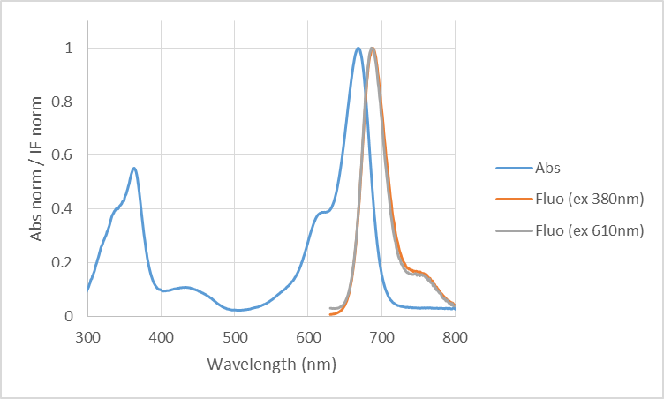
Fig. S22 Normalized absorption and fluorescence emission spectra of BODIPY 4 in toluene.
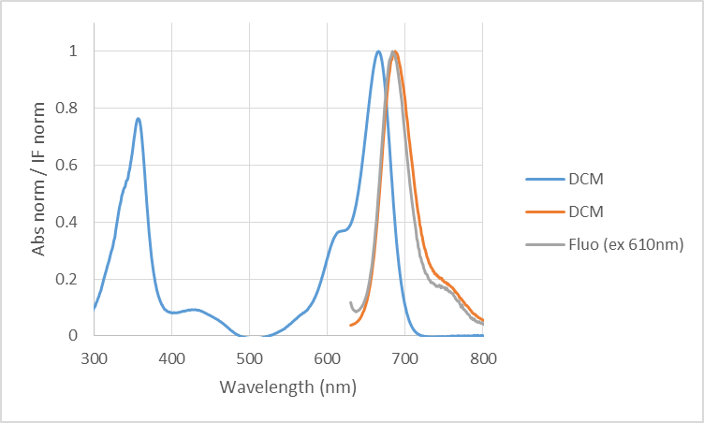
Fig. S23 Normalized absorption and fluorescence emission spectra of BODIPY 4 in dichloromethane.
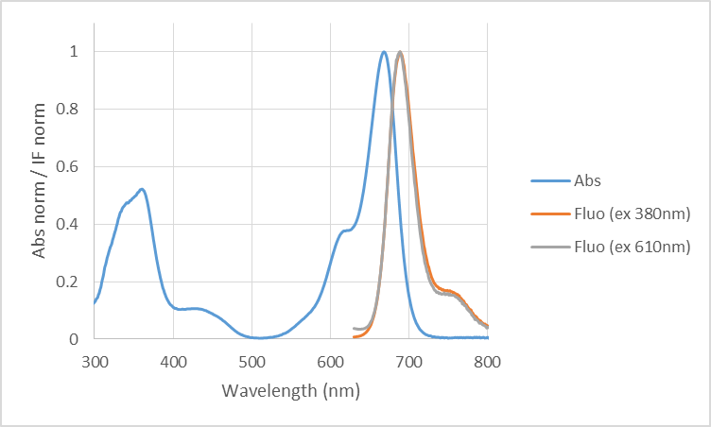
Fig. S24 Normalized absorption and fluorescence emission spectra of BODIPY 4 in mesitylene.
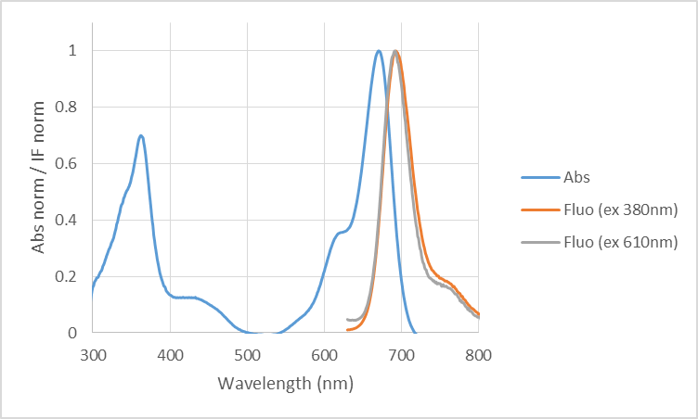
Fig. S25 Normalized absorption and fluorescence emission spectra of BODIPY 4 in benzonitrile.
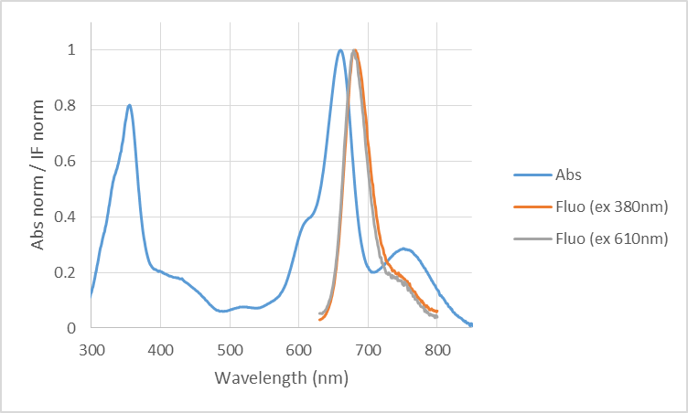
Fig. S26 Normalized absorption and fluorescence emission spectra of BODIPY 4 in acetonitrile.
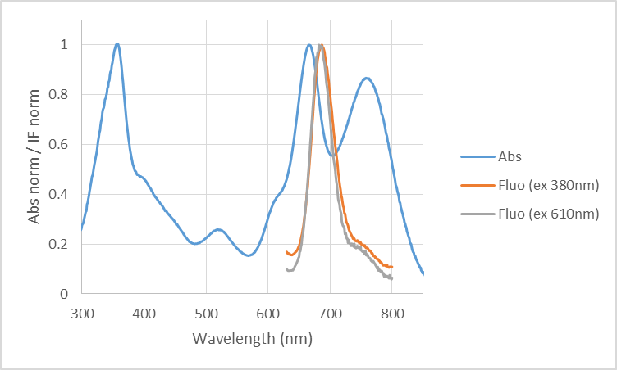
Fig. S27 Normalized absorption and fluorescence emission spectra of BODIPY 4 in propylene carbonate.
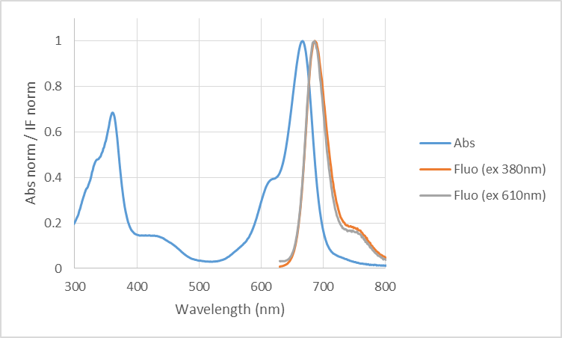
Fig. S28 Normalized absorption and fluorescence emission spectra of BODIPY 4 in 1,4-dioxane.
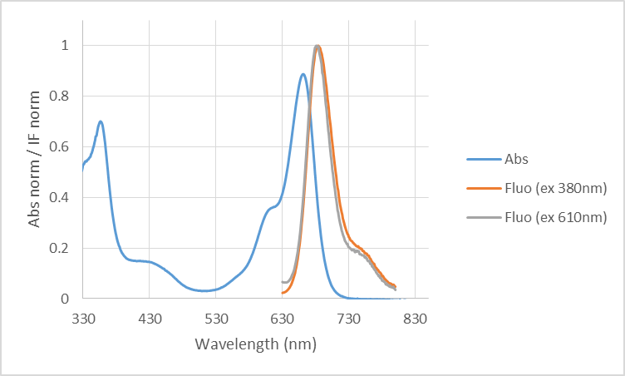
Fig. S29 Normalized absorption and fluorescence emission spectra of BODIPY 4 in acetone.
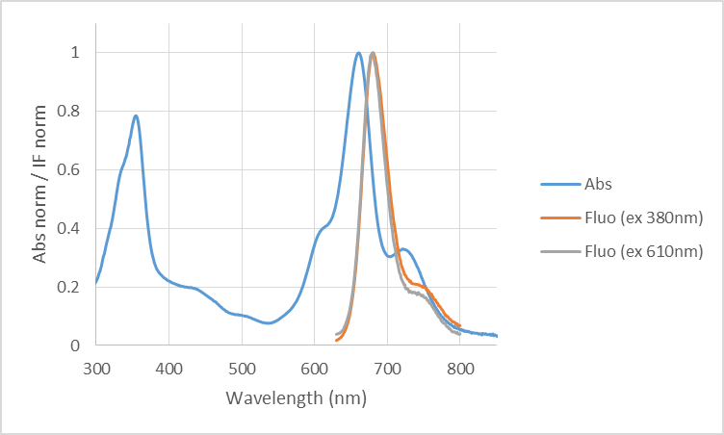
Fig. S30 Normalized absorption and fluorescence emission spectra of BODIPY 4 in ethyl acetate.
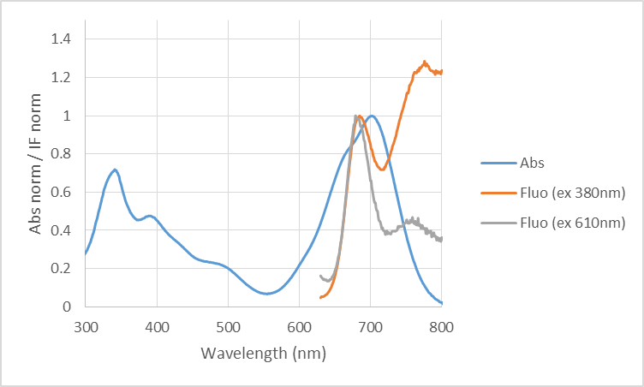
Fig. S31 Normalized absorption and fluorescence emission spectra of BODIPY 4 in methanol.
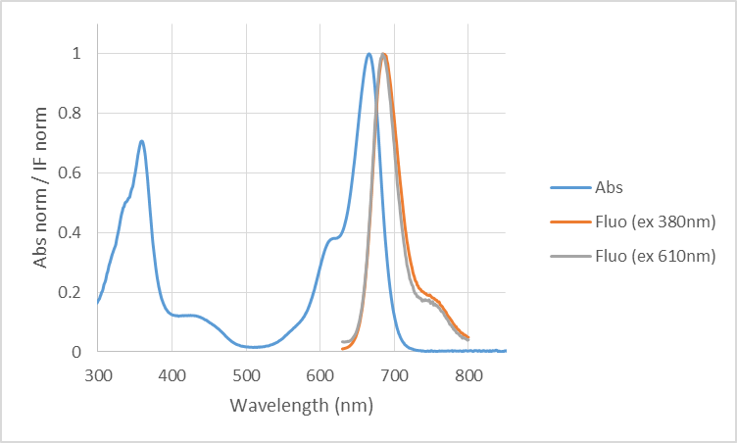
Fig. S32 Normalized absorption and fluorescence emission spectra of BODIPY 4 in tetrahydrofuran.
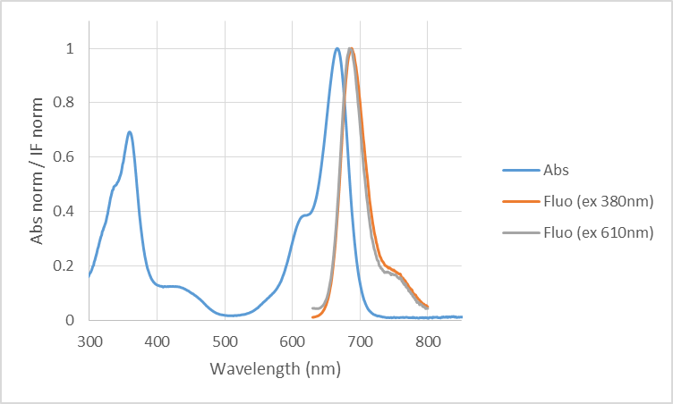
Fig. S33 Normalized absorption and fluorescence emission spectra of BODIPY 4 in tetrahydrofuran and 30µL of water.
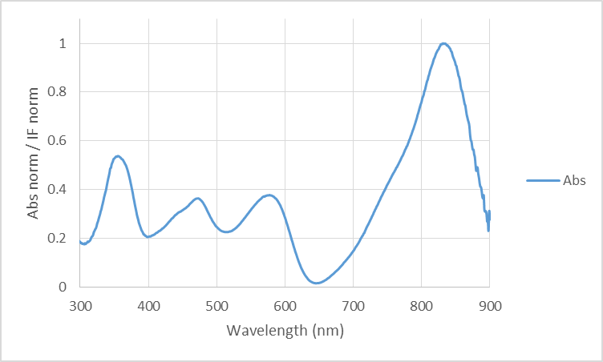
Fig. S34 Normalized absorption spectra of BODIPY 4 in N,N-dimethylformamide.
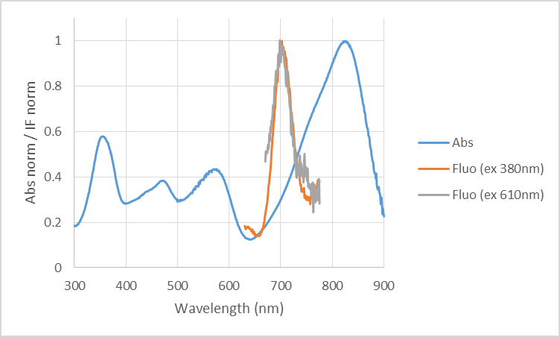
Fig. S35 Normalized absorption spectra of BODIPY 4 in dimethyl sulfoxide.
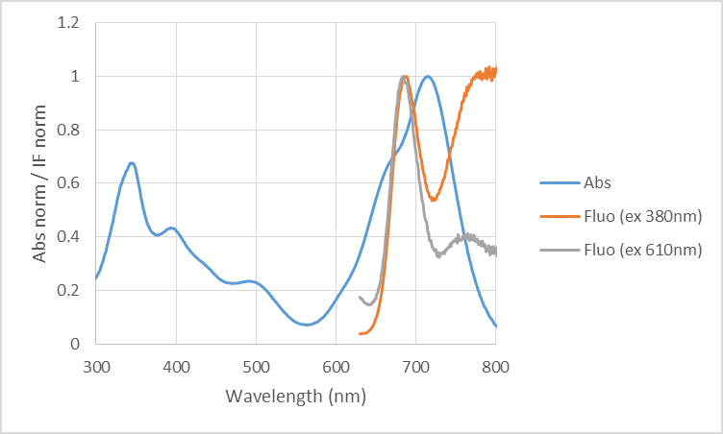
Fig. S36 Normalized absorption spectra of BODIPY 4 in ethanol.

Solvatochromism

Lippert-Mataga
The Lippert-Mataga equation describes the solvatochromic Stokes shift $Δ\overline{ν}={\overline{ν}}_{abs}-{\overline{ν}}_{em}$ (expressed in wavenumbers) as a function of the change of the dipole moment $Δμ_{ge}=μ_{e}-μ_{g}$ of the dye upon excitation. The validity of the equation can be checked by using various solvents with different dielectric constants (ε) and refractive indices (n) and by plotting $Δ\overline{ν}$ as a function of $Δf=f\left(ε\right)-f\left(n^{2}\right)$:
$$Δ\overline{ν}=\frac{2Δf}{4πε_{0}hca^{3}}{\left(μ_{e}-μ_{g}\right)}^{2}+constant$$
with $Δf=\frac{\left(ε-1\right)}{\left(2ε+1\right)}$ and $f\left(n^{2}\right)=\frac{\left(n^{2}-1\right)}{\left(2n^{2}+1\right)}$
where h is the Planck’s constant, c the velocity of light, ε₀ is the permittivity of vacuum, and a represents the radius of the cavity in which the solute resides. μ_{g} and μ_{e} are the dipole moments of the dye in ground and excited states, respectively.
The analysis was done on the phenol band since it is the only fluorescent one in the solvatochromic study. Similarly N,N-dimethylformamide was excluded since BODIPY 4 is not fluorescent in that solvent.
Fig. S37 Stokes shift $Δ\overline{ν}$ of BODIPY 4 versus the Lippert solvent parameter $Δf=f\left(ε\right)-f\left(n^{2}\right)$.
The correlation coefficient is very poor (0.24) and the Stokes shift is weakly dependent on Δf which indicates that the dye’s permanent dipole moments (if any) are similar in the ground and excited states.

Solvent polarity parameter E_{T}(30)
Contrary to the Lippert-Mataga solvent parameter, the solvent polarity parameter E_{T}(30) is a descriptor of both hydrogen bond and electrostatic interactions of solvents. It was thus also tested since the presence of phenols in BODIPY 4 must affect the solvent molecule interactions.

Fig. S38 Solvent polarity parameter E_{T}(30) versus (a) phenol absorption maxima, (b) phenolate absorption maxima and (c) Stokes shift ($Δ\overline{ν}$) of BODIPY 4.
There is no correlation for the absorption maxima of the phenol (r²=0.48) and phenolate (r²=0.16) or the Stokes shift (r²=0.16) with the E_{T}(30) parameter.

Kamlet–Taft scale
Kamlet and Taft proposed to split the solvent effect in three different types of contributions: the π*, a and b parameters to characterize the polarity/polarizability, the acidity and the basicity, respectively, of a given solvent. The absorption maxima of the phenol and phenolate as well as emission maxima and Stokes shifts in the various solvents have been analyzed by the multiple linear regression resolution of the equation:
$$y=y_{0}+a_{α}α+b_{β}β+c_{π^{*}}π^{*}$$
where y is the photophysical parameter, y₀ the property of interest in the gas phase and a_{α}, b_{β}, c_{π*} and d the adjustable coefficients that reflect the sensitivity of the physicochemical property y in a given solvent to the parameters α, β and π* respectively. Table S1 reports the estimated coefficients, and the correlation between the calculated and experimental photophysical parameters are shown in Figure S39.
Table S1 Estimated coefficients (y₀, a_{α}, b_{β} and c_{π*}), their standard errors and correlation coefficients (r²) for the multiple linear regression analyses of λ_{abs} of the phenol and phenolate bands, λ_{em} of the phenol and Stokes shift ($Δ\overline{ν}$) as a function of the Kamlet–Taft solvent scale.
Kamlet-Taft | y₀ | a_{α} | b_{β} | c_{π} | r²
$\overline{ν}$_{abs} (phenol) | 14986 ± 83 | 239 ± 47 | 269 ± 101 | -88 ± 108 | 0.75
$\overline{ν}$_{abs} (phenolate) | 16184 ± 664 | 1006 ± 431 | -2034 ± 894 | -2761 ± 973 | 0.95
$\overline{ν}$_{em} (phenol) | 14779 ± 51 | 123 ± 50 | -127 ± 89 | -302 ± 80 | 0.65
$$Δ\overline{ν}$$ | 454 ± 18 | 29 ± 39 | 7 ± 52 | -0.2 ± 0.7 | 0.08

Fig. S39 a) Linear relationship of the experimental (${\overline{ν}}_{exp}$) and calculated (${\overline{ν}}_{calc}$) absorption maxima of BODIPY 4 a) phenol- and, b) phenolate-form absorption maxima, c) phenol-form fluorescence emission maxima, d) and Stokes shift ($Δ\overline{ν}$) obtained by the multiple linear regression analysis according to Kamlet-Taft analysis.
The Kamlet-Taft scale gives a good correlation only for the phenolate absorption band (r² = 0.95). The property mostly depends on β and π* parameters, which correlate with the basicity (hydrogen bond acceptor) and polarity/polarizability respectively. This is in line with the fact that the BODIPY must give a phenol hydrogen to the solvent to form a polar compound.

References

(a) Lippert, E. (1955). Dipolmoment und Elektronenstruktur von angeregten Molekülen. Z. Naturforsch., A: Phys. Sci., 10, 541−545. (b) Mataga, N., Kaifu, Y., & Koizumi, M. (1955). The solvent effect on fluorescence spectrum – change of solute-solvent interaction during the lifetime of excited solute molecule. Bull. Chem. Soc. Jpn., 28, 690−691. (c) Mataga, N., Kaifu, Y., & Koizumi, M. (1956). Solvent effects upon fluorescence spectra and the dipole moments of excited molecules. Bull. Chem. Soc. Jpn., 29, 465−470.
Cerón-Carrasco, J. P., Jacquemin, D., Laurence, C., Planchat, A., Reichardt, C., & Sraïdi K. (2014). Solvent polarity scales: determination of new E_{T}(30) values for 84 organic solvents. J. Phys. Org. Chem., 27, 512–518.
(a) Kamlet, M. J., & Taft, R.W. (1976). Solvatochromic comparison method. 1. β-Scale of solvent hydrogen-bond acceptor (HBA) basicities. J. Am. Chem. Soc., 98, 377–383; (b) Taft, R. W., & Kamlet M. J. (1976). Solvatochromic comparison method. 2. α-Scale of solvent hydrogen-bond donor (HBD) acidities. J. Am. Chem. Soc., 98, 2886–2894; (c) Kamlet, M. J., Abboud, J. L. M., & Taft, R. W. (1977). Solvatochromic comparison method. 6. π* Scale of solvent polarities. J. Am. Chem. Soc., 99, 6027–6038.

