Table 1 CO₂ Laser Model & Test Range

Model: MS640D 100W  Laser type: CO₂ sealed glass tube laser, wavelength 10.64um  Laser max power: 100W  Resolution: 1000dpi  Working area: 600 × 400mm  Engraving speed: 0-30000mm / min | 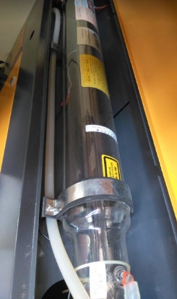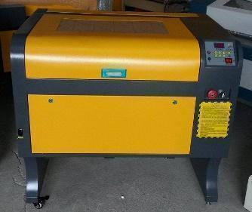  CO₂ sealed glass tube laser

Test Range | Power w | Speed mm/sec | spacing | Over focus
Ceramics (Tiles); Clay; Glass | 5~50w | 0.2~300 | 0.5~0.2mm | 0~40mm

Table 2 The Orton Cone data with kiln firing
Temperature measuring cone  (sintering →melt) | Feldspar 1200°C(melt)  China clay 1310°C(sintering)  Quartz floor tiles 1260°C(sintering)  Clay 1230°C(sintering)
   | Orton Cone 014
  Heating  rate(℃/hour) | 15 | 60 | 150
  Bending  temperature | 757 | 807 | 838
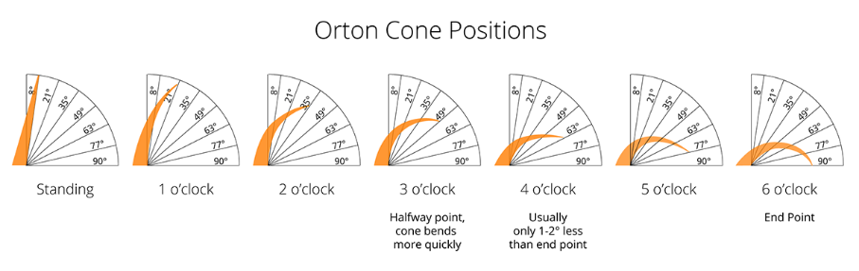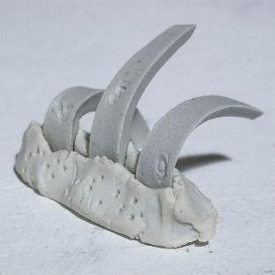
( wiki glazy.org, 2020)

Table 3 The test result of laser speed effect on ceramic surface.
Materials’ class | Speed mm/sec | Result & Ceramic sample firing energy
Blanks (body 1230°C sintering) | 3~5 mm/sec | Start Obvious wavy or Melt & flow  53.05152364~31.83091418
Glazes (1230°C melting) | 8~10 mm/sec | Start Obvious wavy or Melt & flow  19.89432136~15.91545709
laser power 20w

Table 4 The test pictures of laser-firing on the ceramic surfaces with different speeds.
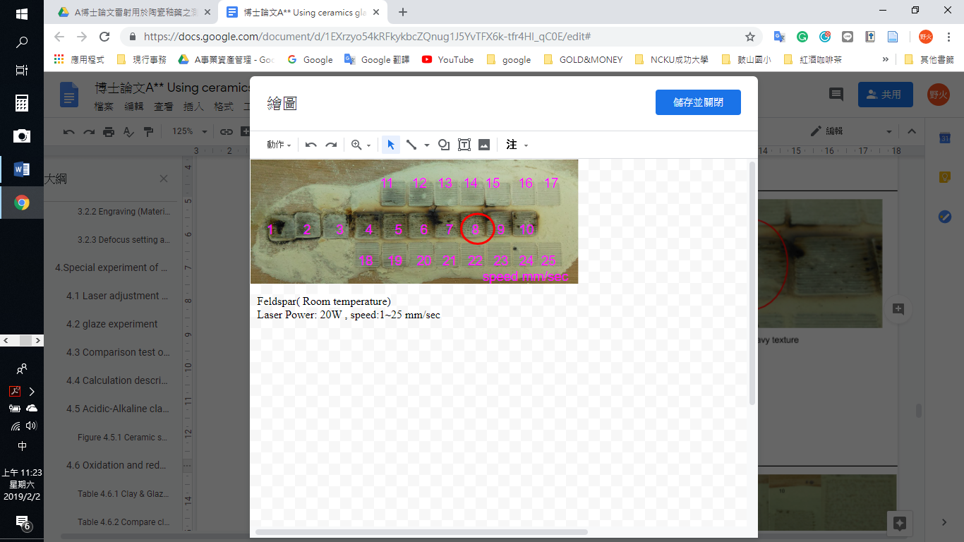  Feldspar( Room temperature)  Laser Power: 20W , speed:1~25 mm/sec. melting at 8 mm/sec. | 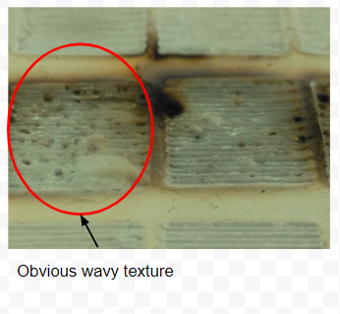
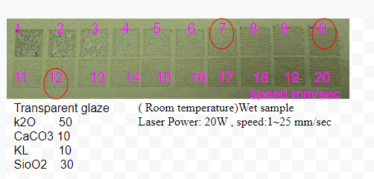  ( Room temperature)Wet sample  Laser Power: 20W , speed:1~25 mm/sec, melting at 10 mm/sec.  Transparent glaze and its components  K₂O 50g  CaCO₃ 10g  KL 10g  SiO₂ 30g | 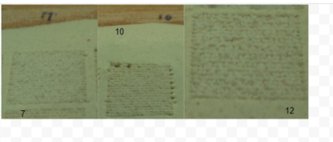
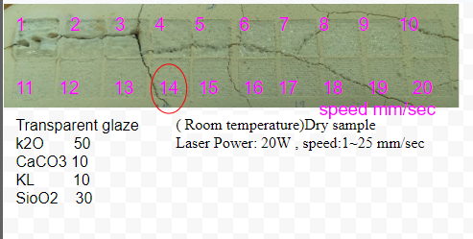  ( Room temperature) Dry sample  Laser Power: 20W , speed:1~25 mm/sec, melting at 14 mm/sec.  Transparent glaze  K₂O 50g  CaCO₃ 10g  KL 10g  SiO₂ 30g | 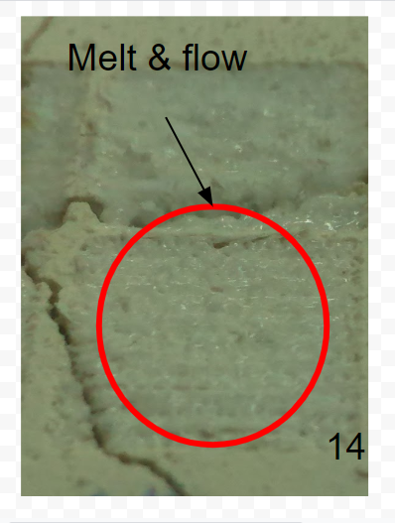
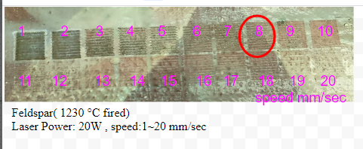  Feldspar (fired at 1230 °C)  Laser Power: 20W , speed:1~20 mm/sec, melting at 8 mm/sec. | 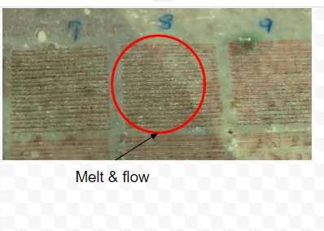
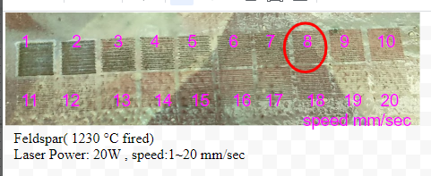  China clay (fired at 800 °C)  Laser power: 20W, speed 1~20 mm/sec, spacing 0.5mm, melting at 8 mm/sec. | 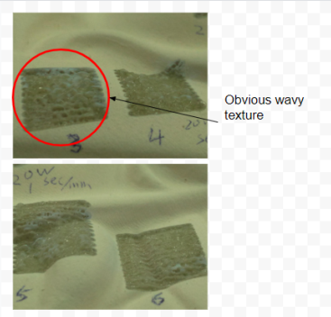
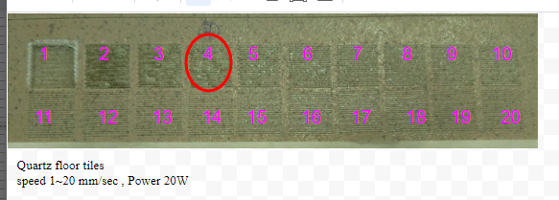  Quartz floor tiles (fired at 1240 °C)  speed 1~20 mm/sec , Power 20W, melting at 4 mm/sec. | 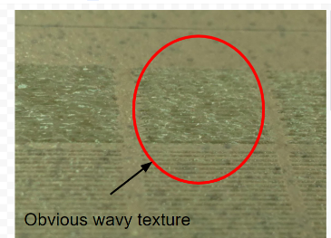
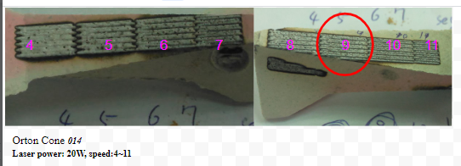  Orton Cone 014 (room temperature)  Laser power: 20W, speed:4~11, melting at 9 mm/sec. | 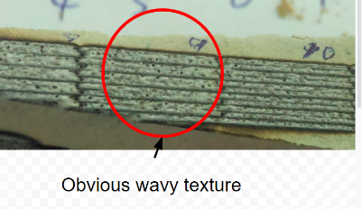
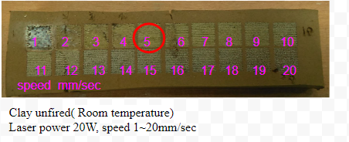  Clay, unfired (room temperature)  Laser power 20W, speed 1~20mm/sec, melting at 5 mm/sec. | 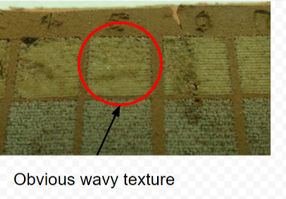
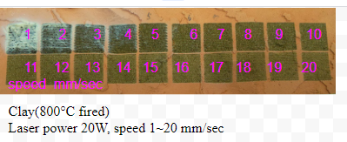  Clay (fired at 800°C)  Laser power 20W, speed 1~20 mm/sec , melting at 5 mm/sec. | 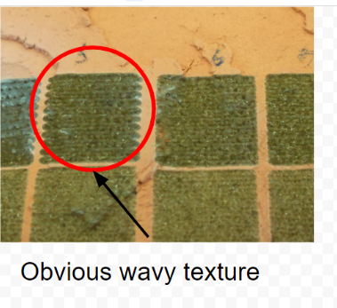
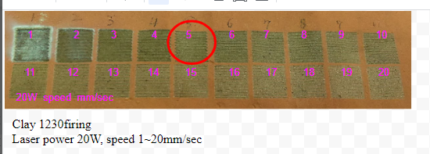  Clay(fired at 1230°C)  Laser power 20W, speed 1~20 mm/sec , melting at 5 mm/sec. | 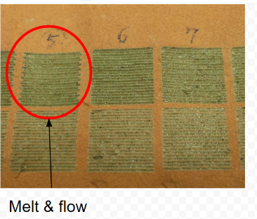

Table 5 The relationship between laser energy and kiln firing temperature
Laser firing energy value W. | 53.05152364 | 45.62525325 | 30.76996576 | 15.91545709 | 0.08488243782
Kiln firing temperature  (speculation) | 1250°C | 1240°C~  1200°C | 1100°C | 1000°C | 1°C  (in kiln firing range of 1250~1000°C)
speed(mm/sec) | 3 | 3.4883 | 5.1724 | 10 | 3~5mm/sec
Table 6 Comparing clay in different firing methods.
A) Clay with 2.33% Fe₂O₃ → displays green color when laser fired.
B) Left: laser firing clay with 2.33% Fe₂O₃. Middle: laser firing glaze with 0% Fe₂O₃. Left: kiln firing clay with 2.33% Fe₂O₃.
C) Clay with 2.33% Fe₂O₃ →kiln firing→laser firing displays a green color.
D) Clay with 2.33% Fe₂O₃ →laser firing→kiln firing displays a brown color.
E) Laser firing 70% Kamado Feldspar + 30% Kaolin glaze with 0% Fe₂O₃ displays a transparent color. F) Laser firing 70% Kamado Feldspar + 30% Kaolin glaze with 2% Fe₂O₃ displays a green color.
G) Laser firing 70% Kamado Feldspar + 30% Kaolin glaze + 3% CuCO₃ displays a red color.
H) 70% Kamado Feldspar + 30% Kaolin glaze + 3% CuCO₃ → oxidation from kiln firing at 1265°C displays a green color→laser firing→displays a red color.
I) After laser firing the CuCO₃ and the Fe₂O₃ on a transparent ceramic surface, the CuCO₃ displays a red color and the CuCO₃ displays a light green color.
J) Taiwan, Patent Number I687394 & I750055.

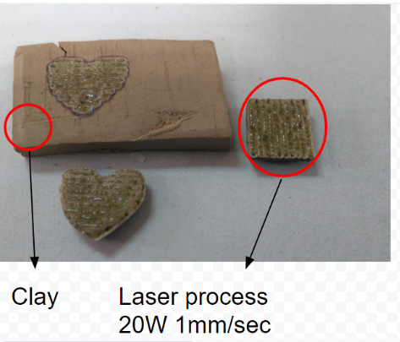A.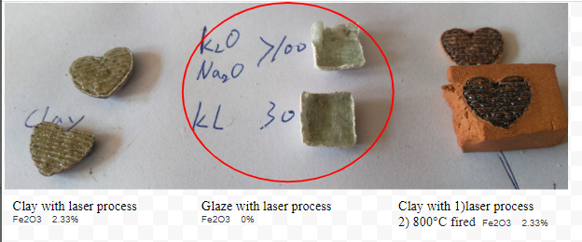B.

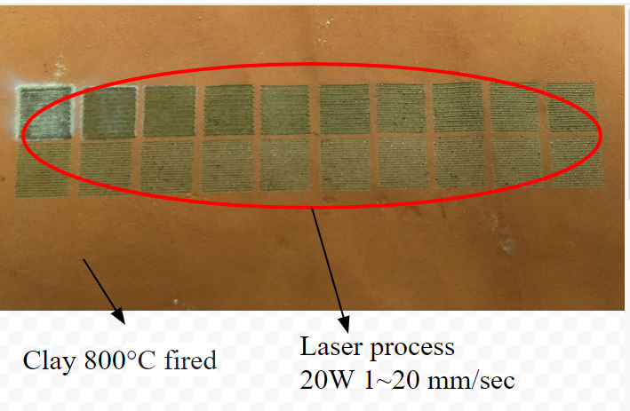C.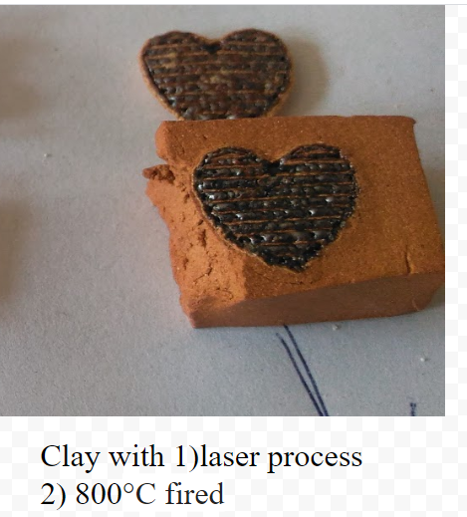D.

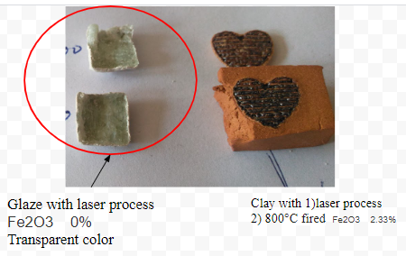E.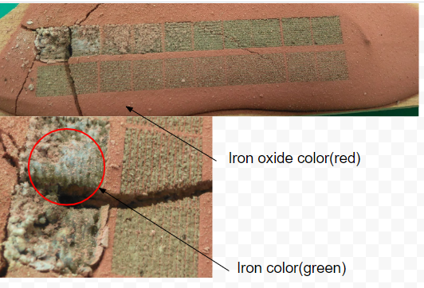F.

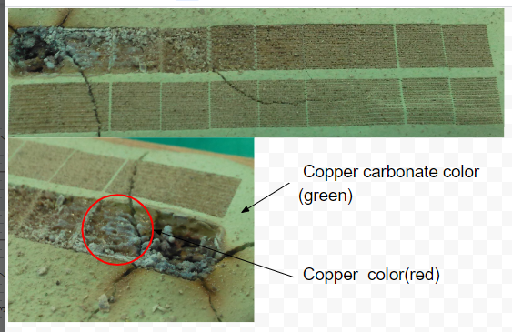G.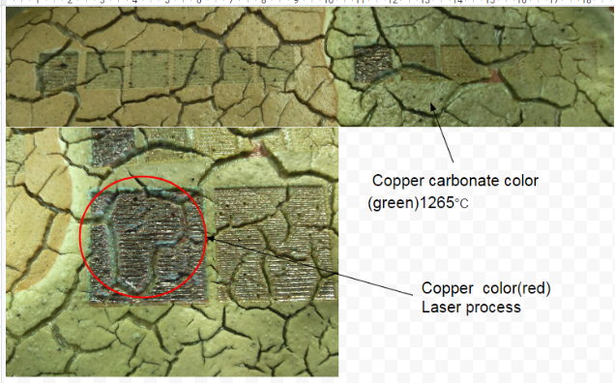H

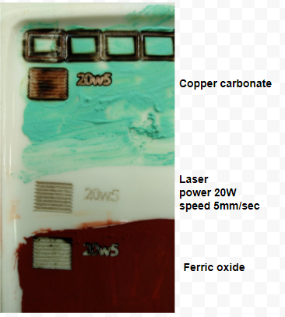I
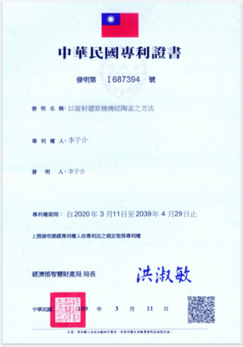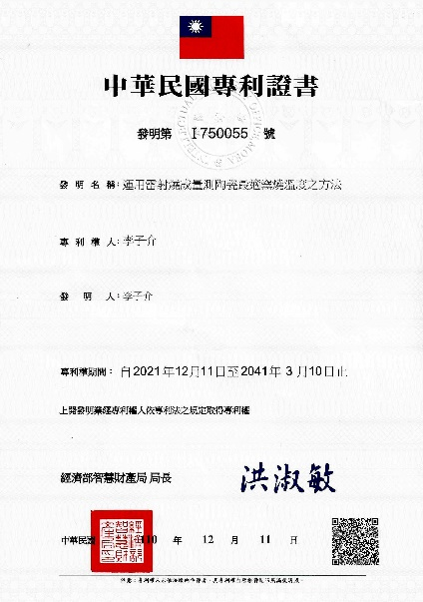J

Table 7 Test images of laser firing Fe₂O₃ and the CuCO₃ on a ceramic surface.[A]The Fe₂O₃ and the CuCO₃ are non-conductive. [B] The Fe₂O₃ and CuCO₃ are placed on a ceramic surface and laser-fired without an airflow tube. [C] Cleaning the ceramic surface.[D] CuCO₃ with 42Ω; Fe₂O₃ with 120Ω.

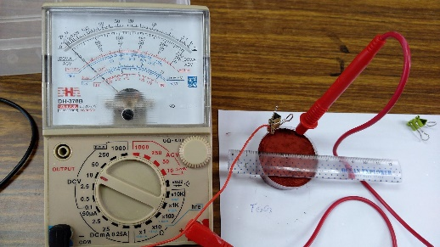[A] 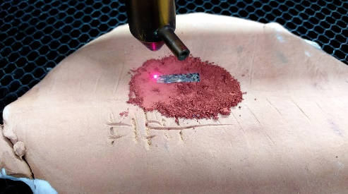[B]
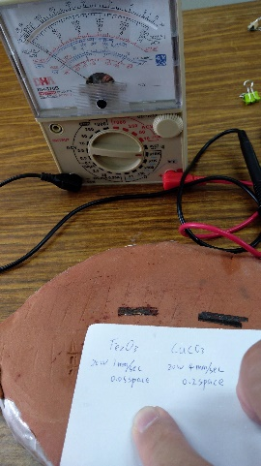[C] 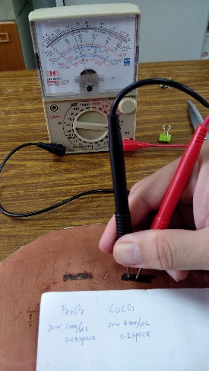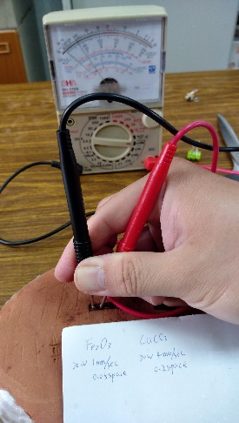[D]

