Supplementary material
2. Materials and methods
2.1 Metabolomics Analysis
For the metabolomics analysis, whole-body tissue of Drosophila both in control group and PS+PE group were used, with each group replicated three times. Each group comprised six flies and evenly divided by gender. The collected samples were thawed on ice, and metabolites were extracted using a 50% methanol buffer, followed by storage at -80 °C until UPLC-MS analysis. The UPLC-MS system was operated according to the manufacturer's standard protocols. The Vanquish Flex UPLC system (Thermo Fisher Scientific, Bremen, Germany) was employed for all chromatographic separations, utilizing an ACQUITY UPLC T3 column (100 mm × 2.1 mm, 1.8 µm, Waters, Milford, USA) for reversed phase separations. The column oven was maintained at 35 °C. The flow rate was 0.4 ml/min and the mobile phase consisted of solvent A (water, 0.1% formic acid) and solvent B (Acetonitrile, 0.1% formic acid). Gradient elution conditions were set as follows: 0～0.5 min, 5% B; 0.5～7 min, 5% to 100% B; 7~8 min, 100% B; 8～8.1 min, 100% to 5% B; 8.1～10 min, 5%B. A high-resolution tandem mass spectrometer Q-Exactive (Thermo Scientific) was used to detect metabolites eluted form the column. The Q-Exactive was operated in negative ion modes. Precursor spectra (70–1050 m/z) were collected at 70,000 resolution to hit an AGC target of 3e6. The maximum inject time was set to 100 ms. A top 3 configuration to acquire data was set in DDA mode. Fragment spectra were collected at 17,500 resolution to hit an AGC target of 1e5 with a maximum inject time of 80 ms. In order to evaluate the stability of the UPLC-MS during the whole acquisition, a quality control sample (Pool of all samples) was acquired after every 10 samples. The acquired data were preprocessed, including peak picking, peak grouping, retention time correction, second peak grouping, and annotation of isotopes and adducts UPLC-MS raw data files were converted into mzXML format and then processed by the XCMS, CAMERA and metaX toolbox implemented with the R software. The online Kyoto Encyclopedia of Genes and Genomes (KEGG) and Human Metabolome Database (HMDB) database were used to annotate the metabolites by matching the exact molecular mass data (m/z) of samples with those from the database. If a mass difference between observed and the database value was less than 10 ppm, the metabolite would be annotated and the molecular formula of metabolites would further be identified and validated by the isotopic distribution measurements. We also used an in-house fragment spectrum library of metabolites to validate the metabolite identification. Principal component analysis (PCA) was performed for outlier detection and batch effects evaluation on the sample dataset including QC. Independent Samples t-test was used to detect differences in metabolite concentrations between the two groups. The Partial Least Squares Discriminant Analysis (PLS-DA) was performed to discriminate the global metabolic differences between groups. Total 200 permutation tests were performed for avoiding the over-fitting of PLS-DA models and evaluating the validity of the models using the model parameters R2 and Q2. The variable importance in projection (VIP) value was calculated, and the differential metabolites were filtered by VIP > 1, P value < 0.05 and fold change < 0.5 or > 2. Finally, the KEGG database was used to explore the roles of these metabolites and metabolic pathways.
2.2 Transcriptomic analysis
In this study, total RNA was isolated from the whole-body tissue of flies cultured on control and PS+PE mediums in triplicate. For each group, six flies were selected and evenly divided by gender. The trizol reagent (Thermo Fisher, 15596018) was used to extract total RNA following the manufacturer's procedure. The RNA amount and purity of each sample was quantified using NanoDrop ND-1000 (NanoDrop, Wilmington, DE, USA). RNA integrity was assessed with an Agilent 2100 bioanalyzer, with only samples exhibiting a RNA Integrity Number (RIN) above 7.0 being deemed suitable for further analysis. The quality and quantity of the extracted RNA were analyzed using Bioanalyzer 2100 and RNA 6000 Nano LabChip Kit (Agilent, CA, USA, 5067-1511), and high-quality RNA samples with an RIN number greater than 7.0 were selected to construct sequencing library. After the total RNA was extracted, mRNA was purified from 5 μg of total RNA using Dynabeads Oligo (Thermo Fisher, CA, USA) with two rounds of purification. The RNA libraries were sequenced on the Illumina NovaseqTM 6000 platform by LC Bio Technology CO., Ltd (Hangzhou, China).
The expression levels of all transcripts were estimated using StringTie and ballgown (http://www.bioconductor.org/packages/release/bioc/html/ballgown.html), and expression abundance for mRNAs was calculated as FPKM (fragment per kilobase of transcript per million mapped reads) value. Genes differential expression analysis was performed by DESeq2 software between two different groups, and by edgeR between two samples. The genes with false discovery rate (FDR) below 0.05 and an absolute fold change of at least 2 were considered differentially expressed genes (DEGs). Subsequently, these DEGs were used for enrichment analyses of the Gene Ontology (GO) and the Kyoto Encyclopedia of Genes and Genomes (KEGG) pathways.

Table S1 Classification of metabolites
Sex | Classification | Metabolites
Male
 | Organic acids and derivatives | L-Glutamine, N-lactoyl-Leucine, N-Acetyl-L-aspartic acid
 | Organoheterocyclic compounds | Xanthine, Lansine
 | Unknown | 2-Keto-D-gluconic acid, N-Lauroylsarcosine
 | Lipids and lipid-like molecules | LysoPC 18:0, LysoPE 18:0, Myristic acid, dodecanedioic acid, 2,2,4,4-Tetramethyl-6-(1-oxobutyl)-1,3,5-cyclohexanetrion, palmitelaidic acid, tetradecanedioic acid, 11-Oxohexadecanoic acid, 3b-Hydroxy-6b-methoxy-7(11)-eremophilen-12, 8a-olide, hexadecanedioic acid, acylcarnitine 14:0, acylcarnitine 15:0, acylcarnitine 16:1
 | Phenylpropanoids and polyketides | Isopimpinellin
 | Organic oxygen compounds | D-Ribose 5-phosphate
 | Nucleosides, nucleotides, and analogues | Adenylosuccinic acid
Female
 | Organoheterocyclic compounds | Hypoxanthine, xanthine
 | Lipids and lipid-like molecules | Rac-Glycerol 3-phosphoate
 | Organic acids and derivatives | Glutamine, N-Acetyl-L-aspartic acid, N-Nonanoylglycine
 | Nucleosides, nucleotides, and analogues | Adenylosuccinic acid

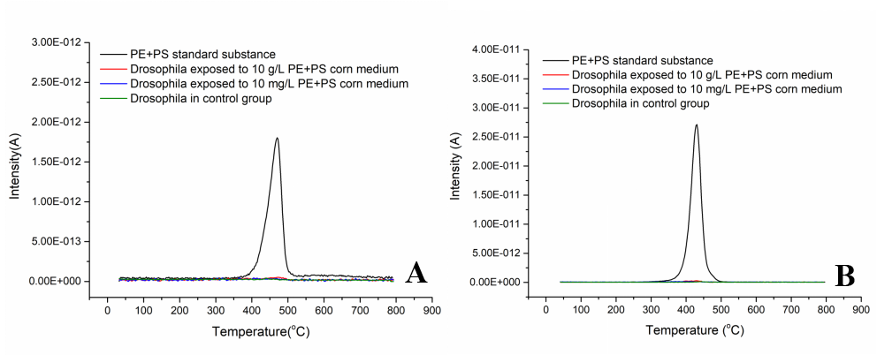
Fig. S1 Mass spectrometer curves of m/z 56 for PE (A) and m/z 104 for PS (B)

Fig. S2 PCA scores plots of female control (CF), male control (CM), PS+PE exposure female (HF), PS+PE exposure male (HM), and quality control (QC) samples; PC1, first principal component; PC2, second principal component.

Fig. S3 PLS-DA analysis on metabolomics profiles in the Drosophila. Score plot of control and PS+PE exposure groups in male (A) and female (C) flies; Permutation test of the PLS-DA model of control and PS+PE exposure groups in male (B) and female (D) flies. PC1, first principal component; PC2, second principal component. The R2Y value represents the goodness of fit of the model. The Q2 value represents the predictability of the models.

